Supplementary material
ECT: In the 20 ECT patients who exhibited theta oscillations both pre- and post-ECT, the regression to predict theta band power was overall significant (R²_{adj} = 0.74, F(3, 16) = 18.90, p = 1.64 x 10⁻⁵). An increase in aperiodic exponent does not predict theta band power (β = 0.25, ɑ_{adj} = 2.50 x 10⁻², p = 0.06, 95% CI[-0.01, 0.52]), nor does theta abundance (β = -0.01, ɑ_{adj} = 0.05, p = 0.96, 95% CI[-0.27, 0.25]), but theta oscillation power was significantly related to theta band power (β= 0.77, ɑ_{adj} = 1.67 x 10⁻², p = 1.80 x 10⁻⁵, 95% CI[0.50, 1.05]). All 22 patients exhibited alpha oscillations both pre- and post-ECT, and the overall regression to predict alpha band power was significant (R²_{adj} = 0.50, F(3, 18) = 7.89, p = 1.44 x 10⁻³). Alpha band power is significantly related to alpha aperiodic adjusted power (β = 0.65, ɑ_{adj} = 1.67 x 10⁻², p = 1.2 x 10⁻³, 95% CI[0.29, 1.00]), but not by alpha abundance (β = -0.31, ɑ_{adj} = 2.50 x 10⁻², p = 0.08, 95% CI[-0.66,0.04]), nor a change in exponent (β = 0.16, ɑ_{adj} = 0.05, p = 0.37, 95% CI[-0.20, 0.52]).

MST: In the 18 patients who exhibited theta oscillations both pre- and post-MST, the regression to predict theta band power was overall significant (R²_{adj} = 0.89, F(3, 14) = 47.33, p = 1.42 x 10⁻⁷). Theta band power was significantly related to both a change in exponent (β = 0.42, ɑ_{adj} = 2.50 x 10⁻², p = 1.73 x 10⁻³, 95% CI[0.19, 0.67]) and theta oscillation power (β = 0.65, ɑ_{adj} = 1.67 x 10⁻², p = 1.01 x 10⁻⁴, 95% CI[0.39, 0.91]). Theta abundance was not related to theta band power (β = -0.11, ɑ_{adj} = 0.05, p = 0.25, 95% CI[-0.30, 0.09]). All 22 patients exhibited alpha oscillations both pre- and post-MST, and the regression for alpha band power was overall significant (R²_{adj} = 0.45, F(3, 18) = 6.63, p = 3.29 x 10⁻³). Both aperiodic exponent (β = 0.64, ɑ_{adj} = 2.50 x 10⁻², p = 4.57 x 10⁻³, 95% CI[0.23, 1.06]) and aperiodic adjusted alpha power (β = 0.85, ɑ_{adj} = 1.67 x 10⁻², p = 4.22 x 10⁻⁴, 95% CI[0.44, 1.27]) were significantly related to alpha band power, but not alpha abundance (β = 0.06, ɑ_{adj} = 0.05, p = 0.73, 95% CI[-0.29, 0.41]).

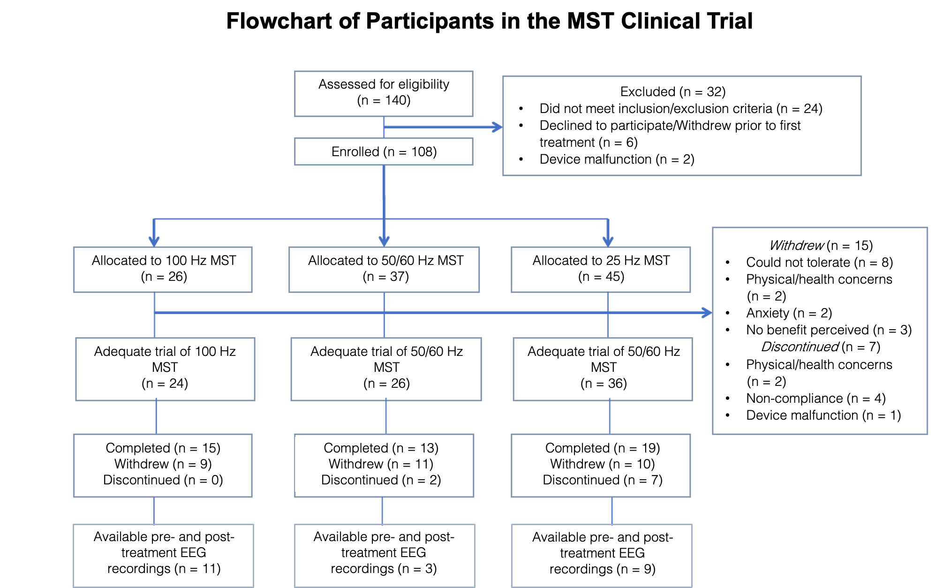
Supplementary Fig. 1: CONSORT flowchart

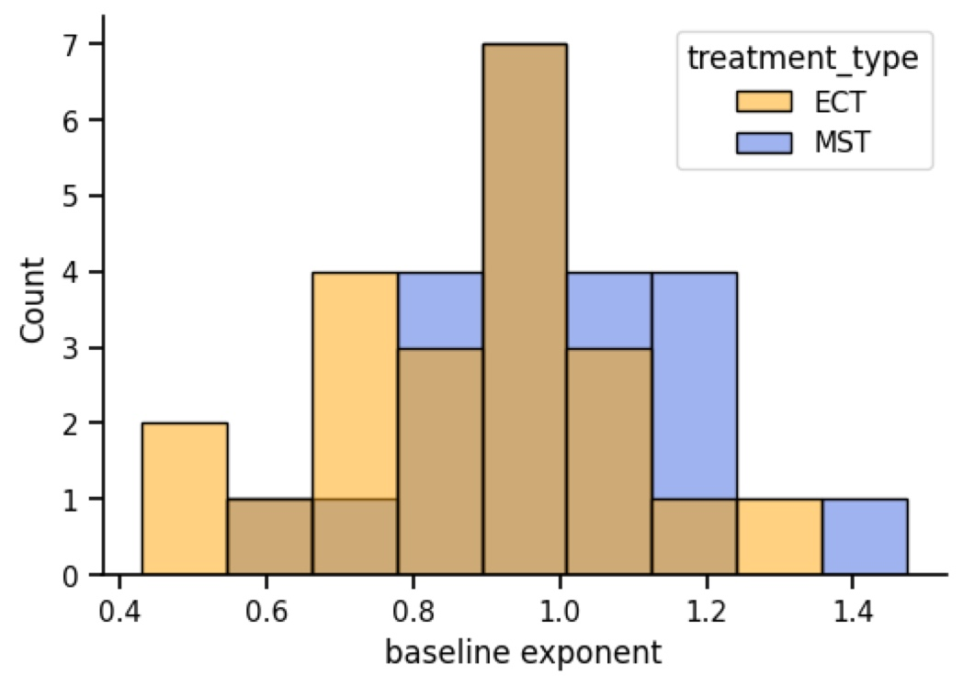

Supplementary Fig. 2: Baseline differences in EEG aperiodic exponent of patients receiving ECT and MST. There is no significant difference in baseline aperiodic exponent between patients receiving either ECT or MST (ECT = 0.88 ± 0.21, MST = 0.98 ± 0.18, t(42) = 1.71, p = 0.094).

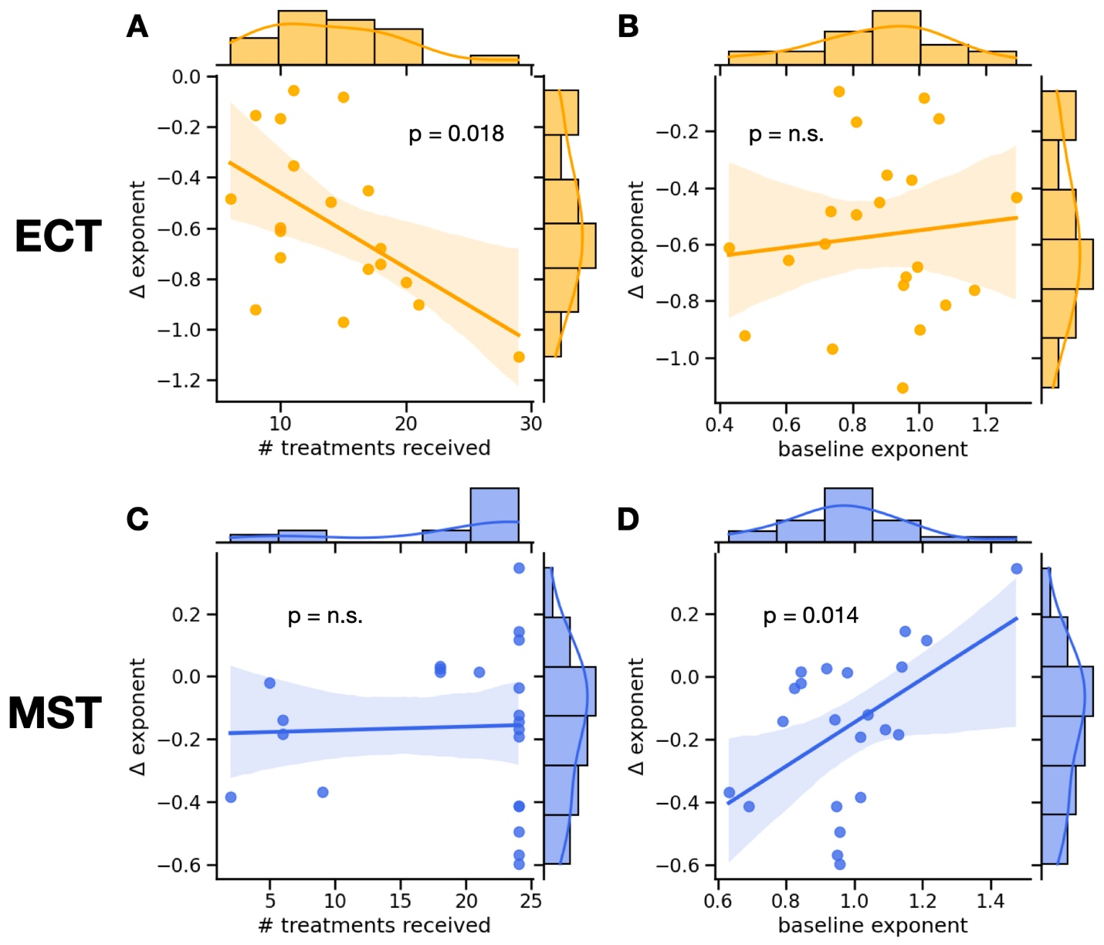

Supplementary Fig.3: Correlations between the difference in exponent due to ECT or MST and the number of treatments received or the baseline exponent. In ECT, the number of treatments received is significantly negatively correlated to the difference in exponent (r = -0.54, p = 0.018). Thus, the more ECT treatments received, the "steeper" the spectrum becomes. Whereas the baseline exponent is not correlated to the difference in exponent (r = 0.11, p = 0.63). In MST, the number of treatments received is not correlated to the difference in exponent (r = 0.034, p = 0.87). Whereas the baseline exponent is significantly positively correlated to the difference in exponent (r = 0.51, p = 0.014). Thus, the "flatter" the spectrum at baseline, the more "steepening" we see due to MST.

Supplementary Table 1: Holm-Bonferroni correction values. Overview of multiplicity-correction for ECT and MST datasets. Each dataset had 8 hypothesis tests performed on EEG features. Holm’s Sequential Bonferroni procedure was applied to adjust alpha threshold for significance testing.
treatment type | Feature for  hypothesis test | p-value | rank | alpha (adjusted) | significant?
ECT | exponent | 1.05E-08 | 1 | 6.25E-03 | yes
ECT | delta band power | 4.83E-08 | 2 | 7.14E-03 | yes
ECT | delta oscillation power | 2.44E-02 | 8 | 5.00E-02 | yes
ECT | delta abundance | 1.77E-04 | 4 | 1.00E-02 | yes
ECT | theta oscillation power | 1.90E-05 | 3 | 8.33E-03 | yes
ECT | theta abundance | 5.40E-03 | 6 | 1.67E-02 | yes
ECT | alpha oscillation power | 3.20E-03 | 5 | 1.25E-02 | yes
ECT | alpha abundance | 1.90E-02 | 7 | 2.50E-02 | yes
MST | exponent | 6.00E-03 | 2 | 7.14E-03 | yes
MST | delta band power | 3.65E-02 | 5 | 1.25E-02 | no
MST | delta oscillation power | 9.80E-03 | 3 | 8.33E-03 | no
MST | delta abundance | 7.96E-01 | 8 | 5.00E-02 | no
MST | theta oscillation power | 3.80E-05 | 1 | 6.25E-03 | yes
MST | theta abundance | 1.81E-02 | 4 | 1.00E-02 | no
MST | alpha oscillation power | 3.91E-01 | 7 | 2.50E-02 | no
MST | alpha abundance | 1.78E-01 | 6 | 1.67E-02 | no

