Supplementary Appendix

Supplementary Figures

Supplementary Figure 1
Example of data statistics process

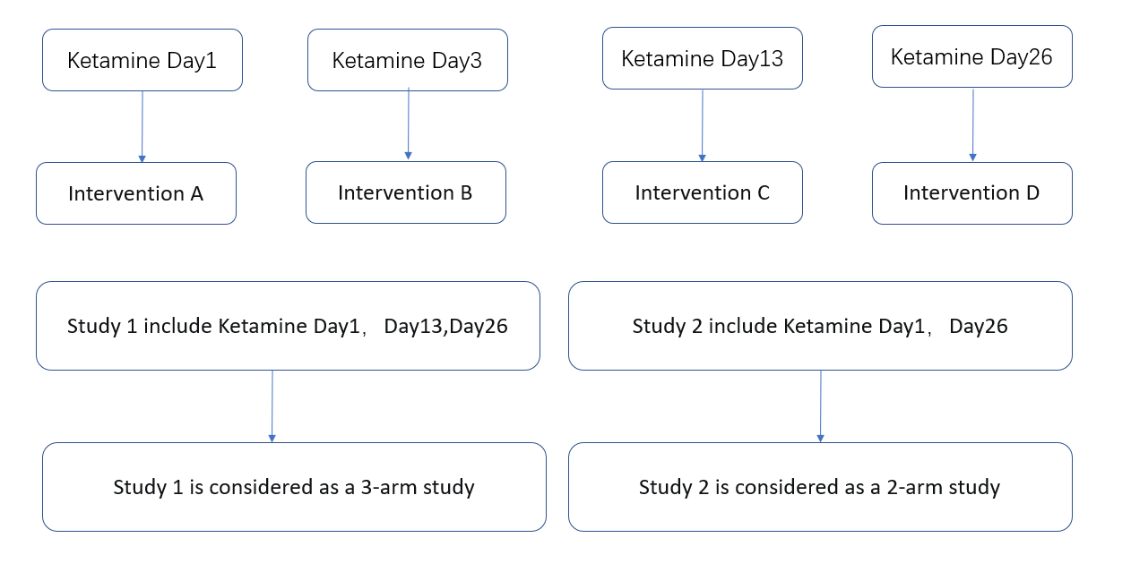

Supplementary Figure 2
Cumulative probability of different treatment measures affecting the remission level of suicidal ideation under multiple time nodes

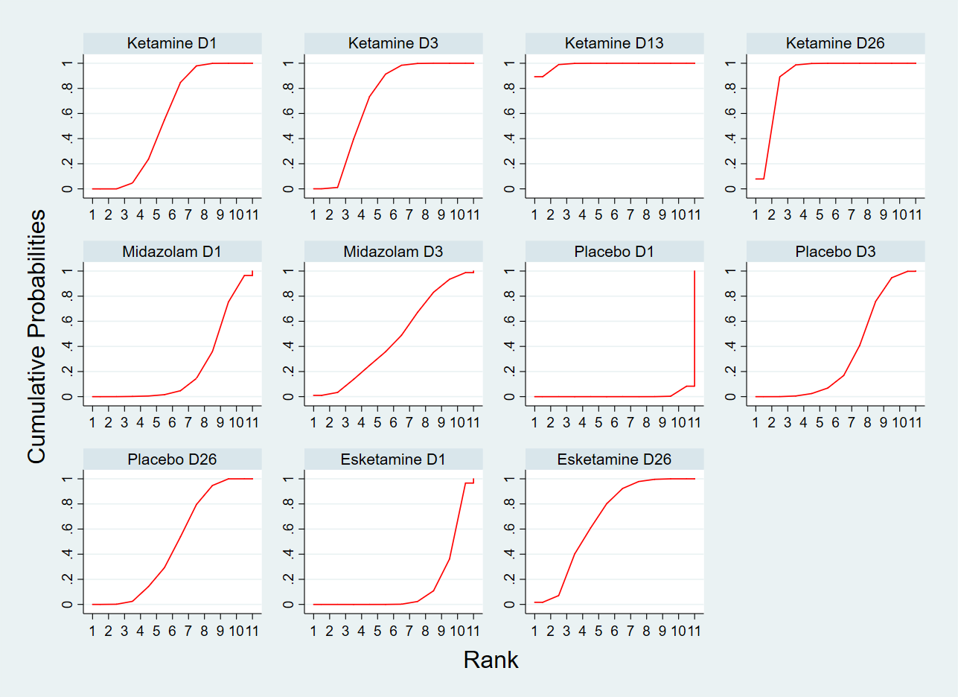

Supplementary Figure 3
Contribution plot of network meta-analysis
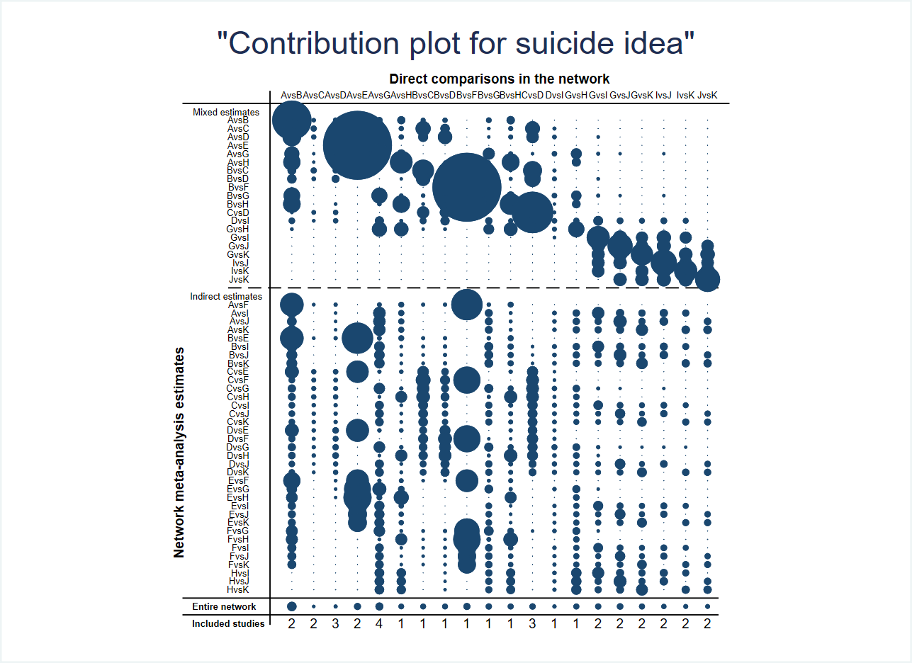

Supplementary Figure 4
Funnel plot of network meta-analysis
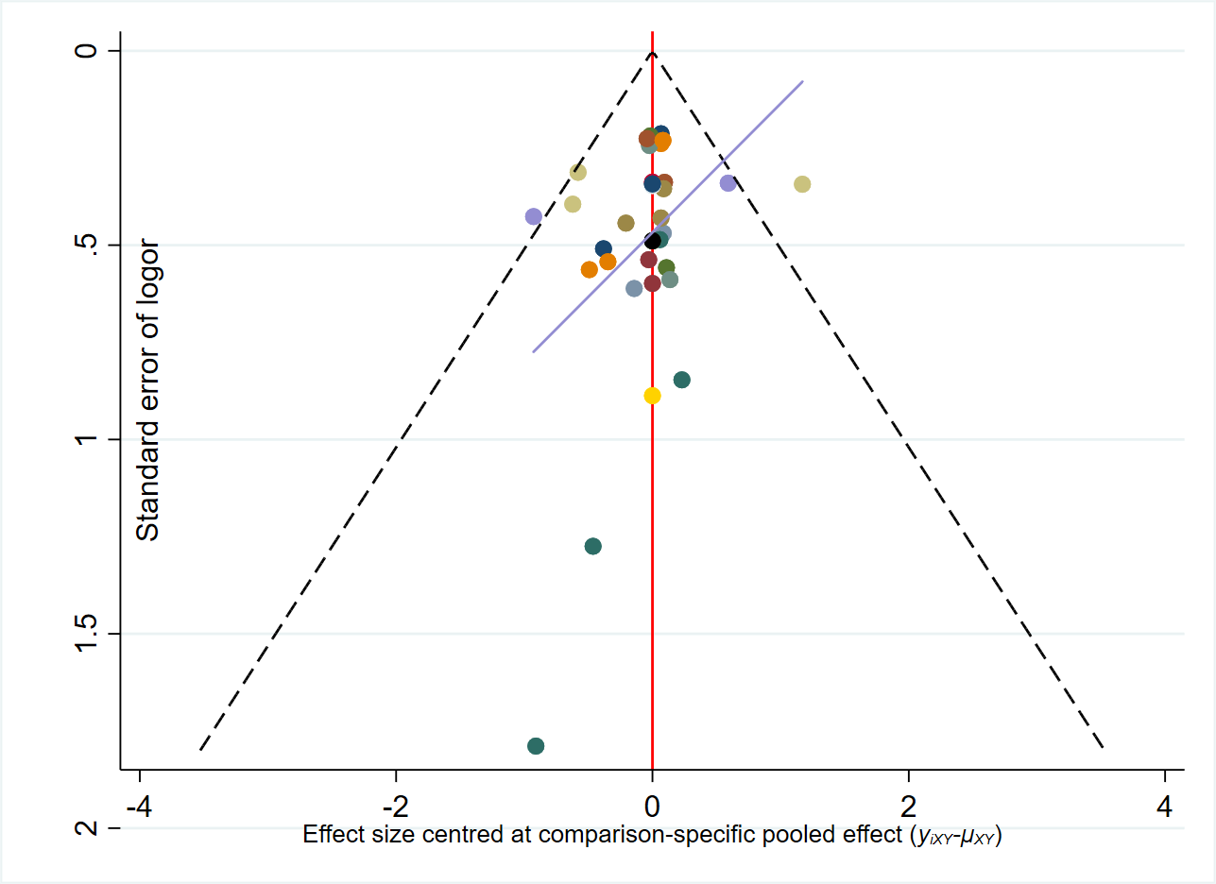

Supplementary Figure 5
Egger’s publication bias plot of the remission effect of suicidal ideation between the first and the last treatment in the repeated administration group
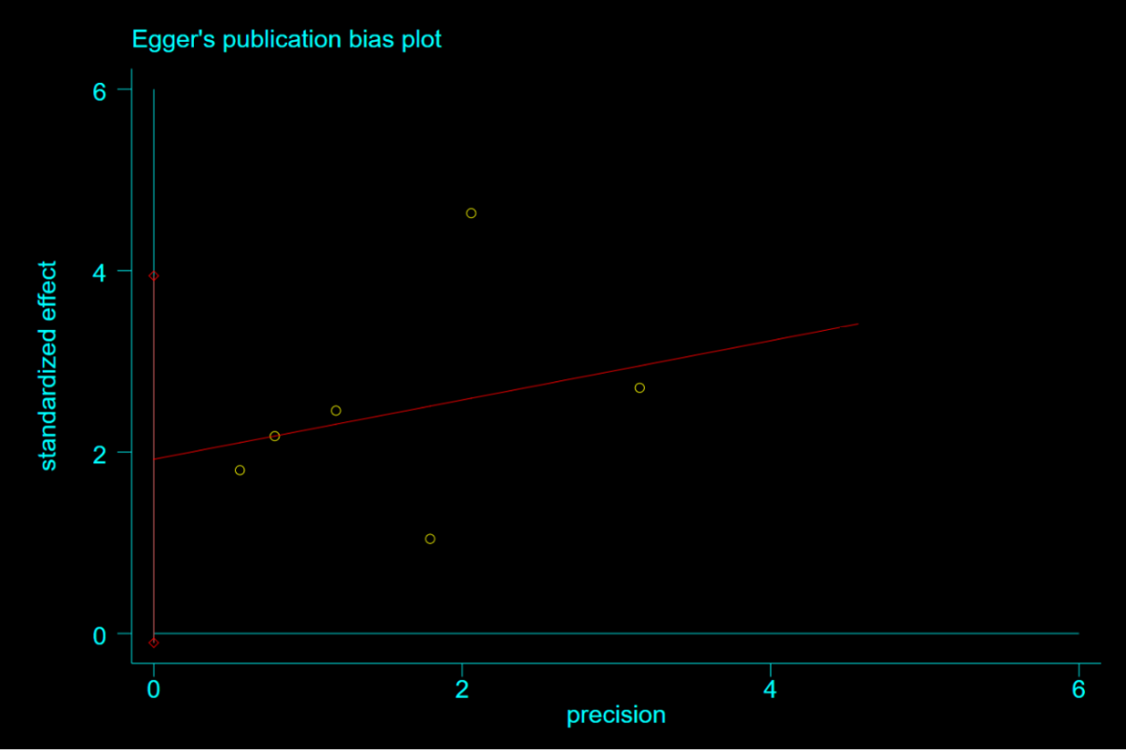

Supplementary Figure 6
Funnel plot of the remission effect of suicidal ideation between the first and the last treatment in the repeated administration group
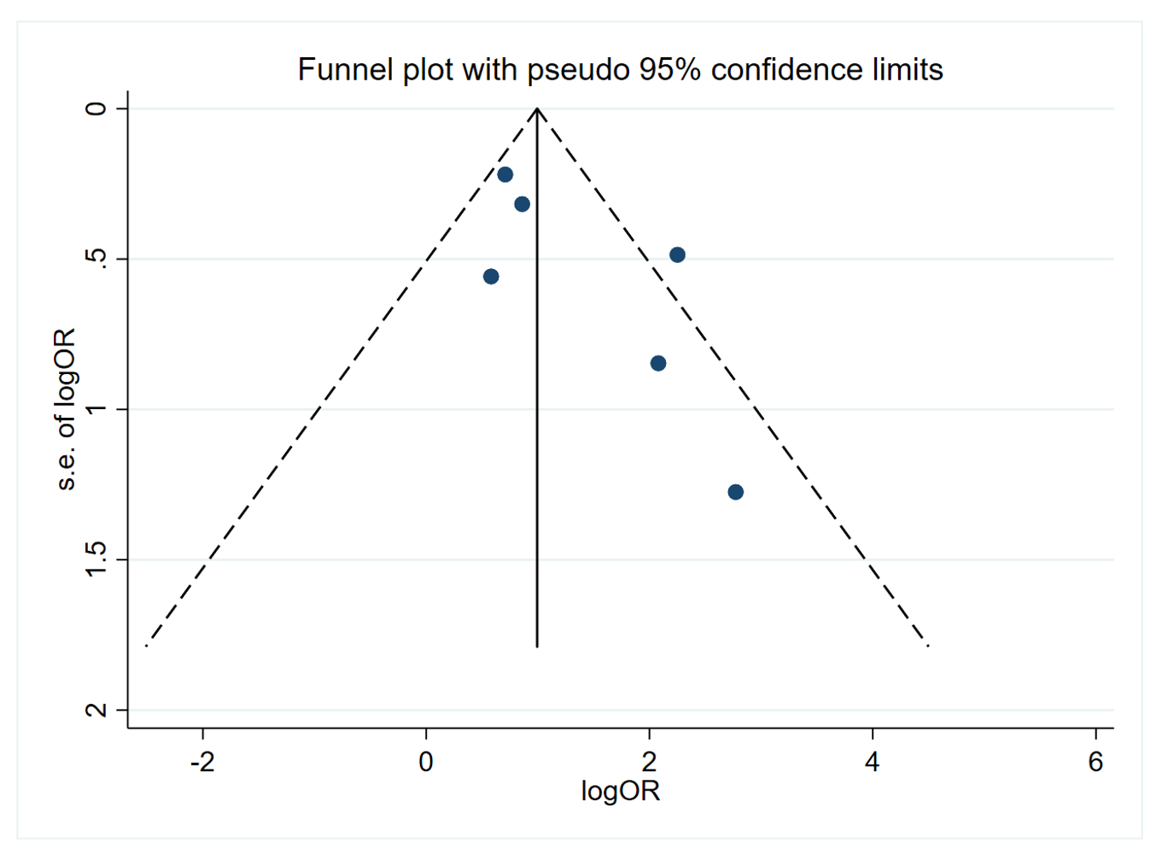

Supplementary Figure 7
Supplementary Figure 7(A)
Risk of bias of included studies in meta-analysis of ketamine studies
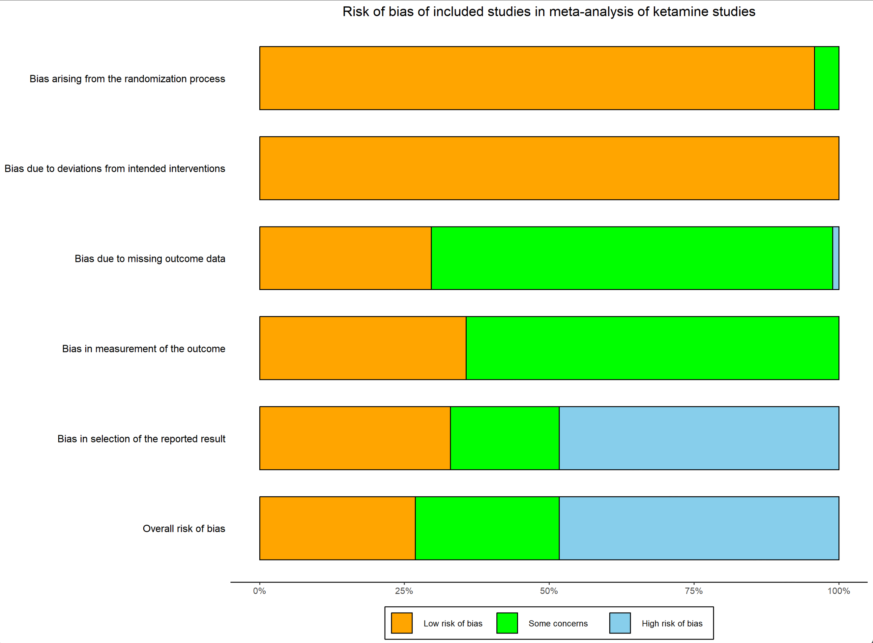

Supplementary Figure 7(B)
Risk of bias of included studies in meta-analysis of ketamine studies
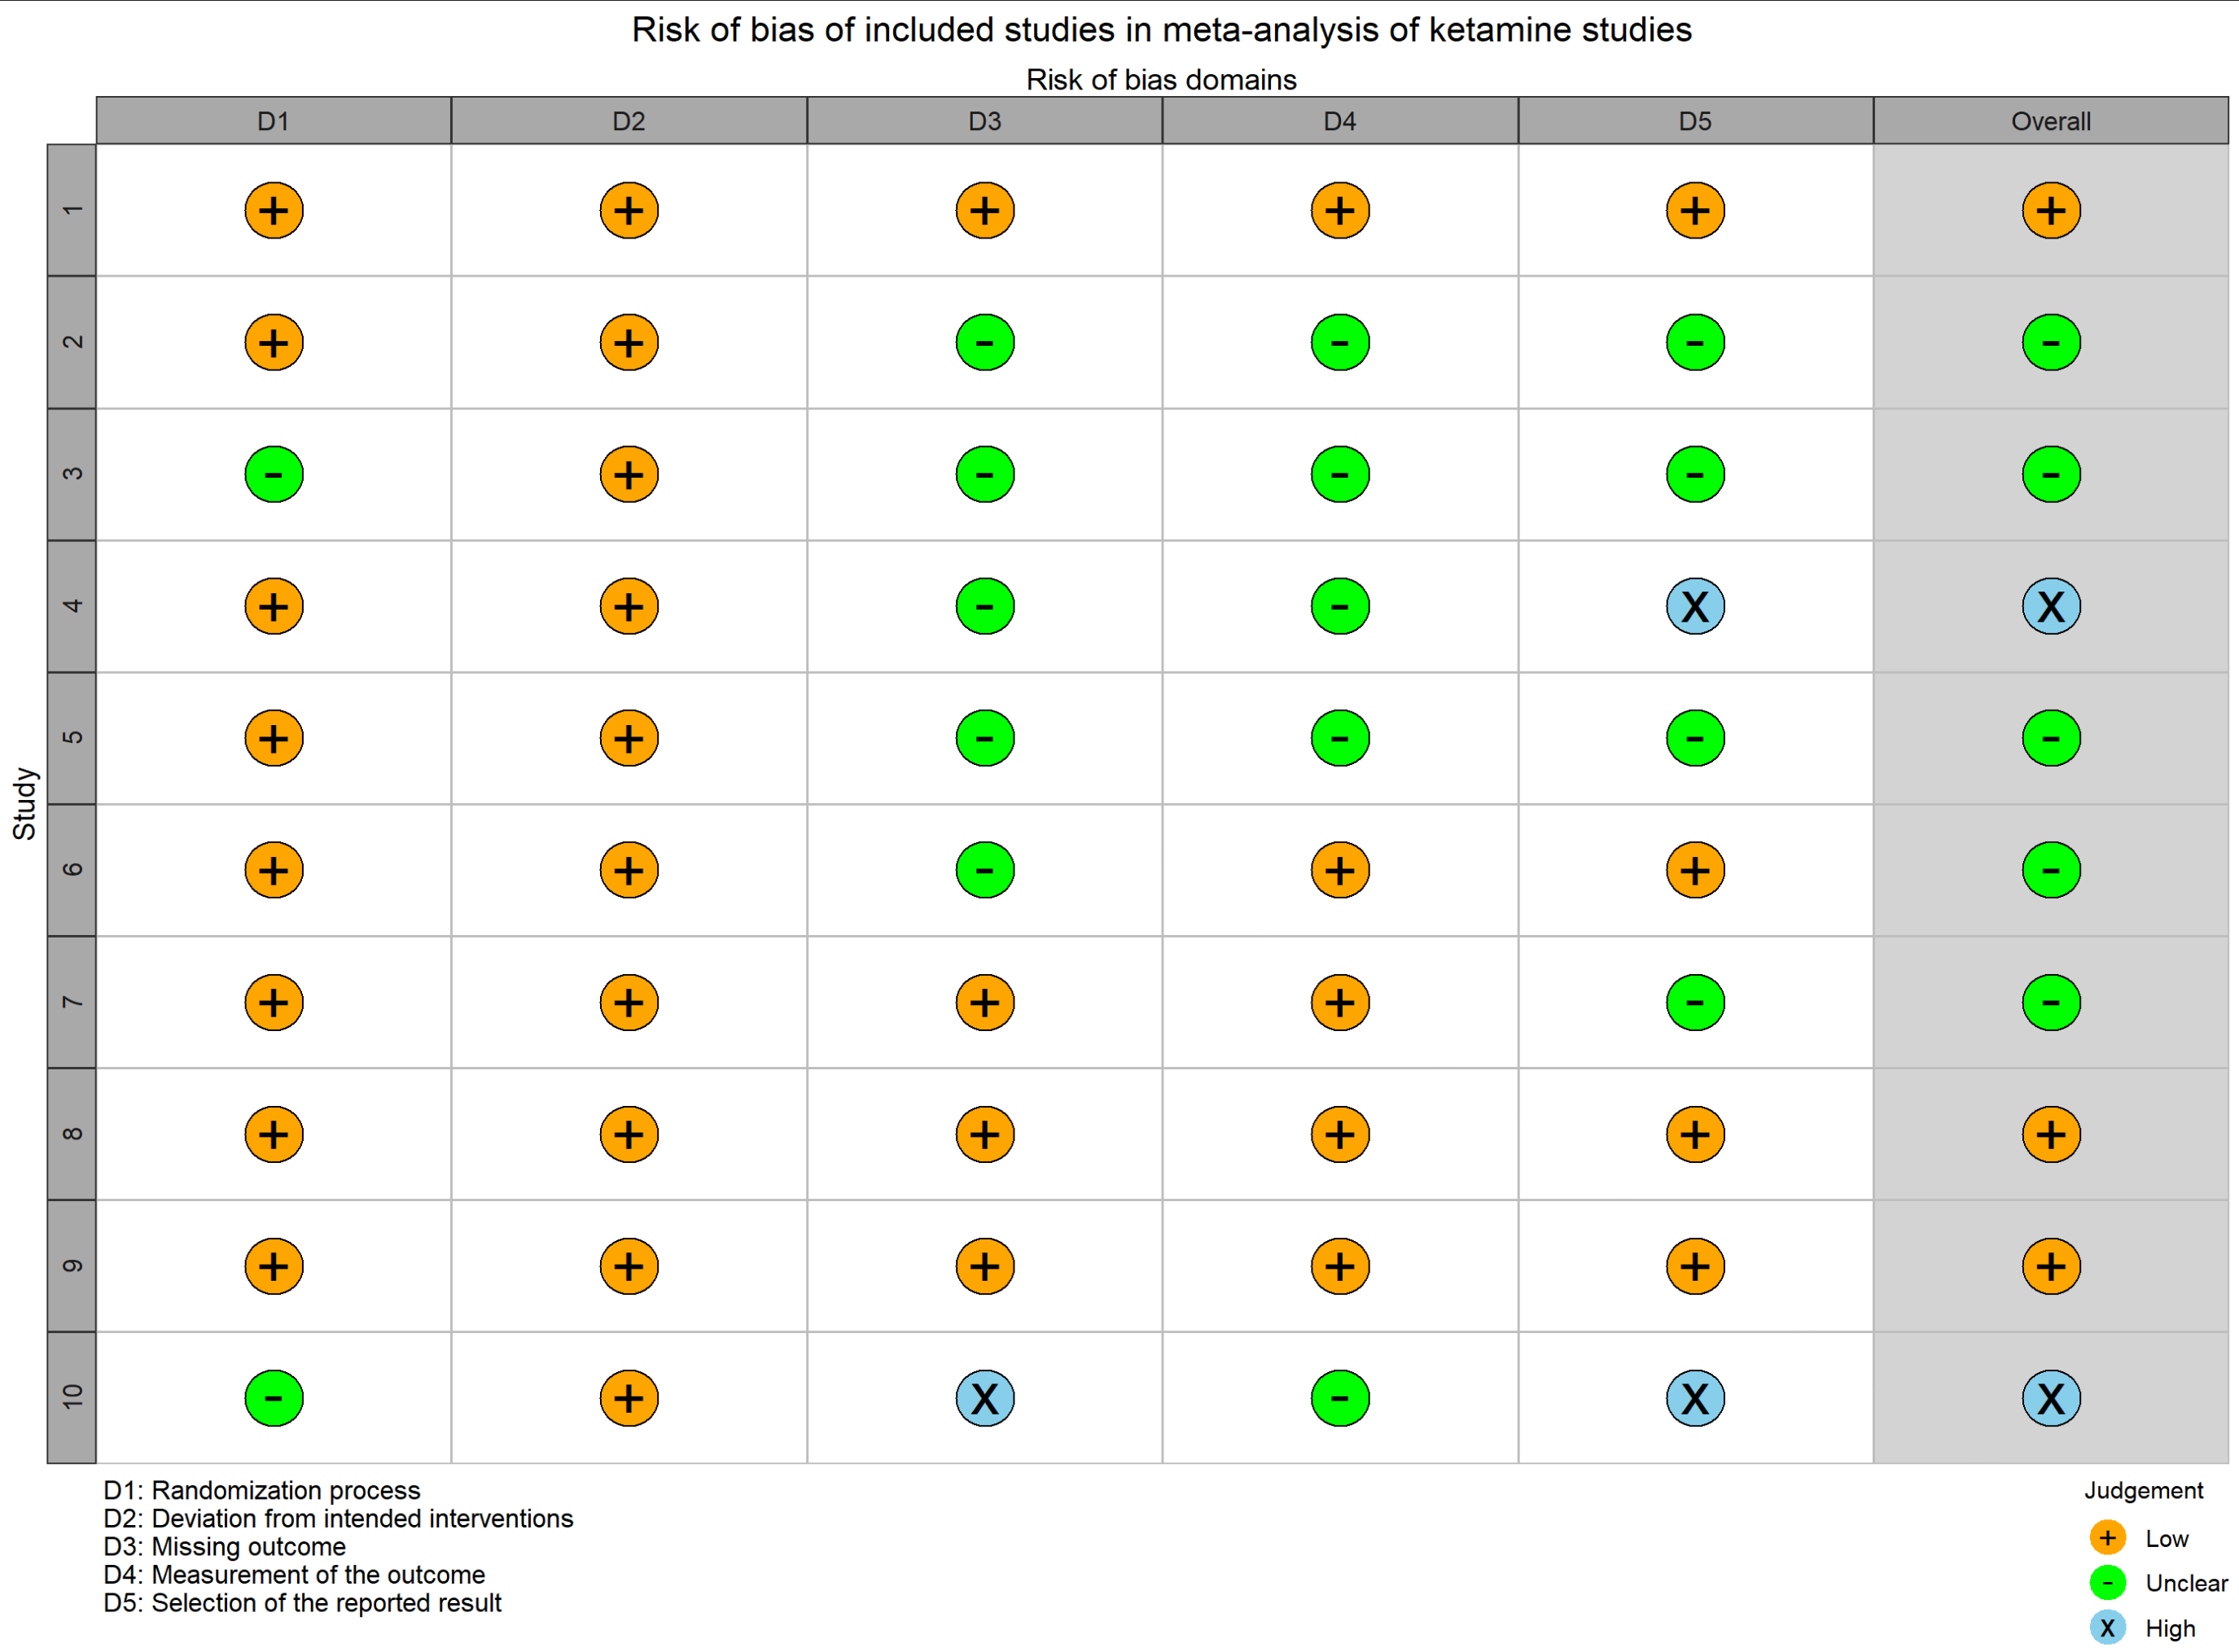

Supplementary Tables

Supplementary Table 1. Risk of bias: RCT (ROB 2).

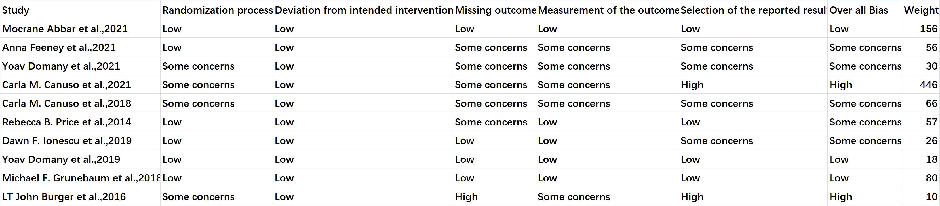

RoB 2, Cochrane Risk of Bias tool 2.

Supplementary Table 2. Risk of bias: non-RCT (MINORS).

MINORS, Methodological Index for Non-Randomized Studies.
0, not report; 1, report but inadequate; 2, Report and adequate.

Supplementary Table 3. The probability ranking SUCRA of the effect of different treatment measures on the remission level of suicidal ideation under multiple time nodes

Database search keywords and information

Search Name:

Cochrane library

ID Search Hits
#1 MeSH descriptor: [Ketamine] explode all trees 2780
#2 MeSH descriptor: [Suicidal Ideation] explode all trees 1048
#3 MeSH descriptor: [Depression] explode all trees 18679
#4 #1 and #2 and #3 31

Embase:

#1 AND #2
115
#2
'ketamine'/exp OR 'ketamine'
65,207
#1
('suicidal ideation'/exp OR 'suicidal ideation') AND ('depression'/exp OR 'depression') AND ('clinical trial'/de OR 'randomized controlled trial'/de)
2,230

115 results

Web of science:

depression(Abstract) and Suicidal ideation(Abstract) and Ktamine(Abstract)

156 results from Web of Science Core Collection

CNKI:

(主题=抑郁) AND (主题=自杀意念)

128 results

PUBMED

Search number Query Sort By Filters Search Details Results
8 (((((((((((((2-(2-Chlorophenyl)-2-(methylamino)cyclohexanone[Title/Abstract]) OR (CI-581[Title/Abstract])) OR (CI 581[Title/Abstract])) OR (CI581[Title/Abstract])) OR (Ketalar[Title/Abstract])) OR (Ketalar[Title/Abstract])) OR (Ketanest[Title/Abstract])) OR (Calipsol[Title/Abstract])) OR (Kalipsol[Title/Abstract])) OR (Calypsol[Title/Abstract])) OR (Ketamine Hydrochloride[Title/Abstract])) OR ("Ketamine"[Mesh])) AND ((((((Depressive Symptoms[Title/Abstract]) OR (Depressive Symptom[Title/Abstract])) OR (Symptom, Depressive[Title/Abstract])) OR (Emotional Depression[Title/Abstract])) OR (Depression, Emotional[Title/Abstract])) OR ("Depression"[Mesh]) "depressive symptoms"[Title/Abstract] OR "depressive symptom"[Title/Abstract] OR "symptom depressive"[Title/Abstract] OR "emotional depression"[Title/Abstract] OR "depression emotional"[Title/Abstract] OR "Depression"[MeSH Terms])) AND ((((Ideation, Suicidal[Title/Abstract]) OR (Ideations, Suicidal[Title/Abstract])) OR (Suicidal Ideations[Title/Abstract])) OR ("Suicidal Ideation"[Mesh]) "ideation suicidal"[Title/Abstract] OR "ideations suicidal"[Title/Abstract] OR "suicidal ideations"[Title/Abstract] OR "Suicidal Ideation"[MeSH Terms]) ((((("2"[All Fields] AND "2-Chlorophenyl"[All Fields]) AND "2"[All Fields]) AND "methylamino"[All Fields]) AND "cyclohexanone"[Title/Abstract]) OR "CI-581"[Title/Abstract] OR "CI-581"[Title/Abstract] OR "CI581"[Title/Abstract] OR "Ketalar"[Title/Abstract] OR "Ketalar"[Title/Abstract] OR "Ketanest"[Title/Abstract] OR "Calipsol"[Title/Abstract] OR "Kalipsol"[Title/Abstract] OR "Calypsol"[Title/Abstract] OR "ketamine hydrochloride"[Title/Abstract] OR "Ketamine"[MeSH Terms]) AND ((("depressive symptoms"[Title/Abstract] OR "depressive symptom"[Title/Abstract] OR "symptom depressive"[Title/Abstract] OR "emotional depression"[Title/Abstract] OR "depression emotional"[Title/Abstract] OR "Depression"[MeSH Terms]) AND "depressive symptoms"[Title/Abstract]) OR "depressive symptom"[Title/Abstract] OR "symptom depressive"[Title/Abstract] OR "emotional depression"[Title/Abstract] OR "depression emotional"[Title/Abstract] OR "Depression"[MeSH Terms]) AND ((("ideation suicidal"[Title/Abstract] OR "ideations suicidal"[Title/Abstract] OR "suicidal ideations"[Title/Abstract] OR "Suicidal Ideation"[MeSH Terms]) AND "ideation suicidal"[Title/Abstract]) OR "ideations suicidal"[Title/Abstract] OR "suicidal ideations"[Title/Abstract] OR "Suicidal Ideation"[MeSH Terms]) 75
7 (((((((((((2-(2-Chlorophenyl)-2-(methylamino)cyclohexanone[Title/Abstract]) OR (CI-581[Title/Abstract])) OR (CI 581[Title/Abstract])) OR (CI581[Title/Abstract])) OR (Ketalar[Title/Abstract])) OR (Ketalar[Title/Abstract])) OR (Ketanest[Title/Abstract])) OR (Calipsol[Title/Abstract])) OR (Kalipsol[Title/Abstract])) OR (Calypsol[Title/Abstract])) OR (Ketamine Hydrochloride[Title/Abstract])) OR ("Ketamine"[Mesh]) (((("2"[All Fields] AND "2-Chlorophenyl"[All Fields]) AND "2"[All Fields]) AND "methylamino"[All Fields]) AND "cyclohexanone"[Title/Abstract]) OR "CI-581"[Title/Abstract] OR "CI-581"[Title/Abstract] OR "CI581"[Title/Abstract] OR "Ketalar"[Title/Abstract] OR "Ketalar"[Title/Abstract] OR "Ketanest"[Title/Abstract] OR "Calipsol"[Title/Abstract] OR "Kalipsol"[Title/Abstract] OR "Calypsol"[Title/Abstract] OR "ketamine hydrochloride"[Title/Abstract] OR "Ketamine"[MeSH Terms] 15,403
6 ((((((((((2-(2-Chlorophenyl)-2-(methylamino)cyclohexanone[Title/Abstract]) OR (CI-581[Title/Abstract])) OR (CI 581[Title/Abstract])) OR (CI581[Title/Abstract])) OR (Ketalar[Title/Abstract])) OR (Ketalar[Title/Abstract])) OR (Ketanest[Title/Abstract])) OR (Calipsol[Title/Abstract])) OR (Kalipsol[Title/Abstract])) OR (Calypsol[Title/Abstract])) OR (Ketamine Hydrochloride[Title/Abstract]) (((("2"[All Fields] AND "2-Chlorophenyl"[All Fields]) AND "2"[All Fields]) AND "methylamino"[All Fields]) AND "cyclohexanone"[Title/Abstract]) OR "CI-581"[Title/Abstract] OR "CI-581"[Title/Abstract] OR "CI581"[Title/Abstract] OR "Ketalar"[Title/Abstract] OR "Ketalar"[Title/Abstract] OR "Ketanest"[Title/Abstract] OR "Calipsol"[Title/Abstract] OR "Kalipsol"[Title/Abstract] OR "Calypsol"[Title/Abstract] OR "ketamine hydrochloride"[Title/Abstract] 1,046
5 "Ketamine"[Mesh] Most Recent "Ketamine"[MeSH Terms] 15,040
4 (((((Depressive Symptoms[Title/Abstract]) OR (Depressive Symptom[Title/Abstract])) OR (Symptom, Depressive[Title/Abstract])) OR (Emotional Depression[Title/Abstract])) OR (Depression, Emotional[Title/Abstract])) OR ("Depression"[Mesh]) "depressive symptoms"[Title/Abstract] OR "depressive symptom"[Title/Abstract] OR "symptom depressive"[Title/Abstract] OR "emotional depression"[Title/Abstract] OR "depression emotional"[Title/Abstract] OR "Depression"[MeSH Terms] (("depressive symptoms"[Title/Abstract] OR "depressive symptom"[Title/Abstract] OR "symptom depressive"[Title/Abstract] OR "emotional depression"[Title/Abstract] OR "depression emotional"[Title/Abstract] OR "Depression"[MeSH Terms]) AND "depressive symptoms"[Title/Abstract]) OR "depressive symptom"[Title/Abstract] OR "symptom depressive"[Title/Abstract] OR "emotional depression"[Title/Abstract] OR "depression emotional"[Title/Abstract] OR "Depression"[MeSH Terms] 188,289
3 (((Ideation, Suicidal[Title/Abstract]) OR (Ideations, Suicidal[Title/Abstract])) OR (Suicidal Ideations[Title/Abstract])) OR ("Suicidal Ideation"[Mesh]) "ideation suicidal"[Title/Abstract] OR "ideations suicidal"[Title/Abstract] OR "suicidal ideations"[Title/Abstract] OR "Suicidal Ideation"[MeSH Terms] (("ideation suicidal"[Title/Abstract] OR "ideations suicidal"[Title/Abstract] OR "suicidal ideations"[Title/Abstract] OR "Suicidal Ideation"[MeSH Terms]) AND "ideation suicidal"[Title/Abstract]) OR "ideations suicidal"[Title/Abstract] OR "suicidal ideations"[Title/Abstract] OR "Suicidal Ideation"[MeSH Terms] 13,422
2 "Suicidal Ideation"[Mesh] "Suicidal Ideation"[MeSH Terms] 13,017
1 "Depression"[Mesh] "Depression"[MeSH Terms] 152,344

