Supplementary Table S1. Demographic data across the three trials (efficacy populations).
 | Pediatric  n=169 | Adolescent  n =146 | Adult  n = 153
Age at baseline (years)
n | 169 | 146 | 153
Mean (SD) | 9.7 (1.3) | 14.3 (1.3) | 39.9 (12.8)
Min, max | 8, 12 | 13, 17 | 18, 76
Sex [n (%)]
n | 169 | 146 | 153
Female | 52 (30.8%) | 60 (41.1%) | 107 (69.9%)
Male | 117 (69.2%) | 86 (58.9%) | 46 (30.1%)
Race [n (%)]
n | 169 | 146 | 153
American Indian or Alaska Native | 1 (.6%) | 3 (2.1%) | 1(0.7%)
Asian | 3 (1.8%) | 1 (.7%) | 7 (4.6%)
Black or African American | 22 (13.0%) | 15 (10.3%) | 15 (9.8%)
White | 125 (73.9%) | 113 (77.4%) | 117 (76.5%)
Multiple | 12 (7.1%) | 11 (7.5%) | 7 (4.6%)
Other | 6 (3.5%) | 3 (2.1%) | 5 (3.3%)
Ethnicity [n (%)]
n | 169 | 146 | 153
Hispanic or Latino | 38 (22.5%) | 26 (17.8%) | 23 (15%)
Not Hispanic or Latino | 128 (75.7%) | 119 (81.5%) | 126 (82.4%)
Not reported | 3 (1.7%) | 1 (.7%) | 4 (2.6%)
Note: ADHD, Attention Deficit Hyperactivity Disorder; max, maximum; min, minimum.
Supplementary Table S2. Relationships of cognitive metric change with TOVA submetric change in the adult trial.
​​
TOVA Submetric | Model term | B | SE | t | p
RTMH1_change | (Intercept) | 8.699 | 15.781 | .551 | .582
RTMH1_change | RTMH1_bl | -.711 | .044 | -16.052 | .000
RTMH1_change | age | .549 | .165 | 3.322 | .001
RTMH1_change | sex (male) | 1.316 | 3.453 | .381 | .704
RTMH1_change | cognitive metric baseline | 1.024 | .226 | 4.523 | .000
RTMH1_change | cognitive metric change | .747 | .175 | 4.259 | .000
VART_change | (Intercept) | .028 | 24.325 | .001 | .999
VART_change | VART_bl | -.786 | .039 | -20.216 | .000
VART_change | age | .197 | .268 | .735 | .464
VART_change | sex (male) | -5.770 | 6.125 | -.942 | .348
VART_change | cognitive metric baseline | 1.126 | .374 | 3.008 | .003
VART_change | cognitive metric change | 1.101 | .298 | 3.697 | .000
DPRH2_change | (Intercept) | -3.829 | 19.896 | -.192 | .848
DPRH2_change | DPRH2_bl | -.489 | .082 | -5.989 | .000
DPRH2_change | age | .405 | .229 | 1.767 | .079
DPRH2_change | sex (male) | -6.861 | 4.964 | -1.382 | .169
DPRH2_change | cognitive metric baseline | .621 | .327 | 1.899 | .060
DPRH2_change | cognitive metric change | .481 | .244 | 1.971 | .051
EXGTAU_change | (Intercept) | 154.691 | 30.453 | 5.080 | .000
EXGTAU_change | EXGTAU_bl | -.820 | .046 | -17.990 | .000
EXGTAU_change | age | -.408 | .321 | -1.269 | .206
EXGTAU_change | sex (male) | -15.002 | 7.023 | -2.136 | .034
EXGTAU_change | cognitive metric baseline | -1.086 | .454 | -2.391 | .018
EXGTAU_change | cognitive metric change | -1.145 | .359 | -3.192 | .002
COMH2_change | (Intercept) | 33.243 | 24.181 | 1.375 | .171
COMH2_change | COMH2_bl | -.452 | .079 | -5.718 | .000
COMH2_change | age | .071 | .268 | .264 | .792
COMH2_change | sex (male) | -2.110 | 5.731 | -.368 | .713
COMH2_change | cognitive metric baseline | -.098 | .377 | -.259 | .796
COMH2_change | cognitive metric change | .295 | .293 | 1.009 | .315
OMH2_change | (Intercept) | -25.340 | 339.853 | -.075 | .941
OMH2_change | OMH2_bl | -.601 | .071 | -8.484 | .000
OMH2_change | age | -.316 | 3.615 | -.087 | .930
OMH2_change | sex (male) | 116.027 | 80.720 | 1.437 | .153
OMH2_change | cognitive metric baseline | -.092 | 5.222 | -.018 | .986
OMH2_change | cognitive metric change | -.210 | 4.103 | -.051 | .959
Note. RTMH1 = Response Time Correct Mean Half 1 (Standard Score); VART = Response Time Variability (Standard Score); DPRH2 = D’prime Half 2 (Standard Score); EXGTAU = ex-Gaussian tau; COMH2 = Commission Errors in Half 2 (Standard Score); OMH2 = Omission Errors in Half 2 (Standard Score)

Supplementary Table S3. Relationships of cognitive metric change with TOVA submetric change in the adolescent trial.
​​
TOVA Submetric | Model term | B | SE | t | p
RTMH1_change | (Intercept) | -6.129 | 17.280 | -.355 | .723
RTMH1_change | RTMH1_bl | -.469 | .058 | -8.048 | .000
RTMH1_change | age | 2.202 | 1.100 | 2.002 | .047
RTMH1_change | sex (male) | -2.788 | 2.862 | -.974 | .332
RTMH1_change | cognitive metric baseline | .502 | .187 | 2.678 | .008
RTMH1_change | cognitive metric change | .378 | .148 | 2.554 | .012
VART_change | (Intercept) | -52.376 | 34.149 | -1.534 | .127
VART_change | VART_bl | -.438 | .064 | -6.811 | .000
VART_change | age | 4.073 | 2.240 | 1.818 | .071
VART_change | sex (male) | -2.734 | 5.864 | -.466 | .642
VART_change | cognitive metric baseline | .758 | .379 | 2.004 | .047
VART_change | cognitive metric change | .507 | .301 | 1.685 | .094
DPRH2_change | (Intercept) | -6.975 | 15.850 | -.440 | .661
DPRH2_change | DPRH2_bl | -.094 | .118 | -.797 | .427
DPRH2_change | age | .230 | .971 | .237 | .813
DPRH2_change | sex (male) | -.801 | 2.498 | -.321 | .749
DPRH2_change | cognitive metric baseline | .325 | .164 | 1.987 | .049
DPRH2_change | cognitive metric change | .376 | .130 | 2.900 | .004
EXGTAU_change | (Intercept) | 333.272 | 70.176 | 4.749 | .000
EXGTAU_change | EXGTAU_bl | -.526 | .061 | -8.565 | .000
EXGTAU_change | age | -12.915 | 4.510 | -2.864 | .005
EXGTAU_change | sex (male) | 11.487 | 11.660 | .985 | .326
EXGTAU_change | cognitive metric baseline | -2.161 | .757 | -2.856 | .005
EXGTAU_change | cognitive metric change | -1.354 | .601 | -2.252 | .026
COMH2_change | (Intercept) | 54.949 | 16.845 | 3.262 | .001
COMH2_change | COMH2_bl | -.610 | .067 | -9.087 | .000
COMH2_change | age | -.156 | 1.049 | -.149 | .882
COMH2_change | sex (male) | -1.966 | 2.706 | -.727 | .469
COMH2_change | cognitive metric baseline | .140 | .176 | .793 | .429
COMH2_change | cognitive metric change | .071 | .141 | .508 | .613
OMH2_change | (Intercept) | -249.252 | 350.316 | -.712 | .478
OMH2_change | OMH2_bl | -.382 | .088 | -4.321 | .000
OMH2_change | age | -4.404 | 23.100 | -.191 | .849
OMH2_change | sex (male) | -67.146 | 59.604 | -1.127 | .262
OMH2_change | cognitive metric baseline | 5.630 | 3.889 | 1.448 | .150
OMH2_change | cognitive metric change | 6.413 | 3.159 | 2.030 | .044
Note. RTMH1 = Response Time Correct Mean Half 1 (Standard Score); VART = Response Time Variability (Standard Score); DPRH2 = D’prime Half 2 (Standard Score); EXGTAU = ex-Gaussian tau; COMH2 = Commission Errors in Half 2 (Standard Score); OMH2 = Omission Errors in Half 2 (Standard Score)
Supplementary Table S4. Relationships of cognitive metric change with TOVA submetric change in the pediatric trial.
​​
TOVA Submetric | Model term | B | SE | t | p
RTMH1_change | (Intercept) | 20.784 | 14.052 | 1.479 | .141
RTMH1_change | RTMH1_bl | -.341 | .080 | -4.247 | .000
RTMH1_change | age | -1.968 | 1.457 | -1.351 | .179
RTMH1_change | sex (male) | 13.083 | 3.575 | 3.660 | .000
RTMH1_change | cognitive metric baseline | .473 | .218 | 2.175 | .031
RTMH1_change | cognitive metric change | .219 | .156 | 1.404 | .162
VART_change | (Intercept) | -8.473 | 19.204 | -.441 | .660
VART_change | VART_bl | -.275 | .070 | -3.955 | .000
VART_change | age | .497 | 2.096 | .237 | .813
VART_change | sex (male) | 7.014 | 5.422 | 1.294 | .198
VART_change | cognitive metric baseline | .445 | .307 | 1.450 | .149
VART_change | cognitive metric change | .500 | .226 | 2.210 | .029
DPRH2_change | (Intercept) | 22.772 | 6.930 | 3.286 | .001
DPRH2_change | DPRH2_bl | -.365 | .068 | -5.324 | .000
DPRH2_change | age | -.156 | .495 | -.314 | .754
DPRH2_change | sex (male) | .623 | 1.260 | .495 | .622
DPRH2_change | cognitive metric baseline | .128 | .073 | 1.750 | .082
DPRH2_change | cognitive metric change | .120 | .053 | 2.265 | .025
EXGTAU_change | (Intercept) | 208.332 | 74.572 | 2.794 | .006
EXGTAU_change | EXGTAU_bl | -.448 | .086 | -5.226 | .000
EXGTAU_change | age | -5.191 | 6.829 | -.760 | .448
EXGTAU_change | sex (male) | -22.329 | 17.354 | -1.287 | .200
EXGTAU_change | cognitive metric baseline | -1.239 | .983 | -1.261 | .209
EXGTAU_change | cognitive metric change | -1.343 | .718 | -1.872 | .063
COMH2_change | (Intercept) | 72.317 | 8.743 | 8.271 | .000
COMH2_change | COMH2_bl | -.497 | .053 | -9.387 | .000
COMH2_change | age | -1.955 | .781 | -2.501 | .013
COMH2_change | sex (male) | .178 | 1.999 | .089 | .929
COMH2_change | cognitive metric baseline | .064 | .115 | .551 | .582
COMH2_change | cognitive metric change | .117 | .084 | 1.395 | .165
OMH2_change | (Intercept) | -117.233 | 77.891 | -1.505 | .134
OMH2_change | OMH2_bl | -.118 | .064 | -1.836 | .068
OMH2_change | age | 2.400 | 8.902 | .270 | .788
OMH2_change | sex (male) | -34.808 | 22.801 | -1.527 | .129
OMH2_change | cognitive metric baseline | 1.435 | 1.312 | 1.094 | .276
OMH2_change | cognitive metric change | -.203 | .943 | -.215 | .830
Note. RTMH1 = Response Time Correct Mean Half 1 (Standard Score); VART = Response Time Variability (Standard Score); DPRH2 = D’prime Half 2 (Standard Score); EXGTAU = ex-Gaussian tau; COMH2 = Commission Errors in Half 2 (Standard Score); OMH2 = Omission Errors in Half 2 (Standard Score)
Supplementary Table S5. Independent relationships of change in the individual submetrics comprising the cognitive metric (navigation 80% threshold, targeting speed, and d’) with TOVA-ACS change across trials.

Study | Outcome | Submetric Predictor of Interest | Model term | B | SE | t | p
Adult | TOVA-ACS_ch | targetingRT_ch | (Intercept) | -6.801 | 2.015 | -3.375 | 0.001
Adult | TOVA-ACS_ch | targetingRT_ch | TOVA-ACS_bl | -0.732 | 0.050 | -14.579 | 0.000
Adult | TOVA-ACS_ch | targetingRT_ch | age | 0.044 | 0.030 | 1.476 | 0.142
Adult | TOVA-ACS_ch | targetingRT_ch | sexM | -0.816 | 0.823 | -0.991 | 0.324
Adult | TOVA-ACS_ch | targetingRT_ch | targetingRT_bl | 11.955 | 2.759 | 4.333 | 0.000
Adult | TOVA-ACS_ch | targetingRT_ch | targetingRT_ch | 8.427 | 2.458 | 3.428 | 0.001
Adolescent | TOVA-ACS_ch | targetingRT_ch | (Intercept) | -8.693 | 3.249 | -2.676 | 0.008
Adolescent | TOVA-ACS_ch | targetingRT_ch | TOVA-ACS_bl | -0.340 | 0.073 | -4.637 | 0.000
Adolescent | TOVA-ACS_ch | targetingRT_ch | age | 0.411 | 0.218 | 1.881 | 0.062
Adolescent | TOVA-ACS_ch | targetingRT_ch | sexM | -0.500 | 0.558 | -0.896 | 0.372
Adolescent | TOVA-ACS_ch | targetingRT_ch | targetingRT_bl | 7.473 | 2.110 | 3.542 | 0.001
Adolescent | TOVA-ACS_ch | targetingRT_ch | targetingRT_ch | 6.537 | 1.967 | 3.323 | 0.001
Pediatric | TOVA-ACS_ch | targetingRT_ch | (Intercept) | -2.430 | 1.956 | -1.242 | 0.216
Pediatric | TOVA-ACS_ch | targetingRT_ch | TOVA-ACS_bl | -0.334 | 0.080 | -4.154 | 0.000
Pediatric | TOVA-ACS_ch | targetingRT_ch | age | -0.057 | 0.213 | -0.266 | 0.791
Pediatric | TOVA-ACS_ch | targetingRT_ch | sexM | 1.321 | 0.526 | 2.510 | 0.013
Pediatric | TOVA-ACS_ch | targetingRT_ch | targetingRT_bl | 4.019 | 2.459 | 1.634 | 0.104
Pediatric | TOVA-ACS_ch | targetingRT_ch | targetingRT_ch | 1.779 | 2.229 | 0.798 | 0.426
Adult | TOVA-ACS_ch | targetingDPR_ch | (Intercept) | -6.151 | 3.934 | -1.563 | 0.120
Adult | TOVA-ACS_ch | targetingDPR_ch | TOVA-ACS_bl | -0.756 | 0.054 | -13.907 | 0.000
Adult | TOVA-ACS_ch | targetingDPR_ch | age | 0.009 | 0.031 | 0.278 | 0.781
Adult | TOVA-ACS_ch | targetingDPR_ch | sexM | -0.279 | 0.870 | -0.321 | 0.749
Adult | TOVA-ACS_ch | targetingDPR_ch | targetingDPR_bl | 10.994 | 6.057 | 1.815 | 0.072
Adult | TOVA-ACS_ch | targetingDPR_ch | targetingDPR_ch | 7.367 | 4.702 | 1.567 | 0.119
Adolescent | TOVA-ACS_ch | targetingDPR_ch | (Intercept) | -17.154 | 4.610 | -3.721 | 0.000
Adolescent | TOVA-ACS_ch | targetingDPR_ch | TOVA-ACS_bl | -0.352 | 0.074 | -4.767 | 0.000
Adolescent | TOVA-ACS_ch | targetingDPR_ch | age | 0.450 | 0.221 | 2.037 | 0.043
Adolescent | TOVA-ACS_ch | targetingDPR_ch | sexM | -0.220 | 0.562 | -0.392 | 0.696
Adolescent | TOVA-ACS_ch | targetingDPR_ch | targetingDPR_bl | 16.033 | 4.948 | 3.241 | 0.001
Adolescent | TOVA-ACS_ch | targetingDPR_ch | targetingDPR_ch | 0.768 | 2.999 | 0.256 | 0.798
Pediatric | TOVA-ACS_ch | targetingDPR_ch | (Intercept) | -3.767 | 2.617 | -1.439 | 0.152
Pediatric | TOVA-ACS_ch | targetingDPR_ch | TOVA-ACS_bl | -0.329 | 0.078 | -4.199 | 0.000
Pediatric | TOVA-ACS_ch | targetingDPR_ch | age | -0.018 | 0.185 | -0.095 | 0.924
Pediatric | TOVA-ACS_ch | targetingDPR_ch | sexM | 1.114 | 0.507 | 2.199 | 0.029
Pediatric | TOVA-ACS_ch | targetingDPR_ch | targetingDPR_bl | 6.105 | 3.441 | 1.774 | 0.078
Pediatric | TOVA-ACS_ch | targetingDPR_ch | targetingDPR_ch | 5.429 | 1.757 | 3.090 | 0.002
Adult | TOVA-ACS_ch | nav_ch | (Intercept) | -8.159 | 2.535 | -3.218 | 0.002
Adult | TOVA-ACS_ch | nav_ch | TOVA-ACS_bl | -0.747 | 0.050 | -14.813 | 0.000
Adult | TOVA-ACS_ch | nav_ch | age | 0.078 | 0.036 | 2.170 | 0.032
Adult | TOVA-ACS_ch | nav_ch | sexM | -1.252 | 0.832 | -1.505 | 0.134
Adult | TOVA-ACS_ch | nav_ch | nav_bl | 11.235 | 3.686 | 3.048 | 0.003
Adult | TOVA-ACS_ch | nav_ch | nav_ch | 9.271 | 2.587 | 3.584 | 0.000
Adolescent | TOVA-ACS_ch | nav_ch | (Intercept) | -8.905 | 3.360 | -2.650 | 0.009
Adolescent | TOVA-ACS_ch | nav_ch | TOVA-ACS_bl | -0.359 | 0.075 | -4.806 | 0.000
Adolescent | TOVA-ACS_ch | nav_ch | age | 0.496 | 0.222 | 2.237 | 0.027
Adolescent | TOVA-ACS_ch | nav_ch | sexM | -0.464 | 0.588 | -0.789 | 0.431
Adolescent | TOVA-ACS_ch | nav_ch | nav_bl | 5.188 | 2.801 | 1.852 | 0.066
Adolescent | TOVA-ACS_ch | nav_ch | nav_ch | 4.867 | 1.875 | 2.596 | 0.010
Pediatric | TOVA-ACS_ch | nav_ch | (Intercept) | -3.014 | 1.838 | -1.640 | 0.103
Pediatric | TOVA-ACS_ch | nav_ch | TOVA-ACS_bl | -0.334 | 0.080 | -4.185 | 0.000
Pediatric | TOVA-ACS_ch | nav_ch | age | -0.042 | 0.198 | -0.212 | 0.833
Pediatric | TOVA-ACS_ch | nav_ch | sexM | 1.426 | 0.550 | 2.594 | 0.010
Pediatric | TOVA-ACS_ch | nav_ch | nav_bl | 4.198 | 2.060 | 2.037 | 0.043
Pediatric | TOVA-ACS_ch | nav_ch | nav_ch | 3.907 | 1.681 | 2.324 | 0.021
Note. Relationship of interest from each model is indicated in italics (and bold if significant according to p<.05). TOVA-ACS_bl = TOVA-ACS baseline; TOVA-ACS_ch = TOVA-ACS change; targetingRT_bl = Targeting response time baseline; targetingRT_ch = Targeting response time change; targetingDPR_bl = Targeting d-prime baseline; targetingDPR_ch = Targeting d-prime change; nav_bl = navigation 80% threshold baseline; nav_ch = navigation 80% threshold change.

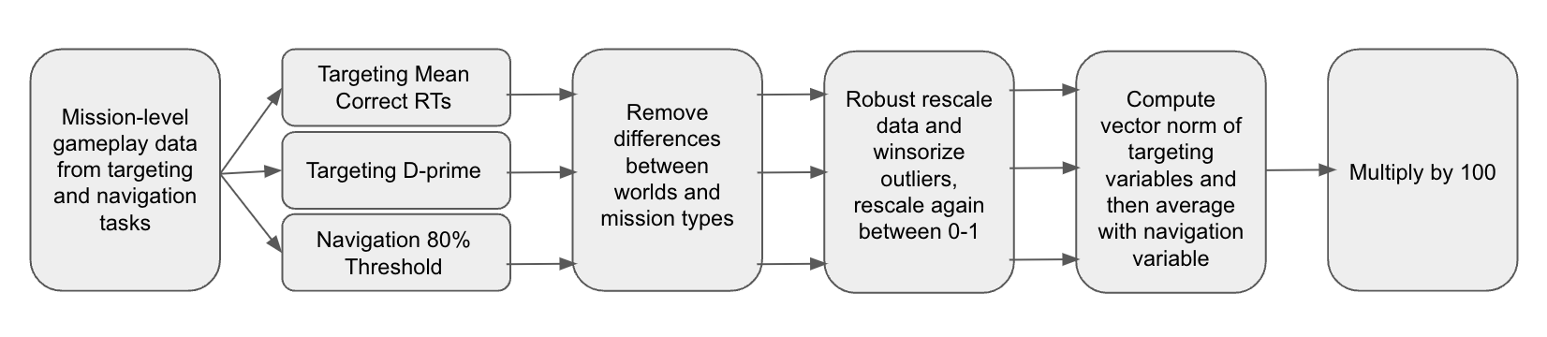
Supplementary Figure S1. Cognitive metric calculation pipeline providing a high-level overview of the flow from raw mission-level gameplay data to a cognitive metric value.

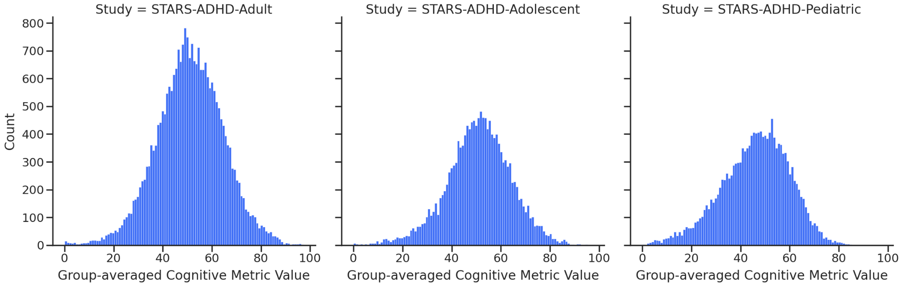

Supplementary Figure S2. Focus Score distributions for the three clinical trials.

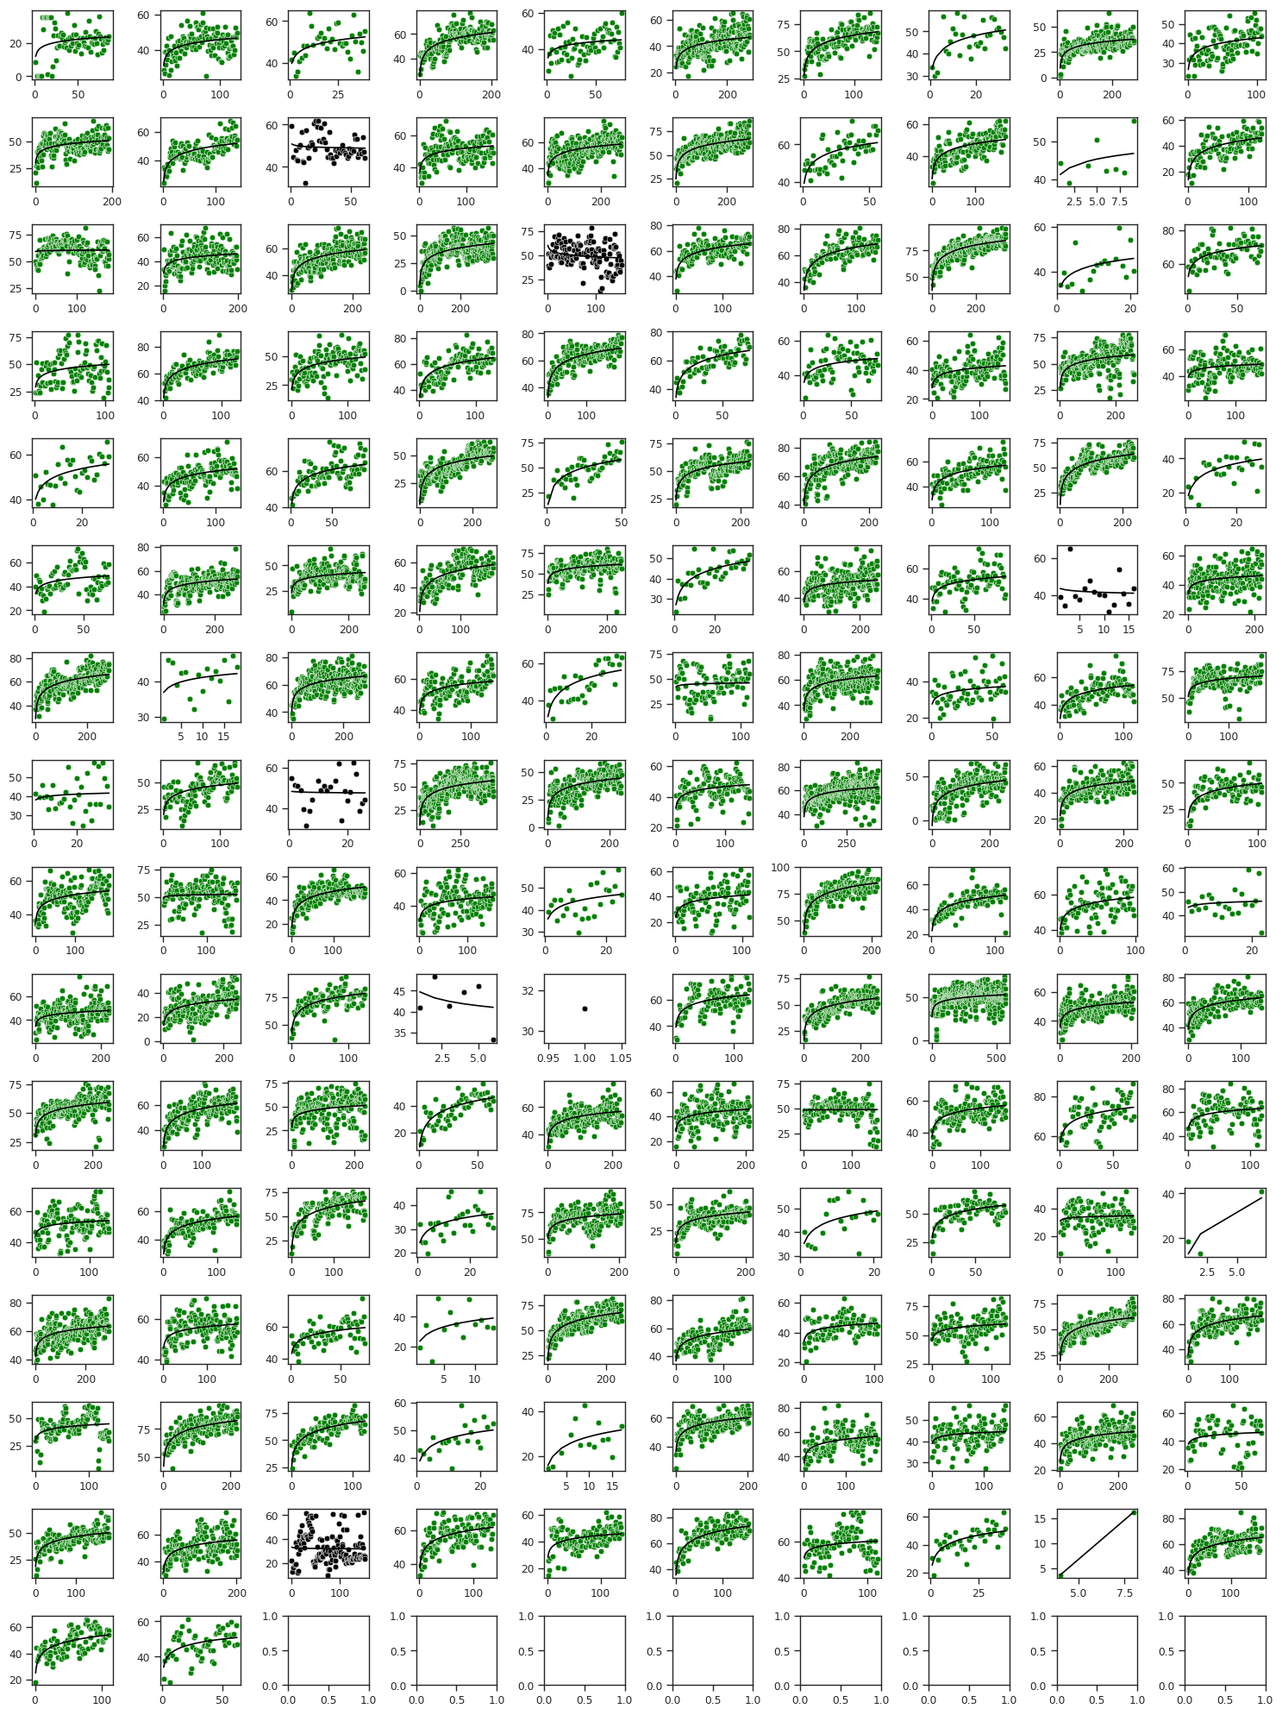
Supplementary Figure S3. Individual subject cognitive metric plots for STARS-ADHD-Adult Study. Each cell is a subject where the x axes are missions played and the y axes are cognitive metric values. Green indicates improvement in cognitive metric and black indicates lack of improvement. The black lines represent the best fitting linear-log model fits.

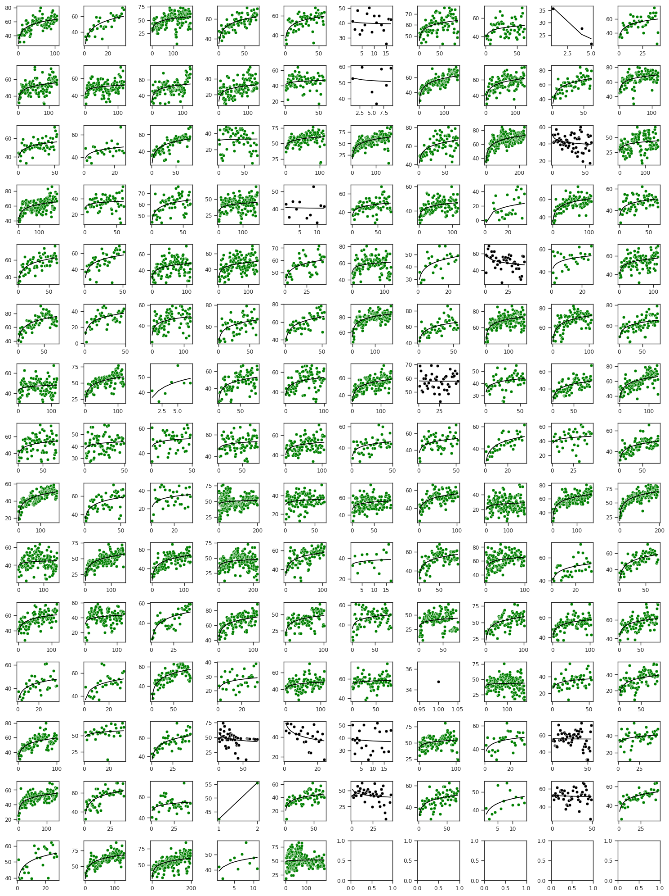
Supplementary Figure S4. Individual subject cognitive metric plots for STARS-ADHD-Adolescent Study. Each cell is a subject where the x axes are missions played and the y axes are cognitive metric values. Green indicates improvement in cognitive metric and black indicates lack of improvement. The black lines represent the best fitting linear-log model fits.
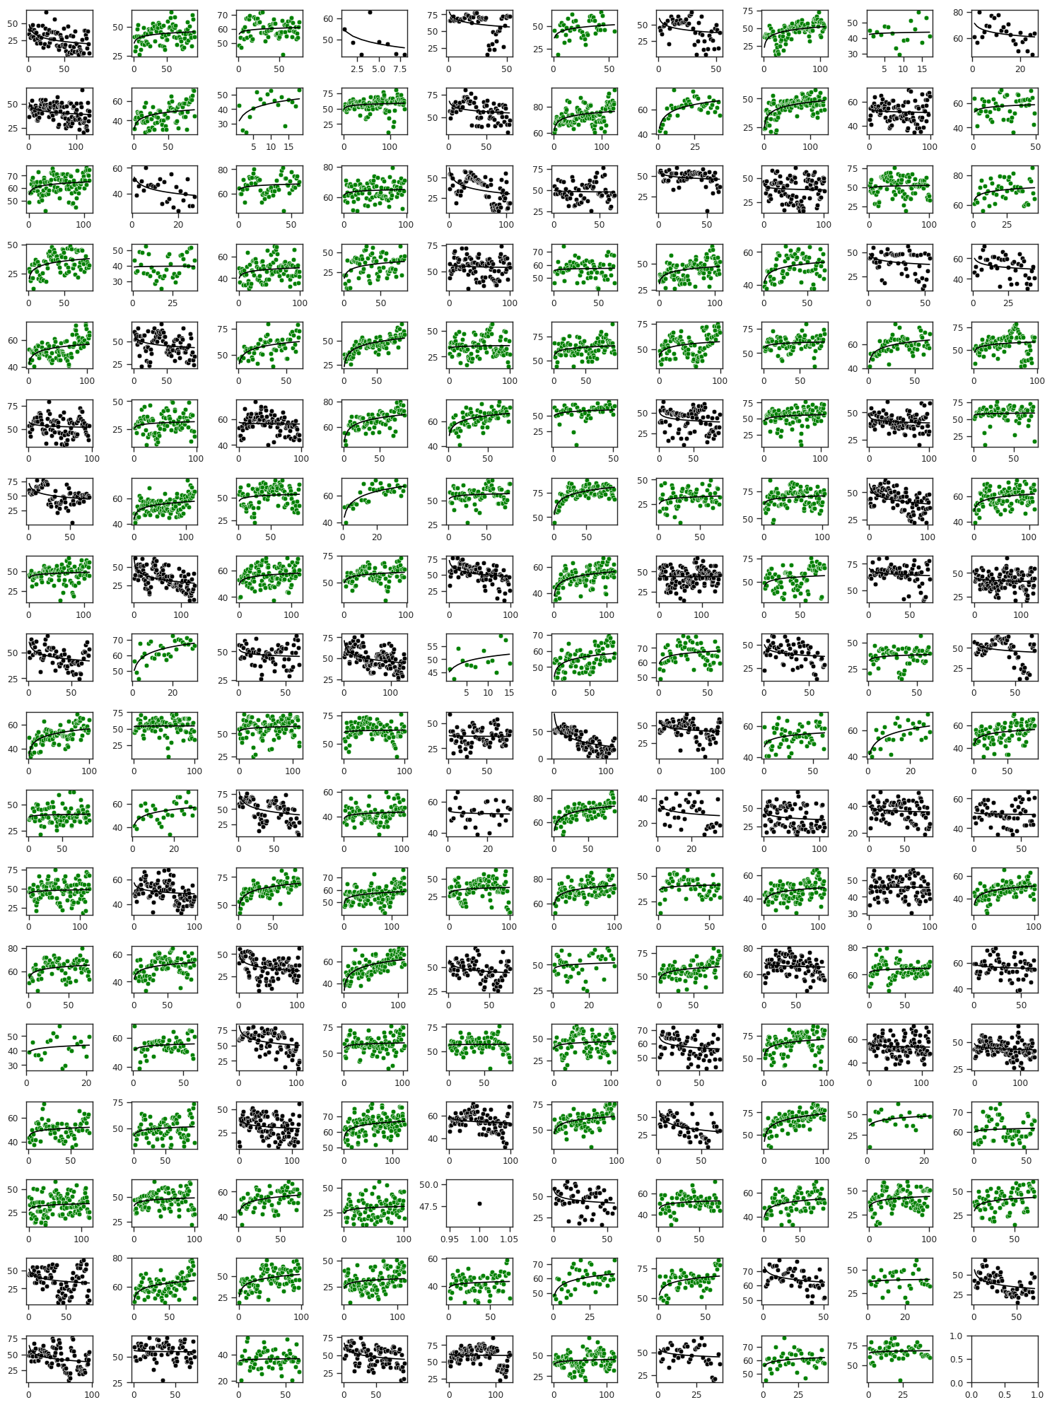
Supplementary Figure S5. Individual subject cognitive metric plots for STARS-ADHD-Pediatric Study. Each cell is a subject where the x axes are missions played and the y axes are cognitive metric values. Green indicates improvement in cognitive metric and black indicates lack of improvement. The black lines represent the best fitting linear-log model fits.

