Supplemental material

Figure S1
CONSORT diagram.

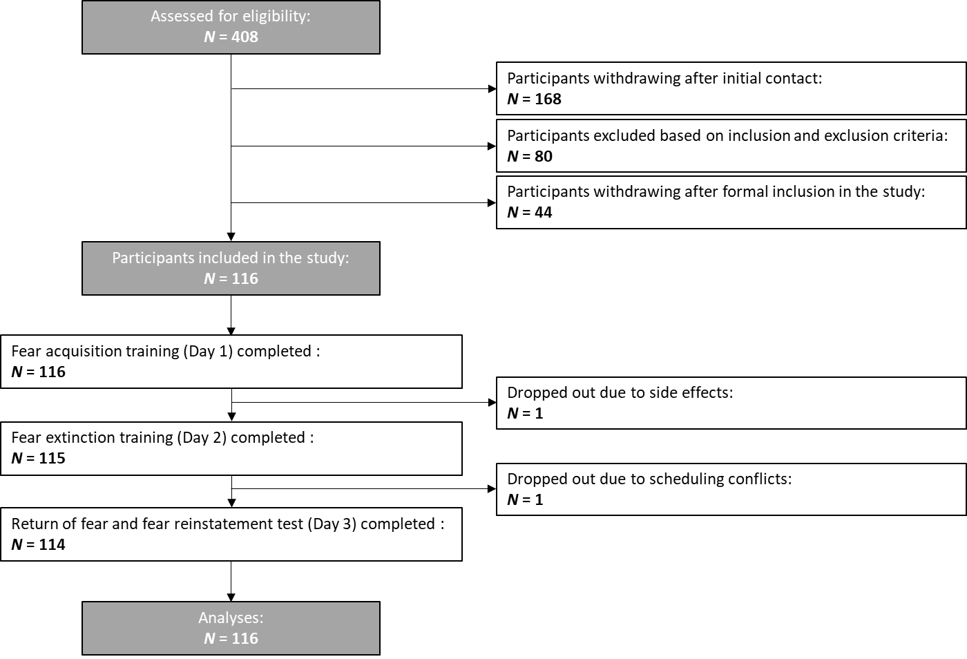

Figure S2
Depiction of saliva estradiol and progesterone concentrations on day 1, day 2, and day 3 broken up for all treatment groups.

Estradiol Progesterone

Day 1: Fear acquisition training
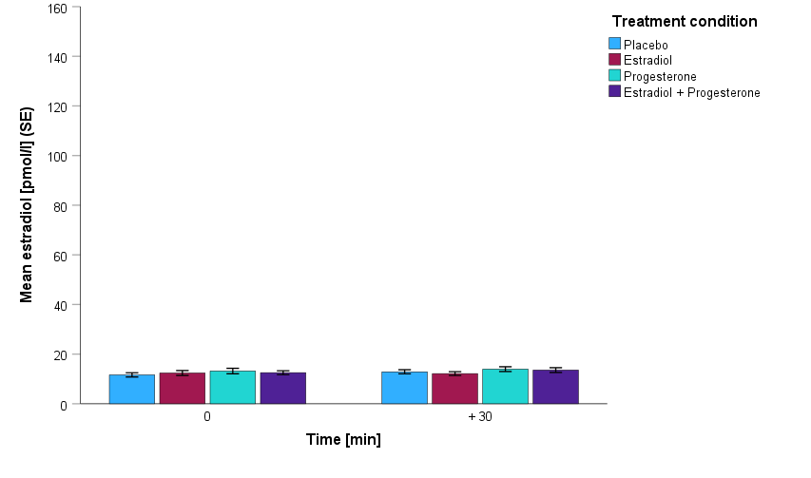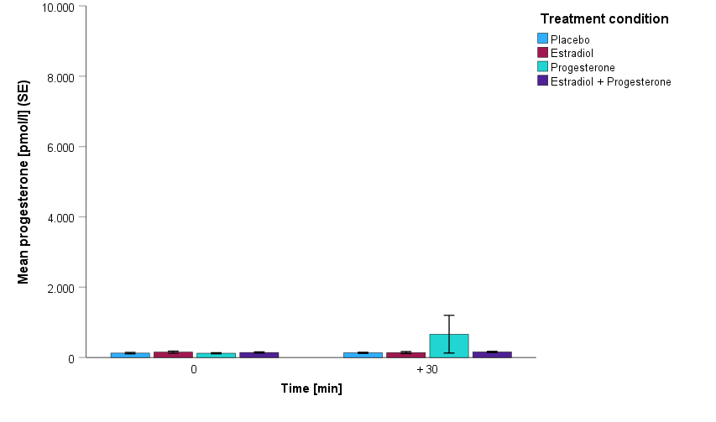

Day 2: Fear extinction training

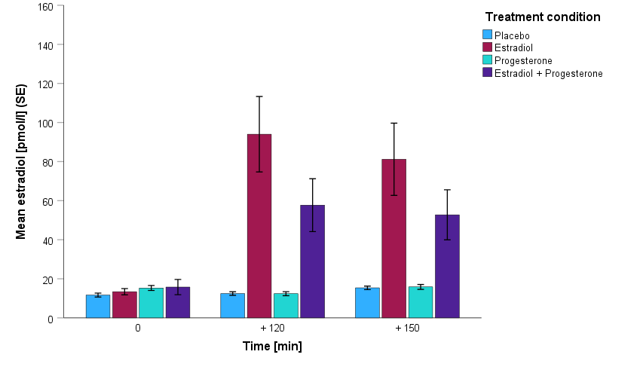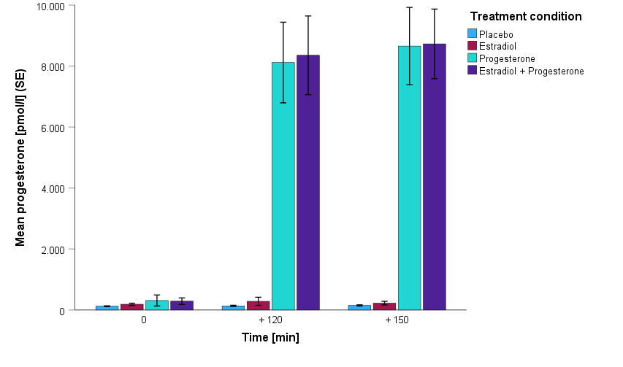

Day 3: Return of fear and fear reinstatement test

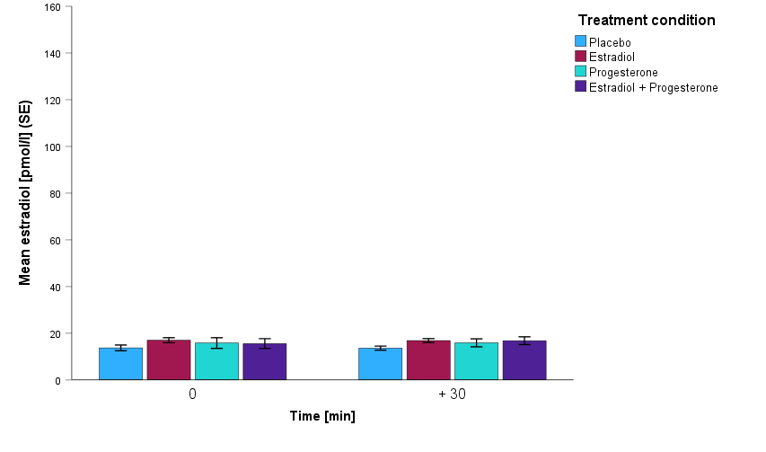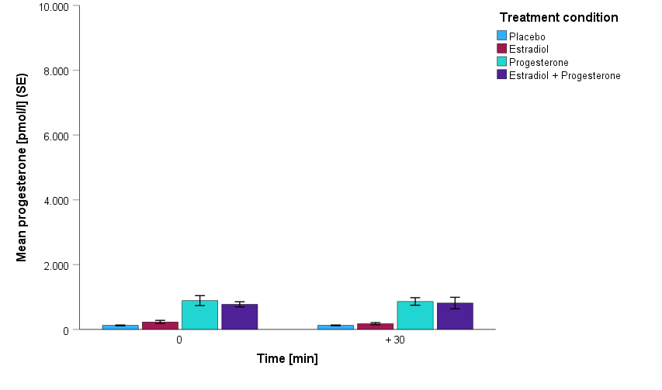

Manipulation check: depiction of saliva estradiol (lest side) and progesterone (right side) concentrations on day 1 and 3 before (0 min) and after testing (+30 min) and on day 2 before drug intake (0 min) as well as before (+120 min) and after fear extinction training (+150 min). A significant time by treatment interaction indicated significantly higher estradiol and progesterone concentrations after the respective drug administration (2 mg estradiol; 400 mg progesterone) on day 2.
Figure S3
Fear acquisition training (Day 1) broken up into the four treatment groups.

a) Placebo b) Progesterone
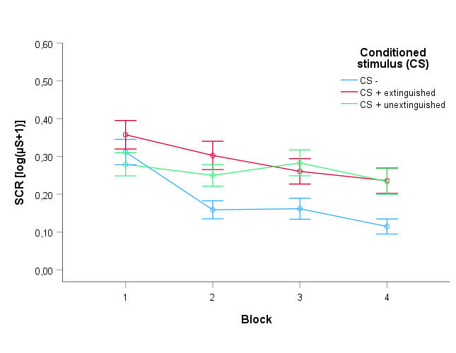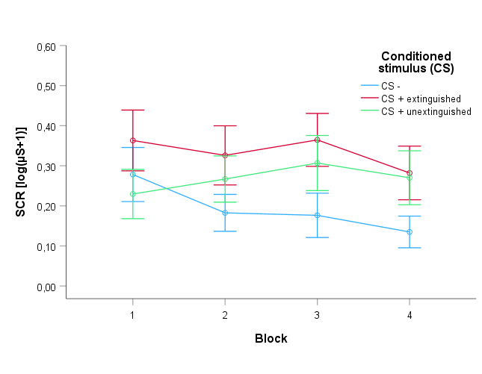

c) Estradiol d) Estradiol and progesterone

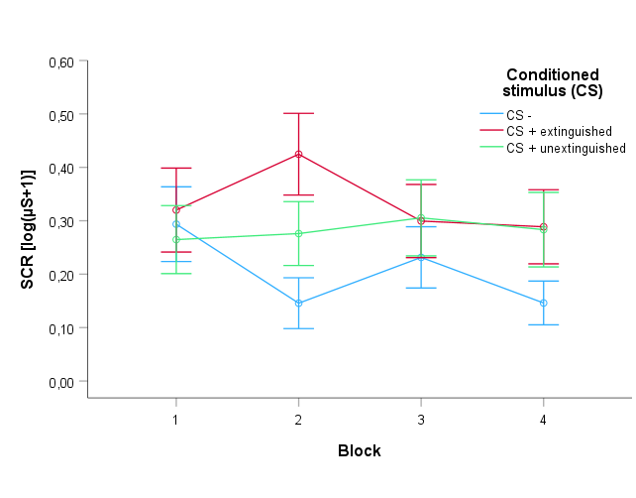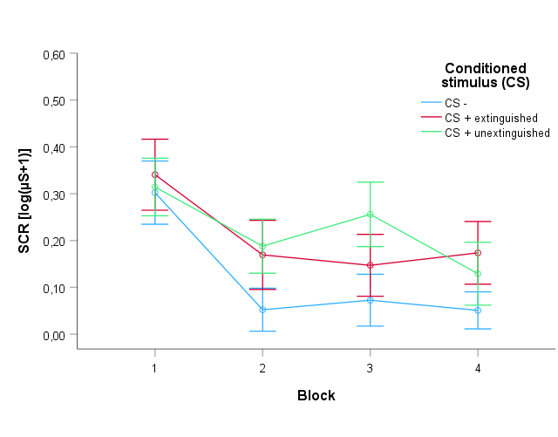

Depiction of the SCRs regarding the three conditioned stimuli (CS-, CS+E, CS+U) over the course of four blocks during fear acquisition training on day 1. Both CS+ were associated with significantly higher SCRs compared to the CS- in block 2, 3 and 4. There were no significant differences in SCRs between the two CS+.

Table S1
Additional analyses: Fear extinction training (Day 2).

Post-hoc t-test CS- vs. CS+E on day 2 (fear extinction training), separate for treatment groups and blocks, bold typeface indicates significant effects after Bonferroni-adjustment.

Table S2
Additional analyses: Return of fear and fear reinstatement test (Day 3).
no Estradiol
t
df
p
Estradiol
t
df
p
Block1
CS- / CS+E
-1,910
57
,061

CS- / CS+E
-4,760
55
,000

CS- / CS+U
-3,315
57
,002

CS- / CS+U
-4,905
55
,000
Block2
CS- / CS+E
-1,180
57
,243
CS- / CS+E
-,235
55
,815
CS- / CS+U
-2,321
57
,024
CS- / CS+U
,801
55
,427
Block3
CS- / CS+E
-2,219
57
,030
CS- / CS+E
-,806
55
,424
CS- / CS+U
-2,229
57
,030
CS- / CS+U
-,719
55
,475
Block4
CS- / CS+E
-,799
57
,428
CS- / CS+E
,744
55
,460
CS- / CS+U
,071
57
,944
CS- / CS+U
-,427
55
,671

Post-hoc t-test CS- vs. CS+E and CS- vs. CS+U on day 3 (return of fear test), separate for the estradiol vs. no estradiol treatment conditions, bold typeface indicates significant effects after Bonferroni-adjustment.

Table S3
Additional analyses: Fear extinction training (Day 2) as well as return of fear and fear reinstatement test (Day 3).

Day 2 - Fear extinction training
CS-
 | df | F | p | partial eta²
time | 1,000 | 19,073 | ,000 | ,147
time * Estradiol | 1,000 | 3,895 | ,051 | ,034
time * Progesterone | 1,000 | ,021 | ,884 | ,000
time * Estradiol * Progesterone | 1,000 | 1,436 | ,233 | ,013
CS+E
time | 2,668 | 32,848 | ,000 | ,228
time * Estradiol | 2,668 | ,451 | ,503 | ,004
time * Progesterone | 2,668 | ,100 | ,752 | ,001
time * Estradiol * Progesterone | 2,668 | ,040 | ,842 | ,000
Day 3 - Return of fear test
CS-
 | df | F | p | partial eta²
time | 2,861 | 5,600 | ,001 | ,048
time * Estradiol | 2,861 | 2,124 | ,100 | ,019
time * Progesterone | 2,861 | 1,899 | ,133 | ,017
time * Estradiol * Progesterone | 2,861 | ,532 | ,652 | ,005
CS+E
time | 2,668 | 25,767 | ,000 | ,190
time * Estradiol | 2,668 | 1,772 | ,159 | ,016
time * Progesterone | 2,668 | ,442 | ,700 | ,004
time * Estradiol * Progesterone | 2,668 | ,033 | ,987 | ,000
CS+U
time | 2,141 | 36,080 | ,000 | ,247
time * Estradiol | 2,141 | 1,474 | ,230 | ,013
time * Progesterone | 2,141 | ,773 | ,471 | ,007
time * Estradiol * Progesterone | 2,141 | 2,787 | ,060 | ,025

rmAMOVA separate for CS-type: Fear extinction training and return of fear test.

