Fig. S1 The effect of CUS on the neuronal activity and synaptic functions of dopamine neurons in the DRN of both (blue color) and female (red color) mice. (A) Quantitative analysis of AP amplitudes (male: unpaired two-tailed t test, t(35) = 0.3901, p = 0.6988; female: Mann Whitney test, p = 0.2516) and half-width (male: Mann Whitney test, p = 0.4612; female: Mann Whitney test, p = 0.0079). Male: n = 18 cells from 4 mice in CUS group, n = 19 cells from 4 mice in control group; female: n = 18 cells from 4 mice per group.(B) Representative traces of sEPSC in dopamine neurons and cumulative probability plots for the amplitude (male: left, Kolmogorov–Smirnov test, D = 0.5339, p < 0.0010; female: left, Kolmogorov–Smirnov test, D = 0.3821, p < 0.0010) and interevent interval (male: right, Kolmogorov–Smirnov test, D = 0.0260, p = 0.6949; female: right, Kolmogorov–Smirnov test, D = 0.0421, p = 0.1600) of sEPSC. The insets show the average amplitude (male: unpaired two-tailed t test, t(31) = 2.9610, p = 0.0058; female: unpaired two-tailed t test, t(30) = 4.3330, p < 0.0010) and frequency (male: unpaired two-tailed t test, t(31) = 0.8079, p = 0.4253; female: unpaired two-tailed t test, t(30) = 0.7902, p = 0.4356) of sEPSC. Male: n = 16 cells from 4 mice in control group, n = 17 cells from 4 mice in CUS group. Female: n = 18 cells from 4 mice in control group, n = 14 cells from 3 mice in CUS group. (C)Representative traces of sIPSC in dopamine neurons and cumulative probability plots for the amplitude (male: Kolmogorov–Smirnov test, D = 0.0423, p = 0.6639; female: Kolmogorov–Smirnov test, D = 0.3009, p < 0.0010) and interevent interval (male: Kolmogorov–Smirnov test, D = 0.0290, p = 0.9654; female: Kolmogorov–Smirnov test, D = 0.0365, p = 0.6296). The insets show the average amplitude (male: unpaired two-tailed t test, t(35) = 0.8417, p = 0.4050; female: unpaired two-tailed t test, t(32) = 4.8880, p < 0.0010) and frequency (male: unpaired two-tailed t test, t(35) = 0.6522, p = 0.5185; female: unpaired two-tailed t test, t(32) = 0.8153, p = 0.4209). Male: n = 19 cells from 4 mice in control group, n = 18 cells from 4 mice in CUS group. Female: n = 17 cells from 4 mice in control group, n = 17 cells from 4 mice in CUS group. **p < 0.010, ***p < 0.0010, compared to the control group.

Fig. S2 The effect of suppressing DRN dopamine neurons in anxiety-related behaviors. (A) Open field test (OFT) (Time in center: Two-way ANOVA: treatment: F(1, 37) = 2.2000, p = 0.1465, gender: F(1, 37) = 0.6440, p = 0.4274, interaction: F(1, 37) = 0.0114, p = 0.9157; male: p = 0.8363; female: p = 0.7433. Total distances: Two-way ANOVA: treatment: F(1, 37) = 1.6270, p = 0.2101, gender: F(1, 37) = 0.8696, p = 0.3573, interaction: F(1, 37) = 0.1816, p = 0.6725; male: p = 0.7826; female: p = 0.8933). (B) Elevated plus-maze (EPM) (Opem arm time: Two-way ANOVA: treatment: F(1, 37) = 0.1551, p = 0.6960, gender: F(1, 37) = 0.0522, p = 0.8205, interaction: F(1, 37) = 0.0506, p = 0.8232; male: p = 0.9984; female: p = 0.9990; Opem arm entries: Two-way ANOVA: treatment: F(1, 37) = 0.0031, p = 0.9556, gender: F(1, 37) = 5.6670, p = 0.0226, interaction: F(1, 37) = 0.1515, p = 0.6994; male: p = 0.9461; female: p = 0.9461). Male: n = 9 per group; female: AAV-mCherry group, n = 11, AAV-hM4D-mCherry group, n = 12.
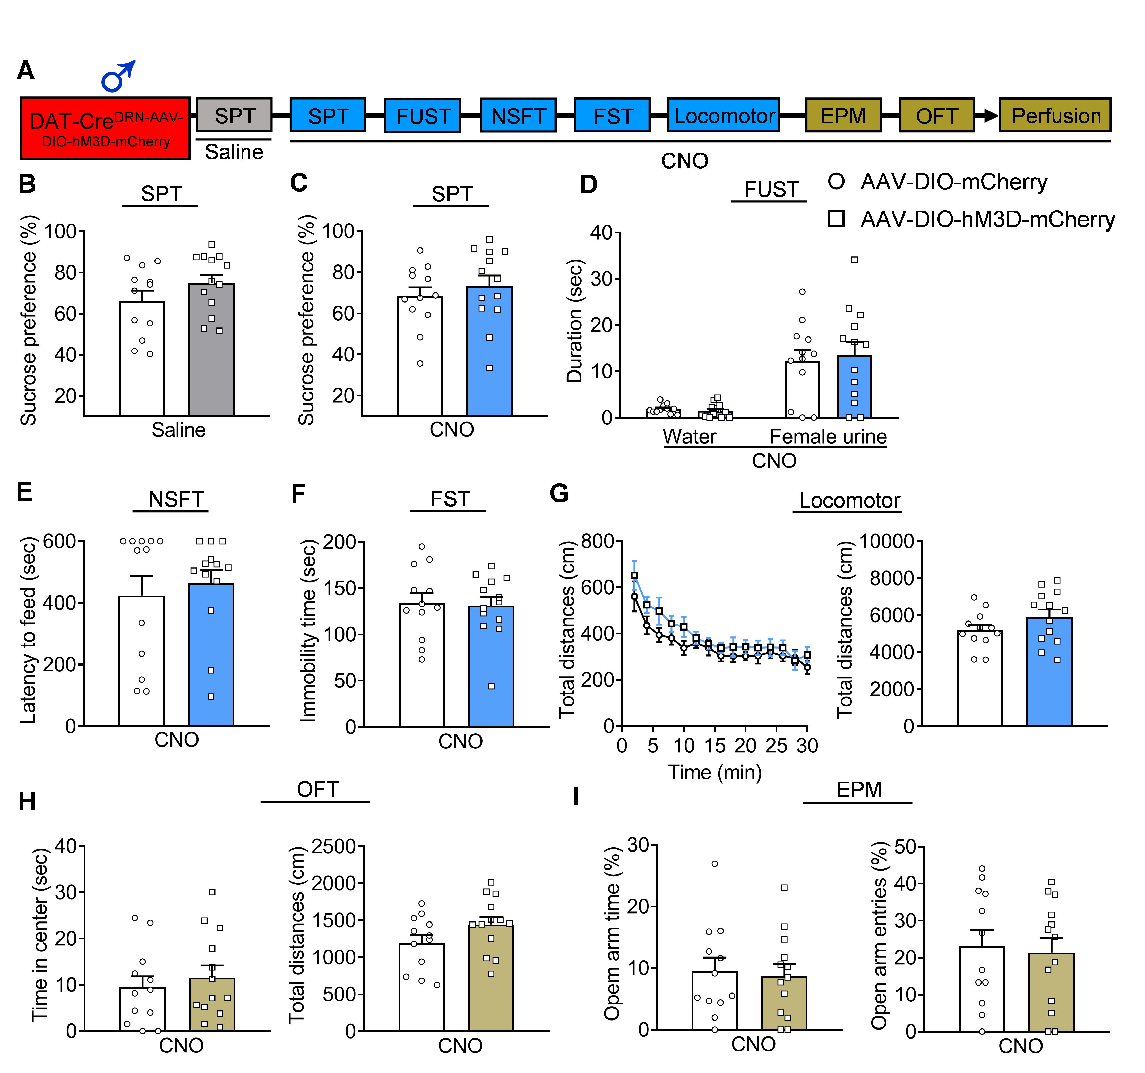
Fig. S3 The effect of activating DRN dopamine neurons on depression-related behaviors under basal conditions in male mice. (A) Schematic diagram of depression-related and anxiety-related behavioral tests. (B) SPT after saline injection (unpaired two-tailed t test, t(23) = 1.3800, p = 0.1808). (C) SPT after CNO injection (unpaired two-tailed t test, t(23) = 0.7354, p = 0.4695). (D) FUST after CNO injection (Two-way repeated ANOVA: treatment: F(1, 23) = 0.0427, p = 0.8380, sniffing object: F(1, 23) = 38.6200, p < 0.0010, interaction: F(1, 23) = 0.2183, p = 0.6447; p < 0.0010 and p = 0.8730). (E) NSFT after CNO injection (Mann Whitney test, p = 0.7330). (F) FST after CNO injection (unpaired two-tailed t test, t(23) = 0.1969, p = 0.8456). (G) Locomotor activity after CNO injection (Two-way repeated ANOVA: treatment: F(1, 23) = 2.1450, p = 0.1566, timepoints: F(14, 322) = 18.3400, p < 0.0010, interaction: F(14, 322) = 0.6695, p = 0.8039; Total distances: unpaired two-tailed t test, t(23) = 1.4650, p = 0.1566). (H) Open field test (OFT) (Time in center: unpaired two-tailed t test, t(23) = 0.5973, p = 0.5562. Total distances: unpaired two-tailed t test, t(23) = 1.6680, p = 0.1088). (I) Elevated plus-maze (EPM) (Opem arm time: unpaired two-tailed t test, t(23) = 0.2670, p = 0.7918. Open arm entries: unpaired two-tailed t test, t(23) = 0.2714, p = 0.7885).

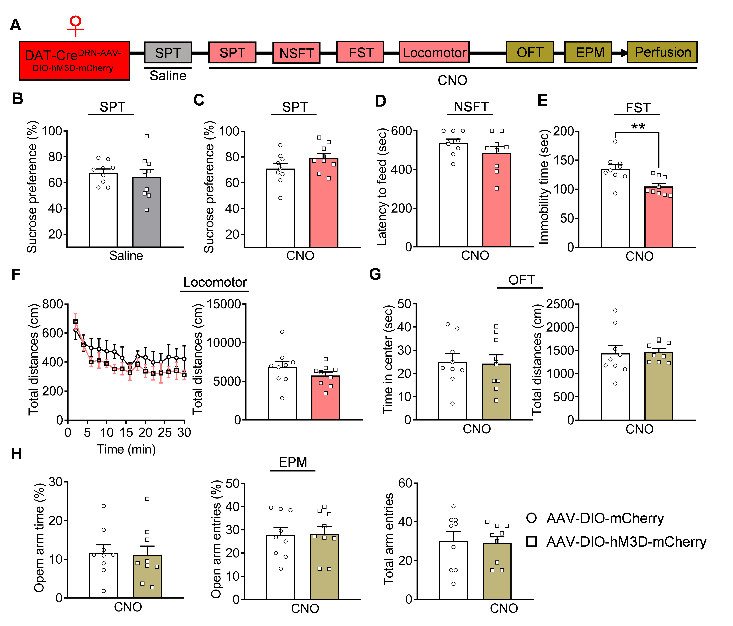
Fig. S4 The effect of activating DRN dopamine neurons on depression-related behaviors under basal conditions in female mice. (A) Schematic diagram of depression-related and anxiety-related behavioral tests. (B) SPT after saline injection (unpaired two-tailed t test, t(16) = 0.5107, p = 0.6165). (C) SPT after CNO injection (unpaired two-tailed t test, t(16) = 1.5300, p = 0.1457). (D) NSFT after CNO injection (unpaired two-tailed t test, t(16) = 1.3830, p = 0.1857). (E) FST after CNO injection (unpaired two-tailed t test, t(16) = 3.1670, p = 0.0060). (F) Locomotor activity after CNO injection (Two-way repeated ANOVA: treatment: F(1, 16) = 1.4300, p = 0.2492, sniffing object: F(14, 224) = 7.6520, p < 0.0010, interaction: F(14, 224) = 0.6372, p = 0.8323; Total distances: unpaired two-tailed t test, t(16) = 1.1840, p = 0.2537). (G) Open field test (OFT) (Time in center: unpaired two-tailed t test, t(16) = 0.1476, p = 0.8845. Total distances: unpaired two-tailed t test, t(16) = 0.1629, p = 0.8727). (H) Elevated plus-maze (EPM) (Opem arm time: unpaired two-tailed t test, t(16) = 0.2062, p = 0.8392. Open arm entries: unpaired two-tailed t test, t(16) = 0.0711, p = 0.9442. Total arm entries: t(16) = 0.1897, p = 0.8519). *p < 0.050, compared to control group
Fig. S5 Identification of the neuronal projections from DRN dopamine neurons to dBNST and the effect of inhibiting DRN^{DA}- dBNST on depression-related behaviors. (A) Schematic diagram of AAVs injection and representative images showing GFP expression in the DRN and neural projection terminals in the BNST, CeA and VTA, co-localization of GFP with TH in dBNST, and relative quantification of fluorescence intensity of these neural terminals (One-way ANOVA). n= 8-10 slice from 3 mice. (B) Schematic diagram of AAVs injection and representative images showing neural terminal infection in the dBNST and GFP expression in the DRN, and the co-localization analysis of GFP with TH in dBNST after AAV-Retro-GFP injection into the dBNST of WT mice. n= 10-15 slice from 4 mice. (C) Schematic diagram of AAVs injection and representative images showing the expression of hM4D-mCherry in the DRN under Cre-driving derived from AAV-Retro-Cre-GFP injection in the dBNST. (D) SPT after CNO injection (t(16) = 3.5800, p = 0.0025). (E) FUST after CNO injection (Two-way repeated ANOVA: treatment: F(1, 16) = 63.1300, p < 0.0010, sniffing object: F(1, 16) = 1888.0000, p < 0.0010, interaction: F(1, 16) = 64.1100, p < 0.0010; p = 0.4707, p < 0.0010). (F) FST after CNO injection (t(16) = 3.8510, p = 0.0014). (G) Locomotor activity after CNO injection (Two-way repeated ANOVA: treatment: F(1, 16) = 0.6142, p = 0.4446, timepoints: F(14, 224) = 28.3300, p < 0.0010, interaction: F(14, 224) = 1.1230, p = 0.3389; Mann Whitney test, p = 0.5457). n = 9 per group. Scale bar is 100 μm.***p < 0.001, compared to the control group.
Fig. S6 The co-localization of AAV2/1-TH-Cre/AAV-DIO-mCherry labeled neurons with TH or TPH2 in DRN, TH mRNA expression in dBNST, and co-localization of TH mRNA or TH protein labeled neural fibers with GFP-labeled neurons in the dBNST. (A) Representative images showing co-localization of mCherry labeled neurons with TH in DRN. Scale bar is 100 μm. (B) Representative images showing co-localization and percentage analysis of mCherry and TPH2 labeled 5-HT neurons. Scale bar is 100 μm. (C) TH mRNA expression and its co-localization with GFP-labeled targeted neurons in dBNST. (D) Representative images showing co-localization of TH marked fibers with GFP-labeled targeted neurons in dBNST. Scale bar is 50 μm at low magnification and 25 μm at high magnification.

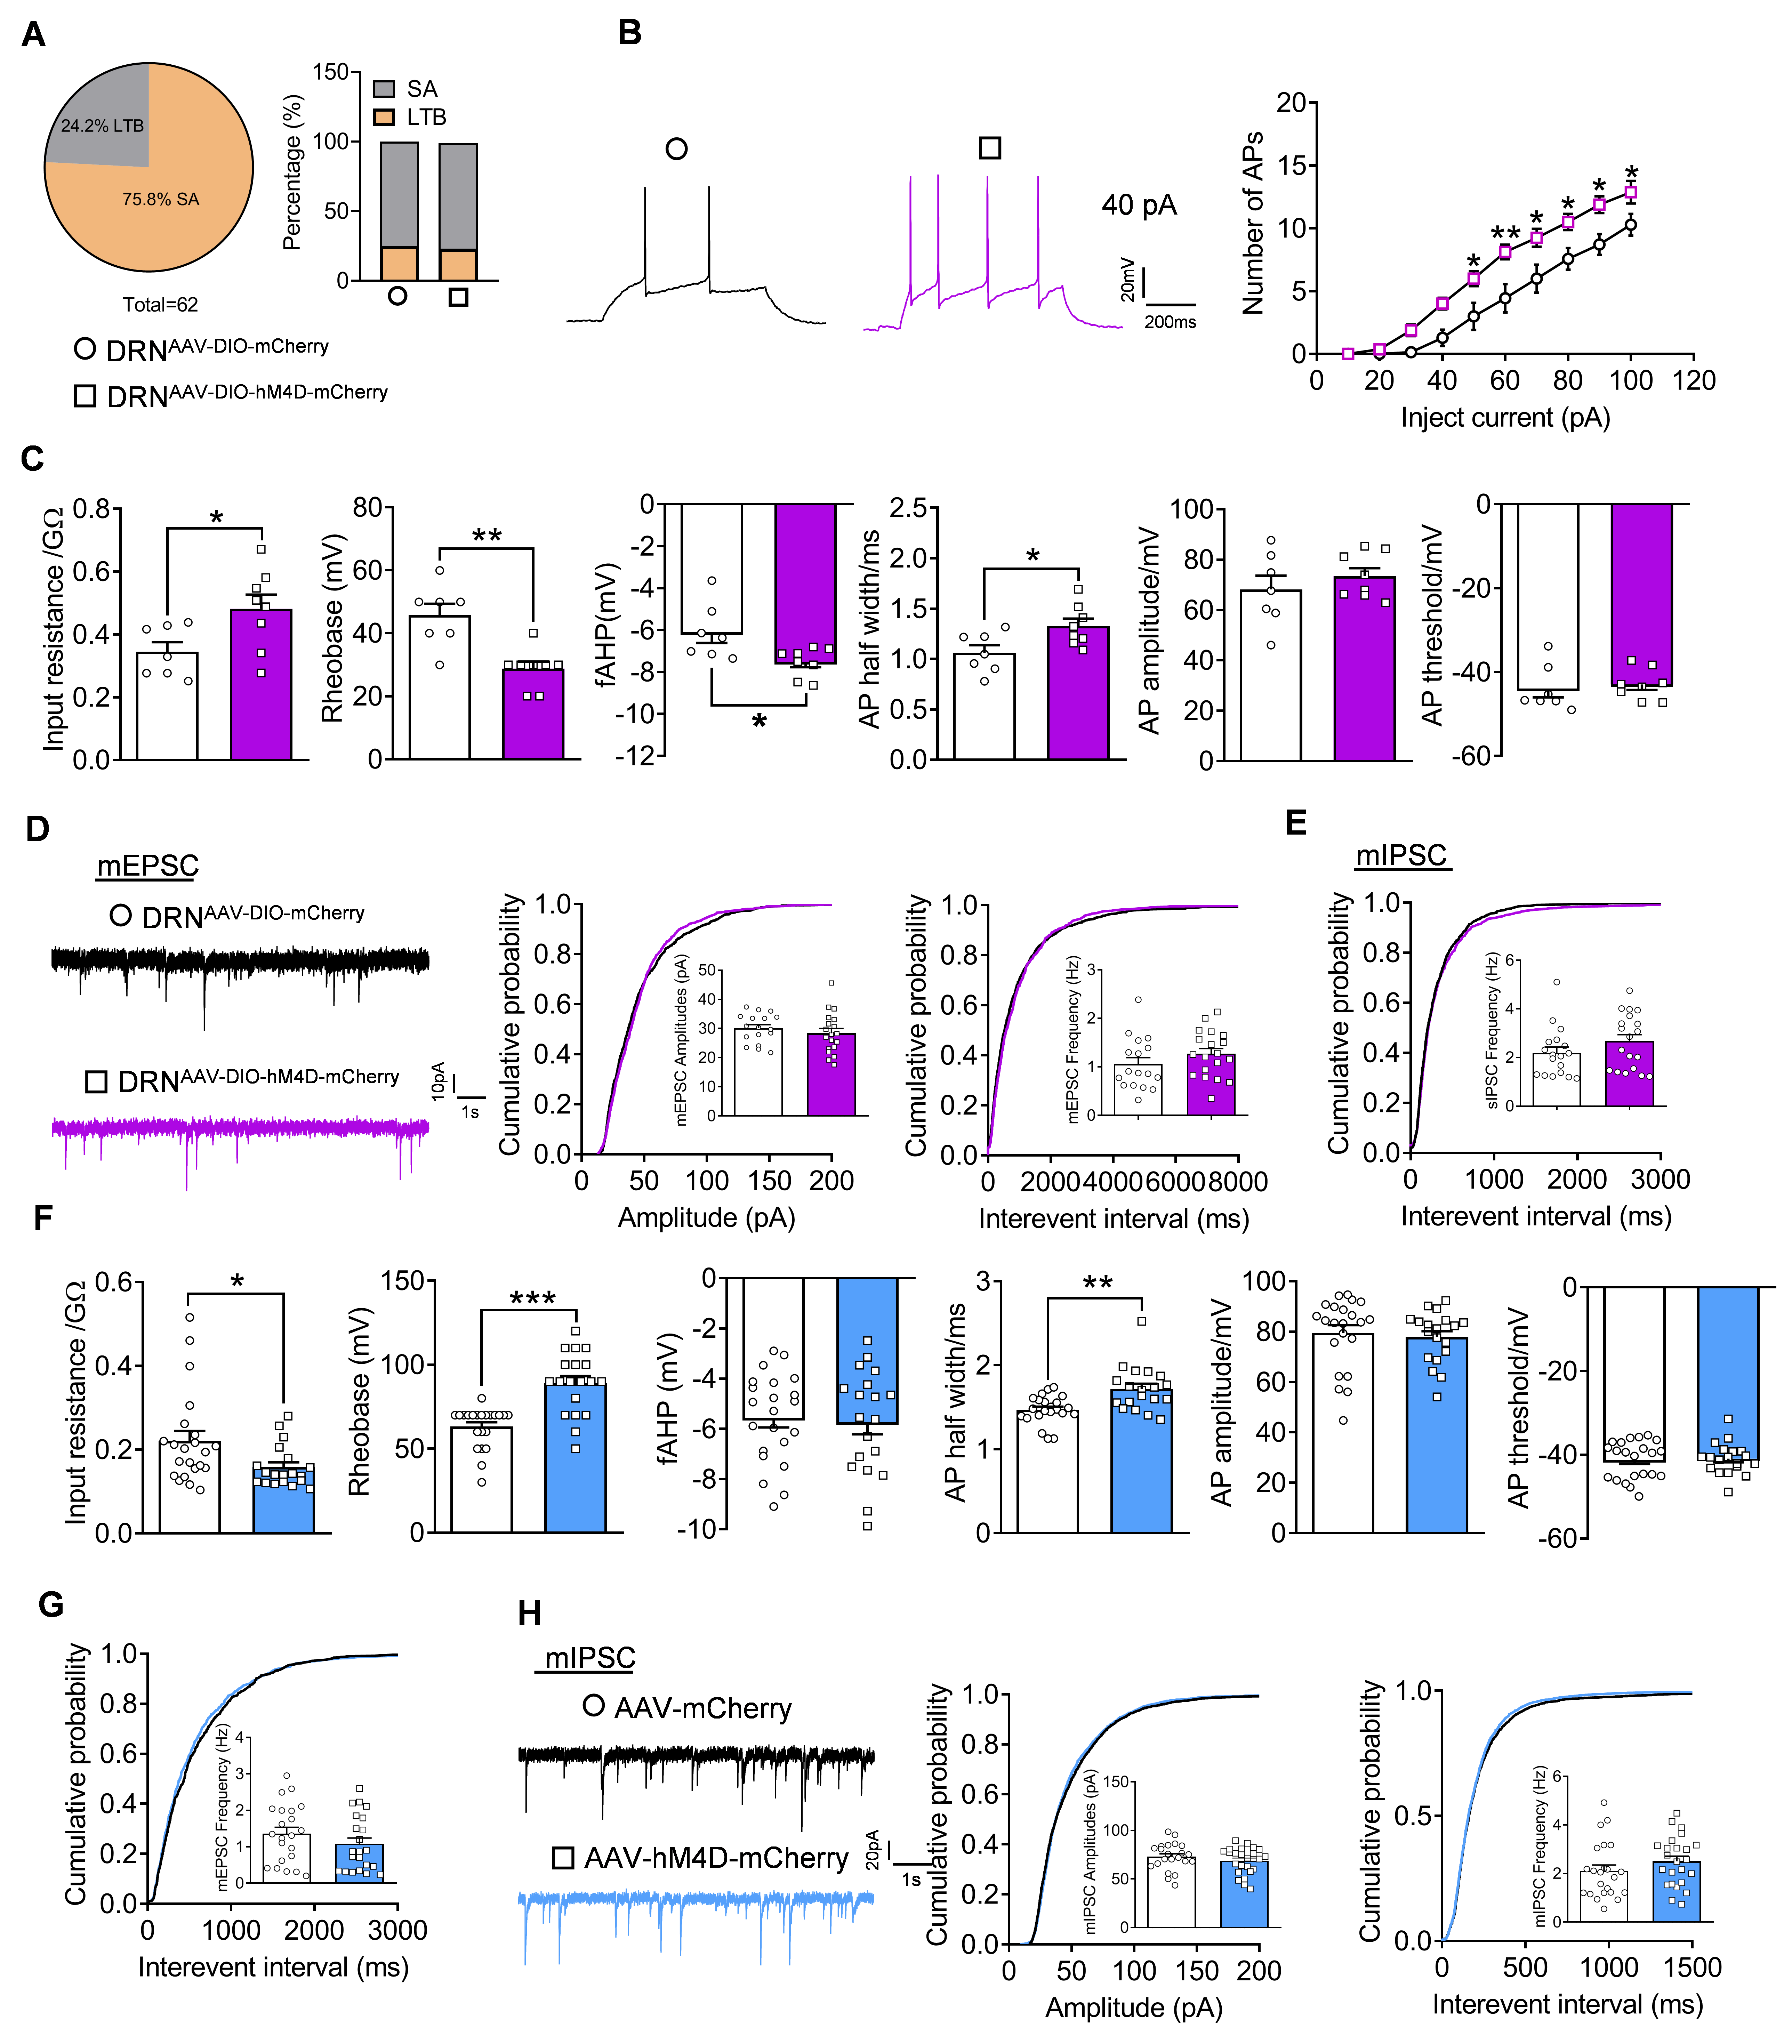
Fig. S7 The effect of inhibiting DRN dopamine neurons on the neural activity, mIPSC and mEPSC of GABAergic neurons in the dBNST. (A) The percentage of the spontaneously active (SA) and low-threshold bursting (LTB) GABAergic neurons. n = 30 cells from 7 mice in DRN^{AAV-DIO-mCherry} group, n = 32 cells from 7 mice in DRN^{AAV-DIO-hM4D-mCherry} group. (B) Representative traces of action potentials of SA GABAergic neurons in the dBNST, and quantitative analysis of APs after injected currents (Two-way repeated ANOVA: treatment: F(1, 13) = 11.2600, p = 0.0052, currents: F(9, 117) = 145.3000, p < 0.0010, interaction: F(9, 117) = 3.0870, p = 0.0023) after inhibiting the activity of dopamine neurons in DRN. (C) Input resistance (t(13) = 2.4200, p = 0.0309), rheobase current (Mann Whitney test, p = 0.0039), fAHP amplitude (t(13) = 2.6300, p = 0.0208), the AP half width (t(13) = 2.5680, p = 0.0234) and AP amplitude (t(13) = 0.4093, p = 0.6890) and AP threshold (Mann Whitney test, p = 0.5358). n = 7 cells from 7 mice in AAV-mCherry group, n = 8 cells from 7 mice in AAV-hM4D-mCherry group. (D) The mEPSC recorded in GABAergic neurons. Representative traces depicting mEPSC, cumulative probability plots for the amplitude (Kolmogorov–Smirnov test, D = 0.0488, p = 0.1720) and cumulative probability plots (Kolmogorov–Smirnov test, D = 0.0520, p = 0.1891) for the interevent interval of mEPSC. The insets show the average amplitude (t(34) = 0.8411, p = 0.4062) and frequency (t(34) = 1.2270, p = 0.2282) of mEPSC. n = 17 cells from 5 mice in DRN^{AAV-DIO-mCherry} group, n = 19 cells from 5 mice in DRN^{AAV-DIO-hM4D-mCherry} group. (E) The cumulative probability plots for the interevent interval of mIPSC recorded in GABAergic neurons (Kolmogorov–Smirnov test, D = 0.0372, p = 0.4573). The insets show the average frequency of mIPSC (Mann Whitney test, p = 0.1419). n = 18 cells from 5 mice in DRN^{AAV-DIO-mCherry} group, n = 19 cells from 5 mice in DRN^{AAV-DIO-hM4D-mCherry} group. *p < 0.050, **p < 0.010, compared to control group. (F) Input resistance (Mann Whitney test, p = 0.0260), rheobase current (Mann Whitney test, p < 0.0010), fAHP amplitude (t(39) = 0.2893, p = 0.7739), the AP half width (Mann Whitney test, p = 0.0012), AP amplitude (Mann Whitney test, p = 0.2697) and AP threshold (Mann Whitney test, p = 0.9462). n = 22 cells from 6 mice in DRN^{AAV-DIO-mCherry} group, n = 19 cells from 6 mice in DRN^{AAV-DIO-hM4D-mCherry} group. (G) The cumulative probability plots for the interevent interval of mEPSC (Kolmogorov–Smirnov test, D = 0.0561, p = 0.1237). The insets show the average frequency of mEPSC (Mann Whitney test, p = 0.2995). n = 22 cells from 6 mice per group. (H) The mIPSC recorded in glutamatergic neurons. Upper-left, representative traces depicting mIPSC; Upper-right: cumulative probability plots for the amplitude of mIPSC (Kolmogorov–Smirnov test, D = 0.0314, p = 0.0826); Lower-left: cumulative probability plots for the interevent interval of mIPSC (Kolmogorov–Smirnov test, D = 0.0269, p = 0.1617). The insets show the average amplitude (t(45) = 0.0680, p = 0.2912) and frequency (Mann Whitney test, p = 0.2234) of mIPSC. n = 23 cells from 6 mice in DRN^{AAV-DIO-mCherry} group, n = 24 cells from 6 mice in DRN^{AAV-DIO-hM4D-mCherry} group. *p < 0.050, **p < 0.010, ***p < 0.001, compared to control group.
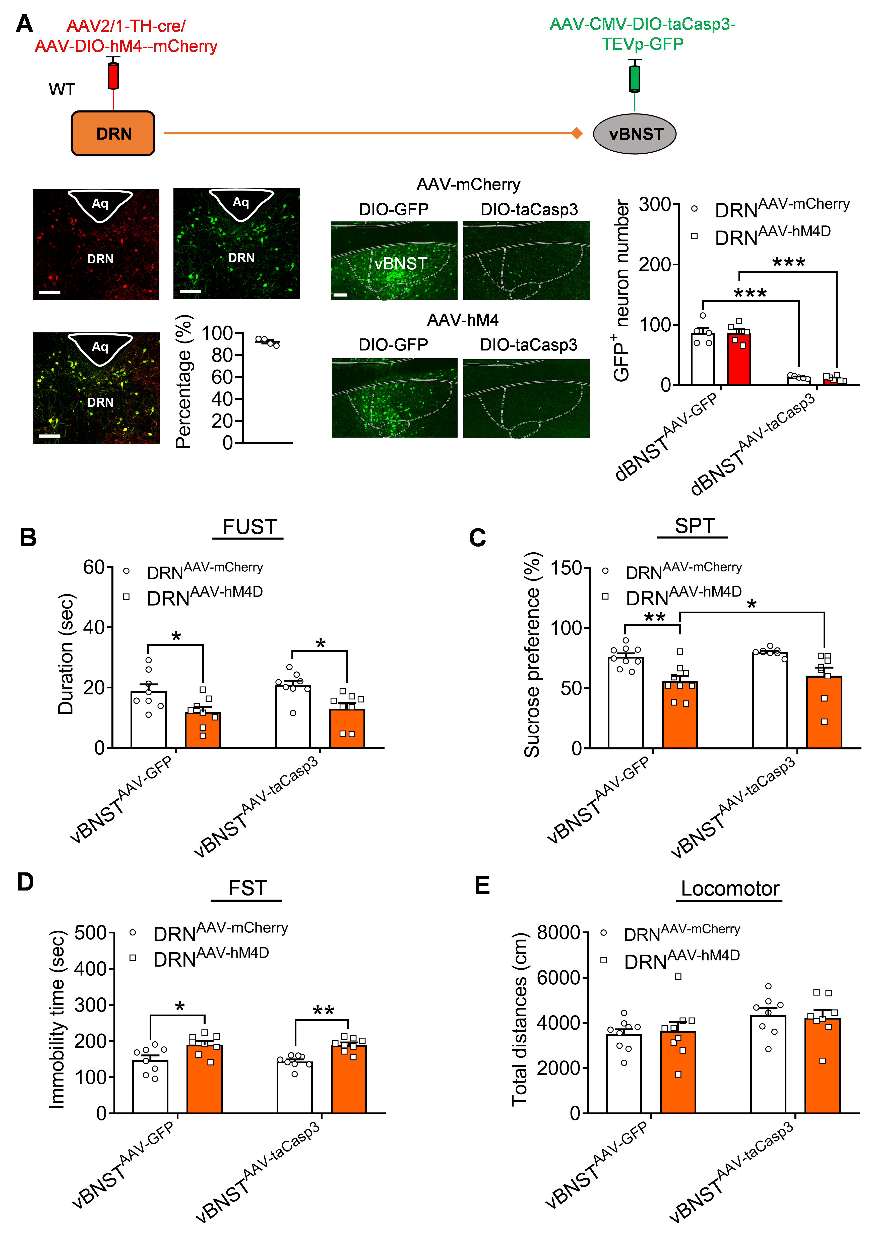
Fig. S8 The effect of ablating vBNST neurons projected from DRN on the depression-related behaviors induced by inhibiting DRN dopamine neurons. (A) Schematic diagram of AAVs injections and representative images showing the expression of hM4D-mCherry in the DRN and the quantitative analysis of GFP labeled neurons in vBNST, GFP+ neuron number: Two-way repeated ANOVA, treatment: F(1, 18) = 0.02800, p = 0.8690, interaction: F (1, 18) = 209.3, p < 0.0010. n = 5 per group. Scale bar is 100 μm. (B) Depression-related behaviors assessed by FUST: Two-way ANOVA, hM4D treatment: F(1, 28) = 15.64, p < 0.0010, taCasp3 treatmen: F(1, 28) = 0.6687, p = 0.4204, interaction: F(1, 28) = 0.03129, p = 0.0466, (C) SPT: Two-way ANOVA, hM4D treatment: F(1, 30) = 21.85, p < 0.0010, taCasp3 treatmen: F(1, 30) = 1.009, p = 0.3232, interaction: F(1, 30) = 0.0085, p = 0.9269, (D) FST: Two-way ANOVA, hM4D treatment: F(1, 28) = 23.41, p < 0.0001, taCasp3 treatmen: F(1, 28) = 0.07829, p = 0.7817, interaction: F(1, 28) = 0.02911, p = 0.8658, (E) Locomotor activity after CNO injection: Two-way ANOVA, hM4D treatment: F(1, 30) = 0.0013, p = 0.9709, taCasp3 treatmen: F(1, 30) = 5.043, p = 0.0322, interaction: F(1, 30) = 0.1801, p = 0.6743. n = 10 per group. *p < 0.05, **p < 0.01, ***p < 0.001.
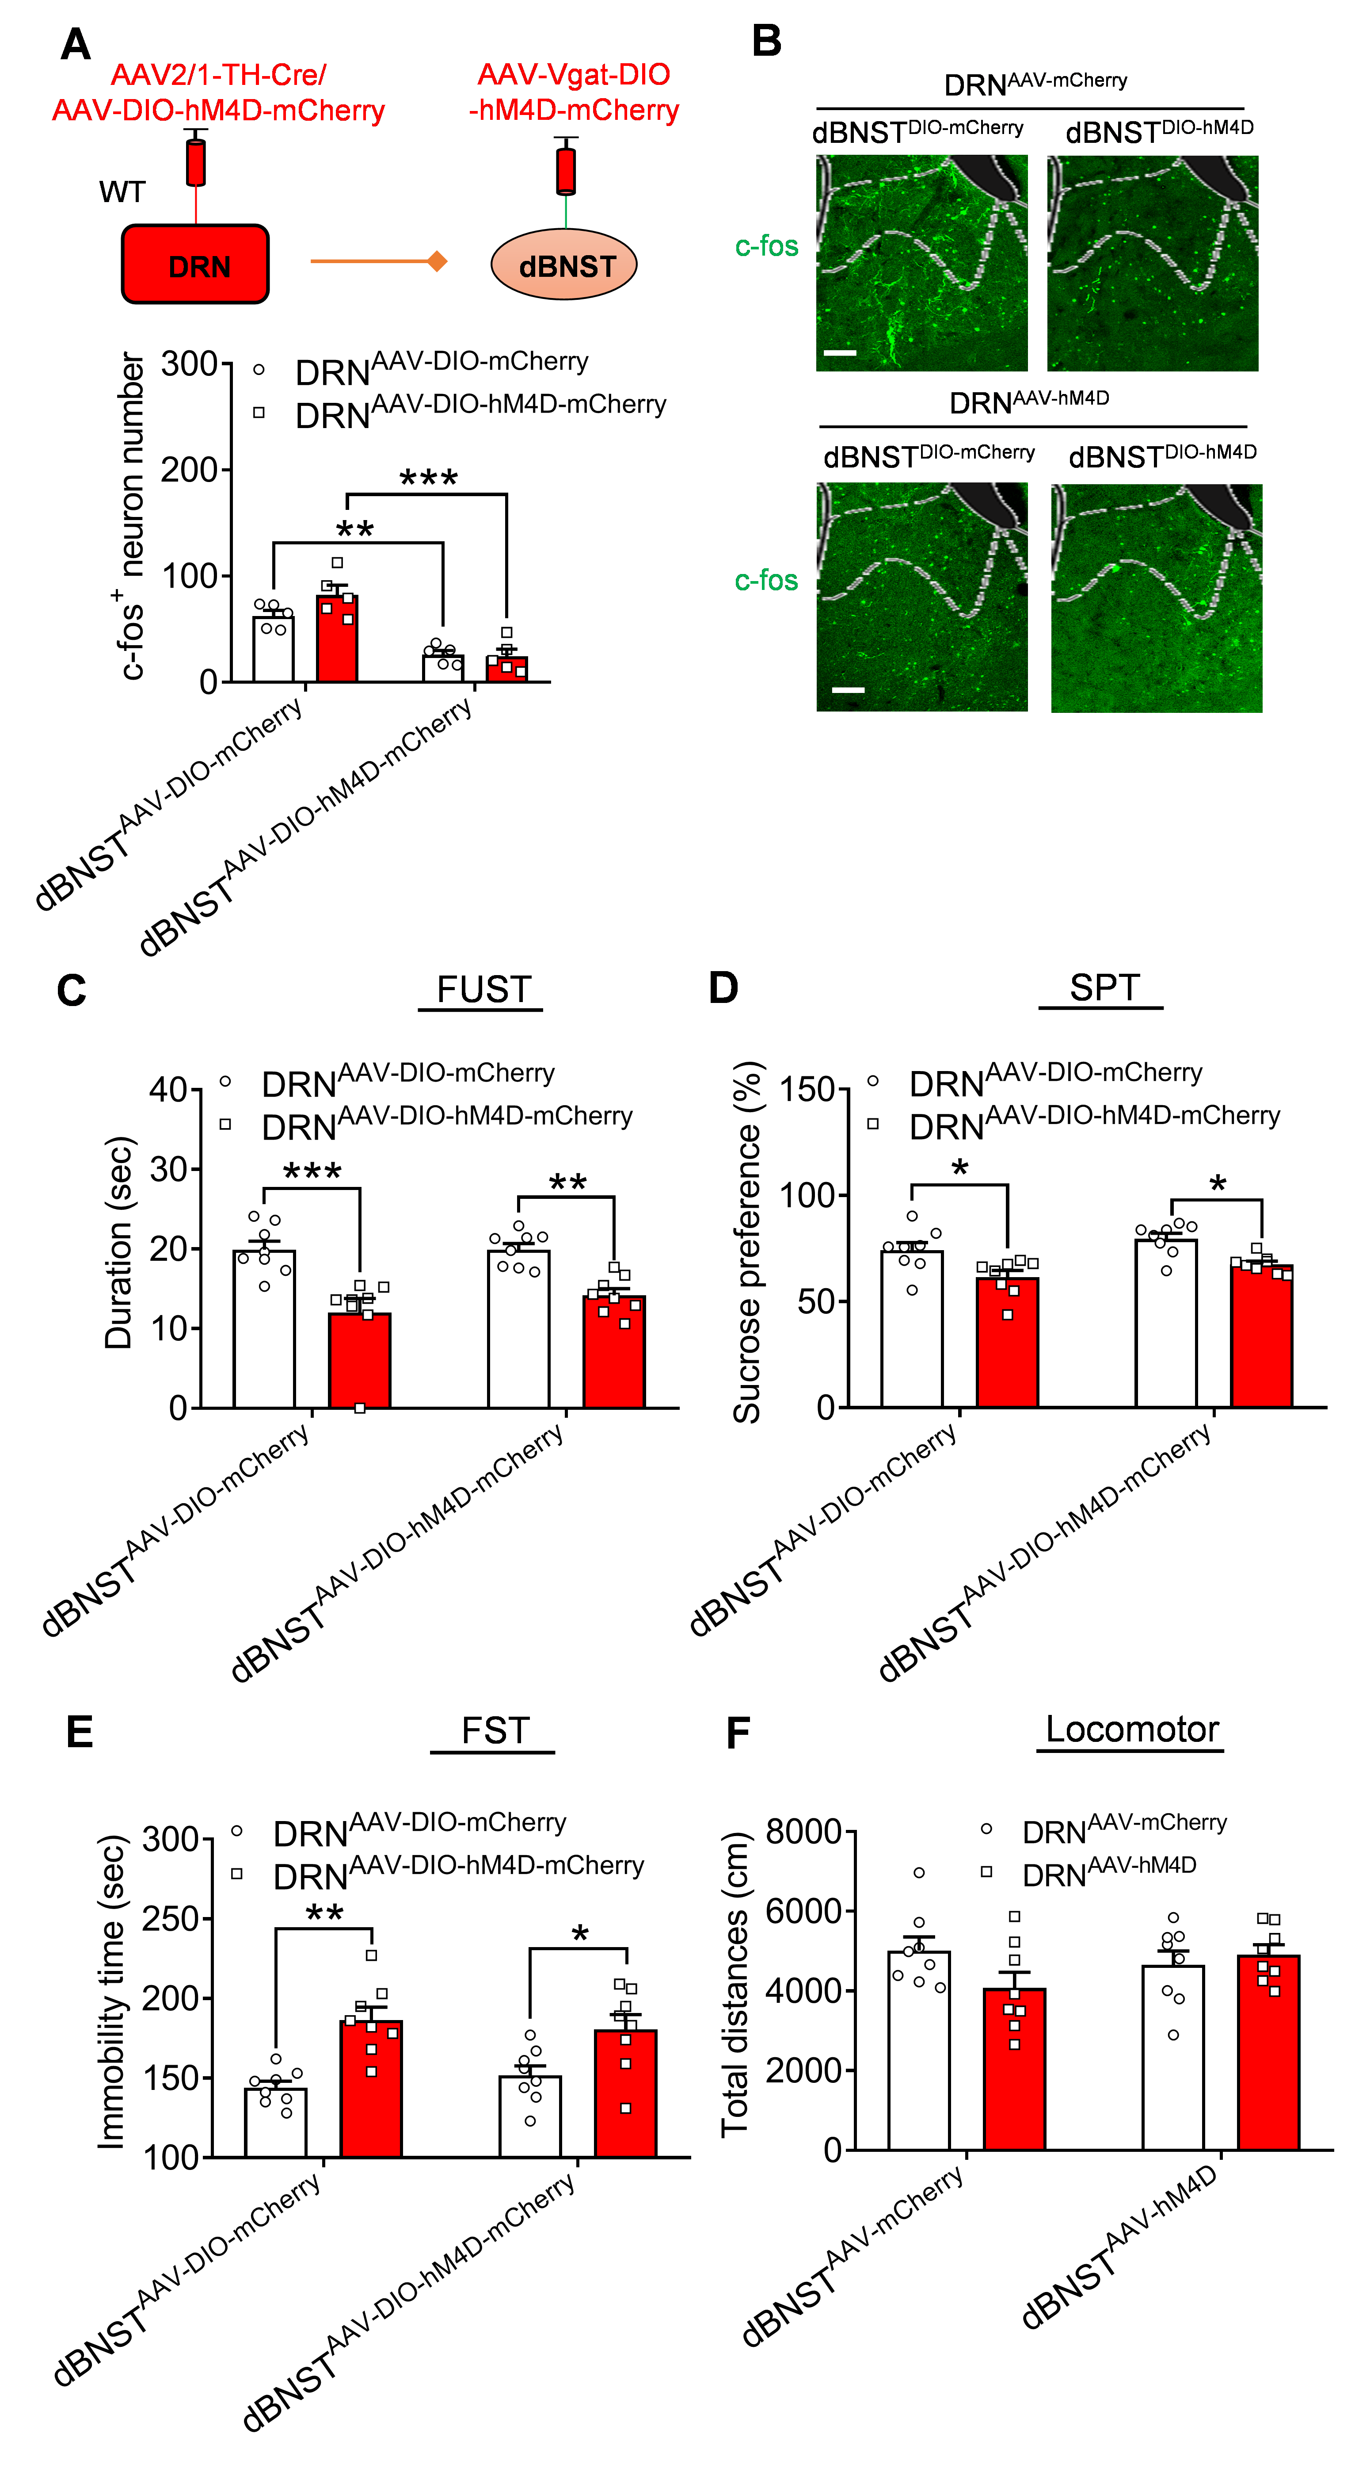
Fig. S9. The effect of reversing the excitability of dBNST GABAergic neurons projected from DRN on the depression-related behaviors induced by inhibiting DRN dopamine neurons. (A) Schematic diagram of AAVs injections and representative images showing the expression of hM4D-mCherry in the DRN. (B) The quantitative analysis of c-fos labeled neurons in DRN and dBNST (Two-way ANOVA: hM4D treatment: F(1, 16) = 1.9550, p = 0.1812, hM4D treatment: F(1, 16) = 51.3700, p < 0.0010, interaction: F(1, 16) = 2.6750, p = 0.1214). n = 12-15 slice form 5 mice per group. Scale bar is 100 μm. (C) FUST (Two-way ANOVA: hM4D treatment: F(1, 28) = 33.2200, p < 0.0010, hM4D treatment: F(1, 28) = 0.8660, p = 0.3600, interaction: F(1, 28) = 0.8271, p = 0.3709). (D) SPT (Two-way ANOVA: hM4D treatment: F(1, 28) = 18.7300, p < 0.0010, hM4D treatment: F(1, 28) = 4.0530, p = 0.0538, interaction: F(1, 28) = 0.0148, p = 0.9192). (E) FST (Two-way ANOVA: hM4D treatment: F(1, 28) = 25.8200, p < 0.0010, hM4D treatment: F(1, 28) = 0.0155, p = 0.9019, interaction: F(1, 28) = 0.9206, p = 0.3455). (F) Locomotor activity after CNO injection (Two-way ANOVA: hM4D treatment: F(1, 28) = 1.0160, p = 0.3221, hM4D treatment: F(1, 28) = 0.5080, p = 0.4819, interaction: F(1, 28) = 3.2260, p = 0.0833). n = 8 per group. *p < 0.05, **p < 0.01, ***p < 0.001, compared to control group.

Fig. S10. (A) Schematic diagram showing AAV2/1-TH-Cre/AAV-DIO-mCherry co-infusion in the DRN and AAV-Vgat-DIO-GFP infusion in the dBNST; representative images of co-localization of GFP with D1 or D2 receptor and the percentage analysis. n= 10-12 slice from 5 mice. Arrowhead showing neurons that contain only GFP, arrows indicating neurons that contain both GFP mRNA and D2 receptor. Scale bar is 50 μm.

Fig. S11. The effect of Quinpirolein the neural activity of CaMKII⁺ neurons in the dBNST. (A) Input resistance (Unpaired t test with Welch's correction, p = 0.0450), rheobase current (t(16) = 4.9500, p < 0.0010), fAHP amplitude (t(16) = 0.1314, p = 0.8971), the AP half width (t(16) = 2.6870, p = 0.0162) and AP amplitude (t(16) = 0.4689 p = 0.6455) and AP threshold (t(16) = 2.7070, p = 0.0155). n = 9 cells from 3 mice per group. *p < 0.05, ***p < 0.001, compared to control group.

