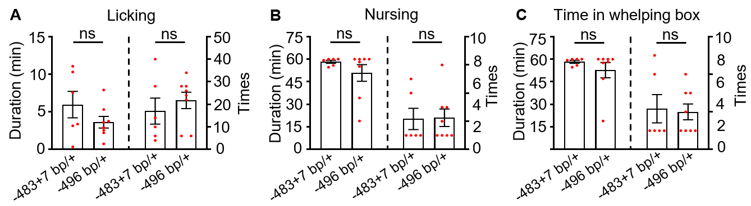
Supplementary Figure S1. No significant difference in maternal behaviors between the two genotypes of -483+7 bp/+ and -496 bp/+.
A–C There were no significant differences in duration and times of licking (A), nursing (B), and time stayed in the whelping box (C) between the two genotypes of -483+7 bp/+ and -496 bp/+.
Data are presented as mean ± SEM, n = 6 for -483+7 bp/+, n = 8 for -496 bp/+, ns, no significant difference by Mann-Whitney test.

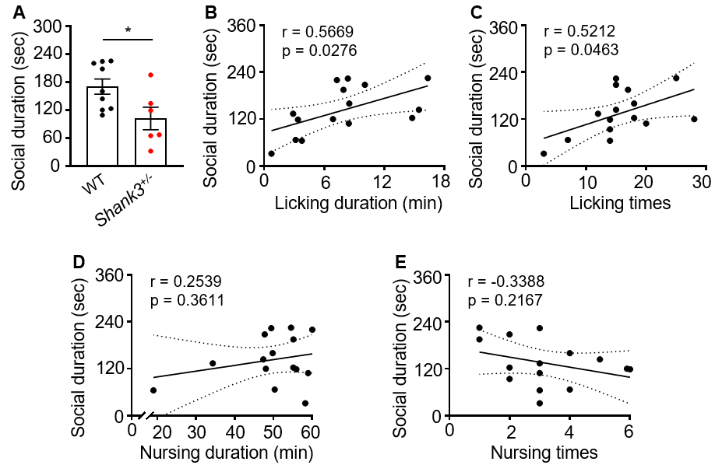
Supplementary Figure S2. Maternal behavior and dog-human social behavior are positively correlated.
A Shank3 mutant dams showed significantly decreased duration of social interactions with humans in the open field test. Each square represents the value of each animal. Data are presented as mean ± SEM, n = 9 for controls and n = 6 for mutants. *p < 0.05 by unpaired t test.
B and C The dog-human social interaction duration in the open field test was positively correlated with the maternal licking duration (B) and licking times (C). n = 15.
D and E No significant correlation between the dog-human social interaction duration in the open field test and nursing duration (D) and nursing times (E). n = 15.
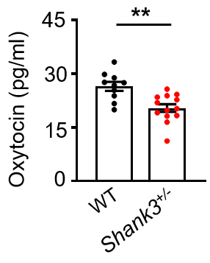
Supplementary Figure S3. Shank3 mutants showed a lower level of blood oxytocin in non-reproductive period.
Shank3 female mutants showed a significantly lower blood OXT level compared with controls in non-reproductive period. Data are presented as mean ± SEM, n = 10 for controls and n = 13 for mutants. **p < 0.01 by unpaired t test.

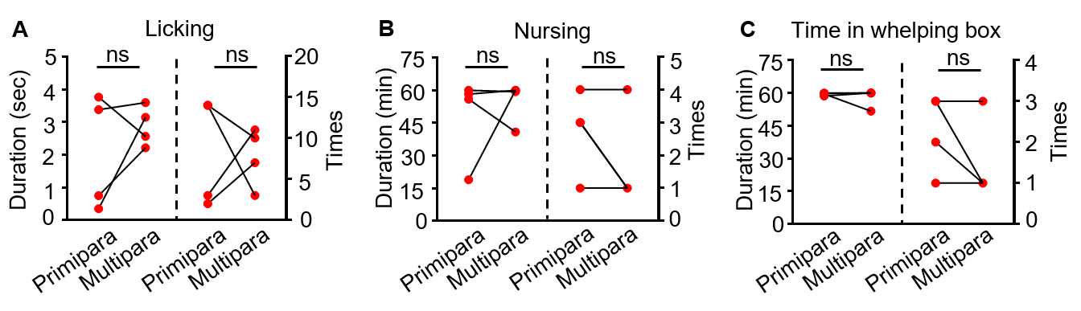Supplementary Figure S4. No significant difference in maternal behavior between primiparous and multiparous mutant dams.
A–C There were no significant differences in duration and times of licking (A), nursing (B), and time stayed in the whelping box (C) between multiparous and primiparous mutant dams.
Data are presented as mean ± SEM, n = 4, ns, no significant difference by Wilcoxon signed rank test.

