Supplementary materials for:

Potential locations for non-invasive brain stimulation in treating ADHD: Results from a cross-dataset validation of functional connectivity analysis

Yue Yang¹, Sitong Yuan¹, Huize Lin¹, Yi Han^{1, 2}, Binlong Zhang^{1, 2#}, Jinna Yu^{1#}

¹Department of Acupuncture and Neurology, Guang’anmen Hospital, China Academy of Chinese Medical Sciences, Beijing 100053, China
²Shandong First Medical University & Shandong Academy of Medical Sciences, Jinan 250117, China

Supplementary Material 1. Figures
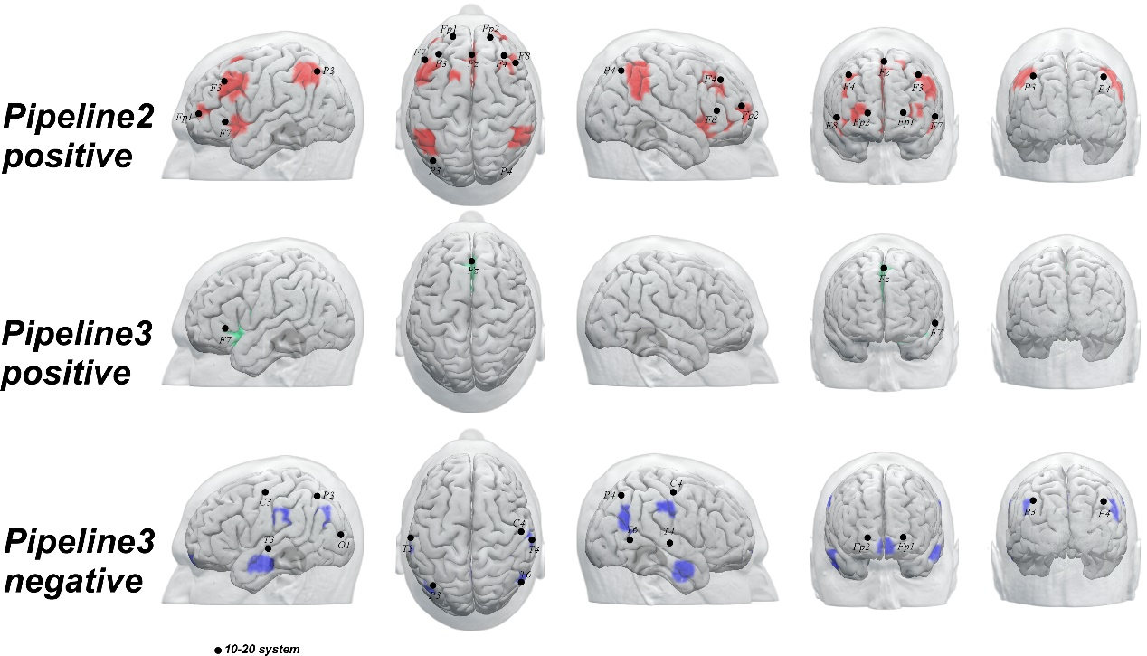Figure S1. Peking database. The identified potential locations and corresponding brain surface regions of NIBS from pipeline2 and pipeline3 in Peking database.

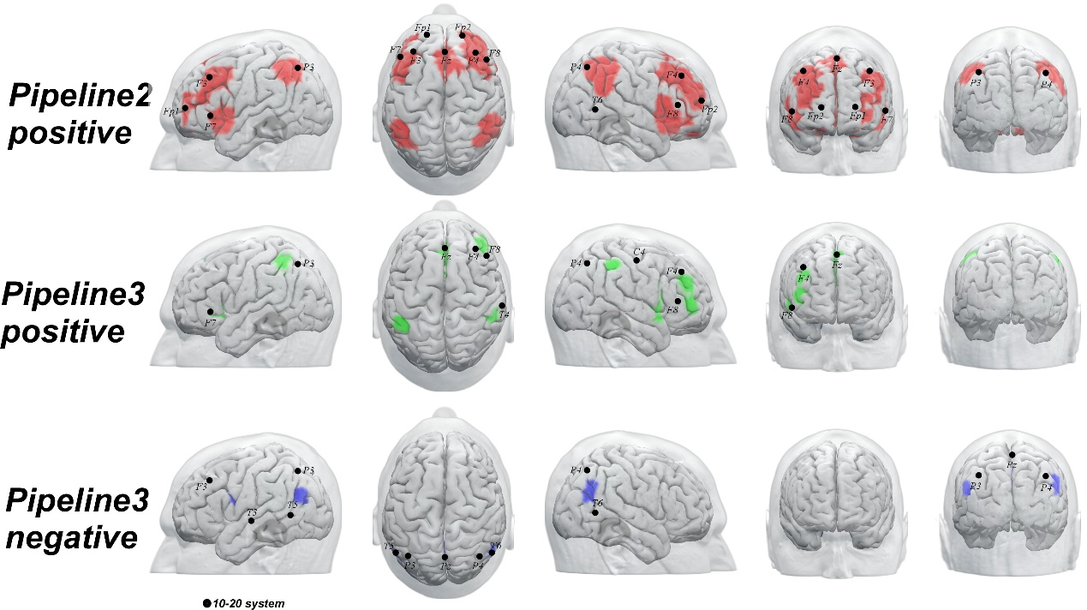
Figure S2. New York database. The identified potential locations and corresponding brain surface regions of NIBS from pipeline2 and pipeline3 in New York database.

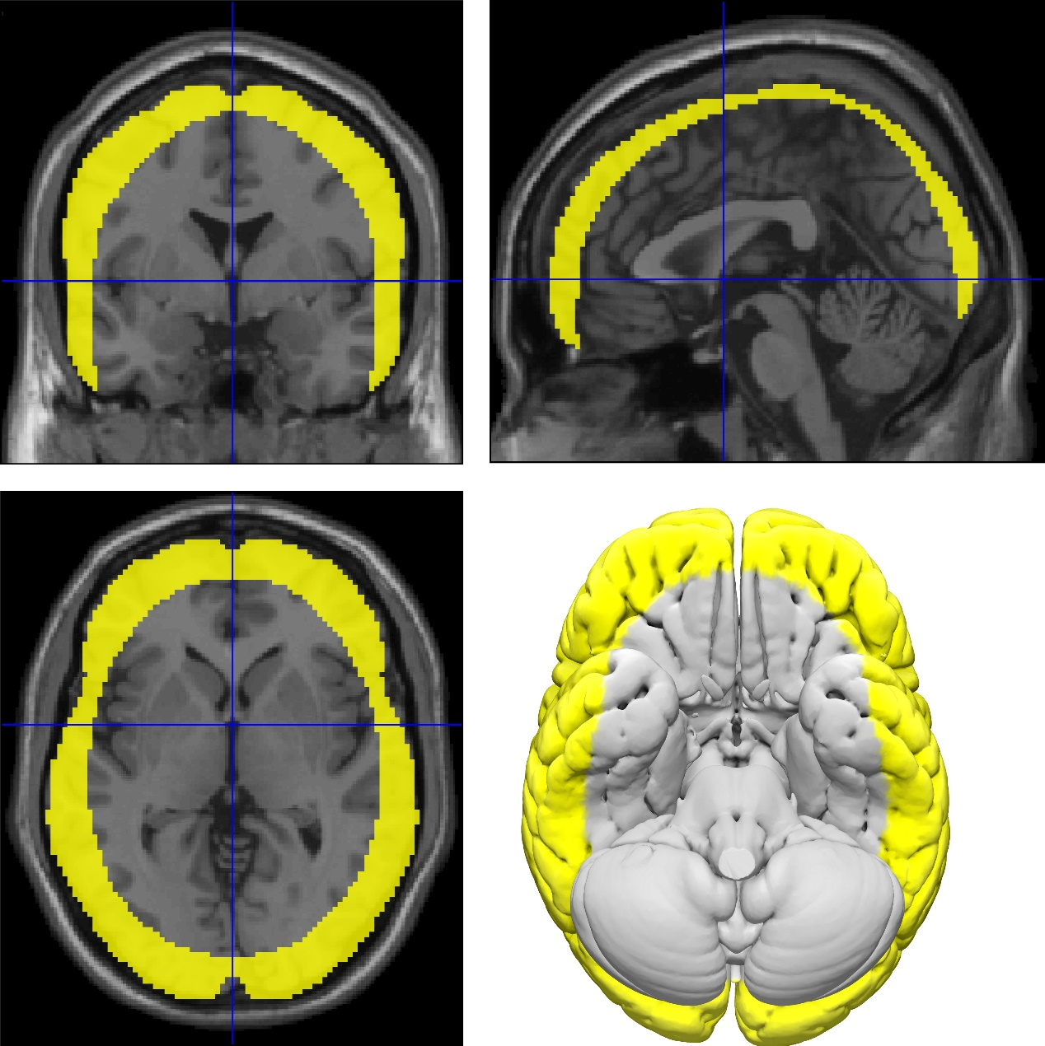
Figure S3. Brain surface mask. The brain surface mask were used to exclude brain regions not on the brain surface after group-level functional connectivity analysis.

Supplementary Material 2. Methods
Inclusion and exclusion criteria
New York University Child Study Center
Psychiatric diagnoses were based on evaluations with the Schedule of Affective Disorders and Schizophrenia for Children—Present and Lifetime Version (KSADS-PL) administered to parents and children and the Conners’ Parent Rating Scale-Revised, Long version (CPRS-LV). Intelligence was evaluated with the Wechsler Abbreviated Scale of Intelligence (WASI). Inclusion in the ADHD group required a diagnosis of ADHD based on parent and child responses to the KSADS-PL as well as on a T-score greater than or equal to 65 on at least one ADHD related index of the CPRS-R: LV. Psychostimulant drugs were withheld at least 24 hours before scanning. Inclusion criteria for TDC required absence of any Axis-I psychiatric diagnoses per parent and child KSADS-PL interview, as well as T-scores below 60 for all the CPRS-R: LV ADHD summary scales. Estimates of FSIQ above 80, right-handedness and absence of other chronic medical conditions were required for all children.

Peking University
Study participants with the diagnosis of ADHD were initially identified using the Computerized Diagnostic Interview Schedule IV (C-DIS-IV). Upon referral for participation to the study participation, all participants (ADHD and TDC) were evaluated with the Schedule of Affective Disorders and Schizophrenia for Children—Present and Lifetime Version (KSADS-PL) with one parent for the establishment of the diagnosis for study inclusion. The ADHD Rating Scale (ADHD-RS) IV was employed to provide dimensional measures of ADHD symptoms. Additional inclusion criteria included: (i) right-handedness, (ii) no lifetime history of head trauma with loss of consciousness, (iii) no history of neurological disease and no diagnosis of either schizophrenia, affective disorder, pervasive development disorder, or substance abuse and (iv) full scale Wechsler Intelligence Scale for Chinese Children-Revised (WISCC-R) score of greater than 80. Psychostimulant medications were withheld at least 48 hours prior to scanning. All research was approved by the Research Ethics Review Board of Institute of Mental Health, Peking University. Informed consent was also obtained from the parent of each subject and all of the children agreed to participate in the study.

fMRI data acquisition
Resting-state functional magnetic resonance imaging (RS-fMRI) data were acquired with a 3T Siemens Trio scanner in the Imaging Center for Brain Research, Peking University. T2-weighted functional images encompassing the whole brain were acquired with the gradient-echo echo-planar imaging sequence (echo time: 30ms, repetition time: 2000ms, flip angle: 90°, slice thickness: 3.5mm, voxel size: 3.1×3.1×3.5mm³ , slice number: 33 and volume number: 240). High-resolution brain structural images were acquired with a T1-weighted three-dimensional (3D) multi-echo magnetization-prepared rapid gradient-echo (MPRAGE) sequence (echo time: 3.39ms, repetition time: 2530ms, slice thickness 1.33mm, voxel size: 1.3×1.0×1.3mm³ (√), field of view (FOV): 256×256mm² and volume number: 128).
Simultaneously resting-state functional magnetic resonance imaging (RS-fMRI) data were acquired with a 3T Siemens Trio scanner in the Imaging Center for Brain Research, New York University Child Study Center. T2-weighted functional images encompassing the whole brain were acquired with the gradient-echo echo-planar imaging sequence (echo time: 15ms, repetition time: 2000ms, flip angle: 90°, slice thickness: 4mm, voxel size: 3.0×3.0×4.0mm³, slice number: 33 and volume number: 180). High-resolution brain structural images were acquired with a T1-weighted three-dimensional (3D) multi-echo magnetization-prepared rapid gradient-echo (MPRAGE) sequence (echo time: 3.25ms, repetition time: 2530ms, slice thickness 1.33mm, voxel size: 1.3×1.0×1.3mm³, field of view (FOV): 256×256mm² and volume number: 128).

Supplementary Material 3. Demographics of the patients included in the functional connectivity analysis
 |  | Peking | New York | P value
Sex | female | 12 | 23 | 0.994
Sex | male | 29 | 52
Age |  | 10.71±2.16 | 10.36±2.42 | 0.206
ADHD type | ADHD-Inattentive | 28 | 39
ADHD type | ADHD-Combined | 12 | 35 | 0.184
ADHD type | ADHD-Hyperactive/Impulsive | 1 | 1
Number |  | 41 | 75

Supplementary Material 4. Articles included in the meta-analysis
Year | First Author | PMID | Journal | Title
2010 | Burgess GC | 20060961 | Biological psychiatry | Attentional control activation relates to working memory in attention-deficit/hyperactivity disorder.
1999 | Bush G | 10376114 | Biological psychiatry | Anterior cingulate cortex dysfunction in attention-deficit/hyperactivity disorder revealed by fMRI and the Counting Stroop.
2008 | Castellanos FX | 17888409 | Biological psychiatry | Cingulate-precuneus interactions: a new locus of dysfunction in adult attention-deficit/hyperactivity disorder.
2012 | Chabernaud C | 21974788 | Biological psychiatry | Dimensional brain-behavior relationships in children with attention-deficit/hyperactivity disorder.
2006 | Durston S | 16712804 | Biological psychiatry | Activation in ventral prefrontal cortex is sensitive to genetic vulnerability for attention-deficit hyperactivity disorder.
2003 | Durston S | 12742674 | Biological psychiatry | Differential patterns of striatal activation in young children with and without ADHD.
2010 | Fair DA | 20728873 | Biological psychiatry | Atypical default network connectivity in youth with attention-deficit/hyperactivity disorder.
2007 | Krauel K | 17210138 | Biological psychiatry | Impact of emotional salience on episodic memory in attention-deficit/hyperactivity disorder: a functional magnetic resonance imaging study.
2013 | McLaughlin KA | 24090797 | Biological psychiatry | Widespread Reductions in Cortical Thickness Following Severe Early-Life Deprivation: A Neurodevelopmental Pathway to Attention-Deficit/Hyperactivity Disorder.
2006 | Mostofsky SH | 16139806 | Biological psychiatry | Atypical motor and sensory cortex activation in attention-deficit/hyperactivity disorder: a functional magnetic resonance imaging study of simple sequential finger tapping.
2013 | Rubia K | 24314347 | Biological psychiatry | Effects of Stimulants on Brain Function in Attention-Deficit/Hyperactivity Disorder: A Systematic Review and Meta-Analysis.
2011 | Rubia K | 21664605 | Biological psychiatry | Methylphenidate normalizes frontocingulate underactivation during error processing in attention-deficit/hyperactivity disorder.
2007 | Rubia K | 17585887 | Biological psychiatry | Temporal lobe dysfunction in medication-naive boys with attention-deficit/hyperactivity disorder during attention allocation and its relation to response variability.
2005 | Seidman LJ | 15949998 | Biological psychiatry | Structural brain imaging of attention-deficit/hyperactivity disorder.
2013 | Smith A | 23731741 | Biological psychiatry | Neurofunctional effects of methylphenidate and atomoxetine in boys with attention-deficit/hyperactivity disorder during time discrimination.
2005 | Valera EM | 15737657 | Biological psychiatry | Functional neuroanatomy of working memory in adults with attention-deficit/hyperactivity disorder.
2010 | Valera EM | 20619827 | Biological psychiatry | Neural substrates of impaired sensorimotor timing in adult attention-deficit/hyperactivity disorder.
2012 | Wong CG | 22209640 | Biological psychiatry | The effects of stimulant medication on working memory functional connectivity in attention-deficit/hyperactivity disorder.
2013 | Grant JA | 23046904 | Biological psychology | Cortical thickness, mental absorption and meditative practice: possible implications for disorders of attention.
2014 | Bhaijiwala M | 25328838 | Brain and behavior | Withholding and canceling a response in ADHD adolescents.
2009 | Dibbets P | 19201515 | Brain and cognition | Differences in feedback- and inhibition-related neural activity in adult ADHD.
2015 | Mohl B | 26188845 | Brain and cognition | Neural dysfunction in ADHD with Reading Disability during a word rhyming Continuous Performance Task.
2015 | Bottelier MA | 25563230 | Brain imaging and behavior | Effects of methylphenidate during emotional processing in amphetamine users: preliminary findings.
2017 | Uytun MC | 27738997 | Brain imaging and behavior | Default mode network activity and neuropsychological profile in male children and adolescents with attention deficit hyperactivity disorder and conduct disorder.
2017 | van der Meer D | 27738993 | Brain imaging and behavior | The interaction between 5-HTTLPR and stress exposure influences connectivity of the executive control and default mode brain networks.
2018 | Yoo JH | 28417219 | Brain imaging and behavior | Treatment effect of methylphenidate on intrinsic functional brain network in medication-naive ADHD children: A multivariate analysis.
2014 | Zhu Y | 24390655 | Brain imaging and behavior | Differences in functional activity between boys with pure oppositional defiant disorder and controls during a response inhibition task: a preliminary study.
2008 | Cao Q | 18534567 | Brain research | Alerting deficits in children with attention deficit/hyperactivity disorder: event-related fMRI evidence.
2009 | Cao X | 19699190 | Brain research | Abnormal resting-state functional connectivity patterns of the putamen in medication-naive children with attention deficit hyperactivity disorder.
2012 | Duerden EG | 22325095 | Brain research | Altered cortical morphology in sensorimotor processing regions in adolescents and adults with attention-deficit/hyperactivity disorder.
2012 | Lemiere J | 22406068 | Brain research | Brain activation to cues predicting inescapable delay in adolescent Attention Deficit/Hyperactivity Disorder: an fMRI pilot study.
2010 | Paakki JJ | 20053346 | Brain research | Alterations in regional homogeneity of resting-state brain activity in autism spectrum disorders.
2011 | Prehn-Kristensen A | 21385569 | Brain research | Methylphenidate does not improve interference control during a working memory task in young patients with attention-deficit hyperactivity disorder.
2012 | Tamm L | 22613230 | Brain research | Fluid reasoning deficits in children with ADHD: evidence from fMRI.
2012 | Siniatchkin M | 22392009 | Brain topography | Behavioural treatment increases activity in the cognitive neuronal networks in children with attention deficit/hyperactivity disorder.
2017 | Sotnikova A | 28213645 | Brain topography | Transcranial Direct Current Stimulation Modulates Neuronal Networks in Attention Deficit Hyperactivity Disorder.
2014 | Cubillo A | 23048018 | Cerebral cortex | Shared and drug-specific effects of atomoxetine and methylphenidate on inhibitory brain dysfunction in medication-naive ADHD boys.
2014 | Tomasi D | 23242198 | Cerebral cortex | Functional connectivity of substantia nigra and ventral tegmental area: maturation during adolescence and effects of ADHD.
2013 | Wang S | 23800705 | Clinical neurophysiology: official journal of the International Federation of Clinical Neurophysiology | Altered neural circuits related to sustained attention and executive control in children with ADHD: an event-related fMRI study.
2012 | Cubillo A | 21575934 | Cortex; a journal devoted to the study of the nervous system and behavior | A review of fronto-striatal and fronto-cortical brain abnormalities in children and adults with Attention Deficit Hyperactivity Disorder (ADHD) and new evidence for dysfunction in adults with ADHD du
2015 | Francx W | 26363140 | Cortex; a journal devoted to the study of the nervous system and behavior | The executive control network and symptomatic improvement in attention-deficit/hyperactivity disorder.
2016 | Ma I | 27399612 | Cortex; a journal devoted to the study of the nervous system and behavior | Ventral striatal hyperconnectivity during rewarded interference control in adolescents with ADHD.
2017 | Schulz KP | 28292705 | Cortex; a journal devoted to the study of the nervous system and behavior | Prefrontal and parietal correlates of cognitive control related to the adult outcome of attention-deficit/hyperactivity disorder diagnosed in childhood.
2012 | Gilsbach S | 22727763 | Developmental cognitive neuroscience | Effects of the DRD4 genotype on neural networks associated with executive functions in children and adolescents.
2015 | Somandepalli K | 26365788 | Developmental cognitive neuroscience | Short-term test-retest reliability of resting state fMRI metrics in children with and without attention-deficit/hyperactivity disorder.
2012 | Bechtel N | 22242637 | Epilepsia | Attention-deficit/hyperactivity disorder in childhood epilepsy: a neuropsychological and functional imaging study.
2010 | Karch S | 19907927 | European archives of psychiatry and clinical neuroscience | Neural correlates (ERP/fMRI) of voluntary selection in adult ADHD patients.
2013 | Ko CH | 23645101 | European archives of psychiatry and clinical neuroscience | Brain activation deficit in increased-load working memory tasks among adults with ADHD using fMRI.
2015 | Chou TL | 26409297 | European neuropsychopharmacology : the journal of the European College of Neuropsychopharmacology | Differential therapeutic effects of 12-week treatment of atomoxetine and methylphenidate on drug-naive children with attention deficit/hyperactivity disorder: A counting Stroop functional MRI study.
2013 | Costa Dias TG | 23206930 | European neuropsychopharmacology : the journal of the European College of Neuropsychopharmacology | Reward circuit connectivity relates to delay discounting in children with attention-deficit/hyperactivity disorder.
2013 | Hoogman M | 22749356 | European neuropsychopharmacology : the journal of the European College of Neuropsychopharmacology | The dopamine transporter haplotype and reward-related striatal responses in adult ADHD.
2011 | Schlochtermeier L | 20570115 | European neuropsychopharmacology : the journal of the European College of Neuropsychopharmacology | Childhood methylphenidate treatment of ADHD and response to affective stimuli.
2013 | Schweren LJ | 23165220 | European neuropsychopharmacology : the journal of the European College of Neuropsychopharmacology | MR imaging of the effects of methylphenidate on brain structure and function in attention-deficit/hyperactivity disorder.
2015 | Villemonteix T | 25934396 | European neuropsychopharmacology : the journal of the European College of Neuropsychopharmacology | Grey matter volumes in treatment naive vs. chronically treated children with attention deficit/hyperactivity disorder: a combined approach.
2017 | Cherkasova MV | 28878639 | Frontiers in human neuroscience | Differential Associations between Cortical Thickness and Striatal Dopamine in Treatment-Naive Adults with ADHD vs. Healthy Controls.
2017 | Qureshi MNI | 28420972 | Frontiers in human neuroscience | Multi-modal, Multi-measure, and Multi-class Discrimination of ADHD with Hierarchical Feature Extraction and Extreme Learning Machine Using Structural and Functional Brain MRI.
2014 | Xia S | 24688465 | Frontiers in human neuroscience | Topological organization of the "small-world" visual attention network in children with attention deficit/hyperactivity disorder (ADHD).
2017 | Wang JB | 28634439 | Frontiers in neuroscience | Inconsistency in Abnormal Brain Activity across Cohorts of ADHD-200 in Children with Attention Deficit Hyperactivity Disorder.
2012 | Dey S | 23162440 | Frontiers in systems neuroscience | Exploiting the brain's network structure in identifying ADHD subjects.
2013 | Hart H | 24123508 | Human brain mapping | Pattern classification of response inhibition in ADHD: Toward the development of neurobiological markers for ADHD.
2010 | Hoekzema E | 20336653 | Human brain mapping | Enhanced neural activity in frontal and cerebellar circuits after cognitive training in children with attention-deficit/hyperactivity disorder.
2010 | Rubia K | 19777552 | Human brain mapping | Disorder-specific dysfunction in right inferior prefrontal cortex during two inhibition tasks in boys with attention-deficit hyperactivity disorder compared to boys with obsessive-compulsive disorder.
2011 | Rubia K | 21391250 | Human brain mapping | Disorder-specific dysfunctions in patients with attention-deficit/hyperactivity disorder compared to patients with obsessive-compulsive disorder during interference inhibition and attention allocation
2009 | Silk TJ | 19107752 | Human brain mapping | White-matter abnormalities in attention deficit hyperactivity disorder: a diffusion tensor imaging study.
2015 | Tegelbeckers J | 25648705 | Human brain mapping | Altered salience processing in attention deficit hyperactivity disorder.
2009 | Wolf RC | 19107748 | Human brain mapping | Regional brain activation changes and abnormal functional connectivity of the ventrolateral prefrontal cortex during working memory processing in adults with attention-deficit/hyperactivity disorder.
2014 | Wu YH | 22936578 | Human brain mapping | White matter tract integrity of frontostriatal circuit in attention deficit hyperactivity disorder: association with attention performance and symptoms.
2017 | Chang K | 28667891 | Journal of affective disorders | Anomalous prefrontal-limbic activation and connectivity in youth at high-risk for bipolar disorder.
2017 | Hafeman D | 27756046 | Journal of affective disorders | Amygdala-prefrontal cortical functional connectivity during implicit emotion processing differentiates youth with bipolar spectrum from youth with externalizing disorders.
2013 | Townsend JD | 23057969 | Journal of affective disorders | Frontostriatal neuroimaging findings differ in patients with bipolar disorder who have or do not have ADHD comorbidity.
2010 | Bedard AC | 20026227 | NeuroImage | Dopamine transporter gene variation modulates activation of striatum in youth with ADHD.
2015 | Khundrakpam BS | 25731999 | NeuroImage | Prediction of brain maturity based on cortical thickness at different spatial resolutions.
2008 | O'Gorman RL | 18511306 | NeuroImage | Increased cerebral perfusion in adult attention deficit hyperactivity disorder is normalised by stimulant treatment: a non-invasive MRI pilot study.
2018 | O'Halloran L | 29274748 | NeuroImage | Neural circuitry underlying sustained attention in healthy adolescents and in ADHD symptomatology.
2008 | Strohle A | 17996464 | NeuroImage | Reward anticipation and outcomes in adult males with attention-deficit/hyperactivity disorder.
2015 | Takeuchi H | 25659462 | NeuroImage | Cognitive and neural correlates of the 5-repeat allele of the dopamine D4 receptor gene in a population lacking the 7-repeat allele.
2012 | Wilbertz G | 22197790 | NeuroImage | Orbitofrontal reward sensitivity and impulsivity in adult attention deficit hyperactivity disorder.
2015 | Barber AD | 25610768 | NeuroImage. Clinical | Connectivity supporting attention in children with attention deficit hyperactivity disorder.
2015 | Hwang S | 26640766 | NeuroImage. Clinical | Executive attention control and emotional responding in attention-deficit/hyperactivity disorder--A functional MRI study.
2016 | McLeod KR | 27419066 | NeuroImage. Clinical | Atypical within- and between-hemisphere motor network functional connections in children with developmental coordination disorder and attention-deficit/hyperactivity disorder.
2017 | Norman LJ | 28529874 | NeuroImage. Clinical | Shared and disorder-specific task-positive and default mode network dysfunctions during sustained attention in paediatric Attention-Deficit/Hyperactivity Disorder and obsessive/compulsive disorder.
2015 | van Rooij D | 25610797 | NeuroImage. Clinical | Altered neural connectivity during response inhibition in adolescents with attention-deficit/hyperactivity disorder and their unaffected siblings.
2017 | Wang T | 28275544 | NeuroImage. Clinical | Polygenic risk for five psychiatric disorders and cross-disorder and disorder-specific neural connectivity in two independent populations.
2011 | Stark R | 21163276 | Neuropsychologia | ADHD related behaviors are associated with brain activation in the reward system.
2015 | He N | 26049007 | Neuroscience letters | Neuroanatomical deficits correlate with executive dysfunction in boys with attention deficit hyperactivity disorder.
2006 | Tian L | 16510242 | Neuroscience letters | Altered resting-state functional connectivity patterns of anterior cingulate cortex in adolescents with attention deficit hyperactivity disorder.
2015 | He N | 26049007 | Neuroscience letters | Neuroanatomical deficits correlate with executive dysfunction in boys with attention deficit hyperactivity disorder.
2014 | Saute R | 24760032 | PloS one | Brain morphology in children with epilepsy and ADHD.
2012 | Massat I | 23166657 | PloS one | Working memory-related functional brain patterns in never medicated children with ADHD.
2013 | Lim L | 23696841 | PloS one | Disorder-specific predictive classification of adolescents with attention deficit hyperactivity disorder (ADHD) relative to autism using structural magnetic resonance imaging.
2012 | Hoekzema E | 23239964 | PloS one | Laminar thickness alterations in the fronto-parietal cortical mantle of patients with attention-deficit/hyperactivity disorder.
2014 | Gates KM | 24642753 | PloS one | Organizing heterogeneous samples using community detection of GIMME-derived resting state functional networks.
2014 | Furukawa E | 24586543 | PloS one | Abnormal striatal BOLD responses to reward anticipation and reward delivery in ADHD.
2011 | Fassbender C | 22102882 | PloS one | Working memory in attention deficit/hyperactivity disorder is characterized by a lack of specialization of brain function.
2014 | Boecker R | 25118701 | PloS one | Impact of early life adversity on reward processing in young adults: EEG-fMRI results from a prospective study over 25 years.
2016 | Jia T | 27001827 | Proceedings of the National Academy of Sciences of the United States of America | Neural basis of reward anticipation and its genetic determinants.
2015 | van Ewijk H | 26190554 | Psychiatry research | Neural correlates of visuospatial working memory in attention-deficit/hyperactivity disorder and healthy controls.
2012 | Sun L | 22424873 | Psychiatry research | Abnormal functional connectivity between the anterior cingulate and the default mode network in drug-naive boys with attention deficit hyperactivity disorder.
2013 | Sokunbi MO | 24183857 | Psychiatry research | Resting state fMRI entropy probes complexity of brain activity in adults with ADHD.
2012 | Sebastian A | 22475505 | Psychiatry research | Neural correlates of interference inhibition, action withholding and action cancelation in adult ADHD.
2015 | Schwarz NF | 26459074 | Psychiatry research | Antisaccade-related brain activation in children with attention-deficit/hyperactivity disorder--A pilot study.
2010 | Schneider MF | 20558047 | Psychiatry research | Impairment of fronto-striatal and parietal cerebral networks correlates with attention deficit hyperactivity disorder (ADHD) psychopathology in adults - a functional magnetic resonance imaging (fMRI).
2011 | Posner J | 21778039 | Psychiatry research | The attenuation of dysfunctional emotional processing with stimulant medication: an fMRI study of adolescents with ADHD.
2014 | Poissant H | 25443178 | Psychiatry research | Intergenerational transmission of fronto-parietal dysfunction during forethought in attention deficit/hyperactivity disorder: a pilot study.
2010 | Passarotti AM | 19926457 | Psychiatry research | Neural correlates of response inhibition in pediatric bipolar disorder and attention deficit hyperactivity disorder.
2011 | Mulligan RC | 21937201 | Psychiatry research | Neural correlates of inhibitory control in adult attention deficit/hyperactivity disorder: evidence from the Milwaukee longitudinal sample.
2007 | McAlonan GM | 17291727 | Psychiatry research | Mapping brain structure in attention deficit-hyperactivity disorder: a voxel-based MRI study of regional grey and white matter volume.
2012 | Liu J | 22285718 | Psychiatry research | Sex differences in anterior cingulate cortex activation during impulse inhibition and behavioral correlates.
2010 | Kobel M | 20702071 | Psychiatry research | Structural and functional imaging approaches in attention deficit/hyperactivity disorder: does the temporal lobe play a key role?
2012 | Ivanov I | 22386967 | Psychiatry research | Parental substance abuse and function of the motivation and behavioral inhibition systems in drug-naive youth.
2010 | Depue BE | 20399622 | Psychiatry research | Symptom-correlated brain regions in young adults with combined-type ADHD: their organization, variability, and relation to behavioral performance.
2010 | Davenport ND | 20153608 | Psychiatry research | Differential fractional anisotropy abnormalities in adolescents with ADHD or schizophrenia.
2014 | Congdon E | 24581734 | Psychiatry research | Neural activation during response inhibition in adult attention-deficit/hyperactivity disorder: preliminary findings on the effects of medication and symptom severity.
2013 | Bush G | 23146254 | Psychiatry research | Atomoxetine increases fronto-parietal functional MRI activation in attention-deficit/hyperactivity disorder: a pilot study.
2011 | Brown AB | 21596533 | Psychiatry research | Relationship of DAT1 and adult ADHD to task-positive and task-negative working memory networks.
2015 | Batty MJ | 26190555 | Psychiatry research | Morphological abnormalities in prefrontal surface area and thalamic volume in attention deficit/hyperactivity disorder.
2016 | Veroude K | 27564545 | Psychiatry research. Neuroimaging | The link between callous-unemotional traits and neural mechanisms of reward processing: An fMRI study.
2017 | Norman LJ | 28988149 | Psychiatry research. Neuroimaging | Neural dysfunction during temporal discounting in paediatric Attention-Deficit/Hyperactivity Disorder and Obsessive-Compulsive Disorder.
2011 | Stoy M | 21298512 | Psychopharmacology | Reward processing in male adults with childhood ADHD--a comparison between drug-naive and methylphenidate-treated subjects.
2015 | Chantiluke K | 25533997 | Psychopharmacology | Inverse fluoxetine effects on inhibitory brain activation in non-comorbid boys with ADHD and with ASD.
2010 | Konrad A | 20374289 | The European journal of neuroscience | Disturbed structural connectivity is related to inattention and impulsivity in adult attention deficit hyperactivity disorder.
2014 | Kessler D | 25505309 | The Journal of neuroscience : the official journal of the Society for Neuroscience | Modality-spanning deficits in attention-deficit/hyperactivity disorder in functional networks, gray matter, and white matter.
2012 | Cocchi L | 23223295 | The Journal of neuroscience : the official journal of the Society for Neuroscience | Altered functional brain connectivity in a non-clinical sample of young adults with attention-deficit/hyperactivity disorder.

