Supplementary Figure

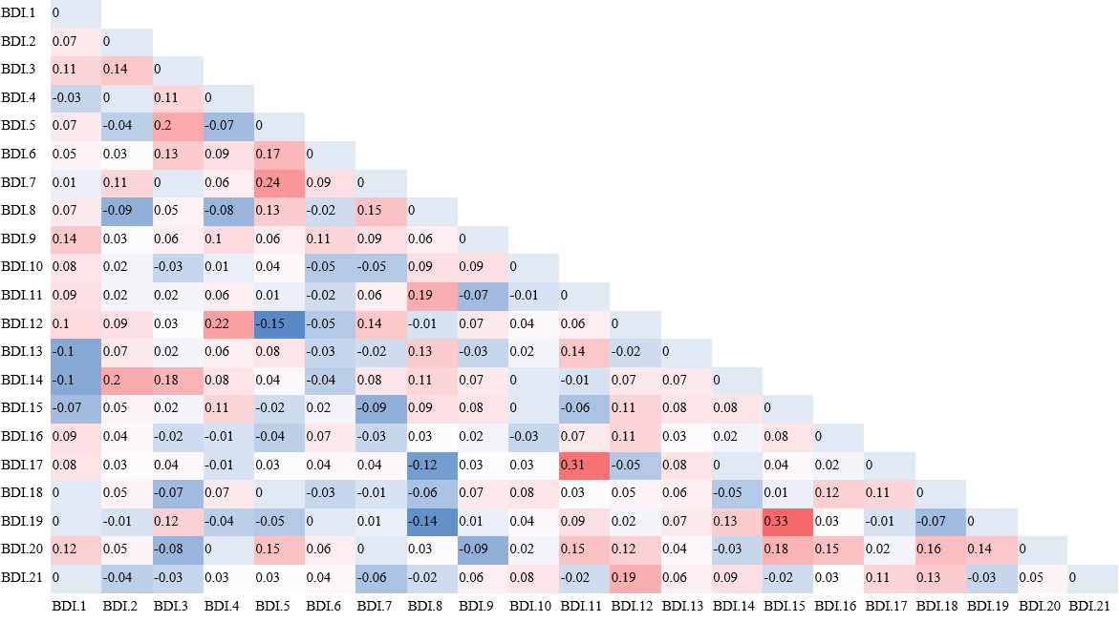
Supplementary Figure 1. Weighted adjacency matrix. Abbreviation: BDI.1, sadness; BDI.2, pessimism; BDI.3, past failure; BDI.4, loss of pleasure; BDI.5, guilty feelings; BDI.6, punishment feelings; BDI.7, self-dislike; BDI.8, self-criticalness; BDI.9, suicidal thoughts or wishes; BDI.10, crying; BDI.11,agitation; BDI.12, loss of interest; BDI.13, indecisiveness; BDI.14, worthlessness; BDI.15, loss of energy; BDI.16, changes in sleep pattern; BDI.17, irritability; BDI.18, changes in appetite; BDI.19, concentration difficulty; BDI.20, tiredness/fatigue; BDI.21, loss of interest in sex.

Supplementary Figure 2. Edge accuracy plot depicting 95% confidence obtained from bootstrap samples. The black line, red line, and gray shaded area show the bootstrap mean, sample values, and their bootstrapped confidence intervals, respectively. Each horizontal line represents an edge of the network, ordered from the highest edge-weights to the lowest ones. Only differences in edge-weights at the extremes differ significantly from each other.

Supplementary Figure 3. Bootstrapped difference test for edge weights.

Supplementary Table
Supplementary Table 1. Centrality indices of network in SD young adults.
Item No. | BDI-II item | Str | Clo | Bet
BDI.1 | Sadness | -0.38 | -0.22 | -0.49
BDI.2 | Pessimism | 0.33 | 0.32 | -0.49
BDI.3 | Past failure | 0.54 | 0.45 | 0.15
BDI.4 | Loss of pleasure | -0.01 | 0.00 | -0.49
BDI.5 | Guilty feelings | -0.48 | -0.46 | -0.16
BDI.6 | Punishment feelings | -0.39 | -0.47 | -0.49
BDI.7 | Self-dislike | -0.27 | -0.49 | -0.49
BDI.8 | Self-criticalness | -1.79 | -1.55 | -0.49
BDI.9 | Suicidal thoughts or wishes | 0.20 | 0.28 | -0.16
BDI.10 | Crying | -1.57 | -1.66 | -0.49
BDI.11 | Agitation | 1.31 | 1.36 | 1.77
BDI.12 | Loss of interest | 2.09 | 2.27 | 2.74
BDI.13 | Indecisiveness | -0.13 | -0.13 | -0.49
BDI.14 | Worthlessness | 0.67 | 0.57 | 0.15
BDI.15 | Loss of energy | 0.99 | 0.72 | -0.49
BDI.16 | Changes in sleep pattern | 0.18 | 0.05 | -0.49
BDI.17 | Irritability | 0.10 | 0.27 | -0.49
BDI.18 | Changes in appetite | -1.24 | -1.05 | -0.49
BDI.19 | Concentration difficulty | -0.55 | -0.70 | -0.49
BDI.20 | Tiredness/fatigue | 1.56 | 1.61 | 2.41
BDI.21 | Loss of interest in sex | -1.14 | -1.19 | -0.49
Abbreviation: Str, Strength; Clo, Closeness; Bet, Betweenness.

Supplementary Table 2. Mean and standard deviation of depressive symptoms as measured using the BDI-II by gender.
Item No. | BDI-II item | Male |  | Female |  | P-value
Item No. | BDI-II item | Mean | SD | Mean | SD | P-value
BDI.1 | Sadness | 0.90 | 0.61 | 0.88 | 0.56 | 0.94
BDI.2 | Pessimism | 1.40 | 0.85 | 1.38 | 0.88 | 0.96
BDI.3 | Past failure | 1.39 | 0.81 | 1.38 | 0.77 | 0.82
BDI.4 | Loss of pleasure | 1.27 | 1.01 | 1.28 | 0.91 | 0.76
BDI.5 | Guilty feelings | 1.02 | 0.62 | 1.04 | 0.63 | 0.58
BDI.6 | Punishment feelings | 1.44 | 1.14 | 1.41 | 1.09 | 0.84
BDI.7 | Self-dislike | 1.56 | 0.88 | 1.47 | 0.95 | 0.27
BDI.8 | Self-criticalness | 1.44 | 0.99 | 1.36 | 0.99 | 0.34
BDI.9 | Suicidal thoughts or wishes | 0.64 | 0.64 | 0.68 | 0.67 | 0.52
BDI.10 | Crying | 1.27 | 1.16 | 1.21 | 1.13 | 0.55
BDI.11 | Agitation | 1.16 | 0.77 | 1.10 | 0.77 | 0.24
BDI.12 | Loss of interest | 1.28 | 0.71 | 1.27 | 0.70 | 0.90
BDI.13 | Indecisiveness | 1.18 | 1.02 | 1.14 | 0.96 | 0.73
BDI.14 | Worthlessness | 1.41 | 0.86 | 1.34 | 0.92 | 0.21
BDI.15 | Loss of energy | 1.61 | 0.78 | 1.54 | 0.75 | 0.27
BDI.16 | Changes in sleep pattern | 1.47 | 0.82 | 1.41 | 0.82 | 0.28
BDI.17 | Irritability | 0.81 | 0.90 | 0.85 | 0.87 | 0.45
BDI.18 | Changes in appetite | 1.17 | 1.00 | 1.09 | 0.95 | 0.29
BDI.19 | Concentration difficulty | 1.24 | 0.75 | 1.27 | 0.72 | 0.66
BDI.20 | Tiredness/fatigue | 1.31 | 0.77 | 1.22 | 0.72 | 0.16
BDI.21 | Loss of interest in sex | 0.70 | 0.92 | 0.70 | 0.86 | 0.75

