SUPPLEMENTAL MATERIALS FOR:

Medial prefrontal glutamate response to acute stress is associated with social subordination in female rhesus macaques

Michael T. Treadway^{1,2*} Samantha A. Betters¹, Jessica A. Cooper², Chun-Xia Li³, Xiaodong Zhang³, Vasiliki Michopoulos^{2,3*}

¹Department of Psychology, Emory University, Atlanta, GA 30322
²Department of Psychiatry and Behavioral Sciences, Emory School of Medicine, Atlanta, GA 30322
³Emory National Primate Research Center, Atlanta, GA 30322

SUPPLEMENTAL METHODS

Biomarker Analyses: All blood samples collected were assayed using commercially prepared immunoassay kits for cortisol (Arbor Assay, K003-H1) and IL-6 (Abcam Monkey IL-6, ab242233) in the Biomarker Core Laboratory at the ENPRC. The cortisol assay had an inter- and intra-assay coefficient of variation of 9.58% and 6.22%, respectively. The IL-6 assay had an inter- and intra-assay coefficient of variation of 11.9% and 11.7%, respectively. One aliquot of plasma collected immediately following removal of animals from their social groups and prior to transportation stress was assayed for CRP (ALPCO, KR9710s). The CRP assay had an intra-assay coefficient of variation of 2.03%.

SUPPLEMENTAL RESULTS

Figure S1: Zero-order Correlations Among Behavioral Variables.

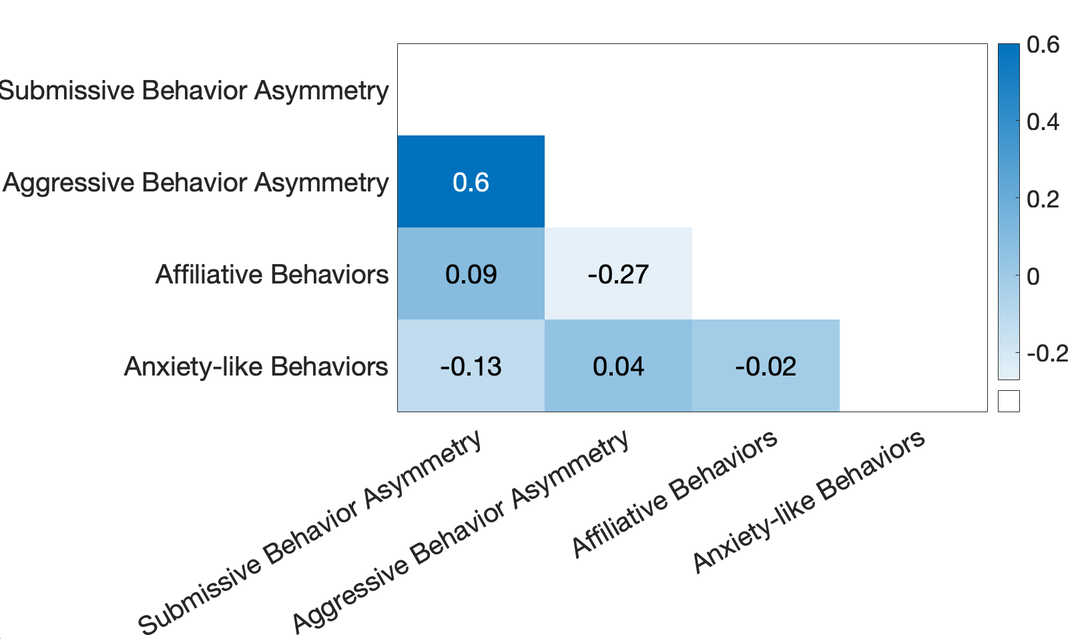

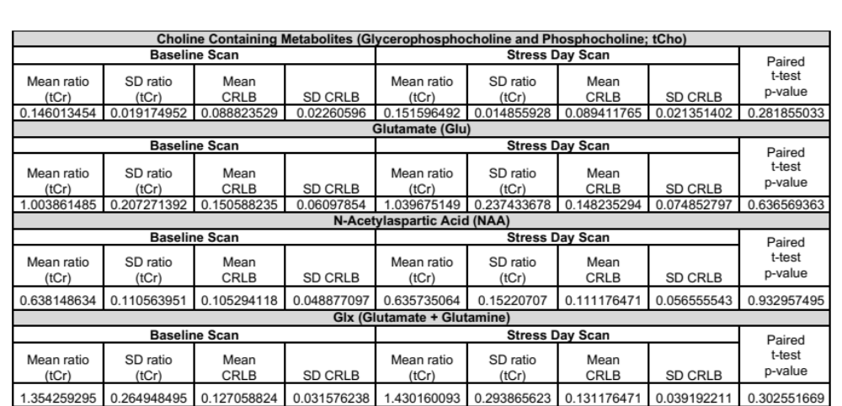
Table S1. MRS METABOLITE VALUES AND CRAMER RAO LOWER BOUNDS (CRLB)

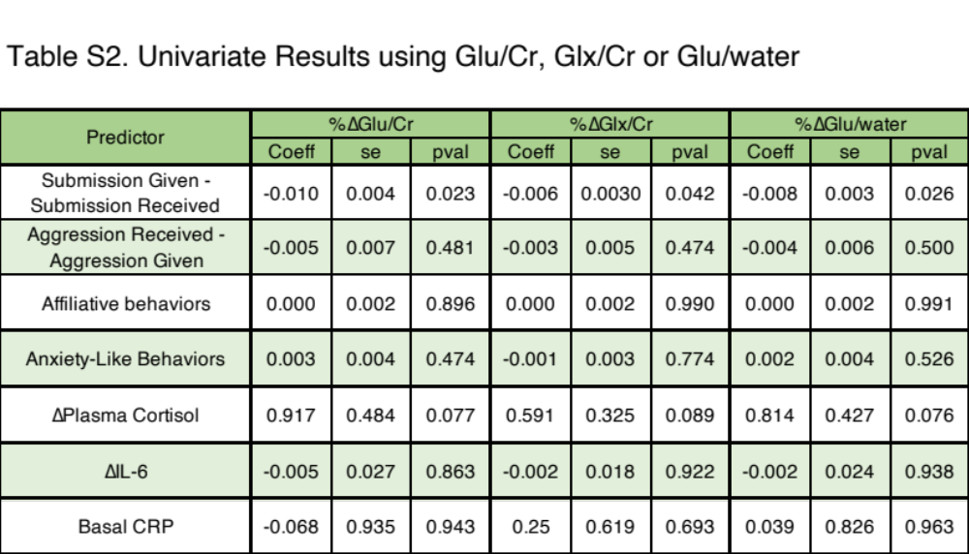

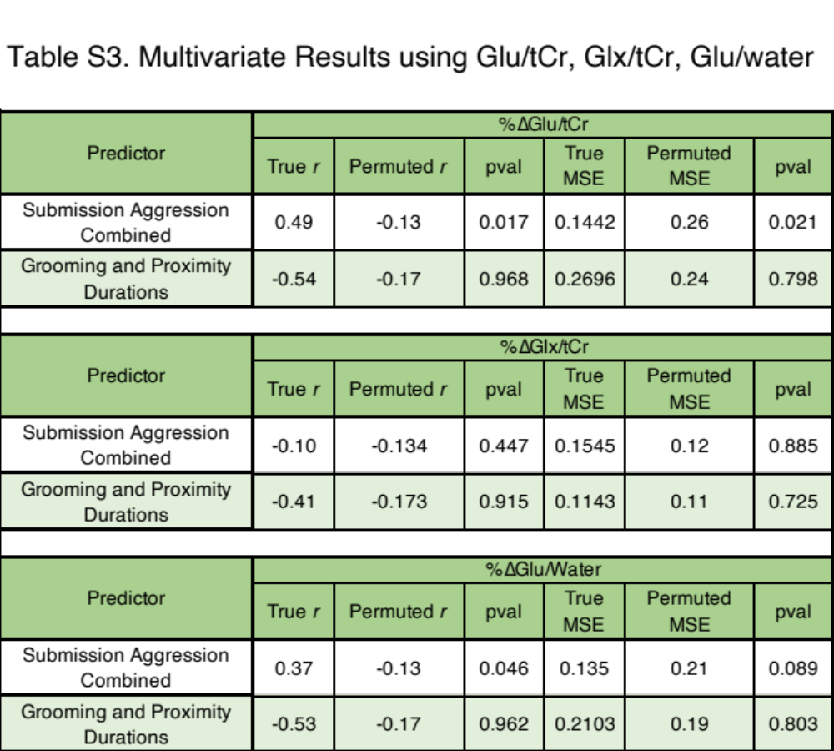

true r = Leave-one-subject-out (LOSO) cross-validated Pearson correlation between training and test data.

permuted r = Leave-one-subject-out (LOSO) cross-validated Pearson correlation between permuted training and test data.

true MSE = Leave-one-subject-out (LOSO) cross-validated mean squared error between training and test data.

permuted MSE = Leave-one-subject-out (LOSO) cross-validated mean squared error between permuted training and test data.

