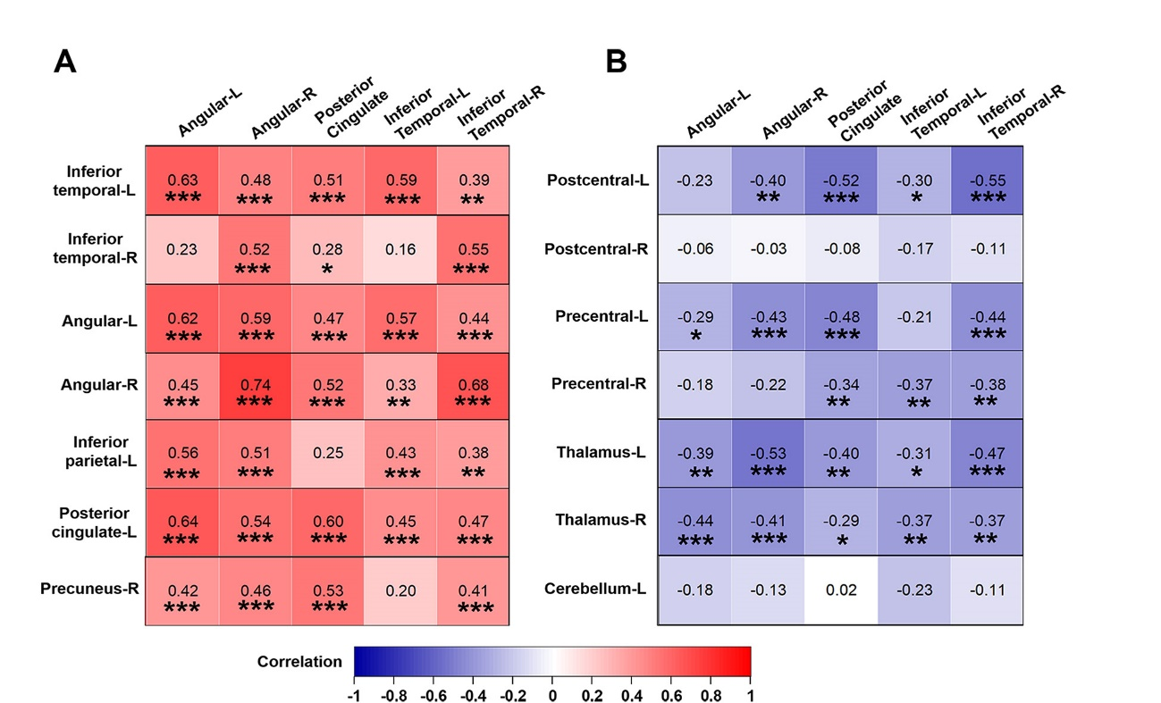
Fig.S1 Correlations between relative value of regional CBF measured with ASL and cerebral metabolism measured with FDG PET in AD patients. Correlation analysis for regions with relatively decreased CBF (A) and regions with relatively increased CBF (B) in patients with AD compared to CU controls, were conducted adjusting for age, sex and educational levels. Cool color indicated negative correlation; warm color indicated positive correlation. L = left, R = right. *P < 0.05, **P < 0.01, ***P < 0.001.
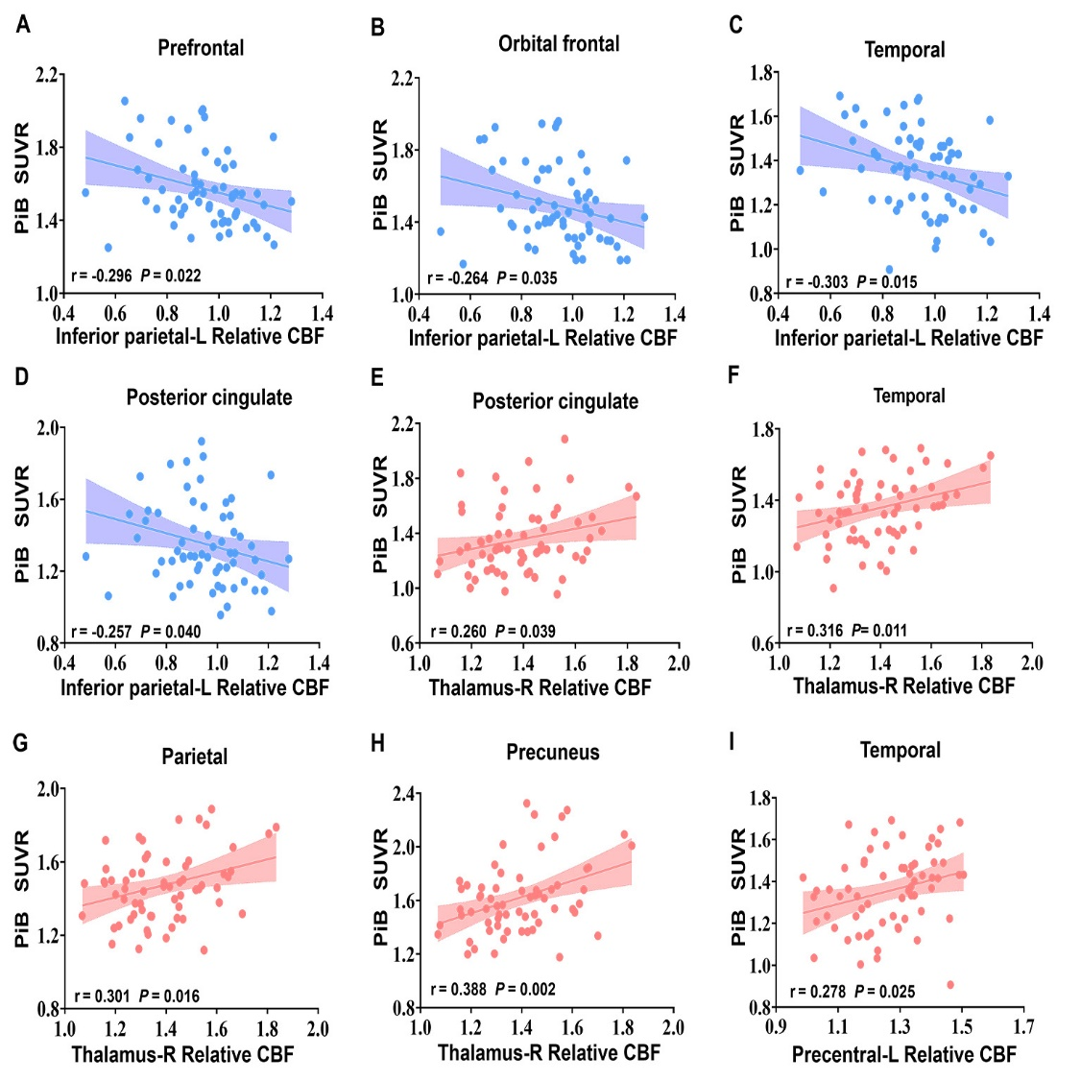
Fig.S2 Correlations between relative value of regional CBF and Aβ deposition in patients with AD. Partial correlations were used to analyze the data, with age, sex, education levels as covariates. SUVR = standardized uptake value ratio, CBF = cerebral blood flow, L = left, R = right.

