Table S1. PRISMA for Network Meta-Analyses Checklist.
Section/Topic | Item # | Checklist Item | Reported on Page #
TITLE
Title | 1 | Identify the report as a systematic review incorporating a network meta-analysis (or related form of meta-analysis). | 1
ABSTRACT
Structured summary | 2 | Provide a structured summary including, as applicable:  Background: main objectives  Methods: data sources; study eligibility criteria, participants, and interventions; study appraisal; and synthesis methods, such as network meta-analysis.  Results: number of studies and participants identified; summary estimates with corresponding confidence/credible intervals; treatment rankings may also be discussed. Authors may choose to summarize pairwise comparisons against a chosen treatment included in their analyses for brevity.  Discussion/Conclusions: limitations; conclusions and implications of findings.  Other: primary source of funding; systematic review registration number with registry name. | 3-
INTRODUCTION
Rationale | 3 | Describe the rationale for the review in the context of what is already known, including mention of why a network meta-analysis has been conducted. | 5-
Objectives | 4 | Provide an explicit statement of questions being addressed, with reference to participants, interventions, comparisons, outcomes, and study design (PICOS). | 5-
METHODS
Protocol and registration | 5 | Indicate whether a review protocol exists and if and where it can be accessed (e.g., Web address); and, if available, provide registration information, including registration number. | 7-
Eligibility criteria | 6 | Specify study characteristics (e.g., PICOS, length of follow-up) and report characteristics (e.g., years considered, language, publication status) used as criteria for eligibility, giving rationale. Clearly describe eligible treatments included in the treatment network, and note whether any have been clustered or merged into the same node (with justification). | 7-
Information sources | 7 | Describe all information sources (e.g., databases with dates of coverage, contact with study authors to identify additional studies) in the search and date last searched. | 7-
Search | 8 | Present full electronic search strategy for at least one database, including any limits used, such that it could be repeated. | 7-
Study selection | 9 | State the process for selecting studies (i.e., screening, eligibility, included in systematic review, and, if applicable, included in the meta-analysis). | 7-
Data collection process | 10 | Describe method of data extraction from reports (e.g., piloted forms, independently, in duplicate) and any processes for obtaining and confirming data from investigators. | 7-
Data items | 11 | List and define all variables for which data were sought (e.g., PICOS, funding sources) and any assumptions and simplifications made. | 7-
Geometry of the network | S1 | Describe methods used to explore the geometry of the treatment network under study and potential biases related to it. This should include how the evidence base has been graphically summarized for presentation, and what characteristics were compiled and used to describe the evidence base to readers. | 7-
Risk of bias within individual studies | 12 | Describe methods used for assessing risk of bias of individual studies (including specification of whether this was done at the study or outcome level), and how this information is to be used in any data synthesis. | 7-
Summary measures | 13 | State the principal summary measures (e.g., risk ratio, difference in means). Also describe the use of additional summary measures assessed, such as treatment rankings and surface under the cumulative ranking curve (SUCRA)* values, as well as modified approaches used to present summary findings from meta-analyses. | 7-
Planned methods of analysis | 14 | Describe the methods of handling data and combining results of studies for each network meta-analysis. This should include, but not be limited to:  - Handling of multi-arm trials;  - Selection of variance structure;  - Selection of prior distributions in Bayesian analyses; and  - Assessment of model fit. | 7-
Assessment of Inconsistency | S2 | Describe the statistical methods used to evaluate the agreement of direct and indirect evidence in the treatment network(s) studied. Describe efforts taken to address its presence when found. | 7-
Risk of bias across studies | 15 | Specify any assessment of risk of bias that may affect the cumulative evidence (e.g., publication bias, selective reporting within studies). | 7-
Additional analyses | 16 | Describe methods of additional analyses if done, indicating which were pre-specified. This may include, but not be limited to, the following:  - Sensitivity or subgroup analyses;  - Meta-regression analyses;  - Alternative formulations of the treatment network; and  - Use of alternative prior distributions for Bayesian analyses (if applicable). | 7-
RESULTS†
Study selection | 17 | Give numbers of studies screened, assessed for eligibility, and included in the review, with reasons for exclusions at each stage, ideally with a flow diagram. | 10-
Presentation of network structure | S3 | Provide a network graph of the included studies to enable visualization of the geometry of the treatment network. | 10-
Summary of network geometry | S4 | Provide a brief overview of characteristics of the treatment network. This may include commentary on the abundance of trials and randomized patients for the different interventions and pairwise comparisons in the network, gaps of evidence in the treatment network, and potential biases reflected by the network structure. | 10-
Study characteristics | 18 | For each study, present characteristics for which data were extracted (e.g., study size, PICOS, follow-up period) and provide the citations. | 10-
Risk of bias within studies | 19 | Present data on risk of bias of each study and, if available, any outcome level assessment. | 10-
Results of individual studies | 20 | For all outcomes considered (benefits or harms), present, for each study: 1) simple summary data for each intervention group, and 2) effect estimates and confidence intervals. Modified approaches may be needed to deal with information from larger networks. | 10-
Synthesis of results | 21 | Present results of each meta-analysis done, including confidence/credible intervals. In larger networks, authors may focus on comparisons versus a particular comparator (e.g. placebo or standard care), with full findings presented in an appendix. League tables and forest plots may be considered to summarize pairwise comparisons. If additional summary measures were explored (such as treatment rankings), these should also be presented. | 10-
Exploration for inconsistency | S5 | Describe results from investigations of inconsistency. This may include such information as measures of model fit to compare consistency and inconsistency models, P values from statistical tests, or summary of inconsistency estimates from different parts of the treatment network. | 10-
Risk of bias across studies | 22 | Present results of any assessment of risk of bias across studies for the evidence base being studied. | 10-
Results of additional analyses | 23 | Give results of additional analyses, if done (e.g., sensitivity or subgroup analyses, meta-regression analyses, alternative network geometries studied, alternative choice of prior distributions for Bayesian analyses, and so forth). | 10-
DISCUSSION
Summary of evidence | 24 | Summarize the main findings, including the strength of evidence for each main outcome; consider their relevance to key groups (e.g., healthcare providers, users, and policy-makers). | 14-
Limitations | 25 | Discuss limitations at study and outcome level (e.g., risk of bias), and at review level (e.g., incomplete retrieval of identified research, reporting bias). Comment on the validity of the assumptions, such as transitivity and consistency. Comment on any concerns regarding network geometry (e.g., avoidance of certain comparisons). | 14-
Conclusions | 26 | Provide a general interpretation of the results in the context of other evidence, and implications for future research. | 14-
FUNDING |  |  | 19
Funding | 27 | Describe sources of funding for the systematic review and other support (e.g., supply of data); role of funders for the systematic review. This should also include information regarding whether funding has been received from manufacturers of treatments in the network and/or whether some of the authors are content experts with professional conflicts of interest that could affect use of treatments in the network.

Table S2. Transitivity assessment.
 | Boxplot | Kruskal–Wallis equality of populations rank test.
Proportion of females (k = 8) | 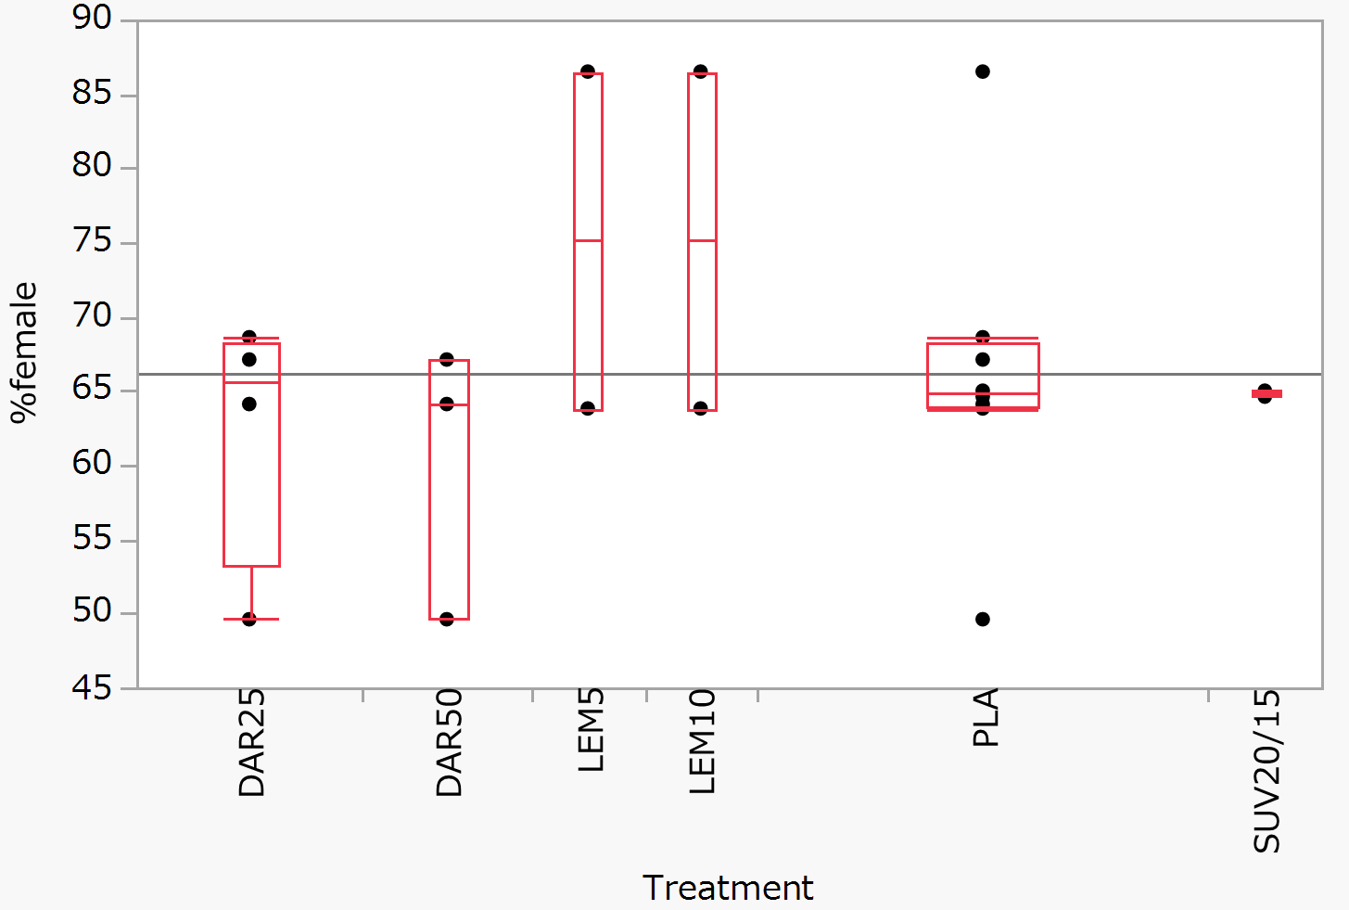 | Chi-squared with ties = 0.85 (df = 5), p = 0.974
Mean age (k = 8) | 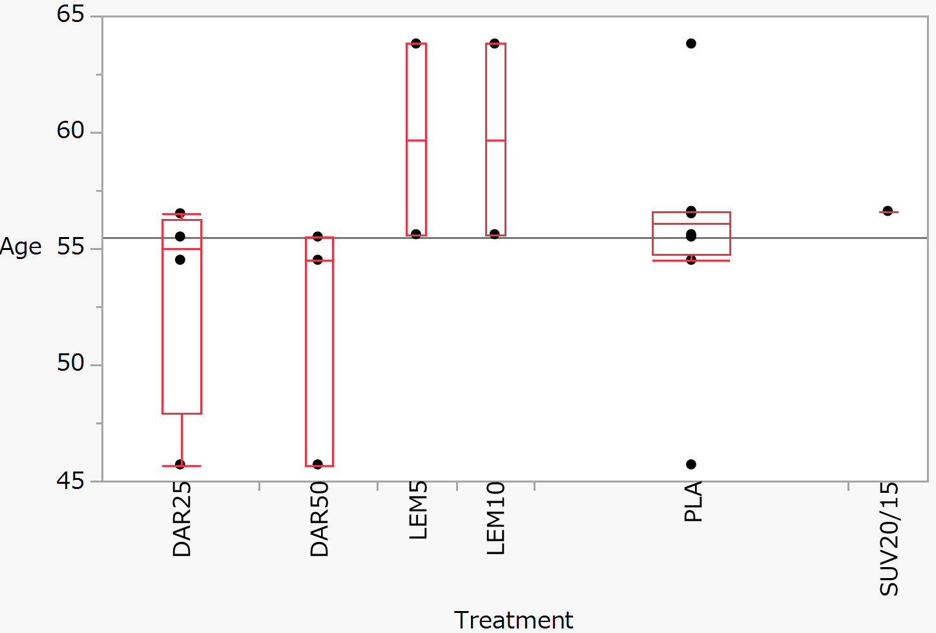 | Chi-squared with ties = 8.27 (df = 5), p = 0.142
Proportion of elderly people (aged >65 years) (k = 8) | 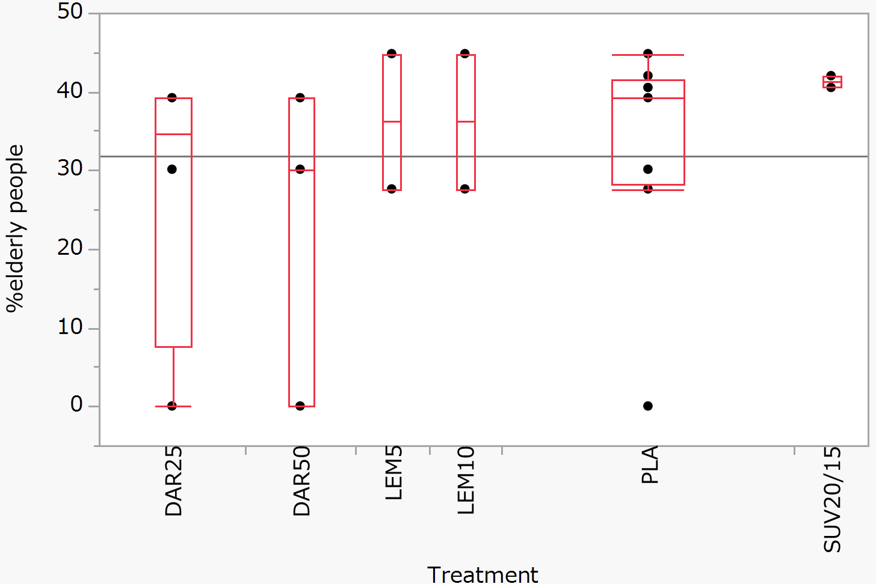 | Chi-squared with ties = 3.76 (df = 5), p = 0.585
Total number of participants (k = 8) | 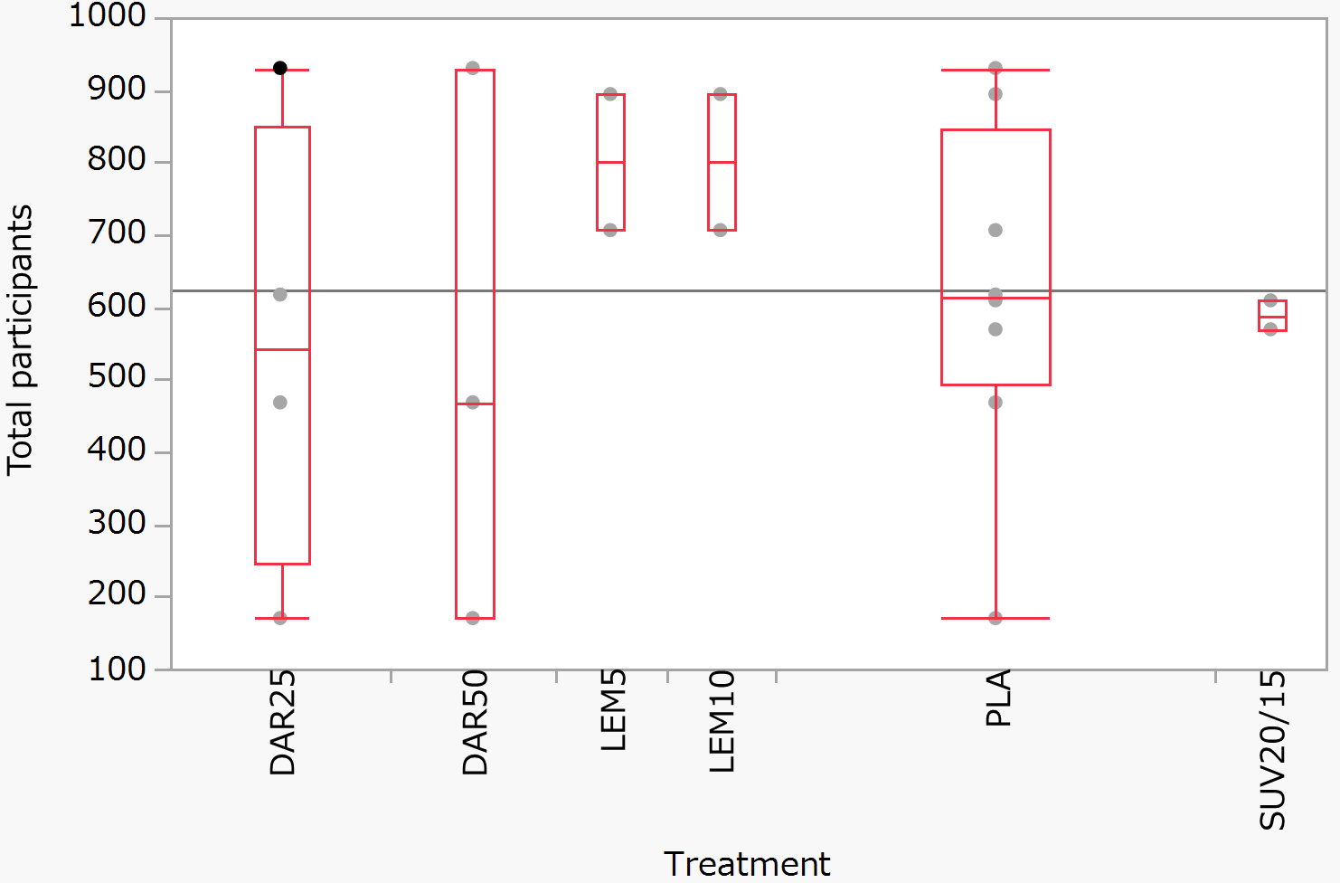 | Chi-squared with ties = 2.99 (df = 5), p = 0.702
Publication year (k = 8) | 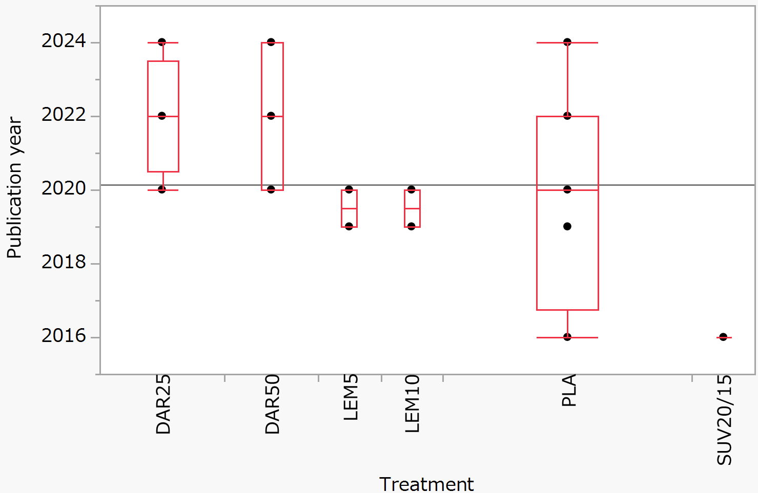 | Chi-squared with ties = 8.81 (df = 5), p = 0.117

Appendix S1. Subjective time to sleep onset at month 1
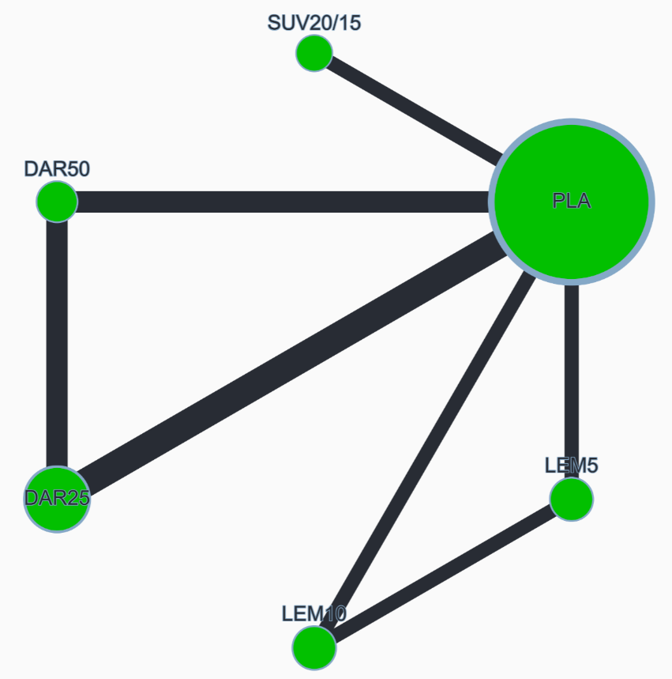
8 studies, 4963 participants

Node size by sample size
Node color by risk of bias
Green: low overall risk of bias
Edge width by number of studies

DAR25: daridorexant 25 mg/day
DAR50: daridorexant 50 mg/day
LEM5: lemborexant 5 mg/day
LEM10: lemborexant 10 mg/day
SUV20/15: suvorexant 20 mg/day (15 mg/day for people >65years)
PLA: placebo

League table (SMD with 95% CI)
DAR25 | 0.101 (-0.028, 0.229) | 0.139 (-0.036, 0.314) | 0.208 (0.032, 0.383) | -0.058 (-0.229, 0.113) | -0.222 (-0.330, -0.114)
 | DAR50 | 0.039 (-0.150, 0.227) | 0.107 (-0.082, 0.296) | -0.159 (-0.344, 0.026) | -0.323 (-0.452, -0.194)
 |  | LEM5 | 0.068 (-0.065, 0.202) | -0.198 (-0.389, -0.006) | -0.362 (-0.499, -0.224)
 |  |  | LEM10 | -0.266 (-0.457, -0.075) | -0.430 (-0.568, -0.292)
 |  |  |  | SUV20/15 | -0.164 (-0.296, -0.031)
 |  |  |  |  | PLA

Global heterogeneity
As previously suggested (Huhn 2019), the common 𝜏² was compared to the empirical distributions of heterogeneity found in the meta‐analyses of pharmacological treatments for mental health outcomes, with a median of the 𝜏² distribution of 0.049 and an inter‐quartile range of 0.010 to 0.242 (Rhodes 2015), and the heterogeneity was considered low when the estimated 𝜏² was below the 25% quartile, moderate when between 25% and 50% of the quartile, and high when above the 50% quartile.
Huhn M, et al. Lancet 2019;394(10202):939-51
Rhodes KM, et al. J Clin Epidemiol 2015;68(1):52-60
Between study variance (𝜏²): 0.002 (heterogeneity assessment: low)

Random-effects design-by-treatment interaction model
p < 0.1 was considered as considerable global inconsistency.
χ² statistic: 0.012 (1 degrees of freedom), P value: 0.912

Local heterogeneity (I²) and incoherence (SIDE test)
I² > 50% was considered as considerable heterogeneity.
As a general rule, there are “no concerns” if the p-value is >0.10, independent of the position of the 95% CIs with respect to the range of equivalence, because the evidence for incoherence is weak (p > 0.10).
Nikolakopoulou A, et al., PLOS Medicine 2020 17 1-19, Papakonstantinou T, et al., Campbell Systematic Reviews 2020 16 e1080
 | NMA SMD | Direct SMD | I² | Indirect SMD | P value (SIDE test)
DAR25 vs DAR50 | 0.101 (-0.028, 0.229) | 0.098 (-0.037, 0.233) | 32.2% | 0.131 (-0.302, 0.564) | 0.221
DAR25 vs PLA |  | -0.222(-0.330, -0.114) | 0.0%
DAR50 vs PLA | -0.323 (-0.452, -0.194) | -0.327 (-0.462, -0.191) | 0.0% | -0.287 (-0.717, 0.143) | 0.863
LEM5 vs LEM10 |  | 0.068(-0.066, 0.201) | 36.5%
LEM5 vs PLA | -0.361 (-0.499, -0.224) | -0.361 (-0.499, -0.223) | 80.2% | -0.703 (-4.792, 3.386) | 0.870
LEM10 vs PLA | -0.430 (-0.568, -0.292) | -0.435 (-0.573, -0.297) | 10.5% | 2.726 (-0.742, 6.193) | 0.074
SUV20/15 vs PLA |  | -0.164(-0.296, -0.031) | 0.0%

Funnel plot (all drugs vs. placebo)
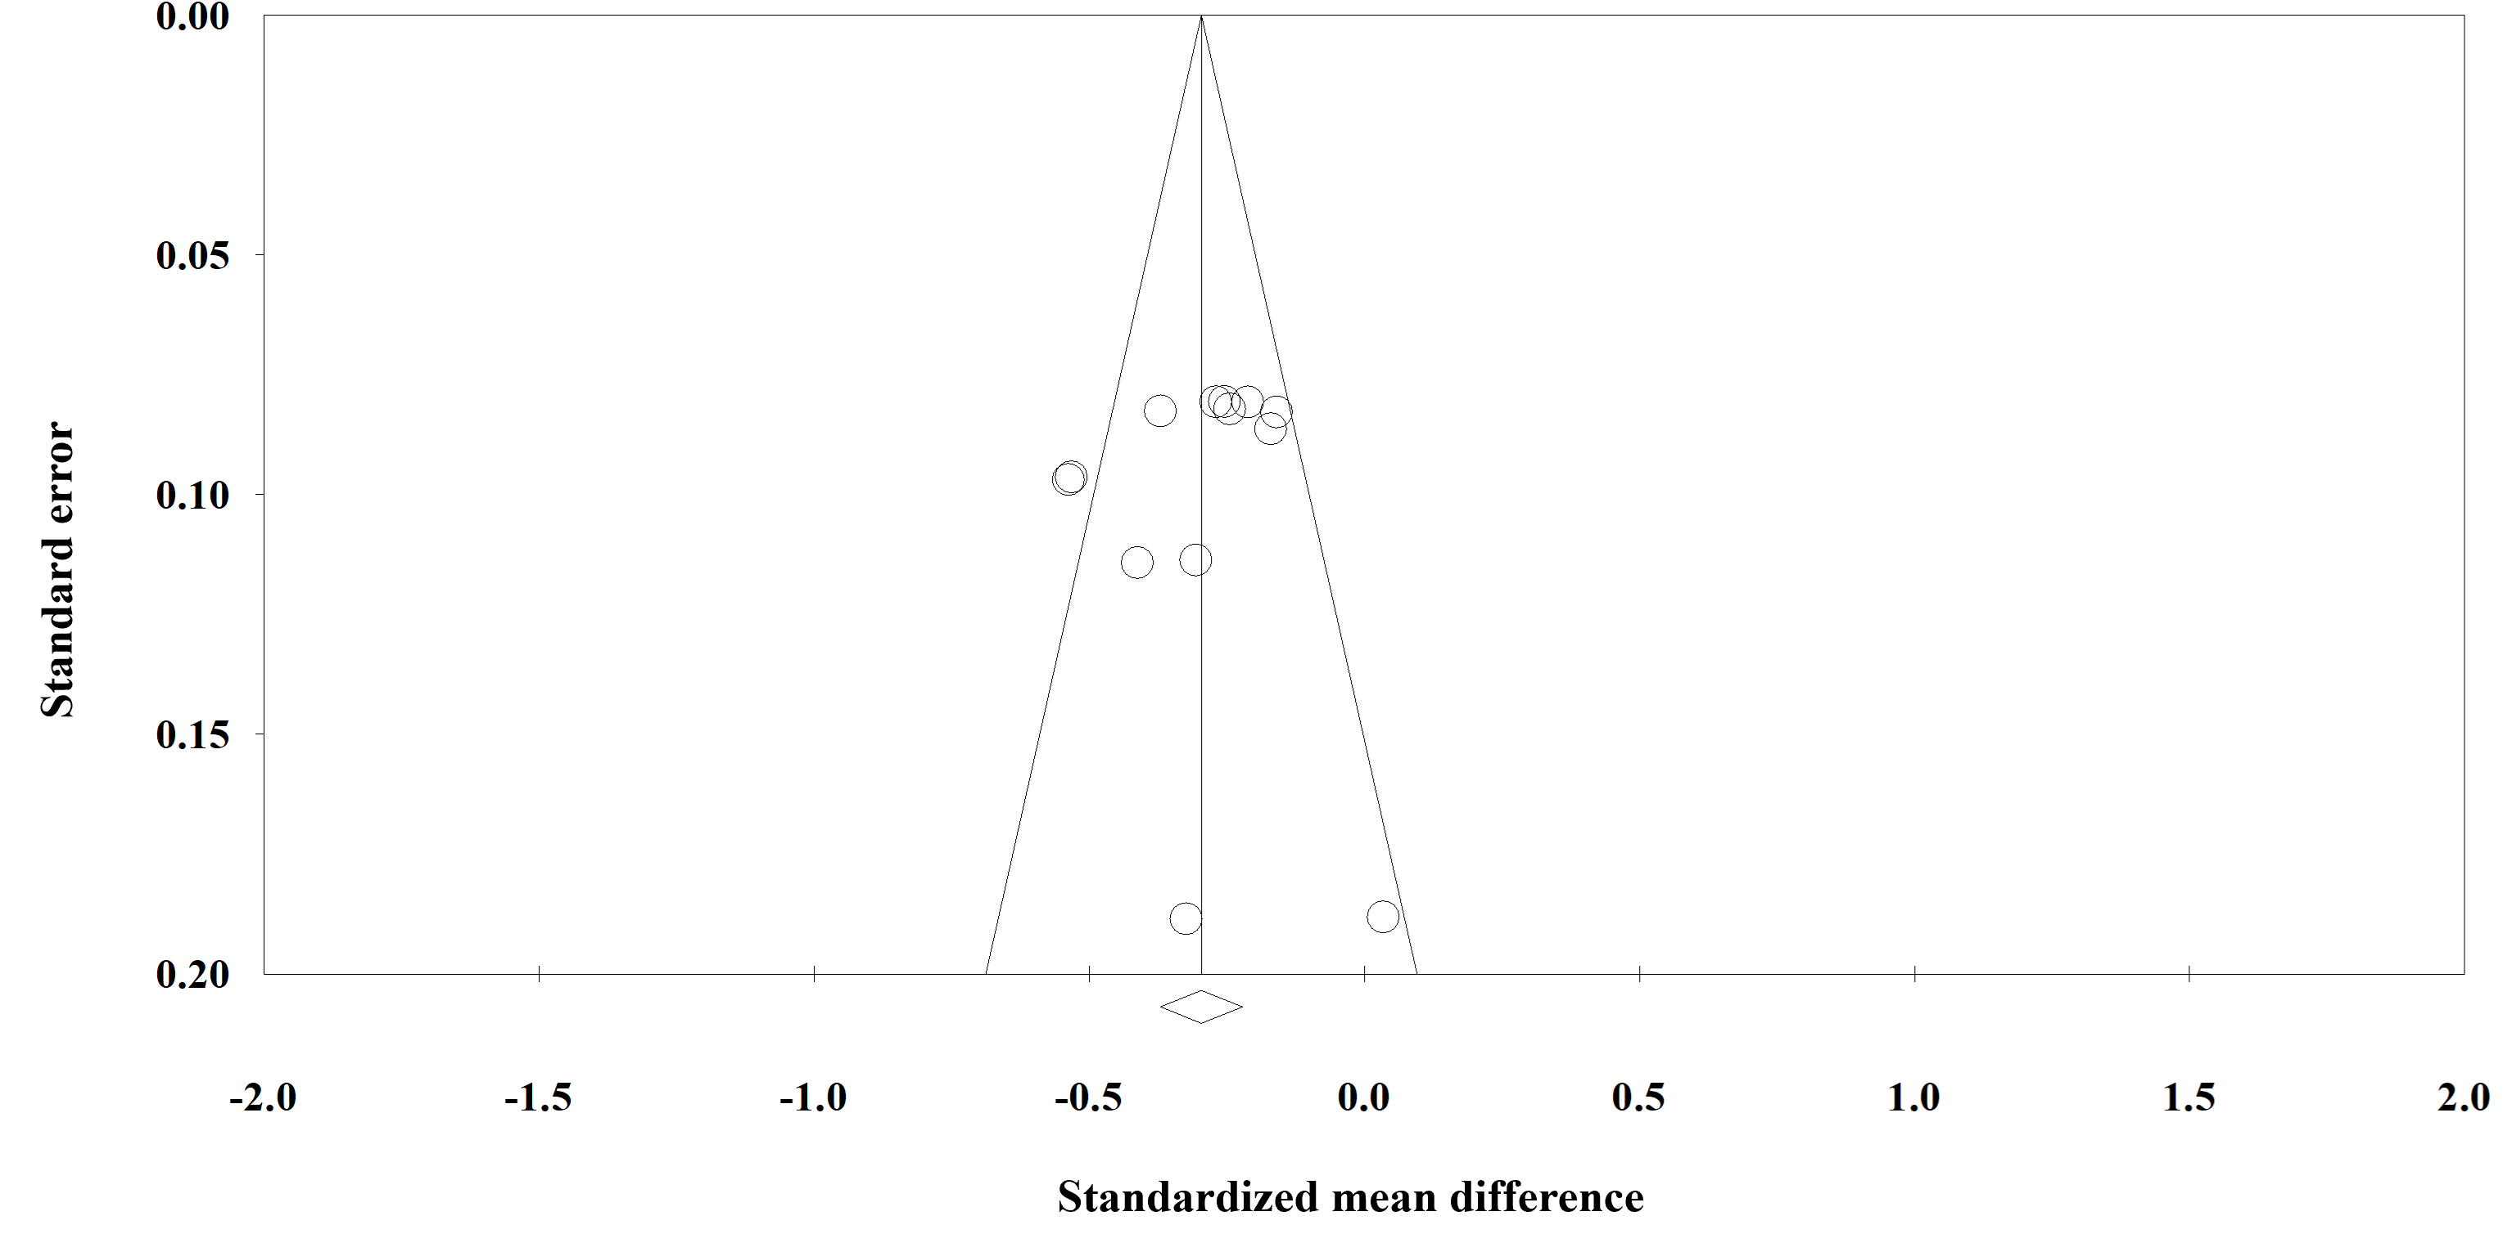

Meta-regression analysis (the placebo was the control)
Potential moderators | β (95% CrI)
Mean age (k = 8) | 0.274 (-31.169, 36.722)
Proportion of females (k = 8) | -0.166 (-25.486, 0.132)
Proportion of elderly patients (k = 8) | -0.108 (-21.259, 45.141)
Publication year (k = 8) | 0.141 (-67.445, 56.834)
Total participants (k = 8) | -0.272 (-32.257, 0.217)

CINeMA confidence rating
CINeMA is a web application that simplifies the evaluation of confidence in the findings from a network meta-analysis. CINeMA is based on a methodological framework described in the following articles, which consider the following six domains: within-study bias, reporting bias, indirectness, imprecision, heterogeneity, and incoherence. CINeMA grades the confidence in the results of each treatment comparison as high, moderate, low, or very low. If the comparison had only indirect evidence, the comparison was downgraded one level.
Nikolakopoulou A, et al., PLOS Medicine 2020 17 1-19, Papakonstantinou T, et al., Campbell Systematic Reviews 2020 16 e1080
(1) Within-study bias: Risk of bias in RCTs for the main outcomes was assessed independently using the Cochrane risk-of-bias tool for randomized trials (RoB 2). In all studies, the overall risk of bias was evaluated as “low risk.” Selected rule: Average
(2) Reporting bias: Comparison-adjusted funnel plots with less than 10 studies are not meaningful. Therefore, all comparisons were “Suspected.”
(3) Indirectness: No indirectness was assumed. Selected rule: Average
(4) Imprecision: For placebo comparisons the clinically meaningful threshold was set at a OR of higher or lower than 1. For placebo comparisons the clinically meaningful threshold was set at a SMD of higher or lower than 0. For comparisons of two active treatments the clinically meaningful threshold was set at SMDs of -0.1 and 0.1, and at ORs of 0.8 and 1.25
for dichotomous outcomes.
(5) Heterogeneity: We used recommendations automatically provided by CINeMA.
(6) Incoherence: We used recommendations automatically provided by CINeMA.
Comparison | Number of studies | Within-study bias | Reporting bias | Indirectness | Imprecision | Heterogeneity | Incoherence | Confidence rating
DAR25 vs DAR50 | 3 | No concerns | Some concerns | No concerns | Major concerns | No concerns | No concerns | Low
DAR25 vs PLA | 4 | No concerns | Some concerns | No concerns | No concerns | No concerns | No concerns | Moderate
DAR50 vs PLA | 3 | No concerns | Some concerns | No concerns | No concerns | No concerns | No concerns | Moderate
LEM5 vs LEM10 | 2 | No concerns | Some concerns | No concerns | Major concerns | No concerns | No concerns | Low
LEM5 vs PLA | 2 | No concerns | Some concerns | No concerns | No concerns | No concerns | No concerns | Moderate
LEM10 vs PLA | 2 | No concerns | Some concerns | No concerns | No concerns | No concerns | Major concerns | Low
SUV20/15 vs PLA | 2 | No concerns | Some concerns | No concerns | No concerns | Major concerns | No concerns | Low
DAR25 vs LEM5 | 0 | No concerns | Some concerns | No concerns | Major concerns | No concerns | No concerns | High
DAR25 vs LEM10 | 0 | No concerns | Some concerns | No concerns | No concerns | Major concerns | No concerns | High
DAR25 vs SUV20/15 | 0 | No concerns | Some concerns | No concerns | Major concerns | No concerns | No concerns | High
DAR50 vs LEM5 | 0 | No concerns | Some concerns | No concerns | Major concerns | No concerns | No concerns | High
DAR50 vs LEM10 | 0 | No concerns | Some concerns | No concerns | Major concerns | No concerns | No concerns | High
DAR50 vs SUV20/15 | 0 | No concerns | Some concerns | No concerns | Major concerns | No concerns | No concerns | High
LEM5 vs SUV20/15 | 0 | No concerns | Some concerns | No concerns | No concerns | Major concerns | No concerns | High
LEM10 vs SUV20/15 | 0 | No concerns | Some concerns | No concerns | No concerns | No concerns | No concerns | Low

Appendix S2. Subjective total sleep time at month 1
8 studies, 4855 participants
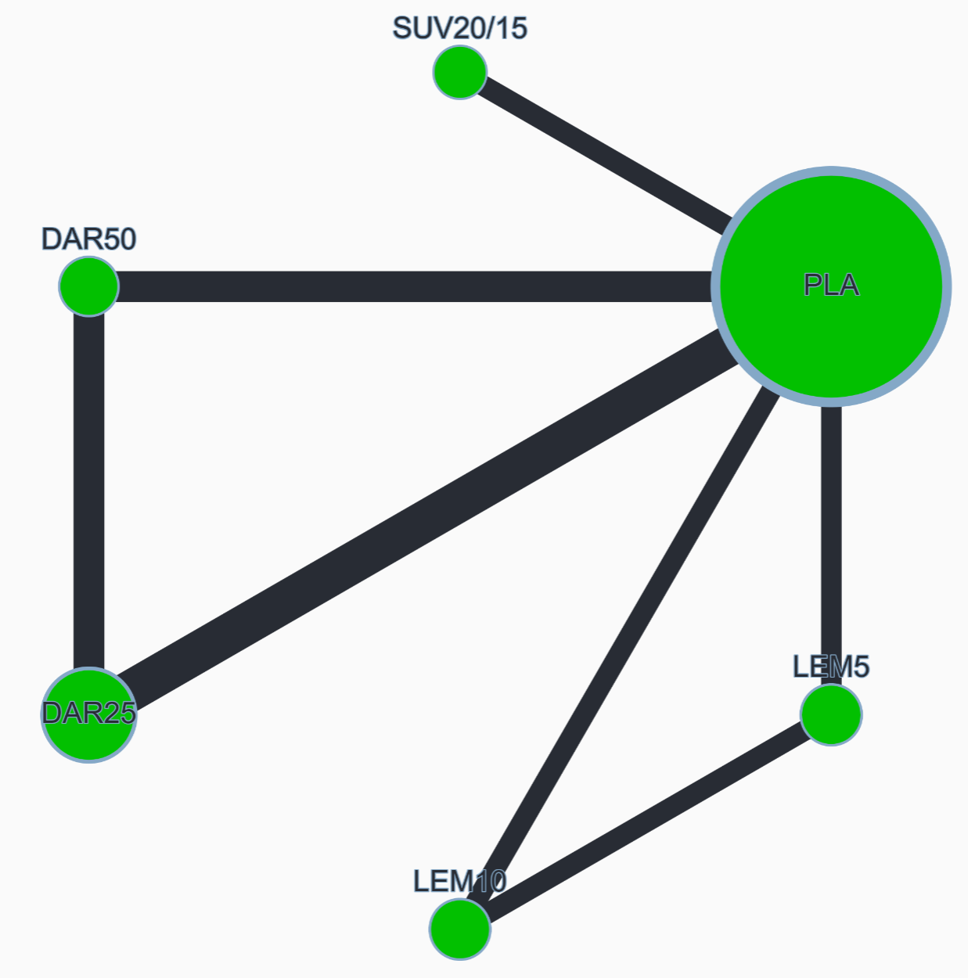

League table (SMD with 95% CI)
DAR25 | 0.199 (0.082, 0.316) | -0.070 (-0.228, 0.088) | 0.152 (-0.008, 0.310) | 0.071 (-0.082, 0.224) | -0.276 (-0.374, -0.178)
 | DAR50 | -0.269 (-0.440, -0.098) | -0.047 (-0.219, 0.125) | -0.128 (-0.295, 0.038) | -0.475 (-0.593, -0.357)
 |  | LEM5 | 0.221 (0.100, 0.342) | 0.141 (-0.030, 0.312) | -0.206 (-0.330, -0.082)
 |  |  | LEM10 | -0.081 (-0.253, 0.091) | -0.428 (-0.553, -0.302)
 |  |  |  | SUV20/15 | -0.347 (-0.464, -0.229)
 |  |  |  |  | PLA

Global heterogeneity
Between study variance (𝜏²): 0.000 (heterogeneity assessment: low)

Random-effects design-by-treatment interaction model
χ² statistic: 0.610 (1 degrees of freedom), P value: 0.435

Local heterogeneity (I²) and incoherence (SIDE test)
 | NMA SMD | Direct SMD | I² | Indirect SMD | P value (SIDE test)
DAR25 vs DAR50 | 0.199 (0.082, 0.316) | 0.213 (0.091, 0.336) | 0.0% | 0.049 (-0.346, 0.443) | 0.435
DAR25 vs PLA |  | -0.276 (-0.374, -0.178) | 0.0%
DAR50 vs PLA | -0.475 (-0.593, -0.357) | -0.461 (-0.584, -0.337) | 0.0% | -0.616 (-1.002, -0.229) | 0.454
LEM5 vs LEM10 |  | 0.222 (0.101, 0.343) | 0.0%
LEM5 vs PLA | -0.206 (-0.330, -0.082) | -0.209 (-0.334, -0.085) | 56.6% | 1.329 (-1.328, 3.987) | 0.257
LEM10 vs PLA | -0.428 (-0.553, -0.302) | -0.429 (-0.555, -0.304) | 68.1% | 0.566 (-2.357, 3.489) | 0.505
SUV20/15 vs PLA |  | -0.347 (-0.465, -0.229) | 0.0%

Funnel plot (all drugs vs. placebo)
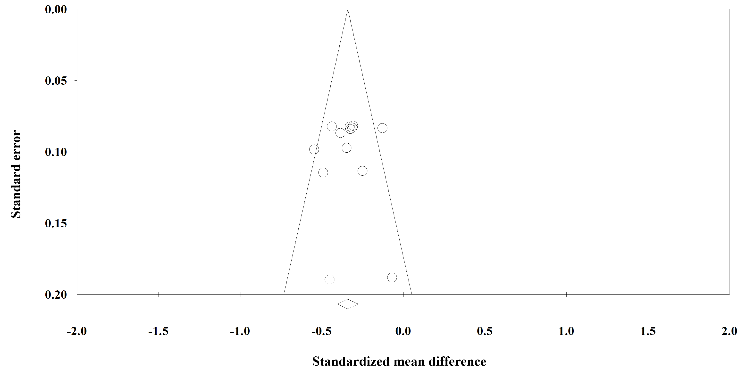

Meta-regression analysis (the placebo was the control)
Potential moderators | β (95% CrI)
Mean age (k = 8) | -43.976 (-130.521, 88.715)
Proportion of females (k = 8) | -13.250 (-180.005, 157.304)
Proportion of elderly patients (k = 8) | 17.653 (-32.977, 95.740)
Publication year (k = 8) | 24.607 (-60.785, 146.658)
Total participants (k = 8) | 67.319 (-27.884, 209.537)

CINeMA confidence rating
Comparison | Number of studies | Within-study bias | Reporting bias | Indirectness | Imprecision | Heterogeneity | Incoherence | Confidence rating
DAR25 vs DAR50 | 3 | No concerns | Some concerns | No concerns | No concerns | No concerns | No concerns | Moderate
DAR25 vs PLA | 4 | No concerns | Some concerns | No concerns | No concerns | No concerns | No concerns | Moderate
DAR50 vs PLA | 3 | No concerns | Some concerns | No concerns | No concerns | No concerns | No concerns | Moderate
LEM5 vs LEM10 | 2 | No concerns | Some concerns | No concerns | No concerns | No concerns | No concerns | Moderate
LEM5 vs PLA | 2 | No concerns | Some concerns | No concerns | No concerns | No concerns | No concerns | Moderate
LEM10 vs PLA | 2 | No concerns | Some concerns | No concerns | No concerns | No concerns | No concerns | Moderate
SUV20/15 vs PLA | 2 | No concerns | Some concerns | No concerns | No concerns | No concerns | No concerns | Moderate
DAR25 vs LEM5 | 0 | No concerns | Some concerns | No concerns | Major concerns | No concerns | No concerns | Very low
DAR25 vs LEM10 | 0 | No concerns | Some concerns | No concerns | Major concerns | No concerns | No concerns | Very low
DAR25 vs SUV20/15 | 0 | No concerns | Some concerns | No concerns | Major concerns | No concerns | No concerns | Very low
DAR50 vs LEM5 | 0 | No concerns | Some concerns | No concerns | No concerns | No concerns | No concerns | Low
DAR50 vs LEM10 | 0 | No concerns | Some concerns | No concerns | Major concerns | No concerns | No concerns | Very low
DAR50 vs SUV20/15 | 0 | No concerns | Some concerns | No concerns | Major concerns | No concerns | No concerns | Very low
LEM5 vs SUV20/15 | 0 | No concerns | Some concerns | No concerns | Major concerns | No concerns | No concerns | Very low
LEM10 vs SUV20/15 | 0 | No concerns | Some concerns | No concerns | Major concerns | No concerns | No concerns | Very low

Appendix S3. Subjective wake after sleep onset at month 1
8 studies, 4934 participants
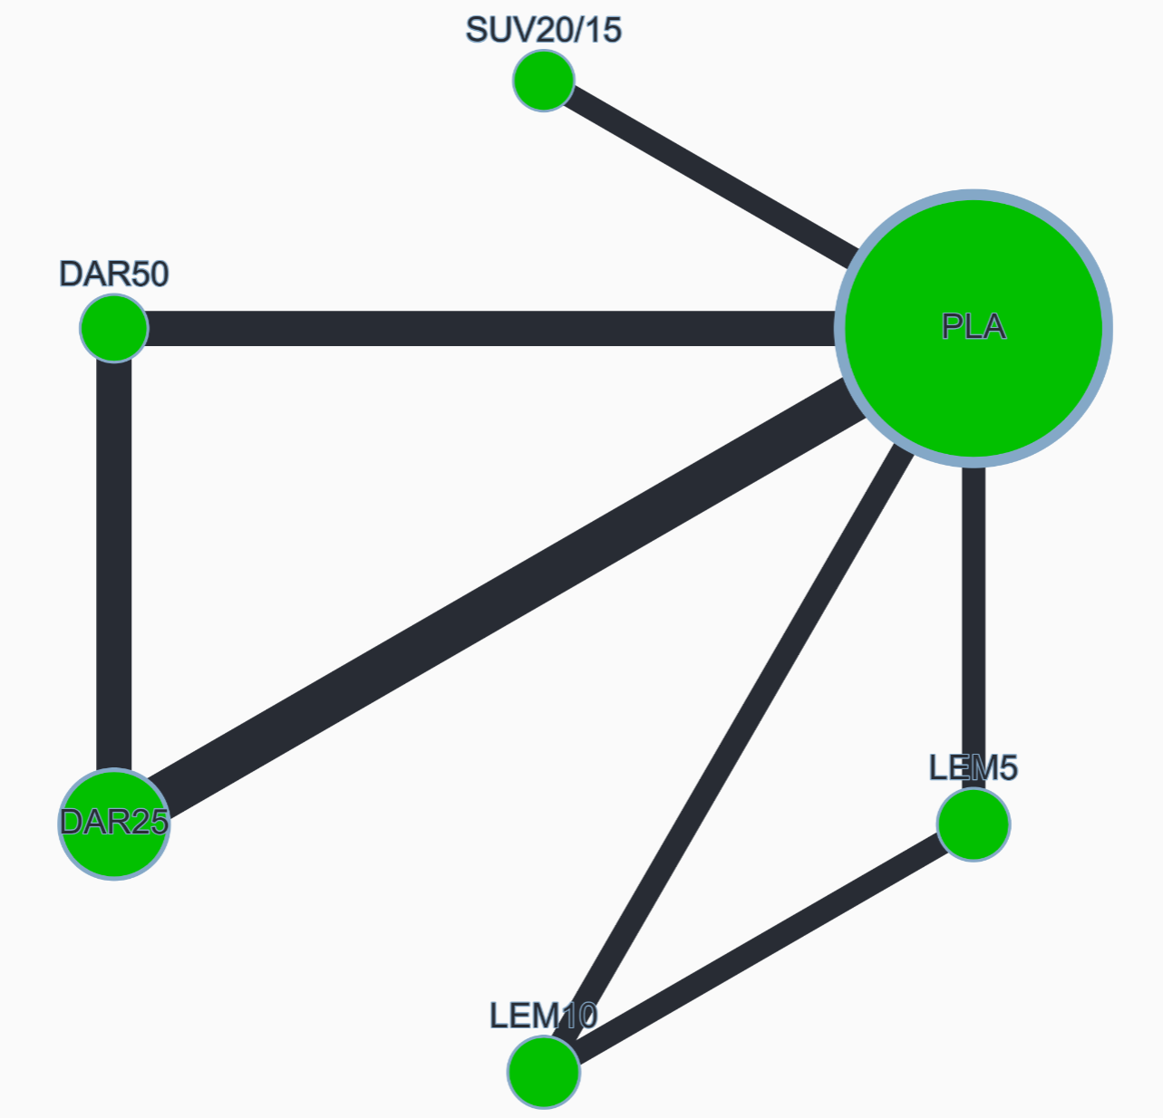

League table (SMD with 95% CI)
DAR25 | 0.023 (-0.093, 0.140) | -0.013 (-0.168, 0.143) | 0.093 (-0.063, 0.249) | 0.056 (-0.096, 0.208) | -0.138 (-0.234, -0.041)
 | DAR50 | -0.036 (-0.205, 0.132) | 0.070 (-0.099, 0.239) | 0.033 (-0.133, 0.198) | -0.161 (-0.277, -0.045)
 |  | LEM5 | 0.106 (-0.013, 0.224) | 0.069 (-0.100, 0.238) | -0.125 (-0.247, -0.003)
 |  |  | LEM10 | -0.037 (-0.207, 0.132) | -0.231 (-0.353, -0.108)
 |  |  |  | SUV20/15 | -0.194 (-0.311, -0.076)
 |  |  |  |  | PLA

Global heterogeneity
Between study variance (𝜏²): 0.000 (heterogeneity assessment: low)

Random-effects design-by-treatment interaction model
χ² statistic: 2.633 (1 degrees of freedom), P value: 0.105

Local heterogeneity (I²) and incoherence (SIDE test)
 | NMA SMD | Direct SMD | I² | Indirect SMD | P value (SIDE test)
DAR25 vs DAR50 | 0.023 (-0.093, 0.140) | -0.007 (-0.129, 0.115) | 0.0% | 0.323 (-0.059, 0.704) | 0.106
DAR25 vs PLA |  | -0.138 (-0.234, -0.041) | 0.0%
DAR50 vs PLA | -0.161 (-0.277, -0.045) | -0.192 (-0.314, -0.070) | 0.0% | 0.139 (-0.241, 0.518) | 0.104
LEM5 vs LEM10 |  | 0.106 (-0.013, 0.225) | 61.1%
LEM5 vs PLA | -0.125 (-0.247, -0.003) | -0.129 (-0.251, -0.007) | 0.0% | 2.827 (-0.293, 5.947) | 0.064
LEM10 vs PLA | -0.231 (-0.353, -0.108) | -0.229 (-0.351, -0.106) | 60.6% | -1.816(-5.082,1.450) | 0.341
SUV20/15 vs PLA |  | -0.194 (-0.311, -0.076) | 0.0%

CINeMA confidence rating
Comparison | Number of studies | Within-study bias | Reporting bias | Indirectness | Imprecision | Heterogeneity | Incoherence | Confidence rating
DAR25 vs DAR50 | 3 | No concerns | Some concerns | No concerns | Major concerns | No concerns | No concerns | Low
DAR25 vs PLA | 4 | No concerns | Some concerns | No concerns | No concerns | No concerns | No concerns | Moderate
DAR50 vs PLA | 3 | No concerns | Some concerns | No concerns | No concerns | No concerns | No concerns | Moderate
LEM5 vs LEM10 | 2 | No concerns | Some concerns | No concerns | Major concerns | No concerns | No concerns | Low
LEM5 vs PLA | 2 | No concerns | Some concerns | No concerns | No concerns | Major concerns | Major concerns | Very low
LEM10 vs PLA | 2 | No concerns | Some concerns | No concerns | No concerns | No concerns | No concerns | Moderate
SUV20/15 vs PLA | 2 | No concerns | Some concerns | No concerns | No concerns | No concerns | No concerns | Moderate
DAR25 vs LEM5 | 0 | No concerns | Some concerns | No concerns | Major concerns | No concerns | No concerns | Very low
DAR25 vs LEM10 | 0 | No concerns | Some concerns | No concerns | Major concerns | No concerns | No concerns | Very low
DAR25 vs SUV20/15 | 0 | No concerns | Some concerns | No concerns | Major concerns | No concerns | No concerns | Very low
DAR50 vs LEM5 | 0 | No concerns | Some concerns | No concerns | Major concerns | No concerns | No concerns | Very low
DAR50 vs LEM10 | 0 | No concerns | Some concerns | No concerns | Major concerns | No concerns | No concerns | Very low
DAR50 vs SUV20/15 | 0 | No concerns | Some concerns | No concerns | Major concerns | No concerns | No concerns | Very low
LEM5 vs SUV20/15 | 0 | No concerns | Some concerns | No concerns | Major concerns | No concerns | No concerns | Very low
LEM10 vs SUV20/15 | 0 | No concerns | Some concerns | No concerns | Major concerns | No concerns | No concerns | Very low

Appendix S4. Insomnia Severity Index scores at month 1
8 studies, 4967 participants
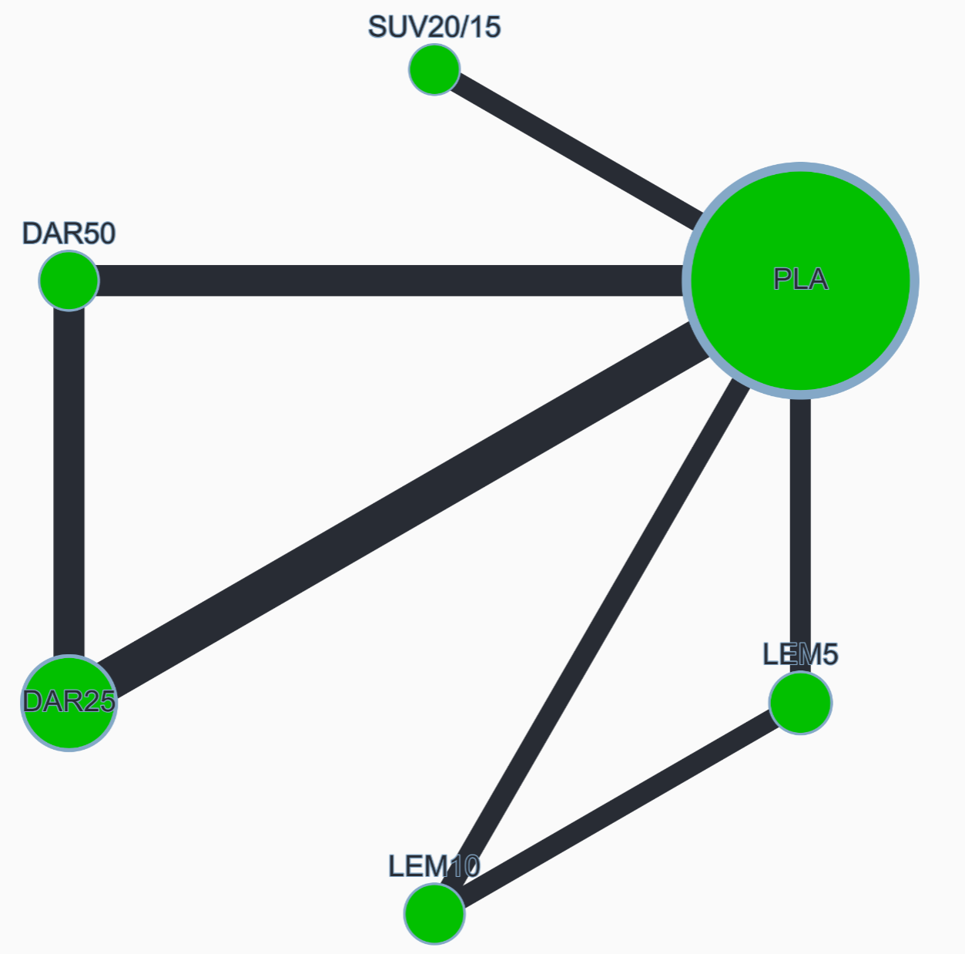

League table (SMD with 95% CI)
DAR25 | 0.070 (-0.045, 0.184) | 0.071 (-0.084, 0.226) | 0.094 (-0.062, 0.250) | 0.100 (-0.053, 0.252) | -0.212 (-0.308, -0.116)
 | DAR50 | 0.002 (-0.166, 0.169) | 0.024 (-0.144, 0.192) | 0.030 (-0.135, 0.195) | -0.282 (-0.396, -0.167)
 |  | LEM5 | 0.023 (-0.096, 0.141) | 0.029 (-0.141, 0.199) | -0.283 (-0.405, -0.161)
 |  |  | LEM10 | 0.006 (-0.165, 0.177) | -0.306 (-0.429, -0.183)
 |  |  |  | SUV20/15 | -0.312 (-0.430, -0.193)
 |  |  |  |  | PLA

Global heterogeneity
Between study variance (𝜏²): 0.000 (heterogeneity assessment: low)

Random-effects design-by-treatment interaction model
χ² statistic: 0.341 (1 degrees of freedom), P value: 0.559

Local heterogeneity (I²) and incoherence (SIDE test)
 | NMA SMD | Direct SMD | I² | Indirect SMD | P value (SIDE test)
DAR25 vs DAR50 | 0.070 (-0.045, 0.184) | 0.081 (-0.040, 0.201) | 0.0% | -0.040 (-0.421, 0.341) | 0.554
DAR25 vs PLA |  | -0.212 (-0.308, -0.116) | 0.0%
DAR50 vs PLA | -0.282 (-0.396, -0.167) | -0.271 (-0.391, -0.150) | 0.0% | -0.389 (-0.766, -0.011) | 0.559
LEM5 vs LEM10 |  | 0.023 (-0.096, 0.141) | 0.0%
LEM5 vs PLA | -0.283 (-0.405, -0.161) | -0.283 (-0.405, -0.161) | 0.0% | -0.206 (-3.608, 3.195) | 0.965
LEM10 vs PLA | -0.306 (-0.429, -0.183) | -0.306 (-0.429, -0.183) | 0.0% | -0.034 (-3.003, 2.936) | 0.857
SUV20/15 vs PLA |  | -0.312 (-0.430, -0.193) | 0.0%

CINeMA confidence rating
Comparison | Number of studies | Within-study bias | Reporting bias | Indirectness | Imprecision | Heterogeneity | Incoherence | Confidence rating
DAR25 vs DAR50 | 3 | No concerns | Some concerns | No concerns | Major concerns | No concerns | No concerns | Low
DAR25 vs PLA | 4 | No concerns | Some concerns | No concerns | No concerns | No concerns | No concerns | Moderate
DAR50 vs PLA | 3 | No concerns | Some concerns | No concerns | No concerns | No concerns | No concerns | Moderate
LEM5 vs LEM10 | 2 | No concerns | Some concerns | No concerns | Major concerns | No concerns | No concerns | Low
LEM5 vs PLA | 2 | No concerns | Some concerns | No concerns | No concerns | No concerns | No concerns | Moderate
LEM10 vs PLA | 2 | No concerns | Some concerns | No concerns | No concerns | No concerns | No concerns | Moderate
SUV20/15 vs PLA | 2 | No concerns | Some concerns | No concerns | No concerns | No concerns | No concerns | Moderate
DAR25 vs LEM5 | 0 | No concerns | Some concerns | No concerns | Major concerns | No concerns | No concerns | Very low
DAR25 vs LEM10 | 0 | No concerns | Some concerns | No concerns | Major concerns | No concerns | No concerns | Very low
DAR25 vs SUV20/15 | 0 | No concerns | Some concerns | No concerns | Major concerns | No concerns | No concerns | Very low
DAR50 vs LEM5 | 0 | No concerns | Some concerns | No concerns | Major concerns | No concerns | No concerns | Very low
DAR50 vs LEM10 | 0 | No concerns | Some concerns | No concerns | Major concerns | No concerns | No concerns | Very low
DAR50 vs SUV20/15 | 0 | No concerns | Some concerns | No concerns | Major concerns | No concerns | No concerns | Very low
LEM5 vs SUV20/15 | 0 | No concerns | Some concerns | No concerns | Major concerns | No concerns | No concerns | Very low
LEM10 vs SUV20/15 | 0 | No concerns | Some concerns | No concerns | Major concerns | No concerns | No concerns | Very low

Appendix S5. All-cause discontinuation
8 studies, 5194 participants
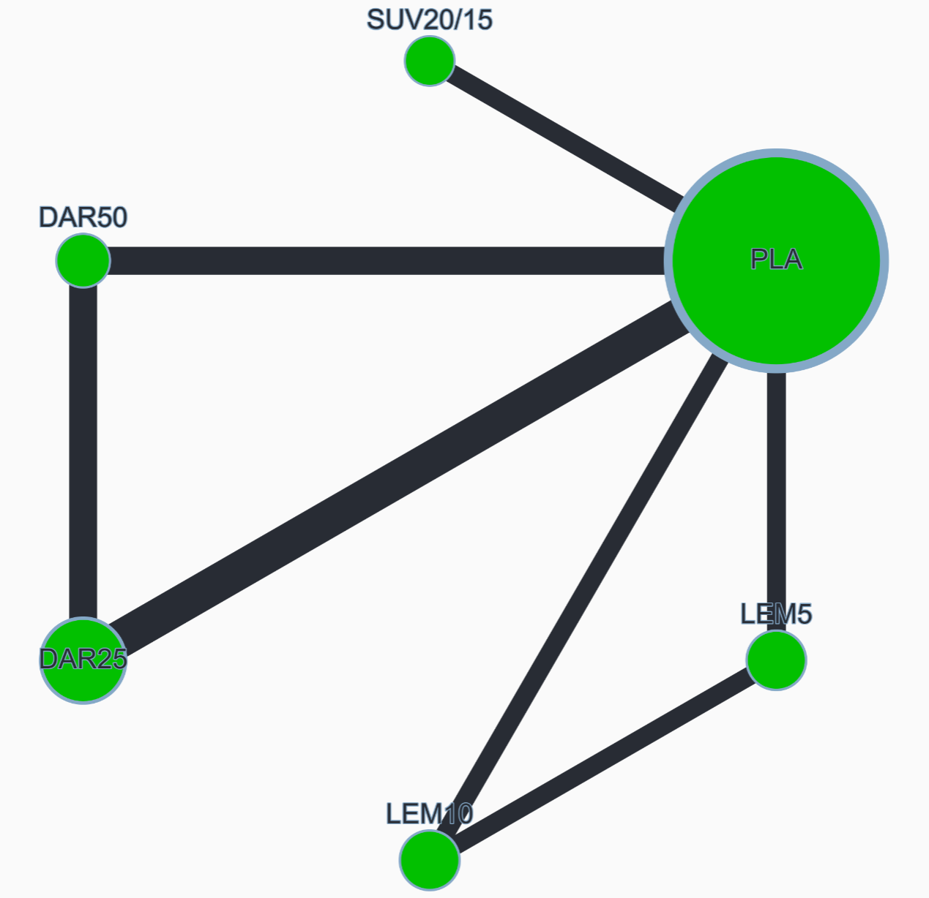

League table (OR with 95% CI)
DAR25 | 1.080 (0.672, 1.733) | 0.961 (0.572, 1.614) | 0.714 (0.429, 1.190) | 1.022 (0.610, 1.710) | 0.963 (0.659, 1.407)
 | DAR50 | 0.890 (0.497, 1.593) | 0.662 (0.373, 1.175) | 0.946 (0.531, 1.687) | 0.892 (0.562, 1.415)
 |  | LEM5 | 0.743 (0.530, 1.043) | 1.063 (0.647, 1.747) | 1.002 (0.703, 1.427)
 |  |  | LEM10 | 1.430 (0.878, 2.328) | 1.348 (0.958, 1.895)
 |  |  |  | SUV20/15 | 0.942 (0.665, 1.335)
 |  |  |  |  | PLA

Global heterogeneity
Between study variance (𝜏²): 0.000 (heterogeneity assessment: low)

Random-effects design-by-treatment interaction model
χ² statistic: 0.872 (1 degrees of freedom), P value: 0.350

Sensitivity analysis excluding Kärppä 2020 study
DAR25 | 1.080 (0.672, 1.733) | 1.560 (0.562, 4.331) | 1.397 (0.517, 3.778) | 1.022 (0.610, 1.710) | 0.963 (0.659, 1.407)
 | DAR50 | 1.445 (0.503, 4.148) | 1.294 (0.463, 3.622) | 0.946 (0.531, 1.687) | 0.892 (0.562, 1.415)
 |  | LEM5 | 0.896 (0.340, 2.358) | 0.655 (0.239, 1.798) | 0.617 (0.239, 1.592)
 |  |  | LEM10 | 0.731 (0.274, 1.954) | 0.689 (0.275, 1.727)
 |  |  |  | SUV20/15 | 0.942 (0.665, 1.335)
 |  |  |  |  | PLA

Global heterogeneity
Between study variance (𝜏²): 0.000 (heterogeneity assessment: low)

Random-effects design-by-treatment interaction model
χ² statistic: 0.872 (1 degrees of freedom), P value: 0.350

Local heterogeneity (I²) and incoherence (SIDE test)
 | NMA OR | Direct OR | I² | Indirect OR | P value (SIDE test)
DAR25 vs DAR50 | 1.080 (0.672, 1.733) | 1.000 (0.607, 1.649) | 0.0% | 2.107 (0.479, 9.267) | 0.350
DAR25 vs PLA |  | 0.963 (0.659, 1.407) | 0.0%
DAR50 vs PLA | 0.892 (0.562, 1.415) | 0.836 (0.516, 1.353) | 0.0% | 1.856 (0.367, 9.374) | 0.355
LEM5 vs LEM10 |  | 0.744 (0.531, 1.045) | 0.0%
LEM5 vs PLA | 1.002 (0.703, 1.427) | 1.007 (0.707, 1.436) | 16.3% | 0.000 (0.000, 222.005) | 0.243
LEM10 vs PLA | 1.348 (0.958, 1.895) | 1.350 (0.960, 1.900) | 58.1% | 0.120 (0.000, 12289.494) | 0.681
SUV20/15 vs PLA |  | 0.942 (0.665, 1.335) | 0.0%

CINeMA confidence rating
Comparison | Number of studies | Within-study bias | Reporting bias | Indirectness | Imprecision | Heterogeneity | Incoherence | Confidence rating
DAR25 vs DAR50 | 3 | No concerns | Some concerns | No concerns | Major concerns | No concerns | No concerns | Low
DAR25 vs PLA | 4 | No concerns | Some concerns | No concerns | Major concerns | No concerns | No concerns | Low
DAR50 vs PLA | 3 | No concerns | Some concerns | No concerns | Major concerns | No concerns | No concerns | Low
LEM5 vs LEM10 | 2 | No concerns | Some concerns | No concerns | Major concerns | No concerns | No concerns | Low
LEM5 vs PLA | 2 | No concerns | Some concerns | No concerns | Major concerns | No concerns | No concerns | Low
LEM10 vs PLA | 2 | No concerns | Some concerns | No concerns | Major concerns | No concerns | No concerns | Low
SUV20/15 vs PLA | 2 | No concerns | Some concerns | No concerns | Major concerns | No concerns | No concerns | Low
DAR25 vs LEM5 | 0 | No concerns | Some concerns | No concerns | Major concerns | No concerns | No concerns | Very low
DAR25 vs LEM10 | 0 | No concerns | Some concerns | No concerns | Major concerns | No concerns | No concerns | Very low
DAR25 vs SUV20/15 | 0 | No concerns | Some concerns | No concerns | Major concerns | No concerns | No concerns | Very low
DAR50 vs LEM5 | 0 | No concerns | Some concerns | No concerns | Major concerns | No concerns | No concerns | Very low
DAR50 vs LEM10 | 0 | No concerns | Some concerns | No concerns | Major concerns | No concerns | No concerns | Very low
DAR50 vs SUV20/15 | 0 | No concerns | Some concerns | No concerns | Major concerns | No concerns | No concerns | Very low
LEM5 vs SUV20/15 | 0 | No concerns | Some concerns | No concerns | Major concerns | No concerns | No concerns | Very low
LEM10 vs SUV20/15 | 0 | No concerns | Some concerns | No concerns | Major concerns | No concerns | No concerns | Very low

Appendix S6. Discontinuation due to adverse events
8 studies, 5194 participants
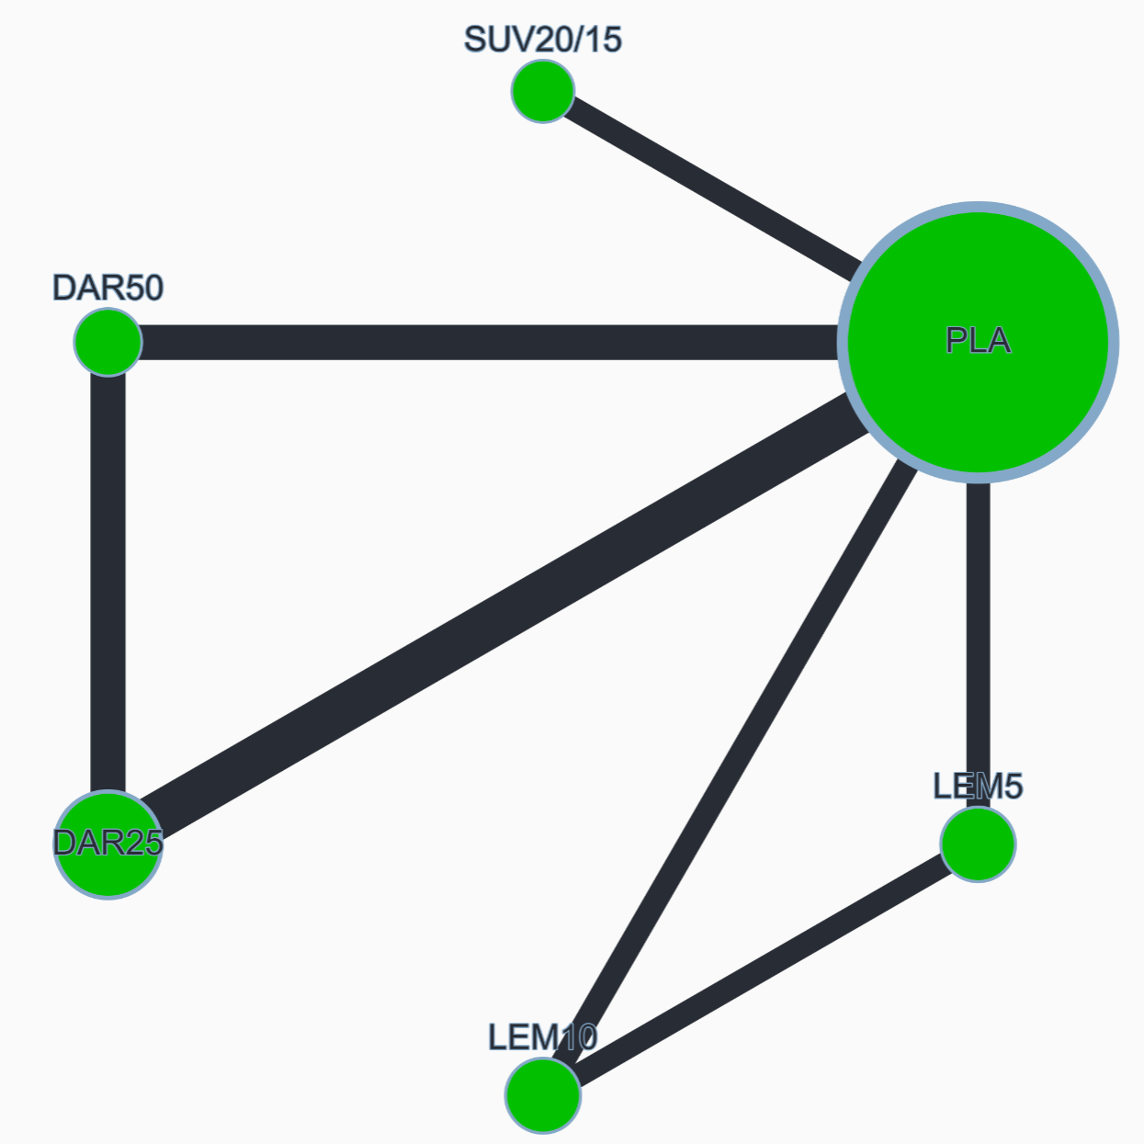

League table (OR with 95% CI)
DAR25 | 0.969 (0.352, 2.665) | 0.613 (0.199, 1.889) | 0.348 (0.121, 1.004) | 0.958 (0.375, 2.448) | 0.639 (0.312, 1.312)
 | DAR50 | 0.632 (0.174, 2.303) | 0.359 (0.104, 1.235) | 0.988 (0.318, 3.069) | 0.660 (0.253, 1.722)
 |  | LEM5 | 0.568 (0.267, 1.208) | 1.563 (0.544, 4.492) | 1.043 (0.439, 2.481)
 |  |  | LEM10 | 2.751 (1.028, 7.363) | 1.837 (0.844, 3.998)
 |  |  |  | SUV20/15 | 0.668 (0.365, 1.221)
 |  |  |  |  | PLA

Global heterogeneity
Between study variance (𝜏²): 0.100 (heterogeneity assessment: moderate to high)

Random-effects design-by-treatment interaction model
χ² statistic: 0.059 (1 degrees of freedom), P value: 0.807

Sensitivity analysis excluding Kärppä 2020 study
DAR25 | 0.969 (0.352, 2.665) | 0.815 (0.100, 6.629) | 0.548 (0.079, 3.799) | 0.958 (0.375, 2.448) | 0.639 (0.312, 1.312)
 | DAR50 | 0.841 (0.094, 7.516) | 0.565 (0.074, 4.339) | 0.988 (0.318, 3.069) | 0.660 (0.253, 1.722)
 |  | LEM5 | 0.672 (0.111, 4.053) | 1.175 (0.150, 9.204) | 0.784 (0.110, 5.614)
 |  |  | LEM10 | 1.749 (0.262, 11.655) | 1.167 (0.193, 7.051)
 |  |  |  | SUV20/15 | 0.668 (0.365, 1.221)
 |  |  |  |  | PLA

Global heterogeneity
Between study variance (𝜏²): 0.000 (heterogeneity assessment: low)

Random-effects design-by-treatment interaction model
χ² statistic: 0.049 (1 degrees of freedom), P value: 0.825

Local heterogeneity (I²) and incoherence (SIDE test)
 | NMA OR | Direct OR | I² | Indirect OR | P value (SIDE test)
DAR25 vs DAR50 | 0.969 (0.352, 2.665) | 1.187 (0.396, 3.559) | 28.9% | 0.311 (0.023, 4.193) | 0.353
DAR25 vs PLA | 0.639 (0.312, 1.312) | 0.636 (0.310, 1.305) | 0.0% | 18.606 (0.000, >1000) | 0.704
DAR50 vs PLA | 0.660 (0.253, 1.722) | 0.612 (0.225, 1.666) | 36.7% | 1.509 (0.055, 41.388) | 0.609
LEM5 vs LEM10 |  | 0.570 (0.268, 1.212) | 0.0%
LEM5 vs PLA |  | 1.046 (0.440, 2.489) | 0.0%
LEM10 vs PLA | 1.837 (0.844, 3.998) | 1.837 (0.844, 4.000) | 0.0% | 1.394 (0.000, >1000) | 0.986
SUV20/15 vs PLA |  | 0.668 (0.365, 1.221) | 41.6%

CINeMA confidence rating
Comparison | Number of studies | Within-study bias | Reporting bias | Indirectness | Imprecision | Heterogeneity | Incoherence | Confidence rating
DAR25 vs DAR50 | 3 | No concerns | Some concerns | No concerns | Major concerns | No concerns | No concerns | Low
DAR25 vs PLA | 4 | No concerns | Some concerns | No concerns | Major concerns | No concerns | No concerns | Low
DAR50 vs PLA | 3 | No concerns | Some concerns | No concerns | Major concerns | No concerns | No concerns | Low
LEM5 vs LEM10 | 2 | No concerns | Some concerns | No concerns | Major concerns | No concerns | No concerns | Low
LEM5 vs PLA | 2 | No concerns | Some concerns | No concerns | Major concerns | No concerns | No concerns | Low
LEM10 vs PLA | 2 | No concerns | Some concerns | No concerns | Major concerns | No concerns | No concerns | Low
SUV20/15 vs PLA | 2 | No concerns | Some concerns | No concerns | Major concerns | No concerns | No concerns | Low
DAR25 vs LEM5 | 0 | No concerns | Some concerns | No concerns | Major concerns | No concerns | No concerns | Very low
DAR25 vs LEM10 | 0 | No concerns | Some concerns | No concerns | Major concerns | No concerns | No concerns | Very low
DAR25 vs SUV20/15 | 0 | No concerns | Some concerns | No concerns | Major concerns | No concerns | No concerns | Very low
DAR50 vs LEM5 | 0 | No concerns | Some concerns | No concerns | Major concerns | No concerns | No concerns | Very low
DAR50 vs LEM10 | 0 | No concerns | Some concerns | No concerns | Major concerns | No concerns | No concerns | Very low
DAR50 vs SUV20/15 | 0 | No concerns | Some concerns | No concerns | Major concerns | No concerns | No concerns | Very low
LEM5 vs SUV20/15 | 0 | No concerns | Some concerns | No concerns | Major concerns | No concerns | No concerns | Very low
LEM10 vs SUV20/15 | 0 | No concerns | Some concerns | No concerns | No concerns | Major concerns | No concerns | Very low

Appendix S7. At least one adverse event
8 studies, 5161 participants
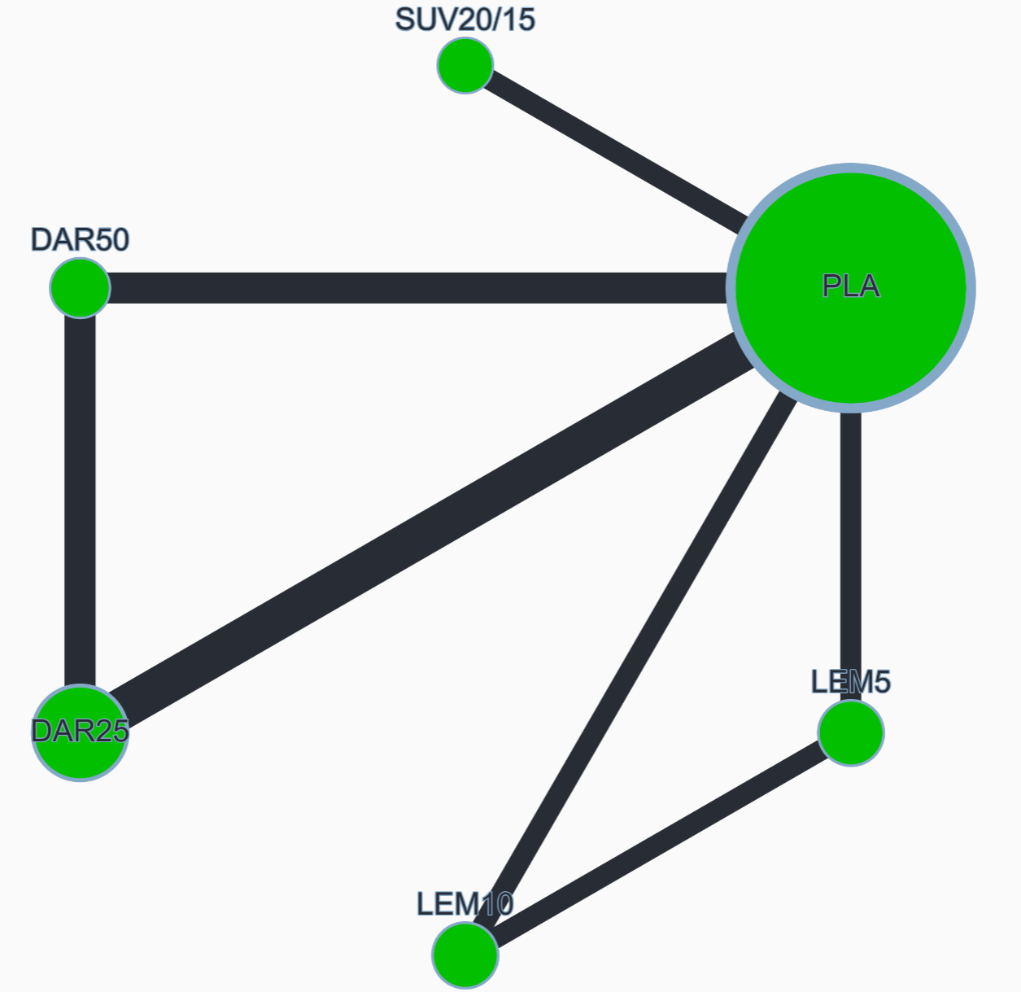

League table (OR with 95% CI)
DAR25 | 1.003 (0.783, 1.286) | 1.176 (0.848, 1.629) | 1.153 (0.833, 1.595) | 1.190 (0.876, 1.618) | 1.175 (0.956, 1.444)
 | DAR50 | 1.172 (0.822, 1.670) | 1.149 (0.807, 1.636) | 1.186 (0.847, 1.661) | 1.171 (0.914, 1.501)
 |  | LEM5 | 0.981 (0.769, 1.250) | 1.012 (0.721, 1.422) | 1.000 (0.776, 1.287)
 |  |  | LEM10 | 1.032 (0.736, 1.448) | 1.019 (0.793, 1.310)
 |  |  |  | SUV20/15 | 0.987 (0.787, 1.239)
 |  |  |  |  | PLA

Global heterogeneity
Between study variance (𝜏²): 0.000 (heterogeneity assessment: low)

Random-effects design-by-treatment interaction model
χ² statistic: 0.915 (1 degrees of freedom), P value: 0.339

Sensitivity analysis excluding Kärppä 2020 study
DAR25 | 1.003 (0.783, 1.286) | 1.036 (0.654, 1.640) | 0.905 (0.574, 1.427) | 1.190 (0.876, 1.618) | 1.175 (0.956, 1.444)
 | DAR50 | 1.032 (0.639, 1.669) | 0.903 (0.561, 1.452) | 1.186 (0.847, 1.661) | 1.171 (0.914, 1.501)
 |  | LEM5 | 0.874 (0.602, 1.270) | 1.149 (0.718, 1.838) | 1.134 (0.752, 1.711)
 |  |  | LEM10 | 1.314 (0.826, 2.093) | 1.298 (0.865, 1.947)
 |  |  |  | SUV20/15 | 0.987 (0.787, 1.239)
 |  |  |  |  | PLA

Global heterogeneity
Between study variance (𝜏²): 0.000 (heterogeneity assessment: low)

Random-effects design-by-treatment interaction model
χ² statistic: 0.915 (1 degrees of freedom), P value: 0.339

Local heterogeneity (I²) and incoherence (SIDE test)
 | NMA OR | Direct OR | I² | Indirect OR | P value (SIDE test)
DAR25 vs DAR50 | 1.003 (0.783, 1.286) | 0.960 (0.739, 1.247) | 0.0% | 1.492 (0.678, 3.284) | 0.299
DAR25 vs PLA | 1.175 (0.956, 1.444) | 1.174 (0.956, 1.443) | 16.5% | 2.620 (0.001, >1000) | 0.853
DAR50 vs PLA | 1.171 (0.914, 1.501) | 1.127 (0.868, 1.464) | 0.0% | 1.658 (0.753, 3.651) | 0.364
LEM5 vs LEM10 |  | 0.982 (0.770, 1.252) | 0.0%
LEM5 vs PLA | 1.000 (0.776, 1.287) | 1.007 (0.782, 1.297) | 0.0% | 0.021 (0.000, 6.815) | 0.190
LEM10 vs PLA | 1.019 (0.793, 1.310) | 1.018 (0.792, 1.309) | 55.0% | 1.389 (0.009, 210.840) | 0.904
SUV20/15 vs PLA |  | 0.987 (0.787, 1.239) | 0.0%

CINeMA confidence rating
Comparison | Number of studies | Within-study bias | Reporting bias | Indirectness | Imprecision | Heterogeneity | Incoherence | Confidence rating
DAR25 vs DAR50 | 3 | No concerns | Some concerns | No concerns | Major concerns | No concerns | No concerns | Low
DAR25 vs PLA | 4 | No concerns | Some concerns | No concerns | Major concerns | No concerns | No concerns | Low
DAR50 vs PLA | 3 | No concerns | Some concerns | No concerns | Major concerns | No concerns | No concerns | Low
LEM5 vs LEM10 | 2 | No concerns | Some concerns | No concerns | Major concerns | No concerns | No concerns | Low
LEM5 vs PLA | 2 | No concerns | Some concerns | No concerns | Major concerns | No concerns | No concerns | Low
LEM10 vs PLA | 2 | No concerns | Some concerns | No concerns | Major concerns | No concerns | No concerns | Low
SUV20/15 vs PLA | 2 | No concerns | Some concerns | No concerns | Major concerns | No concerns | No concerns | Low
DAR25 vs LEM5 | 0 | No concerns | Some concerns | No concerns | Major concerns | No concerns | No concerns | Very low
DAR25 vs LEM10 | 0 | No concerns | Some concerns | No concerns | Major concerns | No concerns | No concerns | Very low
DAR25 vs SUV20/15 | 0 | No concerns | Some concerns | No concerns | Major concerns | No concerns | No concerns | Very low
DAR50 vs LEM5 | 0 | No concerns | Some concerns | No concerns | Major concerns | No concerns | No concerns | Very low
DAR50 vs LEM10 | 0 | No concerns | Some concerns | No concerns | Major concerns | No concerns | No concerns | Very low
DAR50 vs SUV20/15 | 0 | No concerns | Some concerns | No concerns | Major concerns | No concerns | No concerns | Very low
LEM5 vs SUV20/15 | 0 | No concerns | Some concerns | No concerns | Major concerns | No concerns | No concerns | Very low
LEM10 vs SUV20/15 | 0 | No concerns | Some concerns | No concerns | Major concerns | No concerns | No concerns | Very low

Appendix S8. Somnolence
8 studies, 5161 participants
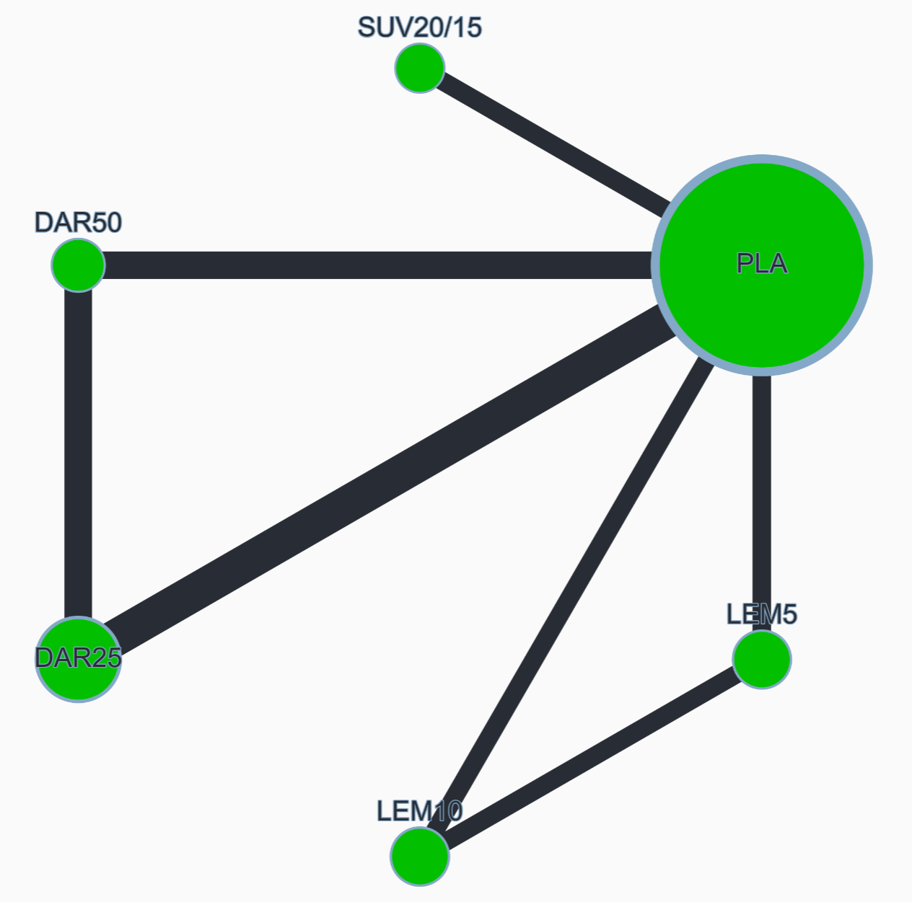

League table (OR with 95% CI)
DAR25 | 1.036 (0.549, 1.957) | 0.498 (0.190, 1.303) | 0.303 (0.118, 0.777) | 0.914 (0.404, 2.069) | 1.945 (1.052, 3.598)
 | DAR50 | 0.480 (0.172, 1.341) | 0.292 (0.107, 0.800) | 0.882 (0.362, 2.151) | 1.877 (0.922, 3.821)
 |  | LEM5 | 0.608 (0.397, 0.932) | 1.837 (0.736, 4.585) | 3.907 (1.864, 8.191)
 |  |  | LEM10 | 3.019 (1.235, 7.376) | 6.421 (3.145, 13.109)
 |  |  |  | SUV20/15 | 2.127 (1.243, 3.641)
 |  |  |  |  | PLA

Global heterogeneity
Between study variance (𝜏²): 0.040 (heterogeneity assessment: moderate to high)

Random-effects design-by-treatment interaction model
χ² statistic: 0.256 (1 degrees of freedom), P value: 0.613

Sensitivity analysis excluding Kärppä 2020 study
DAR25 | 1.040 (0.542, 1.994) | 0.879 (0.230, 3.359) | 0.497 (0.137, 1.796) | 0.915 (0.393, 2.128) | 1.943 (1.037, 3.640)
 | DAR50 | 0.845 (0.211, 3.389) | 0.478 (0.126, 1.816) | 0.880 (0.351, 2.205) | 1.868 (0.905, 3.857)
 |  | LEM5 | 0.565 (0.254, 1.260) | 1.041 (0.280, 3.868) | 2.211 (0.676, 7.230)
 |  |  | LEM10 | 1.842 (0.525, 6.462) | 3.911 (1.274, 12.001)
 |  |  |  | SUV20/15 | 2.123 (1.208, 3.734)
 |  |  |  |  | PLA

Global heterogeneity
Between study variance (𝜏²): 0.001 (heterogeneity assessment: low)

Random-effects design-by-treatment interaction model
χ² statistic: 0.238 (1 degrees of freedom), P value: 0.626

Local heterogeneity (I²) and incoherence (SIDE test)
 | NMA OR | Direct OR | I² | Indirect OR | P value (SIDE test)
DAR25 vs DAR50 | 1.036 (0.549, 1.957) | 1.039 (0.539, 2.004) | 45.7% | 0.996 (0.080, 12.460) | 0.974
DAR25 vs PLA | 1.945 (1.052, 3.598) | 1.962 (1.060, 3.631) | 0.0% | 0.005 (0.000, >1000) | 0.467
DAR50 vs PLA | 1.877 (0.922, 3.821) | 1.600 (0.745, 3.436) | 33.8% | 5.246 (0.753, 36.551) | 0.265
LEM5 vs LEM10 |  | 0.607 (0.396, 0.930) | 0.0%
LEM5 vs PLA | 3.907 (1.864, 8.191) | 3.945 (1.876, 8.296) | 38.6% | 1.230 (0.000, >1000) | 0.780
LEM10 vs PLA | 6.421 (3.145, 13.109) | 6.481 (3.172, 13.243) | 30.0% | 0.120 (0.000, >1000) | 0.598
SUV20/15 vs PLA |  | 2.127 (1.243, 3.641) | 18.1%

CINeMA confidence rating
Comparison | Number of studies | Within-study bias | Reporting bias | Indirectness | Imprecision | Heterogeneity | Incoherence | Confidence rating
DAR25 vs DAR50 | 3 | No concerns | Some concerns | No concerns | Major concerns | No concerns | No concerns | Low
DAR25 vs PLA | 4 | No concerns | Some concerns | No concerns | No concerns | Major concerns | No concerns | Low
DAR50 vs PLA | 3 | No concerns | Some concerns | No concerns | Major concerns | No concerns | No concerns | Low
LEM5 vs LEM10 | 2 | No concerns | Some concerns | No concerns | No concerns | Major concerns | No concerns | Low
LEM5 vs PLA | 2 | No concerns | Some concerns | No concerns | No concerns | No concerns | No concerns | Moderate
LEM10 vs PLA | 2 | No concerns | Some concerns | No concerns | No concerns | No concerns | No concerns | Moderate
SUV20/15 vs PLA | 2 | No concerns | Some concerns | No concerns | No concerns | No concerns | No concerns | Moderate
DAR25 vs LEM5 | 0 | No concerns | Some concerns | No concerns | Major concerns | No concerns | No concerns | Very low
DAR25 vs LEM10 | 0 | No concerns | Some concerns | No concerns | No concerns | No concerns | No concerns | Low
DAR25 vs SUV20/15 | 0 | No concerns | Some concerns | No concerns | Major concerns | No concerns | No concerns | Very low
DAR50 vs LEM5 | 0 | No concerns | Some concerns | No concerns | Major concerns | No concerns | No concerns | Very low
DAR50 vs LEM10 | 0 | No concerns | Some concerns | No concerns | No concerns | No concerns | No concerns | Low
DAR50 vs SUV20/15 | 0 | No concerns | Some concerns | No concerns | Major concerns | No concerns | No concerns | Very low
LEM5 vs SUV20/15 | 0 | No concerns | Some concerns | No concerns | Major concerns | No concerns | No concerns | Very low
LEM10 vs SUV20/15 | 0 | No concerns | Some concerns | No concerns | No concerns | No concerns | No concerns | Low

Appendix S9. Dizziness
7 studies, 4214 participants
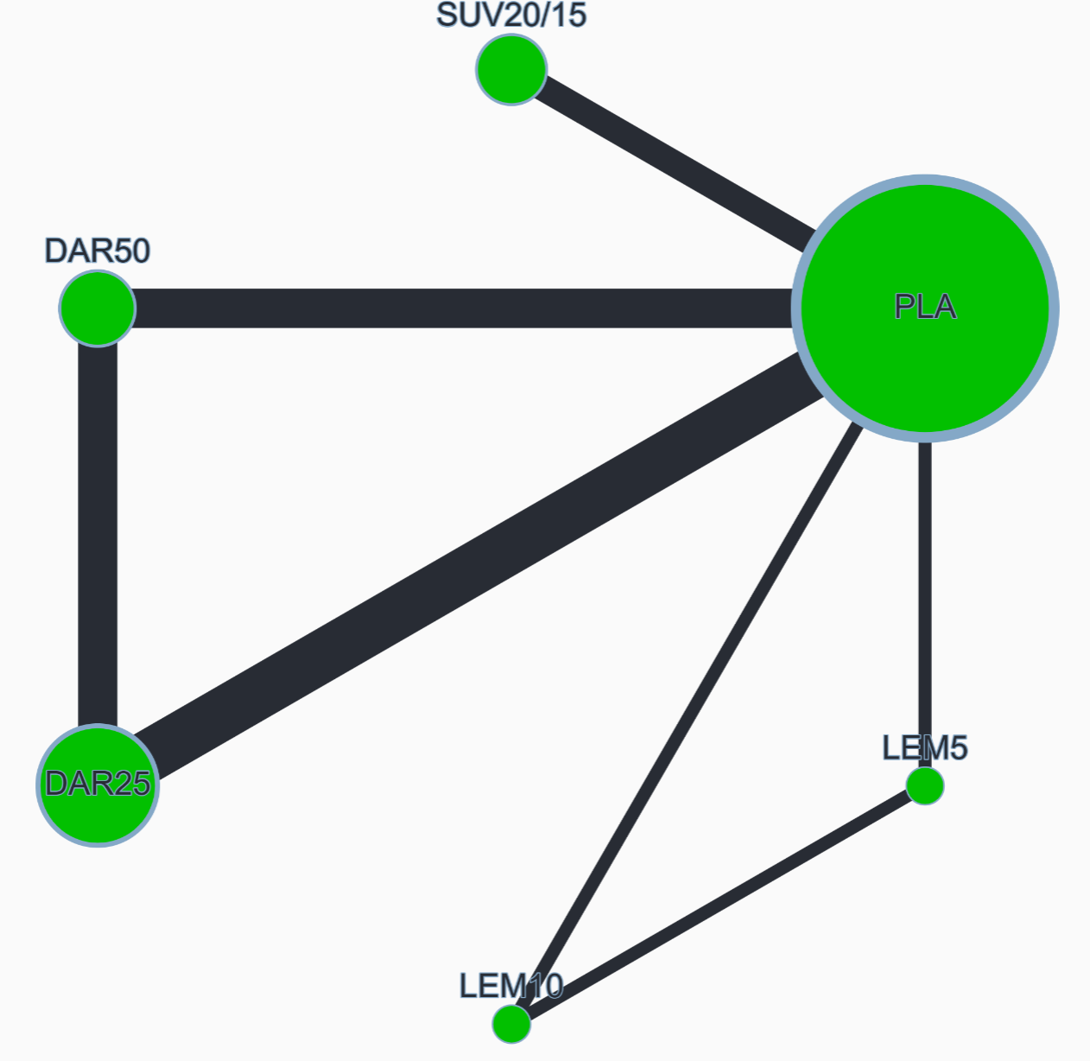

League table (OR with 95% CI)
DAR25 | 0.658 (0.263, 1.649) | 2.603 (0.453, 14.972) | 3.950 (0.577, 27.040) | 1.235 (0.402, 3.792) | 1.522 (0.627, 3.694)
 | DAR50 | 3.954 (0.651, 24.011) | 5.999 (0.834, 43.155) | 1.875 (0.562, 6.256) | 2.312 (0.859, 6.218)
 |  | LEM5 | 1.517 (0.251, 9.153) | 0.474 (0.090, 2.488) | 0.585 (0.129, 2.641)
 |  |  | LEM10 | 0.313 (0.050, 1.969) | 0.385 (0.070, 2.124)
 |  |  |  | SUV20/15 | 1.233 (0.620, 2.451)
 |  |  |  |  | PLA

Global heterogeneity
Between study variance (𝜏²): 0.000 (heterogeneity assessment: low)

Random-effects design-by-treatment interaction model
χ² statistic: 0.001 (1 degrees of freedom), P value: 0.975

The primary analysis did not include the long-term study (Kärppä 2020).

Local heterogeneity (I²) and incoherence (SIDE test)
 | NMA OR | Direct OR | I² | Indirect OR | P value (SIDE test)
DAR25 vs DAR50 | 0.658 (0.263, 1.649) | 0.676 (0.249, 1.833) | 0.0% | 0.570 (0.054, 5.954) | 0.895
DAR25 vs PLA | 1.522 (0.627, 3.694) | 1.474 (0.591, 3.679) | 0.0% | 2.515 (0.067, 94.273) | 0.779
DAR50 vs PLA | 2.312 (0.859, 6.218) | 2.522 (0.816, 7.791) | 0.0% | 1.728 (0.220, 13.577) | 0.752
LEM5 vs LEM10 |  | 1.517 (0.251, 9.153) | na
LEM5 vs PLA |  | 0.585 (0.129, 2.641) | na
LEM10 vs PLA |  | 0.385 (0.070, 2.124) | na
SUV20/15 vs PLA |  | 1.233 (0.620, 2.451) | 0.0%

CINeMA confidence rating
Comparison | Number of studies | Within-study bias | Reporting bias | Indirectness | Imprecision | Heterogeneity | Incoherence | Confidence rating
DAR25 vs DAR50 | 3 | No concerns | Some concerns | No concerns | Major concerns | No concerns | No concerns | Low
DAR25 vs PLA | 4 | No concerns | Some concerns | No concerns | Major concerns | No concerns | No concerns | Low
DAR50 vs PLA | 3 | No concerns | Some concerns | No concerns | Major concerns | No concerns | No concerns | Low
LEM5 vs LEM10 | 1 | No concerns | Some concerns | No concerns | Major concerns | No concerns | No concerns | Low
LEM5 vs PLA | 1 | No concerns | Some concerns | No concerns | Major concerns | No concerns | No concerns | Low
LEM10 vs PLA | 1 | No concerns | Some concerns | No concerns | Major concerns | No concerns | No concerns | Low
SUV20/15 vs PLA | 2 | No concerns | Some concerns | No concerns | Major concerns | No concerns | No concerns | Low
DAR25 vs LEM5 | 0 | No concerns | Some concerns | No concerns | Major concerns | No concerns | No concerns | Very low
DAR25 vs LEM10 | 0 | No concerns | Some concerns | No concerns | Major concerns | No concerns | No concerns | Very low
DAR25 vs SUV20/15 | 0 | No concerns | Some concerns | No concerns | Major concerns | No concerns | No concerns | Very low
DAR50 vs LEM5 | 0 | No concerns | Some concerns | No concerns | Major concerns | No concerns | No concerns | Very low
DAR50 vs LEM10 | 0 | No concerns | Some concerns | No concerns | Major concerns | No concerns | No concerns | Very low
DAR50 vs SUV20/15 | 0 | No concerns | Some concerns | No concerns | Major concerns | No concerns | No concerns | Very low
LEM5 vs SUV20/15 | 0 | No concerns | Some concerns | No concerns | Major concerns | No concerns | No concerns | Very low
LEM10 vs SUV20/15 | 0 | No concerns | Some concerns | No concerns | Major concerns | No concerns | No concerns | Very low

Appendix S10. Falls
8 studies, 5161 participants
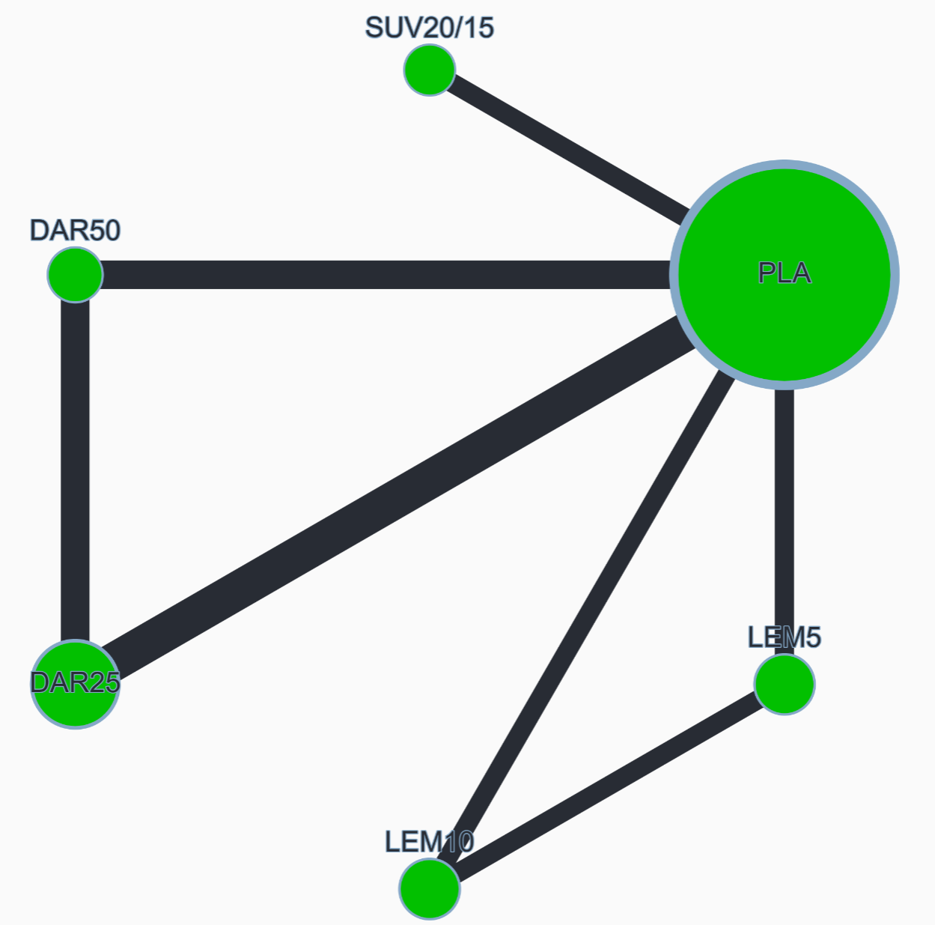

League table (OR with 95% CI)
DAR25 | 0.901 (0.148, 5.495) | 0.472 (0.067, 3.305) | 0.903 (0.121, 6.725) | 0.491 (0.065, 3.733) | 0.455 (0.118, 1.745)
 | DAR50 | 0.523 (0.059, 4.637) | 1.002 (0.107, 9.376) | 0.545 (0.057, 5.194) | 0.504 (0.095, 2.671)
 |  | LEM5 | 1.914 (0.431, 8.509) | 1.041 (0.131, 8.258) | 0.964 (0.236, 3.940)
 |  |  | LEM10 | 0.544 (0.065, 4.570) | 0.504 (0.113, 2.237)
 |  |  |  | SUV20/15 | 0.926 (0.203, 4.225)
 |  |  |  |  | PLA

Global heterogeneity
Between study variance (𝜏²): 0.024 (heterogeneity assessment: low to moderate)

Random-effects design-by-treatment interaction model
χ² statistic: 1.247 (1 degrees of freedom), P value: 0.264

Sensitivity analysis excluding Kärppä 2020 study
DAR25 | 1.011 (0.193, 5.287) | 0.063 (0.003, 1.463) | 0.581 (0.010, 34.636) | 0.503 (0.091, 2.763) | 0.453 (0.144, 1.424)
 | DAR50 | 0.062 (0.002, 1.672) | 0.575 (0.009, 38.313) | 0.497 (0.070, 3.521) | 0.449 (0.100, 2.002)
 |  | LEM5 | 9.205 (0.493, 171.829) | 7.961 (0.328, 193.002) | 7.183 (0.385, 134.169)
 |  |  | LEM10 | 0.865 (0.014, 53.357) | 0.780 (0.015, 39.488)
 |  |  |  | SUV20/15 | 0.902 (0.255, 3.190)
 |  |  |  |  | PLA

Global heterogeneity
Between study variance (𝜏²): 0.027 (heterogeneity assessment: low to moderate)

Random-effects design-by-treatment interaction model
χ² statistic: 1.850 (1 degrees of freedom), P value: 0.174

Local heterogeneity (I²) and incoherence (SIDE test)
 | NMA OR | Direct OR | I² | Indirect OR | P value (SIDE test)
DAR25 vs DAR50 | 0.901(0.148,5.495) | 0.690(0.095,5.008) | 0.0% | 3.373(0.041,275.614) | 0.519
DAR25 vs PLA | 0.455(0.118,1.745) | 0.508(0.131,1.972) | 0.0% | 0.000(0.000,17.685) | 0.189
DAR50 vs PLA | 0.504(0.095,2.671) | 0.426(0.073,2.506) | 32.3% | 1.854(0.013,256.801) | 0.583
LEM5 vs LEM10 | 1.914(0.431,8.509) | 1.661(0.367,7.513) | 46.5% | 857.396(0.043,17216865.264) | 0.222
LEM5 vs PLA | 0.964(0.236,3.940) | 0.863(0.207,3.604) | 64.3% | 37.285(0.010,139469.330) | 0.377
LEM10 vs PLA | 0.504(0.113,2.237) | 0.530(0.119,2.359) | 0.0% | 0.000(0.000,62.866) | 0.087
SUV20/15 vs PLA |  | 0.926(0.203,4.225) | 0.0%

CINeMA confidence rating
Comparison | Number of studies | Within-study bias | Reporting bias | Indirectness | Imprecision | Heterogeneity | Incoherence | Confidence rating
DAR25 vs DAR50 | 3 | No concerns | Some concerns | No concerns | Major concerns | No concerns | No concerns | Low
DAR25 vs PLA | 4 | No concerns | Some concerns | No concerns | Major concerns | No concerns | No concerns | Low
DAR50 vs PLA | 3 | No concerns | Some concerns | No concerns | Major concerns | No concerns | No concerns | Low
LEM5 vs LEM10 | 2 | No concerns | Some concerns | No concerns | Major concerns | No concerns | No concerns | Low
LEM5 vs PLA | 2 | No concerns | Some concerns | No concerns | Major concerns | No concerns | No concerns | Low
LEM10 vs PLA | 2 | No concerns | Some concerns | No concerns | Major concerns | No concerns | No concerns | Low
SUV20/15 vs PLA | 2 | No concerns | Some concerns | No concerns | Major concerns | No concerns | No concerns | Low
DAR25 vs LEM5 | 0 | No concerns | Some concerns | No concerns | Major concerns | No concerns | No concerns | Very low
DAR25 vs LEM10 | 0 | No concerns | Some concerns | No concerns | Major concerns | No concerns | No concerns | Very low
DAR25 vs SUV20/15 | 0 | No concerns | Some concerns | No concerns | Major concerns | No concerns | No concerns | Very low
DAR50 vs LEM5 | 0 | No concerns | Some concerns | No concerns | Major concerns | No concerns | No concerns | Very low
DAR50 vs LEM10 | 0 | No concerns | Some concerns | No concerns | Major concerns | No concerns | No concerns | Very low
DAR50 vs SUV20/15 | 0 | No concerns | Some concerns | No concerns | Major concerns | No concerns | No concerns | Very low
LEM5 vs SUV20/15 | 0 | No concerns | Some concerns | No concerns | Major concerns | No concerns | No concerns | Very low
LEM10 vs SUV20/15 | 0 | No concerns | Some concerns | No concerns | Major concerns | No concerns | No concerns | Very low

Appendix S11. Headache
7 studies, 4672 participants
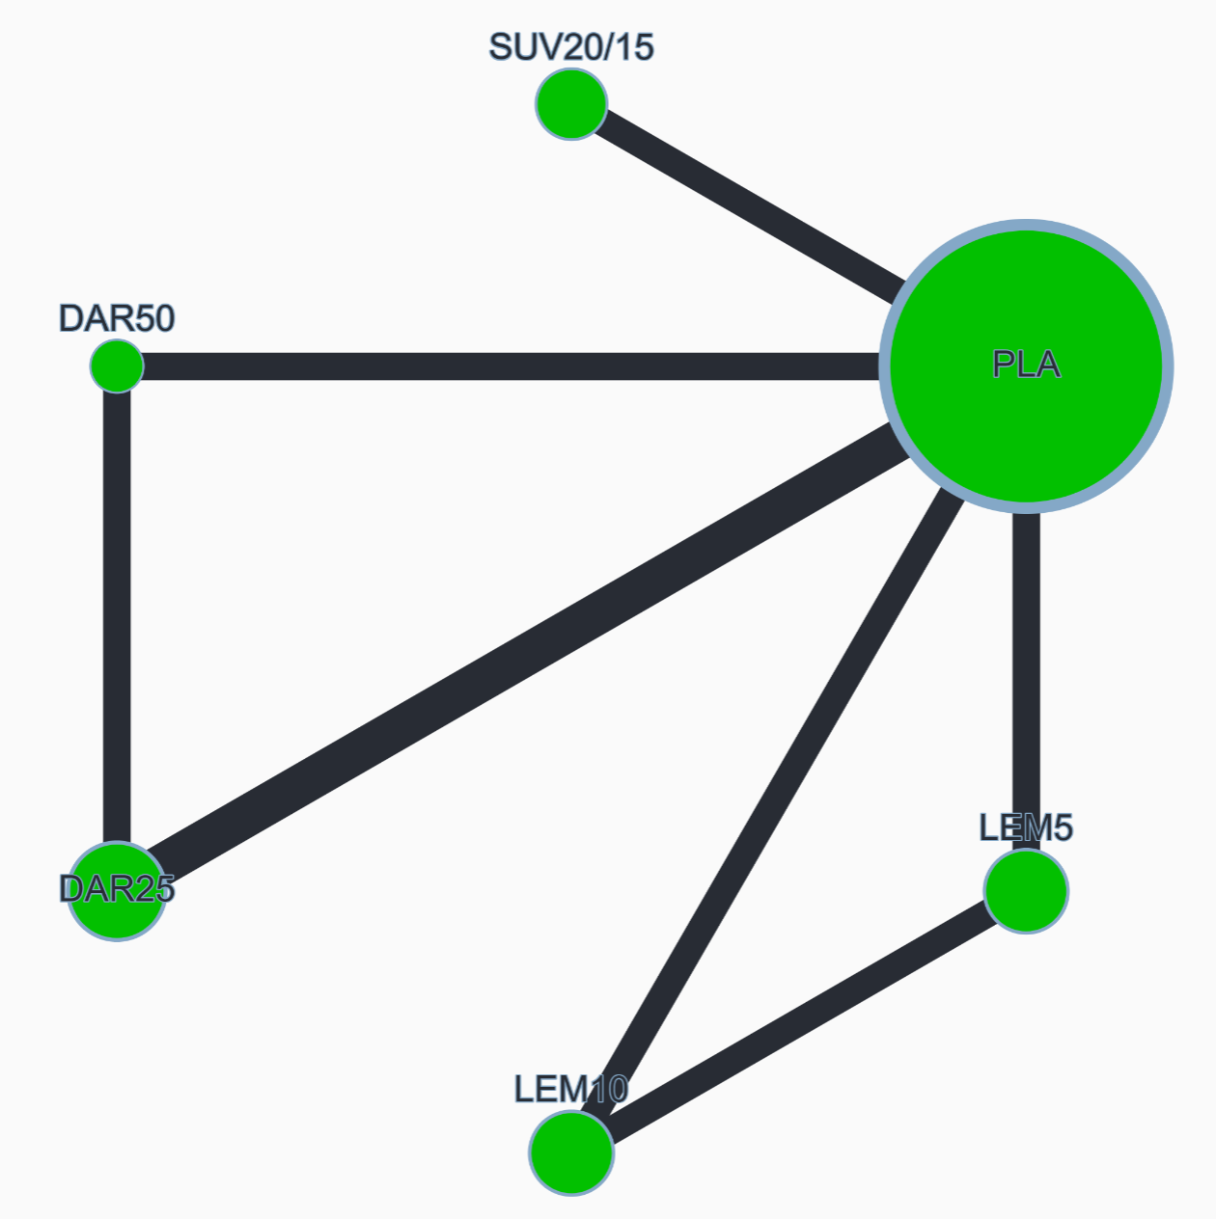

League table (OR with 95% CI)
DAR25 | 0.851 (0.478, 1.514) | 1.190 (0.588, 2.407) | 1.613 (0.782, 3.326) | 1.164 (0.578, 2.342) | 1.473 (0.865, 2.508)
 | DAR50 | 1.398 (0.640, 3.058) | 1.896 (0.852, 4.219) | 1.368 (0.629, 2.977) | 1.732 (0.921, 3.256)
 |  | LEM5 | 1.356 (0.855, 2.151) | 0.978 (0.512, 1.870) | 1.238 (0.780, 1.966)
 |  |  | LEM10 | 0.722 (0.370, 1.408) | 0.913 (0.559, 1.492)
 |  |  |  | SUV20/15 | 1.266 (0.804, 1.993)
 |  |  |  |  | PLA

Global heterogeneity
Between study variance (𝜏²): 0.000 (heterogeneity assessment: low)

Random-effects design-by-treatment interaction model
χ² statistic: 0.055 (1 degrees of freedom), P value: 0.815

Sensitivity analysis excluding Kärppä 2020 study
DAR25 | 0.851 (0.478, 1.514) | 1.431 (0.573, 3.577) | 1.916 (0.739, 4.971) | 1.164 (0.578, 2.342) | 1.473 (0.865, 2.508)
 | DAR50 | 1.682 (0.633, 4.470) | 2.253 (0.819, 6.198) | 1.368 (0.629, 2.977) | 1.732 (0.921, 3.256)
 |  | LEM5 | 1.339 (0.637, 2.815) | 0.813 (0.340, 1.947) | 1.029 (0.488, 2.170)
 |  |  | LEM10 | 0.607 (0.244, 1.512) | 0.769 (0.349, 1.695)
 |  |  |  | SUV20/15 | 1.266 (0.804, 1.993)
 |  |  |  |  | PLA

Global heterogeneity
Between study variance (𝜏²): 0.000 (heterogeneity assessment: low)

Random-effects design-by-treatment interaction model
χ² statistic: 0.055 (1 degrees of freedom), P value: 0.815

Local heterogeneity (I²) and incoherence (SIDE test)
 | NMA OR | Direct OR | I² | Indirect OR | P value (SIDE test)
DAR25 vs DAR50 | 0.851 (0.478, 1.514) | 0.866 (0.473, 1.586) | 0.0% | 0.712 (0.107, 4.757) | 0.848
DAR25 vs PLA | 1.473 (0.865, 2.508) | 1.477 (0.865, 2.520) | 0.0% | 1.165 (0.005, 253.205) | 0.931
DAR50 vs PLA | 1.732 (0.921, 3.256) | 1.838 (0.912, 3.705) | 0.2% | 1.343 (0.315, 5.724) | 0.703
LEM5 vs LEM10 |  | 1.356 (0.855, 2.150) | 0.0%
LEM5 vs PLA |  | 1.238 (0.780, 1.966) | 0.0%
LEM10 vs PLA |  | 0.913 (0.559, 1.492) | 0.0%
SUV20/15 vs PLA |  | 1.266 (0.804, 1.993) | 0.0%

CINeMA confidence rating
Comparison | Number of studies | Within-study bias | Reporting bias | Indirectness | Imprecision | Heterogeneity | Incoherence | Confidence rating
DAR25 vs DAR50 | 2 | No concerns | Some concerns | No concerns | Major concerns | No concerns | No concerns | Low
DAR25 vs PLA | 3 | No concerns | Some concerns | No concerns | Major concerns | No concerns | No concerns | Low
DAR50 vs PLA | 2 | No concerns | Some concerns | No concerns | Major concerns | No concerns | No concerns | Low
LEM5 vs LEM10 | 2 | No concerns | Some concerns | No concerns | Major concerns | No concerns | No concerns | Low
LEM5 vs PLA | 2 | No concerns | Some concerns | No concerns | Major concerns | No concerns | No concerns | Low
LEM10 vs PLA | 2 | No concerns | Some concerns | No concerns | Major concerns | No concerns | No concerns | Low
SUV20/15 vs PLA | 2 | No concerns | Some concerns | No concerns | Major concerns | No concerns | No concerns | Low
DAR25 vs LEM5 | 0 | No concerns | Some concerns | No concerns | Major concerns | No concerns | No concerns | Very low
DAR25 vs LEM10 | 0 | No concerns | Some concerns | No concerns | Major concerns | No concerns | No concerns | Very low
DAR25 vs SUV20/15 | 0 | No concerns | Some concerns | No concerns | Major concerns | No concerns | No concerns | Very low
DAR50 vs LEM5 | 0 | No concerns | Some concerns | No concerns | Major concerns | No concerns | No concerns | Very low
DAR50 vs LEM10 | 0 | No concerns | Some concerns | No concerns | Major concerns | No concerns | No concerns | Very low
DAR50 vs SUV20/15 | 0 | No concerns | Some concerns | No concerns | Major concerns | No concerns | No concerns | Very low
LEM5 vs SUV20/15 | 0 | No concerns | Some concerns | No concerns | Major concerns | No concerns | No concerns | Very low
LEM10 vs SUV20/15 | 0 | No concerns | Some concerns | No concerns | Major concerns | No concerns | No concerns | Very low

Appendix S12. Nasopharyngitis
7 studies, 4672 participants
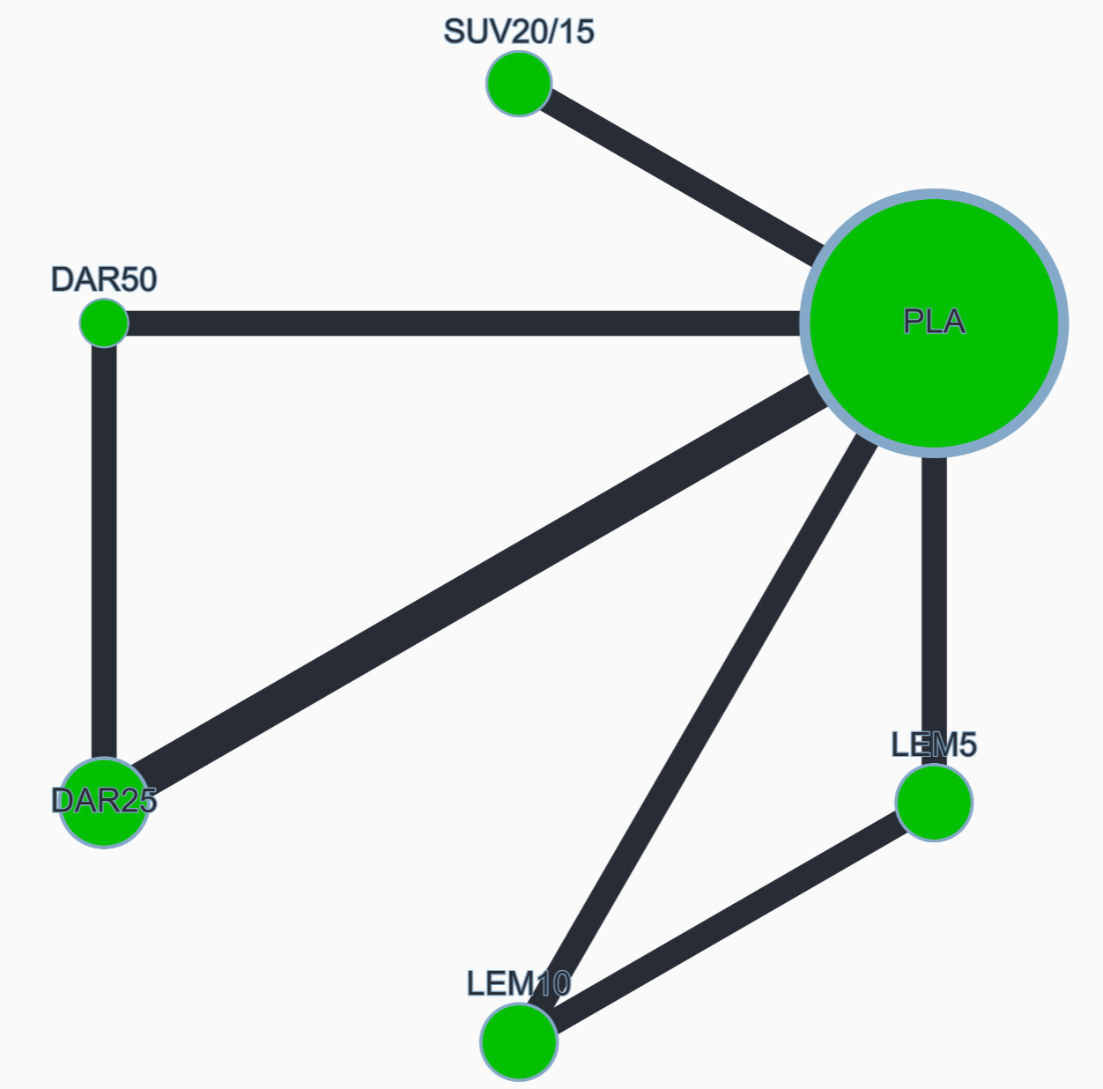

League table (OR with 95% CI)
DAR25 | 0.988 (0.523, 1.868) | 0.995 (0.471, 2.102) | 1.243 (0.576, 2.685) | 1.018 (0.479, 2.159) | 0.862 (0.513, 1.447)
 | DAR50 | 1.006 (0.443, 2.286) | 1.258 (0.543, 2.915) | 1.029 (0.451, 2.348) | 0.872 (0.470, 1.618)
 |  | LEM5 | 1.250 (0.696, 2.245) | 1.023 (0.475, 2.204) | 0.866 (0.505, 1.486)
 |  |  | LEM10 | 0.818 (0.372, 1.801) | 0.693 (0.392, 1.225)
 |  |  |  | SUV20/15 | 0.847 (0.491, 1.461)
 |  |  |  |  | PLA

Global heterogeneity
Between study variance (𝜏²): 0.024 (heterogeneity assessment: low to moderate)

Random-effects design-by-treatment interaction model
χ² statistic: 0.011 (1 degrees of freedom), P value: 0.917

Sensitivity analysis excluding Kärppä 2020 study
DAR25 | 0.992 (0.556, 1.771) | 0.471 (0.111, 1.999) | 3.401 (0.334, 34.584) | 1.039 (0.523, 2.063) | 0.875 (0.544, 1.405)
 | DAR50 | 0.475 (0.108, 2.081) | 3.427 (0.330, 35.581) | 1.047 (0.494, 2.222) | 0.881 (0.500, 1.552)
 |  | LEM5 | 7.216 (0.882, 59.063) | 2.205 (0.516, 9.418) | 1.856 (0.474, 7.266)
 |  |  | LEM10 | 0.306 (0.030, 3.121) | 0.257 (0.027, 2.491)
 |  |  |  | SUV20/15 | 0.842 (0.513, 1.382)
 |  |  |  |  | PLA

Global heterogeneity
Between study variance (𝜏²): 0.000 (heterogeneity assessment: low)

Random-effects design-by-treatment interaction model
χ² statistic: 0.094 (1 degrees of freedom), P value: 0.759

Local heterogeneity (I²) and incoherence (SIDE test)
 | NMA OR | Direct OR | I² | Indirect OR | P value (SIDE test)
DAR25 vs DAR50 | 0.988 (0.523, 1.868) | 0.963 (0.485, 1.910) | 9.2% | 1.167 (0.208, 6.536) | 0.839
DAR25 vs PLA | 0.862 (0.513, 1.447) | 0.872 (0.517, 1.469) | 16.2% | 0.398 (0.006, 28.090) | 0.720
DAR50 vs PLA | 0.872 (0.470, 1.618) | 0.905 (0.472, 1.732) | 0.0% | 0.609 (0.081, 4.595) | 0.715
LEM5 vs LEM10 | 1.250 (0.696, 2.245) | 1.207 (0.668, 2.181) | 67.4% | 6.555 (0.113, 379.214) | 0.419
LEM5 vs PLA | 0.866 (0.505, 1.486) | 0.846 (0.493, 1.452) | 35.5% | 844.631 (0.090, >1000) | 0.140
LEM10 vs PLA | 0.693 (0.392, 1.225) | 0.666 (0.376, 1.180) | 0.0% | 341.620 (0.266,>1000) | 0.089
SUV20/15 vs PLA |  | 0.847 (0.491, 1.461) | 0.0%

CINeMA confidence rating
Comparison | Number of studies | Within-study bias | Reporting bias | Indirectness | Imprecision | Heterogeneity | Incoherence | Confidence rating
DAR25 vs DAR50 | 2 | No concerns | Some concerns | No concerns | Major concerns | No concerns | No concerns | Low
DAR25 vs PLA | 3 | No concerns | Some concerns | No concerns | Major concerns | No concerns | No concerns | Low
DAR50 vs PLA | 2 | No concerns | Some concerns | No concerns | Major concerns | No concerns | No concerns | Low
LEM5 vs LEM10 | 2 | No concerns | Some concerns | No concerns | Major concerns | No concerns | No concerns | Low
LEM5 vs PLA | 2 | No concerns | Some concerns | No concerns | Major concerns | No concerns | No concerns | Low
LEM10 vs PLA | 2 | No concerns | Some concerns | No concerns | Major concerns | No concerns | No concerns | Low
SUV20/15 vs PLA | 2 | No concerns | Some concerns | No concerns | Major concerns | No concerns | No concerns | Low
DAR25 vs LEM5 | 0 | No concerns | Some concerns | No concerns | Major concerns | No concerns | No concerns | Very low
DAR25 vs LEM10 | 0 | No concerns | Some concerns | No concerns | Major concerns | No concerns | No concerns | Very low
DAR25 vs SUV20/15 | 0 | No concerns | Some concerns | No concerns | Major concerns | No concerns | No concerns | Very low
DAR50 vs LEM5 | 0 | No concerns | Some concerns | No concerns | Major concerns | No concerns | No concerns | Very low
DAR50 vs LEM10 | 0 | No concerns | Some concerns | No concerns | Major concerns | No concerns | No concerns | Very low
DAR50 vs SUV20/15 | 0 | No concerns | Some concerns | No concerns | Major concerns | No concerns | No concerns | Very low
LEM5 vs SUV20/15 | 0 | No concerns | Some concerns | No concerns | Major concerns | No concerns | No concerns | Very low
LEM10 vs SUV20/15 | 0 | No concerns | Some concerns | No concerns | Major concerns | No concerns | No concerns | Very low

Appendix S13. Upper respiratory tract infection
7 studies, 4672 participants
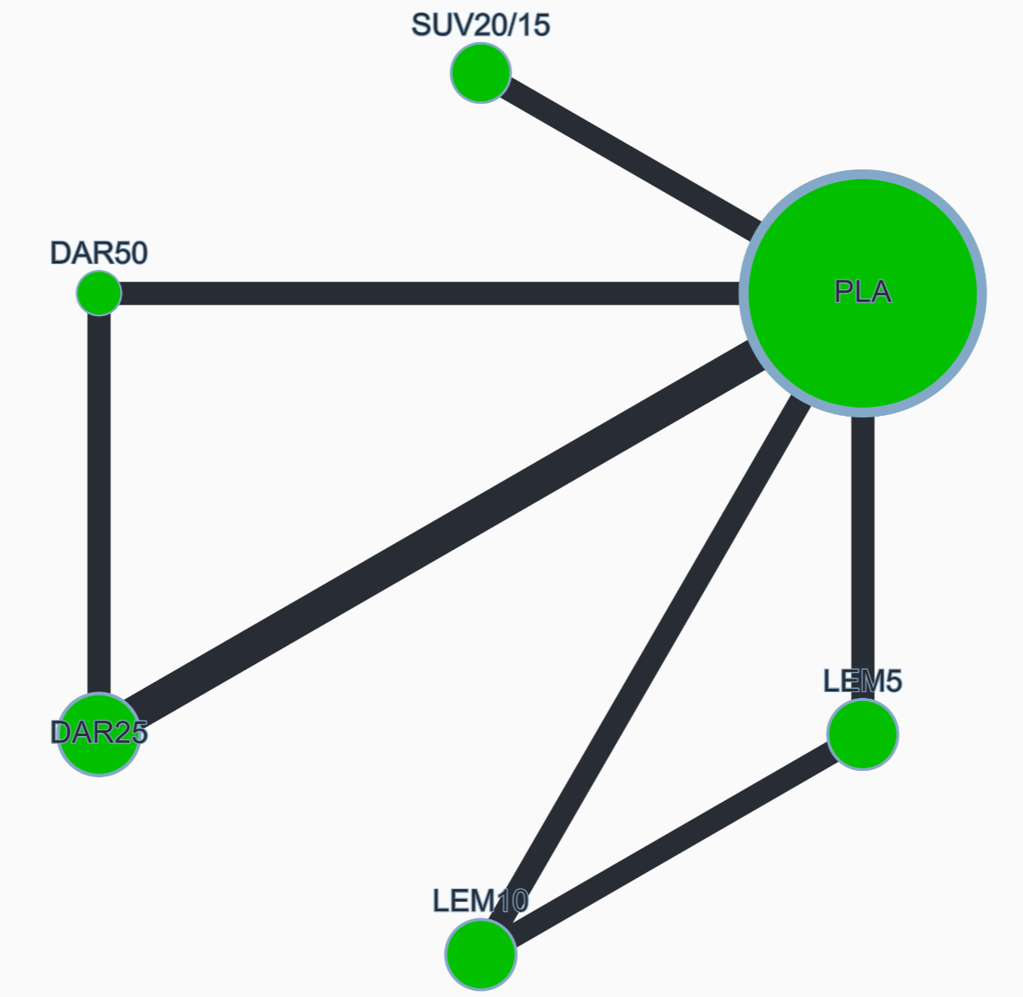

League table (OR with 95% CI)
DAR25 | 1.643 (0.244, 11.064) | 0.435 (0.118, 1.608) | 0.617 (0.158, 2.406) | 0.314 (0.067, 1.473) | 0.563 (0.187, 1.698)
 | DAR50 | 0.265 (0.037, 1.919) | 0.376 (0.050, 2.821) | 0.191 (0.022, 1.634) | 0.343 (0.054, 2.186)
 |  | LEM5 | 1.419 (0.668, 3.015) | 0.723 (0.200, 2.621) | 1.295 (0.642, 2.612)
 |  |  | LEM10 | 0.510 (0.133, 1.949) | 0.912 (0.412, 2.023)
 |  |  |  | SUV20/15 | 1.791 (0.608, 5.272)
 |  |  |  |  | PLA

Global heterogeneity
Between study variance (𝜏²): 0.000 (heterogeneity assessment: low)

Random-effects design-by-treatment interaction model
χ² statistic: 0.097 (1 degrees of freedom), P value: 0.756

Sensitivity analysis excluding Kärppä 2020 study
DAR25 | 1.643 (0.244, 11.064) | 0.476 (0.088, 2.577) | 2.934 (0.251, 34.350) | 0.314 (0.067, 1.473) | 0.563 (0.187, 1.698)
 | DAR50 | 0.290 (0.031, 2.752) | 1.786 (0.101, 31.661) | 0.191 (0.022, 1.634) | 0.343 (0.054, 2.186)
 |  | LEM5 | 6.161 (0.737, 51.532) | 0.660 (0.124, 3.520) | 1.183 (0.329, 4.247)
 |  |  | LEM10 | 0.107 (0.009, 1.242) | 0.192 (0.021, 1.730)
 |  |  |  | SUV20/15 | 1.791 (0.608, 5.272)
 |  |  |  |  | PLA

Global heterogeneity
Between study variance (𝜏²): 0.000 (heterogeneity assessment: low)

Random-effects design-by-treatment interaction model
χ² statistic: 0.097 (1 degrees of freedom), P value: 0.756

Local heterogeneity (I²) and incoherence (SIDE test)
 | NMA OR | Direct OR | I² | Indirect OR | P value (SIDE test)
DAR25 vs DAR50 | 1.643 (0.244, 11.064) | 1.614 (0.197, 13.217) | 0.0% | 1.785 (0.019, 165.224) | 0.969
DAR25 vs PLA | 0.563 (0.187, 1.698) | 0.556 (0.182, 1.695) | 0.0% | 1.054 (0.000, 2304.687) | 0.872
DAR50 vs PLA | 0.343 (0.054, 2.186) | 0.436 (0.061, 3.109) | 0.0% | 0.051 (0.000, 13.036) | 0.475
LEM5 vs LEM10 | 1.419 (0.668, 3.015) | 1.472 (0.686, 3.159) | 50.1% | 0.380 (0.004, 37.989) | 0.569
LEM5 vs PLA |  | 1.287 (0.638, 2.596) | 0.0%
LEM10 vs PLA | 0.912 (0.412, 2.023) | 0.883 (0.393, 1.984) | 53.3% | 2.349 (0.031, 180.224) | 0.664
SUV20/15 vs PLA |  | 1.791 (0.608, 5.272) | 30.3%

CINeMA confidence rating
Comparison | Number of studies | Within-study bias | Reporting bias | Indirectness | Imprecision | Heterogeneity | Incoherence | Confidence rating
DAR25 vs DAR50 | 2 | No concerns | Some concerns | No concerns | Major concerns | No concerns | No concerns | Low
DAR25 vs PLA | 3 | No concerns | Some concerns | No concerns | Major concerns | No concerns | No concerns | Low
DAR50 vs PLA | 2 | No concerns | Some concerns | No concerns | Major concerns | No concerns | No concerns | Low
LEM5 vs LEM10 | 2 | No concerns | Some concerns | No concerns | Major concerns | No concerns | No concerns | Low
LEM5 vs PLA | 2 | No concerns | Some concerns | No concerns | Major concerns | No concerns | No concerns | Low
LEM10 vs PLA | 2 | No concerns | Some concerns | No concerns | Major concerns | No concerns | No concerns | Low
SUV20/15 vs PLA | 2 | No concerns | Some concerns | No concerns | Major concerns | No concerns | No concerns | Low
DAR25 vs LEM5 | 0 | No concerns | Some concerns | No concerns | Major concerns | No concerns | No concerns | Very low
DAR25 vs LEM10 | 0 | No concerns | Some concerns | No concerns | Major concerns | No concerns | No concerns | Very low
DAR25 vs SUV20/15 | 0 | No concerns | Some concerns | No concerns | Major concerns | No concerns | No concerns | Very low
DAR50 vs LEM5 | 0 | No concerns | Some concerns | No concerns | Major concerns | No concerns | No concerns | Very low
DAR50 vs LEM10 | 0 | No concerns | Some concerns | No concerns | Major concerns | No concerns | No concerns | Very low
DAR50 vs SUV20/15 | 0 | No concerns | Some concerns | No concerns | Major concerns | No concerns | No concerns | Very low
LEM5 vs SUV20/15 | 0 | No concerns | Some concerns | No concerns | Major concerns | No concerns | No concerns | Very low
LEM10 vs SUV20/15 | 0 | No concerns | Some concerns | No concerns | Major concerns | No concerns | No concerns | Very low

Appendix S14. Individual adverse events that were very rare.
 | SUV20/15 | LEM5 | LEM10 | DAR25 | DAR50 | Placebo
Death | 0.000% | 0.000% | 0.000% | 0.119% | 0.000% | 0.047%
Suicidal ideation and/or behavior | 0.203% | 0.000% | 0.000% | 0.148% | 0.000% | 0.061%
Sleep paralysis | 0.203% | 0.376% | 1.119% | 0.384% | 0.426% | 0.000%
Abnormal dreams | 1.826% | 2.229% | 1.274% | 0.119% | 0.000% | 0.675%
Nightmare | na | 1.274% | 2.229% | 0.476% | 0.213% | 0.259%
Cataplexy | 0.000% | 0.000% | 0.000% | 0.000% | 0.000% | 0.000%

