Supplementary Information
Dysbiosis and Depression: A Study of Gut Microbiota Alterations and Functional Pathways in Antidepressant-Naïve Mood Disorder Patients
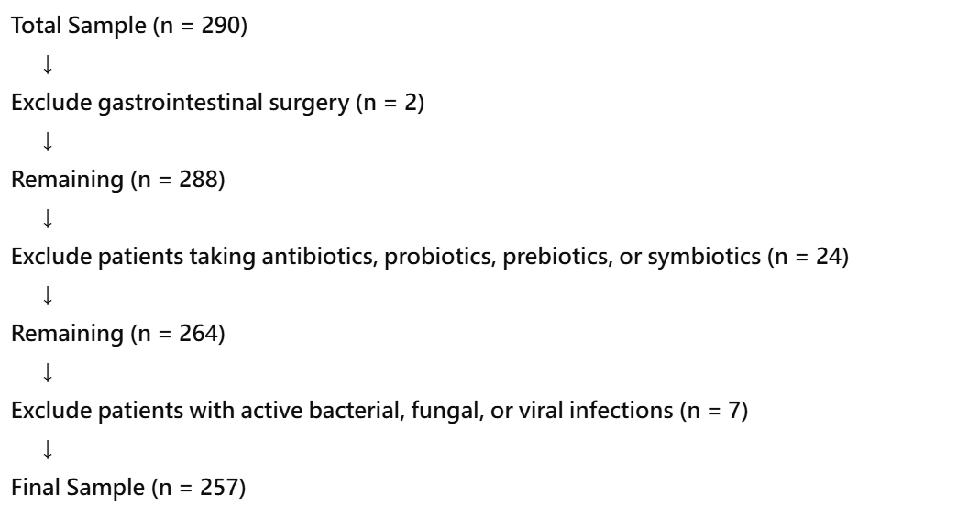
Figure S1. Sample Filtering Flow Chart. n: Sample size

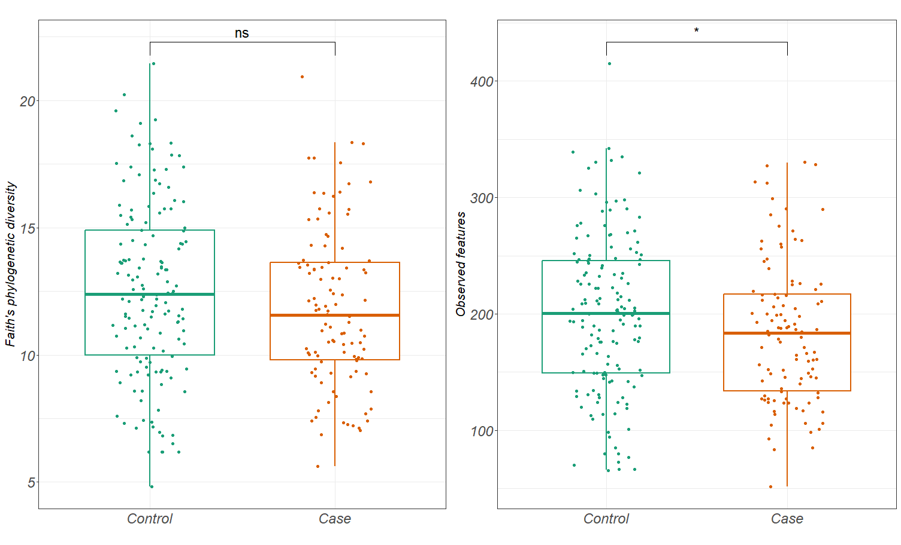
Figure S2. Alpha Diversity Indices Between Case and Control. ns: non-significant; *p-value < 0.05

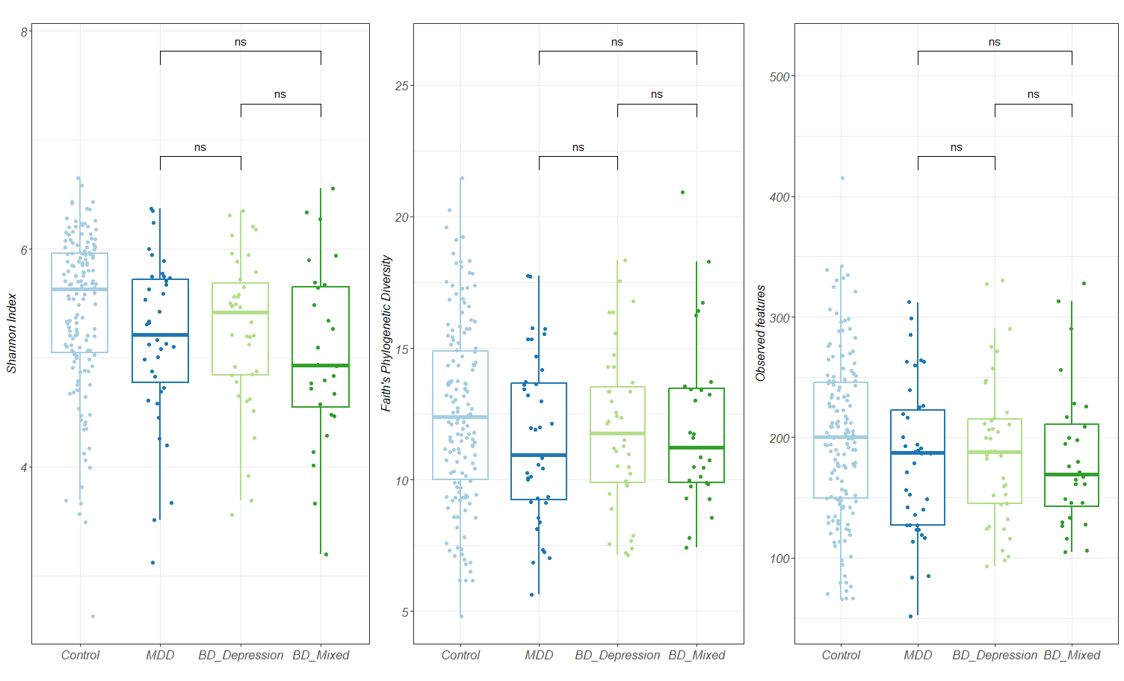
Figure S3. Alpha Diversity Indices Sensitivity Analysis. MDD=Major Depressive Disorder; BD_depression: Bipolar Disorder depression episode; BD_mixed: Bipolar Disorder mixed episode. ns: non-significant

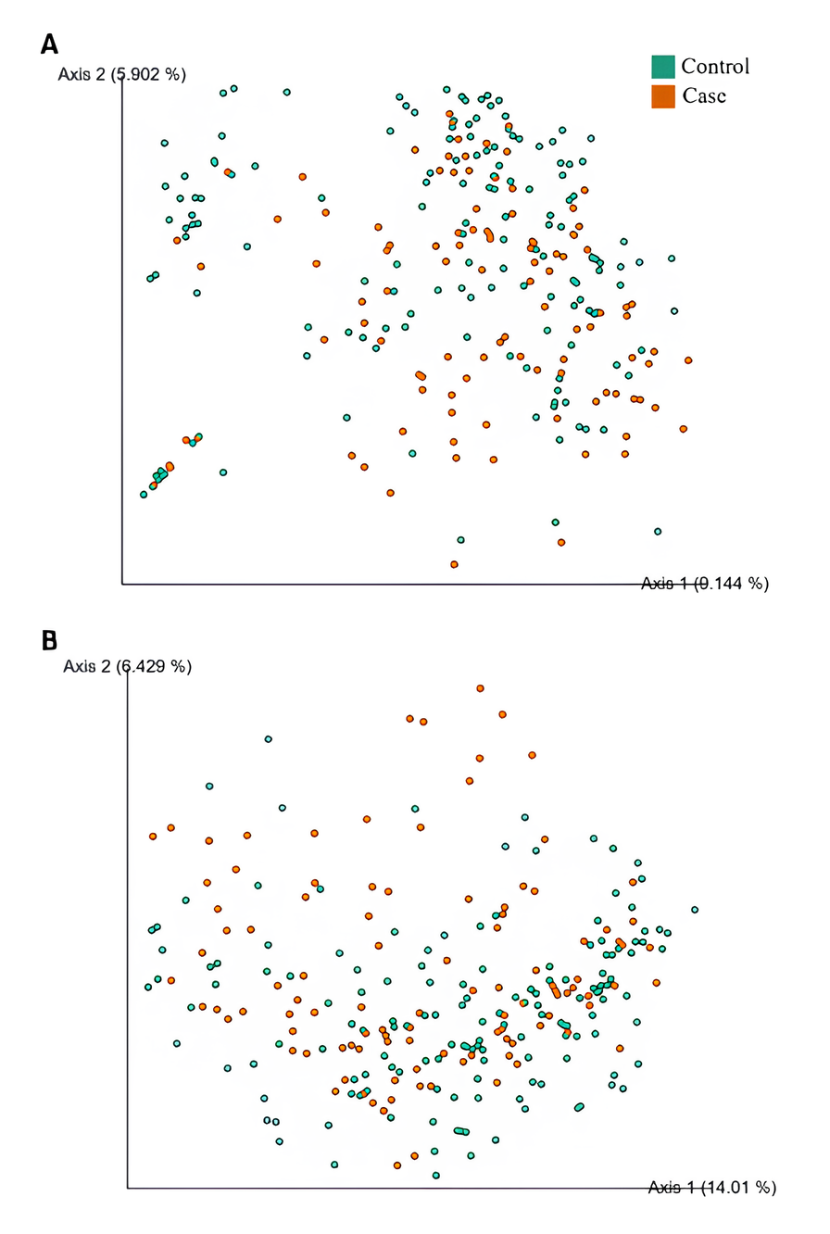
Figure S4. Beta Diversity Principal Coordinate Analysis (PCoA) Plots. (A) Bray-Curtis distance (permutation ANOVA p < 0.001) (B) Unweighted Uni-Frac distance (permutation ANOVA p < 0.001)

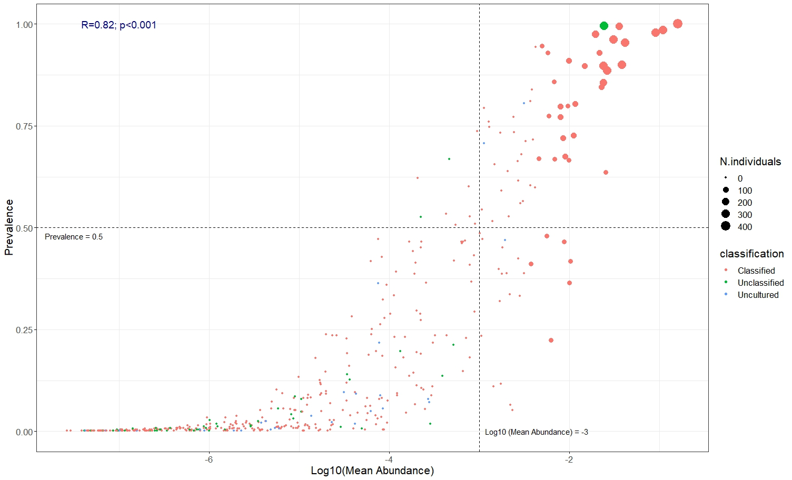
Figure S5. Taxa Prevalence and Abundance Plot at Genus Level. Each point represents an identified genus. The colors of the points represent whether a taxon can or cannot be classified as genus level or can be classified but uncultured. The size of each point (N. individuals) indicates the number of samples in which that taxon has a relative abundance of at least 0.01 (i.e., 1% of the total abundance). The prevalence and the log mean abundance criteria (dotted line) were further applied for taxa filtering. R: Correlation coefficient / Correlation strength

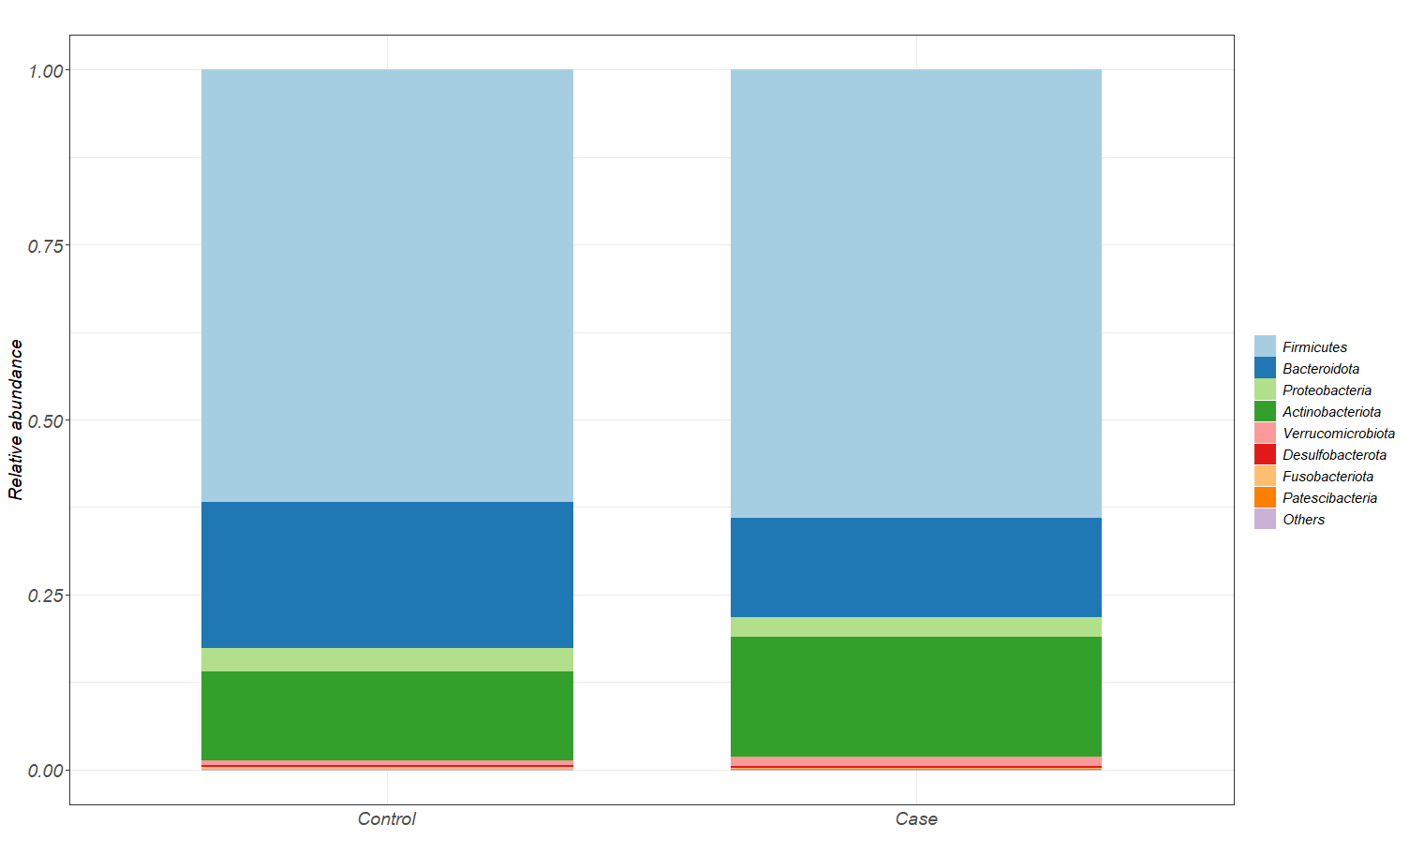
Figure S6. Phylum Level Taxa Average Relative Abundance Bar Plot. Taxa prevalence less than 0.3 were reclassified as “Others”

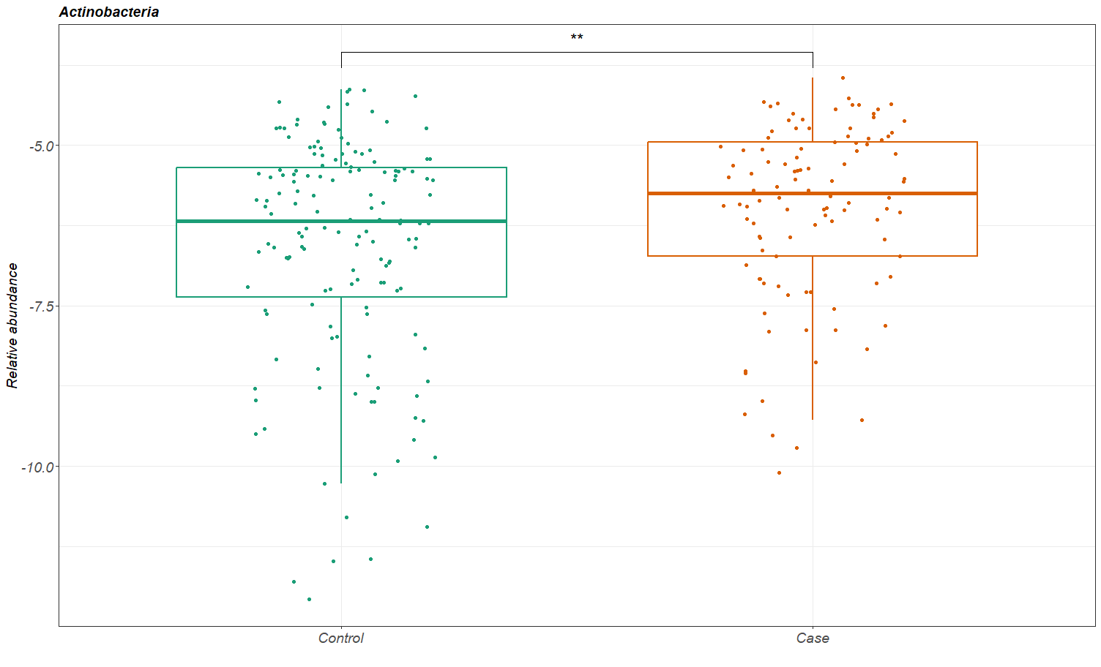
Figure S7. Relative Abundance of Actinobacteria at Phylum Level. The abundance was total sum scale (TSS) normalized, and log transformed. **p-value < 0.01

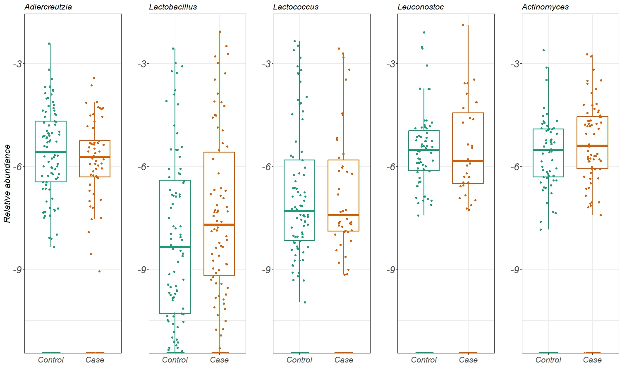
Figure S8. Relative Abundance Boxplots of the Other Significant Taxa (p-value rank six to ten). All the taxa relative abundance was total sum scale (TSS) normalized, and log transformed.

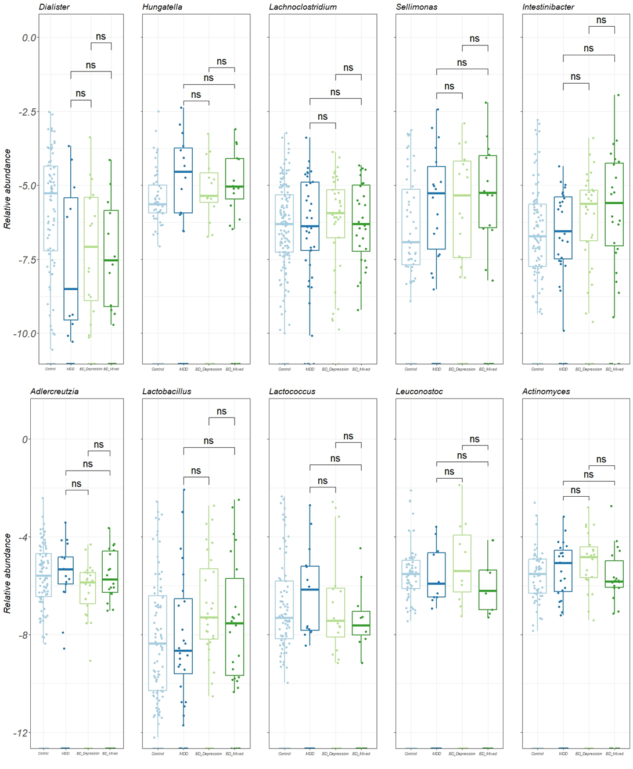
Figure S9. Diagnosis Sensitivity Analysis of Identified Taxa Relative Abundance. All the taxa relative abundance was total sum scale (TSS) normalized, and log transformed. MDD=Major Depressive Disorder; BD_depression: Bipolar Disorder depression episode; BD_mixed: Bipolar Disorder mixed episode; ns: non-significant

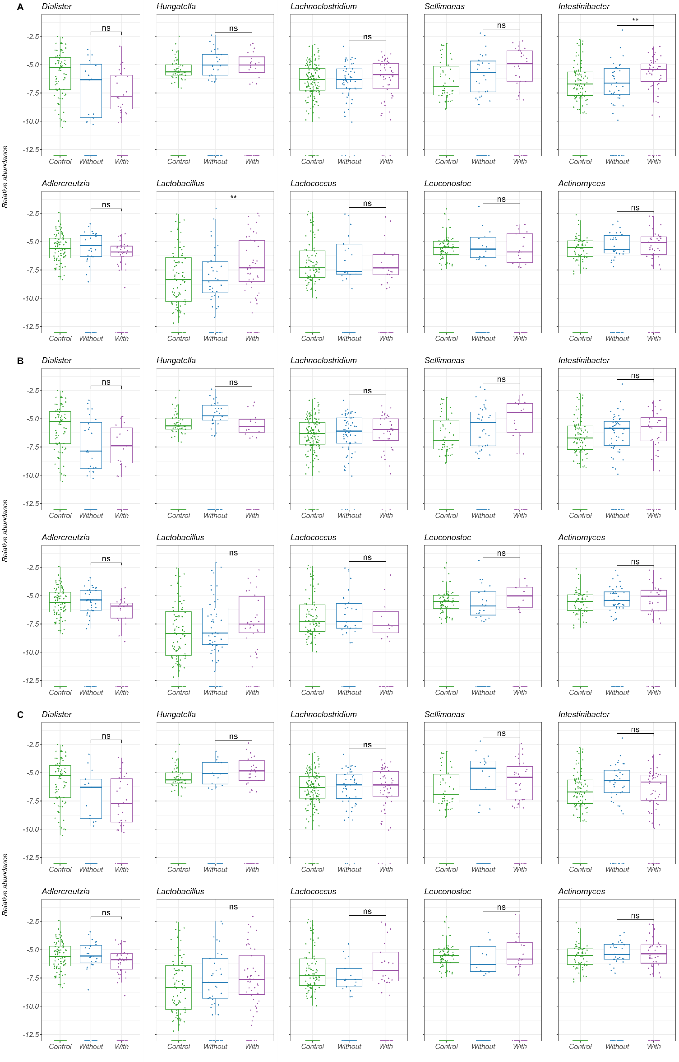
Figure S10. Other Psychotropics Use Sensitivity Analysis of Identified Taxa Relative Abundance. All the taxa relative abundance was total sum scale (TSS) normalized, and log transformed. (A) Antipsychotics use. (B) Mood stabilizers use. (C) Anxiolytics use. Control: Healthy controls; Without: without other psychotropic use; With: with other psychotropic use. ns: non-significant; ns: non-significant; **p-value < 0.01

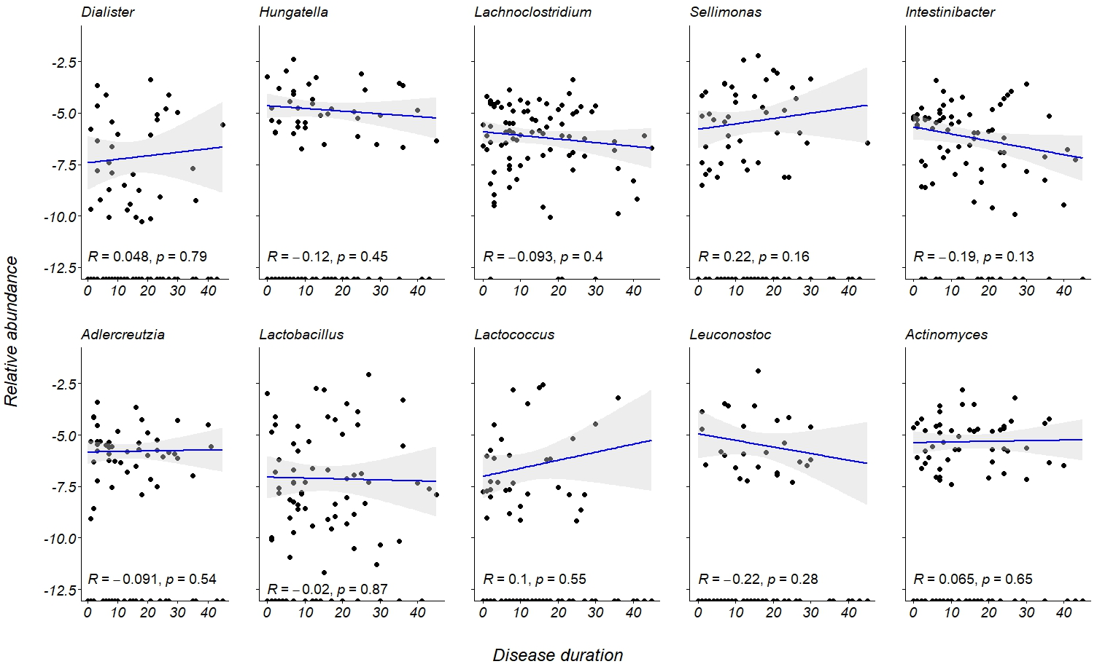
Figure S11. Disease Duration and Identified Taxa Relative Abundance Analysis. All the taxa relative abundance was total sum scale (TSS) normalized, and log transformed. R: Correlation coefficient / Correlation strength; p: p-value

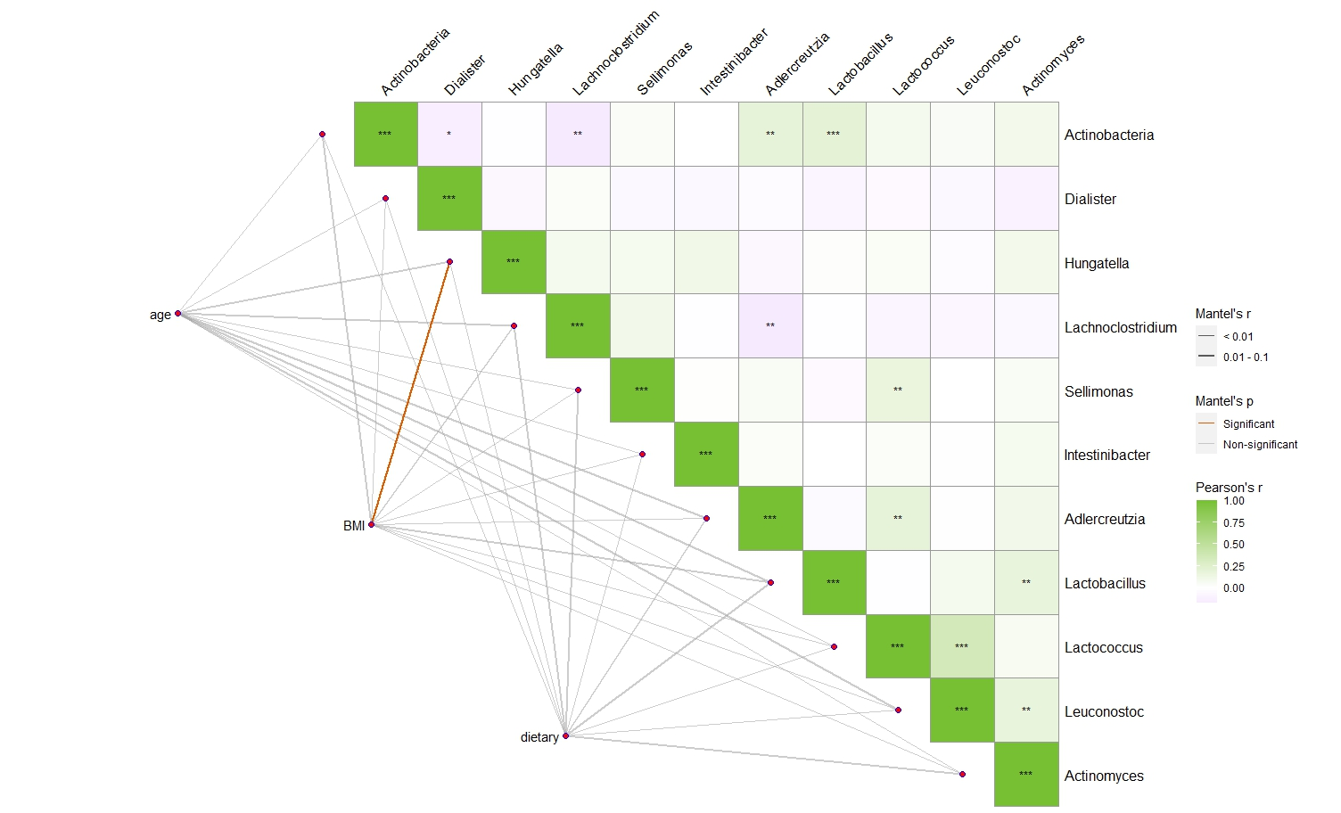
Figure S12. Matrix Correlation of Identified Taxa and Other Demographic, Dietary Factors. The upper side is the correlation heatmap of identified taxa abundance, while the lower side is the correlation metrices between identified taxa abundance matrix and age, BMI, and dietary metrices. Dietary matrix includes total energy, total protein, animal protein, plant protein, total fat, animal fat, plant fat, total carbohydrate, sugar, fructose, lactose, dietary fiber, and crude fiber consumption. Mantel’s r stands for matrix correlation coefficients; the strength is represented by line width. Mantel’s r p-value is represented by line color. Pearson’s r stands for correlation coefficients between each targeted taxon. BMI: Body Mass Index; *p-value < 0.05; **p-value < 0.01; ***p-value < 0.001
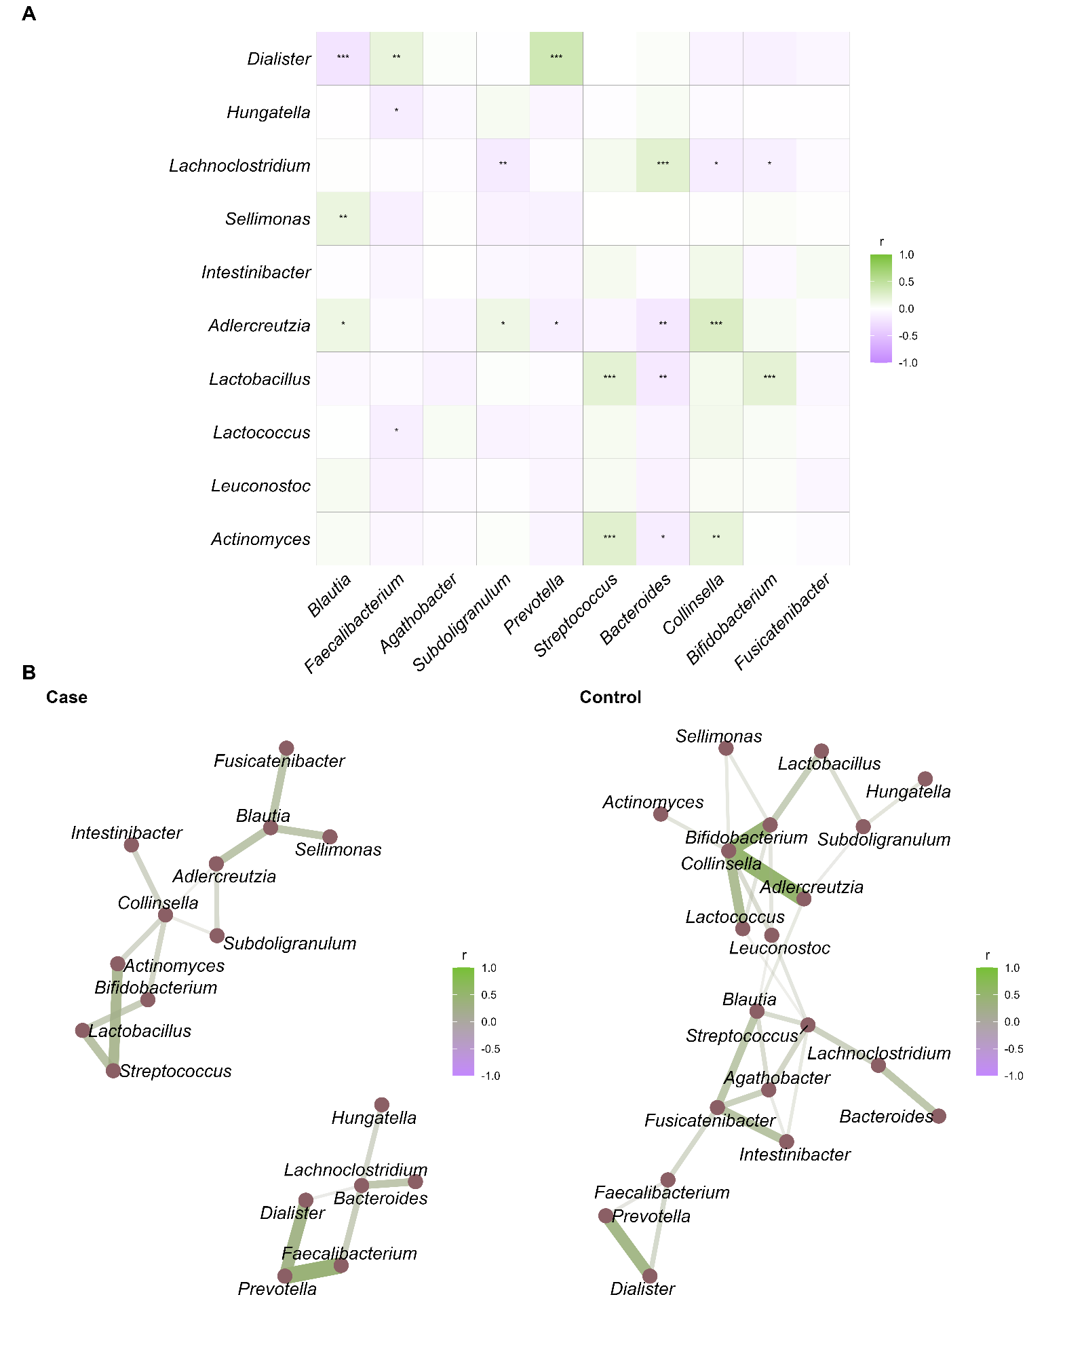
Figure S13. Identified Taxa and Dominate Taxa Correlation Network. (A) Pooled (case and control) correlation heatmap. (B) Co-occurrence network forced-directed graphs in case and control group. r: Correlation coefficient / Correlation strength; *p-value < 0.05; **p-value < 0.01; ***p-value < 0.001

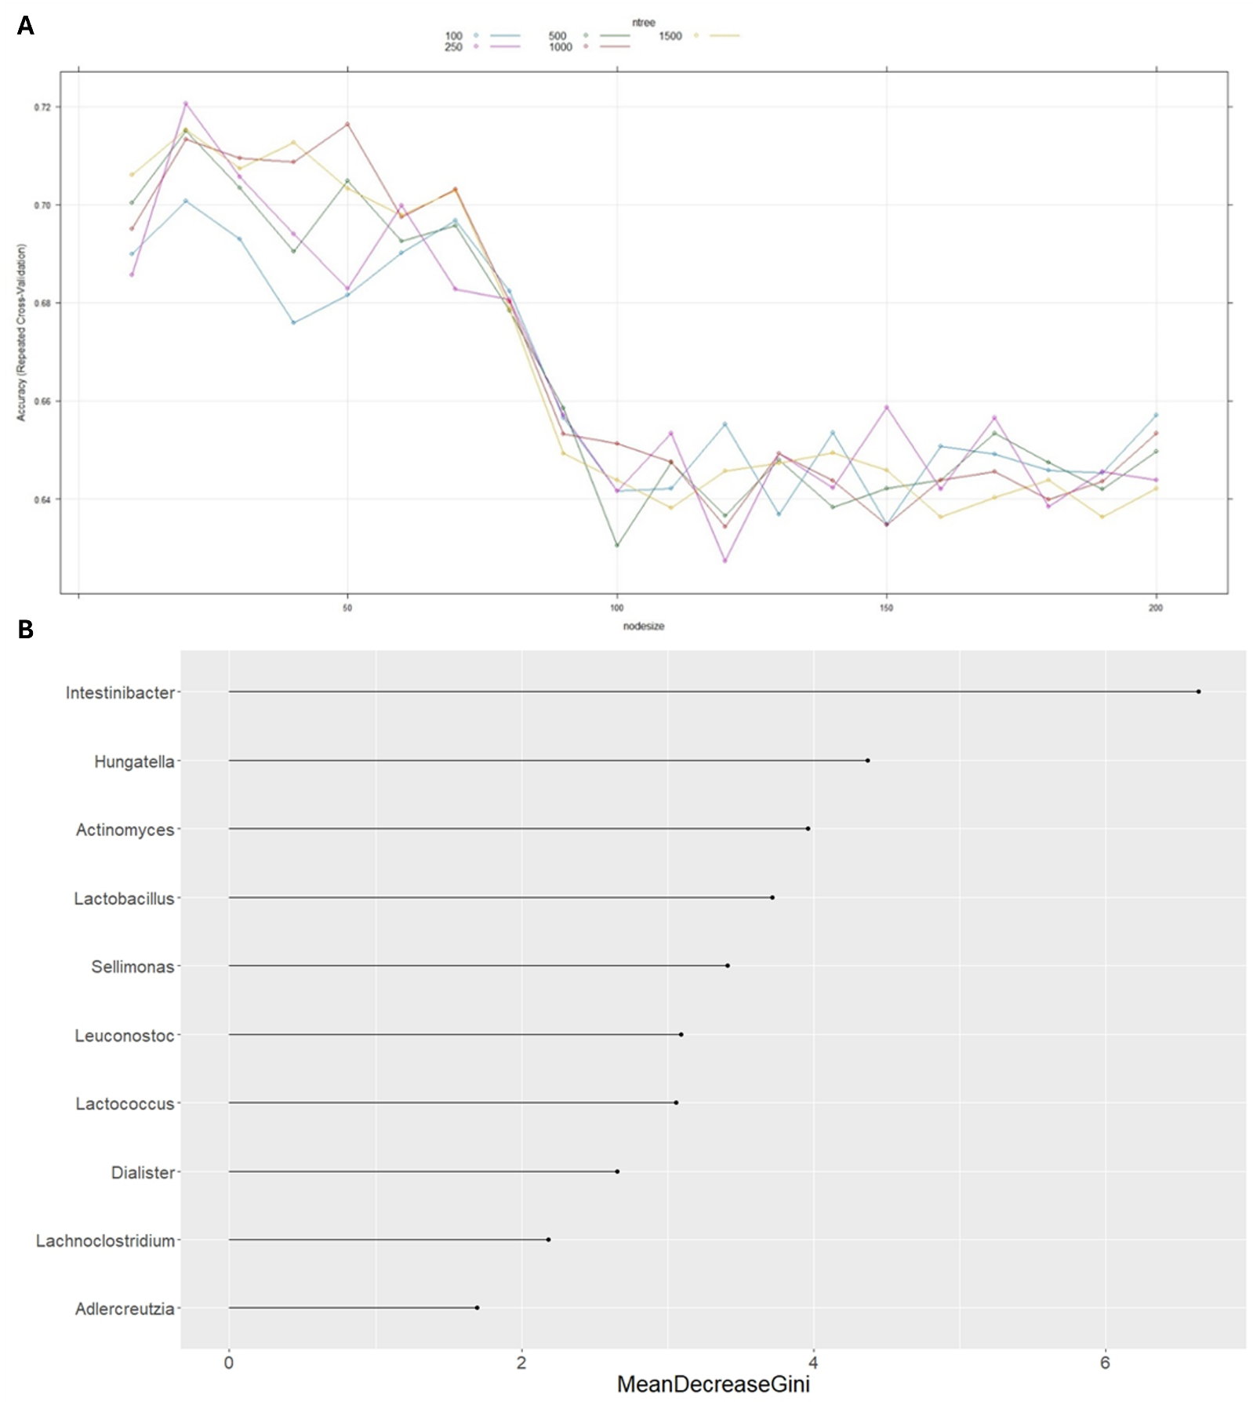
Figure S14. Random Forest Discriminating Model Parameter Tuning and Best Performed Model importance score. (A) We tuned two parameters, number of trees (ntree) and node size in random forest models. ntree was set from 100 to 1500, while the node size was set from 10 to 200 (with 10 as the interval). The y axis represents the model accuracy with cross validation, x axis represents different node sizes, and the lines represent different ntrees. (B) The identified taxa (N=10) at genus level importance scores were calculated by Gini score in best performed random forest model. N: number of taxa

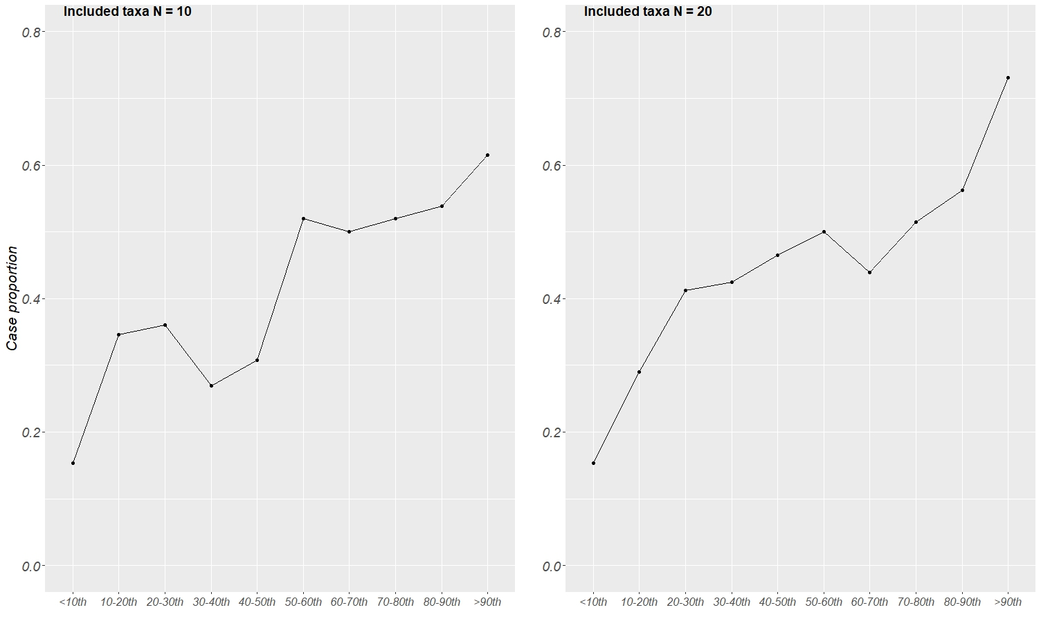
Figure S15. Case Proportion Trend by Each 10th Quantile of DDI_10 and DDI_20 Score. The y axis stands for case proportions while the x axis stands for each quantile of two scores. DDI_10: Includes ranked first 10 taxa for depression dysbiosis index; DDI_20: Includes ranked first 20 taxa for depression dysbiosis index. N: number of taxa

Table S1. Previous Genus Taxa Result from Depression Case Control Studies.
Frequency | Taxa | Directions (case) | Overall direction | Present study
7 or more | Alistipes | ↑Jiang  ↑Naseribafrouei  ↓Zheng  ↓Tillmann  ↓Liu  ↑Caso  ↓Liu2016 | ↓ | ↓ (-0.335)
7 or more | Bacteroides | ↓Jiang (A-MDD)  ↓Zheng  ↑Hu  ↑Chen  ↑Cheng  ↓Liu  ↓Lai  ↓Rong  ↑Liu2016 | ↓ | ↓ (-0.582)
7 or more | Faecalibacterium | ↓Jiang  ↓Zheng  ↓Valles-Colomer  ↓Chen  ↓Zhou  ↓Yao  ↓Liu2016 | ↓ | ↓ (-0.836)
7 or more | Roseburia | ↑Jiang  ↑Chen  ↓Zheng  ↓Tillmann  ↑Yao  ↓Liu  ↓Liu2016 | ↓ | ↓ (-0.015)
6 | Bifidobacterium | ↓Aizawa  ↑Chung  ↑Lai  ↑Rong  ↓Liu2016  ↑ChenJJ | ↑ | ↓ (-0.562)
6 | Blautia | ↑Jiang (A-MDD)  ↑Zheng  ↑Tillmann  ↑Chung  ↓Huang  ↓Liu2016 | ↑ | ↓ (-0.048)
6 | Dialister | ↓Jiang  ↓Tillmann  ↓Valles-Colomer  ↓Caso  ↓Kelly  ↑Liu2016 | ↓ | ↓ (-1.548) Sig.
6 | Eggerthella | ↑Lai  ↑Kelly  ↑Chung  ↑Chen  ↑Rong  ↑Zheng | ↑ | ↑ (0.217)
6 | Prevotella | ↑Lin  ↓Jiang  ↓Kelly  ↓Liu  ↑Liu2016  ↓Chung | ↓ | ↑ (0.125)
5 | Oscillibacter | ↑Jiang (A-MDD)  ↓Jiang (R-MDD)  ↑Lai  ↑Rong  ↓Liu2016 | ↑ | ↑ (0.399)
4 | Clostridium | ↑Jiang (A-MDD)  ↑Lin  ↓Liu  ↑Rong | ↑ | NA
4 | Coprococcus | ↓Tillmann  ↓Valles-Colomer  ↓Huang  ↓Liu2016 | ↓ | ↓ (-0.373)
4 | Parabacteroides | ↑Jiang  ↑Valles-Colomer  ↑Hu  ↓Liu2016 | ↑ | ↓ (-0.435)
4 | Sutterella | ↓Liu2016  ↓Chen  ↓Chung  ↓Zheng | ↓ | ↓ (-0.389)
3 | Anaerostipes | ↑Zheng  ↑Chen  ↓Caso | ↑ | ↓ (-0.292)
3 | Phascolarctobacterium | ↑Jiang  ↑Valles-Colomer  ↓Zhou | ↑ | ↑ (0.611)
3 | Ruminococcus | ↓Jiang  ↓Zhu  ↓Liu2016 | ↓ | ↓ (-0.846)
3 | Streptococcus | ↑Lin  ↑Lai  ↑Rong | ↑ | ↑ (0.420)
3 | Turicibacter | ↓Valles-Colomer  ↓Liu  ↑Kelly | ↓ | ↑ (0.420)
↑/↓ indicates that the abundance of the corresponding taxon was previously reported to be higher/lower in patients with depression compared to healthy controls. Sig.: Significant
Table S2. Fundamental Microbial Unit (ASV) Table Summarizes Each Order After Quality Control. We conducted 12 orders of stool DNA extraction and sequencing.
Order | 1st | 2nd | 3rd | 4th | 5th | 6th | 7th | 8th | 9th | 10th | 11st | 12nd
N | 40 | 40 | 59 | 36 | 77 | 21 | 12 | 74 | 78 | 38 | 72 | 91
ASVs | 2,398 | 2,306 | 3,185 | 2,819 | 1,690 | 6,920 | 1,412 | 3,684 | 2,172 | 1,922 | 3,602 | 4,491
Frequency | 5,498,671 | 5,539,394 | 7,826,059 | 5,008,978 | 6,574,285 | 4,366,179 | 723,759 | 6,458,712 | 5,894,694 | 3,342,662 | 7,094,018 | 8,292,510
N: Sample size; ASV: Amplicon sequence variant, a unique sequence variant identified through QIIME2 analysis. These ASVs serve as discrete microbial units used to assess community composition, diversity, and relative abundance.

Table S3. Summary Table of Truncated Sequence Bases and ASV Among 257 Samples.
Metric | Sample
Number of samples | 257
Number of features | 9,757
Total frequency | 27,950,371

ASVs per sample | Frequency
Minimum frequency | 12,074
1st quartile | 80,499
Median frequency | 95,976
3rd quartile | 131,017
Maximum frequency | 515,819
Mean frequency | 108,756.31
ASV: Amplicon sequence variant, a unique sequence variant identified through QIIME analysis. These ASVs serve as discrete microbial units used to assess community composition, diversity, and relative abundance.
Table S4. Alpha Diversity Linear Regression. We adjusted for diagnosis, age, sex, BMI, and sequence order (not listed) which stands for batch effects.
Shannon index |  | Estimate | Std. Error | t value | p-value
Intercept |  | 5.439 | 0.592 | 91.927 | < 0.001***
Group | Case | -0.281 | 0.106 | -2.642 | 0.009**
Sex | Male | -0.068 | 0.107 | -0.636 | 0.526
Age | - | -0.002 | 0.004 | -0.483 | 0.630
BMI | - | -0.002 | 0.013 | -0.136 | 0.892
Multiple R² = 0.0346; Adjusted R² = 0.02696

Faith’s phylogenetic diversity |  | Estimate | Std. Error | t value | p-value
Intercept |  | 12.528 | 0.269 | 46.508 | < 0.001***
Group | Case | -0.540 | 0.485 | -1.113 | 0.267
Sex | Male | -0.497 | 0.477 | -1.041 | 0.299
Age | - | -0.021 | 0.017 | -1.228 | 0.221
BMI | - | -0.054 | 0.058 | -0.923 | 0.357
Multiple R² = 0.03039; Adjusted R² = 0.008749

Observed features |  | Estimate | Std. Error | t value | p-value
Intercept |  | 231.188 | 27.276 | 8.476 | < 0.001***
Group | Case | -13.231 | 10.552 | -1.254 | 0.211
Sex | Male | -8.197 | 9.460 | -0.867 | 0.387
Age | - | -0.240 | 0.335 | -0.718 | 0.474
BMI | - | -0.887 | 1.151 | -0.770 | 0.442
Multiple R² = 0.02778; Adjusted R² = 0.006078
BMI: Body Mass Index; Std. Error: Standard Error; R²: Coefficient of determination. **p-value < 0.01; ***p-value < 0.001
Table S5. Number of Taxa at All Taxonomic Levels
Taxonomic level | N
Phylum | 17
Class | 28
Order | 75
Family | 143
Genus | 395
N: Number of taxa

Table S6. Genus Level Taxa Prevalence and Abundance Statistics
Indices | Threshold | N
Total taxa count | NA | 395
Prevalence | 0.3 | 111
Log (mean abundance) | -4 | 138
Prevalence & Log (mean abundance) | 0.3 & -4 | 103
N: Number of taxa

Table S7. Mean Abundance and Prevalence of Top Ten Dominated Taxa at Genus Level
Taxa | Abundance | Prevalence (%)
Blautia | 0.1387 | 100.00
Bacteroides | 0.1147 | 97.29
Bifidobacterium | 0.0926 | 97.67
Faecalibacterium | 0.0479 | 96.90
Collinsella | 0.0437 | 93.41
Prevotella | 0.0319 | 65.12
Fusicatenibacter | 0.0318 | 96.12
Streptococcus | 0.0298 | 96.90
Agathobacter | 0.0274 | 86.05
Subdoligranulum | 0.0263 | 86.43

Table S8. Genus Level Targeted Taxa Correlation Pair Tests (PERMUTATION Test)
Pairs |  | Correlation coefficients |  | p-value
 |  | Case | Control | p-value
Dialister | Hungatella | 0.006 | -0.068 | 0.549
Dialister | Lachnoclostridium | 0.044 | 0.044 | 0.999
Dialister | Sellimonas | -0.022 | -0.049 | 0.828
Dialister | Intestinibacter | 0.002 | -0.071 | 0.550
Dialister | Adlercreutzia | -0.083 | -0.050 | 0.790
Dialister | Lactobacillus | -0.083 | -0.082 | 0.994
Dialister | Lactococcus | -0.063 | -0.057 | 0.961
Dialister | Leuconostoc | -0.035 | -0.084 | 0.698
Dialister | Actinomyces | -0.054 | -0.086 | 0.787
Hungatella | Lachnoclostridium | 0.149 | 0.021 | 0.281
Hungatella | Sellimonas | 0.030 | 0.091 | 0.632
Hungatella | Intestinibacter | 0.070 | 0.160 | 0.471
Hungatella | Adlercreutzia | -0.088 | -0.044 | 0.724
Hungatella | Lactobacillus | -0.041 | 0.074 | 0.360
Hungatella | Lactococcus | -0.029 | 0.128 | 0.230
Hungatella | Leuconostoc | -0.075 | 0.023 | 0.444
Hungatella | Actinomyces | 0.086 | 0.054 | 0.803
Lachnoclostridium | Sellimonas | 0.154 | 0.044 | 0.375
Lachnoclostridium | Intestinibacter | 0.044 | -0.087 | 0.308
Lachnoclostridium | Adlercreutzia | -0.221 | -0.157 | 0.577
Lachnoclostridium | Lactobacillus | -0.046 | -0.006 | 0.769
Lachnoclostridium | Lactococcus | -0.050 | -0.098 | 0.706
Lachnoclostridium | Leuconostoc | -0.067 | -0.078 | 0.931
Lachnoclostridium | Actinomyces | -0.092 | -0.052 | 0.749
Sellimonas | Intestinibacter | -0.017 | 0.016 | 0.781
Sellimonas | Adlercreutzia | 0.237 | -0.042 | 0.025*
Sellimonas | Lactobacillus | -0.077 | -0.054 | 0.846
Sellimonas | Lactococcus | 0.111 | 0.309 | 0.118
Sellimonas | Leuconostoc | 0.011 | -0.012 | 0.861
Sellimonas | Actinomyces | -0.097 | 0.292 | 0.002*
Intestinibacter | Adlercreutzia | 0.140 | -0.009 | 0.244
Intestinibacter | Lactobacillus | -0.013 | -0.013 | 0.998
Intestinibacter | Lactococcus | -0.020 | 0.105 | 0.310
Intestinibacter | Leuconostoc | -0.030 | 0.023 | 0.672
Intestinibacter | Actinomyces | -0.002 | 0.155 | 0.210
Adlercreutzia | Lactobacillus | -0.076 | -0.015 | 0.636
Adlercreutzia | Lactococcus | -0.069 | 0.276 | 0.009*
Adlercreutzia | Leuconostoc | -0.060 | 0.012 | 0.576
Adlercreutzia | Actinomyces | -0.049 | 0.232 | 0.029*
Lactobacillus | Lactococcus | -0.005 | -0.021 | 0.897
Lactobacillus | Leuconostoc | -0.033 | 0.270 | 0.012*
Lactobacillus | Actinomyces | 0.281 | -0.045 | 0.008*
Lactococcus | Leuconostoc | 0.632 | 0.166 | <0.001*
Lactococcus | Actinomyces | 0.060 | 0.087 | 0.828
Leuconostoc | Actinomyces | 0.197 | 0.166 | 0.805
*p-value met significance level (< 0.05)
Table S9. Depression Dysbiosis Index Candidate Taxa Robust Rank Test. We randomly selected 70% of dataset as testing set, a total 112 taxa were fitted in Maaslin2 regression. Taxa were ranked 1-50 by the p-values, the others ranked as 100. We then sum all the ranks of each taxon in 100 tests.
$$Weight=\frac{Total Rank Sum/2}{Taxa Rank Sum}, Total Rank Sum=11,200$$
Overall Rank | Taxa | Rank Sum | Weight | Coef. Consistency (%) | Mean Coef. | p.sig (%)
1 | Dialister | 736 | 7.609 | 100.00 | -1.556 | 77.00
2 | Hungatella | 1,254 | 4.466 | 100.00 | 0.729 | 60.00
3 | Lachnoclostridium | 1,347 | 4.157 | 100.00 | 0.903 | 56.00
4 | Sellimonas | 1,413 | 3.963 | 100.00 | 0.990 | 53.00
5 | Intestinibacter | 1,547 | 3.620 | 100.00 | 1.160 | 57.00
6 | Adlercreutzia | 1,837 | 3.048 | 100.00 | -0.977 | 53.00
7 | Actinomyces | 2,266 | 2.471 | 100.00 | 0.547 | 40.00
8 | Lactobacillus | 2,318 | 2.416 | 100.00 | 1.301 | 39.00
9 | Leuconostoc | 2,360 | 2.416 | 100.00 | -0.630 | 32.00
10 | Lactococcus | 2,699 | 2.075 | 100.00 | -0.880 | 33.00
11 | Eubacterium._fissicatena_group | 3,153 | 1.776 | 100.00 | 0.537 | 28.00
12 | Clostridium._innocuum_group | 3,228 | 1.735 | 99.00 | 0.715 | 27.00
13 | Faecalibacterium | 3,445 | 1.626 | 100.00 | -0.817 | 24.00
14 | Ruminococcus._gauvreauii_group | 3,944 | 1.420 | 100.00 | -0.969 | 17.00
15 | Eubacterium._ventriosum_group | 3,945 | 1.419 | 100.00 | -0.829 | 9.00
16 | f__Anaerovoracaceae.g__Family_XIII_UCG.001 | 3,984 | 1.406 | 99.00 | -0.604 | 15.00
17 | Anaerotruncus | 4,026 | 1.390 | 100.00 | 0.564 | 16.00
18 | Enterobacter | 4,040 | 1.386 | 99.00 | 0.912 | 16.00
19 | Eggerthella | 4,057 | 1.380 | 99.00 | 0.677 | 17.00
20 | Veillonella | 4,076 | 1.374 | 98.00 | 0.671 | 16.00
f_: family level; g_: genus level; Coef: Coefficient from MaASLIN2 regression; p.sig: p-value significant

