Supplemental Materials
Methods
Supplemental Figure 1.
EEG Data Processing Flow Diagram
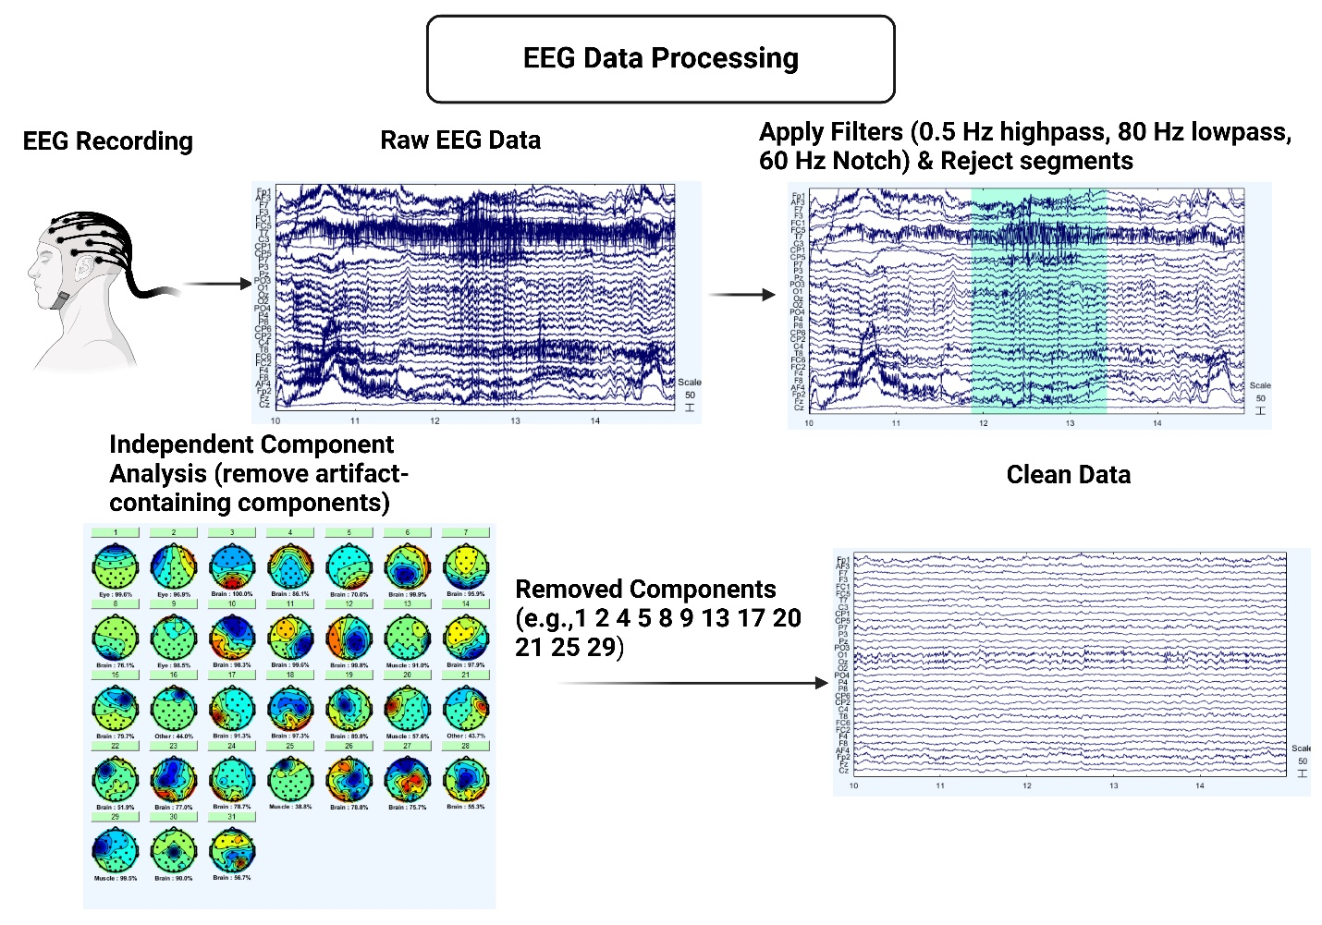
Note. The flow diagram depicts the process of first recording EEG data where both muscle and ocular artifacts are present in the electroencephalogram. Bad channels are interpolated (none present in examples). Artifacts are then removed either by rejection of swaths of data continuing artifact that will not decompose via independent component analysis (ICA). Data are then submitted to ICA for artifact-specific component removal. Made with BioRender.

Supplemental Figure 2.
Data Analysis Flow Diagram
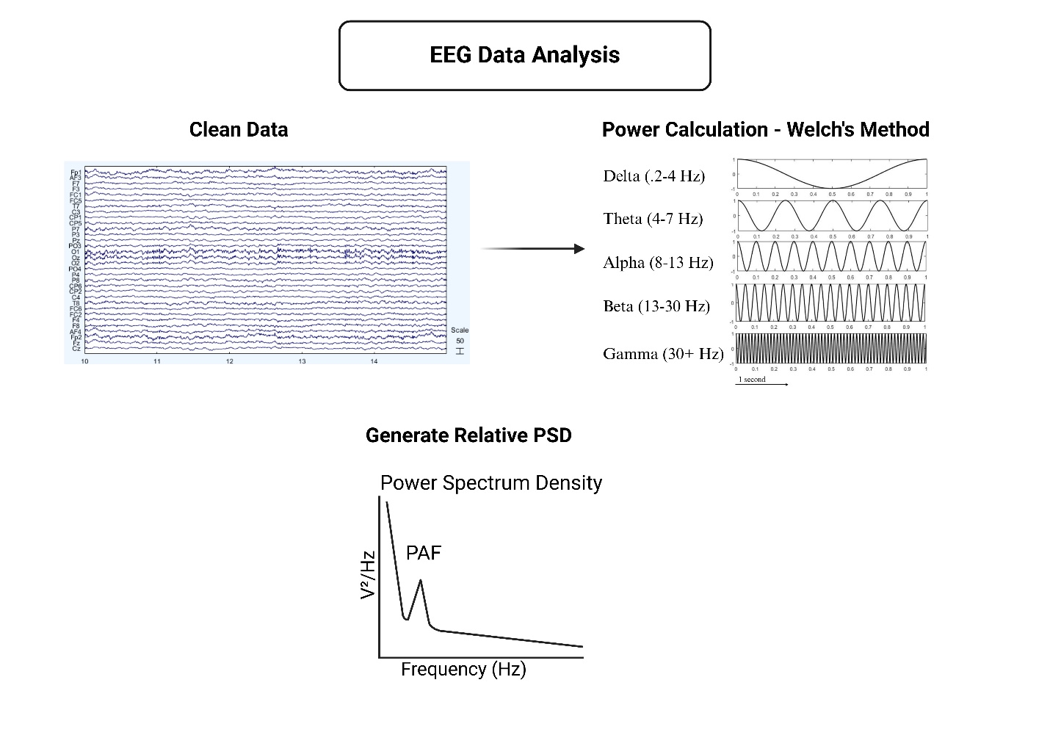
Note. Once the data are clean, power is computed using Welch’s method which also generates the power spectrum density. Peak alpha frequency (PAF) is identified from the power spectrum density (PSD) using the MATLAB function ‘findpeaks’. Of note, the power calculation and derivation of the PSD are relevant to all measurements except for the burst metrics which are described in the main methods and also in Norris et al. (2022). Made with BioRender.

Supplementary Figure 3.
Naïve Bayes Classifier (NBC) Flow Diagram

Results
All Conditions (N = 19).
One-way rmANOVAs tested for differences across all conditions for clinical variables from the original study that showed improvements with BPN14770 (Supplemental Table 1). Only VAS language demonstrated significant improvements with BPN14770. There was a main effect of condition for VAS language demonstrating improvements with BPN14770 (M = 52.89, SE = 5.14) from baseline (M = 33.11, SE = 6.28) but not placebo (M = 52.94, SE = 6.53), F(2, 17) = 8.27, p = .003, ES = .49).
Supplemental Table 1.
Repeated Measures ANOVA for Primary Clinical Variables
 | rmANOVA Statistics
Variable | df | f | p | ES
NIH-TCB
CCC | 2,17 | 0.24 | .788 | .03
PV | 2,17 | 0.69 | .511 | .08
ORR | 2,17 | 0.77 | .477 | .08
PSM | 2,11 | 0.77 | .488 | .12
PCPS | 2,17 | 1.66 | .221 | .16
VAS
Language | 2,17 | 8.27 | .003 | .49
Daily Functioning | 2,17 | 2.28 | .132 | .21
Note. The original study (Berry-Kravis et al., 2021) reported significant BPN14770 efficacy in the depicted variables. The variables were re-evaluated due to the reduced number of measurements included in the current study to determine whether clinical effects were still detectable with the use of measurements from only 3 time points to match EEG, as there were less EEG measurements (N = 3 time points) than clinical measurements (N = 5 time points). For visualization, see main manuscript Figure 2 and for more detail see the limitations section.

One-sample t-tests were conducted on clinical variable BPN14770-baseline difference scores for clinical variables that demonstrated BPN14770 effects in the original study to confirm BNP14770 effects (Supplemental Table 2). The only variable that demonstrated significant BPN14770 effects was the VAS Language domain, t (18) = 4.129, p < .001, d = .947. Both NIH-TCB PCPS and VAS anxiety/irritability trended towards significance (NIH-TCB PCPS: t(18) = 1.65, p = .058, d = .379; VAS anxiety/irritability: t(18) = 1.518, p = .073, d = .348).
Supplemental Table 2.
One-sample t-tests assessing BPN14770 Effect in Clinical Variables of Interest.
 | Statistics
Clinical Variables | t | df | p | d | 95% CI [LL, UP]
NIH-TCB
CCC | -0.508 | 18 | .309 | -.117 | [-2.16, 1.32]
ORR | -1.240 | 18 | .116 | -.285 | [-1.84, .47]
PSM | 0.733 | 14 | .238 | .189 | [-5.52, 11.25]
PV | -0.063 | 18 | .475 | -.015 | [-3.59, 3.39]
VAS
Language | 4.13 | 18 | .001 | .947 | [9.72, 29.86]
Anxiety/Irritability | 1.52 | 18 | .146 | .348 | [-3.52, 21.83]
Daily Functioning | 0.657 | 18 | .260 | .151 | [-9.61, 18.34]
Note. Correlations assessed potential relationships between PAF variable BPN14770-baseline difference scores and clinical measure difference scores of interest but were not significant (Supplemental Table 3).

Supplemental Table 3.
Correlations between PAF Difference Scores and Clinical Variables.
 | BPN14770 – Baseline (N = 17)
Variables (BPN14770 – baseline)
NIH-TCB (N = 19)ª | Frontal PAF | Occipital PAF | Whole Head PAF
CCC | -.044 | -.103 | -.082
PV | -.054 | -.126 | -.118
ORR | -.134 | -.111 | -.158
PSM (N = 15) | -.436 | -.323 | -.444
PCPS | -.313 | -.031 | -.175
VAS (N = 19)
Language | .326 | -.041 | .162
Anxiety/Irritability | .364 | -.164 | .129
Daily Functioning | .309 | .197 | .241
ABC (N = 19)
Hyperactivity | .298 | -.098 | .304
Inappropriate Speech | .216 | .689 | .206
Irritability | .048 | .058 | .122
Lethargy/Withdrawal | .323 | .104 | .296
Social Avoidance | .181 | -.355 | .062
Stereotypy | -.140 | -.213 | -.070
ADAMS (N = 19)
Depressed Mood | .125 | -.012 | .043
General Anxiety | .059 | .255 | .117
Manic/Hyperactive Behavior | -.016 | -.068 | -.080
Obsessive/ Compulsive Behavior | -.318 | -.090 | -.379
Social Avoidance | .140 | -.079 | .107
Note. All correlations are Spearman’s rho. Sample sizes are listed for each task and are the same across all sub-variables unless otherwise noted as Nª. No asterisk = N.S., *p <0.05, **p < 0.01.

Exploratory correlation analyses were conducted to explore relationships between raw PAF variables and all clinical variables for BPN14770 and placebo (Supplemental Table 4).
Supplemental Table 4.
Exploratory Correlations Evaluating Relationships between Raw PAF Scores for BPN14770.
 | BPN14770
Variable | Frontal | Occipital | Whole head
NIH-TCB (N = 19)ª
CCC | -.418 | -.380 | -.445
PV | -.300 | -.409 | -.395
ORR | -.194 | -.107 | -.077
PSM (N = 16) | -.413 | -.421 | -.387
PCPS | -.158 | -.341 | -.084
VAS (N = 19)
Language | .020 | -.065 | -.016
Anxiety/Irritability | .156 | -.054 | .074
Daily Functioning | .081 | .087 | -.054
ABC (N = 19)
Hyperactivity | .051 | .035 | .075
Inappropriate Speech | .183 | -.090 | .229
Irritability | -.048 | .047 | .081
Lethargy/Withdrawal | .422 | .230 | .534*
Social Avoidance | .194 | -.151 | .071
Stereotypy | .373 | .097 | .332
ADAMs (N = 19)
Depressed Mood | .173 | -.160 | .145
General Anxiety | .083 | .249 | .116
Manic/Hyperactive Behavior | .052 | .065 | .149
Obsessive/ Compulsive Behavior | .457* | .419 | .431
Social Avoidance | .398 | .119 | .439
Note. All correlations are Spearman’s rho. Sample sizes are listed for each task and are the same across all sub-variables unless otherwise noted as Nª. No asterisk = N.S., *p <0.05, **p < 0.01.

Multiple linear regression models were assessed to evaluate causal relationships between PAF difference scores across all three head regions and clinical measure difference scores for clinical variables that demonstrated improvements with BPN14770 reported in the original study (Berry-Kravis et al., 2019) (Supplemental Table 5). No models were statistically significant but the model evaluating the BPN14770-placebo difference score across all head regions was marginal for NIH-TBC ORR with the BPN14770 effect explaining 38.6% of the variability in ORR scores (F(3,18) = 3.14, p = .056, R² = .37), driven by the occipital region, β = -77, t(18) = -2.93, p = .010.
Supplemental Table 5.
Multiple Linear Regression Analysis Summary for Predicting BPN14770 Effect using Difference Scores.
Predictor | Coefficients |  |  |  | ANOVA
 | b | β | t | p | F | p | Fit (R²)
BPN14770 – Baseline
VAS Language |  |  |  |  | .66 | .587 | .12
PAF Frontal | 9.38 | .60 | 1.33 | .202
PAF Occipital | 1.82 | .09 | 0.35 | .735
PAF Whole Head | -11.58 | -.41 | -0.87 | .398
VAS Daily Functioning |  |  |  |  | 2.27 | .122 | .31
PAF Frontal | 21.35 | .98 | 2.48 | .026
PAF Occipital | 5.06 | .19 | 0.78 | .446
PAF Whole Head | -26.94 | -.69 | -1.65 | .119
NIH-TCB CCC |  |  |  |  | 0.21 | .207 | .04
PAF Frontal | 0.76 | .28 | 0.59 | .559
PAF Occipital | 0.16 | .05 | 0.17 | .871
PAF Whole Head | -1.82 | -.37 | -0.76 | .461
NIH-TCB PV |  |  |  |  | 0.13 | .938 | .03
PAF Frontal | 1.36 | .25 | 0.53 | .603
PAF Occipital | 0.58 | .09 | 0.30 | .768
PAF Whole Head | -3.07 | -.32 | -0.63 | .536
NIH-TCB ORR |  |  |  |  | 0.12 | .947 | .02
PAF Frontal | 0.31 | .17 | 0.37 | .719
PAF Occipital | -0.15 | -.07 | -0.23 | .824
PAF Whole Head | -0.63 | -.19 | -0.39 | .701
NIH-TCB PSM |  |  |  |  | 1.56 | .255 | .29
PAF Frontal | -3.67 | -.29 | -0.73 | .482
PAF Occipital | -4.58 | -.31 | -1.09 | .301
PAF Whole Head | -2.62 | -.11 | -0.25 | .808
NIH-TCB PCPS |  |  |  |  | 1.15 | .363 | .19
PAF Frontal | -7.63 | -.77 | -1.79 | .094
PAF Occipital | -0.95 | -.08 | -0.29 | .771
PAF Whole Head | 10.22 | .58 | 1.27 | .224
BPN14770 – Placebo
VAS Language |  |  |  |  | 1.72 | .205 | .26
PAF Frontal | -8.05 | -.77 | -2.09 | .053
PAF Occipital | -3.11 | -.38 | -1.32 | .205
PAF Whole Head | 14.66 | .94 | 2.18 | .045
VAS Daily Functioning |  |  |  |  | 0.16 | .919 | .03
PAF Frontal | -2.13 | -.18 | -0.42 | .680
PAF Occipital | -1.12 | -.12 | -0.36 | .722
PAF Whole Head | 5.96 | .33 | 0.67 | .512
NIH-TCB CCC |  |  |  |  | 0.64 | .602 | .11
PAF Frontal | -1.03 | -.19 | -0.49 | .631
PAF Occipital | -1.73 | -.43 | -1.35 | .198
PAF Whole Head | 2.41 | .31 | 0.66 | .521
NIH-TCB PV |  |  |  |  | 0.38 | .767 | .07
PAF Frontal | -1.67 | -.22 | -0.55 | .593
PAF Occipital | -1.11 | -.19 | -0.59 | .563
PAF Whole Head | 0.77 | .07 | 0.14 | .888
NIH-TCB ORR |  |  |  |  | 3.14 | .056 | .39
PAF Frontal | -0.49 | -.12 | -0.36 | .724
PAF Occipital | -2.46 | -.77 | -2.93 | .010
PAF Whole Head | 3.73 | .61 | 1.55 | .142
NIH-TCB PSM |  |  |  |  | 2.07 | .167 | .38
PAF Frontal | -3.78 | -.48 | -1.21 | .255
PAF Occipital | -1.30 | -.17 | -0.51 | .622
PAF Whole Head | -0.79 | -.07 | -0.14 | .891
NIH-TCB PCPS |  |  |  |  | 1.57 | .239 | .24
PAF Frontal | -3.98 | -0.49 | -1.33 | .202
PAF Occipital | -3.74 | -0.60 | -2.05 | .059
PAF Whole Head | 7.39 | 0.62 | 1.41 | .178
Note. All variables (i.e., PAF and clinical variables) are difference scores. Evaluation of placebo effects includes effects from period 2 which contained BPN14770 carryover effects.

Period 1 (N = 23).
Independent samples t-tests were conducted on clinical variables from period 1 only (Supplemental Table 6).

Supplemental Table 6.
Independent Samples T-tests assessing BPN14770 vs. Placebo Effects for Clinical Variables of Interest
 | BPN14770 |  | Placebo |  | Group Differences
Variable | M | SD | M | SD | df | t | p | d
NIH-TCB
CCC | 67.07 | 9.37 | 62.87 | 13.95 | 27 | -0.95 | .353 | -.35
PV | 70.43 | 13.98 | 68.00 | 17.15 | 27 | -0.42 | .681 | -.16
ORR | 68.86 | 10.81 | 63.73 | 15.01 | 27 | -1.05 | .304 | -.39
PSM | 78.57 | 18.95 | 82.08 | 17.27 | 25 | 0.50 | .621 | .19
PCPS | 57.07 | 8.12 | 73.21 | 22.23 | 26 | 2.55 | .017 | .97
VAS
Language | 54.87 | 28.09 | 41.60 | 25.66 | 28 | -1.35 | .188 | -.49
Anxiety/Irritability | 42.33 | 27.64 | 39.93 | 27.82 | 28 | -0.24 | .814 | -.09
Daily Functioning | 49.93 | 29.41 | 36.13 | 24.49 | 28 | -1.39 | .173 | -.51
ABC
Hyperactivity* | 3.33 | 3.02 | 6.47 | 5.89 | 20.87 | 1.83 | .081 | .67
Inappropriate Speech* | 2.67 | 1.99 | 5.07 | 3.79 | 21.17 | 2.17 | .041 | .79
Irritability | 5.53 | 8.12 | 7.87 | 7.43 | 28 | 0.82 | .418 | -.30
Lethargy/Withdrawal | 4.13 | 5.03 | 3.33 | 4.55 | 28 | -0.46 | .651 | -.17
Social Avoidance | 2.60 | 2.75 | 3.27 | 3.08 | 28 | 0.63 | .537 | .23
Stereotypy | 1.80 | 3.29 | 5.07 | 5.48 | 28 | 1.98 | .058 | .72
ADAMs
Depressed Mood | 1.67 | 3.11 | 2.27 | 3.37 | 28 | 0.51 | .616 | .19
General Anxiety | 3.40 | 3.74 | 4.27 | 3.39 | 28 | 0.67 | .511 | .24
Manic/Hyperactive Behavior | 3.07 | 2.40 | 4.73 | 3.79 | 28 | 1.44 | .161 | .53
Obsessive/ Compulsive Behavior | 0.93 | 1.44 | 2.60 | 2.26 | 28 | 2.41 | .023 | .88
Social Avoidance | 4.67 | 4.10 | 6.60 | 4.97 | 28 | 1.16 | .255 | .42
Note. Independent samples t-tests. Variables denoted with an asterisk (*) indicate tests that violated Levene’s test for equality of variances and reported values reflect Welch’s t-test statistics. All others are pooled t-test statistics.

