Supplementary Material

Genotyping, Quality Control, and Imputation

Psychosis Endophenotypes International Consortium (PEIC)
A total of 6,935 blood samples, collected from across the consortium sites, were sent to the Wellcome Trust Sanger Institute (Cambridge, UK). Samples were processed in a 96-well plate format, with each plate carrying a positive and negative control. DNA concentrations were quantified using a PicoGreen assay (Invitrogen, Life Technologies, Grand Island, New York) and an aliquot assayed by agarose gel electrophoresis. To pass quality control, DNA concentrations could not be degraded and had to be at least 50 ng/mL. Thirty SNPs, including sex chromosome markers, were typed on the Sequenom platform and then entered whole genome genotyping. 347 samples were excluded due to degradation, insufficient DNA, or incorrect sex classification. Remaining samples were then sent to the Affymetrix Services Laboratory (www.affymetrix.com).
Samples were genotyped using the Genome-wide Human SNP Array. Genotypes were called using the CHIAMO algorithm that was modified for use with the Affymetrix 6.0 genotyping array ^{1, 2}. Around 30% of the samples were excluded due to poor signal-to-noise ratio in the genotyping array; those excluded were equally distributed across the clinical groups (32% of patients, 30% of relatives and 30% of controls; χ2 (2 df) = 3.2; p = 0.20).
Standard quality control was carried out at UCL using PEDSTATS ³, Evoker ⁴, LDAK ⁵, and PLINK ⁶. In total, 234,363 SNPS were excluded ⁷:
- 11,610 due to a study-wide missing rate of > 5%
- 26,858 due to four or more Mendelian inheritance errors
- 2,404 due to departure from Hardy-Weinberg equilibrium (p < 10^{–6})
- 145,097 due to a MAF < 0.02
- 38,895 from the sex chromosomes or mitochondrial DNA
- 9,499 after visual inspection of genotyping intensity plots

Quality controlled genotypes were then uploaded to the Sanger Imputation Sever (https://imputation.sanger.ac.uk). Pre-phasing and imputation were conducted according to the EAGLE2/PWBT pipeline, based on the Haplotype Reference Consortium panel (r1.1) ^{8, 9}. Imputed genotypes were then converted into best-guess format using a heard-cell threshold of 0.8; SNPs with an INFO score < 0.8 were excluded. Additional quality control was then conducted on these imputed genotypes using PLINK ⁶ to exclude SNPs with a missing rate of > 5%, a MAF < 1%, departure from the Hardy-Weinberg equilibrium (p < 1x10⁻⁶), Mendelian error rate > 10%, or cases versus controls data missingness significance < 5x10⁻⁶. Samples were excluded due to a missing rate > 5%, a Mendelian error rate > 5%, or an inbreeding coefficient > 0.1. LDAK ⁵ was used to identify duplicates or twins; one of each pair was removed.
In total, 6,215,801 SNPs and 4,835 samples remained after quality control.

Adolescent Brain Cognitive Development (ABCD) Study
DNA was extracted from blood or saliva samples that were shipped to the Rutgers University Cell and DNA Repository (RUCDR; New Jersey, USA). The Affymetrix NIDA Smokescreen Array was used to genotype samples ¹⁰, which contained 733,293 SNPs. DNA was extracted using the Chemagen based/Chemagic STAR DNA Saliva4k Kit (CMG-1755-A). Genotyping was done using the Affimetrix GeneTital Instrument. Samples from either blood or saliva samples were used, whichever had successful call rates, a higher non-missing rate, matched genetic sex, or less extensive identity by state ¹¹.
RUCDR performed quality control based on calling signals and variant call rates. Study-based quality control was then conducted by the ABCD Data Analysis, Informatics & Resource Center (DAIRC), following the RICOPILI pipeline ¹². Samples were excluded with a call rate < .09 or sex violations; SNPs were removed with a call rate of < 0.9. This resulted in a sample of 11,099 participants and 516,598 genetic variants.
Imputation was conducted by the ABCD Study® using the TOPMed imputation server. Pre-imputation steps were followed according to TOPMed recommendations (https://topmedimpute.readthedocs.io/en/latest/prepare-your-data.html). Data were checked against reference panels ^{13, 14} then uploaded to the TOPMed Imputation Server and imputation was performed using mixed ancestry and Eagle v2.4 phasing ^{15, 16}.
We downloaded this data from the ABCD Data Repository and used bcftools to annotate the rs IDs, based on dbSNP153 ¹⁷. Imputed SNPs with dosage levels were converted to best-guess genotype format using PLINK v2.0 with a hard call threshold of 0.1 ⁶.
Further, post-imputation quality control was then conducted to remove samples with one problematic plate (associated with failures advertised by the ABCD Study®), or SNPs with imputation quality scores (r2) < 0.3 or MAF < 0.01 ¹¹. This left a sample of 11,017 participants 11,229,083 variants.

Relationship Inference and Principal Component Analysis

Psychosis Endophenotypes International Consortium (PEIC) and Adolescent Brain Cognitive Development (ABCD) Study
The GENESIS R/Bioconductor package ^{18, 19} was used to account for familial relatedness and population structure, by generating a kinship matrix and conducting a principal component (PC) analysis. Using the genotyped data that passed quality control, an unadjusted kinship matrix was generated using KING-robust 2.2.5 ²⁰. The kinship coefficient is defined as the probability that two randomly selected alleles from two participants are identical by descent; the kinship coefficient for monozygotic twins is expected to be 0.5 (2^{−2/2}) and that of first-degree relatives is expected to be 0.25 (2^{−4/2}) ²⁰. Using this, 0.354 (2^{−3/2}) was used as the threshold for differentiating monozygotic twins and first-degree relatives; the same rule applies to more distant relationships (second-degree, third-degree, etc.) ²⁰.
Based on the result from the KING-robust analysis, a principal component analysis was conducted using the PC-AiR package to estimate the ancestrally representative PCs ¹⁷. The genotyped data were filtered and pruned using the SNPRelate package in R, with a MAF threshold of 0.05, linkage disequilibrium threshold of √0.1, and a maximum sliding window of 10⁶ bp ²¹. Pairs of relatives with a kinship coefficient > 0.022 (2^{11/2}) (fourth-degree relatives or closer) were defined as related; pairs with a kinship coefficient less than -0.022 were defined as unrelated ¹¹.
A PC-Relate analysis was then used to generate an adjusted kinship matrix, to estimate the familial relatedness when adjusting for ancestral background ²². Unrelated participants and the first four ancestrally representative PCs were used to estimate such relationships. Any resulting kinship coefficients < 0.022 were sent to 0 to improve processing speed in the regression analyses ¹¹.

Polygenic Score Generation

PRS-CSx allows for the inclusion of multiple ancestries in the generation of a single polygenic score, which aims to improve cross-population prediction ²³. For generation of the schizophrenia polygenic score, as separate GWAS summary statistics were available for four ancestry groups (Asian, African American, European, and Latino), all four were combined in the PGS generation, matched with the following 1000 Genomes reference panels ¹³:
- Asian ancestry summary statistics: East Asian (EAS) reference panel
- African American ancestry summary statistics: African (AFR) reference panel
- Latino ancestry summary statistics: Admixed American (AMR) reference panel
- European ancestry summary statistics: European (EUR) reference panel
As the other summary statistics used only included European ancestry participants (bipolar disorder, intelligence, and educational attainment), the EUR reference panel alone was used for these.

Cognitive Tests

Test (Database) | Cognitive Domain | Description
Block design  (PEIC) | Visuospatial processing  Non-verbal problem solving | Participants were given a number of cube-shaped blocks that have faces of different colours: some are red, some are white, and some are split diagonally to be half red and half white. Participants were asked to use an increasing number of these blocks to replicate a pattern presented to them, which was first presented as a physical model made from the same type of blocks, and then presented as a two-dimensional picture (showing what the top surface of the blocks should look like) ²⁴.  As the tests used different between research centres (WAIS-R or WAIS-III), scores reported have been converted to the percentage of the maximum possible score (participants’ score / maximum score for test).
Digit span  (PEIC) | Working memory  Attention | Consists of two parts: digit forwards, in which participants must repeat back sequences of numbers presented auditorily in the same order that the digits were presented; and digits backwards, where participants must repeat back a sequence in reverse order ²⁵.  As the tests used different between research centres (WAIS-R or WAIS-III), scores reported have been converted to the percentage of the maximum possible score (participants’ score / maximum score for test).
Rey Auditory Verbal Learning Test (RAVLT)  (PEIC) | Verbal learning  Episodic memory  Verbal memory | Participants were presented auditorily with a list of 15 unrelated words over three learning trials, and asked to recall as many as they could after each trial. Participants’ performance on these trials constitutes their immediate recall score. After a 30-minute interval, participants were asked to recall as many words as they could from the first list of 15 words only – performance on this constitutes the delayed recall score.
Rey Auditory Verbal Learning Test (RAVLT)  (ABCD Study®) | Verbal learning  Episodic memory  Verbal memory | Participants were presented auditorily with a list of 15 unrelated words over five learning trials, and asked to recall as many as they could after each trial. Participants’ performance on these trials constitutes their immediate recall score. A new list of 15 words is then presented as a distractor; after recalling as many words as they can from this list, participants were then asked to recall as many words as they could from the first list (without repetition of the list beforehand) – performance on this constitutes the short-delay recall score. After a 30-minute interval, participants were asked to recall as many words as they could from the first list of 15 words only – performance on this constitutes the long-delay recall score ²⁶.
NIH Toolbox Picture Vocabulary Test® (TPVT)  (ABCD Study®) | Language  Verbal intellect  Verbal comprehension | Participants heard a word accompanied by four images, one of which matched the word heard, and were asked to match the word to the image ²⁶.  Part of the Crystalised Intelligence composite score.
NIH Toolbox Oral Reading Recognition Test® (TORRT)  (ABCD Study®) | Language  Reading ability  Reading decoding  Academic achievement | Participants were shown letters and words and asked to read them aloud, measuring their exposure to language materials and the cognitive skills involved in reading ²⁶.  Part of the Crystalised Intelligence composite score.
NIH Toolbox Pattern Comparison Processing Speed Test® (TPCPST)  (ABCD Study®) | Processing speed  Information processing | Participants were shown two pictures and asked to determine whether they were the same or no. Scoring is based on how many trials participants can answer correctly within a given time frame ²⁶.  Part of the Fluid Intelligence composite score.
NIH Toolbox List Sorting Working Memory Test® (TLSWMT)  (ABCD Study®) | Working memory  Categorisation  Information processing | Participants were presented with a series of pictures of animals or foods of different sizes, accompanied by the name of the image auditorily, and then asked to repeat back the items in order from smallest to largest. The test starts with images from just one of the two categories before combining the types of images shown ²⁶.  Part of the Fluid Intelligence composite score.
NIH Toolbox Picture Sequence Memory Test® (TPSMT)  (ABCD Study®) | Visuospatial sequencing  Visuospatial memory | Participants were shown a series of 15 pictures depicting activities or events that occur within a particular setting (e.g. working on a farm) and asked to imitate the actions in the sequence as it was presented ²⁶.  Part of the Fluid Intelligence composite score.
NIH Toolbox Flanker Task® (TFT)  (ABCD Study®) | Cognitive control  Attention | Participants were shown a total of five arrows presented horizontally across the screen. The two outer arrows on each side all faced the same way, either left or right, and the middle arrow faced either the same direction as the others (congruent trials: ßßßßß) or the opposite direction (incongruent trials: ßßàßß). Participants were asked to indicate which direction, left or right, the arrow is pointing. Scoring is based on both speed and accuracy ²⁶.  Part of the Fluid Intelligence composite score.
NIH Toolbox Dimensional Change Card Sort® (TDCCS)  (ABCD Study®) | Flexible thinking  Concept formation  Set shifting | Participants were presented with two objects at the bottom of the screen and a third in the middle of the screen, which they were asked to sort with one of the two objects at the bottom based on either colour or shape. In the first block of trials, the participant sorts the object on one of the dimensions (e.g. colour), on the second they sort the object with the other dimension (e.g. shape), and during the third block the dimension to be used alternates in pseudorandom order between the two. Scoring is based on accuracy and speed of the participants’ responses ²⁶.  Part of the Fluid Intelligence composite score.
Cash Choice Task  (ABCD Study®) | Delay of gratification  Motivation  Impulsivity | Children were asked “Let’s pretend that a kind person wanted to give you some money. Would you rather have $75 in three days, or $115 in three months”, to which they can respond with either monetary option, or “can’t decide”. The first option is considered to reflect a preference for immediate gratification and the second is considered to reflect a preference for delayed gratification ²⁶.
Little Man Task  (ABCD Study®) | Visuospatial attention  Perspective-taking  Mental rotation | A simplistic male figure is shown, holding a briefcase in either his left or right hand. The figure is shown either right-side-up or upside-down, and either facing the participant or facing away. On each trial, the child was asked to determine which hand, left or right, was holding the briefcase ²⁶.
Matrix Reasoning  (ABCD Study®) | Visuospatial ability  Fluid reasoning  Part-whole reasoning  Visual sequencing | Participants were shown a visuospatial array consisting of a series of stimuli which is incomplete alongside four options presented below, and asked to determine which of the four options completed the sequence ²⁶.
Abbreviations: PEIC = Psychosis Endophenotypes International Consortium; ABCD = Adolescent Brain Cognitive Development; NIH = National Institutes of Health

Cognitive Test Performance

PEIC
Supplementary Table S2 displays the unadjusted average cognitive test performance. Supplementary Table S3 displays effect estimates for the differences in performance between groups, controlled for age. The control group performed significantly better, on average, than patients on all tests (ps < 1.23x10⁻¹²). Controls performed significantly better than relatives on block design and digit span (ps < 1.17x10⁻⁹), but there was no statistical difference on the RAVLT (ps > .0741). Relatives performed significantly better than patients on the RAVLT (ps < 2x10⁻¹⁶) and block design (p = .0166), but significantly worse (p = .0448) on digit span.

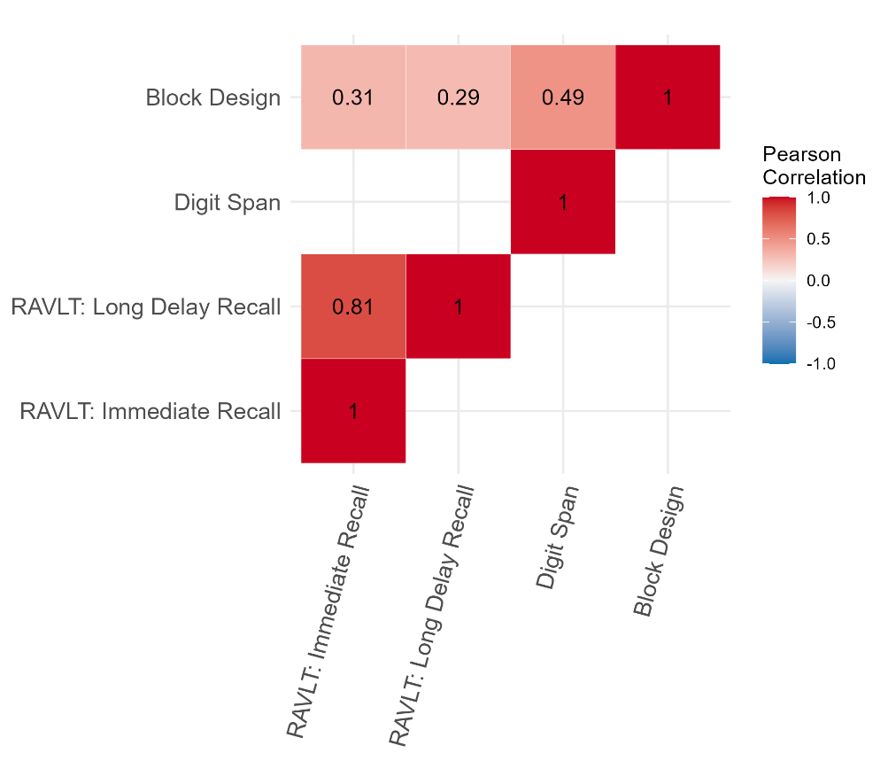
Supplementary Figure S1. Correlation Matrix Between Scores on Cognitive Tests in the Psychosis Endophenotypes International Consortium (PEIC) Sample
Correlation between performance on each of the cognitive tests carried out in the PEIC sample.
Note: No correlation is displayed between the digit span and RAVLT tests as participants only completed one of these tests, not both.
Abbreviations: RAVLT = Rey Auditory Verbal Learning Test

ABCD
Average age-corrected cognitive test scores for the ABCD Study sample are presented in Supplementary Table S4.

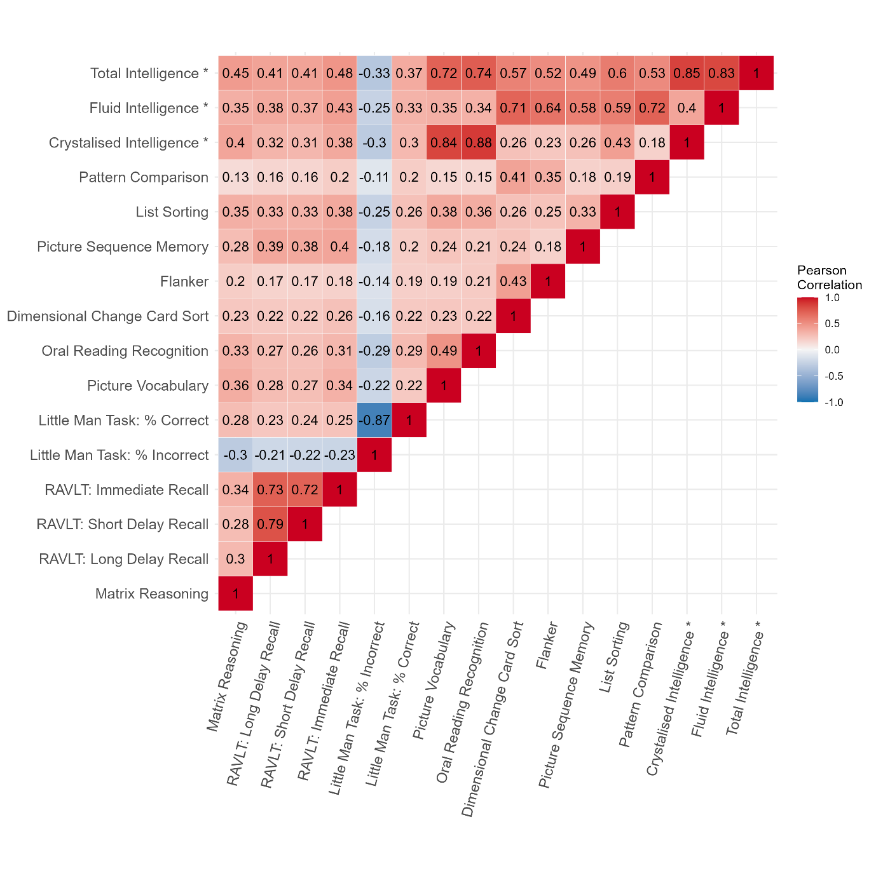
Supplementary Figure S2. Correlation Matrix Between Scores on Cognitive Tests in the Adolescent Brain Cognitive Development (ABCD) Study® Sample
Correlation between performance on each of the cognitive tests carried out in the ABCD Study® sample.
* Composite scores representing the sum of multiple other cognitive tests included in the correlation matrix. Crystalised Intelligence composite score: Picture Vocabulary and Oral Reading Recognition. Fluid Intelligence composite score: Dimensional Change Card Sort, Flanker, Picture Sequence Memory, List Sorting, and Pattern Comparison. Total Intelligence composite score: Crystalised Intelligence and Fluid Intelligence composite scores.
Abbreviations: RAVLT = Rey Auditory Verbal Learning Test

Interaction and Subgroup Analyses in the PEIC Dataset

Subgroup analysis were carried out despite the non-significant interaction effects of clinical group on the effect of PGS on cognitive performance due to the previous evidence of a difference in the strength of the effect between patients and control participants ²⁷. Fixed effect regression analyses were carried out (as the kinship matrix, included as a random effect in the main analyses, was not needed as no participants in the control group or patient group were related to each other). The covariates included were age, sex, research site, and the first four ancestry PCs. Results from the subgroup analyses in the control and patient groups are presented in Supplementary Figure S3 (Supplementary Tables S17 and S18). Neither of the psychosis-related polygenic scores showed a significant effect on performance on any of the cognitive tests when the samples were restricted to the subgroups after correction for multiple comparisons. The effect of cognition-related PGSs were similar between the groups for all tests.
However, interpretation of the subgroup results should consider the non-equal sample sizes (smaller patient sample than control) and that the accompanying interaction analyses were non-significant. Further investigation with larger, equal-sized samples is needed.

(a)
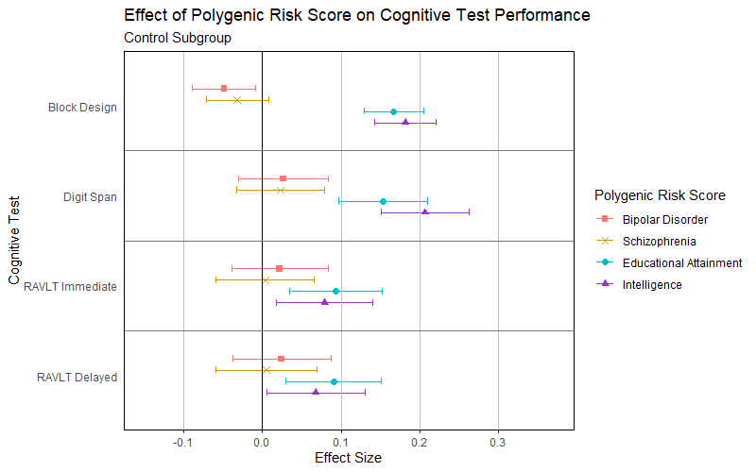
(b)
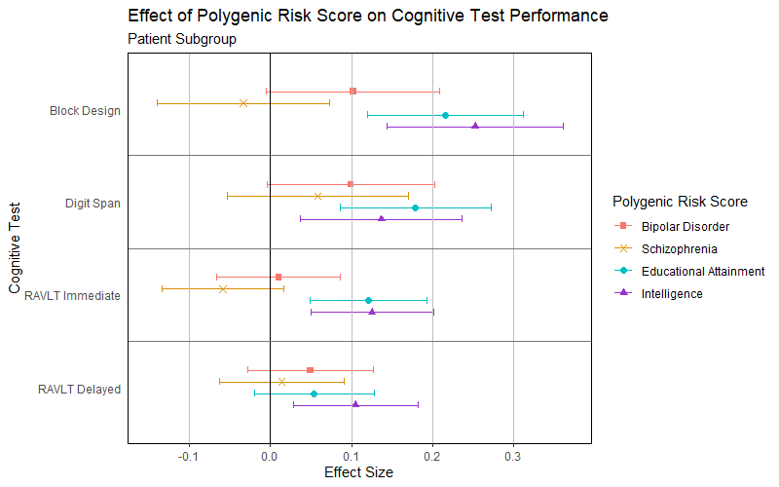
Supplementary Figure S3. Effect of Polygenic Scores on Cognitive Test Performance in (a) the Control Group and (b) the Patient Group in the PEIC Sample
Effect of psychosis-related and cognition-related polygenic scores on cognitive test performance in adults separately in (a) the control group (i.e. no diagnosis of psychosis or family relation to a patient with psychosis) and (b) the patient group (i.e. individuals with a diagnosis of psychosis), while controlling for the effect of age, gender, research site, and ancestry (the first four ancestry principal components). Scores have been standardised using the mean and standard deviation from the control group. Standardised values are given in Supplementary Table S5; non-standardised values are given in Supplementary Table S6.
Abbreviations: PEIC = Psychosis Endophenotype International Consortium; RAVLT = Rey Auditory Verbal Learning Task
Table S1. Neurocognitive Test Domains for Bonferroni Correction to Analyses Using the ABCD Study® Sample

Cognitive Test (and Subtests) |  | Cognitive Domain
NIH Toolbox Picture Vocabulary Test® (TPVT) |  | Language
NIH Toolbox Oral Reading Recognition Test® (TORRT) |  | Language
NIH Toolbox Dimensional Change Card Sort® (TDCCS) |  | Executive functioning
NIH Toolbox Flanker Task® (TFT) |  | Executive functioning
NIH Toolbox Pattern Comparison Processing Speed Test® (TPCPST) |  | Processing speed
NIH Toolbox List Sorting Working Memory Test® (TLSWMT) |  | Working memory
Little Man Task | % Correct | Visuospatial processing
Little Man Task | % Incorrect | Visuospatial processing
Matrix Reasoning |  | Visuospatial processing
NIH Toolbox Picture Sequence Memory Test® (TPSMT) |  | Episodic memory
Rey Auditory Verbal Learning Task (RAVLT) | Immediate Recall | Episodic memory
Rey Auditory Verbal Learning Task (RAVLT) | Short Delayed Recall | Episodic memory
Rey Auditory Verbal Learning Task (RAVLT) | Long Delayed Recall | Episodic memory
Cash Choice Task |  | Motivation/impulsivity
Abbreviations: ABCD = Adolescent Brain Cognitive Development

Predicting Clinical Group Status from Cognition-Related PGS Using a Support Vector Machine Algorithm
Methods
To predict clinical groups, a binary classification Support Vector Machine algorithm (SVM) was employed. SVM is a supervised learning algorithm that can handle non-linear relationships within high-dimensional data ²⁸ and it has been used with success in predicting clinical groups from genetic data ²⁹ and other biomarkers ³⁰. The analysis was carried out using Scikit-learn 1.3.2. and SciPy 1.11.4. packages of Python 3.9 ³¹.
For the PEIC data, binary classifications were performed for patient-control, patient-relative and relative-control comparisons. The predictors in the model were: age, sex, testing location, four ancestry PCs and intelligence or educational attainment PGS. For the ABCD data, the comparisons were between those who experienced psychosis-like symptoms at baseline and those who did not, those who experienced distressing psychosis-like symptoms and those who did not, and those who experienced significantly distressing psychosis-like symptoms and those who did not. The predictors were: age, sex, eight ancestry PCs and intelligence or educational attainment PGS.
As the analyses wanted to follow the regression as closely as possible, the pre-processing steps and scaling operations were the same. However, all participants with missing data were excluded instead of the missing variables being imputed, as within the nested cross-validation procedure this would have risked data leakage. In addition, the testing location variable in the PEIC data was dummy coded.
To mirror the regression’s random effect from the adjusted kinship matrix, this variable was incorporated in the kernel operations during the SVM classification. The SVM models used a custom kernel operation, that summed together the adjusted kinship matrix with the Gram matrix of a regular RBF kernel. The weight of the kinship matrix and the RBF kernel’s Gram matrix added up to 1 (Supplementary Equation S1). The weight component was used as a hyperparameter w and as for any other hyperparameter, its value was determined following a parameter search.

R = w · G + (1 - w) · K
R: the resulting pairwise similarity matrix of the data
w: weight (coefficient) that scales the Gram matrix.
G: Gram matrix resulting from the regular RBF kernel transformation.
K: kinship matrix.
(1−w): scales the kinship matrix
Supplementary Equation S1. Custom kernel operation in the SVM model

The other hyperparameters for the SVM models were C, γ and W. C and γ are part of every RBF kernel SVM model as the regularisation parameter and the radius of influence for training samples, respectively. The hyperparameter W was defined as the weight of the clinical group membership during training phase of the SVM pipeline. This was done to offset the imbalance between the clinical group memberships.
The analysis pipeline took the form of a nested cross-validation, to reduce biases in the hyperparameter tuning. The general structure of this followed the methods of Bracher-Smith et al. ³² with having 10 inner cross-validation folds to determine the best hyperparameters and 10 outer cross-validation folds to evaluate the performance of the SVM model with the selected hyperparameters. Inner cross-validation was only run on the training set, to avoid data leakage.
For each round of outer cross-validation, 100 hyperparameters combinations were drawn using random parameter search ³³. C and γ were sampled from the same distributions as in Bracher-Smith et al. ³². As there was no preconceived constraint for the value of w, it was sampled from a uniform distribution between 10-6 and 1-10-6. W was sampled from a uniform distribution between 1 and 4. The probability density functions of the hyperparameter sampling are depicted in Supplementary Figure S4. Each combination of hyperparameters was tested on 10 inner cross-validation loops and the combination with the highest F1 score was selected as the best. F1 scores were used, as this metric balances the classification errors between false negatives and false positives. After selecting the best hyperparameters, the SVM model was fit on the training dataset. Then, classification performance was evaluated on the unseen test set using measures of accuracy, precision, recall, F1 scores and the areas under the ROC curve (AUROC).
The fitted SVM model was also subjected to a permutation feature importance (PFI) analysis ³⁴, to determine the relative importance of each predictor. This meant that for each predictor in the test set, the values were randomly shuffled between the participants and the SVM model was tested again on this novel data. The decrease in AUROC indicated the importance of the predictor. These values were normalized across predictors, to get a relative measure of importance across the model.

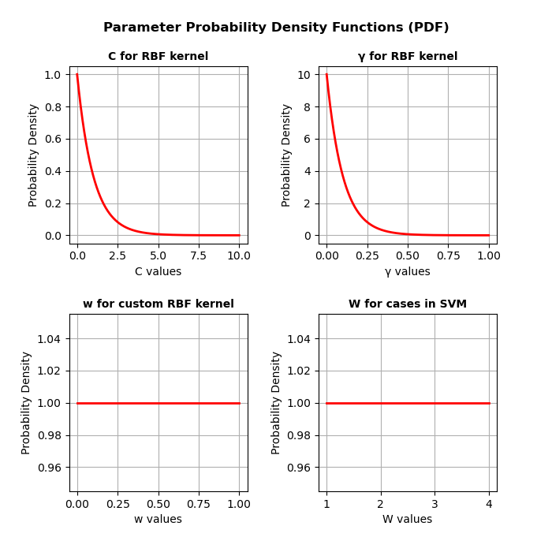
Supplementary Figure S4. Parameter Probability Density Functions for hyperparameter tuning using random search
The probability densities of the C, γ, w (Gram matrix weight) and W (case class weight) hyperparameters, from which the 100 iterations of hyperparameters were sampled randomly. The PDF for C and γ was adapted from Bracher-Smith et al. 2022 and the uniform distribution of w and W values were employed as exploratory measures.

Results
In the PEIC dataset, there were 321 missing age values. After excluding these participants, the analysis was performed on a sample with N = 3,650.
The results of the random hyperparameter search for case-control classification for both SVM models are depicted in Supplementary Figure S5. Generally, higher weighting of the demographic and PGS predictors compared to the kinship matrix yielded a better model performance. This is accompanied by low γ and C parameters. The weight of cases (patients or relatives) compared to controls generally took higher values in the successful classification tasks and low values in the relative-control classification tasks.
The classification performance metrics for both SVM models and classification tasks are depicted in Table S19. The discrimination in the patient-control and patient-relative cases seems robust with high AUROC and moderately high accuracy scores. This corroborates the regression analysis and goes beyond its predictive value in the patient-relative classification case. However, in the relative-control case, there is a large imbalance between positive and negative class predictions, as accuracy and precision scores are always lower than the corresponding recall scores. Due to the almost chance accuracy, these classification performances were determined as not successful. To illustrate the sensitivity-specificity trade-off, Receiver Operating Characteristics (ROC) curves are plotted for each of the 10 outer cross-validation folds for each analysis in Supplementary Figure S6.
The permutation feature analysis revealed the predictors with the highest relative importance in each model. While the regression analysis assessed the separate predictive value of the PGS, this analysis served as a way of comparing the contribution of the PGS to the rest of the model predictors in a model-agnostic fashion. Across the analyses, PGS as a predictor never took up a considerable (M > 0.1) amount of importance. Instead, the most important contributor seemed to be age, and in other cases, ancestry and research sites. These results are illustrated in Supplementary Figure S7. The importance of age and research sites in the model performance are not surprising, given the age imbalance in the data and for some sites providing only patient or only control data.

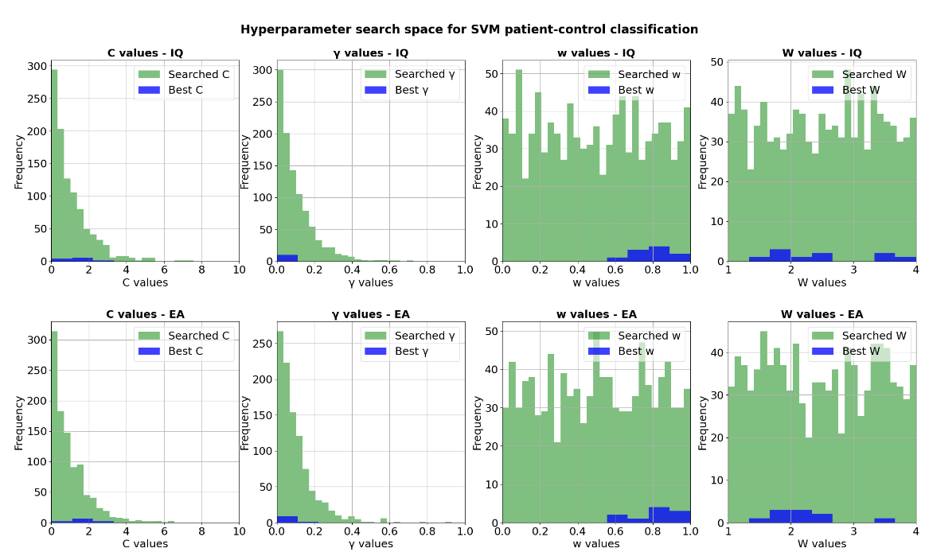

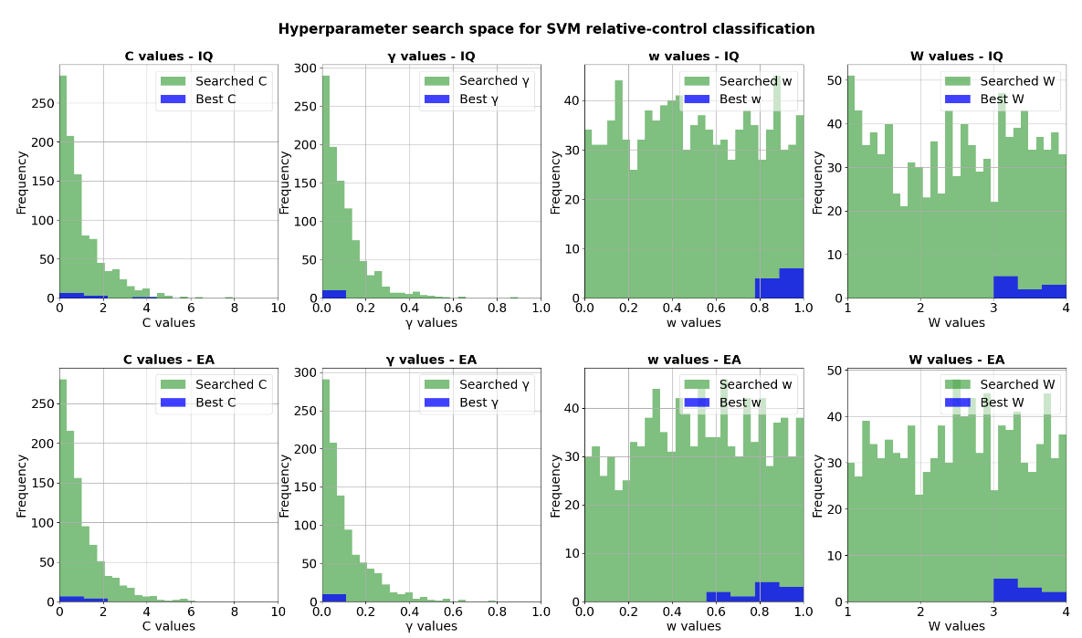
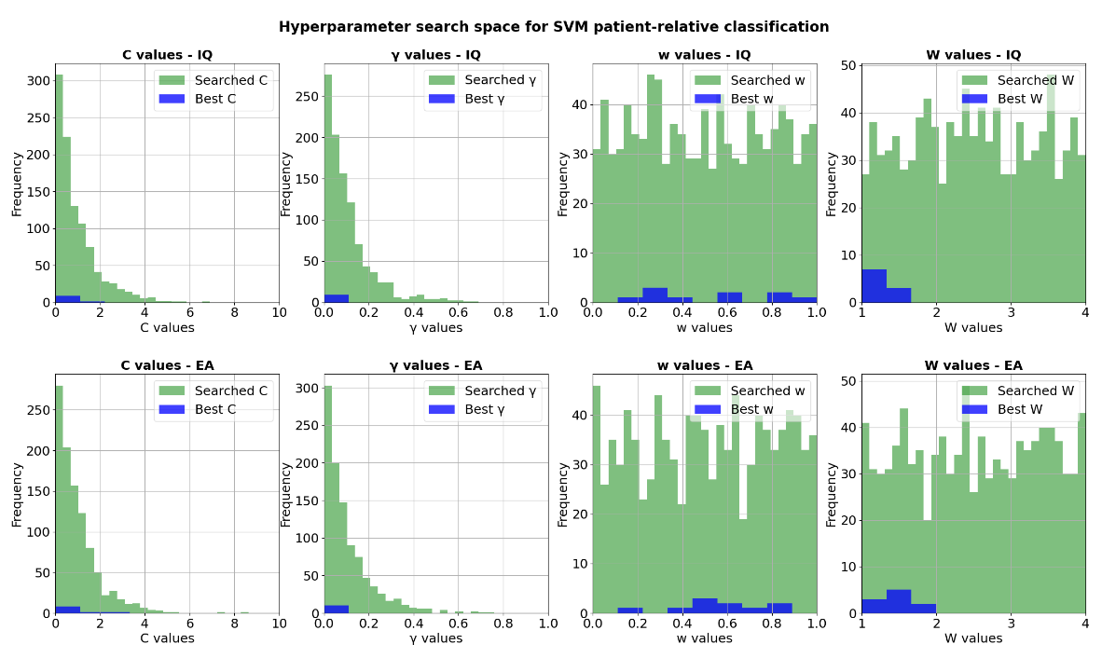
Supplementary Figure S5. Hyperparameters searched and used during the clinical group binary classifications
Binned C, γ, w (Gram matrix weight) and W (case class weight) hyperparameter values that were used in each iteration of the random parameter search (green) and the ones that were selected as best parameters (blue). Best parameters were selected based on highest F1 scores on the 10 inner folds. The histograms display hyperparameter values across all 10 outer folds. The top row shows results of the model using intelligence PGS, the bottom row shows the model with the educational attainment PGS.

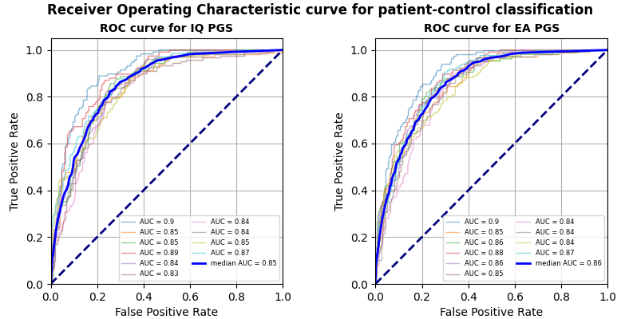
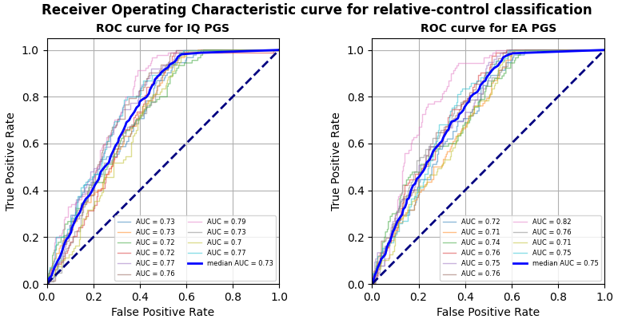
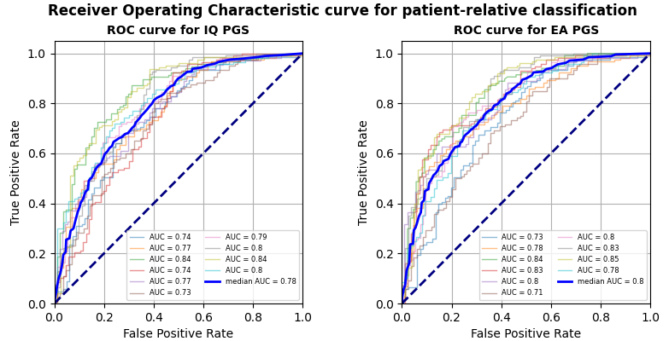
Supplementary Figure S6. ROC curves for clinical group classification using SVM models with IQ and EA predictors
ROC curves are displayed for patient-control, relative-control and patient-relative binary classification tasks. ROC curves plot the false positive rate to the true positive rate, to display the sensitivity-specificity trade-off of the classifier. Each figure depicts the ROC curves for each of the 10 outer folds of cross-validation. Their corresponding measures for the area under the curve (AUC) are reported in the figure legend. The blue line represents the mean of such curves, it is reported with the median AUC. The dashed line represents a classifier at chance level.

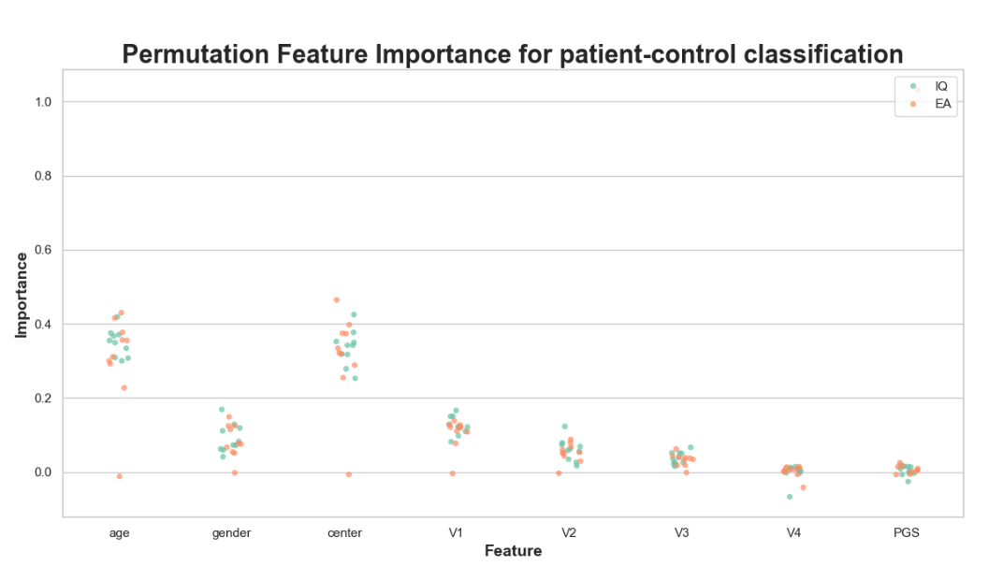
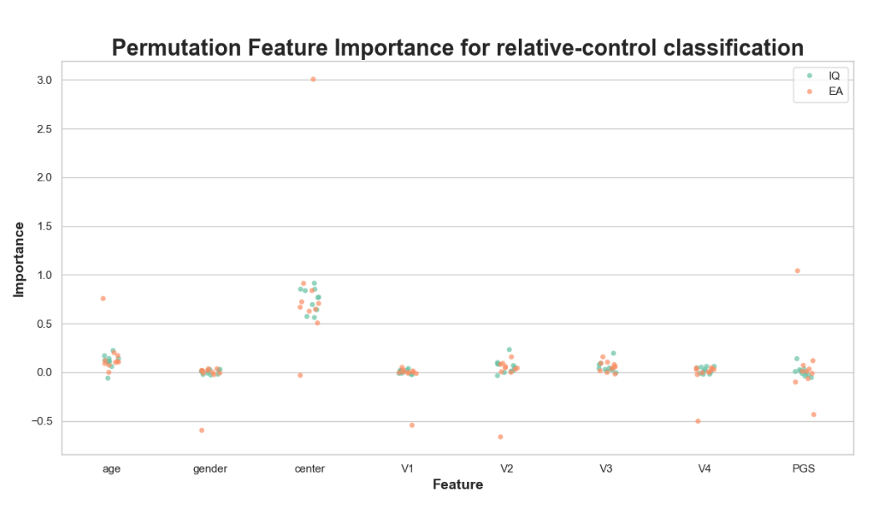
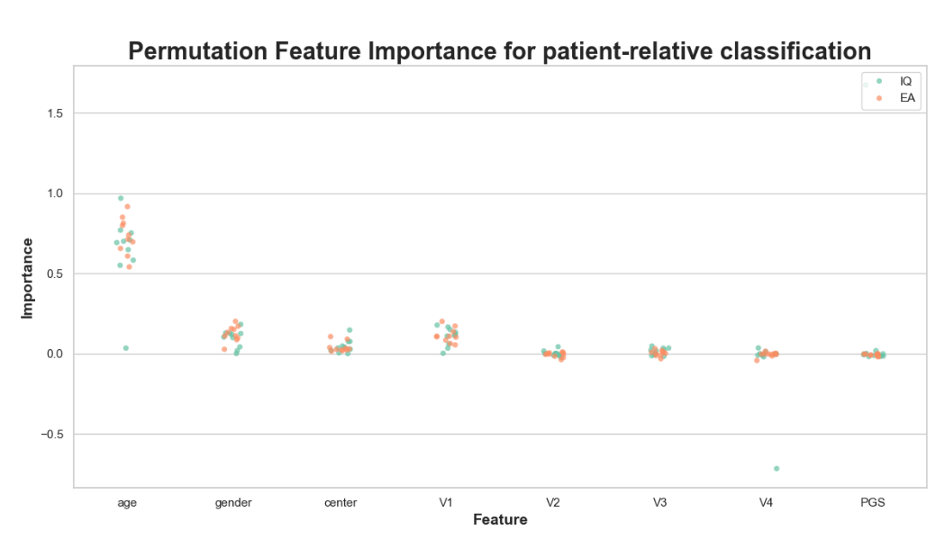
Supplementary Figure S7. PFI scores for clinical group classification using SVM models with IQ and EA predictors
Relative feature importance scores are displayed for each model predictor in each clinical group classification task. Each clinical group classification is on a separate graph. Model predictors are shown on the x axis, with PGS being IQ and EA in corresponding models. Features V1 to V4 are the ancestry principal components used in the model Feature importance scores are indicated on the y axis. They show relative importance, as they are normalized to 1 across features. Scores for IQ PGS models are green, scores for EA PGS models are orange.
In the ABCD dataset no further participants were excluded due to missing data. The results of the hyperparameter random search are displayed in Supplementary Figure S8. Generally, the models performed best with low C and γ parameters and with a generally high Gram matrix weight w. The weight of the case group W ranged across all potential values. However, as the model performance was generally poor, these tendencies convey little meaning.
The classification performance of the SVM models for each psychosis-like symptom group is depicted in Table S20. The ROC curves indicating the sensitivity-specificity trade-off are in Supplementary Figure S9. The discrimination performance and the classification accuracy, as indicated by the AUROC and accuracy values were near chance level for each model and classification task, suggesting a poor model performance. However, the high recall scores indicate that what the models excelled at was the classification of true positives, that is, classifying specifically case category data.
While these performance metrics suggest that the SVM model was unable to validate the results of the main regression analysis, there are also a few model and dataset specifications that could be the reason behind it. Firstly, optimising for F1 scores happens at the cost of accuracy, so potentially an accuracy-optimised model would have been able to have a better predictive value. Secondly, the imbalance in the distressing psychotic symptom-control and significantly distressing psychotic symptom-control comparisons was the highest amongst all comparisons and datasets. Therefore, a W parameter adjusted to these imbalances (e.g. searched between 1 and 10) might have resulted in a better model performance. Regarding the sample itself, it is also important to note that psychosis clinical groups have no relevancy at this young age. Rather, comparisons were made between categories of psychosis-prone symptoms that are experienced even amongst the non-clinical population. Nevertheless, it would be interesting to test whether the SVM model is able to perform classification on the follow-up ABCD data, when psychosis clinical groups become more clearly separated.
The results of the PFI analysis are displayed in Supplementary Figure S10. Again, due to the generally poor model performance, these tendencies do not convey too much relevant information as to which predictors might be the most important for a good model.
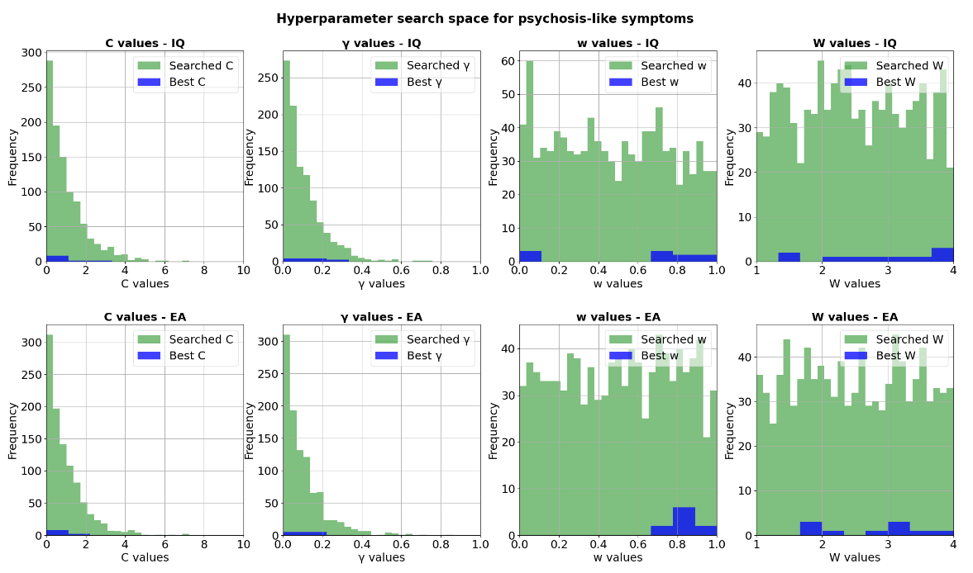

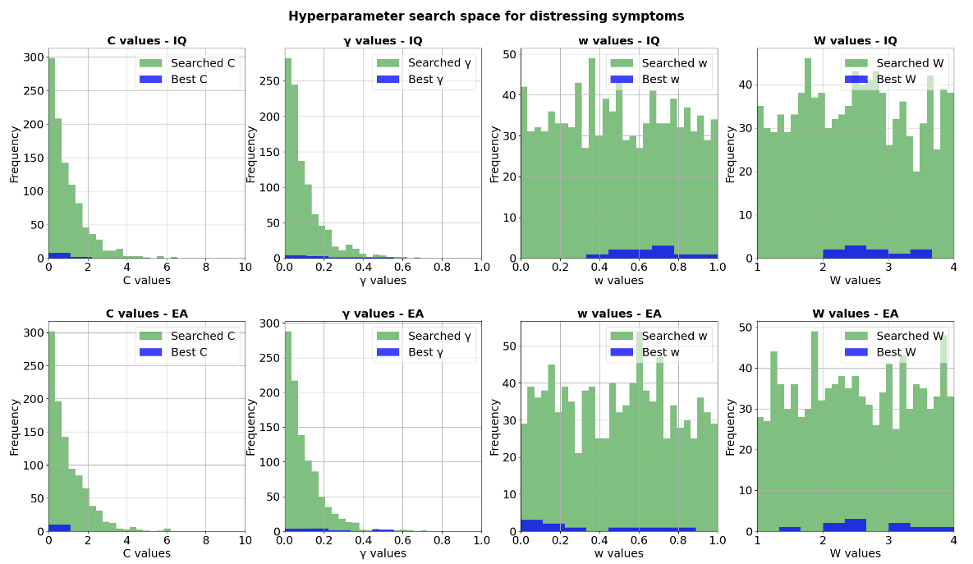
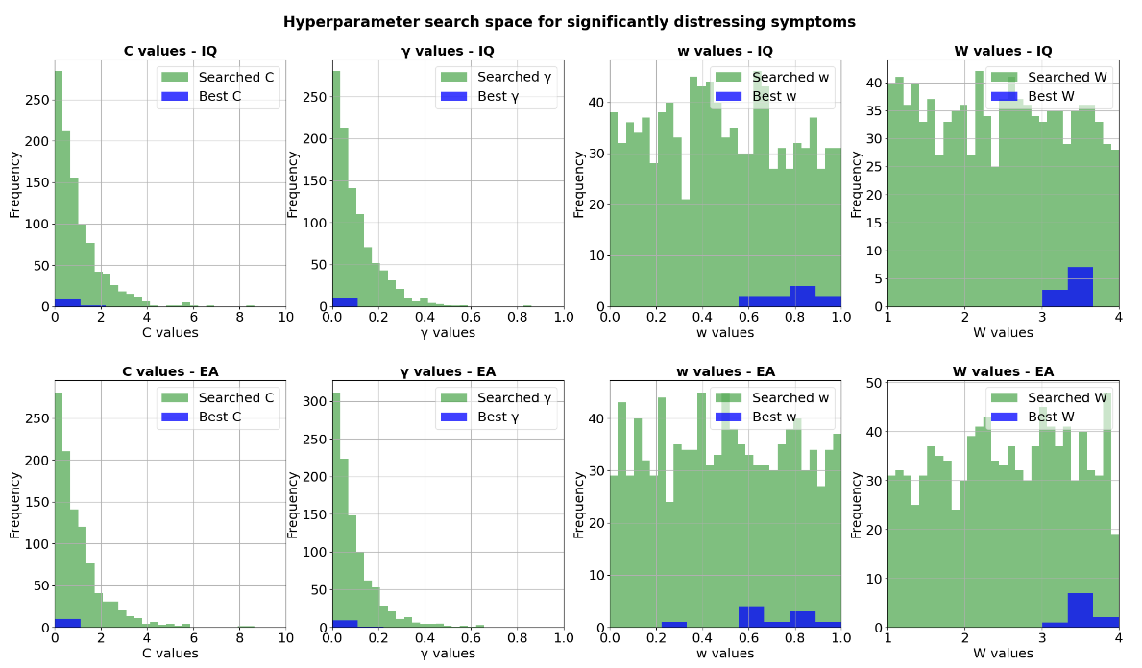
Supplementary Figure S8. Hyperparameters searched and used during the clinical group binary classifications
Binned C, γ, w (Gram matrix weight) and W (case class weight) hyperparameter values that were used in each iteration of the random parameter search (green) and the ones that were selected as best parameters (blue). Best parameters were selected based on highest F1 scores on the 10 inner folds. The histograms display hyperparameter values across all 10 outer folds. The top row shows results of the model using intelligence PGS, the bottom row shows the model with the educational attainment PGS.

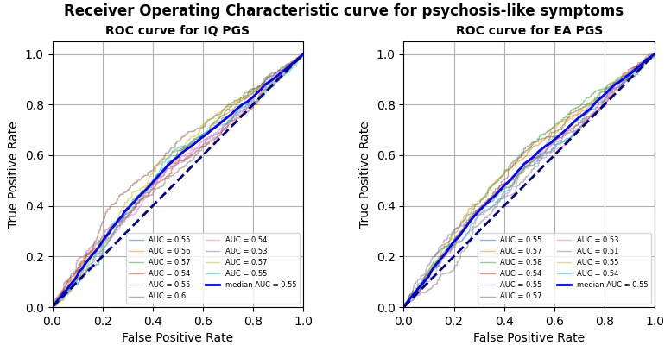

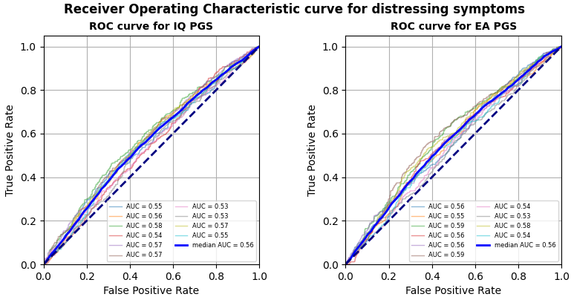

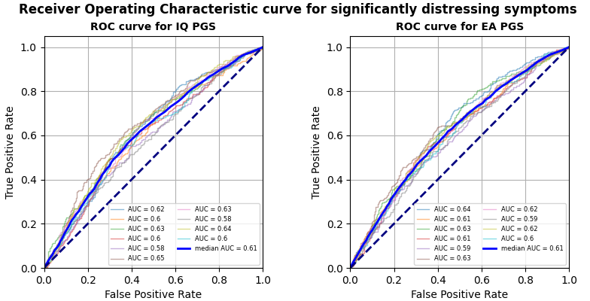

Supplementary Figure S9. ROC curves for clinical group classification using SVM models with IQ and EA predictors
ROC curves are displayed for binary classification tasks between participants who have and do not have psychosis-like symptoms, between participants who have and do not have distressing psychosis-like symptoms and between participants who have and do not have significantly distressing psychosis-like symptoms. ROC curves plot the false positive rate to the true positive rate, to display the sensitivity-specificity trade-off of the classifier. Each figure depicts the ROC curves for each of the 10 outer folds of cross-validation. Their corresponding measures for the area under the curve (AUC) are reported in the figure legend. The blue line represents the mean of such curves, it is reported with the median AUC. The dashed line represents a classifier at chance level.

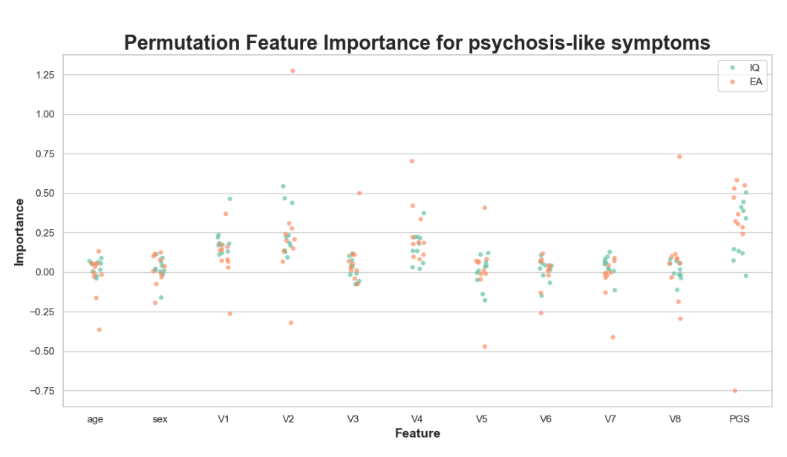
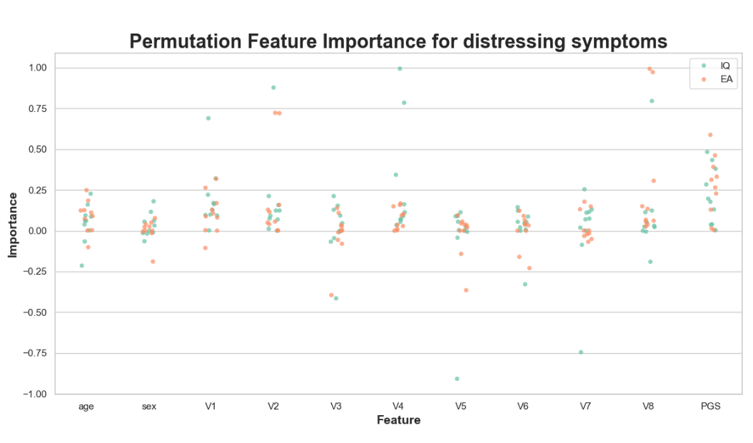
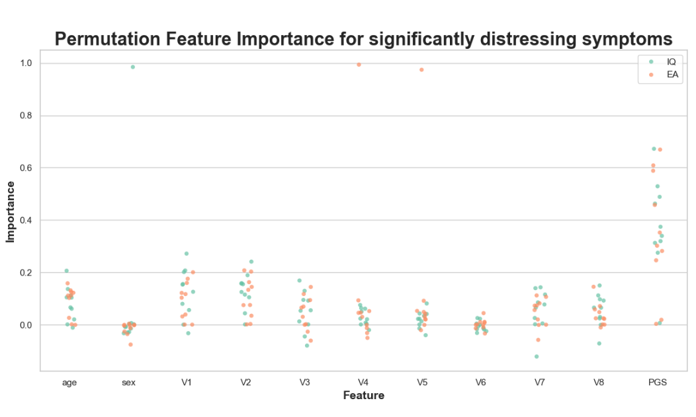

Supplementary Figure S10. PFI scores for clinical group classification using SVM models with IQ and EA predictors
Relative feature importance scores are displayed for each model predictor in each clinical group classification task. Each clinical group classification is on a separate graph. Model predictors are shown on the x axis, with PGS being IQ and EA in corresponding models. Features V1 to V8 are the ancestry principal components used in the model Feature importance scores are indicated on the y axis. They show relative importance, as they are normalized to 1 across features. Scores for IQ PGS models are green, scores for EA PGS models are orange.

Supplementary Material References

1. Wellcome Trust Case Control Consortium. Genome-wide association study of 14,000 cases of seven common diseases and 3,000 shared controls. Nature 2007; 447(7145): 661-678.

2. Marchini J, Howie B, Myers S, McVean G, Donnelly P. A new multipoint method for genome-wide association studies by imputation of genotypes. Nat Genet 2007; 39(7): 906-913.

3. Wigginton JE, Abecasis GR. PEDSTATS: descriptive statistics, graphics and quality assessment for gene mapping data. Bioinformatics 2005; 21(16): 3445-3447.

4. Morris JA, Randall JC, Maller JB, Barrett JC. Evoker: a visualization tool for genotype intensity data. Bioinformatics 2010; 26(14): 1786-1787.

5. Speed D, Cai N, Johnson MR, Nejentsev S, Balding DJ. Reevaluation of SNP heritability in complex human traits. Nat Genet 2017; 49(7): 986-992.

6. Purcell S, Neale B, Todd-Brown K, Thomas L, Ferreira MA, Bender D et al. PLINK: a tool set for whole-genome association and population-based linkage analyses. Am J Hum Genet 2007; 81(3): 559-575.

7. Bramon E, Pirinen M, Strange A, Lin K, Freeman C, Bellenguez C et al. A genome-wide association analysis of a broad psychosis phenotype identifies three loci for further investigation. Biol Psychiatry 2014; 75(5): 386-397.

8. Durbin R. Efficient haplotype matching and storage using the positional Burrows-Wheeler transform (PBWT). Bioinformatics 2014; 30(9): 1266-1272.

9. Loh PR, Danecek P, Palamara PF, Fuchsberger C, Y AR, H KF et al. Reference-based phasing using the Haplotype Reference Consortium panel. Nat Genet 2016; 48(11): 1443-1448.

10. Baurley JW, Edlund CK, Pardamean CI, Conti DV, Bergen AW. Smokescreen: a targeted genotyping array for addiction research. BMC Genomics 2016; 17(1): 145.

11. Wang B, Giannakopoulou O, Austin-Zimmerman I, Irizar H, Harju-Seppanen J, Zartaloudi E et al. Adolescent Verbal Memory as a Psychosis Endophenotype: A Genome-Wide Association Study in an Ancestrally Diverse Sample. Genes (Basel) 2022; 13(1).

12. Lam M, Awasthi S, Watson HJ, Goldstein J, Panagiotaropoulou G, Trubetskoy V et al. RICOPILI: Rapid Imputation for COnsortias PIpeLIne. Bioinformatics 2020; 36(3): 930-933.

13. Auton A, Abecasis GR, Altshuler DM, Durbin RM, Abecasis GR, Bentley DR et al. A global reference for human genetic variation. Nature 2015; 526(7571): 68-74.

14. McCarthy S, Das S, Kretzschmar W, Delaneau O, Wood AR, Teumer A et al. A reference panel of 64,976 haplotypes for genotype imputation. Nat Genet 2016; 48(10): 1279-1283.

15. Loh PR, Palamara PF, Price AL. Fast and accurate long-range phasing in a UK Biobank cohort. Nat Genet 2016; 48(7): 811-816.

16. Das S, Forer L, Schönherr S, Sidore C, Locke AE, Kwong A et al. Next-generation genotype imputation service and methods. Nat Genet 2016; 48(10): 1284-1287.

17. Li H. A statistical framework for SNP calling, mutation discovery, association mapping and population genetical parameter estimation from sequencing data. Bioinformatics 2011; 27(21): 2987-2993.

18. Gogarten SM, Sofer T, Chen H, Yu C, Brody JA, Thornton TA et al. Genetic association testing using the GENESIS R/Bioconductor package. Bioinformatics 2019; 35(24): 5346-5348.

19. R: A language and environment for statistical computing. R Foundation for Statistical Computing, Vienna, Austria. https://www.R-project.org/, 2020, Accessed Date Accessed 2020 Accessed.

20. Manichaikul A, Mychaleckyj JC, Rich SS, Daly K, Sale M, Chen WM. Robust relationship inference in genome-wide association studies. Bioinformatics 2010; 26(22): 2867-2873.

21. Zheng X, Levine D, Shen J, Gogarten SM, Laurie C, Weir BS. A high-performance computing toolset for relatedness and principal component analysis of SNP data. Bioinformatics 2012; 28(24): 3326-3328.

22. Conomos MP, Reiner AP, Weir BS, Thornton TA. Model-free Estimation of Recent Genetic Relatedness. Am J Hum Genet 2016; 98(1): 127-148.

23. Ruan Y, Lin Y-F, Feng Y-CA, Chen C-Y, Lam M, Guo Z et al. Improving polygenic prediction in ancestrally diverse populations. Nature Genetics 2022; 54(5): 573-580.

24. Soto T, Kraper C. Block Design Subtest. In: Volkmar FR (ed). Encyclopedia of Autism Spectrum Disorders. Springer New York: New York, NY, 2013, pp 464-465.

25. Wambach D, Lamar M, Swenson R, Penney DL, Kaplan E, Libon DJ. Digit Span. In: Kreutzer JS, DeLuca J, Caplan B (eds). Encyclopedia of Clinical Neuropsychology. Springer New York: New York, NY, 2011, pp 844-849.

26. Luciana M, Bjork JM, Nagel BJ, Barch DM, Gonzalez R, Nixon SJ, Banich MT. Adolescent neurocognitive development and impacts of substance use: Overview of the adolescent brain cognitive development (ABCD) baseline neurocognition battery. Dev Cogn Neurosci 2018; 32: 67-79.

27. Mallet J, Le Strat Y, Dubertret C, Gorwood P. Polygenic Risk Scores Shed Light on the Relationship between Schizophrenia and Cognitive Functioning: Review and Meta-Analysis. J Clin Med 2020; 9(2).

28. Cortes C, Vapnik V. Support-vector networks. Machine Learning 1995; 20(3): 273-297.

29. Bracher-Smith M, Crawford K, Escott-Price V. Machine learning for genetic prediction of psychiatric disorders: a systematic review. Mol Psychiatry 2021; 26(1): 70-79.

30. Suri G-S, Kaur G, Moein S. Machine Learning in Detecting Schizophrenia: An Overview. Intelligent Automation \& Soft Computing 2021; 27(3): 723--735.

31. Pedregosa F, Varoquaux G, Gramfort A, Michel V, Thirion B, Grisel O et al. Scikit-learn: Machine Learning in Python. Journal of Machine Learning Research 2011; 12(85): 2825-2830.

32. Bracher-Smith M, Rees E, Menzies G, Walters JTR, O'Donovan MC, Owen MJ et al. Machine learning for prediction of schizophrenia using genetic and demographic factors in the UK biobank. Schizophr Res 2022; 246: 156-164.

33. Bergstra J, Bengio Y. Random Search for Hyper-Parameter Optimization. Journal of Machine Learning Research 2012; 13(10): 281-305.

34. Altmann A, Toloşi L, Sander O, Lengauer T. Permutation importance: a corrected feature importance measure. Bioinformatics 2010; 26(10): 1340-1347.

