Supplementary Material for
Dynamic changes in hemispheric lateralization in major depressive disorder correlate with neurotransmitter and genetic profiles: a DIRECT Consortium Study
Supplementary Methods
Sample Selection
The analyzed data was drawn from the phase II of DIRECT dataset, which comprised 23 cohorts and included resting-state functional magnetic resonance imaging (rs-fMRI) and T1-weighted structural MRI data from 1660 MDD patients and 1341 HCs. All patients with MDD were diagnosed by experienced psychiatrists according to the Structured Clinical Interview of the ICD-10 or DSM-IV. We selected the final sample for the image analyses according to the following criteria: (i) Bad image coverage. We excluded the participants with imaging data that covered less than 90 precents of the group mask. The group mask was generated by extracting all brain regions that 90% of all participants’ brain images covered. (ii) Excessive head motion. Individuals with mean frame-wise displacement (FD) larger than 0.2 mm were excluded. (iii) Missing demographical data. (iv) With an fMRI scan repetition time of 2 seconds and scan time ≥ 6 minutes. (v) We removed participants without necessary demographical information (i.e., age, sex, education, and head motion). This yielded a final sample containing 1428 MDD patients and 1183 HCs.
Image preprocessing
Detailed acquisition parameters and scanners for all cohorts can be found in ref.1(1).The preprocessing of fMRI data was conducted using the toolbox for Data Processing & Analysis for Brain Imaging on Surface (DPABISurf) (2), which is based on fMRIPrep (3), FreeSurfer (4), ANTs (5), FSL (6), AFNI (7), SPM (8), PALM (9), dcm2niix (10), GNU Parallel (11), MATLAB (The MathWorks Inc., Natick, MA, US), Docker (https://docker.com) and DPABI (12).
The preprocessing pipeline included: (a) discarding the initial 10 time points; (b) converting data into BIDS format (13); (c) calling fMRIPrep 20.2.1 docker; (d) conducting anatomical data preprocessing as follows: correcting the T1-weighted image for intensity nonuniformity using N4BiasFieldCorrection (14); the corrected T1-weighted image was then skull-stripped with ANTs (5); fast (FSL 5.0.9)(15) was used to segment brain tissue into cerebrospinal fluid (CSF), white-matter (WM) and gray-matter (GM); recon -all (FreeSurfer 6.0.1) (4) was used to reconstruct brain surfaces; ANTs-derived brain masks and FreeSurfer-derived segmentations of the cortical GM were reconciled using a custom variation of the method of Mindboggle (16); Nonlinear registration with antsRegistration (ANTs 2.3.3) was performed for the volume-based spatial normalization to one standard space (MNI152NLin2009cAsym) (17), using brain extracted versions of both T1w reference and the T1w template. (e) conducting functional data preprocessing as follows: generating a reference volume and its skull-stripped version using a custom methodology of fMRIPrep. The BOLD reference was then co-registered to the T1w reference using bbregister (FreeSurfer) which implements boundary-based registration (18). Co-registration was configured with six degrees of freedom. Head-motion parameters with respect to the BOLD reference (transformation matrices, and six corresponding rotation and translation parameters) are estimated before any spatiotemporal filtering using mcflirt (FSL 5.0.9). BOLD runs were slice-time corrected using 3dTshift from AFNI 20160207 (RRID:SCR_005927) (7). The BOLD time-series were resampled into standard space, generating a preprocessed BOLD run in MNI152NLin2009cAsym space; Confounding time-series were calculated based on the preprocessed BOLD series that are in the original space: framewise displacement (FD), DVARS and three region-wise global signals (extracted from the CSF, the WM, and the whole-brain masks). FD was computed using Jenkinson (relative root mean square displacement between affines) and referred to as FDJenkinson (6). (f) Nuisance regression: The Friston 24-parameter model (19) was used to regress out head motion confounds. Additionally, mean framework displacement (FD) was used to address the residual effects of motion in group analyses (6). Other sources of spurious variance (WM and CSF signals) were also removed from the data through linear regression to reduce respiratory and cardiac effects. We performed preprocessing pipelines without global signal regression (GSR). Additionally, linear trends were included as a regressor to account for drifts in the blood oxygen level dependent (BOLD) signal. (g) Finally, a bandpass temporal filter (0.01–0.1 Hz) was applied to the normalized functional images. The BOLD time-series on the cortical surface were smoothed by a 6 mm smoothing kernel.

Supplementary Tables
Supplementary Table S1. Regions with significant between-group differences in the LF
Brain Region | Subnetwork | t | Cohen’s d | P | FDR-q
MDD > Controls
LH_Vis_31 | VIS | 4.264 | 0.168 | 2.08×10⁻⁵ | 7.55×10⁻⁴
LH_DorsAttn_Post_9 | DAN | 4.211 | 0.166 | 2.63×10⁻⁵ | 7.02×10⁻⁴
LH_DorsAttn_Post_13 | DAN | 4.672 | 0.184 | 3.14×10⁻⁶ | 2.51×10⁻⁴
LH_Cont_OFC_1 | FPN | 4.154 | 0.163 | 3.38×10⁻⁵ | 7.94×10⁻⁴
LH_Default_PFC_6 | DMN | 4.200 | 0.165 | 2.76×10⁻⁵ | 6.91×10⁻⁴
LH_Default_PFC_13 | DMN | 4.153 | 0.163 | 3.39×10⁻⁵ | 7.53×10⁻⁴
LH_Default_PFC_14 | DMN | 4.231 | 0.166 | 2.41×10⁻⁵ | 7.42×10⁻⁴
LH_Default_pCunPCC_4 | DMN | 4.143 | 0.163 | 3.53×10⁻⁵ | 7.43×10⁻⁴
RH_SomMot_1 | SMN | 4.096 | 0.161 | 4.33×10⁻⁵ | 8.67×10⁻⁴
RH_SomMot_4 | SMN | 4.988 | 0.196 | 6.52×10⁻⁷ | 8.69×10⁻⁵
RH_SomMot_17 | SMN | 4.360 | 0.171 | 1.35×10⁻⁵ | 5.40×10⁻⁴
RH_DorsAttn_Post_4 | DAN | 4.081 | 0.160 | 4.61×10⁻⁵ | 8.79×10⁻⁴
RH_DorsAttn_Post_5 | DAN | 4.373 | 0.172 | 1.27×10⁻⁵ | 5.66×10⁻⁴
RH_DorsAttn_Post_10 | DAN | 4.564 | 0.179 | 5.24×10⁻⁶ | 3.49×10⁻⁴
RH_DorsAttn_Post_11 | DAN | 4.454 | 0.175 | 8.78×10⁻⁶ | 5.01×10⁻⁴
RH_DorsAttn_Post_12 | DAN | 4.966 | 0.195 | 7.29×10⁻⁷ | 7.29×10⁻⁵
RH_DorsAttn_Post_13 | DAN | 4.043 | 0.159 | 5.42×10⁻⁵ | 9.42×10⁻⁴
RH_SalVentAttn_FrOperIns_3 | VAN | 5.028 | 0.198 | 5.29×10⁻⁷ | 1.06×10⁻⁴
RH_Cont_Par_4 | FPN | 4.063 | 0.160 | 5.00×10⁻⁵ | 9.08×10⁻⁴
RH_Cont_Par_6 | FPN | 4.236 | 0.167 | 2.35×10⁻⁵ | 7.84×10⁻⁴
RH_Cont_PFCl_13 | FPN | 4.23 | 0.166 | 2.42×10⁻⁵ | 6.91×10⁻⁴
RH_Cont_PFCl_14 | FPN | 5.482 | 0.216 | 4.62×10⁻⁸ | 1.85×10⁻⁵
RH_Default_Temp_3 | DMN | 4.399 | 0.173 | 1.13×10⁻⁵ | 5.65×10⁻⁴
Abbreviations: FDR, false discovery rate. VIS, visual network, SMN, sensorimotor network, DAN, dorsal attention network, VAN, ventral attention network, LIB, limbic network, FPN, frontoparietal network, DMN, default mode network.

Supplementary Table S2. Between-group differences in the LF of the subnetworks in the mean maps
Subnetworks | t | Cohen’s d | P | FDR-q
MDD > Controls
Left hemisphere
VIS | 17.001 | 3.053 | 6.013×10⁻¹⁷ | 9.353×10⁻¹⁷
SMN | 26.335 | 4.329 | 4.074×10⁻²⁵ | 1.426×10⁻²⁴
DAN | 18.734 | 3.906 | 5.200×10⁻¹⁵ | 6.066×10⁻¹⁵
VAN | 23.128 | 4.931 | 2.014×10⁻¹⁶ | 2.819×10⁻¹⁶
LIB | 21.066 | 5.843 | 7.601×10⁻¹¹ | 8.186×10⁻¹¹
FPN | 24.661 | 5.258 | 5.480×10⁻¹⁷ | 9.589×10⁻¹⁷
DMN | 42.177 | 5.849 | 2.529×10⁻⁴¹ | 3.540×10⁻⁴⁰
Right hemisphere
VIS | 18.748 | 3.423 | 9.402×10⁻¹⁸ | 1.880×10⁻¹⁷
SMN | 24.675 | 3.901 | 2.082×10⁻²⁵ | 9.714×10⁻²⁵
DAN | 19.012 | 3.964 | 3.829×10⁻¹⁵ | 4.874×10⁻¹⁵
VAN | 25.961 | 5.192 | 4.476×10⁻¹⁹ | 1.044×10⁻¹⁸
LIB | 18.449 | 5.117 | 3.572×10⁻¹⁰ | 3.572×10⁻¹⁰
FPN | 27.135 | 4.954 | 3.664×10⁻²² | 1.026×10⁻²¹
DMN | 27.112 | 4.341 | 1.818×10⁻²⁶ | 1.272×10⁻²⁵
Abbreviations: FDR, false discovery rate; VIS, visual network, SMN, sensorimotor network, DAN, dorsal attention network, VAN, ventral attention network, LIB, limbic network, FPN, frontoparietal network, DMN, default mode network.
Brain Region | HRDS-17 total |  |  | anxiety/somatization |  |  | cognitive disturbance |  |  | sleep disruption |  |  | retardation |  |  | weight
Brain Region | r | P | FDR-P | r | P | FDR-P | r | P | FDR-P | r | P | FDR-P | r | P | FDR-P | r | P | FDR-P
LH_Vis_31 | 0.025 | 0.462 | 0.708 | 0.013 | 0.733 | 1.297 | 0.019 | 0.610 | 0.6375 | 0.051 | 0.179 | 0.823 | 0.055 | 0.149 | 0.686 | 0.015 | 0.683 | 1.965
LH_DorsAttn_Post_9 | 0.014 | 0.686 | 0.830 | 0.040 | 0.291 | 1.115 | 0.036 | 0.345 | 0.4410 | 0.020 | 0.601 | 1.064 | 0.009 | 0.814 | 1.101 | 0.043 | 0.258 | 1.976
LH_DorsAttn_Post_13 | 0.060 | 0.076 | 1.752 | 0.062 | 0.101 | 1.159 | 0.056 | 0.140 | 0.2478 | 0.013 | 0.733 | 1.124 | 0.009 | 0.811 | 1.166 | 0.005 | 0.901 | 1.219
LH_Cont_OFC_1 | 0.010 | 0.757 | 0.870 | 0.008 | 0.828 | 1.190 | 0.119 | 0.002 | 0.0401 | 0.006 | 0.866 | 1.106 | 0.011 | 0.781 | 1.283 | 0.003 | 0.931 | 1.127
LH_Default_PFC_6 | 0.044 | 0.195 | 0.559 | 0.021 | 0.580 | 1.213 | 0.092 | 0.015 | 0.0566 | 0.018 | 0.641 | 1.053 | 0.004 | 0.906 | 0.992 | 0.020 | 0.607 | 2.325
LH_Default_PFC_13 | 0.047 | 0.162 | 0.621 | 0.036 | 0.341 | 0.981 | 0.087 | 0.022 | 0.0634 | 0.059 | 0.123 | 0.709 | 0.007 | 0.845 | 1.080 | 0.005 | 0.891 | 1.281
LH_Default_PFC_14 | 0.051 | 0.130 | 0.998 | 0.051 | 0.177 | 0.816 | 0.083 | 0.029 | 0.0733 | 0.007 | 0.864 | 1.168 | 0.003 | 0.936 | 0.979 | 0.014 | 0.719 | 1.837
LH_Default_pCunPCC_4 | 0.026 | 0.447 | 0.734 | 0.039 | 0.309 | 1.015 | 0.045 | 0.237 | 0.3633 | 0.000 | 0.995 | 0.995 | 0.006 | 0.868 | 1.051 | 0.012 | 0.760 | 1.588
RH_SomMot_1 | 0.008 | 0.814 | 0.892 | 0.007 | 0.850 | 1.150 | 0.034 | 0.367 | 0.4446 | 0.064 | 0.093 | 1.073 | 0.005 | 0.890 | 1.023 | 0.059 | 0.118 | 2.725
RH_SomMot_4 | 0.049 | 0.146 | 0.672 | 0.004 | 0.918 | 1.006 | 0.036 | 0.342 | 0.4621 | 0.003 | 0.940 | 1.030 | 0.016 | 0.681 | 1.205 | 0.003 | 0.936 | 1.025
RH_SomMot_17 | 0.014 | 0.684 | 0.873 | 0.009 | 0.807 | 1.238 | 0.082 | 0.030 | 0.0700 | 0.063 | 0.097 | 0.746 | 0.034 | 0.371 | 0.949 | 0.007 | 0.844 | 1.294
RH_DorsAttn_Post_4 | 0.032 | 0.346 | 0.796 | 0.029 | 0.439 | 1.122 | 0.103 | 0.007 | 0.0524 | 0.021 | 0.583 | 1.117 | 0.044 | 0.247 | 0.810 | 0.024 | 0.528 | 2.429
RH_DorsAttn_Post_5 | 0.027 | 0.419 | 0.804 | 0.019 | 0.609 | 1.168 | 0.008 | 0.825 | 0.8250 | 0.007 | 0.860 | 1.236 | 0.052 | 0.170 | 0.651 | 0.008 | 0.838 | 1.377
RH_DorsAttn_Post_10 | 0.007 | 0.843 | 0.843 | 0.007 | 0.859 | 1.040 | 0.028 | 0.465 | 0.5348 | 0.041 | 0.276 | 0.793 | 0.024 | 0.533 | 1.114 | 0.032 | 0.396 | 2.275
RH_DorsAttn_Post_11 | 0.056 | 0.096 | 1.107 | 0.059 | 0.120 | 0.920 | 0.117 | 0.002 | 0.0235 | 0.032 | 0.396 | 0.912 | 0.081 | 0.032 | 0.743 | 0.001 | 0.979 | 0.979
RH_DorsAttn_Post_12 | 0.042 | 0.210 | 0.536 | 0.065 | 0.085 | 1.949 | 0.042 | 0.263 | 0.3784 | 0.004 | 0.911 | 1.103 | 0.079 | 0.037 | 0.428 | 0.010 | 0.798 | 1.529
RH_DorsAttn_Post_13 | 0.026 | 0.439 | 0.776 | 0.007 | 0.855 | 1.092 | 0.095 | 0.012 | 0.0551 | 0.043 | 0.262 | 0.860 | 0.042 | 0.268 | 0.772 | 0.013 | 0.740 | 1.702
RH_SalVentAttn_FrOperIns_3 | 0.050 | 0.134 | 0.772 | 0.006 | 0.866 | 0.996 | 0.088 | 0.020 | 0.0670 | 0.003 | 0.935 | 1.075 | 0.010 | 0.783 | 1.200 | 0.052 | 0.172 | 1.984
RH_Cont_Par_4 | 0.007 | 0.826 | 0.863 | 0.012 | 0.760 | 1.248 | 0.062 | 0.100 | 0.2090 | 0.026 | 0.492 | 1.028 | 0.022 | 0.560 | 1.074 | 0.017 | 0.664 | 2.182
RH_Cont_Par_6 | 0.044 | 0.193 | 0.633 | 0.052 | 0.175 | 1.005 | 0.049 | 0.197 | 0.3233 | 0.046 | 0.229 | 0.877 | 0.075 | 0.049 | 0.373 | 0.003 | 0.933 | 1.073
RH_Cont_PFCl_13 | 0.017 | 0.609 | 0.876 | 0.000 | 0.990 | 0.990 | 0.061 | 0.106 | 0.2031 | 0.040 | 0.287 | 0.733 | 0.001 | 0.987 | 0.987 | 0.002 | 0.951 | 0.995
RH_Cont_PFCl_14 | 0.028 | 0.411 | 0.859 | 0.001 | 0.970 | 1.014 | 0.096 | 0.011 | 0.0661 | 0.084 | 0.026 | 0.609 | 0.064 | 0.094 | 0.542 | 0.004 | 0.910 | 1.162
RH_Default_Temp_3 | 0.015 | 0.658 | 0.890 | 0.029 | 0.449 | 1.033 | 0.025 | 0.510 | 0.5590 | 0.002 | 0.949 | 0.992 | 0.026 | 0.498 | 1.145 | 0.008 | 0.837 | 1.481
Supplementary Table S3. Associations between the regions with significant differences in LF and the HDRS-17 across patients
Supplementary Table S4. Spatial correlation between the meta-analytic map of cognitive terms and MDD-related alterations in the LF
Cognitive terms | LF (t-map)
Cognitive terms | r | P_{spin}
intention | 0.214 | 0.037
belief | 0.206 | 0.027
reasoning | 0.194 | 0.033
intelligence | 0.193 | 0.027
memory retrieval | 0.191 | 0.025
autobiographical memory | 0.187 | 0.026
LF, laterality fluctuation. Cognitive terms were selected as the intersection of Neurosynth database (http://neurosynth.org/) and Cognitive atlas (http://cognitiveatlas.org/). Correlation coefficients are estimated by Pearson’s correlation tests. Statistical significances of correlations are examined by spin permutations tests (10,000 times).

PET Map | Fishers z (Spearman rho) | P | p_exact (spatial permutations) | FDR-P
5HT1a_WAY_HC36 (27) | 0.218 | 1.51×10⁻⁵ | 0.099 | 0.198
5HT1a_cumi_hc8_beliveau (31) | 0.149 | 3.09×10⁻³ | 0.293 | 0.400
5HT1b_P943_HC22 (27) | 0.131 | 9.16×10⁻³ | 0.255 | 0.383
5HT1b_az_hc36_beliveau (29) | -0.033 | 0.517 | 0.754 | 0.754
5HT2a_ALT_HC19 (27) | 0.156 | 1.97×10⁻³ | 0.091 | 0.195
5HT2a_cimbi_hc29_beliveau (29) | 0.068 | 0.174 | 0.525 | 0.630
5HT4_sb20_hc59_beliveau (29) | 0.168 | 8.52×10⁻⁴ | 0.139 | 0.246
CB1_FMPEPd2_hc22_laurikainen (31) | 0.284 | 2.00×10⁻⁸ | 0.011 | 0.040
CBF_ASL_MRI (20) | 0.249 | 8.17×10⁻⁷ | 0.001 | 0.007
D1_SCH23390_c11 (22) | 0.051 | 0.306 | 0.649 | 0.671
D2_RACLOPRIDE_c11 (26) | -0.053 | 0.289 | 0.575 | 0.639
D2_fallypride_hc49_jaworska (21) | 0.206 | 4.30×10⁻⁵ | 0.010 | 0.042
DAT_DATSPECT (25) | -0.198 | 8.34×10⁻⁵ | 0.064 | 0.148
FDOPA_f18 (26) | -0.143 | 4.41×10⁻³ | 0.241 | 0.380
GABAa_FLUMAZENIL_c11 (28) | -0.070 | 0.162 | 0.531 | 0.613
GABAa_flumazenil_hc16_norgaard (21) | -0.129 | 0.0103 | 0.270 | 0.386
KappaOp_LY2795050_hc10_ShokriKoori | 0.070 | 0.165 | 0.583 | 0.625
MU_CARFENTANIL_c11 (28) | 0.348 | 7.14×10⁻¹² | 0.008 | 0.040
MU_carfentanil_hc39_turtonen (31) | 0.331 | 6.58×10⁻¹¹ | 0.013 | 0.043
NAT_MRB_c11 (24) | -0.141 | 4.99×10⁻³ | 0.038 | 0.103
NMDA_ge179_29hc_galovic2021 (30) | -0.152 | 2.54×10⁻³ | 0.124 | 0.233
SERT_DASB_HC30 (27) | -0.191 | 1.52×10⁻⁴ | 0.007 | 0.042
SERT_MADAM_c11 | -0.114 | 0.0231 | 0.024 | 0.073
SERT_dasb_hc100_beliveau (29) | -0.282 | 2.39×10⁻⁸ | 0.000 | 0.012
VAChT_feobv_hc18_aghourian (31) | -0.088 | 0.0807 | 0.193 | 0.321
VAChT_feobv_hc4_tuominen (31) | -0.169 | 8.01×10⁻⁴ | 0.001 | 0.009
VAChT_feobv_hc5_bedard (31) | -0.162 | 1.29×10⁻³ | 0.047 | 0.117
mGluR5_abp_hc22_rosaneto (31) | 0.072 | 0.154 | 0.420 | 0.525
mGluR5_abp_hc28_dubois (31) | 0.098 | 0.0504 | 0.343 | 0.447
mGluR5_abp_hc73_smart (31) | 0.239 | 2.19×10⁻⁶ | 0.001 | 0.007
Supplementary Table S5. Spatial correlation between the neurotransmitter receptor/transporter density maps and MDD-related alterations in the LF
JuSpace toolbox (v1.5, https://github.com/juryxy/JuSpace) (32) was used to calculate the spatial correlation between the altered LF(t-map) and 30 PET-based neurotransmitter receptor/transporter density maps using Spearman correlation and permutation test (exact p-values, n = 10,000 permutations; adjusted for spatial autocorrelation). FDR was used for multiple comparisons correction at q < 0.05 for the 30 measures of neurotransmitter receptor/transporter density maps.

Category | Term | Description | LogP | Log(q-value) | GeneInGOAndHitList
GO:0099536 | GO Biological Processes | synaptic signaling | -9.12 | -4.93 | 44
GO:0010035 | GO Biological Processes | response to inorganic substance | -8.68 | -4.79 | 47
GO:0030001 | GO Biological Processes | metal ion transport | -8.36 | -4.77 | 53
GO:0006887 | GO Biological Processes | exocytosis | -6.82 | -3.71 | 26
GO:0034762 | GO Biological Processes | regulation of transmembrane transport | -6.63 | -3.63 | 46
GO:0045926 | GO Biological Processes | negative regulation of growth | -5.31 | -2.8 | 24
GO:0031175 | GO Biological Processes | neuron projection development | -5.18 | -2.69 | 47
GO:0070201 | GO Biological Processes | regulation of establishment of protein localization | -5.05 | -2.6 | 39
GO:0051952 | GO Biological Processes | regulation of amine transport | -4.57 | -2.25 | 13
GO:0099505 | GO Biological Processes | regulation of presynaptic membrane potential | -4.36 | -2.09 | 7
hsa04978 | KEGG Pathway | Mineral absorption | -7.02 | -3.83 | 13
hsa04020 | KEGG Pathway | Calcium signaling pathway | -6.7 | -3.63 | 27
hsa04015 | KEGG Pathway | Rap1 signaling pathway | -6.57 | -3.61 | 24
hsa04080 | KEGG Pathway | Neuroactive ligand-receptor interaction | -4.94 | -2.53 | 30
Table S6. Gene enrichment analysis for PLS1 gene set (|Z|>5)

Supplementary Figures
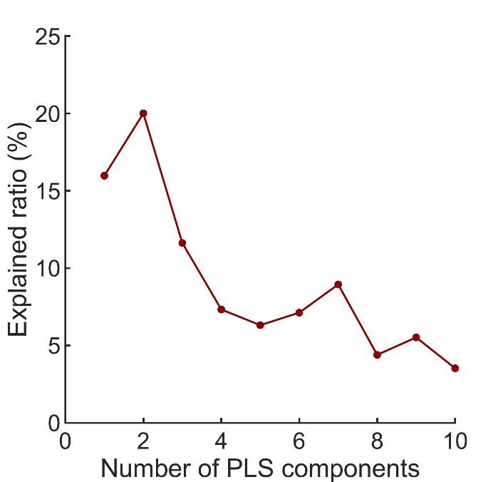
Supplementary Figure. S1 The explained ratios for the first 10 components obtained from the partial least squares (PLS) regression analysis. Each component denotes a weighted linear combination of the expressions of all genes.

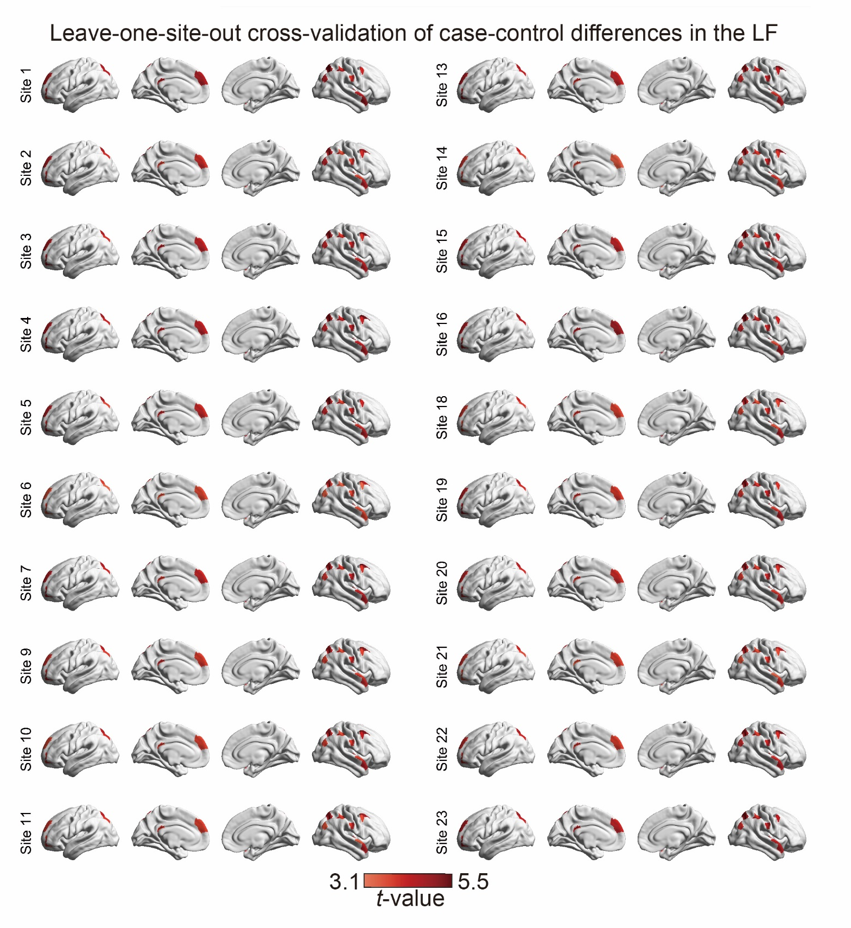
Supplementary Figure. S2 Leave-one-site-out cross-validation of regional alterations in the LF. The case-control differences in the regional LF were largely comparable after excluding data from different centers and were highly similar to the main findings. Specifically, the MDD group showed significantly altered LF compared with the control group (FDR–corrected p < 0.001). LF, laterality fluctuation.
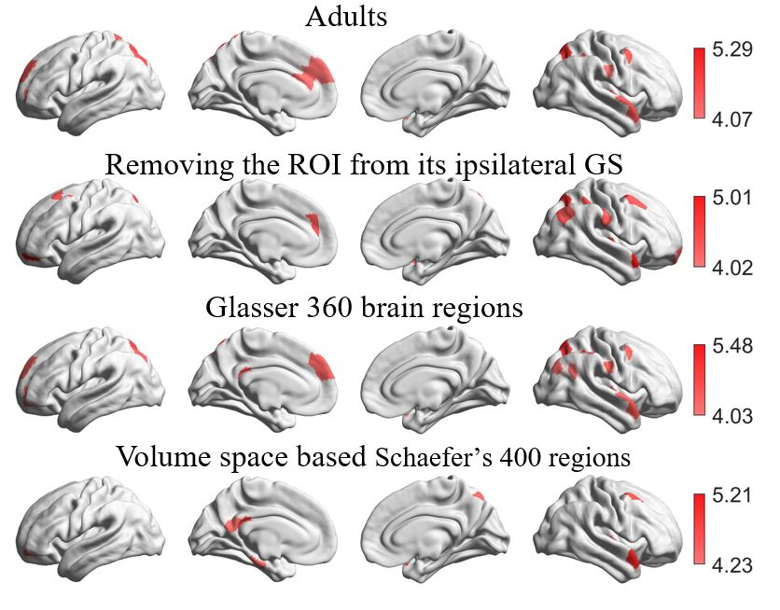
Supplementary Figure. S3 Laterality fluctuation alterations derived from the data of the adult participants, removing the specific ROI from its ipsilateral hemisphere global signal, different parcellation (360 bilateral parcels), volume-based Schaefer’s 400 regions. The case-control differences in these cases were similar to the main findings. The significance level of was FDR–corrected p < 0.001.

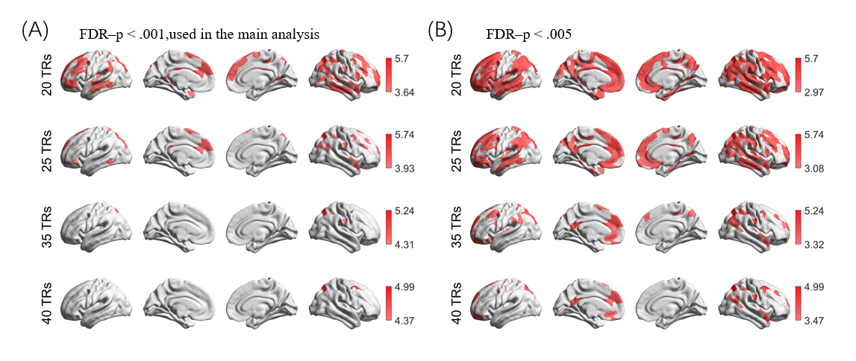
Supplementary Figure. S4 Laterality fluctuation alterations derived from different time window lengths using different choices of FDR–corrected p values. (A) FDR-p < .001, (B) FDR-p < 0.005, respectively.

References
1. Chen X., Lu B., Wang Y-W, Li X-Y, Wang Z-H, Li H-X, et al. (2023). The Complexity of Functional Connectivity Profiles of the Subgenual Anterior Cingulate Cortex and Dorsal Lateral Prefrontal Cortex in Major Depressive Disorder: a DIRECT Consortium Study. BioRxiv, 2023.03.09.531726.
2. Yan C-G, Wang X-D, Lu B (2021): DPABISurf: data processing & analysis for brain imaging on surface. Science Bulletin.
3. Esteban O, Markiewicz CJ, Blair RW, Moodie CA, Isik AI, Erramuzpe A, et al. (2019): fMRIPrep: a robust preprocessing pipeline for functional MRI. Nat Methods. 16:111-116.
4. Dale AM, Fischl B, Sereno MI (1999): Cortical surface-based analysis. I. Segmentation and surface reconstruction. Neuroimage. 9:179-194.
5. Avants BB, Tustison N, Song G (2009): Advanced normalization tools (ANTS). Insight j. 2:1-35.
6. Jenkinson M, Bannister P, Brady M, Smith S (2002): Improved Optimization for the Robust and Accurate Linear Registration and Motion Correction of Brain Images. NeuroImage. 17:825-841.
7. Cox RW, Hyde JS (1997): Software tools for analysis and visualization of fMRI data. NMR Biomed. 10:171-178.
8. Ashburner J (2012): SPM: a history. Neuroimage. 62:791-800.
9. Winkler AM, Ridgway GR, Webster MA, Smith SM, Nichols TE (2014): Permutation inference for the general linear model. NeuroImage. 92:381-397.
10. Li X, Morgan PS, Ashburner J, Smith J, Rorden C (2016): The first step for neuroimaging data analysis: DICOM to NIfTI conversion. J Neurosci Methods. 264:47-56.
11. Tange O (2011): Gnu parallel-the command-line power tool. The USENIX Magazine. 36:42-47.
12. Yan C-G, Wang X-D, Zuo X-N, Zang Y-F (2016): DPABI: Data Processing & Analysis for (Resting-State) Brain Imaging. Neuroinformatics. 14:339-351.
13. Gorgolewski KJ, Auer T, Calhoun VD, Craddock RC, Das S, Duff EP, et al. (2016): The brain imaging data structure, a format for organizing and describing outputs of neuroimaging experiments. Sci Data. 3:160044.
14. Tustison NJ, Avants BB, Cook PA, Zheng Y, Egan A, Yushkevich PA, et al. (2010): N4ITK: improved N3 bias correction. IEEE Trans Med Imaging. 29:1310-1320.
15. Zhang Y, Brady M, Smith S (2001): Segmentation of brain MR images through a hidden Markov random field model and the expectation-maximization algorithm. IEEE Trans Med Imaging. 20:45-57.
16. Klein A, Ghosh SS, Bao FS, Giard J, Häme Y, Stavsky E, et al. (2017): Mindboggling morphometry of human brains. PLoS Comput Biol. 13:e1005350.
17. Fonov VS, Evans AC, McKinstry RC, Almli CR, Collins DL (2009): Unbiased nonlinear average age-appropriate brain templates from birth to adulthood. NeuroImage. 47.
18. Greve DN, Fischl B (2009): Accurate and robust brain image alignment using boundarybased registration. Neuroimage. 48:63-72.
19. Friston KJ, Williams S, Howard R, Frackowiak RSJ, Turner R (1996): Movement-Related effects in fMRI time-series. Magnetic resonance in medicine. 35:346-355.
20. Holiga Š, Sambataro F, Luzy C, et al. Test-retest reliability of task-based and resting-state blood oxygen level dependence and cerebral blood flow measures. PLoS One. 2018. http://dx.doi.org/10.1371/journal.pone.0206583.
21. Nørgaard M, Beliveau V, Ganz M, et al. A high-resolution in vivo atlas of the human brain’s benzodiazepine binding site of GABA receptors. Neuroimage. 2021. http://dx.doi.org/10.1016/j.neuroimage.2021.117878.
22. Kaller S, Rullmann M, Patt M, et al. Test-retest measurements of dopamine D-type receptors using simultaneous PET/MRI imaging. Eur J Nucl Med Mol Imaging. 2017. http://dx.doi.org/10.1007/s00259-017-3645-0.
23. Alakurtti K, Johansson JJ, Joutsa J, et al. Long-term test-retest reliability of striatal and extrastriatal dopamine D2/3 receptor binding: study with [(11)C] raclopride and high-resolution PET. J Cereb Blood Flow Metab. 2015. http://dx.doi.org/10.1038/jcbfm.2015.53.
24. Hesse S, Becker G-A, Rullmann M, et al. Central noradrenaline transporter availability in highly obese, non-depressed individuals. Eur J Nucl Med Mol Imaging. 2017. http://dx.doi.org/10.1007/s00259-016-3590-3.
25. Dukart J, Holiga Š, Chatham C, et al. Cerebral blood flow predicts differential neurotransmitter activity. Sci Rep. 2018. http://dx.doi.org/10.1038/s41598-018-22444-0.
26. García-Gómez FJ, García-Solís D, Luis-Simón FJ, et al. [Elaboration of the SPM template for the standardization of SPECT images with 123I-Ioflupane]. Rev Esp Med Nucl Imagen Mol. 2013. http://dx.doi.org/10.1016/j.remn.2013.02.009.
27. Savli M, Bauer A, Mitterhauser M, et al. Normative database of the serotonergic system in healthy subjects using multi-tracer PET. Neuroimage. 2012. http://dx.doi.org/10.1016/j.neuroimage.2012.07.001.
28. Kantonen T, Karjalainen T, Isojärvi J, et al. Interindividual variability and lateralization of μ-opioid receptors in the human brain. Neuroimage. 2020. http://dx.doi.org/10.1016/j.neuroimage.2020.116922.
29. Beliveau V, Ganz M, Feng L, et al. A High-Resolution In Vivo Atlas of the Human Brain’s Serotonin System. J Neurosci Off J Soc Neurosci. 2017;37(1):120-128. doi:10.1523/JNEUROSCI.2830-16.2016
30. Galovic M, Al-Diwani A, Vivekananda U, et al. In vivo NMDA receptor function in people with NMDA receptor antibody encephalitis. medRxiv. 2021. https://www.medrxiv.org/content/early/2021/12/05/2021.12.04.21267226.
31. Hansen JY, Shafiei G, Markello RD, et al. Mapping neurotransmitter systems to the structural and functional organization of the human neocortex. Nat Neurosci. 2022;25(11):1569-1581. doi:10.1038/s41593-022-01186-3

