Supplementary Material
Abnormal cortical topographic patterns associated with auditory verbal hallucination in first-episode schizophrenia
Gao ZY et al.
Supplementary Methods
Supplementary Tables and Figures
Table S1 Information on six donors in the Allen Human Brain Atlas database
Table S2 Receptors and transporters included in the neurotransmitter analysis
Table S3 Comparisons of gradient range for first three cortical gradients and global dispersion among AVH, NAVH and HCs
Table S4 Group differences in within-network dispersion among AVH, NAVH and HCs
Table S5 Group differences in between-network dispersion among AVH, NAVH and HCs
Table S6 Functional enrichment results of the genes related to nodal eccentricity alterations in AVH patients
Table S7 Relationship between AVH-related manifold eccentricity alterations and specific neurotransmitter profiles
Figure S1 The average explained ratio (λ values) of the first 19 components in the AVH, NAVH and HC groups
Figure S2 Topographic pattern of the first three cortical gradients in AVH, NAVH and HCs
Figure S3 The post-hoc analysis t-map for the group differences of nodal eccentricity between AVH and HC, NAVH and HC, and AVH and NAVH
Reference
Supplementary Methods
Image Acquisition
High-resolution three-dimensional T1-weighted anatomical images were obtained using a spoiled gradient (SPGR) sequence: repetition time (TR) = 8.5 ms, echo time (TE) = 3.4 ms, flip angle =12°, slice number = 156, voxel size = 0.47 × 0.47 × 1mm³, matrix size = 256 × 256, field of view (FOV) = 240 × 240 mm². Resting-state fMRI data were acquired via gradient-echo echo-planar imaging sequence with following settings: TR = 2000 ms, TE = 30 ms, flip angle = 90°, voxel size = 3.75 × 3.75 × 5 mm³, matrix = 64 × 64, FOV = 240 × 240 mm². The total volumes of the resting-state fMRI data were 200, resulting in 6min 40s for scanning. Foam padding was used to minimize the head motion effect and earplugs were provided to reduce scanner noise. During the scanning, all participants were asked to stay relaxed but awake, close their eyes, and keep their mind wandering. Obtained imaging data from each participant were visually inspected by an experienced neuroradiologist to make sure no visible brain structure abnormalities.
Image Preprocessing
The following boilerplate text was automatically generated by fMRIPrep and XCP-D with the express intention that users should copy and paste this text into their manuscripts unchanged. It is released under the CC0 license.
Anatomical data preprocessing
A total of 1 T1-weighted (T1w) images were found within the input BIDS dataset. The T1w image was corrected for intensity non-uniformity (INU) with N4BiasFieldCorrection^{[1]}, distributed with ANTs 2.3.3^{[2]} (RRID:SCR_004757), and used as T1w-reference throughout the workflow. The T1w-reference was then skull-stripped with a Nipype implementation of the antsBrainExtraction.sh workflow (from ANTs), using OASIS30ANTs as target template. Brain tissue segmentation of cerebrospinal fluid (CSF), white-matter (WM) and gray-matter (GM) was performed on the brain-extracted T1w using fast^{[3]} (FSL 5.0.9, RRID:SCR_002823). Brain surfaces were reconstructed using recon-all^{[4]} (FreeSurfer 6.0.1, RRID:SCR_001847), and the brain mask estimated previously was refined with a custom variation of the method to reconcile ANTs-derived and FreeSurfer-derived segmentations of the cortical gray-matter of Mindboggle^{[5]} (RRID:SCR_002438). Volume-based spatial normalization to two standard spaces (MNI152NLin2009cAsym, MNI152NLin6Asym) was performed through nonlinear registration with antsRegistration (ANTs 2.3.3), using brain-extracted versions of both T1w reference and the T1w template. The following templates were selected for spatial normalization: ICBM 152 Nonlinear Asymmetrical template version 2009c^{[6]} [RRID: SCR_008796; TemplateFlow ID: MNI152NLin2009cAsym], FSL’s MNI ICBM 152 non-linear 6th Generation Asymmetric Average Brain Stereotaxic Registration Model^{[7]} [RRID:SCR_002823; TemplateFlow ID: MNI152NLin6Asym].
Functional data preprocessing
For each of the BOLD runs found per subject (across all tasks and sessions), the following preprocessing was performed. First, a reference volume and its skull-stripped version were generated using a custom methodology of fMRIPrep. Susceptibility distortion correction (SDC) was omitted. The BOLD reference was then co-registered to the T1w reference using bbregister (FreeSurfer) which implements boundary-based registration^{[8]}. Co-registration was configured with six degrees of freedom. Head-motion parameters with respect to the BOLD reference (transformation matrices, and six corresponding rotation and translation parameters) are estimated before any spatiotemporal filtering using mcflirt^{[9]} (FSL 5.0.9). BOLD runs were slice-time corrected using 3dTshift from AFNI 20160207 (RRID:SCR_005927). The BOLD time-series were resampled onto the following surfaces (FreeSurfer reconstruction nomenclature): fsaverage. The BOLD time-series (including slice-timing correction when applied) were resampled onto their original, native space by applying the transforms to correct for head-motion. These resampled BOLD time-series will be referred to as preprocessed BOLD in original space, or just preprocessed BOLD. The BOLD time-series were resampled into standard space, generating a preprocessed BOLD run in MNI152NLin2009cAsym space. First, a reference volume and its skull-stripped version were generated using a custom methodology of fMRIPrep. Grayordinates files^{[10]} containing 91k samples were also generated using the highest-resolution fsaverage as intermediate standardized surface space. Several confounding time-series were calculated based on the preprocessed BOLD: framewise displacement (FD), DVARS and three region-wise global signals. FD was computed using two formulations following Power^{[11]}(absolute sum of relative motion) and Jenkinson^{[9]} (relative root mean square displacement between affines). FD and DVARS are calculated for each functional run, both using their implementations in Nipype (following the definitions by Power et al. 2014) ^{[11]}. The three global signals are extracted within the CSF, the WM, and the whole-brain masks. Additionally, a set of physiological regressors were extracted to allow for component-based noise correction (CompCor) ^{[12]}. Principal components are estimated after high-pass filtering the preprocessed BOLD time-series (using a discrete cosine filter with 128s cut-off) for the two CompCor variants: temporal (tCompCor) and anatomical (aCompCor). tCompCor components are then calculated from the top 2% variable voxels within the brain mask. For aCompCor, three probabilistic masks (CSF, WM and combined CSF+WM) are generated in anatomical space. The implementation differs from that of Behzadi et al. in that instead of eroding the masks by 2 pixels on BOLD space, the aCompCor masks are subtracted a mask of pixels that likely contain a volume fraction of GM. This mask is obtained by dilating a GM mask extracted from the FreeSurfer’s aseg segmentation, and it ensures components are not extracted from voxels containing a minimal fraction of GM. Finally, these masks are resampled into BOLD space and binarized by thresholding at 0.99 (as in the original implementation). Components are also calculated separately within the WM and CSF masks. For each CompCor decomposition, the k components with the largest singular values are retained, such that the retained components’ time series are sufficient to explain 50 percent of variance across the nuisance mask (CSF, WM, combined, or temporal). The remaining components are dropped from consideration. The head-motion estimates calculated in the correction step were also placed within the corresponding confounds file. The confound time series derived from head motion estimates and global signals were expanded with the inclusion of temporal derivatives and quadratic terms for each^{[13]}. Frames that exceeded a threshold of 0.5 mm FD or 1.5 standardised DVARS were annotated as motion outliers. All resamplings can be performed with a single interpolation step by composing all the pertinent transformations (i.e. head-motion transform matrices, susceptibility distortion correction when available, and co-registrations to anatomical and output spaces). Gridded (volumetric) resamplings were performed using antsApplyTransforms (ANTs), configured with Lanczos interpolation to minimize the smoothing effects of other kernels^{[14]}. Non-gridded (surface) resamplings were performed using mri_vol2surf (FreeSurfer).
XCP-D postprocessing
For each of the one BOLD runs found per subject (across all tasks and sessions), the following post-processing was performed. In order to identify high-motion outlier volumes, framewise displacement was calculated using the formula from Power et al. (2014)^{[11]}, with a head radius of 50 mm. Volumes with framewise displacement greater than 0.3 mm were flagged as high-motion outliers for the sake of later censoring ^{[11]}. In total, 36 nuisance regressors were selected from the preprocessing confounds, according to the ‘36P’ strategy. These nuisance regressors included six motion parameters, mean global signal, mean white matter signal, mean cerebrospinal fluid signal with their temporal derivatives, and quadratic expansion of six motion parameters, tissue signals and their temporal derivatives ^{[13,15]}. Finally, linear trend and intercept terms were added to the regressors prior to denoising. The BOLD data were converted to NIfTI format, despiked with AFNI’s 3dDespike, and converted back to CIFTI format. Nuisance regressors were regressed from the BOLD data using linear regression, as implemented in Nilearn. Any volumes censored earlier in the workflow were then interpolated in the residual time series produced by the regression. The interpolated timeseries were then band-pass filtered using a second-order Butterworth filter, in order to retain signals between 0.01-0.08 Hz. The filtered, interpolated time series were then re-censored to remove high-motion outlier volumes. The denoised BOLD was then smoothed using Connectome Workbench with a Gaussian kernel (FWHM=6.0 mm). Processed functional time series were extracted from residual BOLD using Connectome Workbench.
Test the confounding effects of head motions
To investigate the potential confounding impact of head motion on gradient measures, we conducted correlation analyses to examine whether the mean FD related to the altered topographic characteristics. We found no significant associations between FD measures and the range of gradient 1 (r = -0.142, p = 0.051), the global dispersion (r=-0.075, p = 0.303), and the network dispersion between DAN-DMN(r = -0.135, p = 0.062), LIM-DMN(r = -0.119, p = 0.101) and LIM-FPN(r = 0.060, p = 0.406).
Supplementary Tables and Figures
Table S1 Information on six donors in the Allen Human Brain Atlas database
Donor ID | Sex | Age  (year) | Postmortem interval (h) | Handedness | Hemispheres | Samples
H0351.2001 | M | 24 | 23 | Left | Both | 946
H0351.2002 | M | 39 | 10 | Left | Both | 893
H0351.1009 | M | 57 | 25.5 | Cross-dominant | Left | 363
H0351.1012 | M | 31 | 17.5 | Right | Left | 529
H0351.1015 | F | 49 | 30 | Right | Left | 470
H0351.1016 | M | 55 | 18 | Right | Left | 501
Abbreviations: M: male; F: female.

Table S2 Receptors and transporters included in the neurotransmitter analysis
Receptor/ Transporter | Neuro-transmitter | Tracer | Modality | Age (SD) | Numbers (Male) | Reference
5-HT1a | serotonin | [11C] WAY-100635 | PET | 26.3 (5.2) | 35 (18) | Savli M, et al. (2012)^{[16]}
5-HT1b | serotonin | [11C]P943 | PET | 28.7 (7.0) | 23 (15) | Savli M, et al. (2012)^{[16]}
5-HT2a | serotonin | [18F]altanserin | PET | 28.2 (5.7) | 19 (11) | Savli M, et al. (2012)^{[16]}
SERT | serotonin | [11C]DASB | PET | 30.5 (9.5) | 18 (12) | Savli M, et al. (2012)^{[16]}
D1 receptor | dopamine | [11C]SCH23390 | PET | 33.0 (13.0) | 13 (6) | Kaller S, et al. (2017)^{[17]}
D2 receptor | dopamine | [11C]Raclopride | PET | NA | 7 (7) | Alakurtti K，et al. (2015)^{[18]}
DAT | dopamine | [123I]FP-CIT | SPECT | 61.0 (11.0) | 174 (109) | Dukart J, et al. (2018)^{[19]}
FDOPA | dopamine | [123I]Ioflupane | SPECT | NA | 26 (NA) | García-Gómez FJ, et al. (2013)^{[20]}
GABAa | GABA | [11C]flumazenil | PET | 26.6 (8.0) | 16 (7) | Nørgaard M, et al. (2021)^{[21]}
MU | opioid | [11C]carfentanil | PET | 32.4 (NA) | 204 (132) | Kantonen T, et al. (2020)^{[22]}
NAT | norepinephrine | [11C]OMRB | PET | 33.3 (9.0) | 20 (12) | Hesse S, et al. (2017)^{[23]}
VAchT | acetylcholine | [18 F] FEOBV | PET | 66.8 (6.8) | 18 (5) | Aghouria M, et al. (2017)^{[24]}
mGluR5 | glutamate | [11C]ABP688 | PET | 20.0 (3.0) | 74 (25) | Smart K, et al. (2019)^{[25]}
Abbreviations: 5-HT, 5-hydroxytryptamine; SERT, serotonin transporter; DAT, dopamine transporter; FDOPA, fluorodopa; GABA, gamma-aminobutyric acid; NAT, noradrenaline transporter; VAChT, vesicular acetylcholine transporter; mGluR, metabotropic glutamate; PET, positron emission tomography; SPECT, single photon emission computed tomography.

Table S3 Comparisons of gradient range for first three cortical gradients and global dispersion among AVH, NAVH and HCs.
Global gradient metrics | F statistics ª | p value ª | T statistics (p value) for Pairwise comparison ^{b}
Global gradient metrics | F statistics ª | p value ª | AVH vs. HC | NAVH vs. HC | AVH vs. NAVH
Gradient 1 Range | 3.144 | 0.045* | -2.172 (0.031) | 0.362 (0.718) | 2.252 (0.026)
Gradient 2 Range | 0.412 | 0.663 | - | - | -
Gradient 3 Range | 2.176 | 0.116 | - | - | -
Global Dispersion | 4.749 | 0.010* | -2.902 (0.004) | -0.058 (0.954) | -2.594 (0.011)
a The F statistics and p values for the group effects in the ANCOVA analysis, with age and sex as covariance. * indicates the significant difference among the three groups.
b The T statistics and p values for post-hoc pairwise comparisons. Significant differences of post-hoc comparisons were shown in bold font.
Abbreviations: AVH, schizophrenia patients with auditory verbal hallucination; NAVH, schizophrenia patients without auditory verbal hallucination; HC, healthy control.

Table S4 Group differences in within-network dispersion among AVH, NAVH and HCs.
Network | F statistics ª | p value ª
Visual Network | 0.708 | 0.494
Somatomotor Network | 1.065 | 0.347
Dorsal Attention Network | 2.055 | 0.131
Ventral Attention Network | 0.172 | 0.842
Limbic Network | 1.568 | 0.211
Frontoparietal Network | 0.430 | 0.651
Default Mode Network | 0.724 | 0.486

a The F statistics and p values for the group effects in the ANCOVA analysis, with age and sex as covariance.
Abbreviations: AVH, schizophrenia patients with auditory verbal hallucination; NAVH, schizophrenia patients without auditory verbal hallucination; HC, healthy control.

Table S5 Group differences in between-network dispersion among AVH, NAVH and HCs.
Network | F statistics ª | p value ª | T statistics (p value) for Pairwise comparison ^{b}
Network | F statistics ª | p value ª | AVH vs. HC | NAVH vs. HC | AVH vs. NAVH
VN-SMN | 2.237 | 0.110 | -0.120 (0.905) | 1.825 (0.070) | -2.151 (0.034)
VN-DAN | 4.685 | 0.010 | -2.551 (0.012) | 0.632 (0.528) | -3.021 (0.003)
VN-VAN | 3.663 | 0.028 | -2.034 (0.044) | 1.011 (0.314) | -2.580 (0.011)
VN-LIM | 1.091 | 0.338 | -1.179 (0.240) | 0.411 (0.681) | -1.486 (0.140)
VN-FPN | 3.158 | 0.045 | -1.734 (0.085) | 1.029 (0.305) | -2.564 (0.012)
VN-DMN | 3.383 | 0.036 | -2.088 (0.038) | 0.665 (0.507) | -2.574 (0.012)
SMN-DAN | 3.037 | 0.050 | -2.427 (0.016) | -1.114 (0.267) | -0.929 (0.355)
SMN-VAN | 0.964 | 0.383 | -1.373 (0.172) | -0.494 (0.622) | -0.731 (0.466)
SMN-LIM | 0.126 | 0.881 | -0.207 (0.836) | -0.644 (0.521) | 0.263 (0.793)
SMN-FPN | 1.399 | 0.249 | -0.932 (0.353) | 0.808 (0.421) | -1.722 (0.088)
SMN-DMN | 2.054 | 0.131 | -2.040 (0.043) | -0.468 (0.640) | -1.260 (0.211)
DAN-VAN | 0.573 | 0.565 | 0.229 (0.819) | -0.928 (0.355) | 1.021 (0.310)
DAN-LIM | 1.394 | 0.251 | 0.585 (0.559) | -1.348 (0.180) | 1.667 (0.099)
DAN-FPN | 0.419 | 0.658 | -0.453 (0.652) | 0.505 (0.614) | -0.925 (0.357)
DAN-DMN | 5.665 | 0.004* | -3.342 (0.001) | -0.566 (0.572) | -2.324 (0.022)
VAN-LIM | 0.002 | 0.998 | 0.112 (0.911) | -0.055 (0.956) | 0.050 (0.960)
VAN-FPN | 2.019 | 0.136 | -0.737 (0.462) | 1.506 (0.135) | -1.928 (0.057)
VAN-DMN | 3.508 | 0.032 | -2.517 (0.013) | 0.120 (0.905) | -2.163 (0.033)
LIM-FPN | 6.636 | 0.002* | -2.991 (0.003) | 0.821 (0.413) | -3.354 (0.001)
LIM-DMN | 6.120 | 0.003* | -3.443 (0.001) | -0.535 (0.593) | -2.474 (0.015)
FPN-DMN | 3.454 | 0.034 | -2.704 (0.008) | -0.578 (0.565) | -1.605 (0.112)
a The F statistics and p values for the group effects in the ANCOVA analysis, with age and sex as covariance. * indicates that the p value was survived after FDR correction.
b The T statistics and p values for post-hoc pairwise comparisons. Significant differences of post-hoc comparisons were shown in bold font.
Abbreviations: AVH, schizophrenia patients with auditory verbal hallucination; NAVH, schizophrenia patients without auditory verbal hallucination; HC, healthy control. VN, visual network; SMN, somatomotor network: DAN, dorsal attention network; VAN, ventral attention network; LIM, limbic network; FPN, frontoparietal network; DMN, default-mode network.

Table S6 Functional enrichment results of the genes related to nodal eccentricity alterations in AVH patients
ID | Description | p value | q value  (FDR correction) | Input Gene Number
Top 10 gene pathways of PLS+ gene set
GO:0030029 | actin filament-based process | 1.51E-09 | 3.34E-05 | 29
GO:0043065 | positive regulation of apoptotic process | 7.03E-07 | 3.89E-03 | 23
GO:0006897 | endocytosis | 1.02E-06 | 4.51E-03 | 22
GO:1904375 | regulation of protein localization to cell periphery | 1.43E-06 | 4.51E-03 | 11
GO:0050767 | regulation of neurogenesis | 3.14E-06 | 7.51E-03 | 18
GO:0022604 | regulation of cell morphogenesis | 3.40E-06 | 7.51E-03 | 14
GO:0007167 | enzyme-linked receptor protein signaling pathway | 4.19E-06 | 8.39E-03 | 23
GO:0071394 | cellular response to testosterone stimulus | 4.93E-06 | 8.39E-03 | 4
GO:0032535 | regulation of cellular component size | 5.66E-06 | 8.94E-03 | 17
GO:0032989 | cellular anatomical entity morphogenesis | 1.08E-05 | 1.27E-02 | 22
Top 10 gene pathways of PLS- gene set
GO:0050804 | modulation of chemical synaptic transmission | 4.13E-11 | 4.86E-07 | 40
GO:0050807 | regulation of synapse organization | 7.92E-09 | 4.38E-05 | 24
GO:0034762 | regulation of transmembrane transport | 1.77E-07 | 6.07E-04 | 33
GO:0042391 | regulation of membrane potential | 2.19E-07 | 6.07E-04 | 31
GO:0010035 | response to inorganic substance | 9.50E-07 | 2.20E-03 | 33
GO:1903530 | regulation of secretion by cell | 1.65E-06 | 2.73E-03 | 34
GO:0007610 | behavior | 1.73E-06 | 2.73E-03 | 36
GO:0031400 | negative regulation of protein modification process | 2.50E-06 | 3.18E-03 | 28
GO:0140352 | export from cell | 2.59E-06 | 3.18E-03 | 30
WP536 | Calcium regulation in cardiac cells | 5.03E-06 | 4.28E-03 | 15

Table S7 Relationship between AVH-related manifold eccentricity alterations and specific neurotransmitter profiles.
Neurotransmitter | Spearman rho (r) | p_exact (spatial permutations)
5-HT1a | -0.0933 | 0.3705
5-HT1b | 0.0134 | 0.8864
5-HT2a | -0.1611 | 0.0400
SERT | 0.0221 | 0.7471
D1 receptor | 0.0093 | 0.9114
D2 receptor | 0.0811 | 0.2236
DAT | 0.0374 | 0.6397
FDOPA | 0.0161 | 0.8496
GABAa | -0.0849 | 0.3307
MU | 0.0345 | 0.8222
NAT | 0.2492 | 0.0004
VAchT | 0.2142 | 0.0004
mGluR5 | 0.0737 | 0.2212
Abbreviations: 5-HT, 5-hydroxytryptamine; SERT, serotonin transporter; DAT, dopamine transporter; FDOPA, fluorodopa; GABA, gamma-aminobutyric acid; NAT, noradrenaline transporter; VAChT, vesicular acetylcholine transporter; mGluR, metabotropic glutamate

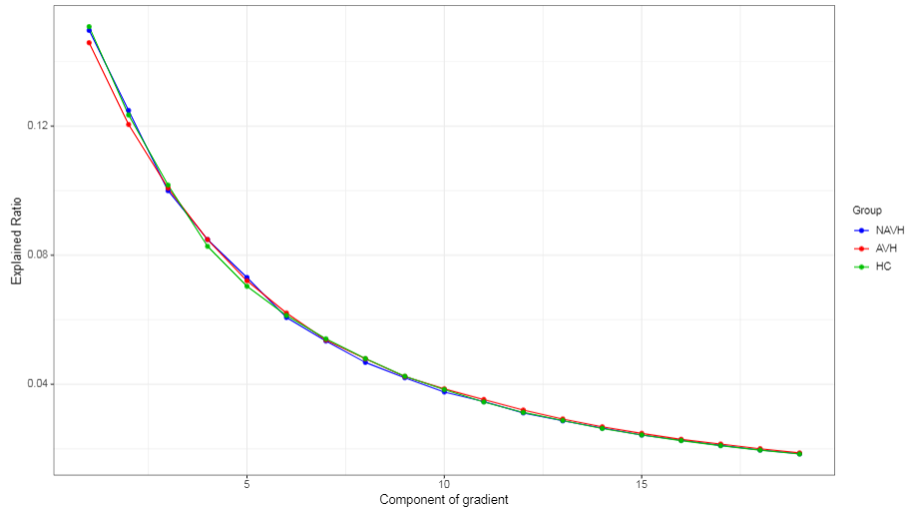
Figure S1 The average explained ratio (λ values) of the first 19 components in the AVH, NAVH and HC groups. The AVH group is shown in red, the NAVH group is shown in blue, while the HC group is shown in green. The first three gradients explained 0.37±0.02 of the total variance in connectivity across all individuals (AVH: 0.37±0.02; NAVH: 0.37±0.02; HC: 0.38±0.03). There are no difference of explained ratios in the first three gradients among the AVH, NAVH and HC group (Gradient 1: p = 0.08; Gradient 2: p = 0.10; Gradient 3: p = 0.58). AVH: auditory verbal hallucination schizophrenia; NAVH: non-auditory verbarl hallucination schizophrenia; HC: healthy control.

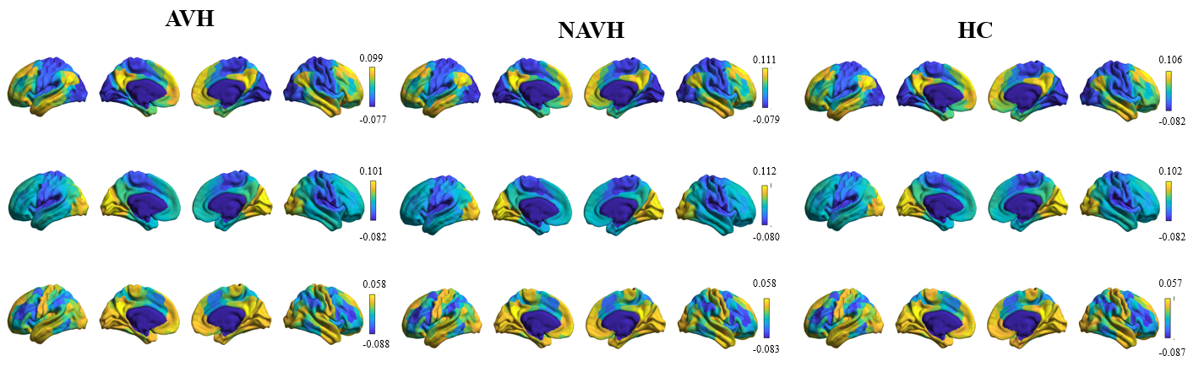
Figure S2 Topographic pattern of the first three cortical gradients in AVH, NAVH and HCs. The individual-level gradient solution was aligned to the group-level embedding from a subsample of HCP dataset (n=237) via Procrustes rotations. The distribution of group-averaged connectome gradient scores along the first three gradients are mapped onto the cortical surface in AVH, NAVH and HC group. HCP: Human Connectome Project; G1: Grandient-1; G2: Grandient-2; G3: Grandient-3.

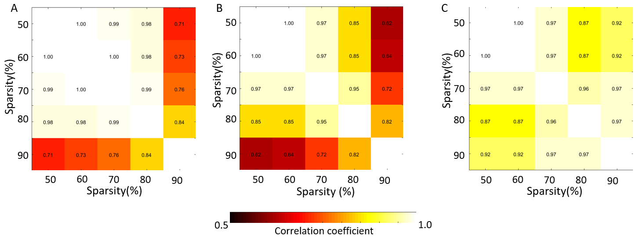
Figure S3 Correlation matrix of mean loadings of the first three gradients (gradient1-gradient3: A-C) computed with different thresholds.
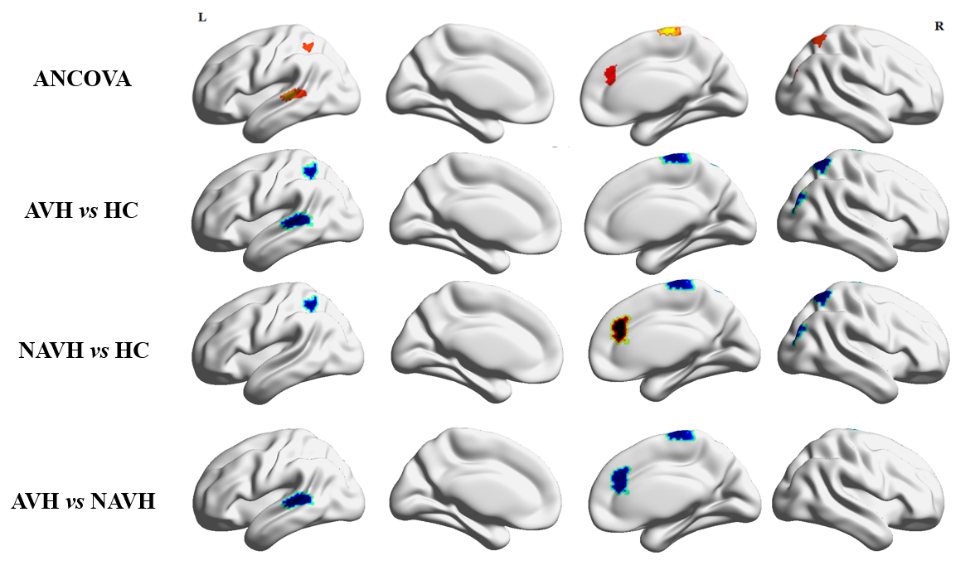
Figure S4 The post-hoc analysis t-map for the group differences of nodal eccentricity between AVH and HC, NAVH and HC, and AVH and NAVH. The blue color means t<0 and the red color means t>0.

Reference:
[1] Tustison NJ, et al. N4ITK: improved N3 bias correction. IEEE Trans Med Imaging. 2010 Jun;29(6):1310-20.
[2] Avants BB, et al. Symmetric diffeomorphic image registration with cross-correlation: evaluating automated labeling of elderly and neurodegenerative brain. Med Image Anal. 2008 Feb;12(1):26-41.
[3] Zhang Y, et al. Segmentation of brain MR images through a hidden Markov random field model and the expectation-maximization algorithm. IEEE Trans Med Imaging. 2001 Jan;20(1):45-57.
[4] Dale AM, et al. Cortical surface-based analysis. I. Segmentation and surface reconstruction. Neuroimage. 1999 Feb;9(2):179-94.
[5] Klein A, et al. Mindboggling morphometry of human brains. PLoS Comput Biol. 2017 Feb 23;13(2):e1005350.
[6] Fonov VS, et al. Unbiased Nonlinear Average Age-Appropriate Brain Templates from Birth to Adulthood. NeuroImage. 2009 (47), Supplement 1: S102.
[7] Evans AC, et al. Brain templates and atlases. Neuroimage. 2012 Aug 15;62(2):911-22.
[8] Greve DN, et al. Accurate and robust brain image alignment using boundary-based registration. Neuroimage. 2009 Oct 15;48(1):63-72.
[9] Jenkinson M, et al. Improved optimization for the robust and accurate linear registration and motion correction of brain images. Neuroimage. 2002 Oct;17(2):825-41.
[10] Glasser MF, et al. The minimal preprocessing pipelines for the Human Connectome Project. Neuroimage. 2013 Oct 15;80:105-24.
[11] Power JD, et al. Methods to detect, characterize, and remove motion artifact in resting state fMRI. Neuroimage. 2014 Jan 1;84:320-41.
[12] Behzadi Y, et al. A component based noise correction method (CompCor) for BOLD and perfusion based fMRI. Neuroimage. 2007 Aug 1;37(1):90-101.
[13] Satterthwaite TD, et al. An improved framework for confound regression and filtering for control of motion artifact in the preprocessing of resting-state functional connectivity data. Neuroimage. 2013 Jan 1;64:240-56.
[14] Lanczos C. Evaluation of Noisy Data. Journal of the Society for Industrial and Applied Mathematics Series B Numerical Analysis. 1964; 1 (1): 76–85.
[15] Ciric R, et al. Benchmarking of participant-level confound regression strategies for the control of motion artifact in studies of functional connectivity. Neuroimage. 2017 Jul 1;154:174-187.
[16] Savli M, et al. Normative database of the serotonergic system in healthy subjects using multi-tracer PET. Neuroimage. 2012 Oct 15;63(1):447-59.
[17] Kaller S, et al. Test-retest measurements of dopamine D₁-type receptors using simultaneous PET/MRI imaging. Eur J Nucl Med Mol Imaging. 2017 Jun;44(6):1025-1032.
[18] Alakurtti K, et al. Long-term test-retest reliability of striatal and extrastriatal dopamine D2/3 receptor binding: study with [(11)C]raclopride and high-resolution PET. J Cereb Blood Flow Metab. 2015 Jul;35(7):1199-205.
[19] Dukart J, et al. Cerebral blood flow predicts differential neurotransmitter activity. Sci Rep. 2018 Mar 6;8(1):4074.
[20] García-Gómez FJ, et al. [Elaboration of the SPM template for the standardization of SPECT images with 123I-Ioflupane]. Rev Esp Med Nucl Imagen Mol. 2013 Nov-Dec;32(6):350-6.
[21] Nørgaard M, et al. A high-resolution in vivo atlas of the human brain's benzodiazepine binding site of GABAA receptors. Neuroimage. 2021 May 15;232:117878.
[22] Kantonen T, et al. Interindividual variability and lateralization of μ-opioid receptors in the human brain. Neuroimage. 2020 Aug 15;217:116922.
[23] Hesse S, et al. Central noradrenaline transporter availability in highly obese, non-depressed individuals. Eur J Nucl Med Mol Imaging. 2017 Jun;44(6):1056-1064.
[24] Aghourian M, et al. Quantification of brain cholinergic denervation in Alzheimer's disease using PET imaging with [18F]-FEOBV. Mol Psychiatry. 2017 Nov;22(11):1531-1538.
[25] Smart K, et al. Sex differences in [11C]ABP688 binding: a positron emission tomography study of mGlu5 receptors. Eur J Nucl Med Mol Imaging. 2019 May;46(5):1179-1183.

