SUPPLEMENTAL MATERIALS

Supplemental Methods
RNA extraction via PAXgene kit
For RNA isolation, samples were moved from 80°C (long-term storage) to -20C° for 2 hours then left at room temperature (RT) overnight. Tubes were centrifuged the next day (10 min, 3000xg at 25°C). The pellet was dissolved in RNase free water, centrifuged again and resuspended in BM1 buffer (350µL). Samples were then diluted in 300µL of BM2 buffer and 40µL of proteinase K. After 10 min incubation at 55°C (400 rpm), samples were purified using PAXgene Shredder spin columns and dissolved in 700µL isopropanol. Samples were then dissolved in 350µL of wash buffer (BM3). A DNAse I mix with Buffer RDD was added, and samples were incubated for 30 minutes. RNA was then purified using PAXgene spin columns with Buffer BM3 (350 µL) and centrifuged (30 s at 8000×g), followed by two washes with Buffer BM4 and centrifugation (2 min at 8000×g). RNA was eluted twice with 40 µL of Buffer BR5 after 10 min incubation at RT and centrifugation (2 min at 8000×g). The final RNA eluate was incubated at 60 °C for 15 minutes, then cooled on ice. RNA concentration was measured using a NanoDrop spectrophotometer (Thermo Scientific, Wilmington, DE, USA). Total RNA was extracted from PAXgene blood RNA tubes, and RNA integrity was verified with RIN values > 7.0.
Real-Time Quantitative Polymerase Chain Reaction (RT-PCR)
The reverse transcription of total RNA (~200 ng) was performed using SuperScript III Reverse Transcriptase (Invitrogen), as previously described (Matrisciano & Pinna, 2021). To determine the optimal cDNA input for quantitative PCR, serial dilutions were tested, and a standard curve was constructed. Based on this, 2 μL cDNA (~2 ng) was selected for subsequent reactions. Real-time quantitative PCR (qPCR) was carried out in 10 μL reactions containing 5 μL Agilent Brilliant III Ultra-Fast SYBR® Green Master Mix (Cat# 600882) and 0.5 μM each of forward and reverse primers. Primer sequences (Table S1) were designed using NCBI Primer-BLAST to ensure specificity and synthesized by Integrated DNA Technologies (IDT). Primer efficiencies were calculated from standard curves generated using serial dilutions of cDNA. Amplification was performed using the Agilent AriaMx Real-Time PCR System with the following cycling conditions: initial denaturation at 95 °C for 10 min, followed by 40 cycles of 95 °C for 30 s, 60 °C for 30 s, and 72 °C for 45 s. Ct values were normalized to the housekeeping gene β-actin.
In line with MIQE guidelines, we have validated our qPCR results to ensure the reliability and reproducibility of mRNA expression claims. Amplification and melt curve analyses for GABRD, GABRG2, and GABRA5 confirmed efficient amplification and the presence of a single, specific product without primer-dimer formation. Amplicon sizes were verified by agarose gel electrophoresis, with all bands matching the predicted fragment lengths.
Sanger sequencing confirmed target specificity for each qPCR amplicon by alignment with the corresponding reference genomic sequences: GABRA5 (α5 subunit) aligned with chromosome 15 sequence (ACCTACCTTCCCTGCATAATGACCGTGATCTTATCACAGGTG TCCTTTT, Accession ID: NC_000015.10), GABRG2 (γ2 subunit) with chromosome 5 (ATGGGNNACTTTACCATCCAGACCTATATCCCC TGCACACTCNTTGTCGTCCT, Accession ID: NC_000005.10), and GABRD (δ subunit) with chromosome 1 (CCTTTGCTC TTTCACGCCGACTACAGGAAGAAGCAGAAGA, Accession ID: NC_000001.11). The aligned sequencing reads matched the expected amplicon regions, confirming primer specificity and product identity.
For the limit of detection (LOD), we applied a two-step approach to ensure both technical and biological reliability. First, we used an analytical threshold based on the quantification cycle (Cq ≥32) to exclude samples with unreliable amplification. Second, we applied a normalized biological LOD, defined as 2^–ΔCt < 0.00001, corresponding to approximately 100,000-fold lower expression than the reference gene. This threshold was empirically derived from standard curves and replicate analyses and reflects the lowest cDNA concentration consistently detected across replicates, with a Cq standard deviation ≤ 0.5 and minimum amplification efficiency of 90%. Our approach aligns with the MIQE guidelines, which define LOD as the lowest concentration at which ≥95% of replicates yield detectable amplification.

Supplemental Tables

Table S1. Primer sequences for qPCR analysis.

 | FORWARD 5’-3’ | REVERSE 5’-3’ | Amplicon size | Slope | Efficiency | R₂
β-ACTIN | CAG CCT TCC TTC CTG GGC AT | GTC ACA CTT CAT GAT GGA GTT G
GABA α5 | CAT GCG CTT GAC CAT CTC TG | TAG CTG CCA AAT TTC AGA GG | 90 | -3.48 | 95% | 0.99
GABA γ2 | AAC TTC CGG AGA TTA TGT GG | ATA GGA CGA CAA TGA GTG TG | 107 | -3.14 | 107% | 0.99
GABA δ | TCT GCT ATG TCT TCG TGT TT | CTT CTG CTT CTT CCT GTA GT | 80 | -3.10 | 107% | 0.99

Table S2. Affective symptom items from the daily record of severity of problems (DRSP). Participants rated symptoms from the DRSP each evening, with instructions to report on their symptom severity over the past 24 hours.
Scale | Item Text | Response Options
DRSP | I felt depressed, down, or blue. | 1 - Not at All | 2 - Minimal | 3 - Mild | 4 - Moderate | 5 - Very Much | 6 - Extreme
DRSP | I felt anxious, keyed up, or on edge. | 1 - Not at All | 2 - Minimal | 3 - Mild | 4 - Moderate | 5 - Very Much | 6 - Extreme
DRSP | I felt irritable. | 1 - Not at All | 2 - Minimal | 3 - Mild | 4 - Moderate | 5 - Very Much | 6 - Extreme

Table S3. Suicide-related symptoms. In the patient group only, we created a mean SI score calculated from eight items, which were adapted from the Adult Suicidal Ideation Questionnaire (ASIQ), the Columbia Suicide Severity Rating Scale (C-SSRS), and the Beck Depression Inventory II (BDI-II) to reflect suicidal ideation severity in the past 24 hours.
Scale (Adapted From) | Item Text | Response Options
ASIQ | I wished I were dead. | 1 - Not at All | 2 - Slightly | 3 - Moderately | 4 - Very Much | 5 - Extremely
C-SSRS | I wished I could go to sleep and not wake up. | 1 - Not at All | 2 - Slightly | 3 - Moderately | 4 - Very Much | 5 - Extremely
ASIQ | I thought about killing myself. | 1 - Not at All | 2 - Slightly | 3 - Moderately | 4 - Very Much | 5 - Extremely
BDI-II | I wanted to kill myself. | 1 - Not at All | 2 - Slightly | 3 - Moderately | 4 - Very Much | 5 - Extremely
ASIQ | I thought that life was not worth living. | 1 - Not at All | 2 - Slightly | 3 - Moderately | 4 - Very Much | 5 - Extremely
ASIQ | I thought it would be better if I was not alive. | 1 - Not at All | 2 - Slightly | 3 - Moderately | 4 - Very Much | 5 - Extremely
ASIQ | I thought that if things did not get better I would kill myself. | 1 - Not at All | 2 - Slightly | 3 - Moderately | 4 - Very Much | 5 - Extremely
ASIQ | I thought about killing myself, but would not do it. | 1 - Not at All | 2 - Slightly | 3 - Moderately | 4 - Very Much | 5 - Extremely

Table S4. Model fit statistics for nested models predicting daily depression from various model designs. Nested models “linear-linear” (two linear splines predicting depression) compared to “quadratic-linear (a quadratic luteal spline and a linear follicular spline predicting depression), where a chi-square comparison test showed that the more complex model improved fit. Then, nested models “quadratic-linear” and “quadratic-quadratic” (two quadratic splines predicting depression), where a chi-square comparison test showed that the more complex model did not improve fit. Significant improvement (p<-0.05) in model fit is bolded. Abbreviations: npar: number of parameters in model; AIC: Akaike information criterion; BIC: Bayesian information criterion; loglik: log-likelihood; chisq: Chi-square; df: degrees of freedom.
Model fitting of spline analyses. In general, we were able to successfully fit several models for each symptom where time was modeled as a continuous, day-to-day outcome from LH surge to menses, and from menses to next estimated LH surge. In all models across all four symptoms, any random slope that fit in a model that converged without error also significantly improved fit over the random intercepts only version. For example, when the model could be specified with a random effect of the luteal phase spline (linear), the luteal phase spline (quadratic), and the follicular phase spline (linear), inclusion of all three random slopes significantly improved model fit. We will describe the model fitting and selection process for the symptom outcome of depression as an example of our process, which was identical for all four symptoms. For models predicting depression across the menstrual cycle, we found that of our five possible trajectories (quadratic; two linear splines with knot at menses; quadratic spline and linear spline; linear spline and quadratic spline; two quadratic splines), a quadratic spline across the luteal phase with a linear spline across the follicular phase was the best fitting model to predict depression. In all models, random slopes that fit in the model also improved model fit over a random intercepts-only version. In Table S4, we compared two pairs of nested models. The more complex quadratic-linear combination was a significantly better fit than the nested linear-linear combination, but increasing complexity to allow quadratic-quadratic splines did not improve model fit over the quadratic-linear.
Depression
Nested models | npar | AIC | BIC | loglik | deviance | chisq | df | p
Linear-linear | 10 | 6398.2 | 6456.7 | -3189.1 | 6378.2
Quadratic-linear | 15 | 6349.2 | 6437 | -3159.6 | 6319.2
Chi-square comparing fit between linear-linear and quadratic-linear models |  |  |  |  |  | 58.989 | 5 | 1.97E-11
Quadratic-linear | 15 | 6349.2 | 6437 | -3159.6 | 6319.2
Quadratic-quadratic | 16 | 6351.2 | 6444.8 | -3159.6 | 6319.2
Chi-square comparing fit between quadratic-linear and quadratic-quadratic models |  |  |  |  |  | 0.0027 | 1 | 0.9582

Table S5. Model fit statistics for non-nested models predicting daily depression from five model designs. The model indicated in bold demonstrated superior fit statistics, where lower values of each index indicates a better fit. AIC: Akaike Information Criterion, BIC: Bayesian Information Criterion, RMSE: Root Mean Square Error. In Table S5, we compared model fitting statistics for all five model designs, focusing on the non-nested models that had yet to be compared. While we had already statistically tested fit between the nested models (linear-linear, quadratic-linear, and quadratic linear), showing that the quadratic-linear combination of splines was the best fit, we had not compared the best fitting of the nested models to the non-nested models (quadratic and linear-quadratic). On all measures of fit, the quadratic-linear model outperformed the quadratic and linear-quadratic models. In sum, for analyses where depression was the outcome, we chose to only test one version of “cycle time,” where the model was split into two splines with a knot at menses, and the luteal phase spline was quadratic, while the follicular phase spline was linear. The same process was repeated for anxiety, irritability, and SI (data not shown). For models predicting anxiety, we found that the linear-linear combination of splines was the best fit of the nested models (in other words, increasing complexity by adding 1-2 quadratic terms did not improve model fit), followed by the quadratic-linear combination of splines. For irritability, we found that both the linear-quadratic and the quadratic-linear combination of splines were significantly better fits than the linear-linear splines. Allowing both splines to fluctuate on a quadratic curve was a marginal improvement in model fit (p=0.09), but random slope fitting was more effective for the linear-quadratic and quadratic-linear combinations. Finally, for SI, we retained the linear-quadratic and quadratic-linear versions of the model, similar to irritability. Both of those models were a significantly better fit than a linear-linear spline fit and a quadratic-quadratic fit. In sum, this systematic model fitting process shows that symptom trajectories can be successfully modeled using continuous linear and quadratic splines representing time across the menstrual cycle, and accounting for individual differences in slopes along these splines significantly improves the models.

Depression
 | Random slopes | AIC | BIC | RMSE | Sigma
Quadratic | quad + lin | 6437.429 | 6495.915 | 0.711 | 0.746
Linear-Linear | lut+fol | 6406.615 | 6465.101 | 0.705 | 0.74
Linear-Quadratic | lut+fol+folquad | 6392.07 | 6479.798 | 0.693 | 0.732
Quadratic-Linear | lut+lutquad+fol | 6358.802 | 6446.53 | 0.686 | 0.725
Quadratic-Quadratic | lut+lutquad+fol | 6362.17 | 6455.747 | 0.686 | 0.725

Table S6. Descriptive statistics for GABRD, GABRG2, and GABRA5 gene expression.
W=winsorized data, SD=standard deviation, Q=quartile, IQR=interquartile range, CV=coefficient of variance

 | GABRD |  |  | GABRG2 |  |  | GABRA5
 | raw | w | log(w+1) | raw | w | log(w+1) | raw | w | log(w+1)
n | 485 | 485 | 485 | 491 | 491 | 491 | 476 | 476 | 476
maximum | 7.6999 | 0.1035 | 0.0984 | 23.5888 | 0.1018 | 0.0970 | 7.6999 | 0.0936 | 0.0895
minimum | 0.0000 | 0.0000 | 0.0000 | 0.0000 | 0.0000 | 0.0000 | 0.0000 | 0.0000 | 0.0000
mean | 0.0767 | 0.0164 | 0.0159 | 0.0867 | 0.0125 | 0.0121 | 0.0683 | 0.0136 | 0.0132
SD | 0.5186 | 0.0282 | 0.0270 | 1.0792 | 0.0260 | 0.0249 | 0.5069 | 0.0251 | 0.0241
median | 0.0034 | 0.0034 | 0.0034 | 0.0013 | 0.0013 | 0.0013 | 0.0026 | 0.0026 | 0.0026
skew | 10.9984 | 2.1313 | 2.0973 | 21.0703 | 2.5665 | 2.5311 | 11.6818 | 2.3008 | 2.2706
kurtosis | 133.7179 | 3.3896 | 3.2418 | 455.0989 | 5.5454 | 5.3634 | 148.2769 | 4.1329 | 3.9955
Q1 | 0.0009 | 0.0009 | 0.0009 | 0.0002 | 0.0002 | 0.0002 | 0.0003 | 0.0003 | 0.0003
Q3 | 0.0153 | 0.0153 | 0.0151 | 0.0077 | 0.0077 | 0.0077 | 0.0112 | 0.0112 | 0.0111
IQR | 0.0143 | 0.0143 | 0.0142 | 0.0075 | 0.0075 | 0.0075 | 0.0109 | 0.0109 | 0.0108
CV | 676.4030 | 172.0094 | 169.6997 | 1245.1620 | 208.1821 | 205.6683 | 741.8043 | 184.6605 | 182.4302

Table S7. Between-person and repeated measures correlation coefficients for GABRD, GABRG2, and GABRA5 genes. Significant correlations (p < 0.001) are denoted with bold text and an asterisk; marginal significance (p < 0.1) is denoted with italic text and a dagger symptom. We analyzed between-person correlation coefficients designed to test whether a person’s average (traitlike) degree of gene expression in one subunit was associated with their average expression of another subunit, and repeated measures correlation coefficients, designed to test whether gene expression for one subunit covaries with that of another subunit within-person across repeated visits.
Between-person correlations |  |  |  |  | Repeated measures correlations
 | GABRD | GABRG2 | GABRA5 |  |  | GABRD | GABRG2 | GABRA5
GABRD | 1 |  |  |  | GABRD | 1
GABRG2 | 0.263* | 1 |  |  | GABRG2 | 0.344* | 1
GABRA5 | 0.920* | 0.173† | 1 |  | GABRA5 | 0.883* | 0.280* | 1

Table S8. Predicting GABAAR subunit gene expression across the menstrual cycle.
A) Results from multilevel models predicting subunit (GABRD, GABRG2) from three visits. Visits were timed to LH+7 (“MIDLUT”), LH+14 (“PERIMENS”), and LH+22 (“MIDFOL”). Models predicting GABRA5 did not converge. Est: estimate; CI: 95% confidence interval. B) Results from multilevel models predicting gene expression from luteal and follicular phase linear splines.
Random slopes of linear luteal and follicular phase splines significantly improved model fit and were included for GABRD and GABRA5. GABRG2 best-fitting model included random intercepts only. Abbreviations: LH: luteinizing hormone; MIDLUT: midluteal; PERIMENS: perimenstrual; MIDFOL: midfollicular; Est: Estimate; CI: 95% confidence interval; ICC: intraclass correlation.

A) Predicting Subunit Gene Expression Means at Cycle-Timed Visits
 |  |  | GABRD |  |  |  |  |  | GABRG2 |  |  |  |  |  | GABRA5
Predictors |  | Est |  |  | CI |  | p |  | Est |  | CI |  | p |  | Est |  | CI | p
(Intercept) |  | 0.018 |  |  | 0.009 – 0.026 |  | <0.001 |  | 0.017 |  | 0.009 – 0.025 |  | <0.001 |  | NA |  | NA | NA
MIDFOL vs. PERIMENS |  | -0.001 |  |  | -0.010 – 0.008 |  | 0.831 |  | -0.003 |  | -0.011 – 0.006 |  | 0.559 |  | NA |  | NA | NA
MIDLUT vs. PERIMENS |  | 0.001 |  |  | -0.008 – 0.011 |  | 0.769 |  | -0.009 |  | -0.017 – 0.000 |  | 0.051 |  | NA |  | NA | NA
Group (Patient vs HC) |  | 0.002 |  |  | -0.007 – 0.011 |  | 0.704 |  | 0.004 |  | -0.005 – 0.013 |  | 0.383 |  | NA |  | NA | NA
Random Effects
σ² |  |  | 8.04 x 10⁻⁴ |  |  |  |  |  | 1.44 x 10⁻⁴ |  |  |  |  |  |  | NA
τ₀₀ |  |  | 9.38 x 10⁻⁵ _{id} |  |  |  |  |  | 6.85 x 10⁻⁴ _{id} |  |  |  |  |  |  | NA
ICC |  |  | 0.10 |  |  |  |  |  | 0.17 |  |  |  |  |  |  | NA
N |  |  | 78 _{id} |  |  |  |  |  | 79 _{id} |  |  |  |  |  |  | NA
Observations |  |  | 210 |  |  |  |  |  | 212 |  |  |  |  |  |  | NA
Marginal R² / Conditional R² |  |  | 0.002 / 0.106 |  |  |  |  |  | 0.020 / 0.190 |  |  |  |  |  |  | NA
B) Predicting Subunit Gene Expression Trajectory Across Linear Luteal and Follicular Phases
 | GABRD |  |  |  |  |  |  | GABRG2 |  |  |  |  |  | GABRA5
Predictors | Est |  |  | CI |  | p |  | Est |  | CI |  | p |  | Est |  |  | CI |  | p
(Intercept) | 0.0149 |  |  | 0.0078 – 0.0220 |  | <0.001 |  | 0.0116 |  | 0.0053 – 0.0180 |  | <0.001 |  | 0.0116 |  |  | 0.0053 – 0.0179 |  | <0.001
Luteal Phase Spline | 0.0032 |  |  | -0.0123 – 0.0187 |  | 0.683 |  | 0.0064 |  | -0.0050 – 0.0178 |  | 0.268 |  | 0.0013 |  |  | -0.0129 – 0.0155 |  | 0.860
Follicular Phase Spline | 0.0011 |  |  | -0.0125 – 0.0148 |  | 0.869 |  | 0.0033 |  | -0.0067 – 0.0133 |  | 0.514 |  | 0.0041 |  |  | -0.0087 – 0.0168 |  | 0.530
Group (Patient vs HC) | 0.0024 |  |  | -0.0042 – 0.0089 |  | 0.475 |  | 0.0029 |  | -0.0039 – 0.0097 |  | 0.398 |  | 0.0024 |  |  | -0.0033 – 0.0082 |  | 0.405
Random Effects
σ² | 4.81 x 10⁻⁴ |  |  |  |  |  |  | 4.52 x 10⁻⁴ |  |  |  |  |  | 3.83 x 10⁻⁴
τ₀₀ | 4.34 x 10⁻⁴ _{id} |  |  |  |  |  |  | 1.90 x 10⁻⁴ _{id} |  |  |  |  |  | 3.41 x 10⁻⁴ _{id}
τ₁₁ | 2.42 x 10⁻³ _{id.scaled_lutspline} |  |  |  |  |  |  |  |  |  |  |  |  | 2.11 x 10⁻³ _{id.scaled_lutspline}
 | 1.54 x 10⁻³ _{id.scaled_folspline} |  |  |  |  |  |  |  |  |  |  |  |  | 1.40 x 10⁻³ _{id.scaled_folspline}
ρ₀₁ | 0.85 |  |  |  |  |  |  |  |  |  |  |  |  | 0.84
 | -0.67 |  |  |  |  |  |  |  |  |  |  |  |  | -0.63
ICC | 0.35 |  |  |  |  |  |  | 0.29 |  |  |  |  |  | 0.37
N | 105 _{id} |  |  |  |  |  |  | 106 _{id} |  |  |  |  |  | 105 _{id}
Observations | 468 |  |  |  |  |  |  | 474 |  |  |  |  |  | 460
Marginal R² / Conditional R² | 0.003 / 0.356 |  |  |  |  |  |  | 0.009 / 0.301 |  |  |  |  |  | 0.004 / 0.377

Table S9. GABAAR Subunit Gene Expression Detectability Among Participants and Healthy Controls. GABAAR subunit gene expression was detectible in most individuals in both the Patient (with SI) and HC recruitment groups. Frequency of gene expression was calculated as the number of unique IDs with gene expression meeting the lower limit of detection divided by the number of unique IDs assayed. Given that GABAAR subunit expression was expected to vary across the menstrual cycle, gene expression frequencies are illustrated by lab visit (L), which were designed to correspond generally with the phase (L1; positive LH test + 7 days and L2; positive LH test + 10 days), the perimenstrual phase (L3; positive LH test + 14 days), and the follicular phase (L4; positive LH test + 18 days and L5; positive LH test + 22 days).

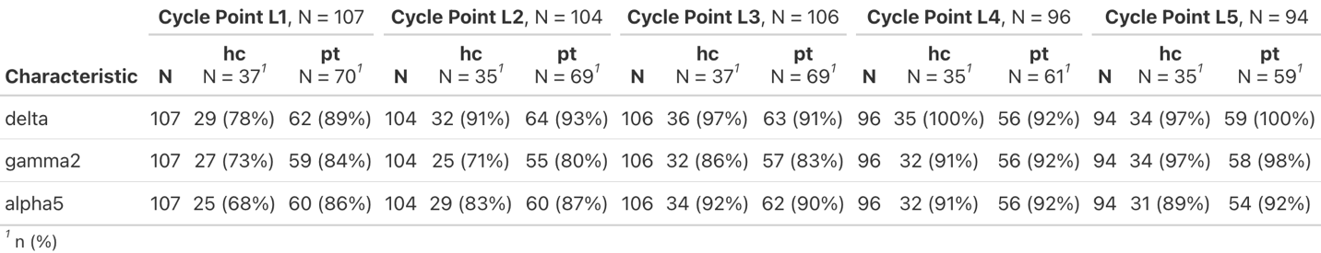

Table S10. Results from multilevel models predicting depression, anxiety, irritability, and SI from interactions between cycle time variables and trait-like indices of GABRG2 gene expression.
Models predicting depression and SI were specified with a quadratic slope across the luteal phase and a linear slope across the follicular phase. Models predicting anxiety and irritability were specified with linear slopes across both the luteal and follicular phase. Significant results (p<0.05) are shown with asterisks and bolded; marginally significant effects (p<0.10) are denoted with dagger symbols and italicized.

GABRG2 gene expression predicting symptom trajectories
 |  | DRSP1:  log(Depression) |  |  | DRSP4:  log(Anxiety) |  |  | DRSP7b: log(Irritability) |  |  | log(SI Composite)
Predictors |  | Est | CI | p | Est | CI | p | Est | CI | p | Est | CI | p
(Intercept) |  | 0.56 | 0.46 – 0.67 | <0.001 | 0.50 | 0.40 – 0.61 | <0.001 | 0.40 | 0.32 – 0.48 | <0.001 | 0.27 | 0.18 – 0.36 | <0.001
GABRG2 (AUCi) (z-scored) |  | 0.05 | -0.05 – 0.15 | 0.336 | 0.07 | -0.03 – 0.18 | 0.157 | 0.13 | 0.05 – 0.21 | 0.001* | 0.04 | -0.04 – 0.13 | 0.331
Luteal phase spline (linear) |  | -0.03 | -0.27 – 0.22 | 0.821 | 0.01 | -0.07 – 0.10 | 0.759 | 0.02 | -0.06 – 0.10 | 0.608 | 0.02 | -0.27 – 0.30 | 0.908
Luteal phase spline (quadratic) |  | -0.08 | -0.31 – 0.16 | 0.523 |  |  |  |  |  |  | -0.02 | -0.32 – 0.28 | 0.878
Follicular phase spline (linear) |  | -0.02 | -0.12 – 0.08 | 0.727 | -0.03 | -0.12 – 0.06 | 0.520 | -0.10 | -0.19 – -0.00 | 0.047* | 0.02 | -0.08 – 0.13 | 0.644
GABRG2 person-mean (z-scored) |  | 0.10 | -0.01 – 0.21 | 0.066 | 0.08 | -0.03 – 0.18 | 0.139 | 0.03 | -0.05 – 0.11 | 0.454 | 0.06 | -0.03 – 0.15 | 0.172
GABRG2 (AUCi) x  luteal phase spline (linear) |  | -0.12 | -0.36 – 0.13 | 0.349 | 0.04 | -0.05 – 0.12 | 0.413 | 0.11 | 0.03 – 0.18 | 0.008* | -0.01 | -0.28 – 0.25 | 0.919
GABRG2 (AUCi) x  luteal phase spline (quadratic) |  | -0.16 | -0.40 – 0.07 | 0.170 |  |  |  |  |  |  | -0.09 | -0.37 – 0.19 | 0.534
GABRG2 (AUCi) x  follicular phase spline (linear) |  | -0.06 | -0.16 – 0.04 | 0.232 | -0.10 | -0.19 – -0.01 | 0.034* | -0.15 | -0.25 – -0.06 | 0.001* | -0.03 | -0.12 – 0.07 | 0.584
GABRG2 (mean) x  luteal phase spline (linear) |  | -0.03 | -0.29 – 0.22 | 0.789 | 0.05 | -0.04 – 0.14 | 0.271 | 0.03 | -0.05 – 0.11 | 0.436 | 0.26 | -0.01 – 0.53 | 0.058†
GABRG2 (mean) x  luteal phase spline (quadratic) |  | -0.09 | -0.33 – 0.15 | 0.461 |  |  |  |  |  |  | 0.17 | -0.11 – 0.45 | 0.242
GABRG2 (mean) x  follicular phase spline (linear) |  | 0.02 | -0.08 – 0.12 | 0.705 | -0.04 | -0.13 – 0.06 | 0.452 | 0.00 | -0.10 – 0.10 | 0.958 | -0.10 | -0.19 – -0.01 | 0.044*
Random Effects
σ² | 0.09 |  |  |  | 0.12 |  |  | 0.14 |  |  | 0.08
τ₀₀ | 0.24 _{id} |  |  |  | 0.23 _{id} |  |  | 0.12 _{id} |  |  | 0.11 _{id}
τ₁₁ | 0.86 _{id.scaled_lutspline} |  |  |  | 0.12 _{id.scaled_lutspline} |  |  | 0.07 _{id.scaled_lutspline} |  |  | 0.70 _{id.scaled_lutspline}
 | 0.66 _{id.scaled_lutspline_quad} |  |  |  | 0.10 _{id.scaled_folspline} |  |  | 0.10 _{id.scaled_folspline} |  |  | 0.75 _{id.scaled_lutspline_quad}
 | 0.15 _{id.scaled_folspline} |  |  |  |  |  |  |  |  |  | 0.07 _{id.scaled_folspline}
ρ₀₁ | 0.22 |  |  |  | 0.32 |  |  | 0.26 |  |  | 0.21
 | 0.08 |  |  |  | -0.42 |  |  | -0.39 |  |  | 0.07
 | -0.28 |  |  |  |  |  |  |  |  |  | -0.47
ICC | 0.72 |  |  |  | 0.63 |  |  | 0.47 |  |  | 0.55
N | 95 _{id} |  |  |  | 95 _{id} |  |  | 93 _{id} |  |  | 60 _{id}
Observations | 2320 |  |  |  | 2320 |  |  | 2256 |  |  | 1407
Marginal R² / Conditional R² | 0.032 / 0.733 |  |  |  | 0.016 / 0.641 |  |  | 0.026 / 0.483 |  |  | 0.013 / 0.557

Table S11. Results from multilevel models predicting depression, anxiety, irritability, and SI from interactions between cycle time variables and trait-like indices of GABRA5 gene expression.
All models presented were specified with a quadratic slope across the luteal phase and a linear slope across the follicular phase. Significant results (p<0.05) are shown with asterisks and bolded; marginally significant effects (p<0.10) are denoted with dagger symbols and italicized.

GABRA5 gene expression predicting symptom trajectories
 | DRSP1: log(Depression) |  |  | DRSP4: log(Anxiety) |  |  | DRSP7b: log(Irritability) |  |  | log(SI Composite)
Predictors | Est | CI | p | Est | CI | p | Est | CI | p | Est | CI | p
(Intercept) | 0.55 | 0.45 – 0.66 | <0.001 | 0.49 | 0.39 – 0.59 | <0.001 | 0.39 | 0.30 – 0.47 | <0.001 | 0.25 | 0.16 – 0.34 | <0.001
GABRA5 (AUCi) (z-scored) | -0.06 | -0.17 – 0.05 | 0.278 | -0.12 | -0.22 – -0.02 | 0.022* | -0.03 | -0.11 – 0.05 | 0.427 | -0.04 | -0.13 – 0.05 | 0.424
Luteal phase spline (linear) | -0.03 | -0.28 – 0.23 | 0.838 | 0.00 | -0.25 – 0.25 | 0.986 | 0.00 | -0.08 – 0.09 | 0.920 | -0.01 | -0.22 – 0.20 | 0.910
Luteal phase spline (quadratic) | -0.07 | -0.31 – 0.18 | 0.604 | -0.01 | -0.26 – 0.23 | 0.915 |  |  |  | -0.03 | -0.24 – 0.18 | 0.782
Follicular phase spline (linear) | -0.01 | -0.11 – 0.10 | 0.893 | -0.02 | -0.12 – 0.08 | 0.689 | -0.08 | -0.18 – 0.02 | 0.123 | 0.04 | -0.07 – 0.16 | 0.460
GABRA5 person-mean (z-scored) | 0.00 | -0.11 – 0.11 | 0.977 | 0.00 | -0.10 – 0.11 | 0.967 | -0.01 | -0.09 – 0.07 | 0.817 | -0.04 | -0.13 – 0.05 | 0.363
GABRA5 (AUCi) x luteal phase spline (linear) | 0.08 | -0.18 – 0.34 | 0.531 | -0.22 | -0.47 – 0.03 | 0.086† | 0.07 | -0.01 – 0.16 | 0.089† | -0.27 | -0.49 – -0.06 | 0.012*
GABRA5 (AUCi) x luteal phase spline (quadratic) | 0.08 | -0.17 – 0.33 | 0.520 | -0.18 | -0.43 – 0.07 | 0.159 |  |  |  | -0.27 | -0.49 – -0.06 | 0.013*
GABRA5 (AUCi) x follicular phase spline (linear) | 0.02 | -0.09 – 0.12 | 0.747 | 0.04 | -0.05 – 0.14 | 0.372 | -0.00 | -0.10 – 0.10 | 0.958 | 0.04 | -0.07 – 0.15 | 0.469
GABRA5 (mean) x luteal phase spline (linear) | -0.05 | -0.31 – 0.22 | 0.717 | -0.25 | -0.51 – 0.00 | 0.052† | -0.01 | -0.10 – 0.07 | 0.799 | -0.07 | -0.29 – 0.14 | 0.511
GABRA5 (mean) x follicular phase spline (linear) | -0.04 | -0.30 – 0.21 | 0.737 | 0.02 | -0.08 – 0.12 | 0.712 | -0.02 | -0.12 – 0.09 | 0.736 | -0.05 | -0.17 – 0.07 | 0.444
GABRA5 (mean) x luteal phase spline (quadratic) | -0.02 | -0.13 – 0.09 | 0.739 | -0.28 | -0.53 – -0.03 | 0.028* |  |  |  | -0.07 | -0.29 – 0.14 | 0.499
Random Effects
σ² | 0.09 |  |  | 0.12 |  |  | 0.13 |  |  | 0.09
τ₀₀ | 0.24 _{id} |  |  | 0.21 _{id} |  |  | 0.13 _{id} |  |  | 0.10 _{id}
τ₁₁ | 0.95 _{id.scaled_lutspline} |  |  | 0.65 _{id.scaled_lutspline} |  |  | 0.08 _{id.scaled_lutspline} |  |  | 0.06 _{id.scaled_lutspline}
 | 0.74 _{id.scaled_lutspline_quad} |  |  | 0.51 _{id.scaled_lutspline_quad} |  |  | 0.13 _{id.scaled_folspline} |  |  | 0.10 _{id.scaled_folspline}
 | 0.16 _{id.scaled_folspline} |  |  | 0.10 _{id.scaled_folspline}
ρ₀₁ | 0.23 |  |  | 0.13 |  |  | 0.36 |  |  | 0.39
 | 0.08 |  |  | -0.02 |  |  | -0.44 |  |  | -0.47
 | -0.25 |  |  | -0.38
ICC | 0.72 |  |  | 0.63 |  |  | 0.48 |  |  | 0.50
N | 91 _{id} |  |  | 91 _{id} |  |  | 89 _{id} |  |  | 58 _{id}
Observations | 2219 |  |  | 2219 |  |  | 2155 |  |  | 1360
Marginal R² / Conditional R² | 0.012 / 0.715 |  |  | 0.023 / 0.640 |  |  | 0.016 / 0.486 |  |  | 0.017 / 0.510

Table S12. Results from multilevel models predicting depression, anxiety, irritability, and SI from interactions between cycle time variables and trait-like indices of GABRD gene expression.
All models presented were specified with a quadratic slope across the luteal phase and a linear slope across the follicular phase. Significant results (p<0.05) are shown with asterisks and bolded; marginally significant effects (p<0.10) are denoted with dagger symbols and italicized.
GABRD gene expression predicting symptom trajectories
 | DRSP1:  log(Depression) |  |  | DRSP4:  log(Anxiety) |  |  | DRSP7b: log(Irritability) |  |  | log(SI Composite)
Predictors | Est | CI | p | Est | CI | p | Est | CI | p | Est | CI | p
(Intercept) | 0.56 | 0.46 – 0.67 | <0.001 | 0.50 | 0.40 – 0.60 | <0.001 | 0.38 | 0.29 – 0.46 | <0.001 | 0.27 | 0.18 – 0.36 | <0.001
GABRD (AUCi) (z-scored) | 0.01 | -0.09 – 0.12 | 0.793 | -0.03 | -0.14 – 0.07 | 0.512 | -0.00 | -0.08 – 0.08 | 0.978 | -0.01 | -0.10 – 0.08 | 0.845
Luteal phase spline (linear) | -0.02 | -0.27 – 0.23 | 0.872 | -0.00 | -0.25 – 0.24 | 0.975 | -0.15 | -0.42 – 0.12 | 0.282 | 0.03 | -0.26 – 0.31 | 0.857
Luteal phase spline (quadratic) | -0.06 | -0.30 – 0.17 | 0.595 | -0.02 | -0.26 – 0.22 | 0.867 | -0.18 | -0.44 – 0.08 | 0.172 | 0.00 | -0.29 – 0.30 | 0.985
Follicular phase spline (linear) | -0.01 | -0.12 – 0.09 | 0.783 | -0.02 | -0.11 – 0.08 | 0.717 | -0.06 | -0.17 – 0.05 | 0.301 | 0.03 | -0.07 – 0.14 | 0.546
GABRD person-mean  (z-scored) | 0.03 | -0.08 – 0.14 | 0.602 | 0.03 | -0.07 – 0.14 | 0.566 | -0.01 | -0.10 – 0.07 | 0.810 | -0.01 | -0.11 – 0.09 | 0.825
GABRD (AUCi) x  luteal phase spline (linear) | 0.05 | -0.20 – 0.30 | 0.697 | -0.18 | -0.43 – 0.06 | 0.144 | -0.03 | -0.31 – 0.24 | 0.806 | -0.27 | -0.54 – 0.01 | 0.057†
GABRD (AUCi) x  luteal phase spline (quadratic) | 0.05 | -0.19 – 0.29 | 0.690 | -0.13 | -0.38 – 0.11 | 0.294 | -0.10 | -0.37 – 0.16 | 0.443 | -0.28 | -0.56 – 0.01 | 0.057†
GABRD (AUCi) x  follicular phase spline (linear) | 0.03 | -0.07 – 0.13 | 0.554 | 0.04 | -0.05 – 0.13 | 0.403 | 0.02 | -0.09 – 0.12 | 0.778 | 0.04 | -0.05 – 0.13 | 0.364
GABRD (mean) x  luteal phase spline (linear) | -0.05 | -0.31 – 0.20 | 0.691 | -0.22† | -0.47 – 0.03 | 0.081† | -0.16 | -0.44 – 0.12 | 0.271 | -0.08 | -0.39 – 0.22 | 0.587
GABRD (mean. x  follicular phase spline (linear) | 0.00 | -0.10 – 0.11 | 0.961 | 0.01 | -0.08 – 0.11 | 0.778 | 0.02 | -0.09 – 0.13 | 0.747 | -0.04 | -0.14 – 0.07 | 0.525
GABRD (mean) x  luteal phase spline (quadratic) | -0.05 | -0.29 – 0.20 | 0.707 | -0.23 | -0.48 – 0.01 | 0.064† | -0.14 | -0.41 – 0.13 | 0.299 | -0.09 | -0.40 – 0.23 | 0.580
Random Effects
σ² | 0.09 |  |  | 0.12 |  |  | 0.13 |  |  | 0.08
τ₀₀ | 0.25 _{id} |  |  | 0.23 _{id} |  |  | 0.14 _{id} |  |  | 0.11 _{id}
τ₁₁ | 0.91 _{id.scaled_lutspline} |  |  | 0.65 _{id.scaled_lutspline} |  |  | 0.91 _{id.scaled_lutspline} |  |  | 0.70 _{id.scaled_lutspline}
 | 0.70 _{id.scaled_lutspline_quad} |  |  | 0.53 _{id.scaled_lutspline_quad} |  |  | 0.65 _{id.scaled_lutspline_quad} |  |  | 0.72 _{id.scaled_lutspline_quad}
 | 0.15 _{id.scaled_folspline} |  |  | 0.10 _{id.scaled_folspline} |  |  | 0.15 _{id.scaled_folspline} |  |  | 0.07 _{id.scaled_folspline}
ρ₀₁ | 0.22 |  |  | 0.22 |  |  | 0.34 |  |  | 0.25
 | 0.08 |  |  | 0.08 |  |  | 0.27 |  |  | 0.13
 | -0.26 |  |  | -0.40 |  |  | -0.50 |  |  | -0.46
ICC | 0.73 |  |  | 0.64 |  |  | 0.48 |  |  | 0.56
N | 94 _{id} |  |  | 94 _{id} |  |  | 92 _{id} |  |  | 60 _{id}
Observations | 2293 |  |  | 2293 |  |  | 2229 |  |  | 1407
Marginal R² / Conditional R² | 0.006 / 0.731 |  |  | 0.010 / 0.644 |  |  | 0.006 / 0.487 |  |  | 0.008 / 0.560

Supplemental Figures

Figure S1. Comparisons of trait-level gene expression indices between recruitment groups (Patients with Suicidality vs. Healthy Controls). T-tests between recruitment groups (HC, Patients) showed no statistically significant differences between person-mean, AUCi, or absolute value of AUCi on any gene of interest (all p’s > 0.05).
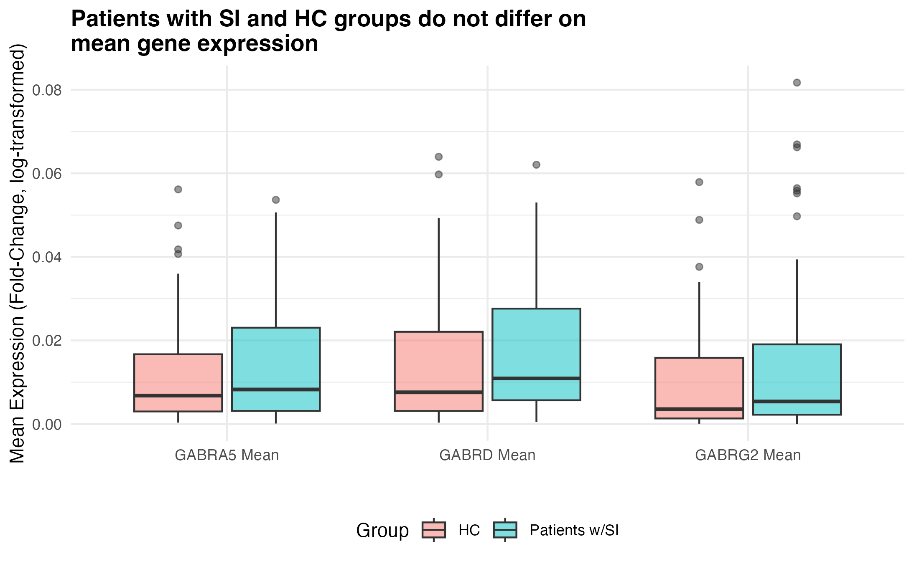
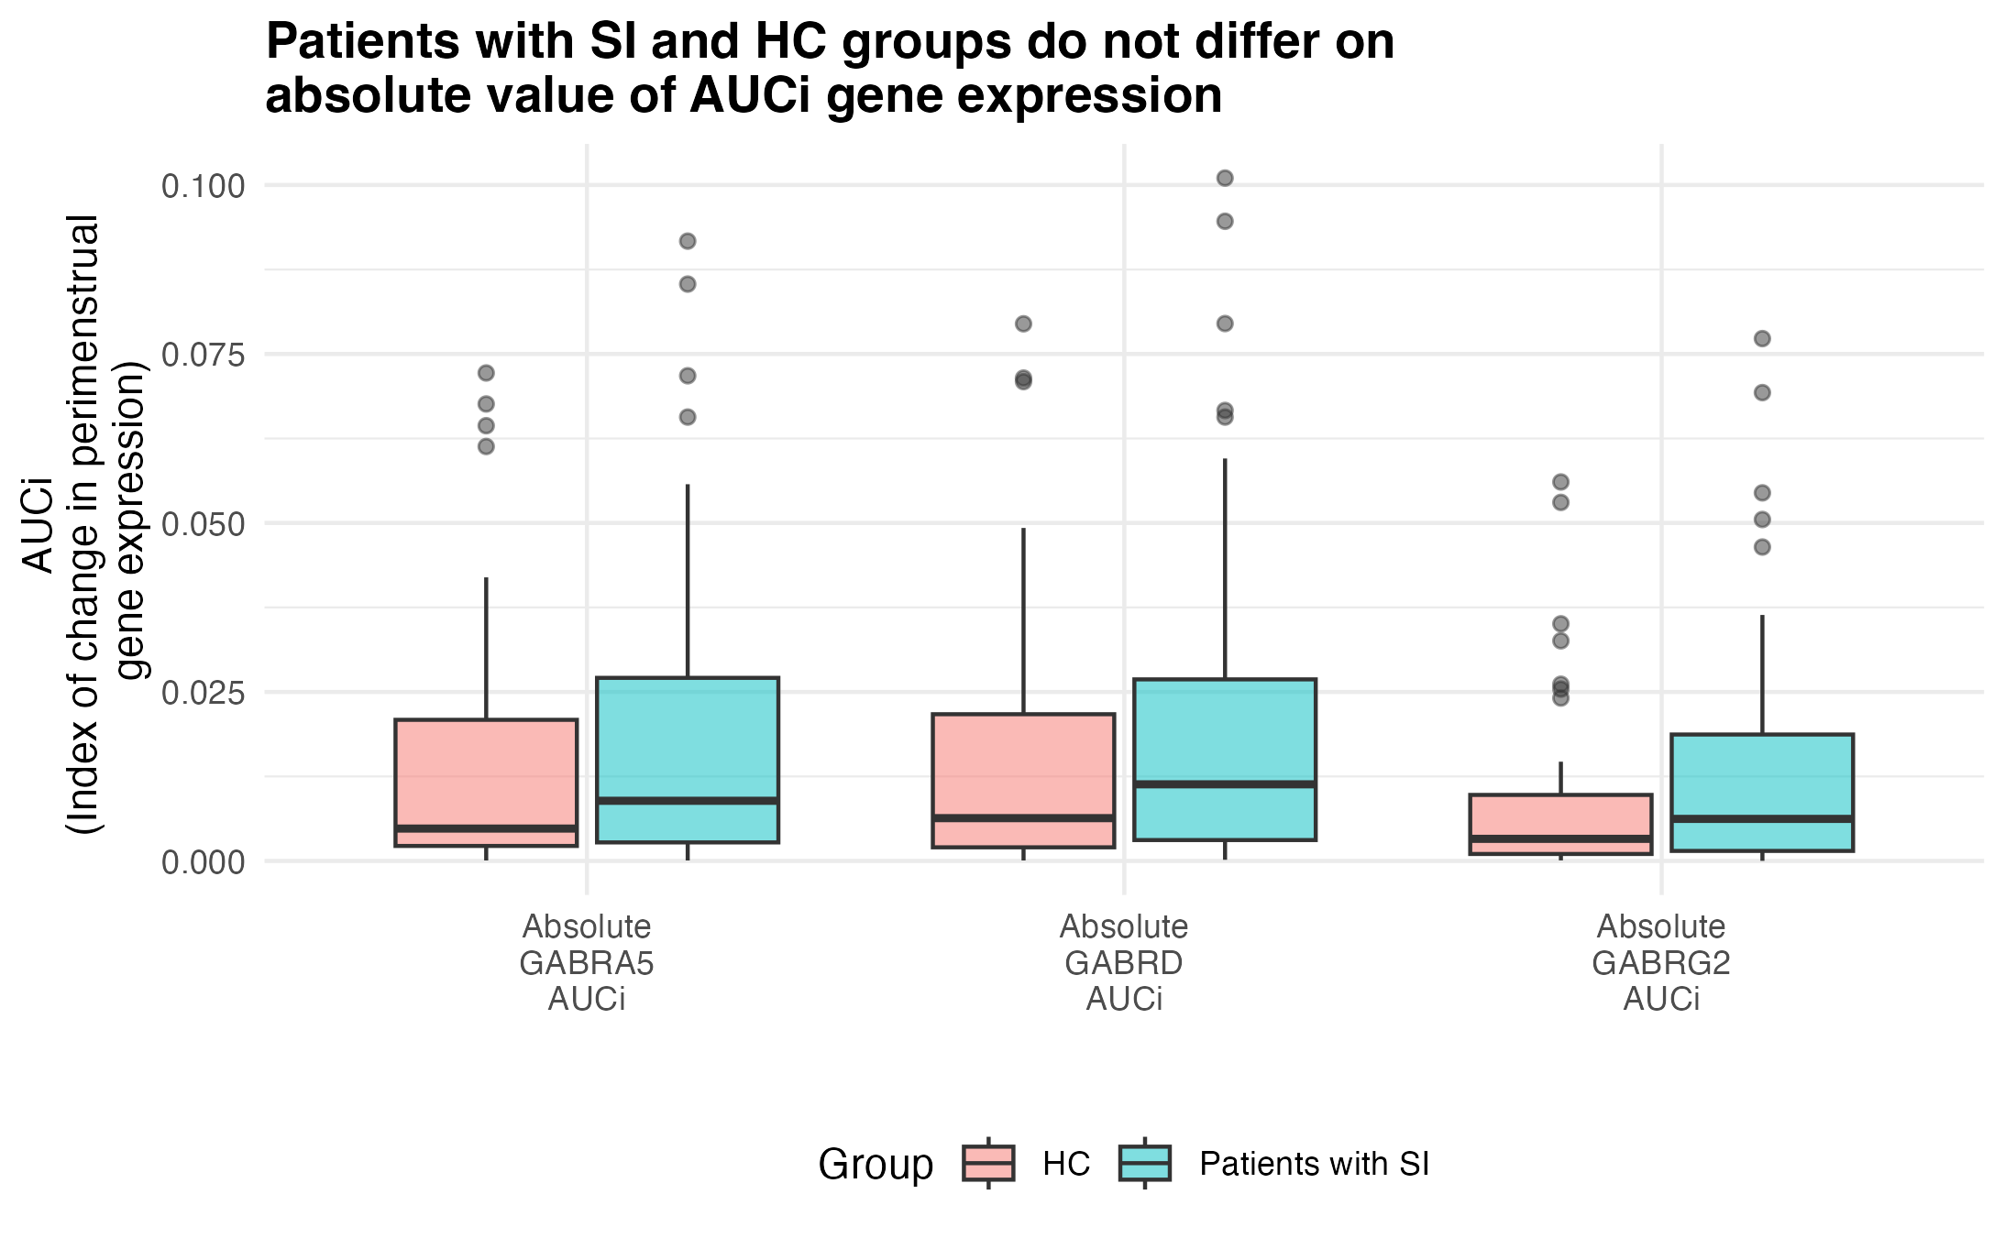
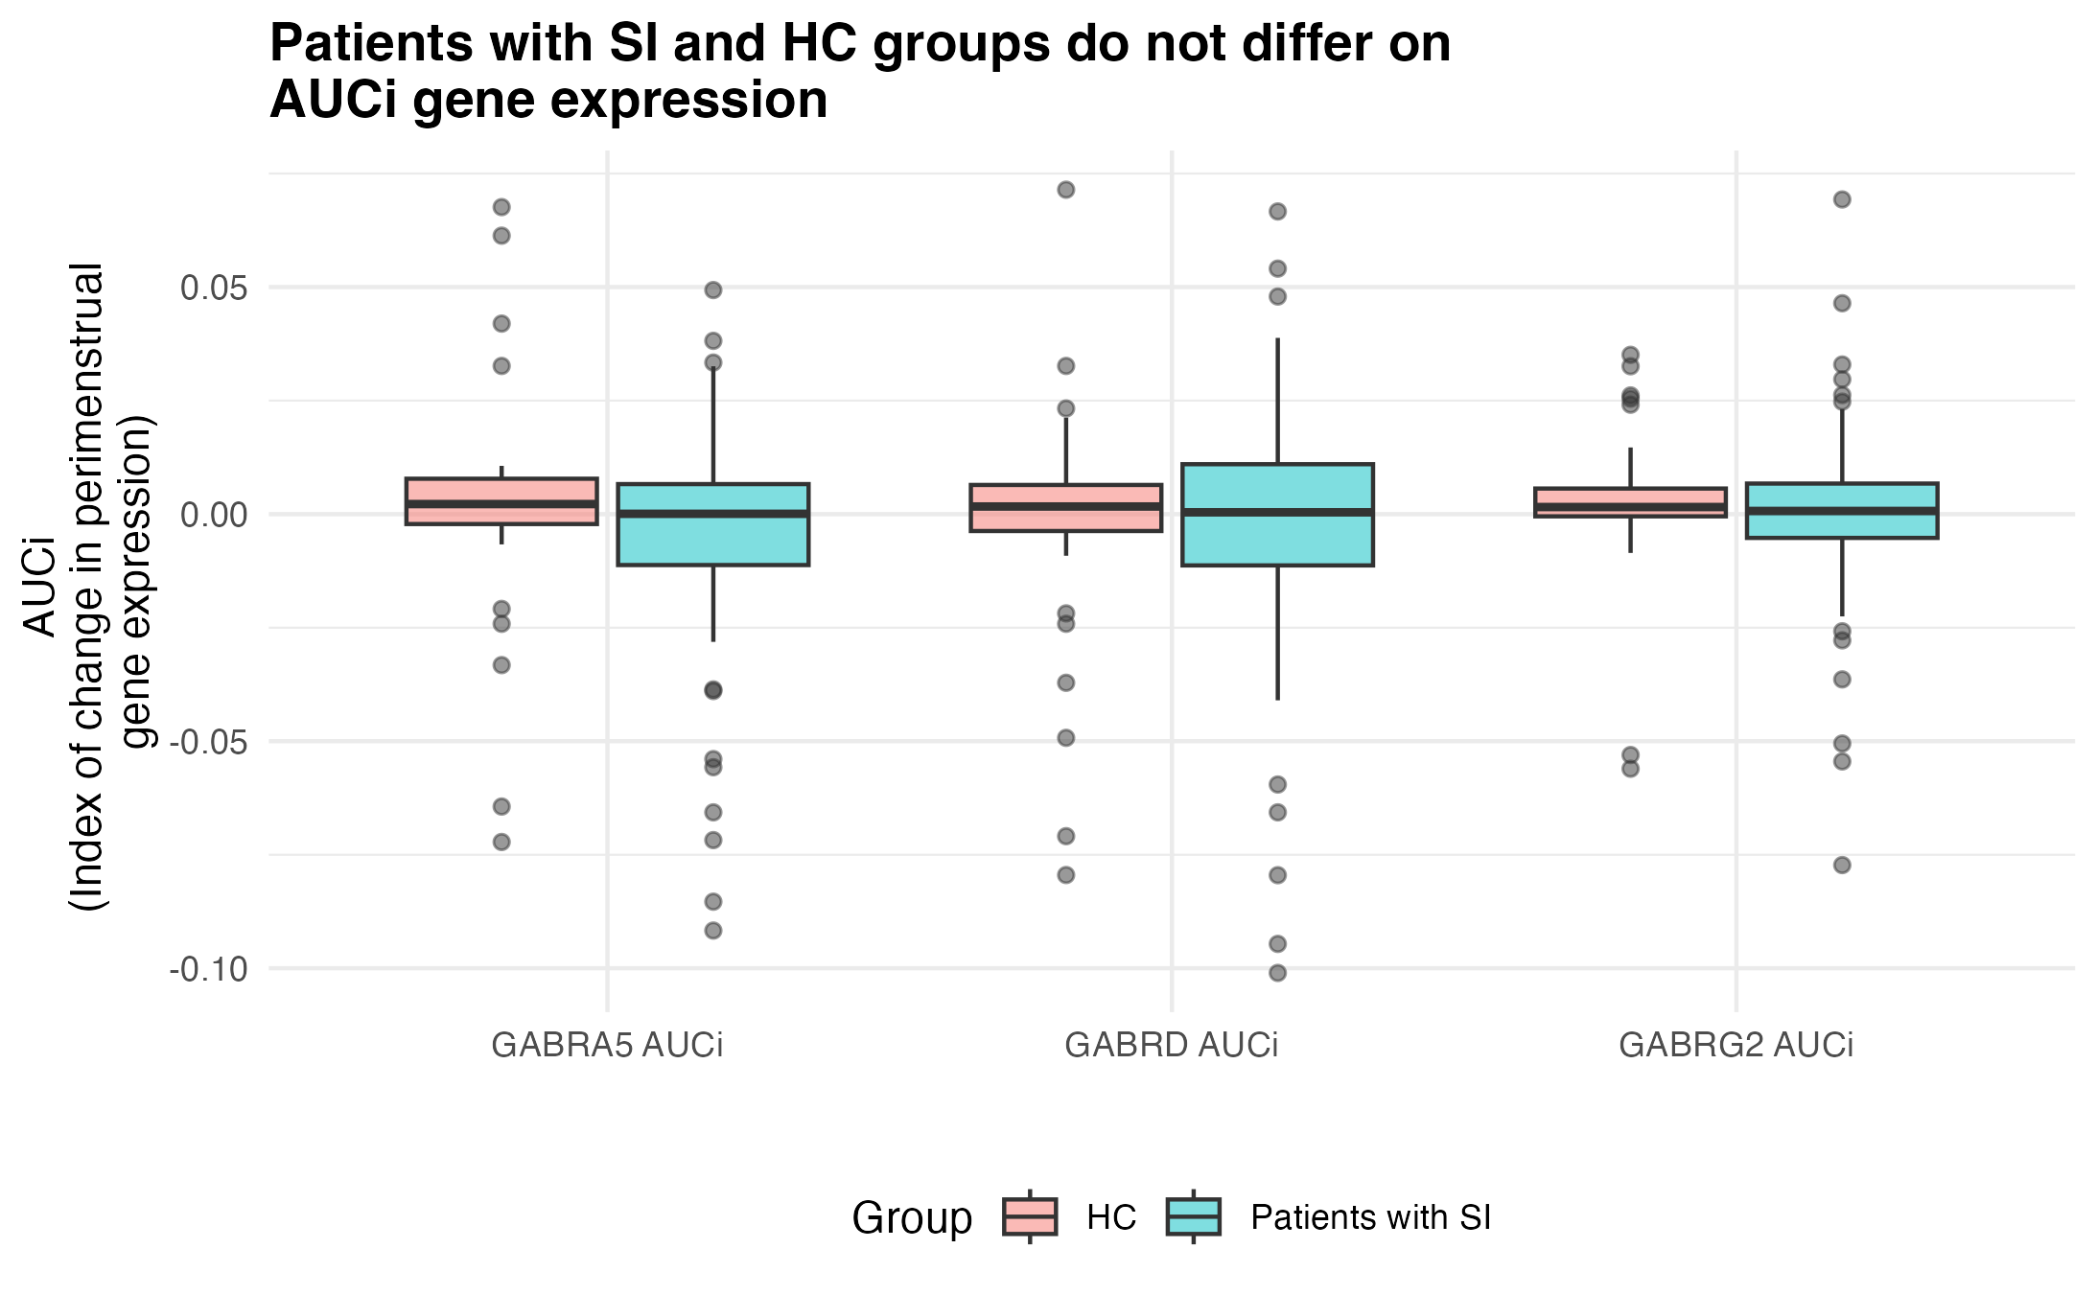
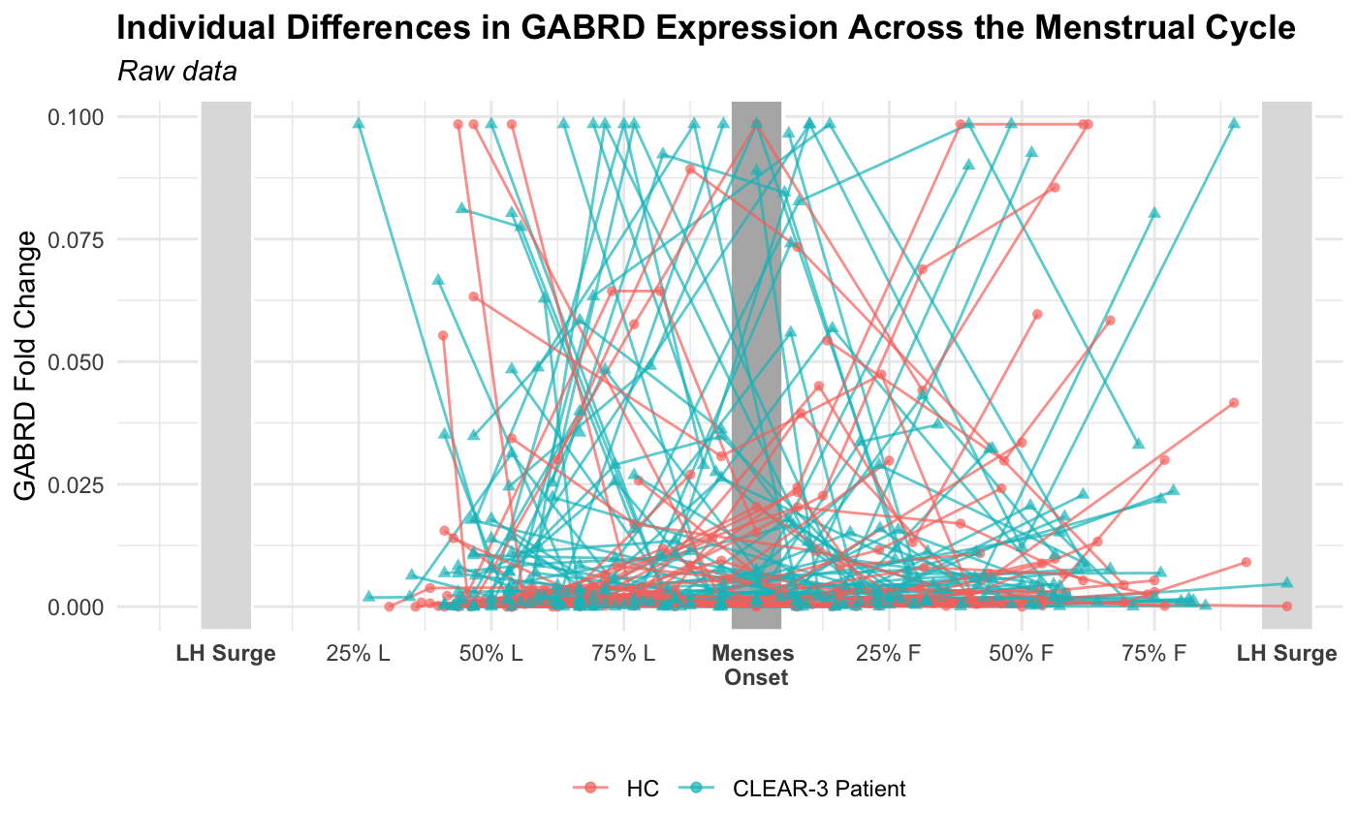
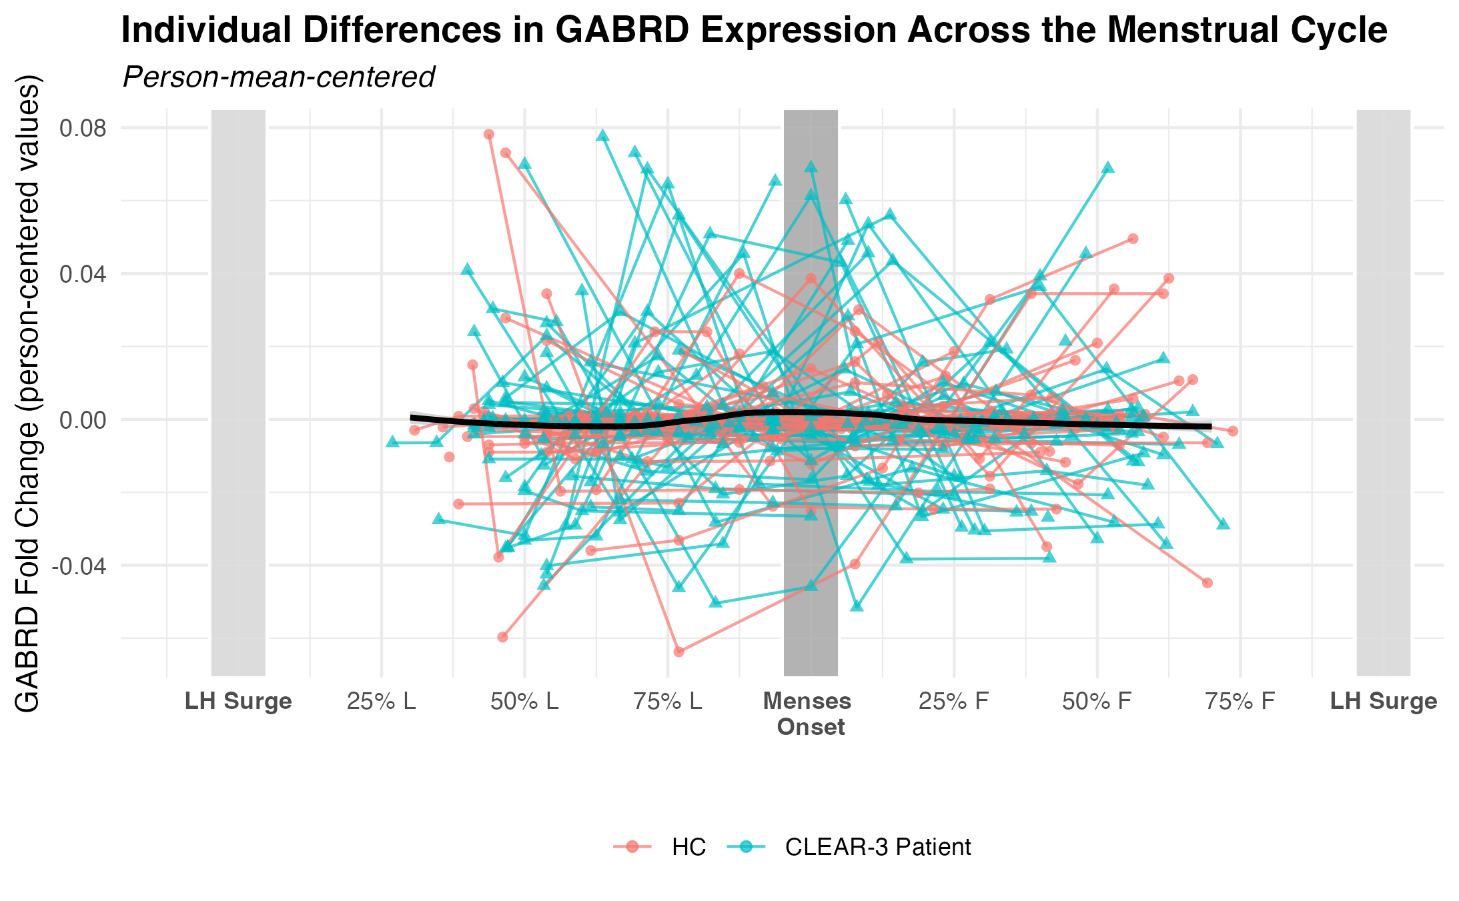
A.
B.

Figure S2. Spaghetti plots of individual differences in GABRD trajectory across the menstrual cycle. Each line represents one participant’s gene expression trajectory. In panel A, the y-axis represents raw gene expression values (i.e. fold-change). In panel B, the y-axis represents person-mean-centered values, where 0 on the Y-axis indicates a participant’s mean gene expression level; positive values represent higher-than-usual expression, and negative values represent lower-than-usual expression for that individual. Black line is the average person-centered value over time. Visits were scheduled at LH+7, LH+10, LH+14, LH+18, and LH+22. Time (x-axis) was then standardized onto a continuous timeline for each person where -1 represents LH surge, 0 represents menses onset, and +1 represents next LH surge, to more accurately represent cycle time as a continuous predictor. First LH surge is confirmed with urine testing; second LH surge is estimated.

Figure S3. Spaghetti plots of individual differences in GABRG2 trajectory across the menstrual cycle.
Each line represents one participant’s gene expression trajectory. In panel A, the y-axis represents raw gene expression values (i.e. fold-change). In panel B, the y-axis represents person-mean-centered values, where 0 on the Y-axis indicates a participant’s mean gene expression level; positive values represent higher-than-usual expression, and negative values represent lower-than-usual expression for that individual. Black line is the average person-centered value over time. Visits were scheduled at LH+7, LH+10, LH+14, LH+18, and LH+22. Time (x-axis) was then standardized onto a continuous timeline for each person where -1 represents LH surge, 0 represents menses onset, and +1 represents next LH surge, to more accurately represent cycle time as a continuous predictor. First LH surge is confirmed with urine testing; second LH surge is estimated.

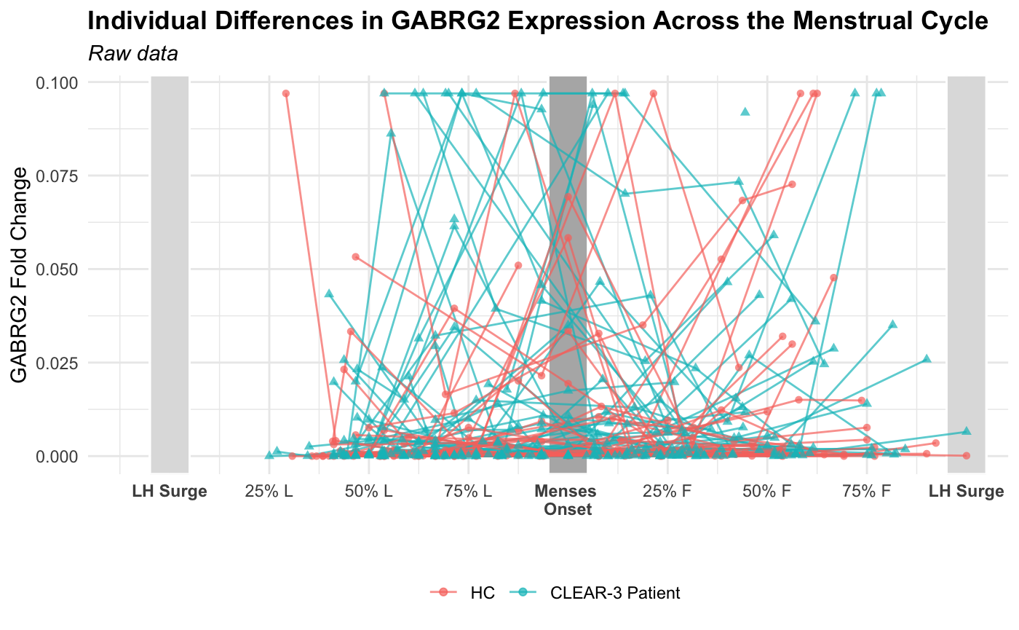
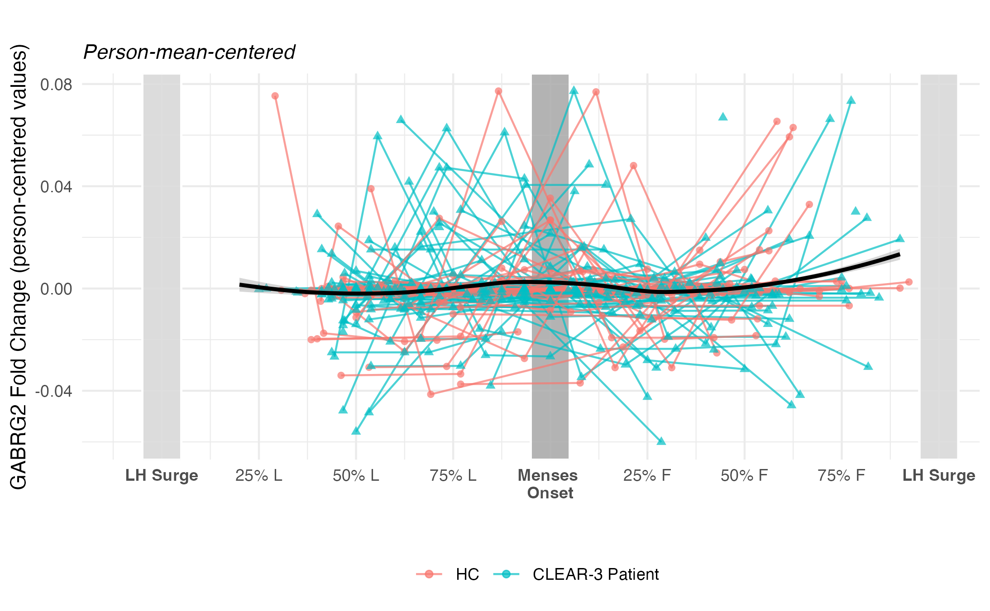
A.
B.

Figure S4. Spaghetti plots of individual differences in GABRA5 trajectory across the menstrual cycle. Each line represents one participant’s gene expression trajectory. In panel A, the y-axis represents raw gene expression values (i.e. fold-change). In panel B, the y-axis represents person-mean-centered values, where 0 on the Y-axis indicates a participant’s mean gene expression level; positive values represent higher-than-usual expression, and negative values represent lower-than-usual expression for that individual. Black line is the average person-centered value over time. Visits were scheduled at LH+7, LH+10, LH+14, LH+18, and LH+22. Time (x-axis) was then standardized onto a continuous timeline for each person where -1 represents LH surge, 0 represents menses onset, and +1 represents next LH surge, to more accurately represent cycle time as a continuous predictor. First LH surge is confirmed with urine testing; second LH surge is estimated.
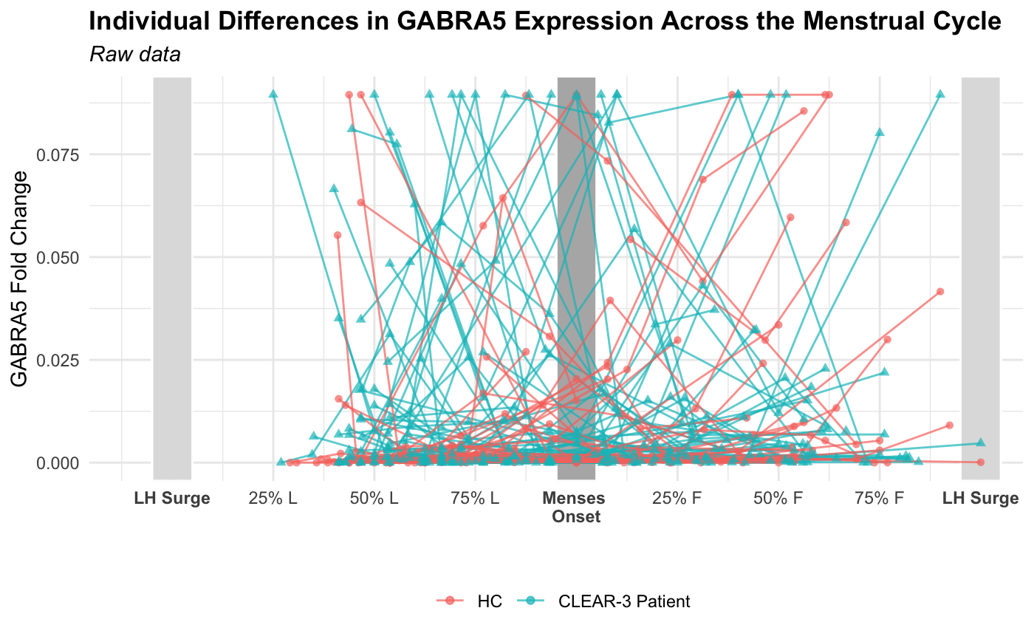
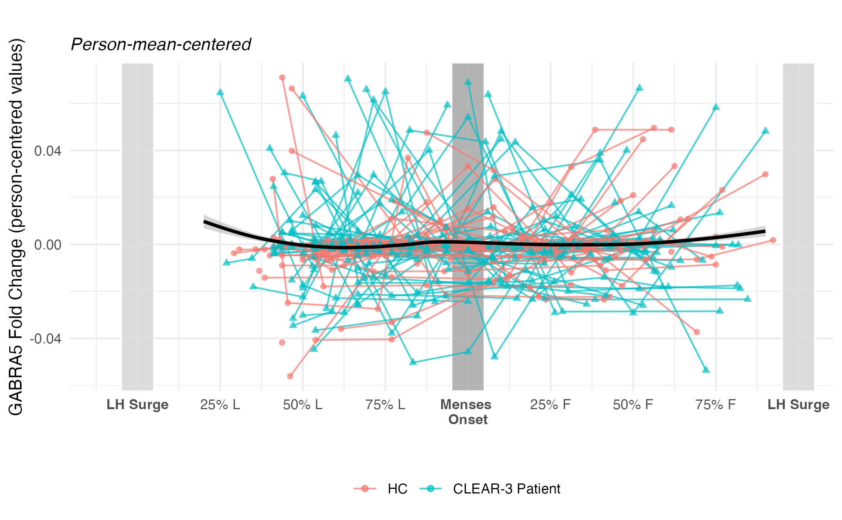
A.
B.

