Supplementary Information for
Electrophysiological effects of psilocybin co-administered with midazolam

Michael H. Sutherland^{1,2}, Christopher R. Nicholas^{3,4}, Richard L. Lennertz^{1,4}, Cody J. Wenthur^{4,5}, Bryan M. Krause¹, Christina J. Sauder², Brady A. Riedner^{2,6}, Richard F. Smith^{2,6}, Paul R. Hutson^{4,5}, Charles L. Raison^{2,4}, Matthew I. Banks^{1,4,7}

¹ Department of Anesthesiology, School of Medicine and Public Health, University of Wisconsin-Madison, Madison, WI 53792
² Department of Psychiatry, School of Medicine and Public Health, University of Wisconsin-Madison, Madison, WI 53719
³ Department of Family Medicine and Community Health, School of Medicine and Public Health, University of Wisconsin-Madison, Madison, WI 53705
⁴ Transdisciplinary Center for Research in Psychoactive Substances, University of Wisconsin-Madison, Madison, WI 53705
⁵ School of Pharmacy, University of Wisconsin-Madison, Madison, WI 53705
⁶ Wisconsin Institute for Sleep and Consciousness, University of Wisconsin -Madison, Madison, WI 53706
⁷ Department of Neuroscience, School of Medicine and Public Health, University of Wisconsin-Madison, Madison, WI 53705

Corresponding author:
Mathew I. Banks, PhD
Department of Anesthesiology
School of Medicine and Public Health
University of Wisconsin-Madison
600 Highland Ave B6/319
Madison, WI 53792
mibanks@wisc.edu

Supplementary Tables

Contrast | Estimate | Lower CL | Upper CL | SE | df | t ratio | p
Delta power
15 - base | 0.0356 | -0.0253 | 0.0965 | 0.0232 | 4481 | 1.5357 | 0.4781
30 - base | -0.0358 | -0.1044 | 0.0329 | 0.0261 | 4481 | -1.3702 | 0.5995
60 - base | -0.0963 | -0.1588 | -0.0338 | 0.0238 | 4481 | -4.0508 | 0.0004
90 - base | -0.2074 | -0.2743 | -0.1404 | 0.0255 | 4481 | -8.1424 | <0.0001
120 - base | -0.2356 | -0.2996 | -0.1716 | 0.0243 | 4481 | -9.684 | <0.0001
160 - base | -0.2693 | -0.3344 | -0.2041 | 0.0248 | 4481 | -10.8687 | <0.0001
210 - base | -0.344 | -0.4095 | -0.2785 | 0.0249 | 4481 | -13.8052 | <0.0001
360 - base | -0.1898 | -0.2512 | -0.1284 | 0.0234 | 4481 | -8.1244 | <0.0001
Theta power
15 - base | -0.1367 | -0.2046 | -0.0687 | 0.0259 | 4481 | -5.2853 | <0.0001
30 - base | -0.222 | -0.2985 | -0.1455 | 0.0291 | 4481 | -7.6213 | <0.0001
60 - base | -0.3624 | -0.4321 | -0.2927 | 0.0265 | 4481 | -13.6556 | <0.0001
90 - base | -0.434 | -0.5086 | -0.3593 | 0.0284 | 4481 | -15.2706 | <0.0001
120 - base | -0.508 | -0.5794 | -0.4367 | 0.0272 | 4481 | -18.7088 | <0.0001
160 - base | -0.4964 | -0.569 | -0.4238 | 0.0277 | 4481 | -17.9521 | <0.0001
210 - base | -0.5054 | -0.5785 | -0.4324 | 0.0278 | 4481 | -18.174 | <0.0001
360 - base | -0.3265 | -0.395 | -0.2579 | 0.0261 | 4481 | -12.5143 | <0.0001
Alpha power
15 - base | -0.1038 | -0.187 | -0.0206 | 0.0317 | 4481 | -3.2777 | 0.007
30 - base | -0.3838 | -0.4775 | -0.29 | 0.0357 | 4481 | -10.7588 | <0.0001
60 - base | -0.481 | -0.5664 | -0.3956 | 0.0325 | 4481 | -14.805 | <0.0001
90 - base | -0.5303 | -0.6218 | -0.4388 | 0.0348 | 4481 | -15.2381 | <0.0001
120 - base | -0.5094 | -0.5968 | -0.422 | 0.0332 | 4481 | -15.3199 | <0.0001
160 - base | -0.4872 | -0.5762 | -0.3982 | 0.0339 | 4481 | -14.3884 | <0.0001
210 - base | -0.432 | -0.5215 | -0.3424 | 0.0341 | 4481 | -12.6843 | <0.0001
360 - base | -0.3225 | -0.4065 | -0.2386 | 0.0319 | 4481 | -10.099 | <0.0001
Beta power
15 - base | 0.2309 | 0.1753 | 0.2865 | 0.0212 | 4481 | 10.9051 | <0.0001
30 - base | 0.1161 | 0.0535 | 0.1787 | 0.0238 | 4481 | 4.8717 | <0.0001
60 - base | 0.0236 | -0.0335 | 0.0807 | 0.0217 | 4481 | 1.0861 | 0.8081
90 - base | -0.0265 | -0.0876 | 0.0346 | 0.0233 | 4481 | -1.1407 | 0.7707
120 - base | -0.0353 | -0.0937 | 0.0231 | 0.0222 | 4481 | -1.5877 | 0.4428
160 - base | -0.0778 | -0.1372 | -0.0183 | 0.0226 | 4481 | -3.4352 | 0.004
210 - base | -0.0826 | -0.1424 | -0.0228 | 0.0228 | 4481 | -3.6274 | 0.0023
360 - base | -0.0748 | -0.1309 | -0.0187 | 0.0214 | 4481 | -3.5024 | 0.0032
Gamma power
15 - base | -0.0356 | -0.0947 | 0.0235 | 0.0225 | 4481 | -1.5831 | 0.4473
30 - base | -0.0844 | -0.1505 | -0.0182 | 0.0252 | 4481 | -3.3529 | 0.0055
60 - base | -0.0707 | -0.1312 | -0.0101 | 0.023 | 4481 | -3.0678 | 0.0139
90 - base | -0.0377 | -0.1023 | 0.027 | 0.0246 | 4481 | -1.5309 | 0.4837
120 - base | -0.1133 | -0.1752 | -0.0514 | 0.0235 | 4481 | -4.8115 | <0.0001
160 - base | -0.0561 | -0.1191 | 0.007 | 0.024 | 4481 | -2.3384 | 0.1034
210 - base | -0.0181 | -0.0815 | 0.0452 | 0.0241 | 4481 | -0.7521 | 0.9656
360 - base | -0.022 | -0.0816 | 0.0376 | 0.0227 | 4481 | -0.9717 | 0.8786

Supplementary Table 1. Contrasts between time points for EEG band power. All models were constructed as follows: Band power ~ time + (1 | participant). Band power Estimates have units of log10(µV²/Hz).

Contrast | Estimate | Lower CL | Upper CL | SE | df | t ratio | p
15 - base | -0.0007 | -0.0062 | 0.0048 | 0.0021 | 4481 | -0.3202 | 1
30 - base | 0.0052 | -0.001 | 0.0114 | 0.0024 | 4481 | 2.1856 | 0.145
60 - base | 0.0086 | 0.0029 | 0.0142 | 0.0021 | 4481 | 4.0007 | <0.001
90 - base | 0.0114 | 0.0053 | 0.0174 | 0.0023 | 4481 | 4.9401 | <0.001
120 - base | 0.0086 | 0.0028 | 0.0143 | 0.0022 | 4481 | 3.9011 | <0.001
160 - base | 0.0091 | 0.0033 | 0.015 | 0.0022 | 4481 | 4.0871 | <0.001
210 - base | 0.0129 | 0.007 | 0.0188 | 0.0022 | 4481 | 5.7191 | <0.001
360 - base | 0.0054 | -0.0001 | 0.0109 | 0.0021 | 4481 | 2.5608 | 0.059

Supplementary Table 2. Contrasts between time points for LZCn ~ time + (1 | participant).

Contrast | Estimate | Lower CL | Upper CL | SE | df | t ratio | p
15 - base | -0.0735 | -0.137 | -0.01 | 0.0242 | 4481 | -3.0418 | 0.015
30 - base | -0.0283 | -0.0997 | 0.0432 | 0.0272 | 4481 | -1.039 | 0.838
60 - base | 0.035 | -0.0301 | 0.1001 | 0.0248 | 4481 | 1.4118 | 0.569
90 - base | 0.138 | 0.0682 | 0.2077 | 0.0265 | 4481 | 5.1989 | <0.001
120 - base | 0.1057 | 0.039 | 0.1723 | 0.0254 | 4481 | 4.1669 | <0.001
160 - base | 0.1698 | 0.1019 | 0.2376 | 0.0258 | 4481 | 6.5736 | <0.001
210 - base | 0.2644 | 0.1962 | 0.3327 | 0.026 | 4481 | 10.1807 | <0.001
360 - base | 0.1252 | 0.0611 | 0.1892 | 0.0244 | 4481 | 5.1364 | <0.001

Supplementary Table 3. Contrasts between time points for spectral exponent ~ time + (1 | participant).

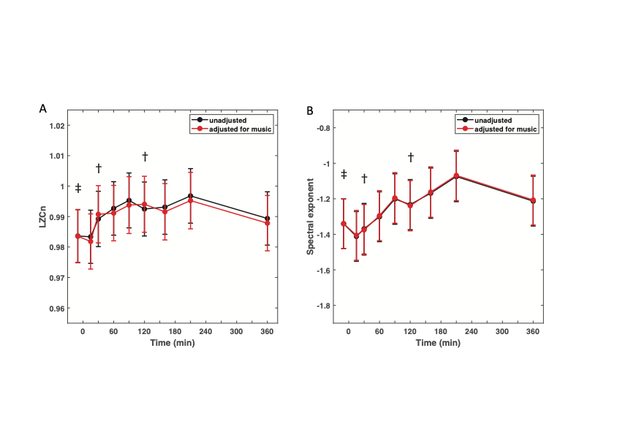
Supplementary Figure 1. Complexity and spectral slope change little when adjusting for music. Shown are time series of marginal mean LZCn (A) and spectral exponent (B). Black lines represent marginal means derived from models run without adjusting for music (also shown in Fig. 3A, C), and red lines represent models adjusted for music (Measure ~ time + music + (1 | participant). Symbol † represents time points with solely music-off data, and symbol ‡ signifies the time point with both music-on and music-off data.

