Supplement
Supplementary Figure S1 - Correlation of differentially expressed genes with AUD across samples in PFC

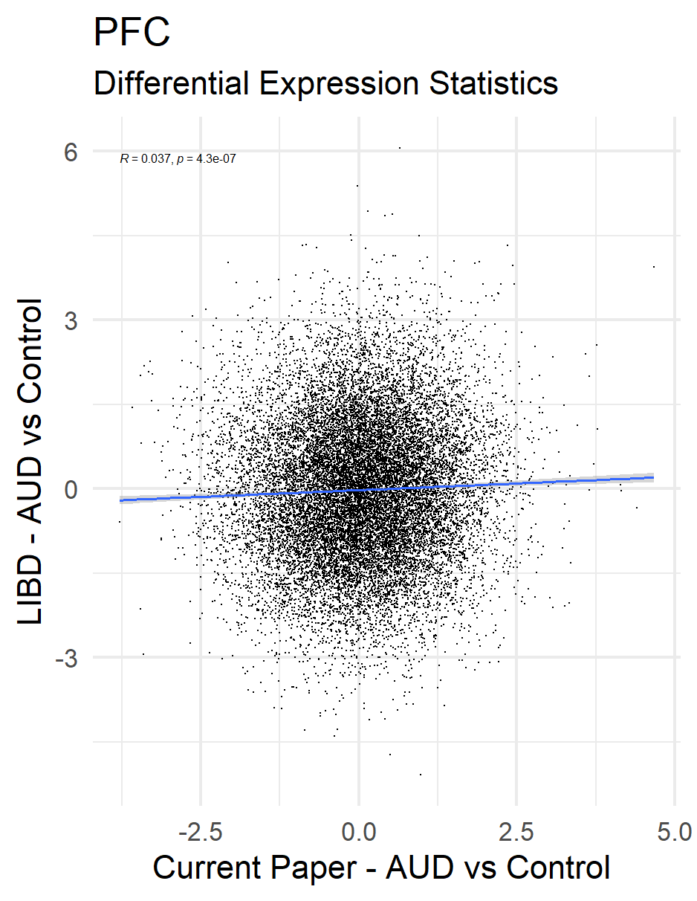
Correlating results of AUD vs Control differentially expressed genes from the current paper (x-axis) and results from Lieber Institute for Brain Development (LIBD; PMID: 39394458). R = Pearson correlation coefficient.

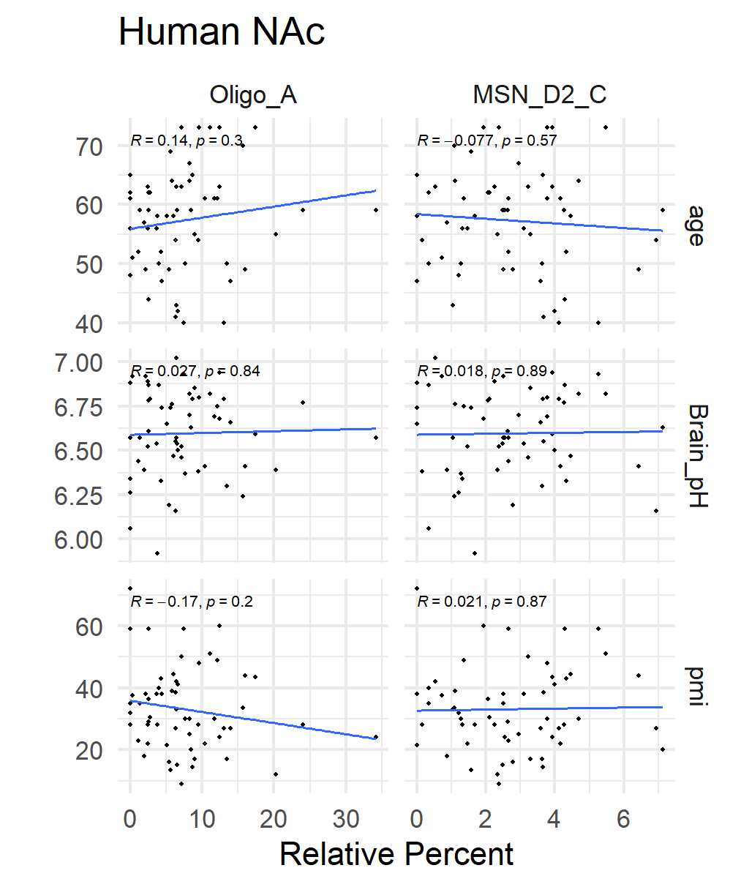
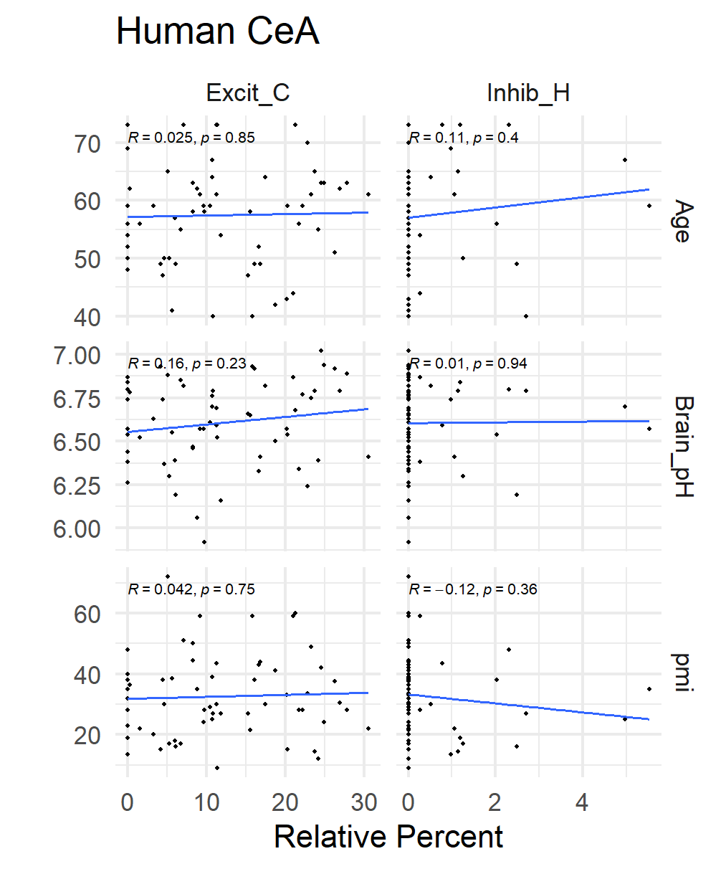
Supplementary Figure S2 - Correlation of CIBERSORT relative cell-type proportions with human meta-data
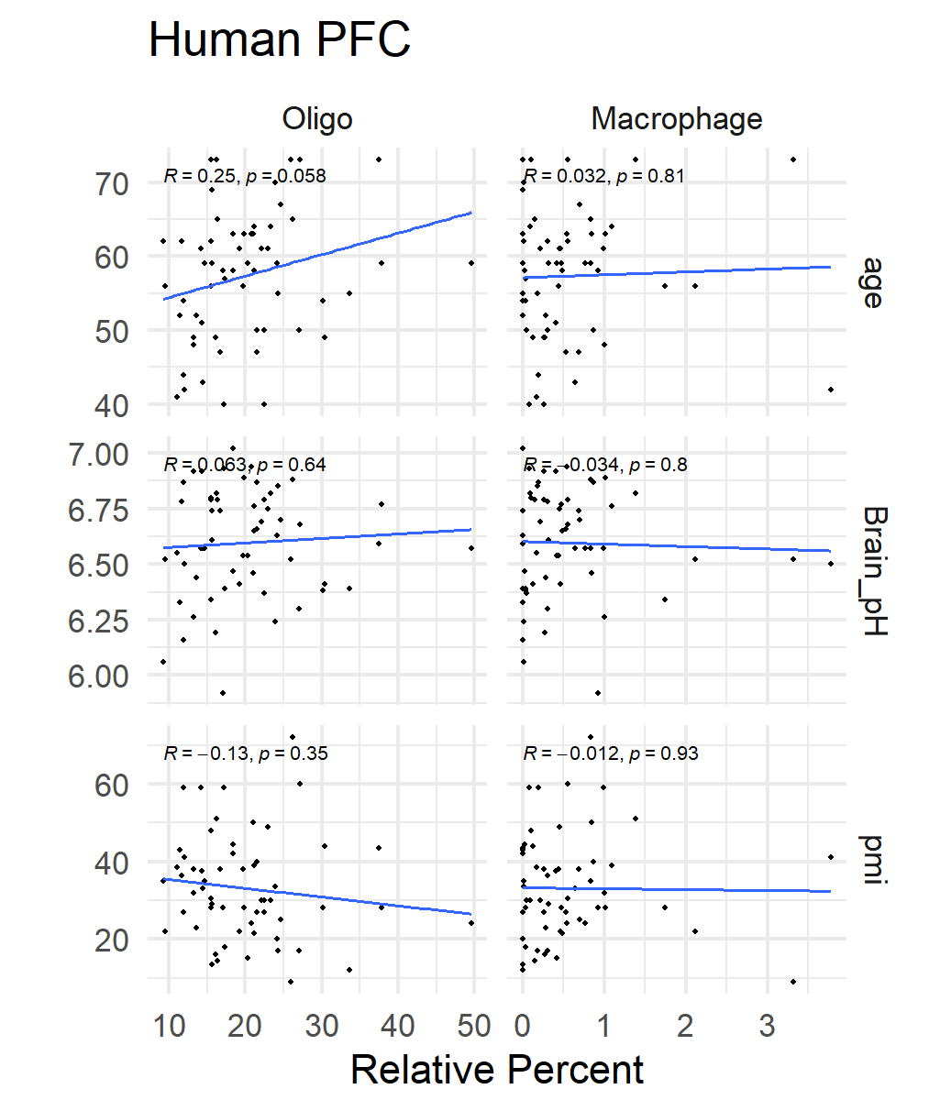

Correlating results of cell types different between AUD vs control with metadata from PFC, NAc and CeA. R = Pearson correlation coefficient.

Supplementary Figure S3 - Conservation of AUD Gene Co-Expression Networks Across Species

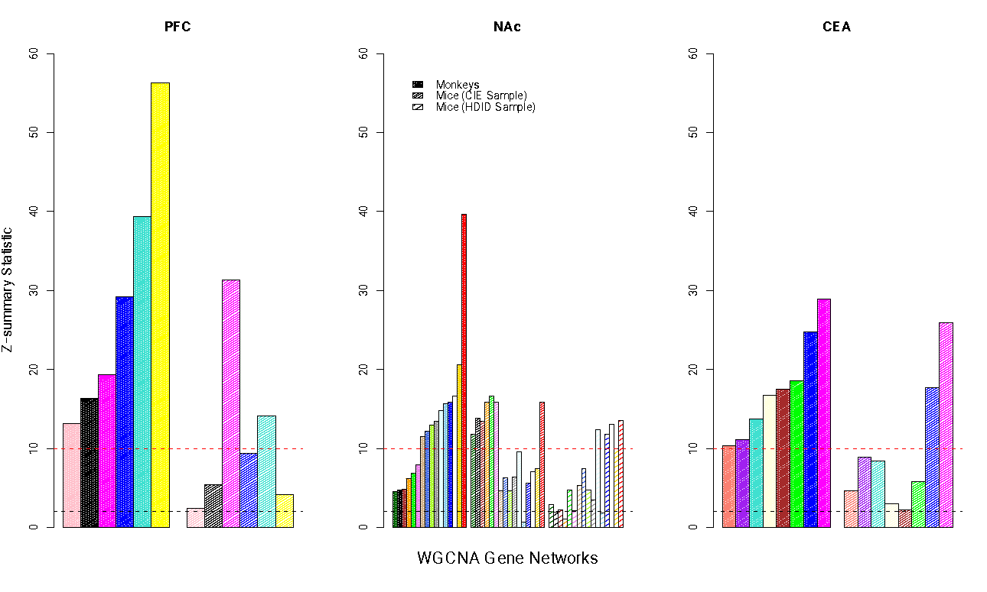
Gene network conservation across human AUD samples with primate and mouse models of alcohol use. Gene networks were made in human brain tissue and tested for their reproducibility in mammalian models of alcohol use. Zsummary is the metric of conservation. Zsummary > 10 indicates a highly reproducible gene co-expression network, a value between 2-10 would be weakly to moderately conserved and below 2 would not be conserved. WGCNA = weighted gene co-expression network analysis; CIE = chronic intermittent alcohol exposure; HDID = high drinking in the dark. Note color for WGCNA networks are arbitrary and the magenta gene network in the PFC is distinct from the magenta gene network in the CeA.

