Supplementary information

Identification of plasma biomarkers in lipid metabolism for accurate prediction of Alzheimer’s disease
Xiaohui Luo^{1,2,3}, Longhao Jia^{1,2,3}, Jixin Cao^{1,2,3}, Qihao Guo⁸, the ZIB Consortium#, Jingqi Chen^{1,6,7*} and Xing‑Ming Zhao^{2,3,4,5,6,7*}

Author affiliations:
- Institute of Science and Technology for Brain-Inspired Intelligence, Fudan University, Shanghai 200433, China
- Department of Neurology, Zhongshan Hospital, Fudan University, Shanghai 200433, China
- College of Biomedical Engineering, Fudan University, Shanghai 200433, China.
- Lingang Laboratory, Shanghai 200031, China
- State Key Laboratory of Medical Neurobiology, Institutes of Brain Science, Fudan University, Shanghai 200032, China
- MOE Key Laboratory of Computational Neuroscience and Brain‑Inspired Intelligence, and MOE Frontiers Center for Brain Science, Fudan University, Shanghai 200433, China
- Zhangjiang Fudan International Innovation Center, Fudan University, Shanghai 200433, China.
- Department of Gerontology, Shanghai Jiao Tong University Affiliated Sixth People’s Hospital, Shanghai 200233, China

*Address correspondence to:
Xing-Ming Zhao, Ph.D.
Department of Neurology, Zhongshan Hospital and College of Biomedical Engineering, Fudan University
220 Handan Road, Shanghai, China
Phone number: (86) 150 2189 2726
E-mail: xmzhao@fudan.edu.cn

Jingqi Chen, Ph.D.
Institute of Science and Technology for Brain-Inspired Intelligence, Fudan University
220 Handan Road, Shanghai, China
E-mail: jingqichen@fudan.edu.cn

Supplementary methods
Zhangjiang International Brain Bank
Zhangjiang International Brain Bank (https://zib.fudan.edu.cn/index) of Fudan University is the database platform of Fudan Zhangjiang International Innovation Center for Brain and Brain-like Intelligence. The brain bank includes three important parts: dry bank, wet bank and algorithm bank. It fully draws on the platform construction model of the International Brain Research Center to form the construction idea of "three banks integration, multi-source sharing" and "full-dimensional, multi-modal, multi-source sharing". Across "time and space" data acquisition mode. The dry library and algorithm library are built by the institute integrating several domestic and foreign medical and scientific research institutions. It has more than 520,000 international shared databases such as UK Biobank, ABCD and HCP.
By 2023, the Zhangjiang International Brain Bank has established a comprehensive research infrastructure, encompassing six distinct cohorts: schizophrenia, depression, autism, stroke, neurodegenerative diseases, and a control group of individuals without these conditions. It has amassed a collection of 15,000 cases from these cohorts, each documented with extensive multi-dimensional data that includes environmental, behavioral, genetic, brain imaging, and neurological information at the 'O' scale.
In its pursuit of excellence, the institution has independently developed a suite of cutting-edge intelligent algorithms and software for the analysis and processing of spatiotemporal data. Moreover, it has forged long-term collaborative and sharing agreements with leading global biological and brain science databases. This strategic networking has laid the foundation for creating the world's largest and most comprehensive Brain Database and Algorithm Center.
This center is not only a beacon for fundamental brain science research but also a pivotal resource for clinical diagnosis and treatment of brain-related diseases. Additionally, it plays a significant role in fostering the emergence and growth of new industries related to brain-like intelligence technologies.
Neuropsychological assessment
All participants underwent a battery of neuropsychological assessments including a subjective cognitive decline interview [1], six neuropsychological tests in three cognitive domains (i.e., Rey Auditory Verbal Learning Test-HuaShan version (AVLT-H) 30-minute delayed free recall auditory verbal learning test (AVLT-N5) and AVLT recognition (AVLT- N7) [2] in memory domain; Boston Naming Test (BNT) [3] and Animal Fluency Test (AFT) [4] in language domain; and Shape Trail-Making Test parts A and B (STT-A, STT-B) [5] in attention/executive domain), global cognition tests (e.g., the Mini-Mental State Examination (MMSE) [6]; Montreal cognitive assessment-basic (MoCA_B) [7]; Addenbrooke's Cognitive Examination – III (ACEIII) [8]), Daily functional activities (FAQ), and Everyday cognition (ECOG) [9]. All tests for each participant were conducted during the same interview session to ensure consistency.

Diagnostic criteria
Diagnosis of Alzheimer’s disease. The AD patients were diagnosed following the guidelines of the National Institute on Aging-Alzheimer's Association (NIA-AA) [10], which were: (1) Interfere with the ability to function at work or usual activities; (2) Represent a decline from previous levels of functioning and performing; (3) Are not explained by delirium or major psychiatric disorder; (4) Cognitive impairment is detected and diagnosed through a combination of history taking, physical exam and cognitive evaluation, such as MMSE≤24; (5) Meets criteria for dementia described above, and in addition, has the following characteristics: (a) insidious onset, (b) clear-cut history of worsening of cognition, (c) history and examination in amnestic or non-amnestic presentations, (d) no important features of other dementia types.

Diagnosis of mild cognitive impairment. The MCI participants were determined with Jak/Bondi criteria [11], which were: (1) memory complaints by the participants, family members or physicians in the previous 6 months; (2) a MoCA-B score of 25 or under; (3) an MMSE score of 24 or over; (4) impaired scores in two measures within the same cognitive domain or at least 1 measure across all 3 cognitive domains or FAQ > 9; (5) no neurologic or psychiatric disease.

Metabolomics Analysis
Methods for extraction of hydrophilic compounds
Sample was thawed on ice, vortex for 10 s and mix well, 300 uL of pure methanol was added to 50 uL of plasma/serum, whirl the mixture for 3 min and centrifuge it with 12,000 rpm at 4 °C for 10 min. Then collect the supernatant and centrifuge it at 12,000 rpm at 4 °C for 5 min. Leave in a refrigerator at -20 °C for 30 min, centrifuge at 12000 r/min at 4 °C for 3 min, and take 150 uL of supernatant in the liner of the corresponding injection bottle for on-board analysis.
Methods for extraction of hydrophobic compounds
Sample was thawed on ice, whirl around 10 s, and then centrifuge it with 3000 rpm at 4 °C for 5 min. Take 50 uL of one sample and homogenize it with 1 mL mixture (include methanol, MTBE and internal standard mixture). Whirl the mixture for 15 min. Then add 200 uL of water and whirl the mixture for 1 min, and centrifuge it with 12,000 rpm at 4 °C for 10 min. Extract 500 uL supernatant and concentrate it. Dissolve powder with 200 uL mobile phase B, then stored in -80 °C. Finally take the dissolving solution into the sample bottle for LC-MS/MS analysis.
UPLC Conditions
UPLC Conditions of hydrophilic compounds
The sample extracts were analyzed using an LC-ESI-MS/MS system (UPLC, ExionLC AD, https://sciex. com.cn/; MS, QTRAP® System, https://sciex.com/). The analytical conditions were as follows, UPLC: column, Waters ACQUITY UPLC HSS T3 C18 (1.8 μm, 2.1 mm*100 mm); column temperature, 40 °C; flow rate, 0.4 mL/min; injection volume, 2μL; solvent system, water (0.1% formic acid): acetonitrile (0.1% formic acid); gradient program, 95:5 V/V at 0 min, 10:90 V/V at 11.0 min,10:90 V/V at 12.0 min, 95:5 V/V at 12.1 min, 95:5 V/V at 14.0 min.
UPLC Conditions of hydrophobic compounds
The sample extracts were analyzed using an LC-ESI-MS/MS system (UPLC, ExionLC AD, https://sciex. com.cn/; MS, QTRAP® System, https://sciex.com/). The analytical conditions were as follows, UPLC: column, Thermo AccucoreTM C30 (2.6 μm, 2.1 mm*100 mm i.d.); solvent system, A: acetonitrile/water (60/40,V/V, 0.1% formic acid, 10 mmol/L ammonium formate), B: acetonitrile/isopropanol (10/90 V/V, 0.1% formic acid, 10 mmol/L ammonium formate); gradient program, A/B (80:20, V/V) at 0 min, 70:30 V/V at 2.0 min, 40:60 V/V at 4 min, 15:85 V/V at 9 min, 10:90 V/V at 14 min, 5:95 V/V at 15.5 min, 5:95 V/V at 17.3 min, 80:20 V/V at 17.3 min, 80:20 V/V at 20 min; flow rate, 0.35 ml/min; temperature, 45 °C; Injection volume: 2μl. The effluent was alternatively connected to an ESI-triple quadrupole-linear ion trap (QTRAP)-MS.
ESI-Q TRAP-MS/MS
ESI-Q TRAP-MS/MS of hydrophilic compounds
LIT and triple quadrupole (QQQ) scans were acquired on a triple quadrupole-linear ion trap mass spectrometer (QTRAP), QTRAP® LC-MS/MS System, equipped with an ESI Turbo Ion-Spray interface, operating in positive and negative ion mode and controlled by Analyst 1.6.3 software (Sciex). The ESI source operation parameters were as follows: source temperature 500 °C; ion spray voltage (IS) 5500 V (Positive), -4500 V (Negative); ion source gas I (GSI), gas II (GSII), curtain gas (CUR) were set at 55, 60, and 25.0 psi, respectively; the collision gas (CAD) was high. Instrument tuning and mass calibration were performed with 10 and 100 μmol/L polypropylene glycol solutions in QQQ and LIT modes, respectively. A specific set of MRM transitions were monitored for each period according to the metabolites eluted within this period.
ESI-Q TRAP-MS/MS of hydrophobic compounds
LIT and triple quadrupole (QQQ) scans were acquired on a triple quadrupole-linear ion trap mass spectrometer (QTRAP), QTRAP® LC-MS/MS System, equipped with an ESI Turbo Ion-Spray interface, operating in positive and negative ion mode and controlled by Analyst 1.6.3 software (Sciex). The ESI source operation parameters were as follows: ion source, turbo spray; source temperature 500 °C; ion spray voltage (IS) 5500 V(Positive), -4500 V(Negative); ion source gas 1 (GS1), gas 2 (GS2), curtain gas (CUR) were set at 45, 55, and 35 psi, respectively; the collision gas (CAD) was medium. Instrument tuning and mass calibration were performed with 10 and 100 μmol/L polypropylene glycol solutions in QQQ and LIT modes, respectively. QQQ scans were acquired as MRM experiments with collision gas (nitrogen) set to 5 psi. DP and CE for individual MRM transitions was done with further DP and CE optimization. A specific set of MRM transitions were monitored for each period according to the metabolites eluted within this period.

QTOF-MS/MS
The Triple TOF mass spectrometer was used for its ability to acquire MS/MS spectra on an information- dependent basis (IDA) during an LC/MS experiment. In this mode, the acquisition software (TripleTOF 6600, AB SCIEX) continuously evaluates the full scan survey MS data as it collects and triggers the acquisition of MS/MS spectra depending on preselected criteria. In each cycle, 12 precursor ions whose intensity greater than 100 were chosen for fragmentation at collision energy (CE) of 30 V (12 MS/MS events with product ion accumulation time of 50 msec each). ESI source conditions were set as following: Ion source gas 1 as 50 Psi, Ion source gas 2 as 50 Psi, Curtain gas as 25 Psi, source temperature 500 °C, Ion Spray Voltage Floating (ISVF) 5500 V or -4500 V in positive or negative modes, respectively.

Supplementary Figures
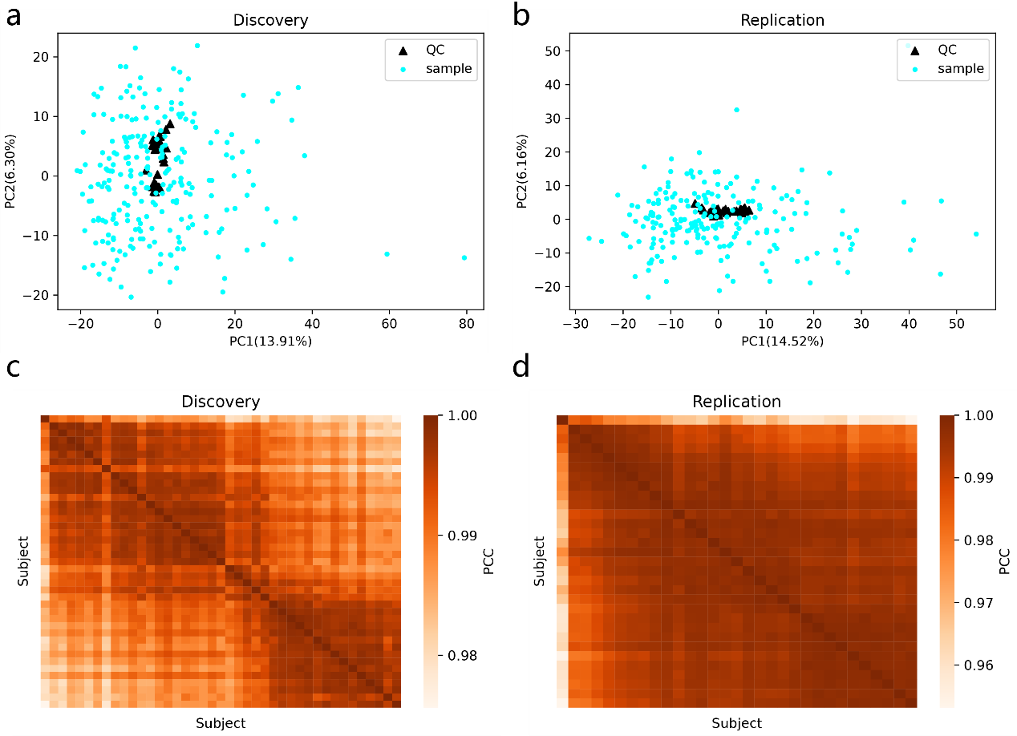
Supplementary Figure 1. Validation of the stability of the metabolomics platform. a-b, Principal component analysis (PCA) of quality control (QC) and samples in discovery cohort and replication cohort. c-d, Correlation of quality control subjects in discovery cohort and replication cohort. PCC, Pearson correlation coefficient.

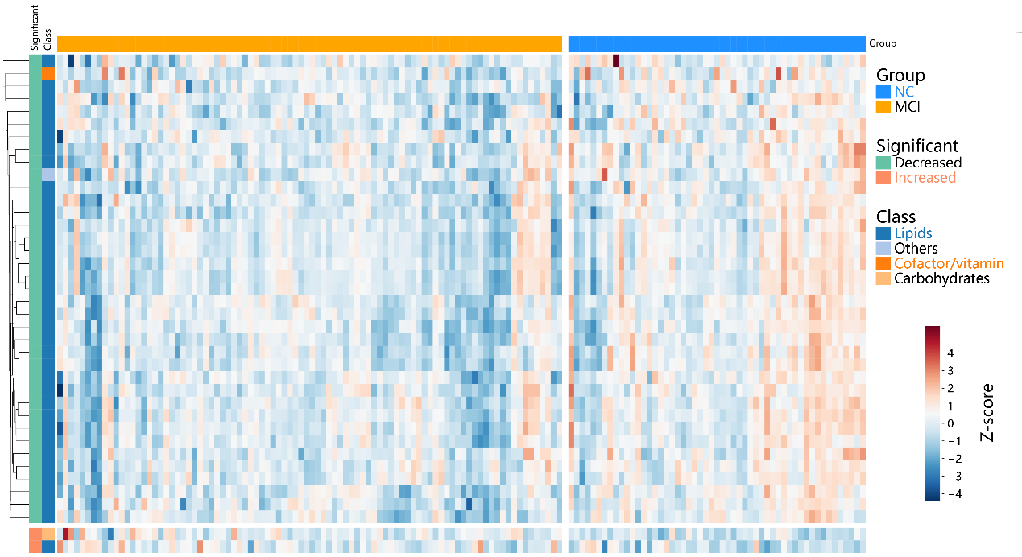
Supplementary Figure 2. Heatmap of the abundance (z-score) of significantly differential metabolites in MCI vs NC. MCI, Mild cognitive impairment; NC, Normal controls.

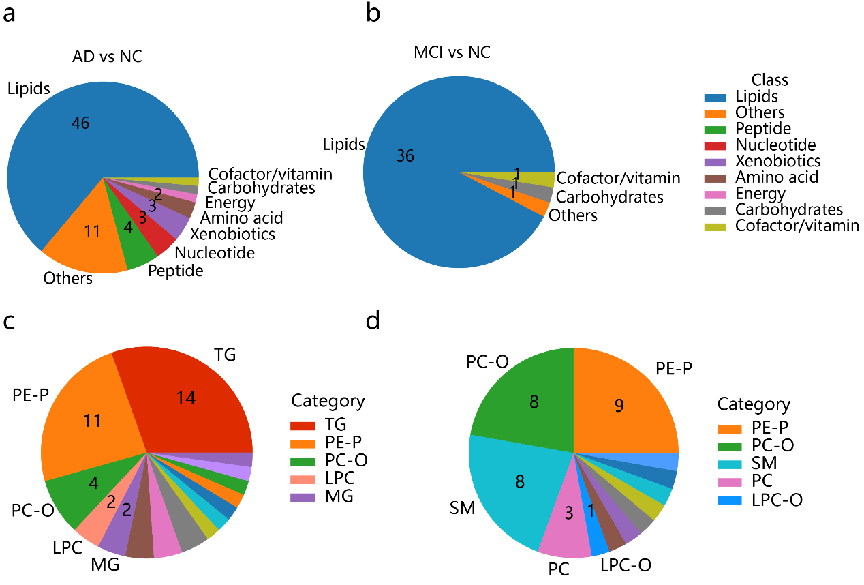
Supplementary Figure 3. Compositions and counts of differential metabolites. a-b. Classes and counts of differential metabolites between AD and MCI compared to NC. c. Categories and counts (only top 5 were showed) of differential metabolites in lipid class between AD and NC. d. Categories and counts (only top 5 were showed) of differential metabolites in lipid class between MCI and NC. AD, Alzheimer’s disease; NC, Normal controls; MCI, Mild cognitive impairment; TG, Triglyceride; PE-P, Plasmenyl Phosphatidylethanolamine; PC, Phosphatidylcholine; PC-O, Alkyl Phosphatidylcholine; LPC, Lysophosphatidylcholine; LPC-O, Alkyl Lysophosphatidylcholine; MG, Monoglyceride; SM, Sphingomyelin.

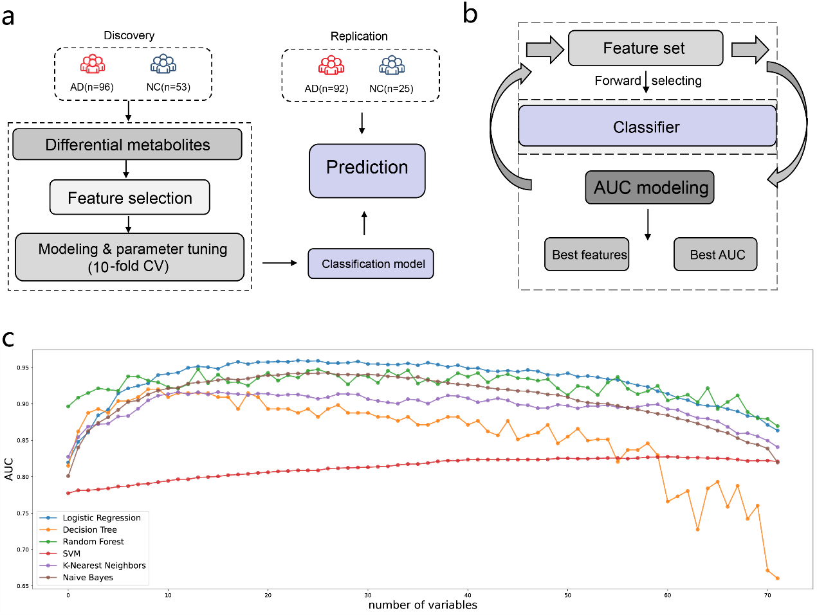
Supplementary Figure 4. The establishment workflow of the AD classifiers and feature selection algorithm. a. A classification model was trained based on an optimal plasma metabolite panel selected from differential metabolites in the discovery cohort by 10-fold cross-validation, and evaluation of the prediction performance in the replication cohort. b. Feature selection was based on forward selection and aimed to obtain the best feature set with the best AUC. c. The AUC trajectories of 6 widely used machine learning classifiers in feature selection.

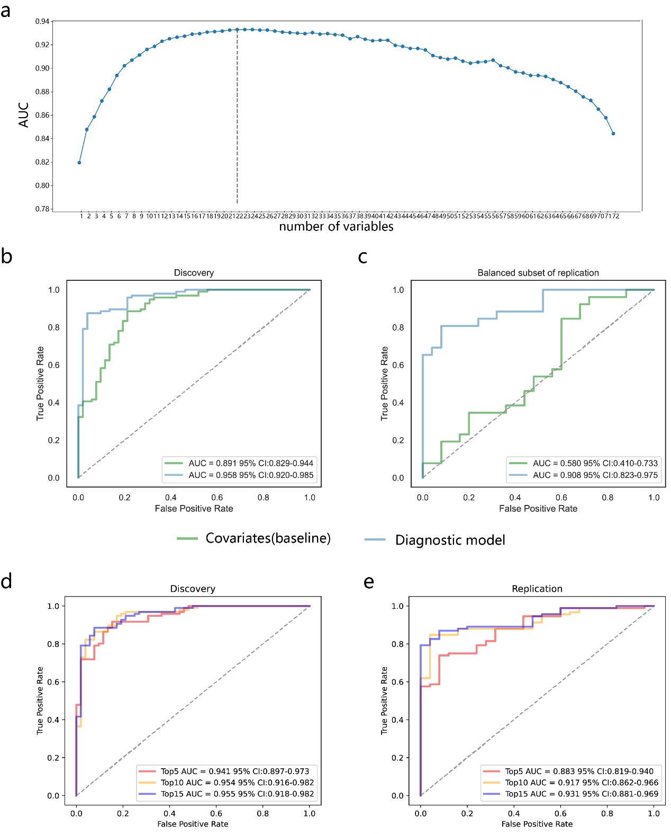
Supplementary Figure 5. AUC trajectory of feature selection algorithm and performances of reduced models. a. In the forward feature selection based on AUC value with logistic regression model, variables were gradually added, and the scatterplot showed that the AUC value reached its maximum with 22 variables. b-c. Performance of the logistic regression-based AD-diagnostic model and baseline model in the discovery cohort and a balanced subset of replication cohort. d-e. Performance of the logistic regression models with top 5, top 10 and top 15 variables in the discovery and replication cohorts.

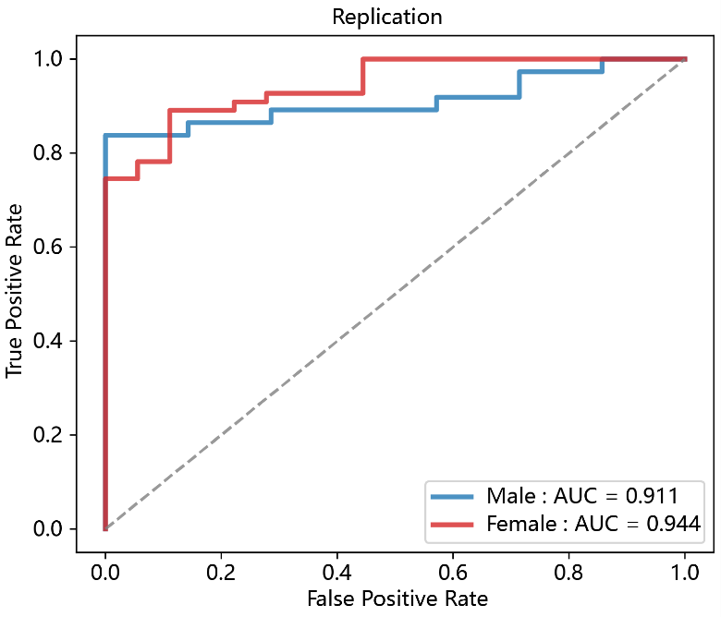
Supplementary Figure 6. Performance of the logistic regression-based AD-diagnostic model in the male-only and female-only subset of replication cohort.

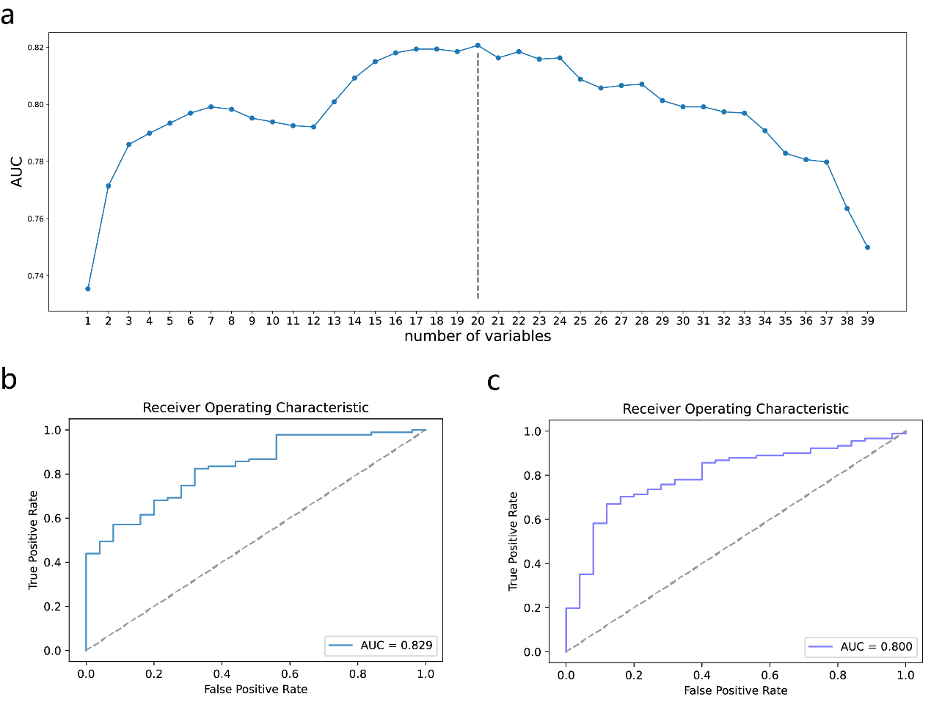
Supplementary Figure 7. MCI diagnosis. a. The trajectory of AUC in the feature selection models, yielding optimal AUC with 20 variables. b. Performance of the logistic regression-based MCI-diagnostic model with optimal feature set in replication cohort. c. Performance of the logistic regression-based MCI-diagnostic model with 22 AD biomarkers in replication cohort.

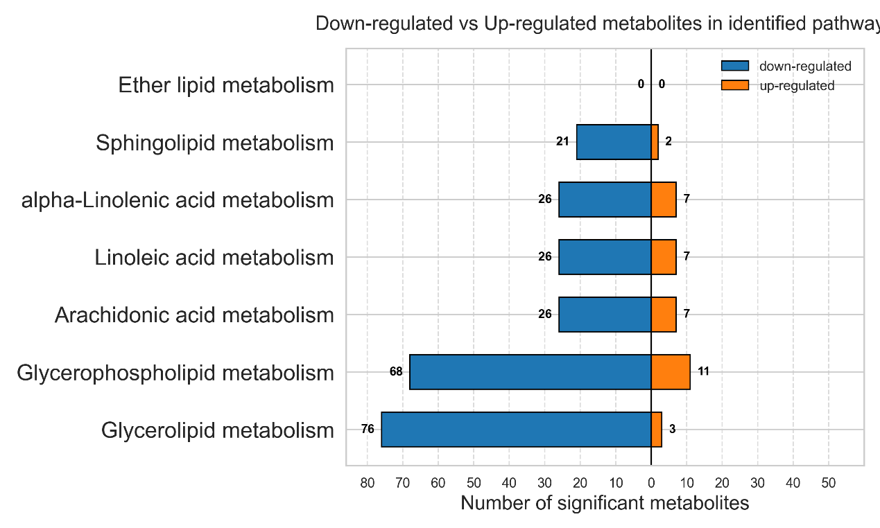
Supplementary Figure 8. Number of significant metabolites measured in the identified pathways.

References
1. Miebach L, Wolfsgruber S, Polcher A, Peters O, Menne F, Luther K et al. Which features of subjective cognitive decline are related to amyloid pathology? Findings from the DELCODE study. Alzheimers Res Ther 2019; 11(1): 66.
2. Zhao Q, Lv Y, Zhou Y, Hong Z, Guo Q. Short-term delayed recall of auditory verbal learning test is equivalent to long-term delayed recall for identifying amnestic mild cognitive impairment. PloS one 2012; 7(12): e51157.
3. Guo Q-H, Hong Z, W.X S, Sun Y-M, C.Z L. Boston naming test using by Chinese elderly, patient with mild cognitive impairment and Alzheimer's dementia. Chin Ment Health J 2006; 20: 81-85.
4. Shi Y-b, Guo Q-H, Yu H, Zhao Q-h, Hong Z. Validity study of Animal-City Alternating Form Fluency Test in the identification of mild cognitive impairment and Alzheimer's disease. Chinese Journal of Contemporary Neurology and Neurosurgery 2015; 15: 560-564.
5. Zhao Q, Guo Q, Li F, Zhou Y, Wang B, Hong Z. The Shape Trail Test: application of a new variant of the Trail making test. PLoS One 2013; 8(2): e57333.
6. Katzman R, Zhang MY, Ouang Ya Q, Wang ZY, Liu WT, Yu E et al. A Chinese version of the Mini-Mental State Examination; impact of illiteracy in a Shanghai dementia survey. J Clin Epidemiol 1988; 41(10): 971-978.
7. Chen KL, Xu Y, Chu AQ, Ding D, Liang XN, Nasreddine ZS et al. Validation of the Chinese Version of Montreal Cognitive Assessment Basic for Screening Mild Cognitive Impairment. J Am Geriatr Soc 2016; 64(12): e285-e290.
8. Pan FF, Wang Y, Huang L, Huang Y, Guo QH. Validation of the Chinese version of Addenbrooke's cognitive examination III for detecting mild cognitive impairment. Aging Ment Health 2021: 1-8.
9. Farias ST, Mungas D, Reed BR, Cahn-Weiner D, Jagust W, Baynes K et al. The measurement of everyday cognition (ECog): scale development and psychometric properties. Neuropsychology 2008; 22(4): 531-544.
10. McKhann GM, Knopman DS, Chertkow H, Hyman BT, Jack CR, Jr., Kawas CH et al. The diagnosis of dementia due to Alzheimer's disease: recommendations from the National Institute on Aging-Alzheimer's Association workgroups on diagnostic guidelines for Alzheimer's disease. Alzheimers Dement 2011; 7(3): 263-269.
11. Bondi MW, Edmonds EC, Jak AJ, Clark LR, Delano-Wood L, McDonald CR et al. Neuropsychological criteria for mild cognitive impairment improves diagnostic precision, biomarker associations, and progression rates. J Alzheimers Dis 2014; 42(1): 275-289.

