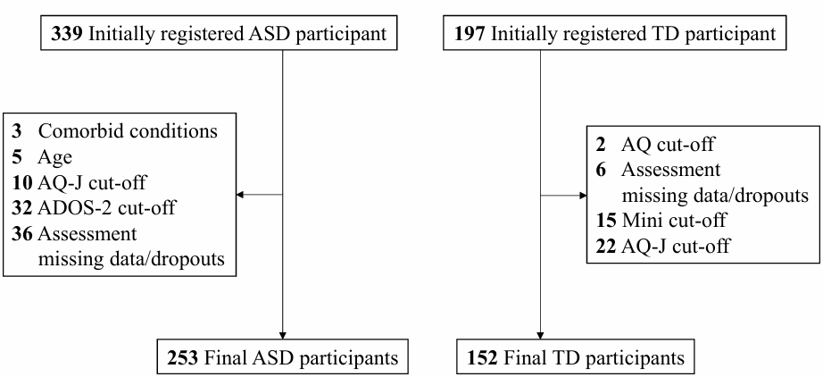
Supplementary Figure 1. Participant flow diagram for ASD and TD groups
This figure illustrates the participant selection process for the autism spectrum disorder (ASD) and typically developing (TD) groups. A total of 339 individuals were initially registered as ASD participants. After exclusions due to age (n = 5), comorbid conditions (n = 3), failure to meet the AQ-J cut-off (n = 10), failure to meet the ADOS-2 cut-off (n = 32), and missing assessment data or dropouts (n = 36), 253 ASD participants were included in the final analysis.
For the TD group, 197 participants were initially registered. Participants were excluded based on the AQ cut-off (n = 2), missing assessment data or dropouts (n = 6), failure to meet the Mini cut-off (n = 15), and failure to meet the AQ-J cut-off (n = 22). The final TD sample consisted of 152 participants.
Abbreviations: ASD, autism spectrum disorder; TD, typically developing; AQ, Autism-Spectrum Quotient; AQ-J, Japanese version of AQ; ADOS-2, Autism Diagnostic Observation Schedule–2; Mini, Mini-International Neuropsychiatric Interview.

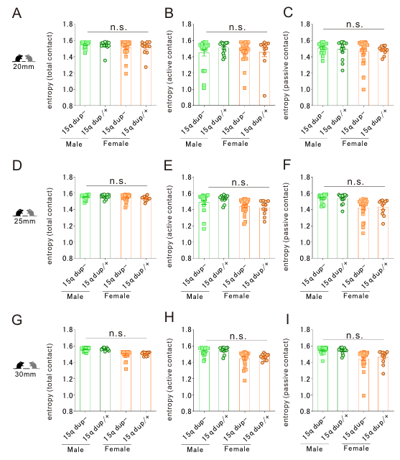
Supplementary Figure 2. Assessment of social behavior in freely moving mice
A–C. The social interaction threshold distance was defined as 20 mm. D–F. The social interaction threshold distance was defined as 25 mm. G–I. The social interaction threshold distance was defined as 30 mm. A. No differences in entropy of total contacts across genotype and sex (two-way ANOVA, genotype [15q dup- or 15q dup/+] × sex [male or female] interaction, F_{1,64} = 0.023, p = 0.880; effect of genotype F_{1,64} = 0.051, p = 0.821; effect of sex F_{1,64} = 2.943, p = 0.091). B. No differences in entropy of active contacts across genotype and sex (two-way ANOVA, genotype [15q dup- or 15q dup/+] × sex [male or female] interaction, F_{1,64} = 0.390, p = 0.535; effect of genotype F_{1,64} = 0.242, p = 0.624; effect of sex F_{1,64} = 0.539, p = 0.465). C. No differences in entropy of passive contacts across genotype and sex (two-way ANOVA, genotype [15q dup- or 15q dup/+] × sex [male or female] interaction, F_{1,64} = 0.278, p = 0.600; effect of genotype F_{1,64} = 0.958×10⁻⁵, p = 0.998; effect of sex F_{1,64} = 0.819, p = 0.369). D. No differences in entropy of total contacts across genotype and sex (two-way ANOVA, genotype [15q dup- or 15q dup/+] × sex [male or female] interaction, F_{1,64} = 0.713, p = 0.402; effect of genotype F_{1,64} = 0.017, p = 0.898; effect of sex F_{1,64} = 3.374, p = 0.071). E. No differences in entropy of active contacts across genotype and sex (two-way ANOVA, genotype [15q dup- or 15q dup/+] × sex [male or female] interaction, F_{1,64} = 0.097, p = 0.756; effect of genotype F_{1,64} = 0.251, p = 0.618; effect of sex F_{1,64} = 4.027, *p = 0.049). F. No differences in entropy of passive contacts across genotype and sex (two-way ANOVA, genotype [15q dup- or 15q dup/+] × sex [male or female] interaction, F_{1,64} = 5.959, *p = 0.017; effect of genotype F_{1,64} = 0.444, p = 0.507; effect of sex F_{1,64} = 0.607, p = 0.439). G. No differences in entropy of total contacts across genotype and sex (two-way ANOVA, genotype [15q dup- or 15q dup/+] × sex [male or female] interaction, F_{1,64} = 0.143, p = 0.707; effect of genotype F_{1,64} = 0.437, p = 0.511; effect of sex F_{1,64} = 0.338, p = 0.563). H. No differences in entropy of active contacts across genotype and sex (two-way ANOVA, genotype [15q dup- or 15q dup/+] × sex [male or female] interaction, F_{1,64} = 0.652, p = 0.422; effect of genotype F_{1,64} = 2.648, p = 0.109; effect of sex F_{1,64} = 0.026, p = 0.872). I. No differences in entropy of passive contacts across genotype and sex (two-way ANOVA, genotype [15q dup- or 15q dup/+] × sex [male or female] interaction, F_{1,64} = 0.275, p = 0.602; effect of genotype F_{1,64} = 0.119, p = 0.731; effect of sex F_{1,64} = 1.951, p = 0.167).
Abbreviation list: ANOVA = analysis of variance; 15q dup = 15q11–q13 duplication.

Supplementary Table 1. Psychiatric comorbidities of the ASD sample (N = 253)
Comorbidities | N (%)
Attention-Deficit/Hyperactivity Disorder | 28 (11.1 %)
Major Depressive Disorder | 12 (4.7 %)
Obsessive-Compulsive Disorder | 4 (1.6 %)
Adjustment Disorders | 4 (1.6 %)
Dysthymia | 3 (1.2 %)
Alcohol Use Disorder | 2 (0.8 %)
Anxiety Disorders | 2 (0.8 %)
Borderline Personality Disorder | 1 (0.4 %)
Developmental Coordination Disorder | 1 (0.4 %)
Dissociative Disorders | 1 (0.4 %)
Eating Disorders | 1 (0.4 %)
Learning Disorder | 1 (0.4 %)
Obsessive-Compulsive Personality Disorder | 1 (0.4 %)
Somatic Symptom and Related Disorders | 1 (0.4 %)
Values are presented as n (%). Percentages were calculated based on the total autism spectrum disorder (ASD) sample (N = 253). Psychiatric diagnoses were based on DSM-5 criteria. The total number represents the sum of comorbid conditions; overall, 52 participants had at least one comorbid diagnosis, and some participants had more than one comorbid diagnosis.

Supplementary Table 2. Medication categories in the ASD sample (N = 253)
Medication categories | N (%)
Antidepressants | 82 (32.4%)
Benzodiazepines | 73 (28.9%)
Atypical antipsychotics | 50 (19.8%)
Mood stabilizers / antiepileptic drugs | 22 (8.7%)
ADHD medications | 21 (8.3%)
Non-benzodiazepine hypnotics | 20 (7.9%)
Non-benzodiazepine anxiolytics | 9 (3.6%)
Orexin receptor antagonists | 7 (2.8%)
Typical antipsychotics | 5 (2.0%)
Antiparkinsonian drugs | 3 (1.2%)
Values are presented as n (%). Percentages were calculated based on the total autism spectrum disorder (ASD) sample (N = 253). Multiple medications per participant were allowed.
Abbreviations: ADHD, Attention-Deficit/Hyperactivity Disorder.
Supplementary Table 3. Cross-species mapping of human measures and mouse behavioral tasks
Symptom / Domain | Human Measure | Primary Outcome | Mouse Task | Primary Behavioral Index
Sensory sensitivity/avoidance | AASP (Sensory Sensitivity, Sensation Avoiding) | Heightened sensory responsivity | Open field test (bright vs dim light conditions) | Center time, center distance ratio
Light-related sensory response | AASP (Sensory Sensitivity) | Sensitivity to sensory input | Light–dark transition test | Time in light/dark compartments
Social behavior (observational) | ADOS-2 (Social Affect) | Observable social interaction patterns | Social approach task (AR-LABO) | Frequency and duration of active social approaches
Autistic traits (self-report) | AQ-J | Subjective autistic traits | — | —
This table summarizes the correspondence between human clinical and self-report measures and the behavioral tasks used in the 15q dup/+ mouse model. Human measures are paired with mouse tasks based on shared symptom domains and primary behavioral outcomes, with the aim of facilitating interpretation of the cross-species design. The mappings are phenotype-based and intended to aid conceptual alignment rather than to imply direct mechanistic equivalence across species.
Abbreviations: AASP, Adolescent/Adult Sensory Profile; ADOS-2, Autism Diagnostic Observation Schedule, Second Edition; AQ-J, Autism-Spectrum Quotient, Japanese version.

