Supplementary Fig. 1 Body weight monitoring during behavioral testing.
A Body weights of SD and WKY rats measured at 4, 5, and 6 weeks of age. Behavioral testing in SD rats was completed at 6 weeks of age. A significant difference between SD and WKY rats was observed at 5 weeks of age. B Body weights of WKY and SHR measured longitudinally from 4 to 8 weeks of age, corresponding to the full duration of behavioral testing in these strains. No significant differences in body weight were observed between WKY and SHR rats at any time point. Data are represented as mean ± SEM. ***p < 0.001; ns = not significant; unpaired t-test.

Supplementary Fig. 2 Behavioral comparisons between SD and WKY rats reveal strain-specific differences.
A In the CAT, WKY rats exhibited significantly shorter jumping latencies than SD rats. B Similar findings were observed in the VCAT. C WKY rats traveled a significantly greater total distance during the 5-min open field test (OFD5). D WKY rats spent more time in the inner zone during the 5-min open field test (OFI5), indicating reduced anxiety-like behavior. E–F In the 5-min elevated plus maze (EPM), WKY rats spent significantly more time in open arms (EPO5, E) and less time in closed arms (EPCL5, F). G–H WKY rats also showed increased wall-leaning frequency during the early 5 min of the 10-min test (WL5E, G) and more rearing events during the early 5 min of the 10-min test (R5E, H), indicative of heightened exploratory behavior. Data are presented as mean ± SEM. *p < 0.05, **p < 0.01, ***p < 0.001, and ****p < 0.0001.

Supplementary Fig. 3 Baseline behavioral assessments with no significant strain differences.
A-B In NOR10 (N10T, A) and NOR24 (N24T, B), time spent investigating object zones showed no difference between SD and WKY rats. C–D Number of displaced (MD, C) and buried marbles (MB, D) in the marble burying test. E Nestlet shredding weight (Ng). F–H Grooming duration during the early 5 min of the 10-min test (G5E, F), time spent in the center zone of the 5-min EPM (EPCE5, G), and head-dipping counts (EPH5, H) were not significantly different. I–L PPI at 68, 71, 77, and 82 dB showed no significant strain differences. M–N NOR indices at 10 min (N10IN, M) and 24 hours (N24IN, N) post-training. O Spontaneous alternation percentage in the Y-maze. All measures were not significantly different between SD and WKY rats. Data are represented as mean ± SEM. ns = not significant.

Supplementary Fig. 4 Exploratory behaviors in WKY and SHR rats across a 10-minute test period.
A Total distance traveled; no significant group difference was detected at 10 min. B Zone transition number; no significant group differences. C Locomotor velocity; no significant group differences. D–F Time spent in the inner (D), side (E), and edge (F) zones. No significant differences were observed between WKY and SHR rats at the 10-min test. G–I Exploratory behaviors during the late 5 min of the 10-min test: wall-leaning (WL5L, G), rearing (R5L, H), and grooming duration (G5L, I). J–L Exploratory behaviors during the full 10-min test: wall-leaning (WL10, J), rearing (R10, K), and grooming duration (G10, L). Data are presented as mean ± SEM. ***p < 0.001, and ****p < 0.0001; ns = not significant; unpaired t-test.

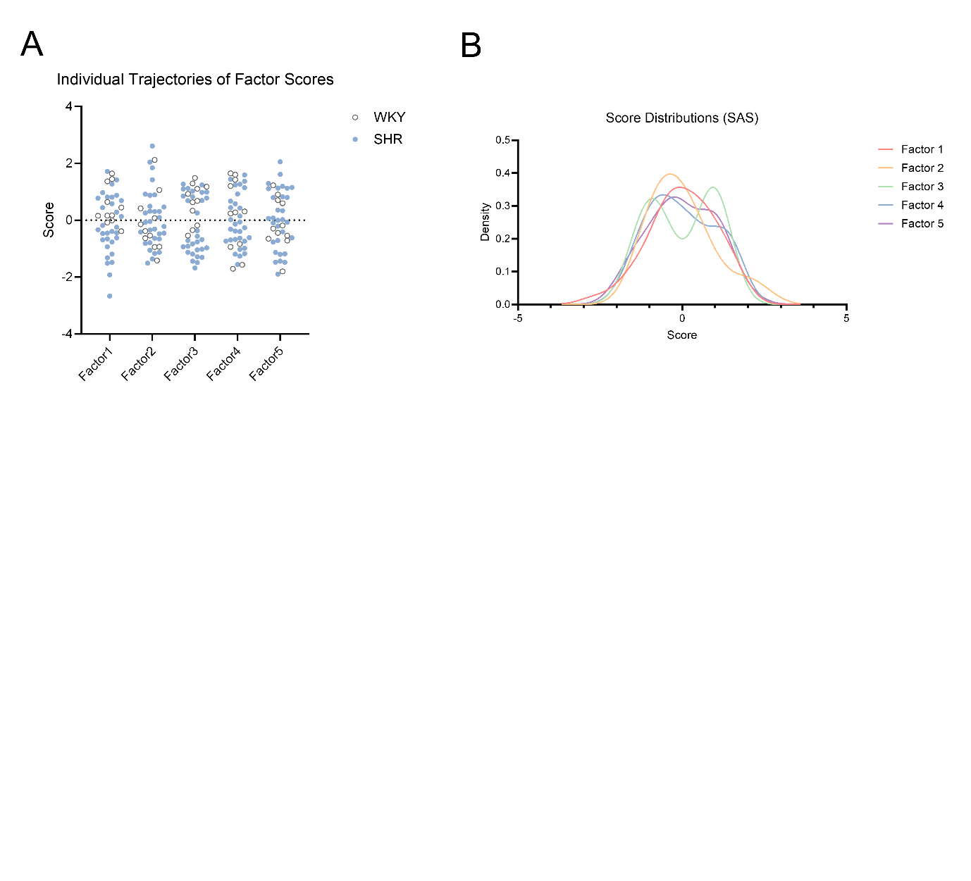
Supplementary Fig. 5 Distribution and trajectory of individual factor scores.
A Individual data points for each subject’s factor scores across all five dimensions, color-coded by strain. B Density plots showing the distribution of factor scores. All factors exhibited approximately normal distributions without significant skewness or floor/ceiling effects.
Abbreviation | Description | Test Duration
N10T | NOR: Total exploration time (%) in familiar and novel object zones | 10 min
N24T | NOR 24 h: Total exploration time (%) in familiar and novel object zones | 10 min
MB | Number of buried marbles | 30 min
MD | Number of displaced marbles | 30 min
Ng | Nestlet weight (Nestlet g) | Overnight  (O/N)
CAT | Cliff avoidance test: Latency to fall | 10 min
VCAT | Visual cliff avoidance test: Latency to fall | 6 min
EPO5 | EPM: Time spent in open arms | 5 min
EPCE5 | EPM: Time spent in center zone | 5 min
EPCL5 | EPM: Time spent in closed arms | 5 min
EPH5 | EPM: Number of head dips | 5 min
OFI10 | OFT: Time spent in inner zone | 10 min
ND10 | NOR: Total distance traveled during 1st NOR test | 10 min
ND24 | NOR 24 h: Total distance traveled during 2nd NOR test | 10 min
N10IN | NOR index: (Stranger – Familiar) / (Stranger + Familiar) in 1st test | 10 min
N24IN | NOR index: (Stranger – Familiar) / (Stranger + Familiar) in 2nd test | 10 min
P68 | PPI: Startle response at 68 dB | –
P71 | PPI: Startle response at 71 dB | –
P77 | PPI: Startle response at 77 dB | –
P82 | PPI: Startle response at 82 dB | –
Y | Y-maze: Spontaneous alternation (%) | 8 min
WL10 | OFT: Number of wall-leaning events | 10 min
R10 | OFT: Number of rearing events | 10 min
G10 | OFT: Grooming time (seconds) | 10 min
OFD10 | OFT: Total distance traveled | 10 min
N10T1 | NOR: Time spent in Zone 1 (non-object zone) | 10 min

Supplementary Table 1. Abbreviations and descriptions of behavioral variables used in factor analysis.
Includes test name, definition of measured outcome, and test duration. Variables were drawn from multiple behavioral paradigms: OFT, EPM, MBT, NOR, Y-maze, CAT, VCAT, NST, and PPI.

Factor | Variance  Explained (%) | Key Variables  (Loading ≥ 0.4) | WKY mean | SHR  mean | p-value
Factor 1  (Exploratory Locomotor and  Attentional  Response) | 26.36 | OFD10; R10;  N10T1; OFI10;  P71; WL10;  P68; P77 | 0.505 | -0.179 | p < 0.05
Factor 2  (Risk Avoidance  and Anxiety  -related Behavior) | 21.35 | VCAT; EPCE5;  EPO5; EPCL5 | -0.121 | 0.043 | 0.645
Factor 3  (Impulsivity  and Behavioral Disinhibition) | 11.89 | CAT | 0.595 | -0.211 | p < 0.05
Factor 4  (Long-term Recognition  Memory and  Exploration) | 13.32 | ND24; N24IN | 0.148 | -0.052 | 0.575
Factor 5  (Task-specific Locomotor  Output) | 27.08 | ND10 | -0.111 | 0.039 | 0.673

Supplementary Table 2. Summary of extracted factors, key contributing variables, group means, and variance explained.
For each factor, key variables with loadings ≥ 0.4 are listed along with the variance explained, mean scores for WKY and SHR rats, and p-values for between-group comparisons. Significant group differences were observed for Factor 1 and Factor 3.

Variable | Factor 1 | Factor 2 | Factor 3 | Factor 4 | Factor 5
OFD10 | −0.64 | 0.21 | 0.48 | 0.19 | 0.10
R10 | −0.66 | −0.62 | 0.54 | 0.10 | 0.24
N10T | −0.86 | −0.32 | 0.16 | −0.10 | 0.07
N24T | −0.66 | −0.22 | −0.27 | 0.27 | 0.06
WL10 | −0.58 | −0.41 | 0.35 | 0.44 | 0.31
EPO5 | 0.46 | 0.75 | 0.28 | −0.11 | 0.07
EPCE5 | 0.57 | 0.74 | −0.27 | 0.09 | 0.01
EPCL5 | −0.22 | −0.95 | 0.11 | 0.07 | 0.06
EPH5 | 0.46 | 0.62 | −0.28 | 0.24 | 0.25
P68 | −0.39 | −0.11 | 0.78 | −0.29 | −0.02
P71 | −0.40 | 0.11 | 0.75 | −0.13 | 0.15
P77 | −0.29 | −0.22 | 0.73 | 0.02 | 0.18
P82 | 0.05 | −0.16 | 0.74 | 0.06 | −0.08
ND24 | −0.26 | −0.23 | 0.28 | 0.02 | 0.81
N24IN | 0.33 | −0.36 | 0.10 | −0.05 | 0.50

Supplementary Table 3. Factor loadings from principal axis factoring (PAF).
To examine the robustness of the behavioral factor structure identified by principal component analysis (PCA), exploratory factor analysis was re-performed using PAF with promax rotation to extract latent constructs based on shared variance. A five-factor solution was specified to allow direct comparison with the original PCA-based structure. Factor loadings with an absolute value ≥ 0.40 are shown in bold.
Interpretation.
Because PCA and PAF rely on different analytical principles, factor numbering was not expected to be identical across methods; therefore, factors were interpreted based on similarity of loading profiles and behavioral domain correspondence rather than numerical order.
The PAF solution yielded five interpretable factors corresponding to:
Factor 1, exploratory locomotor and attentional response;
Factor 2, anxiety-related and risk-avoidance behavior;
Factor 3, locomotor activity;
Factor 4, impulsivity and behavioral disinhibition;
Factor 5, task-specific locomotor output.

Importantly, the overall loading pattern and behavioral interpretation were highly consistent with the original PCA-derived structure, supporting the stability of the identified behavioral domains across extraction methods.

Supplementary Fig. 6. Factor number determination.
Scree plot showing eigenvalues obtained from exploratory factor analysis, with Factors 1–5 highlighted. Although the Kaiser criterion (eigenvalue > 1) suggested a larger number of factors, this criterion is known to overestimate dimensionality in behavioral datasets. Visual inspection of the scree plot revealed a clear inflection at five factors, beyond which eigenvalues plateaued. The five-factor solution provided a parsimonious and interpretable structure with minimal cross-loadings and coherent behavioral domains and was therefore retained for subsequent analyses.

 | Variable | Mean loading | 95% CI
Factor 1  Stability of the exploratory–attentional behavioral dimension | N10T | 0.94 | 0.573 – 1.057
 | N10T1 | -0.94 | -1.057 – -0.573
 | N24T | 0.61 | 0.136 – 0.919
Factor 2  Stability of the anxiety- and risk-related behavioral dimension | P68 | 0.88 | 0.305 – 0.952
 | P71 | 0.84 | 0.269 – 0.891
 | P82 | 0.52 | 0.08 – 0.969
Factor 3  Stability of the disinhibition-related behavioral dimension | EPH5 | 0.79 | 0.333 – 0.887
 | EPCE5 | 0.77 | 0.376 – 0.915
 | EPO5 | 0.65 | 0.368 – 0.913
Factor 4  Stability of the novelty-driven exploratory behavioral dimension | MD | 0.89 | 0.547 – 1.053
 | MB | 0.89 | 0.532 – 0.992
 | WL10 | 0.45 | 0.129 – 0.732
 | Y | -0.42 | -0.76 – -0.036
Factor 5  Stability of the task-specific locomotor behavioral dimension | ND24 | 0.93 | 0.247 – 0.981
 | N24IN | 0.56 | 0.112 – 0.883
 | ND10 | 0.45 | 0.043 – 0.803
Supplementary Table 4. Bootstrap stability of factor loadings.
Bootstrap resampling (1,000 iterations) was performed to assess the stability of factor loadings associated with the PCA-derived behavioral dimensions. For each resampled dataset, exploratory factor analysis using principal axis factoring (PAF) with promax rotation was conducted, and empirical 95% confidence intervals were calculated for individual loadings. Variables whose confidence intervals did not include zero were considered stable contributors to the corresponding behavioral dimension. Variables not meeting this criterion are not shown.

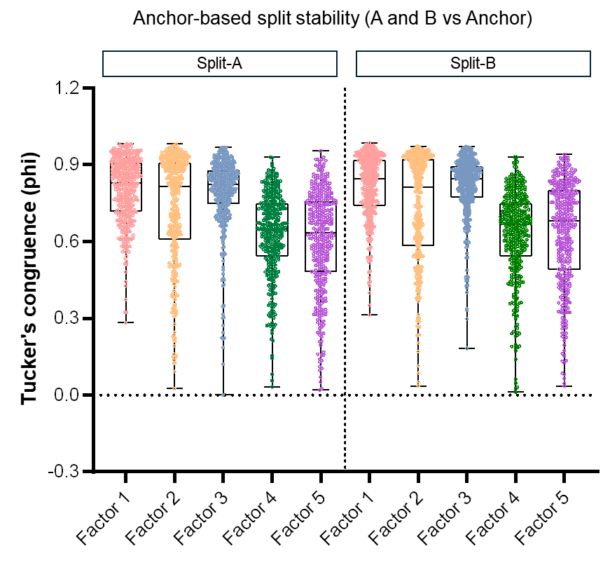

Supplementary Fig. 7 Anchor-based split-sample stability of the factor structure.
Boxplots depict the distribution of absolute Tucker’s congruence coefficients (|φ|) for each factor across anchor-based split-sample exploratory factor analyses. Across 389 stratified split iterations, datasets were divided into two halves (A and B), yielding 778 half-sample solutions. Factor solutions from each half were optimally aligned to the full-sample anchor solution derived from the primary PCA-based analysis using permutation-based matching with sign correction. Higher |φ| values indicate greater structural stability across subsamples.

Split-sample EFA
Factor | N (splits x 2) | Median |φ| | q1 | q3 | Mean |φ| | SD
1 | 778 | 0.84 | 0.73 | 0.91 | 0.81 | 0.13
2 | 778 | 0.82 | 0.60 | 0.91 | 0.73 | 0.21
3 | 778 | 0.83 | 0.75 | 0.89 | 0.80 | 0.14
4 | 778 | 0.66 | 0.54 | 0.75 | 0.63 | 0.17
5 | 778 | 0.67 | 0.49 | 0.80 | 0.64 | 0.20

Supplementary Table 5. Anchor-based split-sample stability of the factor structure.
This table summarizes the distribution of absolute Tucker’s congruence coefficients (|φ|) for each factor obtained from anchor-based split-sample validation, with factor solutions aligned to the full-sample reference derived from the primary PCA-based analysis. Median, first quartile (q1), third quartile (q3), mean, and standard deviation are reported across 778 half-sample solutions.

Test | Measure | Groups compared | Statistical test | df | Test statistic | p-value
CAT | Jumping latency | SD (n=12) vs  WKY (n=11) | Unpaired t test | 21 | t = 2.322 | p < 0.05
VCAT | Jumping latency | SD (n=12) vs  WKY (n=11) | Mann-Whitney test | df=N/A | U = 19 | p < 0.01
OFD5 | Distance | SD (n=12) vs  WKY (n=11) | Unpaired t test | 21 | t = 3.578 | p < 0.01
OFI5 | Time in inner zone | SD (n=12) vs  WKY (n=11) | Unpaired t test | 21 | t = 10.500 | p < 0.0001
WL5E | Wall-leaning number | SD (n=12) vs  WKY (n=11) | Unpaired t test | 21 | t = 2.046 | p < 0.05
R5E | Rearing number | SD (n=12) vs  WKY (n=11) | Unpaired t test | 21 | t = 5.734 | p < 0.0001
G5E | Grooming time | SD (n=12) vs  WKY (n=11) | Unpaired t test | 21 | t = 1.746 | p = 0.096
EPO5 | Time in open arms | SD (n=12) vs  WKY (n=11) | Unpaired t test | 21 | t = 4.312 | p < 0.001
EPCL5 | Time in closed arms | SD (n=12) vs  WKY (n=11) | Unpaired t test | 21 | t = 2.709 | p < 0.05
EPCE5 | Time in center zone | SD (n=12) vs  WKY (n=11) | Unpaired t test | 21 | t = 0.1651 | p = 0.871
EPH5 | Head-dip number | SD (n=12) vs  WKY (n=11) | Unpaired t test | 21 | t = 1.529 | p = 0.141
N10T | Time in object zone | SD (n=12) vs  WKY (n=11) | Unpaired t test | 21 | t = 1.977 | p = 0.061
N24T | Time in object zone | SD (n=12) vs  WKY (n=11) | Unpaired t test | 21 | t = 0.746 | p = 0.464
N10IN | Discrimination index | SD (n=12) vs  WKY (n=11) | Unpaired t test | 21 | t = 0.663 | p = 0.515
N24IN | Discrimination index | SD (n=12) vs  WKY (n=11) | Unpaired t test | 21 | t = 0.046 | p = 0.964
MD | Number of displaced marbles | SD (n=12) vs  WKY (n=11) | Unpaired t test | 21 | t = 0.005 | p = 0.996
MB | Number of buried marbles | SD (n=12) vs  WKY (n=11) | Unpaired t test | 21 | t = 0.0793 | p = 0.938
Ng | Nestlet | SD (n=12) vs  WKY (n=11) | Mann-Whitney test | df=N/A | U = 40.500 | p = 0.196
P68 | PPI: Startle response at 68 dB | SD (n=9) vs  WKY (n=11) | Unpaired t test | 18 | t = 0.754 | p = 0.461
P71 | PPI: Startle response at 71 dB | SD (n=9) vs  WKY (n=11) | Unpaired t test | 18 | t = 0.067 | p = 0.948
P77 | PPI: Startle response at 77 dB | SD (n=9) vs  WKY (n=11) | Unpaired t test | 18 | t = 1.774 | p = 0.093
P82 | PPI: Startle response at 82 dB | SD (n=9) vs  WKY (n=11) | Unpaired t test | 18 | t = 1.456 | p = 0.163
Y | % alternation | SD (n=12) vs  WKY (n=11) | Unpaired t test | 21 | t = 0.290 | p = 0.775

Supplementary Table 6. Statistical summary of behavioral comparisons between SD and WKY rats.
For each behavioral measure, statistical tests were selected based on assessment of data normality. Parametric comparisons were performed using unpaired t-tests, whereas non-parametric comparisons were conducted using Mann–Whitney tests when normality assumptions were violated. Test statistics, degrees of freedom (where applicable), and exact p-values are reported.

