Supplementary Material
The Sex-Specific Role of Adrenal Androgens in Youth Psychopathology
Franka Edith Weisner; Bianca Serio, MSc; Sofie Valk, PhD; Luise Bläschke; Franziska Degenhardt, MD; Anke Hinney, PhD; and Raphael Hirtz, MD, PhD; and Lars Dinkelbach, MD

Supplementary Methods – ABCD sample analyses
Study Sample
Supplementary Figure S1. Participant Selection and Final Sample Composition.

Exposure: Hormone values
Supplementary Figure S2. Final Hormone Values Baseline and 1-Year Follow-Up by Sex.
Supplementary Figure S3. Log-Transformed Hormone Values by Sex.

Outcome: Child Behavior Checklist (CBCL)-Scores
Supplementary Figure S4. Distribution of CBCL Category Scores.

Covariates and Missingness
Supplementary Figure S5. Directed Acyclic Graph to Identify a Minimal Adjustment Set.
Supplementary Table S1. Comparison of Included and Excluded Participants at 2-Year Follow-Up
Supplementary Table S2. Comparison of Included and Excluded Participants at 3-Year Follow-Up.
Supplementary Table S3. Comparison of Included and Excluded Participants at 4-Year Follow-Up.
Supplementary Table S4. Baseline Hormone and CBCL Values by Inclusion in 4-Year Follow-Up.
Supplementary Figure S6. Histogram of Imputed DHEA Values Below Lower Limit of Detection.
Supplementary Figure S7. Histogram of Final DHEA Values Including Imputed and Outlier Data.
Supplementary Figure S8. Histogram of Imputed Estradiol Values Below Lower Limit of Detection.
Supplementary Figure S9. Histogram of Final Estradiol Values Including Imputed and Outlier Data.
Supplementary Figure S10. Histogram of Imputed Testosterone Value Below Lower Limit of Detection.
Supplementary Figure S11. Histogram of Final Testosterone Value Including Imputed and Outlier Data.

Linear Mixed Models - Assumptions
Supplementary Table S5. Testing Multicollinearity in Males in DHEA at 3-Year Follow-Up.
Supplementary Table S6. Testing Multicollinearity in Females in DHEA at 3-Year Follow-Up.
Supplementary Figure S12. QQ-Plots to Assess the Normal Distribution of Residuals in Males.
Supplementary Figure S13. QQ-Plots to Assess the Normal Distribution of Residuals in Females.
Supplementary Figure S14. Evaluating Non-Linear Effects in Crude and Adjusted Models by Sex.
Supplementary Table S7. GAMMs Evaluating Non-Linear Effects of DHEA at 3-Year Follow-Up.

Sensitivity Analysis
Supplementary Table S8. Sensitivity Analysis – Negative Binomial Mixed Models for Males.
Supplementary Table S9. Sensitivity Analysis – Negative Binomial Mixed Models for Females.
Supplementary Table S10. Sensitivity Analysis – Excluding Males on Medication at Baseline.
Supplementary Table S11. Sensitivity Analysis – Excluding Females Medication at Baseline.
Supplementary Table S12. Sensitivity Analysis – Adjusting for PDS Sum Score at Baseline in Males.
Supplementary Table S13. Sensitivity Analysis – Adjusting for PDS Sum Score at Baseline in Females.
Supplementary Table S14. Sensitivity Analysis – Adjusting for PDS Sum Score at 3-Year in Males.
Supplementary Table S15. Sensitivity Analysis – Adjusting for PDS Sum Score at 3-Year in Females.
Supplementary Table S16. Sensitivity Analysis – Excluding Males with Hormone Levels below LLD.
Supplementary Table S17. Sensitivity Analysis – Excluding Females with Hormone Levels below LLD.
Supplementary Figure S15. Sensitivity Analysis – Sex-Stratified Associations Between DHEA Levels and CBCL Scores Across Follow-Ups in Raw, Adjusted, and Baseline-CBCL-Adjusted Models
Supplementary Table S18. Sensitivity Analysis – BPM Instead of Parent-Report CBCL in Males.
Supplementary Table S19. Sensitivity Analysis – BPM Instead of Parent-Report CBCL in Females.
Supplementary Table S20. Sensitivity Analysis – Using Baseline and 1-Year Follow-Up DHEA as Exposure Instead of Average in Males.
Supplementary Table S21. Sensitivity Analysis – Using Baseline and 1-Year Follow-Up DHEA as Exposure Instead of Average in Females.
Supplementary Table S22. Sensitivity Analysis – Adjusting for Baseline-to-2-Year Age in DHEA Change in Males.
Supplementary Table S23. Sensitivity Analysis – Adjusting for Baseline-to-2-Year Age in DHEA Change in Females.
Supplementary Table S24. Sensitivity Analysis – Winsorized Models to Assess the Influence of Extreme Values in Males.
Supplementary Table S25. Sensitivity Analysis – Winsorized Models to Assess the Influence of Extreme Values in Females.

Supplementary Results
Supplementary Table S26. Correlations between Hormones across Timepoints.
Supplementary Figure S16. Associations of DHEA with DSM-5 Problem Scores at 2-Year Follow-Up.
Supplementary Figure S17. Associations of DHEA with DSM-5 Problem Scores at 3-Year Follow-Up.
Supplementary Figure S18. Associations of DHEA with DSM-5 Problem Scores at 4-Year Follow-Up.
Supplementary Figure S19. Sex-Stratified Risk Ratios for the Associations between DHEA Levels and Child Behavior Checklist (CBCL) Diagnostic Categories.
Supplementary Table S27. DHEA × Sex-Interaction Effects on CBCL Outcomes Across Follow-Ups.
Supplementary Table S28. DHEA × Age Interactions on CBCL Scores.
Supplementary Methods – ABCD sample analyses
Study Sample
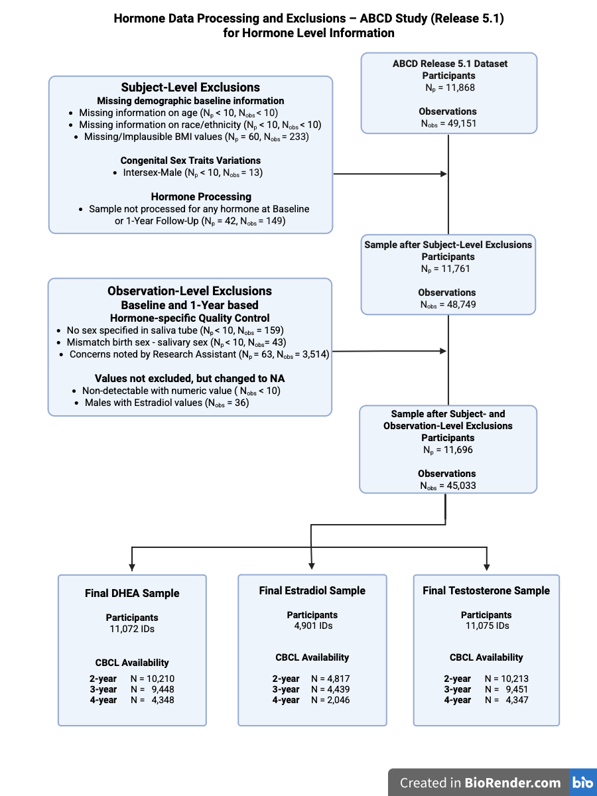
Supplementary Figure S1. Participant Selection and Final Sample Composition. This figure depicts the exclusion criteria applied to derive the final study sample used for the hormone level analyses, separately for each hormone and timepoint. N_{p} denotes the number of participants and N_{obs} the number of observations, as the ABCD study includes up to five assessments per participant (baseline to 4-year follow-up). Hormone Level is defined as the arithmetic mean of the log-transformed baseline and 1-year follow-up hormone values per participant. For example: DHEA Level = log(mean of baseline and 1-year follow-up DHEA value). If only baseline DHEA (N=1,809) or 1-year follow-up DHEA (N=1,665) was available, that single time point was used. ‘No sex specified’ in the saliva tube includes participants being unable to provide a sample, refusing to give one, or were affected by COVID-related restrictions. Birth sex refers to the sex assigned at birth. Salivary sex indicates the sex recorded on the saliva sample tube. The variable ‘mismatch birth sex – salivary sex’ identifies participants for whom these two values differ. Please note that, in accordance with ABCD study privacy protection policies, numbers fewer than 10 are suppressed. The figure was created using Biorender.com.
Exposure: Final Hormone Values Prior to Level and Change Calculations
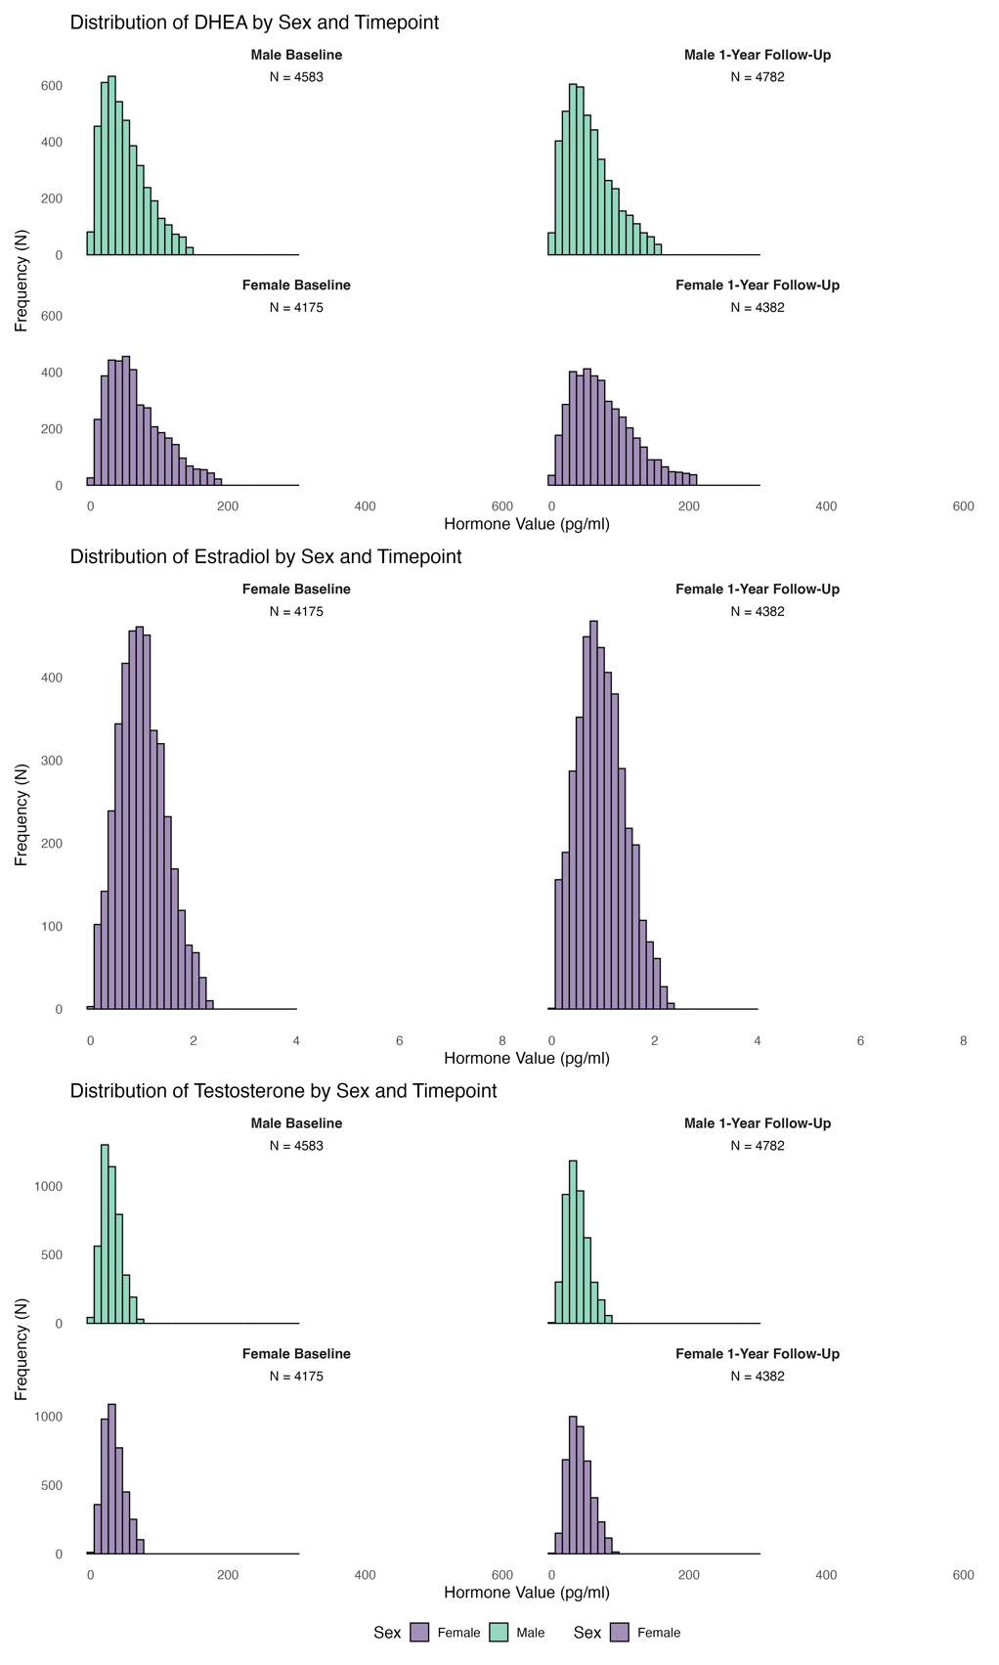
Supplementary Figure S2. Hormone Values Baseline and 1-Year Follow-Up by Sex. Final raw hormone values represent the average of two replicates per hormone and serve as the basis for calculating the hormone level and change variables. The x-axis limits of the histograms were adjusted to highlight the main distribution range of hormone values. Values outside these limits are not presented (N < 10). The observed outliers were as follows: DHEA: Male 1-Year Follow-Up: 615.70 ; Female Baseline: 648.62; Female 1-Year Follow-Up: 669.07, 933.42; Testosterone: Male 1-Year Follow-Up: 615.06; Female 1-Year Follow-Up: 1592.79 pg/ml. Please note that, in accordance with ABCD study privacy protection policies, numbers fewer than 10 are suppressed.
Exposure: Log-Transformed Hormone Levels and Changes

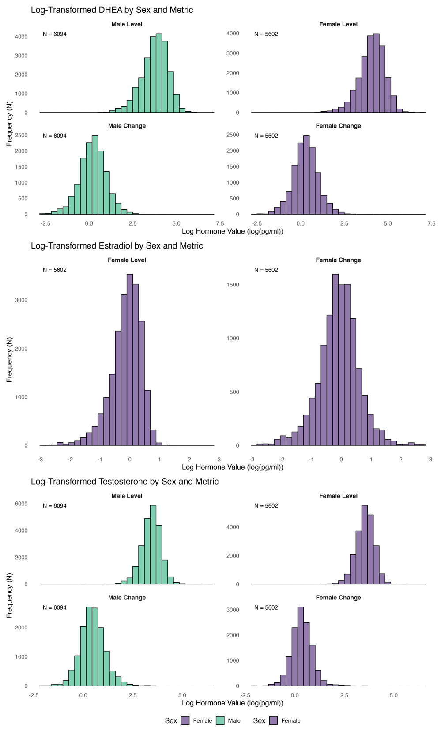
Supplementary Figure S3. Log-Transformed Hormone Values by Sex. Histograms of log-transformed hormone values for DHEA, Estradiol, and Testosterone in Males and Females, separated by Hormone Level and Change. Hormone Level is defined as the natural logarithm of the arithmetic mean of baseline and 1-year follow-up hormone values per participant. Hormone Change is defined as the natural logarithm of the ratio between 2-Year Follow-Up and baseline hormone values per participant. For example: DHEA Level = log(mean of baseline and 1-year follow-up DHEA value); DHEA Change = log(ratio of 2-year follow-up to baseline DHEA). Note: Estradiol was only measured in females.
Outcome: Child Behavior Checklist (CBCL)

The Child Behavior Checklist (CBCL) is a standardized parent-report questionnaire assessing emotional and behavioral problems in children and adolescents over the past six months. It includes 113 items rated on a three-point Likert scale (0 = not true, 1 = somewhat true, 2 = very true). The CBCL provides symptom-oriented syndrome scales (e.g., Anxious/Depressed, Aggressive Behavior) and composite scores for Total Problems, Externalizing Problems, and Internalizing Problems, with higher scores indicating greater difficulties. In addition, DSM-5–oriented subscales are available, aligning items with clinical diagnostic categories such as ADHD and Anxiety Disorders.
For this study, primary analyses focused on the syndrome-oriented composite scales “CBCL Externalizing” (Rule-Breaking and Aggressive Behavior) and “CBCL Internalizing” (Anxious/Depressed, Withdrawn/Depressed, Somatic Complaints). The six individual DSM-5–oriented subscales were explored in secondary analyses. Importantly, raw scores (the sum of item ratings) were used instead of standardized T-scores, preserving the original metric and facilitating longitudinal modeling of symptom changes. An exception was the calculation of risk ratios, for which CBCL categories of normal, borderline, and clinical were based on standardized T-scores, as these clinical thresholds rely on T-score cutoffs. CBCL data from the 2-, 3-, and 4-year follow-ups served as outcome measures to assess associations with earlier hormonal profiles.
Outcome: Child Behavior Checklist (CBCL) Scores – DHEA final values

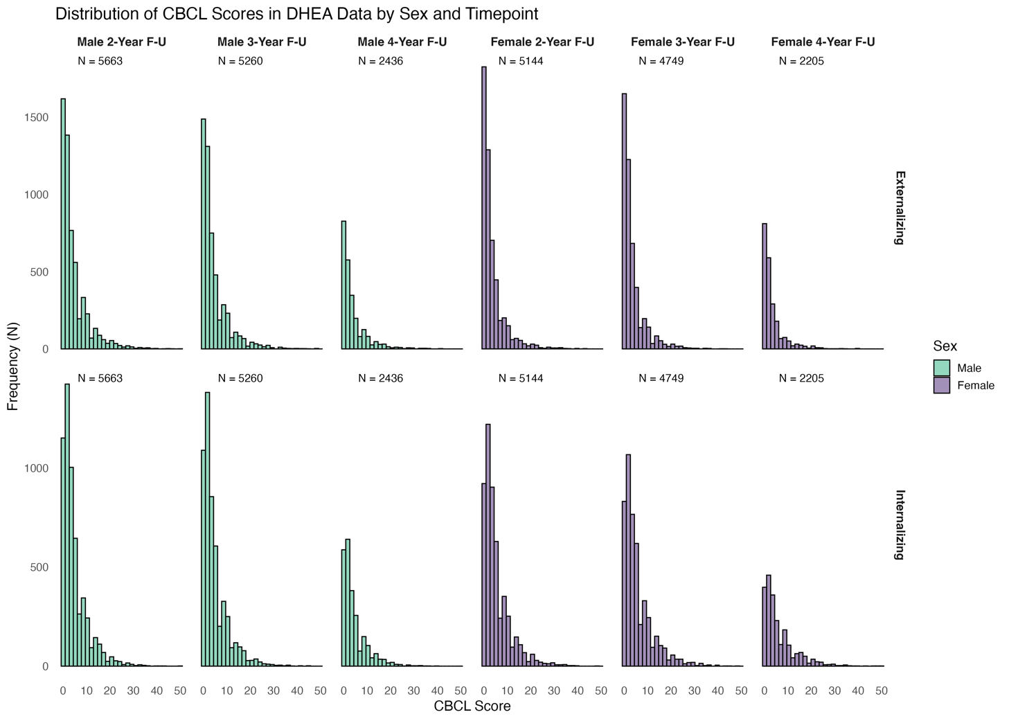Supplementary Figure S4. Distribution of CBCL Category Scores in DHEA Sample by Sex. Histograms showing the distribution of Externalizing and Internalizing CBCL scores across follow-up years (2-Year, 3-Year, and 4-Year Follow-Up) for male and female participants in the DHEA sample. Abbreviation: F-U = Follow-Up.

Covariates – Directed Analytic Graph (DAG)

Directed Acyclic Graphs (DAGs) are graphical representations of assumed causal relationships between variables. We used DAGs to identify potential confounders and covariates with DHEA as the primary hormone of interest. The identified adjustment set was then applied to models examining the effects of testosterone and estradiol as well. DAGs help to differentiate potential confounders from mediators, and colliders, and help to evaluate associations between confounders. Thus, they help to identify a minimally sufficient adjustment set for statistical analyses to minimize confounder bias.

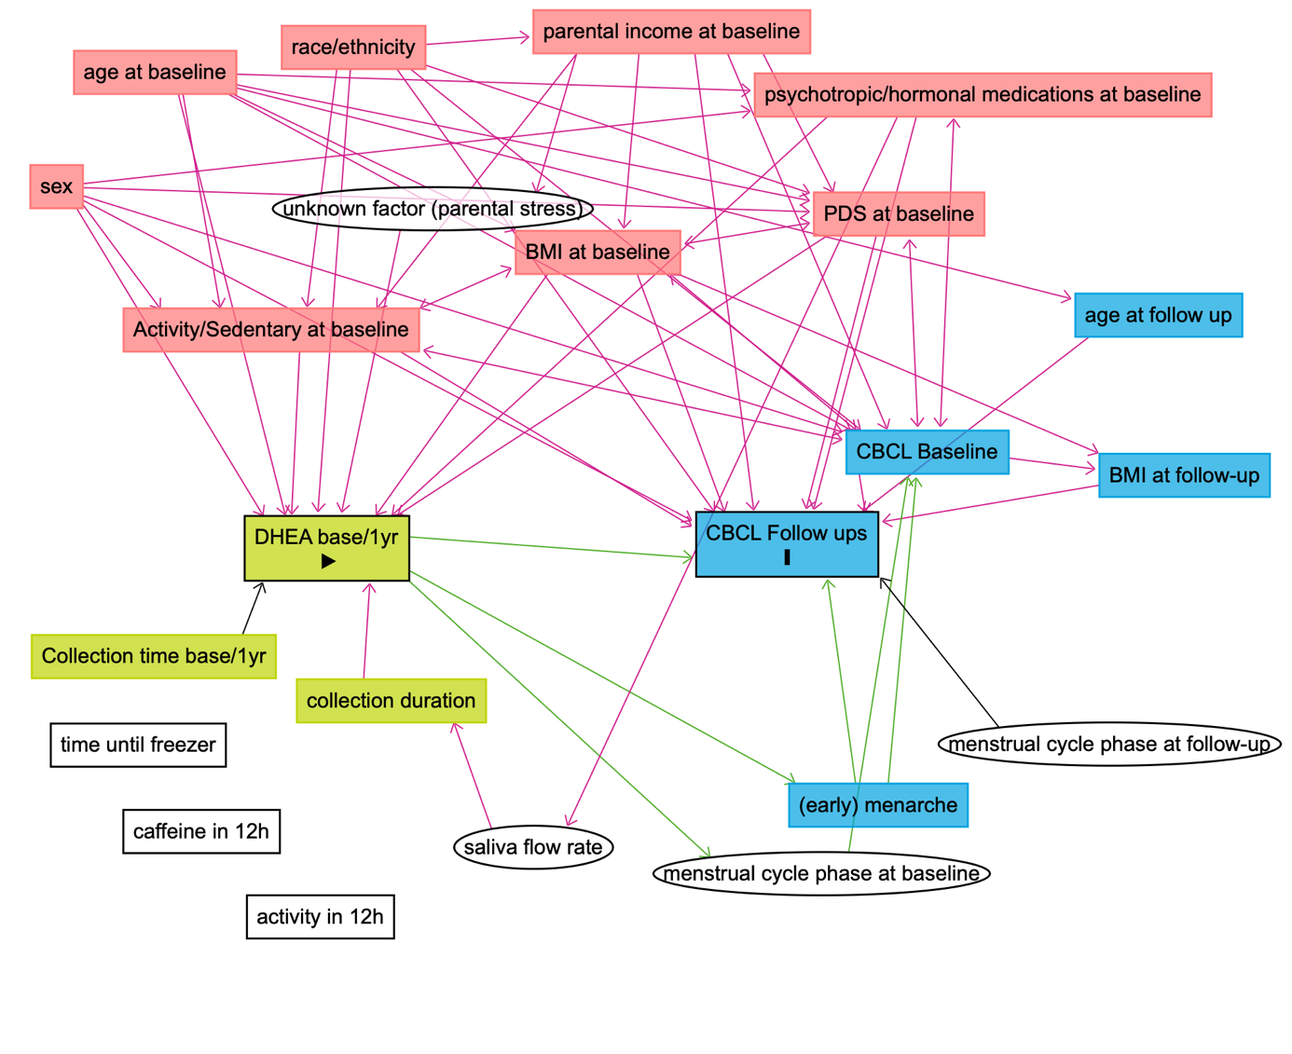Supplementary Figure S5. Directed Acyclic Graph to Identify a Minimal Adjustment Set. Directed Acyclic Graph (DAG) illustrating assumed causal relationships between exposure (DHEA levels at baseline/1-year follow-up), outcome (CBCL outcomes at 2-, 3-, and 4-year follow-ups), and covariates. The DAG was created using DAGitty (www.dagitty.net; [1]). Light green boxes represent the exposure and its ancestors; blue boxes indicate the outcome and its ancestors. Red boxes denote shared ancestors of both exposure and outcome (i.e., potential confounders), while white boxes refer to unmeasured variables. Green arrows represent hypothesized causal paths; pink arrows indicate biasing paths (e.g., due to confounding). This visualization informed covariate selection for statistical adjustment in our models.

Based on theoretical reasoning and prior literature, causal directions in the DAG were specified as follows:
Age at baseline: DHEA levels begin to rise around age 6 in girls and 8 in boys and increase through puberty, indicating that age influences DHEA levels [2, 3]. Age-related changes in psychopathology further justify age → CBCL [4].
BMI SDS at baseline: Higher BMI is associated with increased adrenal androgens in prepubertal children [5], supporting BMI → DHEA. Higher childhood BMI predicts internalizing problems such as anxiety and social withdrawal [6, 7]. Bidirectional effects exist, but evidence supports BMI as an early and thus predominant factor [8, 9].
Race/Ethnicity: Ethnic differences in DHEA levels exist even pre-adrenarche [10], and race/ethnicity also influences symptom expression and diagnosis in youth [11, 12].
Physical activity/sedentary behavior: Physical activity may alter DHEA [13, 14] and is associated with emotional wellbeing [15]. Activity itself is influenced by sex, age, BMI, CBCL, and socioeconomic status [16-18].
Pubertal development (PDS): More advanced pubertal stage corresponds to higher DHEA levels [19, 20] and earlier timing predicts increased psychopathology [21, 22]. Associations with BMI are also documented [23]. It has been proposed that controlling for pubertal stage should be avoided when examining the effects of pubertal hormones on mental health [24], as hormones drive physical changes, making pubertal development a potential confounder along the causal pathway from hormone → pubertal development → mental health. This reasoning applies to gonadal hormones such as testosterone and estradiol, which directly underlie the physical changes of puberty [25]. However, it is less applicable to DHEA, which produces only subtle physical changes, making a causal pathway of pubertal development → DHEA → mental health more plausible (as shown). To remain consistent across evaluated hormones and to avoid the loss of participants due to missing PDS observations, we decided against controlling for PDS at baseline in the primary models but included a sensitivity analysis controlling for the PDS score at baseline as an additional covariate for the DHEA-models.
Prescribed medication at baseline: Antipsychotic medication is associated with elevated DHEA [26]. Psychopathology and medication have bidirectional influence, but CBCL scores typically precede pharmacological treatment. To assess effect modulation with medication use, a sensitivity analyses was conducted.
Socioeconomic Status via Parental/Household income: Lower household income is associated with reduced DHEA [27] and increased behavioral/emotional problems [28, 29]. However, a direct effect of household income on hormonal levels is physiologically implausible. Income also predicts physical activity, BMI and pubertal timing [20, 30, 31], all with known associations to hormonal levels, rendering these variables plausible mediators of the income → DHEA relationship. Therefore, the minimally sufficient adjustment set included these variables but not the parental income.
Baseline CBCL: Baseline CBCL is a strong predictor of later CBCL scores, reflecting symptom continuity [32]. However, it remains unclear whether adrenal androgens influence psychopathological symptoms, implying that baseline CBCL scores might act as a mediator and should not be adjusted for, or whether the relationship operates in the opposite direction, making baseline CBCL scores a potential confounder (see Background section of the main manuscript). Given our primary hypothesis, namely that adrenal androgens influence youth psychopathology, we chose not to adjust for baseline CBCL scores in the main analyses. Nonetheless, we included them in extensive sensitivity analyses to assess the robustness of our findings.
Saliva Collection Context: Saliva collection time, caffeine intake, recent activity, and freezing delay were not found to systematically bias DHEA in previous studies [20, 26, 33]. Saliva flow rate may impact hormone concentration [34] which was not recorded in our study. However, all these variables are unlikely to affect later psychopathology (measured via the CBCL) and therefore are unlikely to act as confounders in the current study.
Given these considerations, the following minimally sufficient adjustment set to estimate the total causal effect of DHEA at baseline on CBCL scores at later follow-ups was identified: baseline age (continuous), race/ethnicity (five-category factor), baseline BMI SDS, and baseline physical activity (minutes per week). In separate sensitivity analyses, we included baseline psychopathology (CBCL scores), Pubertal Development Scale (PDS) sum score as additional covariates, and excluded participants with psychotropic or hormone-related medication use.
All models were estimated using linear mixed-effects models (LMMs) implemented in the lme4 package in R. Besides the hormonal levels/changes and the above mentioned covariates as fixed factors, models additionally included a random intercept for study site (1 | site) and family nested within study site ((1 | site:family)) to account for clustering at both family and site levels. Separate models were run for each sex, hormone level and hormone change variable, and outcome.
Raw models included the exposure and Analyses were performed in R (version 4.4.3; [35]) using the lme4 package (version 1.1-37) for fitting linear mixed-effects models.
Physical activity/sedentary behavior (SAIQ)
Physical activity was operationalized using items from the ABCD Longitudinal Parent Sports and Activities Involvement Questionnaire (SAIQ) of the ABCD Study. For each reported sport, parents reported the number of days per week participants engaged in each activity as well as the average time spent per session. Because only physical activity and sedentary behavior at baseline may influence both hormone levels and mental health outcomes, we restricted analyses to baseline data.
Following the ABCD scoring protocol, frequency of participation was assessed on a categorical scale (1–7 days per week, once every two weeks, once a month, less than once a month). The response option “Don’t know” was coded as missing. Average duration per session was reported in minutes, with response options ranging from <30 minutes to >180 minutes. For analysis, <30 minutes was recoded as 15 minutes and >180 minutes as 210 minutes; “Don’t know” was again treated as missing.
Weekly minutes of activity were computed as the product of days per week and minutes per session. Total weekly physical activity was then derived as the sum across all reported sports and activities.
The following activities were included: ballet/dance, baseball/softball, basketball, climbing, field hockey, football, gymnastics, ice hockey, horseback riding/polo, ice or inline skating, martial arts, lacrosse, rugby, skateboarding, skiing/snowboarding, soccer, surfing, swimming/water polo, tennis, track/running, mixed martial arts (MMA), volleyball, yoga.
Activities not included due to their minimal contribution to physical exertion were: (1) playing a musical instrument, (2) visual arts (drawing, painting, graphic art, photography, pottery), (3) drama, theater, acting, film drama, (4) crafts (e.g., knitting, building model cars or airplanes), (5) competitive games (e.g., chess, cards, darts), and (6) hobbies such as collecting stamps or coins.
The resulting variable reflects total minutes of sports-related physical activity per week, which was included as covariate in all adjusted models.

Missingness
Initially, there were 49,151 observations from 11,868 participants. After applying exclusion criteria, 45,033 observations (91.6%) from 11,696 participants (98.6%) remained.
At the subject level, we excluded participants with missing values on key demographic variables (age at interview, race/ethnicity, missing or implausible BMI values), as well as those who completely lacked hormonal measurements at both baseline or 1-year follow-up. Additionally, participants with congenital differences in sex development were excluded.
At the observational level, we did not exclude entire participants but removed specific observations as part of hormone-specific quality control. Observations were excluded if the participant refused or was unable to provide a saliva sample, including COVID-19 related reasons, if there was a sex mismatch between sex assigned at birth and sex specified for the saliva sample, or if concerns were noted by the research assistant. Measurements labeled as “none [no hormone] detectable” that nonetheless produced values, as well as estradiol values for male participants, were set to missing values. Numbers are provided in Supplementary Figure 1.
For each follow-up year (2-, 3-, and 4-year), we generated a binary exclusion variable to identify observations meeting any of the exclusion criteria. We then compared excluded and included observations with respect to age, sex, race/ethnicity, and family income. Across all follow-up years, participants with excluded observations did not differ in age compared to participants with included observations. No statistically significant differences were observed in race/ethnicity. However, excluded participants were more likely to be male and tended to come from lower-income families, with significant differences in family income observed at the 2- and 4-year follow-ups (see Supplementary Tables S1–S3).

Supplementary Table S1. Comparison of Included and Excluded Participants at 2-Year Follow-Up.
Characteristics |  | Included  (N = 10,883) | Excluded  (N = 89) | p values ª  t-test/Χ²-test
Age (Years), mean (SD) |  | 12.03 (0.67) | 12.05 (0.69) | 0.781
Sex, N (%)
 | Male | 5,699 (52.37) | 54 (60.00) | < 0.001
 | Female | 5,184 (47.63) | 33 (36,67) | < 0.001
 | Intersex-Male | < 10 ^{b} | < 10 ^{b} | < 0.001
Race/Ethnicity, N (%)
 | White | 5,816 (53,44) | 45 (50.00) | 0.685
 | Black | 1,545 (14.20) | 16 (17.78) | 0.685
 | Hispanic | 2,418 (19.74) | 16 (17.78) | 0.685
 | Asian | 230 (2.11) | < 10 ^{b} | 0.685
 | Other/Multiethnic | 1,144 (10.51) | 12 (13.33) | 0.685
Family Income (past year) ª, N (%)
 | < $5000 | 401(3.68) | < 10 ^{b} | 0.044
 | $5,000 - $11,999 | 417 (3.83) | < 10 ^{b} | 0.044
 | $12,000 - $15,999 | 261 (2.40) | < 10 ^{b} | 0.044
 | $16,000 - $24,999 | 517 (4.75) | < 10 ^{b} | 0.044
 | $25,000 - $34,999 | 674 (6.19) | < 10 ^{b} | 0.044
 | $35,000 - $49,999 | 943 (8.66) | < 10 ^{b} | 0.044
 | $50,000 - $74,999 | 1,485 (13.65) | 14 (15.56) | 0.044
 | $75,000 - $99,999 | 1,598 (14.68) | 14 (15.56) | 0.044
 | $100,000 - $199,999 | 3,342 (30.71) | 29 (32.22) | 0.044
 | > $200,000 | 1,245 (11.44) | < 10 ^{b} | 0.044
Abbreviations: N = Number, SD = Standard deviation.
- For categorical data (sex, race/ethnicity, family income class), Chi-squared tests were calculated. For numeric data (age), a t-test was calculated.
- Please note that, in accordance with ABCD study privacy protection policies, numbers fewer than 10 are suppressed.

Supplementary Table S2. Comparison of Included and Excluded Participants at 3-Year Follow-Up.
Characteristics |  | Included  (N = 10,248) | Excluded  (N = 87) | p values ª  t-test/Χ²-test
Age (Years), mean (SD) |  | 12.91 (0.65) | 12.92 (0.63) | 0.632
Sex, N (%)
 | Male | 5,371 (52.41) | 53 (60.23) | < 0.001
 | Female | 4,877 (47.59) | 32 (36-36) | < 0.001
 | Intersex-Male | < 10 ^{b} | < 10 ^{b} | < 0.001
Race/Ethnicity, N (%)
 | White | 5,549 (54.15) | 43 (49.43) | 0.426
 | Black | 1,346 (13.13) | 15 (17.24) | 0.426
 | Hispanic | 2,060 (20.10) | 15 (17.24) | 0.426
 | Asian | 220 (2.15) | < 10 ^{b} | 0.426
 | Other/Multiethnic | 1,073 (10.47) | 13 (14.94) | 0.426
Family Income (past year) ª, N (%)
 | < $5000 | 343 (3.35) | < 10 ^{b} | 0.153
 | $5,000 - $11,999 | 357 (3.48) | < 10 ^{b}) | 0.153
 | $12,000 - $15,999 | 245 (2.39) | < 10 ^{b} | 0.153
 | $16,000 - $24,999 | 477 (4.65) | < 10 ^{b} | 0.153
 | $25,000 - $34,999 | 614 (5.99) | < 10 ^{b} | 0.153
 | $35,000 - $49,999 | 881 (8.60) | < 10 ^{b} | 0.153
 | $50,000 - $74,999 | 1,402 (13.68) | 14 (15.91) | 0.153
 | $75,000 - $99,999 | 1,511 (14.74) | 14 (15.91) | 0.153
 | $100,000 - $199,999 | 3,206 (31.28) | 27 (30.68) | 0.153
 | > $200,000 | 1,212 (11.83) | < 10 ^{b} | 0.153
Abbreviations: N = Number, SD = Standard deviation.
- For categorical data (sex, race/ethnicity, family income class), Chi-squared tests were calculated. For numeric data (age), a t-test was calculated.
- Please note that, in accordance with ABCD study privacy protection policies, numbers fewer than 10 are suppressed.

Supplementary Table S3. Comparison of Included and Excluded Participants at 4-Year Follow-Up.
Characteristics |  | Included  (N = 4,718) | Excluded  (N = 36) | p values ª  t-test/Χ²-test
Age (Years), mean (SD) |  | 14.08 (0.68) | 14.12 (0.68) | 0.763
Sex, N (%)
 | Male | 2,470 (52.35) | 18 (50.00) | < 0.001
 | Female | 2,248 (47.65) | 17 (47.22.) | < 0.001
 | Intersex-Male | < 10 ^{b} | < 10 ^{b} | < 0.001
Race/Ethnicity, N (%)
 | White | 2,666 (56.51) | 16 (44.44) | 0.562
 | Black | 504 (10.68) | < 10 ^{b} | 0.562
 | Hispanic | 971 (20.58) | < 10 ^{b} | 0.562
 | Asian | 109 (2.31) | < 10 ^{b} | 0.562
 | Other/Multiethnic | 468 (9.92) | < 10 ^{b}) | 0.562
Family Income (past year) ª, N (%)
 | < $5000 | 145 (3.07) | < 10 ^{b} | 0.022
 | $5,000 - $11,999 | 151 (3.20) | < 10 ^{b} | 0.022
 | $12,000 - $15,999 | 104 (2.20) | < 10 ^{b} | 0.022
 | $16,000 - $24,999 | 201 (4.26) | < 10 ^{b} | 0.022
 | $25,000 - $34,999 | 289 (6.13) | < 10 ^{b} | 0.022
 | $35,000 - $49,999 | 413 (8.75) | < 10 ^{b} | 0.022
 | $50,000 - $74,999 | 655 (13.88) | < 10 ^{b} | 0.022
 | $75,000 - $99,999 | 720 (15.26) | < 10 ^{b} | 0.022
 | $100,000 - $199,999 | 1,478 (31.33) | 10 (27.78) | 0.022
 | > $200,000 | 562 (11.91) | < 10 ^{b} | 0.022
Abbreviations: N = Number, SD = Standard deviation.
- For categorical data (sex, race/ethnicity, family income class), Chi-squared tests were calculated. For numeric data (age), a t-test was calculated.
- Please note that, in accordance with ABCD study privacy protection policies, numbers fewer than 10 are suppressed.

Comparison of Baseline Hormone Levels and CBCL Values by Inclusion in 4-Year Follow-Up.
Primary analyses indicated an increasing sex x DHEA level interaction effect over time. To evaluate whether this increasing pattern was due to selective missingness in later follow-ups, an additional missingness analysis was conducted for missingness at 4-year follow-up. Missingness at 4-year follow-up primarily reflects the limited availability of 4-year follow-up data in release 5.1, in which only about half of the cohort was documented. To assess the missingness pattern at 4-year follow-up regarding the exposure and outcome variable, we compared baseline hormone levels of DHEA, testosterone, estradiol and CBCL externalizing and internalizing scores between participants who contributed data to the 4-year follow-up and those who did not. While group differences regarding DHEA, Testosterone, Estradiol and CBCL externalizing reached statistical significance, the absolute differences were small. DHEA and testosterone levels at baseline showed opposite patterns of missingness: DHEA levels at baseline were smaller while Testosterone levels were larger in those participants missing at the 4-year follow-up. However, Testosterone and DHEA interaction effects with sex were similar in direction and magnitude at the 4-year follow-up, making selective missingness an unlikely contributor to this finding. Regarding CBCL, differences were only present for externalizing scores, while increasing sex x DHEA interaction effects were found for both, internalizing and externalizing CBCL scales. Additionally, our findings remained robust when controlling for baseline CBCL (Supplementary Figure S15). Together, these considerations indicate that, while missingness is not completely at random, it is unlikely to account for the observed associations at the 4-year follow-up.

Supplementary Table S4. Baseline Hormone and CBCL Values by Inclusion in 4-Year Follow-Up.
Baseline Variable | Included in 4-year FU |  |  | Missing in 4-year FU |  |  | p-value
 | N | Mean | SD | N | Mean | SD
DHEA Level | 6,724 | 3.90 | 0.77 | 4,348 | 3.96 | 0.73 | <0.001
Testosterone Level | 6,739 | 3.51 | 0.48 | 4,336 | 3.47 | 0.47 | <0.001
Estradiol Level | 3,207 | -0.19 | 0.54 | 2,046 | -0.07 | 0.48 | <0.001
CBCL Externalizing Score | 7,513 | 4.63 | 6.12 | 4,347 | 4.15 | 5.38 | <0.001
CBCL Internalizing Score | 7,513 | 5.10 | 5.63 | 4,347 | 4.97 | 5.35 | 0.213
Means and standard deviations for hormone levels are based on log-transformed concentrations. Abbreviations: CBCL = Child Behavior Checklist; DHEA = Dehydroepiandrosterone; FU = Follow Up; N = Number.

Imputation of Hormone Values Below the Lower Limit of Detection (LLD)
Hormone values below the Lower Limit of Detection (LLD; DHEA: 5 pg/ml; Estradiol: 0.1 pg/ml; Testosterone: 1 pg/ml) were imputed on the log-transformed scale using age and sex as predictors (except for Estradiol, measured only in females). Imputation was conducted using a truncated normal distribution on the log scale to ensure imputed values did not exceed the LLD and to maintain the statistical properties of the transformed data. Prior log-transformation was applied to approximate a normal distribution of hormone values, thereby justifying the use of normal distribution-based imputation methods. Imputations were performed separately for each hormone replicate and each time point to retain valuable data otherwise lost due to censoring. Each final hormone value was then calculated as the average of both hormone replicates. The total number of imputed values was: DHEA Replicate 1: N = 308 (0.90%), DHEA Replicate 2: N = 321 (0.94%), Estradiol Replicate 1: N = 116 (0.71%), Estradiol Replicate 2: N = 109 (0.67%), Testosterone Replicate 1: N < 10. Testosterone Replicate 2: N < 10. All imputed values remained below their respective detection limits. Please note that, in accordance with ABCD study privacy protection policies, numbers fewer than 10 are suppressed.
For each hormone, two log-transformed histograms were drawn: the first illustrates the distribution of values imputed for measurements below the LLD on a log-transformed scale, while the second displays the full distribution of all hormone values, including imputed values and identified outliers. These plots demonstrate that the imputed values align well with the expected continuation of a log-normal distribution of the values above the LLD, consistent with physiological expectations.

DHEA
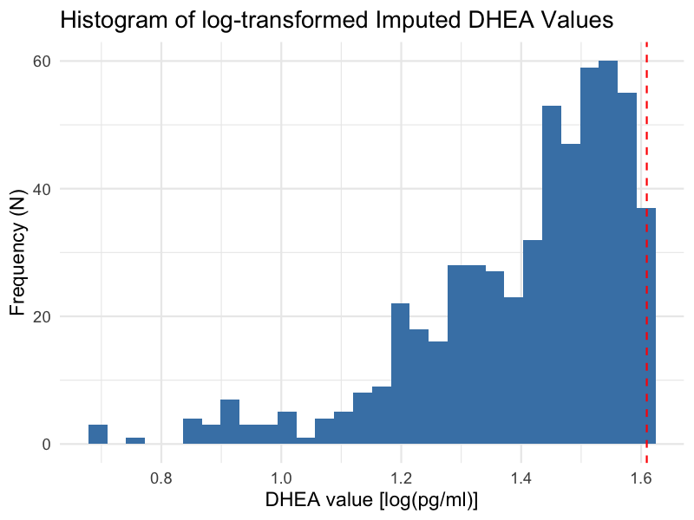
Supplementary Figure S6. Histogram of Imputed DHEA Values Below Lower Limit of Detection. The lower limit of detection (LLD) for DHEA is 5 pg/ml, corresponding to a log-transformed value (natural logarithm) of approximately 1.6.

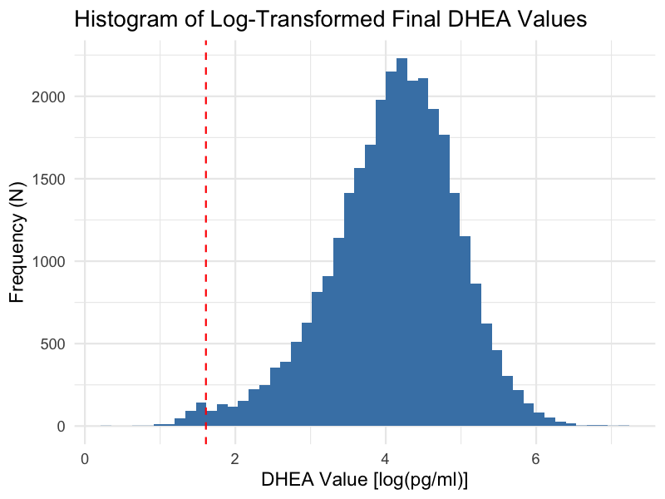
Supplementary Figure S7. Histogram of Final DHEA Values Including Imputed and Outlier Data.

Estradiol
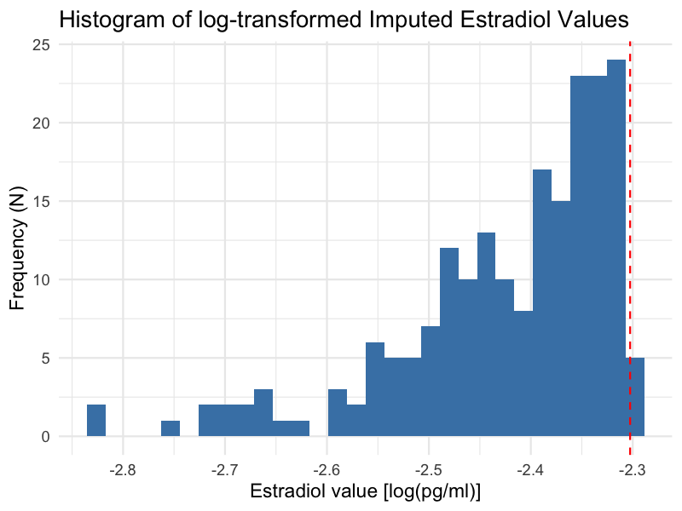Supplementary Figure S8. Histogram of Imputed Estradiol Values Below Lower Limit of Detection. The lower limit of detection (LLD) for DHEA is 0.1 pg/ml, corresponding to a log-transformed value (natural logarithm) of approximately -2.3.

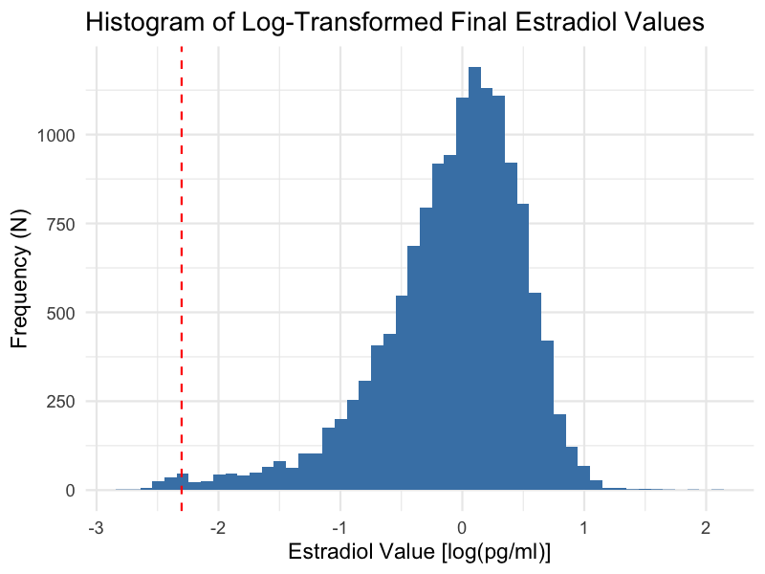
Supplementary Figure S9. Histogram of Final Estradiol Values Including Imputed and Outlier Data.
Testosterone
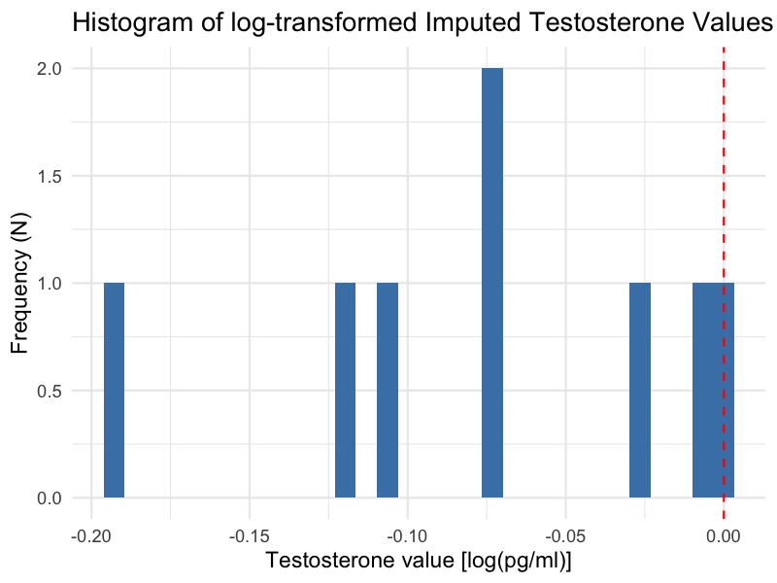
Supplementary Figure S10. Histogram of Imputed Testosterone Value Below Lower Limit of Detection. The lower limit of detection (LLD) for DHEA is 1 pg/ml, corresponding to a log-transformed value (natural logarithm) of 0.0.

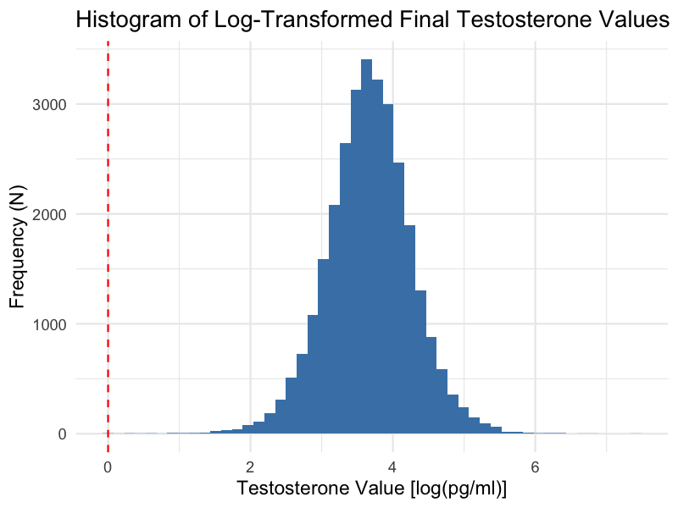
Supplementary Figure S11. Histogram of Final Testosterone Value Including Imputed and Outlier Data.
Linear Mixed Models – Assumptions
Multicollinearity
To assess multicollinearity among predictors, we computed generalized variance inflation factors (GVIFs) from linear models including only fixed effects (random effects were excluded). To enable comparisons across categorical variables with differing numbers of levels, GVIFs were scaled using the transformation GVIF^(1/(2*df)), and we interpreted the squared values of these adjusted GVIFs (i.e., GVIF^(1/df)). A squared adjusted GVIF exceeding a threshold of 4–5 was considered indicative of potentially problematic multicollinearity warranting further investigation. None of the covariates approached this threshold, indicating that problematic multicollinearity was unlikely.

Supplementary Table S5. Testing Multicollinearity in Males in DHEA at 3-Year Follow-Up.
 |  | CBCL Externalizing |  | CBCL Internalizing
Variable |  | GVIF | GVIF^{1/df} | GVIF | GVIF^{1/df}
 | DHEA Level ª | 1.11 | 1.11 | 1.11 | 1.11
 | Age | 1.06 | 1.06 | 1.06 | 1.06
 | Race/Ethnicity | 1.11 | 1.03 | 1.11 | 1.03
 | BMI-SDS at baseline | 1.11 | 1.11 | 1.11 | 1.11
 | Physical Activity | 1.04 | 1.04 | 1.04 | 1.04
Abbreviation: CBCL = Child Behavior Checklist, BMI-SDS = Body Mass Index – Standard Deviation Scores; GVIF = Generalized variance inflation factors. GVIF^{1/df} = squared adjusted GVIF. ª DHEA Level = log(DHEA Mean of Baseline and 1-Year Follow-Up).

Supplementary Table S6. Testing Multicollinearity in Females in DHEA at 3-Year Follow-Up.
 |  | CBCL Externalizing |  | CBCL Internalizing
Variable |  | GVIF | GVIF^{1/df} | GVIF | GVIF^{1/df}
 | DHEA Level ª | 1.18 | 1.18 | 1.18 | 1.18
 | Age | 1.10 | 1.10 | 1.10 | 1.10
 | Race/Ethnicity | 1.13 | 1.03 | 1.13 | 1.03
 | BMI-SDS at baseline | 1.13 | 1.13 | 1.13 | 1.13
 | Physical Activity | 1.05 | 1.05 | 1.05 | 1.05
Abbreviation: CBCL = Child Behavior Checklist, BMI-SDS = Body Mass Index – Standard Deviation Scores; GVIF = Generalized variance inflation factors. GVIF^{1/df} = squared adjusted GVIF.
ª DHEA Level = log(DHEA Mean of Baseline and 1-Year Follow-Up).
Normality of Residuals
To assess the assumption of normally distributed residuals in the adjusted linear mixed-effects models, Quantile-Quantile (QQ) plots were generated for each outcome measure (CBCL Externalizing and CBCL Internalizing) at the 3-year follow-up, separately for males and females. These plots compare the quantiles of the standardized residuals to the theoretical quantiles of a normal distribution. Even though hormone levels were log-transformed prior to analysis to improve normality, visual inspection revealed deviations from normality, especially at the lower and upper extremes of the distribution. These presumably stem from the non-normal distribution of the outcome variable (see Supplementary Figure S4). Therefore, log-binomial distribution models were calculated as sensitivity analyses.

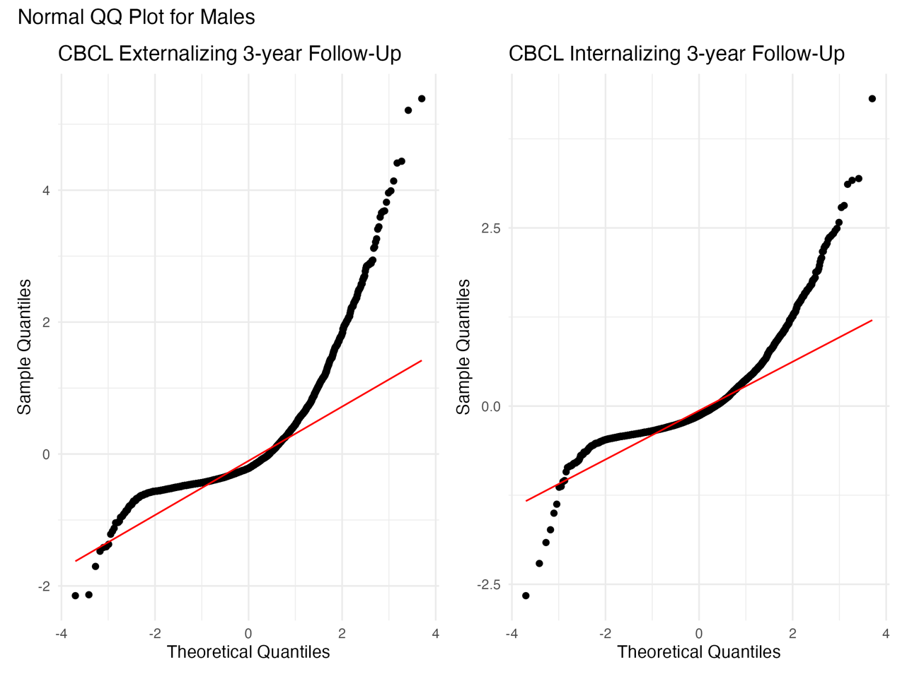
Supplementary Figure S12. QQ-Plots to Assess the Normal Distribution of Residuals in Males.
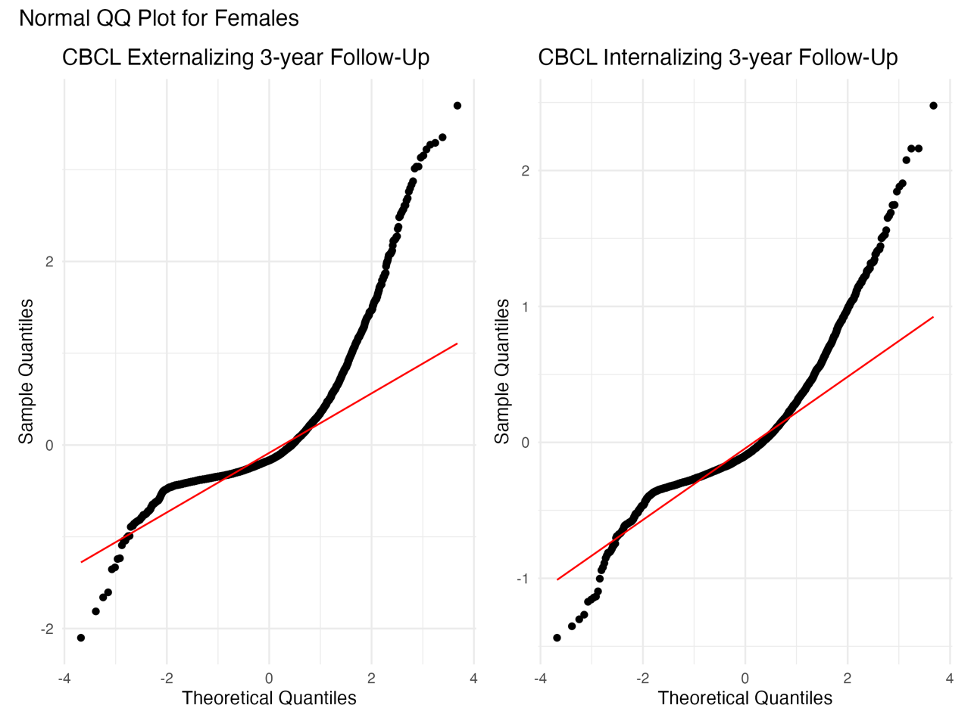

Supplementary Figure S13. QQ-Plots to Assess the Normal Distribution of Residuals in Females.

Non-Linearity
To evaluate the suitability of linear models, we first plotted the raw associations between hormone levels and CBCL outcomes to visually inspect potential non-linear relationships in the raw data (see Supplementary Figure S14), which compares raw and adjusted models to raw hormone values and indicates approximately linear associations. Additionally, we fitted Generalized Additive Mixed Models (GAMMs) incorporating penalized thin plate regression splines for DHEA level and DHEA change at the 2-year follow-up. These models were run separately for CBCL Externalizing and Internalizing symptoms, stratified by sex, and adjusted for age, race/ethnicity, BMI-SDS, Pubertal Development Score (PDS), and physical activity. Model comparisons using the Akaike Information Criterion (AIC), with a threshold of Δ AIC ≥ 2 indicating improved fit [36], alongside likelihood ratio tests (LRT), showed no significant advantage of the more complex GAMMs over simpler linear models [37]. Given the visual evidence and these statistical results, as well as the greater interpretability of linear models we focused our main analyses on linear effects.

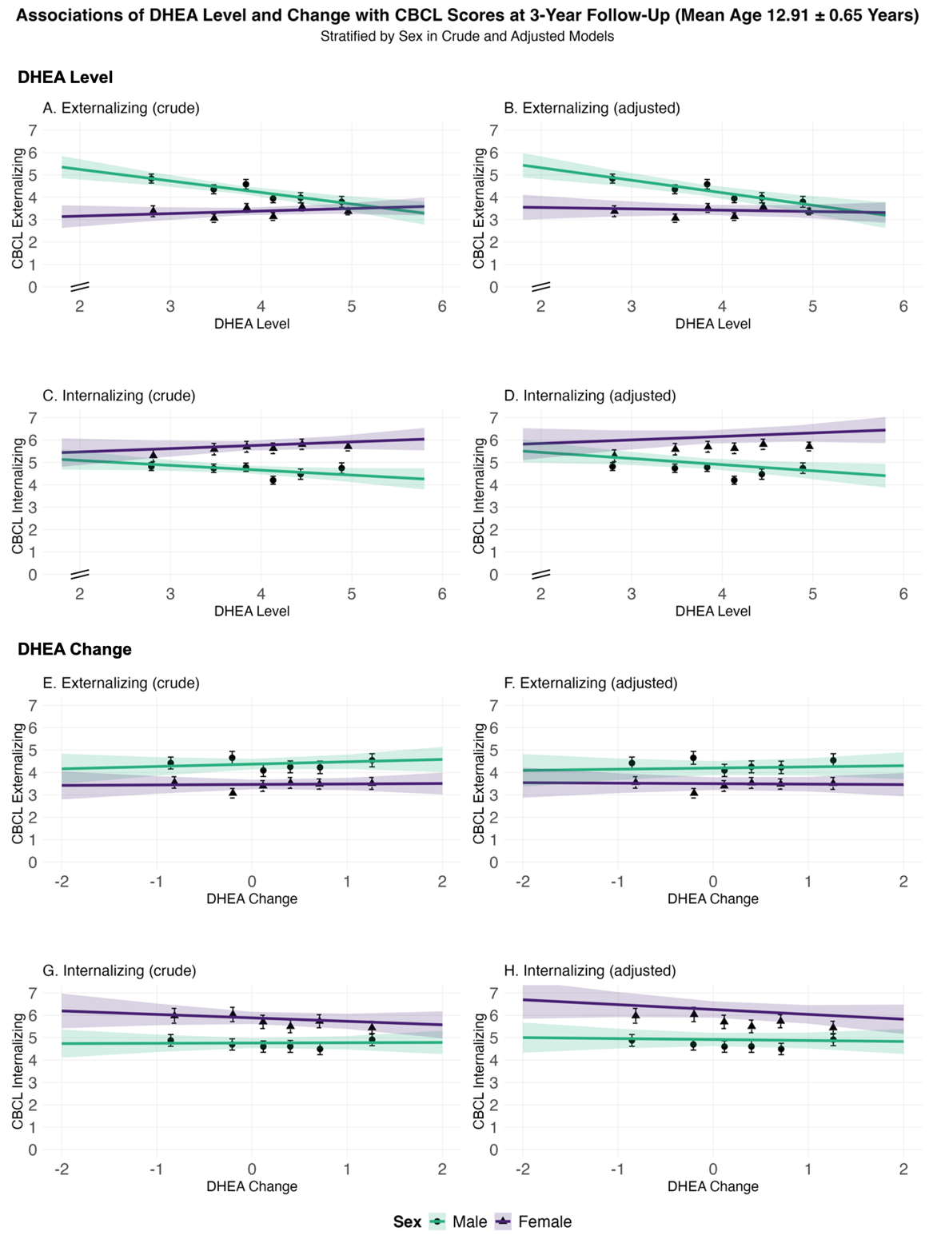
Supplementary Figure S14. Evaluating Non-Linear Effects in Crude and Adjusted Models. This figure displays sex-stratified associations between DHEA exposures and Child Behavior Checklist (CBCL) outcomes at 3-year follow-up. Separate panels show crude models (left column: A, C, E, G) and models adjusted for age, race/ethnicity, BMI SDS and physical activity assessed at baseline (right column: B, D, F, H), estimated using linear mixed-effect models. DHEA exposures include DHEA Level (log-transformed mean of baseline and 1-year values; panels A–D) and DHEA Change (log-transformed ratio of 2-year to baseline; panels E–H). CBCL outcomes are Externalizing Problem Scores (A, B, E, F) and Internalizing Problem Scores (C, D, G, H). The x-axis for DHEA Level is truncated below x=2, as indicated by axis break. The y-axis represents CBCL scores (range: 0–7). Sample sizes: males (teal), N=5,371; females (purple), N=4,877. Error bars indicate 95% confidence intervals. For complete data, including non-truncated plots, see Supplementary Figure S7. Abbreviations: DHEA = dehydroepiandrosterone; CBCL = Child Behavior Checklist; BMI SDS = body mass index standard deviation score.

Supplementary Table S7. GAMM Results Evaluating Non-Linear Effects of DHEA at 3-Year Follow-Up.
 |  | Males |  |  |  | Females
Variable |  | EDF ª | p_{smooth} ^{b} | Δ AIC ^{c} | p_{LRT} ^{d} | EDF ª | p_{smooth} ^{b} | Δ AIC ^{c} | p_{LRT} ^{d}
 | Externalizing (Level, Raw) | 1.77 | <0.001 | -2.09 | 1.000 | 1.00 | 0.459 | -2.63 | 1.000
 | Externalizing (Level, Adjusted) | 1.79 | <0.001 | -2.00 | 1.000 | 1.00 | 0.372 | -2.62 | 1.000
 | Internalizing (Level, Raw) | 1.00 | 0.100 | -2.60 | 1.000 | 1.00 | 0.244 | -2.63 | 1.000
 | Internalizing (Level, Adjusted) | 1.00 | 0.043 | -2.60 | 1.000 | 1.00 | 0.324 | -2.63 | 1.000
 | Externalizing (Change, Raw) | 2.41 | 0.310 | -1.24 | 1.000 | 1.00 | 0.830 | -2.67 | 1.000
 | Externalizing (Change, Adjusted) | 2.25 | 0.493 | -1.81 | 1.000 | 1.25 | 0.897 | -2.65 | 1.000
 | Internalizing (Change, Raw) | 1.60 | 0.723 | -2.33 | 1.000 | 1.00 | 0.362 | -2.67 | 1.000
 | Internalizing (Change, Adjusted) | 1.00 | 0.804 | -2.52 | 1. 000 | 1.00 | 0.228 | -2.58 | 1.000

Abbreviations: EDF = Effective Degrees of Freedom; GAMM = Generalized Additive Mixed Models; AIC = Akaike Information Criterion; LRT = Likelihood Ratio Test.
- An EDF value of 1.00 indicates that the GAMM (Generalized Additive Mixed Model) estimated a linear relationship for DHEA Level or DHEA Change. Values of EDF greater than 1.00 indicate a non-linear (smoothed) term.
- P-values representing the effect of DHEA Level or DHEA Change on Externalizing or Internalizing Symptoms, as estimated by a GAMM with a smoothed term (k = 5) for puberty timing (at baseline). Models included fixed effects for age, race/ethnicity, BMI-SDS, Pubertal Development Score (PDS), and physical activity. Random intercepts accounted for family nested within study site.
- AIC difference between GAMMs with a smoothed versus a linear term for DHEA Level or DHEA Change. A negative Δ AIC indicates a better model fit with a linear term, a positive Δ AIC a better fit with a smoothed term; differences ≥ 2 were interpreted as relevant[36].
- P-values of the likelihood ratio test (LRT) evaluating whether the more complex model with a smoothed term significantly improves fit compared to the simpler linear model. P-values < 0.05 were considered statistically significant.

Sensitivity Analyses – Negative binomial mixed models instead of linear mixed-effects models

The outcome variables (CBCL Externalizing and Internalizing Scores) were highly right-skewed, with a large proportion of participants exhibiting low scores and only a small number showing very high values. To account for this distributional characteristic, we conducted a sensitivity analysis using negative binomial mixed models instead of linear mixed-effects models. Negative binomial models are specifically suited for overdispersed count-like or skewed continuous data. The results from these models were largely consistent with those obtained from the primary analyses.

Supplementary Table S8. Sensitivity Analysis – Negative Binomial Mixed Models for Males: Association of DHEA Levels at 3-Year Follow-Up.
Outcome: CBCL Categories (Metric, Model) |  | Linear Mixed-Effects Models |  |  |  | Negative Binominal Mixed Models
Outcome: CBCL Categories (Metric, Model) |  | N_{obs} | b | 95%-CI | p | N_{obs} | b | 95%-CI | p
Externalizing (Level, Crude) |  | 4,946 | -0.06 | (-0.09, -0.04) | <0.001 | 4,946 | -0.09 | (-0.14, -0.05) | <0.001
Externalizing (Level, Adjusted) |  | 4,946 | -0.07 | (-0.10, -0.04) | <0.001 | 4,946 | -0.10 | (-0.15, -0.06) | <0.001
Internalizing (Level, Crude) |  | 4,946 | -0.02 | (-0.05, 0.01) | 0.123 | 4,946 | -0.02 | (-0.06, 0.01) | 0.193
Internalizing (Level, Adjusted) |  | 4,946 | -0.03 | (-0.06, 0.00) | 0.054 | 4,946 | -0.03 | (-0.07, 0.01) | 0.114
Externalizing (Change, Crude) |  | 2,817 | 0.01 | (-0.02, 0.05) | 0.445 | 2,817 | 0.00 | (-0.05, 0.05) | 0.877
Externalizing (Change, Adjusted) |  | 2,817 | 0.01 | (-0.02, 0.05) | 0.486 | 2,817 | 0.00 | (-0.05, 0.05) | 0.955
Internalizing (Change, Crude) |  | 2,817 | 0.00 | (-0.04, 0.04) | 0.966 | 2,817 | -0.01 | (-0.05, 0.04) | 0.799
Internalizing (Change, Adjusted) |  | 2,817 | 0.00 | (-0.04, 0.04) | 0.969 | 2,817 | -0.01 | (-0.05, 0.03) | 0.688
Abbreviations: CBCL = Child Behavior Checklist, N_{obs} = Number of observations

Supplementary Table S9. Sensitivity Analysis – Negative Binomial Mixed Models for Females: Association of DHEA Levels at 3-Year Follow-Up.
Outcome: CBCL Categories (Metric, Model) |  | Linear Mixed-Effects Models |  |  |  |  |  | Negative Binominal Mixed Models
Outcome: CBCL Categories (Metric, Model) |  | N_{obs} |  | b |  | 95%-CI | p | N_{obs} | b | 95%-CI | p
Externalizing (Level, Crude) |  | 4,502 | 0.01 |  | (-0.02, 0.04) |  | 0.541 | 4,502 | 0.02 | (-0.02, 0.07) | 0.333
Externalizing (Level, Adjusted) |  | 4,500 | -0.01 |  | (-0.04, 0.02) |  | 0.539 | 4,500 | 0.00 | (-0.05, 0.04) | 0.848
Internalizing (Level, Crude) |  | 4,502 | 0.02 |  | (-0.01, 0.05) |  | 0.125 | 4,502 | 0.02 | (-0.02, 0.05) | 0.390
Internalizing (Level, Adjusted) |  | 4,500 | 0.03 |  | (0.00, 0.06) |  | 0.094 | 4,500 | 0.02 | (-0.01, 0.06) | 0.216
Externalizing (Change, Crude) |  | 2,603 | 0.00 |  | (-0.03, 0.04) |  | 0.861 | 2,603 | 0.00 | (-0.06, 0.06) | 0.955
Externalizing (Change, Adjusted) |  | 2,602 | 0.00 |  | (-0.03, 0.04) |  | 0.864 | 2,602 | 0.00 | (-0.06, 0.06) | 0.967
Internalizing (Change, Crude) |  | 2,603 | -0.02 |  | (-0.05, 0.02) |  | 0.372 | 2,603 | -0.01 | (-0.06, 0.03) | 0.534
Internalizing (Change, Adjusted) |  | 2,602 | -0.02 |  | (-0.06, 0.02) |  | 0.276 | 2,602 | -0.02 | (-0.06, 0.02) | 0.405
Abbreviations: CBCL = Child Behavior Checklist, N_{obs} = Number of observations

Sensitivity Analyses – Exclusion of Participants on Psychotropic or Hormone-Related Medication at Baseline
Psychotropic or hormone-related medications may be associated with either the exposure (hormone levels and changes) or the outcome (CBCL scores). In the ABCD Study protocol, parents were asked to report any medications their child had taken during the past two weeks, with up to 15 entries possible. Reported medication names correspond to variants listed in the BioPortal RxNorm database (https://bioportal.bioontology.org). We extracted all medication entries across the 15 columns, yielding N = 973 unique medication names. From these, we manually identified all psychotropic and hormone-related medications, resulting in N = 291 distinct medication names. Those medications included stimulants (e.g., methylphenidate, amphetamines), antidepressants (e.g., fluoxetine, escitalopram), antipsychotics, and glucocorticoids. The three most frequently reported excluded medications were Albuterol (142 mentions), Methylphenidate (127 mentions), and Adderall (118 mentions). A complete list of 291 psychotropic and hormone-related medications is available from the authors upon request.
In total, 10.6 % of the final study sample (N = 1,241) were reported by their parents to take at least one of these medications at baseline. Thus, we conducted a sensitivity analysis excluding these participants. Of these, N = 865 were males (14.2% of male participants) and N = 376 were females (6.7% of female participants). We then compared the results of these models to those from the primary analyses including all participants. The findings were consistent with the primary analyses.

Supplementary Table S10. Sensitivity Analysis – Excluding Males on Medication at Baseline: Association of DHEA Levels and CBCL at 3-Year Follow-Up.
Outcome: CBCL Categories (Metric, Model) |  | Primary Analysis: Participants with medication included |  |  |  |  | Sensitivity Analysis: Participants with medication excluded
Outcome: CBCL Categories (Metric, Model) |  | N_{obs} | b |  | 95%-CI | p | N_{obs} | b | 95%-CI | p
Externalizing (Level, Crude) |  | 4,946 | -0.06 | (-0.09, -0.04) |  | <0.001 | 4,292 | -0.06 | (-0.09, -0.03) | <0.001
Externalizing (Level, Adjusted) |  | 4,946 | -0.07 | (-0.10, -0.04) |  | <0.001 | 4, 292 | -0.08 | (-0.11, -0.05) | <0.001
Internalizing (Level, Crude) |  | 4,946 | -0.02 | (-0.05, 0.01) |  | 0.123 | 4.292 | -0.01 | (-0.04, 0.02) | 0.359
Internalizing (Level, Adjusted) |  | 4,946 | -0.03 | (-0.06, 0.00) |  | 0.054 | 4, 292 | -0.02 | (-0.06, 0.01) | 0.131
Externalizing (Change, Crude) |  | 2,817 | 0.01 | (-0.02, 0.05) |  | 0.445 | 2,449 | 0.00 | (-0.04, 0.04) | 0.909
Externalizing (Change, Adjusted) |  | 2,817 | 0.01 | (-0.02, 0.05) |  | 0.486 | 2, 449 | 0.00 | (-0.04, 0.04) | 0.939
Internalizing (Change, Crude) |  | 2,817 | 0.00 | (-0.04, 0.04) |  | 0.966 | 2, 449 | -0.01 | (-0.05, 0.03) | 0.534
Internalizing (Change, Adjusted) |  | 2,817 | 0.00 | (-0.04, 0.04) |  | 0.969 | 2, 449 | -0.01 | (-0.05, 0.02) | 0.436
Abbreviations: CBCL = Child Behavior Checklist, N_{obs} = Number of observations

Supplementary Table S11. Sensitivity Analysis – Excluding Females on Medication at Baseline: Association of DHEA Levels and CBCL at 3-Year Follow-Up.
Outcome: CBCL Categories (Metric, Model) |  | Primary Analysis: Participants with medication included |  |  |  | Sensitivity Analysis: Participants with medication excluded
Outcome: CBCL Categories (Metric, Model) |  | N_{obs} | b | 95%-CI | p | N_{obs} | b | 95%-CI | p
Externalizing (Level, Crude) |  | 4,502 | 0.01 | (-0.02, 0.04) | 0.541 | 4,202 | 0.02 | (0.00, 0.05) | 0.205
Externalizing (Level, Adjusted) |  | 4,500 | -0.01 | (-0.04, 0.02) | 0.539 | 4,200 | 0.00 | (-0.03, 0.03) | 0.988
Internalizing (Level, Crude) |  | 4,502 | 0.02 | (-0.01, 0.05) | 0.125 | 4,202 | 0.03 | (0.00, 0.06) | 0.040
Internalizing (Level, Adjusted) |  | 4,500 | 0.03 | (0.00, 0.06) | 0.094 | 4,200 | 0.04 | (0.01, 0.07) | 0.023
Externalizing (Change, Crude) |  | 2,603 | 0.00 | (-0.03, 0.04) | 0.861 | 2,423 | -0.01 | (-0.05, 0.03) | 0.715
Externalizing (Change, Adjusted) |  | 2,602 | 0.00 | (-0.03, 0.04) | 0.864 | 2,422 | -0.01 | (-0.05, 0.03) | 0.659
Internalizing (Change, Crude) |  | 2,603 | -0.02 | (-0.05, 0.02) | 0.372 | 2,423 | -0.02 | (-0.06, 0.01) | 0.234
Internalizing (Change, Adjusted) |  | 2,602 | -0.02 | (-0.06, 0.02) | 0.276 | 2,422 | -0.03 | (-0.06, 0.01) | 0.166
Abbreviations: CBCL = Child Behavior Checklist, N_{obs} = Number of observations

Sensitivity Analyses – Adjusting for PDS Sum Score at Baseline as an Additional Covariate
The Pubertal Development Scale (PDS) is a widely used, non-invasive questionnaire designed to assess pubertal status based on observable physical changes [38]. It includes items on body hair growth, skin changes, and growth spurts, as well as sex-specific items like breast development and menarche (for girls) or facial hair growth and voice deepening (for boys). Each item is rated on a 4-point Likert scale (1 = “has not begun” to 4 “already complete”), with the exception of menarche, which is binary (1 = no, 4 = yes). The final PDS score is calculated as the average across all items, providing a continuous measure of pubertal development.
In this study, we used the parent-report version of the PDS, which is particularly appropriate for younger participants[39]. For each participant, a PDS Sum Score was calculated as follows: First, responses were screened for validity. Participants with missing responses or non-informative answers (coded as “999”) on any of the five PDS items were excluded from the computation. Next, we computed the mean across all five PDS items separately for males and females (using sex-specific items). Finally, this mean score (ranging from 1 to 4) was multiplied by 5 to reconstruct a sum score equivalent to the total across all items, resulting in a PDS Sum Score ranging from 5 to 20. Higher scores indicate more advanced pubertal development. Although we did not adjust for baseline PDS in the primary models for reasons described in the “Covariates – Directed Analytic Graph (DAG)” section of the Supplemental Material (Supplemental Figure S5), we performed a sensitivity analysis including the PDS sum score at baseline as an additional covariate to verify that associations between DHEA and mental health were not driven by pubertal stage.
Supplementary Table S12. Sensitivity Analysis – Adjusting for PDS Sum Score at Baseline in Males: Association of DHEA Levels and CBCL at 3-Year Follow-Up.
Outcome: CBCL Categories (Metric, Model) |  | Linear Mixed-Effects Models without PDS Adjustment |  |  |  | Linear Mixed-Effects Models Adjusted for PDS Sum Score at Baseline
Outcome: CBCL Categories (Metric, Model) |  | N_{obs} | b | 95%-CI | p | N_{obs} | b | 95%-CI | p
Externalizing (Level, Adjusted) |  | 4,946 | -0.07 | (-0.01, -0.04) | <0.001 | 4,778 | -0.07 | (-0.01, -0.04) | <0.001
Internalizing (Level, Adjusted) |  | 4, 946 | -0.03 | (-0.06, 0.00) | 0.054 | 4,778 | -0.03 | (-0.06, -0.01) | 0.034
Externalizing (Change, Adjusted) |  | 2,817 | 0.01 | (-0.02, 0.05) | 0.486 | 2,738 | 0.01 | (-0.02, 0.05) | 0.509
Internalizing (Change, Adjusted) |  | 2,817 | 0.00 | (-0.04, 0.04) | 0.969 | 2,738 | 0.00 | (-0.04, 0.04) | 0.991
Abbreviations: CBCL = Child Behavior Checklist, N_{obs} = Number of observations

Supplementary Table S13. Sensitivity Analysis – Adjusting for PDS Sum Score at Baseline in Females: Association of DHEA Levels and CBCL at 3-Year Follow-Up.
Outcome: CBCL Categories (Metric, Model) |  | Linear Mixed-Effects Models without PDS Adjustment |  |  |  | Linear Mixed-Effects Models Adjusted for PDS Sum Score at Baseline
Outcome: CBCL Categories (Metric, Model) |  | N_{obs} | b | 95%-CI | p | N_{obs} | b | 95%-CI | p
Externalizing (Level, Adjusted) |  | 4,500 | -0.01 | (-0.04, 0.02) | 0.539 | 4,359 | -0.01 | (-0.04, 0.02) | 0.525
Internalizing (Level, Adjusted) |  | 4,500 | 0.03 | (0.00, 0.06) | 0.094 | 4,359 | 0.02 | (-0.01, 0.05) | 0.205
Externalizing (Change, Adjusted) |  | 2,602 | 0.00 | (-0.03, 0.04) | 0.864 | 2,528 | 0.01 | (-0.03, 0.04) | 0.770
Internalizing (Change, Adjusted) |  | 2,602 | -0.02 | (-0.06, 0.02) | 0.276 | 2,528 | -0.02 | (-0.05, 0.02) | 0.390
Abbreviations: CBCL = Child Behavior Checklist, N_{obs} = Number of observations

Sensitivity Analyses - PDS Sum Score at 3-year Follow-Up instead of at baseline assessment
The previous sensitivity analysis included the PDS Sum Score at baseline to account for pubertal status at study entry. However, pubertal development can change substantially between baseline and the 3-year follow-up, the time point at which the CBCL outcomes were assessed, potentially introducing additional variance. In our sample, the mean PDS Sum Score increased from 7.20 ± 1.85 in males and 8.88 ± 2.60 in females at baseline to 10.85 ± 3.18 in males and 14.63 ± 2.94 in females at the 3-year follow-up, reflecting expected pubertal progression over this period.
To address this, we conducted a sensitivity analysis using the PDS Sum Score at the 3-year follow-up as a covariate. This allows for adjustment based on current pubertal status, which may more directly influence psychological symptoms. This sensitivity analysis therefore assesses the robustness of our findings when controlling for pubertal status at the outcome assessment, rather than only at baseline.
Supplementary Table S14. Sensitivity Analysis – Adjusting for PDS Sum Score at 3-Year in Males: Association of DHEA Levels and CBCL at 3-Year Follow-Up.
Outcome: CBCL Categories (Metric, Model) |  | Linear Mixed-Effects Models without PDS Adjustment |  |  |  |  |  |  | Linear Mixed-Effects Models Adjusted for PDS Sum Score at 3-Year Follow Up
Outcome: CBCL Categories (Metric, Model) |  | N_{obs} |  | b |  | 95%-CI |  | p | N_{obs} | b |  |  | 95%-CI |  | p
Externalizing (Level, Adjusted) |  | 4,946 | -0.07 |  | (-0.01, -0.04) |  | <0.001 |  | 4,659 |  | -0.07 | (-0.01, -0.04) |  | <0.001
Internalizing (Level, Adjusted) |  | 4, 946 | -0.03 |  | (-0.06, 0.00) |  | 0.054 |  | 4,659 |  | -0.03 | (-0.06, 0.00) |  | 0.053
Externalizing (Change, Adjusted) |  | 2,817 | 0.01 |  | (-0.02, 0.05) |  | 0.486 |  | 2,657 |  | 0.01 | (-0.03, 0.05) |  | 0.574
Internalizing (Change, Adjusted) |  | 2,817 | 0.00 |  | (-0.04, 0.04) |  | 0.969 |  | 2,657 |  | -0.01 | (-0.04, 0.03) |  | 0.734
Abbreviations: CBCL = Child Behavior Checklist, N_{obs} = Number of observations

Supplementary Table S15. Sensitivity Analysis – Adjusting for PDS Sum Score at 3-Year in Females: Association of DHEA Levels and CBCL at 3-Year Follow-Up.
Outcome: CBCL Categories (Metric, Model) |  | Linear Mixed-Effects Models without PDS Adjustment |  |  |  |  |  | Linear Mixed-Effects Models Adjusted for PDS Sum Score at 3-Year Follow Up
Outcome: CBCL Categories (Metric, Model) |  | N_{obs} |  | b | 95%-CI |  | p | N_{obs} | b |  | 95%-CI | p
Externalizing (Level, Adjusted) |  | 4,500 | -0.01 |  |  | (-0.04, 0.02) | 0.539 | 4,118 | -0.02 | (-0.05, 0.01) |  | 0.284
Internalizing (Level, Adjusted) |  | 4,500 | 0.03 |  |  | (0.00, 0.06) | 0.094 | 4,118 | 0.01 | (-0.02, 0.05) |  | 0.374
Externalizing (Change, Adjusted) |  | 2,602 | 0.00 |  |  | (-0.03, 0.04) | 0.864 | 2,387 | -0.01 | (-0.04, 0.03) |  | 0.743
Internalizing (Change, Adjusted) |  | 2,602 | -0.02 |  |  | (-0.06, 0.02) | 0.276 | 2,387 | -0.03 | (-0.06, 0.01) |  | 0.177
Abbreviations: CBCL = Child Behavior Checklist, N_{obs} = Number of observations

Sensitivity Analyses – Excluding Participants with Hormone Levels below Lower Limit of Detection Instead of Imputation.
In the main adjusted models, hormone values below the lower limit of detection (LLD) were imputed to preserve statistical power and reduce bias due to non-random missingness. However, imputation introduces assumptions about the distribution of undetectable values, which cannot directly be tested and may influence the results.
To test the robustness of our findings, we conducted a sensitivity analysis excluding all participants with DHEA levels below the LLD, thus relying exclusively on observed hormone values. This approach eliminates potential biases introduced by imputation and provides complementary evidence for the stability of associations between DHEA and CBCL outcomes.

Supplementary Table S16. Sensitivity Analysis – Excluding Males with Hormone Levels below LLD: Association of Mean DHEA Levels at 3-Year Follow-Up.
Outcome: CBCL Categories (Metric, Model) |  | Primary Analysis: Values below LLD imputed |  |  |  | Sensitivity Analysis: Values below LLD excluded
Outcome: CBCL Categories (Metric, Model) |  | N_{obs} | b | 95%-CI | p | N_{obs} | b | 95%-CI | p
Externalizing (Level, Crude) |  | 4,946 | -0.06 | (-0.09, -0.04) | <0.001 | 4,940 | -0.06 | (-0.09, -0.04) | <0.001
Externalizing (Level, Adjusted) |  | 4,946 | -0.07 | (-0.10, -0.04) | <0.001 | 4,940 | -0.07 | (-0.10, -0.04) | <0.001
Internalizing (Level, Crude) |  | 4,946 | -0.02 | (-0.05, 0.01) | 0.123 | 4,940 | -0.02 | (-0.05, 0.00) | 0.144
Internalizing (Level, Adjusted) |  | 4,946 | -0.03 | (-0.06, 0.00) | 0.054 | 4,940 | -0.03 | (-0.06, 0.00) | 0.064
Externalizing (Change, Crude) |  | 2,817 | 0.01 | (-0.02, 0.05) | 0.445 | 2,814 | 0.01 | (-0.02, 0.05) | 0.432
Externalizing (Change, Adjusted) |  | 2,817 | 0.01 | (-0.02, 0.05) | 0.486 | 2,814 | 0.01 | (-0.02, 0.05) | 0.474
Internalizing (Change, Crude) |  | 2,817 | 0.00 | (-0.04, 0.04) | 0.966 | 2,814 | 0.00 | (-0.04, 0.04) | 0.973
Internalizing (Change, Adjusted) |  | 2,817 | 0.00 | (-0.04, 0.04) | 0.969 | 2,814 | 0.00 | (-0.04, 0.04) | 0.962
Abbreviations: LLD = Lower Limit of Detection, CBCL = Child Behavior Checklist, N_{obs} = Number of observations

Supplementary Table S17. Sensitivity Analysis – Excluding Females with Hormone Levels below LLD: Association of Mean DHEA Levels at 3-Year Follow-Up.
Outcome: CBCL Categories (Metric, Model) |  | Primary Analysis: Values below LLD imputed |  |  |  | Sensitivity Analysis: Values below LLD excluded
Outcome: CBCL Categories (Metric, Model) |  | N_{obs} | b | 95%-CI | p | N_{obs} | b | 95%-CI | p
Externalizing (Level, Crude) |  | 4,502 | 0.01 | (-0.02, 0.04) | 0.541 | 4,500 | 0.01 | (-0.02, 0.04) | 0.535
Externalizing (Level, Adjusted) |  | 4,500 | -0.01 | (-0.04, 0.02) | 0.539 | 4,498 | -0.01 | (-0.04, 0.02) | 0.541
Internalizing (Level, Crude) |  | 4,502 | 0.02 | (-0.01, 0.05) | 0.125 | 4,500 | 0.03 | (0.00, 0.06) | 0.097
Internalizing (Level, Adjusted) |  | 4,500 | 0.03 | (0.00, 0.06) | 0.094 | 4,498 | 0.03 | (0.00, 0.06) | 0.072
Externalizing (Change, Crude) |  | 2,603 | 0.00 | (-0.03, 0.04) | 0.861 | 2,601 | 0.00 | (-0.03, 0.04) | 0.864
Externalizing (Change, Adjusted) |  | 2,602 | 0.00 | (-0.03, 0.04) | 0.864 | 2,600 | 0.00 | (-0.03, 0.04) | 0.870
Internalizing (Change, Crude) |  | 2,603 | -0.02 | (-0.05, 0.02) | 0.372 | 2,601 | -0.02 | (-0.05, 0.02) | 0.392
Internalizing (Change, Adjusted) |  | 2,602 | -0.02 | (-0.06, 0.02) | 0.276 | 2,600 | -0.02 | (-0.05, 0.02) | 0.293
Abbreviations: LLD = Lower Limit of Detection, CBCL = Child Behavior Checklist, N_{obs} = Number of observations

Sensitivity Analyses – Adjusting for Baseline CBCL Scores.
It can be assumed that earlier symptomatology and CBCL scores at baseline are predictive of higher scores at later time points. Therefore, we ran an expanded model that included baseline CBCL scores as an additional covariate. The results yielded similar results, however, with slightly attenuated effect sizes across all follow-up assessments.
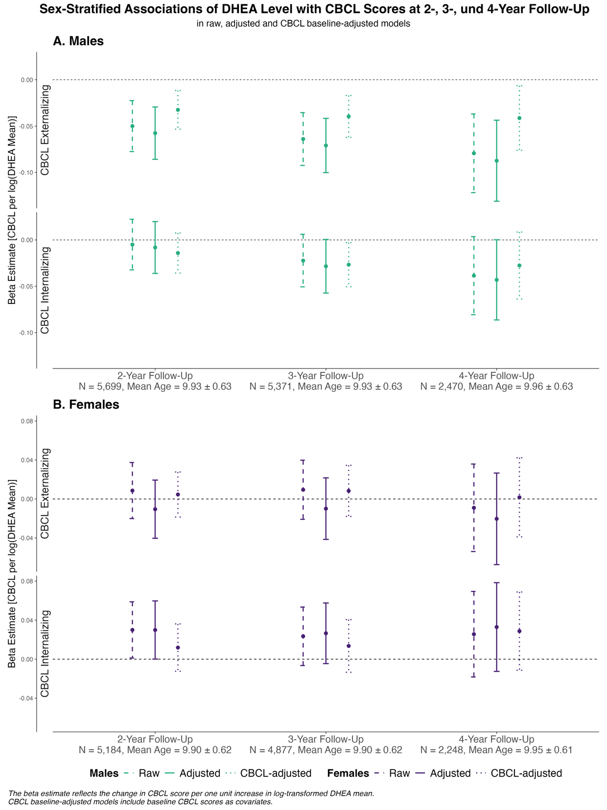
Supplementary Figure S15. Sensitivity Analysis – Sex-Stratified Associations Between DHEA Levels and CBCL Scores Across Follow-Ups in Raw, Adjusted, and Baseline-CBCL-Adjusted Models. Panel A: Males, Panel B: Females. Beta estimates (points) and 95% confidence intervals (vertical lines) are shown for three model specifications: raw (dashed line), adjusted for covariates (solid line), and additionally adjusted for baseline CBCL score (dotted line). Raw models include only baseline age and a random intercept for family nested within study site. Adjusted models additionally include the minimally sufficient adjustment set: baseline values of age, race/ethnicity, BMI standard deviation score, physical activity, and the random intercept for family nested within study site. Baseline-CBCL-adjusted models further control for baseline CBCL scores. Beta estimates reflect the change in CBCL score per per SD-change of log-transformed mean DHEA level. Sample sizes and mean ages for each follow-up are reported below.
Sensitivity Analyses - Using BPM Scores Instead of Parent-Report CBCL.
In the main analyses, we used parent-report CBCL scores to examine associations between preadolescent DHEA and later internalizing and externalizing symptoms. Parent reports were chosen because they are consistently available across all ABCD assessment waves, provide reliable information for the age range studied, and allow comparability across developmental stages.
To assess whether the observed associations were dependent on parent-report measures, we performed supplementary analyses using self-report measures. As the ABCD 5.1 dataset lacks the Youth Self-Report (YSR) prior to mid-year 4, the self-report counterpart to the parent-report Child Behavior Checklist (CBCL), we used Brief Problem Monitor (BPM) self-report scores instead. These analyses replicated the main models using BPM outcomes instead of parent-reported CBCL scores.
Overall, the sensitivity analyses showed patterns consistent with the main findings. In boys, higher preadolescent DHEA remained associated with lower externalizing symptoms, although effect sizes were slightly smaller. In girls, as in the primary analyses, no significant associations were observed. These results indicate that the main findings are not solely driven by parent-report measures, supporting the robustness of the observed developmental associations.

Supplementary Table S18. Sensitivity Analysis – Using BPM Scores Instead of Parent-Report CBCL in Males.
 |  | Outcome: CBCL Categories (Metric, Model) |  | Analysis with CBCL |  |  |  |  |  |  | Analysis with BPM
 |  |  |  | N_{obs} |  | b |  | 95%-CI |  | p | N_{obs} | b |  | 95%-CI |  | p
 |  | 2-year
 |  | Externalizing  (Level, Crude) | 5,327 |  |  | -0.05 |  | [-0.08, -0.02] |  | <0.001 | 5,073 | -0.01 |  | [-0.04, 0.02] |  | 0.400
 |  | Externalizing  (Level, Adjusted) | 5,326 |  |  | -0.06 |  | [-0.09, -0.03] |  | <0.001 | 5,072 | -0.03 |  | [-0.06, 0.00] |  | 0.049
 |  | Internalizing  (Level, Crude) | 5,327 |  |  | 0.00 |  | [-0.03, 0.02] |  | 0.720 | 5,133 | 0.00 |  | [-0.03, 0.03] |  | 0.872
 |  | Internalizing  (Level, Adjusted) | 5,326 |  |  | -0.01 |  | [-0.04, 0.02] |  | 0.568 | 5,132 | -0.01 |  | [-0.04, 0.02] |  | 0.575
 |  | Externalizing (Change, Crude) | 2,985 |  |  | 0.02 |  | [-0.01, 0.06] |  | 0.256 | 2,842 | 0.02 |  | [-0.02, 0.06] |  | 0.332
 |  | Externalizing (Change, Adjusted) | 2,985 |  |  | 0.02 |  | [-0.02, 0.06] |  | 0.277 | 2,842 | 0.02 |  | [-0.02, 0.05] |  | 0.342
 |  | Internalizing (Change, Crude) | 2,985 |  |  | 0.02 |  | [-0.01, 0.06] |  | 0.207 | 2,873 | 0.00 |  | [-0.04, 0.04] |  | 0.955
 |  | Internalizing (Change, Adjusted) | 2,985 |  |  | 0.02 |  | [-0.01, 0.06] |  | 0.238 | 2,873 | 0.00 |  | [-0.04, 0.04] |  | 0.998
 | 3-year
 | Externalizing  (Level, Crude) |  | 4,946 |  |  | -0.06 |  | [-0.09, -0.04] |  | <0.001 | 4,729 | -0.02 |  | [-0.05, 0.01] |  | 0.166
 |  | Externalizing  (Level, Adjusted) | 4,946 |  |  | -0.07 |  | [-0.1, -0.04] |  | <0.001 | 4,729 | -0.04 |  | [-0.07, -0.01] |  | 0.020
Internalizing  (Level, Crude) |  |  | 4,946 |  |  | -0.02 |  | [-0.05, 0.01] |  | 0.123 | 4,778 | -0.01 |  | [-0.04, 0.02] |  | 0.586
Internalizing  (Level, Adjusted) |  |  | 4,946 |  |  | -0.03 |  | [-0.06, 0.00] |  | 0.054 | 4,778 | -0.02 |  | [-0.05, 0.01] |  | 0.279
Externalizing  (Change, Crude) |  |  | 2,817 |  |  | 0.01 |  | [-0.02, 0.05] |  | 0.445 | 2,761 | 0.02 |  | [-0.01, 0.06] |  | 0.187
Externalizing  (Change, Adjusted) |  |  | 2,817 |  |  | 0.01 |  | [-0.02, 0.05] |  | 0.486 | 2,761 | 0.02 |  | [-0.01, 0.06] |  | 0.245
 |  | Internalizing (Change, Crude) | 2,817 |  |  | 0.00 |  | [-0.04, 0.04] |  | 0.966 | 2,778 | 0.00 |  | [-0.04, 0.03] |  | 0.904
 |  | Internalizing (Change, Adjusted) | 2,817 |  |  | 0.00 |  | [-0.04, 0.04] |  | 0.969 | 2,778 | 0.00 |  | [-0.04, 0.03] |  | 0.873
 |  | 4-year
 |  | Externalizing  (Level, Crude) | 2,272 |  | -0.08 |  | [-0.12, -0.04] |  | <0.001 |  | 2,051 | -0.04 |  | [-0.09, 0.00] |  | 0.048
 |  | Externalizing  (Level, Adjusted) | 2,272 |  | -0.09 |  | [-0.13, -0.04] |  | <0.001 |  | 2,051 | -0.05 |  | [-0.1, -0.01] |  | 0.025
 |  | Internalizing  (Level, Crude) | 2,272 |  | -0.04 |  | [-0.08, 0.00] |  | 0.073 |  | 2,078 | -0.01 |  | [-0.05, 0.04] |  | 0.769
 |  | Internalizing  (Level, Adjusted) | 2,272 |  | -0.04 |  | [-0.09, 0.00] |  | 0.051 |  | 2,078 | -0.02 |  | [-0.06, 0.03] |  | 0.434
 |  | Externalizing  (Change, Crude) | 1,733 |  | 0.03 |  | [-0.02, 0.07] |  | 0.317 |  | 1,541 | 0.00 |  | [-0.05, 0.05] |  | 0.915
 |  | Externalizing  (Change, Adjusted) | 1,733 |  | 0.03 |  | [-0.02, 0.07] |  | 0.317 |  | 1,541 | 0.00 |  | [-0.05, 0.05] |  | 0.887
 |  | Internalizing  (Change, Crude) | 1,733 |  | 0.03 |  | [-0.01, 0.08] |  | 0.166 |  | 1,562 | 0.05 |  | [0.00, 0.10] |  | 0.072
 |  | Internalizing  (Change, Adjusted) | 1,733 |  | 0.03 |  | [-0.02, 0.08] |  | 0.200 |  | 1,562 | 0.05 |  | [0.00, 0.1] |  | 0.062
Abbreviations: BPM = Brief Problem Monitor, CBCL = Child Behavior Checklist, N_{obs} = Number of observations.

Supplementary Table S19. Sensitivity Analysis – Using BPM Scores Instead of Parent-Report CBCL in Females.
 |  | Outcome: CBCL Categories (Metric, Model) |  | Analysis with CBCL Models |  |  |  |  |  |  | Analysis with BPM Models
 |  |  |  | N_{obs} |  | b |  | 95%-CI |  | p | N_{obs} | b |  | 95%-CI |  | p
 |  | 2-year
 |  | Externalizing  (Level, Crude) | 4,883 |  |  | 0.01 |  | [-0.02, 0.04] |  | 0.555 | 4,686 | 0.04 |  | [0.01, 0.07] |  | 0.014
 |  | Externalizing  (Level, Adjusted) | 4,880 |  |  | -0.01 |  | [-0.04, 0.02] |  | 0.493 | 4,684 | 0.02 |  | [-0.01, 0.05] |  | 0.268
 |  | Internalizing  (Level, Crude) | 4,883 |  |  | 0.03 |  | [0.00, 0.06] |  | 0.041 | 4,726 | 0.02 |  | [-0.01, 0.05] |  | 0.206
 |  | Internalizing  (Level, Adjusted) | 4,880 |  |  | 0.03 |  | [0.00, 0.06] |  | 0.049 | 4,723 | 0.01 |  | [-0.02, 0.05] |  | 0.365
 |  | Externalizing (Change, Crude) | 2,779 |  |  | -0.01 |  | [-0.04, 0.03] |  | 0.712 | 2,659 | 0.02 |  | [-0.02, 0.06] |  | 0.347
 |  | Externalizing (Change, Adjusted) | 2,777 |  |  | -0.01 |  | [-0.04, 0.03] |  | 0.747 | 2,658 | 0.02 |  | [-0.02, 0.06] |  | 0.359
 |  | Internalizing (Change, Crude) | 2,779 |  |  | -0.01 |  | [-0.04, 0.03] |  | 0.716 | 2,683 | 0.04 |  | [0.00, 0.08] |  | 0.037
 |  | Internalizing (Change, Adjusted) | 2,777 |  |  | -0.01 |  | [-0.04, 0.03] |  | 0.597 | 2,681 | 0.04 |  | [0.00, 0.07] |  | 0.046
 | 3-year
 | Externalizing  (Level, Crude) |  | 4,502 |  |  | 0.01 |  | [-0.02, 0.04] |  | 0.541 | 4,352 | 0.02 |  | [-0.01, 0.05] |  | 0.205
 |  | Externalizing  (Level, Adjusted) | 4,500 |  |  | -0.01 |  | [-0.04, 0.02] |  | 0.539 | 4,349 | 0.01 |  | [-0.03, 0.04] |  | 0.658
Internalizing  (Level, Crude) |  |  | 4,502 |  |  | 0.02 |  | [-0.01, 0.05] |  | 0.125 | 4,357 | 0.02 |  | [-0.01, 0.06] |  | 0.133
Internalizing  (Level, Adjusted) |  |  | 4,500 |  |  | 0.03 |  | [0.00, 0.06] |  | 0.094 | 4,354 | 0.03 |  | [-0.01, 0.06] |  | 0.129
Externalizing  (Change, Crude) |  |  | 2,603 |  |  | 0.00 |  | [-0.03, 0.04] |  | 0.861 | 2,574 | 0.01 |  | [-0.03, 0.05] |  | 0.512
Externalizing  (Change, Adjusted) |  |  | 2,602 |  |  | 0.00 |  | [-0.03, 0.04] |  | 0.864 | 2,572 | 0.01 |  | [-0.03, 0.05] |  | 0.547
 |  | Internalizing (Change, Crude) | 2,603 |  |  | -0.02 |  | [-0.05, 0.02] |  | 0.372 | 2,577 | 0.02 |  | [-0.02, 0.06] |  | 0.380
 |  | Internalizing (Change, Adjusted) | 2,602 |  |  | -0.02 |  | [-0.06, 0.02] |  | 0.276 | 2,575 | 0.01 |  | [-0.03, 0.05] |  | 0.495
 |  | 4-year
 |  | Externalizing  (Level, Crude) | 2,076 |  | -0.01 |  | [-0.05, 0.04] |  | 0.694 |  | 1,915 | 0.01 |  | [-0.03, 0.06] |  | 0.562
 |  | Externalizing  (Level, Adjusted) | 2,074 |  | -0.02 |  | [-0.07, 0.03] |  | 0.396 |  | 1,913 | 0.00 |  | [-0.05, 0.05] |  | 0.968
 |  | Internalizing  (Level, Crude) | 2,076 |  | 0.03 |  | [-0.02, 0.07] |  | 0.252 |  | 1,919 | 0.02 |  | [-0.03, 0.07] |  | 0.421
 |  | Internalizing  (Level, Adjusted) | 2,074 |  | 0.03 |  | [-0.01, 0.08] |  | 0.156 |  | 1,917 | 0.02 |  | [-0.03, 0.07] |  | 0.501
 |  | Externalizing  (Change, Crude) | 1,638 |  | 0.03 |  | [-0.01, 0.08] |  | 0.160 |  | 1,499 | -0.01 |  | [-0.06, 0.04] |  | 0.616
 |  | Externalizing  (Change, Adjusted) | 1,636 |  | 0.03 |  | [-0.02, 0.08] |  | 0.195 |  | 1,497 | -0.01 |  | [-0.06, 0.04] |  | 0.683
 |  | Internalizing  (Change, Crude) | 1,638 |  | 0.01 |  | [-0.04, 0.06] |  | 0.718 |  | 1,503 | 0.01 |  | [-0.04, 0.06] |  | 0.709
 |  | Internalizing  (Change, Adjusted) | 1,636 |  | 0.00 |  | [-0.05, 0.05] |  | 0.987 |  | 1,501 | 0.01 |  | [-0.05, 0.06] |  | 0.826
Abbreviations: BPM = Brief Problem Monitor, CBCL = Child Behavior Checklist, N_{obs} = Number of observations.

Sensitivity Analyses – Using Baseline DHEA and 1-Year Follow-Up DHEA as Exposure Instead of Average.
In our main analysis, we used the arithmetic mean of the log-transformed baseline and 1-year follow-up DHEA values as the exposure. To address the potential conflation of between-person differences with within-person developmental change, we conducted sensitivity analyses using baseline and 1-year follow-up DHEA separately. This approach allows us to assess whether the associations observed with the averaged measure are consistent across individual timepoints and to clarify which aspect of the hormone trajectory drives the observed effects.
Analyses were performed for CBCL externalizing and internalizing outcomes at 2-, 3-, and 4-year follow-ups, including available covariates (age and BMI at each timepoint; physical activity only at baseline, as follow-up data were not collected). Across both males (Supplementary Table S20) and females (Supplementary Table S21), patterns of association were largely consistent between averaged and single-timepoint measures, indicating that the findings are not an artefact of the averaging strategy.

Supplementary Table S20. Sensitivity Analysis – Using Baseline and 1-Year Follow-Up DHEA as Exposure Instead of Average in Males.
Outcome: CBCL Categories (Metric, Model) | Analysis Using Average |  |  |  | Analysis Using Baseline DHEA |  |  |  | Analysis Using 1-Year DHEA
Outcome: CBCL Categories (Metric, Model) | N_{obs} | b | 95%-CI | p | N_{obs} | b | 95%-CI | p | N_{obs} | b |  |  |  | 95%-CI |  |  |  |  | p
2-year
Externalizing  (Level, Crude) | 5,327 | -0.05 | [-0.08, -0.02] | <0.001 | 4,473 | -0.04 | [-0.07, -0.01] | 0.012 | 4,561 | -0.05 |  |  |  | [-0.08, -0.02] |  |  |  |  | 0,001
Externalizing  (Level, Adjusted) | 5,326 | -0.06 | [-0.09, -0.03] | <0.001 | 4,472 | -0.05 | [-0.08, -0.02] | 0.003 | 4,560 | -0.06 |  |  |  | [-0.09, -0.03] |  |  |  |  | <0.001
Internalizing  (Level, Crude) | 5,327 | 0.00 | [-0.03, 0.02] | 0.720 | 4,473 | -0.01 | [-0.04, 0.02] | 0.330 | 4,561 | 0.00 |  |  |  | [-0.03, 0.03] |  |  |  |  | 0.802
Internalizing  (Level, Adjusted) | 5,326 | -0.01 | [-0.04, 0.02] | 0.568 | 4,472 | -0.02 | [-0.05, 0.01] | 0.184 | 4,560 | -0.01 |  |  |  | [-0.04, 0.02] |  |  |  |  | 0.582
3-year
Externalizing (Level, Crude) | 4,946 | -0.06 | [-0.09, -0.04] | <0.001 | 4,167 | -0.05 | [-0.08, -0.02] | 0.003 | 4,244 |  |  | -0.06 | [-0.09, -0.03] |  |  |  |  |  |  | <0.001
Externalizing  (Level, Adjusted) | 4,946 | -0.07 | [-0.1, -0.04] | <0.001 | 4,167 | -0.05 | [-0.09, -0.02] | 0.001 | 4,244 |  |  | -0.07 | [-0.10, -0.04] |  |  |  |  |  |  | <0.001
Internalizing (Level, Crude) | 4,946 | -0.02 | [-0.05, 0.01] | 0.123 | 4,167 | -0.02 | [-0.05, 0.01] | 0.139 | 4,244 |  |  | -0.02 | [-0.05, 0.01] |  |  |  |  |  |  | 0.116
Internalizing (Level, Adjusted) | 4,946 | -0.03 | [-0.06, 0.00] | 0.054 | 4,167 | -0.03 | [-0.06, 0.00] | 0.052 | 4,244 |  |  | -0.03 | [-0.06, 0.00] |  |  |  |  |  |  | 0.037
4-year
Externalizing  (Level, Crude) | 2,272 | -0.08 | [-0.12, -0.04] | <0.001 | 1,841 | -0.07 | [-0.12, -0.03] | 0.003 | 1,961 |  |  | -0.07 | [-0.12, -0.03] |  |  |  |  |  |  | 0.001
Externalizing  (Level, Adjusted) | 2,272 | -0.09 | [-0.13, -0.04] | <0.001 | 1,841 | -0.08 | [-0.13, -0.03] | 0.001 | 1,961 |  |  | -0.08 | [-0.12, -0.03] |  |  |  |  |  |  | 0.001
Internalizing  (Level, Crude) | 2,272 | -0.04 | [-0.08, 0.00] | 0.073 | 1,841 | -0.05 | [-0.1, -0.01] | 0.029 | 1,961 |  |  | -0.04 | [-0.08, 0.01] |  |  |  |  |  |  | 0.127
Internalizing  (Level, Adjusted) | 2,272 | -0.04 | [-0.09, 0.00] | 0.051 | 1,841 | -0.06 | [-0.1, -0.01] | 0.024 | 1,961 |  |  | -0.04 | [-0.09, 0.01] |  |  |  |  |  |  | 0.083
Abbreviations: CBCL = Child Behavior Checklist, DHEA = Dehydroepiandrosterone, N_{obs} = Number of observations.

Supplementary Table S21. Sensitivity Analysis – Using Baseline and 1-Year Follow-Up DHEA as Exposure Instead of Average in Females.
Outcome: CBCL Categories (Metric, Model) | Analysis Using Average |  |  |  | Analysis Using Baseline DHEA |  |  |  | Analysis Using 1-Year DHEA
Outcome: CBCL Categories (Metric, Model) | N_{obs} | b | 95%-CI | p | N_{obs} | b | 95%-CI | p | N_{obs} | b |  |  |  | 95%-CI |  |  |  |  | p
2-year
Externalizing  (Level, Crude) | 4,883 | 0.01 | [-0.02, 0.04] | 0.555 | 4,152 | 0.02 | [-0.01, 0.05] | 0.181 | 4,185 | 0.00 |  |  |  | [-0.03, 0.03] |  |  |  |  | 0.952
Externalizing  (Level, Adjusted) | 4,880 | -0.01 | [-0.04, 0.02] | 0.493 | 4,149 | 0.01 | [-0.03, 0.04] | 0.707 | 4,184 | -0.02 |  |  |  | [-0.05, 0.02] |  |  |  |  | 0.329
Internalizing  (Level, Crude) | 4,883 | 0.03 | [0.00, 0.06] | 0.041 | 4,152 | 0.02 | [-0.01, 0.05] | 0.133 | 4,185 | 0.03 |  |  |  | [0.00, 0.07] |  |  |  |  | 0.025
Internalizing  (Level, Adjusted) | 4,880 | 0.03 | [0.00, 0.06] | 0.049 | 4,149 | 0.03 | [-0.01, 0.06] | 0.107 | 4,184 | 0.04 |  |  |  | [0.00, 0.07] |  |  |  |  | 0.024
3-year
Externalizing (Level, Crude) | 4,502 | 0.01 | [-0.02, 0.04] | 0.541 | 3,813 | 0.01 | [-0.02, 0.04] | 0.496 | 3,869 |  |  | 0.02 | [-0.01, 0.06] |  |  |  |  |  |  | 0.140
Externalizing  (Level, Adjusted) | 4,500 | -0.01 | [-0.04, 0.02] | 0.539 | 3,811 | 0.00 | [-0.04, 0.03] | 0.817 | 3,868 |  |  | 0.01 | [-0.03, 0.04] |  |  |  |  |  |  | 0.708
Internalizing (Level, Crude) | 4,502 | 0.02 | [-0.01, 0.05] | 0.125 | 3,813 | 0.02 | [-0.01, 0.05] | 0.262 | 3,869 |  |  | 0.03 | [0.00, 0.07] |  |  |  |  |  |  | 0.037
Internalizing (Level, Adjusted) | 4,500 | 0.03 | [0.00, 0.06] | 0.094 | 3,811 | 0.02 | [-0.01, 0.06] | 0.136 | 3,868 |  |  | 0.04 | [0.01, 0.07] |  |  |  |  |  |  | 0.020
4-year
Externalizing  (Level, Crude) | 2,076 | -0.01 | [-0.05, 0.04] | 0.694 | 1,713 | -0.02 | [-0.07, 0.03] | 0.399 | 1,804 |  |  | 0.00 | [-0.04, 0.05] |  |  |  |  |  |  | 0.861
Externalizing  (Level, Adjusted) | 2,074 | -0.02 | [-0.07, 0.03] | 0.396 | 1,711 | -0.03 | [-0.08, 0.02] | 0.250 | 1,804 |  |  | 0.00 | [-0.05, 0.05] |  |  |  |  |  |  | 0.884
Internalizing  (Level, Crude) | 2,076 | 0.03 | [-0.02, 0.07] | 0.252 | 1,713 | 0.03 | [-0.02, 0.07] | 0.300 | 1,804 |  |  | 0.03 | [-0.02, 0.07] |  |  |  |  |  |  | 0.256
Internalizing  (Level, Adjusted) | 2,074 | 0.03 | [-0.01, 0.08] | 0.156 | 1,711 | 0.04 | [-0.01, 0.09] | 0.118 | 1,804 |  |  | 0.03 | [-0.02, 0.08] |  |  |  |  |  |  | 0.230
Abbreviations: CBCL = Child Behavior Checklist, DHEA = Dehydroepiandrosterone, N_{obs} = Number of observations.

Sensitivity Analyses – Adjusting for Time Interval Between Baseline and 2-Year-Follow-Up in the DHEA change variable.
In addition to our main analyses, we conducted sensitivity analyses on DHEA change scores to account for potential variability in the time interval between assessments. Change scores were defined as the log-ratio of 2‑year follow-up to baseline DHEA, reflecting within-individual hormone progression, in contrast to DHEA level, which captures between-individual differences. In these supplementary analyses, we included an additional covariate representing the time interval between baseline and 2-year follow-up assessments (operationalized as the age difference between assessments) alongside baseline age. Results, presented separately for males (Supplementary Table S22) and females (Supplementary Table S23), show that adjustment for interval length did not materially alter the associations: effect estimates remained close to zero and non-significant, consistent with our main finding that DHEA change scores show no robust associations with CBCL outcomes.

Supplementary Table S22. Sensitivity Analysis – Adjusting for Time Interval Between Baseline and 2-Year-Follow-Up in DHEA Change in Males.
 |  | Outcome: CBCL Categories (Metric, Model) | Analysis Adjusting for Age at Baseline |  |  |  | Analysis Adjusting for Age Interval Between 2-Year and Baseline Assessments
 |  | Outcome: CBCL Categories (Metric, Model) | N_{obs} | b | 95%-CI | p | N_{obs} | b | 95%-CI | p
 |  | 2-year
 |  | Externalizing (Change, Adjusted) | 2,985 | 0.02 | [-0.02, 0.06] | 0.277 | 2,985 | 0.02 | [-0.02, 0.05] | 0.327
 |  | Internalizing (Change, Adjusted) | 2,985 | 0.02 | [-0.01, 0.06] | 0.238 | 2,985 | 0.02 | [-0.02, 0.06] | 0.272
 | 3-year
Externalizing  (Change, Adjusted) |  |  | 2,817 | 0.01 | [-0.02, 0.05] | 0.486 | 2,817 | 0.01 | [-0.02, 0.05] | 0.473
 |  | Internalizing  (Change, Adjusted) | 2,817 | 0.00 | [-0.04, 0.04] | 0.969 | 2,817 | 0.00 | [-0.04, 0.04] | 0.999
 |  | 4-year
 |  | Externalizing (Change, Adjusted) | 1,733 | 0.03 | [-0.02, 0.07] | 0.317 | 1,733 | 0.03 | [-0.02, 0.08] | 0.300
 |  | Internalizing (Change, Adjusted) | 1,733 | 0.03 | [-0.02, 0.08] | 0.200 | 1,733 | 0.03 | [-0.02, 0.08] | 0.203
Abbreviations: CBCL = Child Behavior Checklist, N_{obs} = Number of observations.

Supplementary Table S23. Sensitivity Analysis – Adjusting for Time Interval Between Baseline and 2-Year-Follow-Up in DHEA Change in Females.
 |  | Outcome: CBCL Categories (Metric, Model) | Analysis Adjusting for Age at Baseline |  |  |  | Analysis Adjusting for Age Interval Between 2-Year and Baseline Assessments
 |  | Outcome: CBCL Categories (Metric, Model) | N_{obs} | b | 95%-CI | p | N_{obs} | b | 95%-CI | p
 |  | 2-year
 |  | Externalizing (Change, Adjusted) | 2,777 | -0.01 | [-0.04, 0.03] | 0.747 | 2,777 | -0.01 | [-0.04, 0.03] | 0.701
 |  | Internalizing (Change, Adjusted) | 2,777 | -0.01 | [-0.04, 0.03] | 0.597 | 2,777 | -0.01 | [-0.05, 0.02] | 0.513
 | 3-year
Externalizing  (Change, Adjusted) |  |  | 2,602 | 0 | [-0.03, 0.04] | 0.864 | 2,602 | 0.01 | [-0.03, 0.04] | 0.781
 |  | Internalizing (Change, Adjusted) | 2,602 | -0.02 | [-0.06, 0.02] | 0.276 | 2,602 | -0.02 | [-0.06, 0.02] | 0.284
 |  | 4-year
 |  | Externalizing (Change, Adjusted) | 1,636 | 0.03 | [-0.02, 0.08] | 0.195 | 1,636 | 0,03 | [-0.02, 0.08] | 0.206
 |  | Internalizing (Change, Adjusted) | 1,636 | 0 | [-0.05, 0.05] | 0.987 | 1,636 | 0 | [-0.05, 0.04] | 0.908
Abbreviations: CBCL = Child Behavior Checklist, N_{obs} = Number of observations.

Sensitivity Analyses – Winsorized Models to Assess the Impact of Potentially Influental Outliers.

To evaluate the potential impact of extreme values on our results, all numeric variables included in the models were winsorized at the 1st and 99th percentiles (i.e., values below the 1st percentile or above the 99th percentile were replaced by the respective percentile value). Because our analyses were based on linear mixed-effects models, standard influence diagnostics such as Cook’s Distance are not directly applicable. The models were re-estimated using the winsorized datasets.
The results from the winsorized models were highly similar to those from the main analyses, with virtually identical effect estimates, confidence intervals, and significance levels, indicating that the observed associations were not driven by extreme values. Findings are presented in Supplementary Tables S24–S25.

Supplementary Table S24. Sensitivity Analysis – Winsorized Models to Assess the Influence of Extreme Values in Males.
 |  | Outcome: CBCL Categories (Metric, Model) |  | Analysis with CBCL |  |  |  |  |  |  | Analysis with BPM
 |  |  |  | N_{obs} |  | b |  | 95%-CI |  | p | N_{obs} | b |  | 95%-CI |  | p
 |  | 2-year
 |  | Externalizing  (Level, Crude) | 5,327 |  |  | -0.05 |  | [-0.08, -0.02] |  | <0.001 | 5,327 | -0.05 |  | [-0.08, -0.02] |  | <0.001
 |  | Externalizing  (Level, Adjusted) | 5,326 |  |  | -0.06 |  | [-0.09, -0.03] |  | <0.001 | 5,326 | -0.06 |  | [-0.08, -0.03] |  | <0.001
 |  | Internalizing  (Level, Crude) | 5,327 |  |  | 0.00 |  | [-0.03, 0.02] |  | 0.720 | 5,327 | -0.01 |  | [-0.03, 0.02] |  | 0.676
 |  | Internalizing  (Level, Adjusted) | 5,326 |  |  | -0.01 |  | [-0.04, 0.02] |  | 0.568 | 5,326 | -0.01 |  | [-0.04, 0.02] |  | 0.525
 |  | Externalizing (Change, Crude) | 2,985 |  |  | 0.02 |  | [-0.01, 0.06] |  | 0.256 | 2,985 | 0.02 |  | [-0.01, 0.06] |  | 0.198
 |  | Externalizing (Change, Adjusted) | 2,985 |  |  | 0.02 |  | [-0.02, 0.06] |  | 0.277 | 2,985 | 0.02 |  | [-0.01, 0.06] |  | 0.217
 |  | Internalizing (Change, Crude) | 2,985 |  |  | 0.02 |  | [-0.01, 0.06] |  | 0.207 | 2,985 | 0.02 |  | [-0.02, 0.06] |  | 0.276
 |  | Internalizing (Change, Adjusted) | 2,985 |  |  | 0.02 |  | [-0.01, 0.06] |  | 0.238 | 2,985 | 0.02 |  | [-0.02, 0.05] |  | 0.313
 | 3-year
 | Externalizing  (Level, Crude) |  | 4,946 |  |  | -0.06 |  | [-0.09, -0.04] |  | <0.001 | 4,946 | -0.07 |  | [-0.1, -0.04] |  | <0.001
 |  | Externalizing  (Level, Adjusted) | 4,946 |  |  | -0.07 |  | [-0.1, -0.04] |  | <0.001 | 4,946 | -0.07 |  | [-0.1, -0.05] |  | <0.001
Internalizing  (Level, Crude) |  |  | 4,946 |  |  | -0.02 |  | [-0.05, 0.01] |  | 0.123 | 4,946 | -0.02 |  | [-0.05, 0.01] |  | 0.127
Internalizing  (Level, Adjusted) |  |  | 4,946 |  |  | -0.03 |  | [-0.06, 0.00] |  | 0.054 | 4,946 | -0.03 |  | [-0.06, 0.00] |  | 0.056
Externalizing  (Change, Crude) |  |  | 2,817 |  |  | 0.01 |  | [-0.02, 0.05] |  | 0.445 | 2,817 | 0.02 |  | [-0.02, 0.05] |  | 0.371
Externalizing  (Change, Adjusted) |  |  | 2,817 |  |  | 0.01 |  | [-0.02, 0.05] |  | 0.486 | 2,817 | 0.02 |  | [-0.02, 0.05] |  | 0.405
 |  | Internalizing (Change, Crude) | 2,817 |  |  | 0.00 |  | [-0.04, 0.04] |  | 0.966 | 2,817 | 0.00 |  | [-0.04, 0.04] |  | 0.999
 |  | Internalizing (Change, Adjusted) | 2,817 |  |  | 0.00 |  | [-0.04, 0.04] |  | 0.969 | 2,817 | 0.00 |  | [-0.04, 0.03] |  | 0.944
 |  | 4-year
 |  | Externalizing  (Level, Crude) | 2,272 |  | -0.08 |  | [-0.12, -0.04] |  | <0.001 |  | 2,272 | -0.08 |  | [-0.12, -0.04] |  | <0.001
 |  | Externalizing  (Level, Adjusted) | 2,272 |  | -0.09 |  | [-0.13, -0.04] |  | <0.001 |  | 2,272 | -0.09 |  | [-0.13, -0.04] |  | <0.001
 |  | Internalizing  (Level, Crude) | 2,272 |  | -0.04 |  | [-0.08, 0.00] |  | 0.073 |  | 2,272 | -0.04 |  | [-0.08, 0.01] |  | 0.087
 |  | Internalizing  (Level, Adjusted) | 2,272 |  | -0.04 |  | [-0.09, 0.00] |  | 0.051 |  | 2,272 | -0.04 |  | [-0.08, 0.00] |  | 0.068
 |  | Externalizing  (Change, Crude) | 1,733 |  | 0.03 |  | [-0.02, 0.07] |  | 0.317 |  | 1,733 | 0.02 |  | [-0.03, 0.07] |  | 0.346
 |  | Externalizing  (Change, Adjusted) | 1,733 |  | 0.03 |  | [-0.02, 0.07] |  | 0.317 |  | 1,733 | 0.02 |  | [-0.03, 0.07] |  | 0.349
 |  | Internalizing  (Change, Crude) | 1,733 |  | 0.03 |  | [-0.01, 0.08] |  | 0.166 |  | 1,733 | 0.03 |  | [-0.02, 0.08] |  | 0.209
 |  | Internalizing  (Change, Adjusted) | 1,733 |  | 0.03 |  | [-0.02, 0.08] |  | 0.200 |  | 1,733 | 0.03 |  | [-0.02, 0.07] |  | 0.249
Abbreviations: CBCL = Child Behavior Checklist, N_{obs} = Number of observations.

Supplementary Table S25. Sensitivity Analysis – Winsorized Models to Assess the Influence of Extreme Values in Females.
 |  | Outcome: CBCL Categories (Metric, Model) |  | Analysis with CBCL |  |  |  |  |  |  | Analysis with BPM
 |  |  |  | N_{obs} |  | b |  | 95%-CI |  | p | N_{obs} | b |  | 95%-CI |  | p
 |  | 2-year
 |  | Externalizing  (Level, Crude) | 4,883 |  |  | 0.01 |  | [-0.02, 0.04] |  | 0.555 | 4,883 | 0.01 |  | [-0.02, 0.04] |  | 0.578
 |  | Externalizing  (Level, Adjusted) | 4,880 |  |  | -0.01 |  | [-0.04, 0.02] |  | 0.493 | 4,880 | -0.01 |  | [-0.04, 0.02] |  | 0.465
 |  | Internalizing  (Level, Crude) | 4,883 |  |  | 0.03 |  | [0.00, 0.06] |  | 0.041 | 4,883 | 0.03 |  | [0.00, 0.06] |  | 0.027
 |  | Internalizing  (Level, Adjusted) | 4,880 |  |  | 0.03 |  | [0.00, 0.06] |  | 0.049 | 4,880 | 0.03 |  | [0.00, 0.06] |  | 0.031
 |  | Externalizing (Change, Crude) | 2,779 |  |  | -0.01 |  | [-0.04, 0.03] |  | 0.712 | 2,779 | -0.01 |  | [-0.04, 0.03] |  | 0.648
 |  | Externalizing (Change, Adjusted) | 2,777 |  |  | -0.01 |  | [-0.04, 0.03] |  | 0.747 | 2,777 | -0.01 |  | [-0.04, 0.03] |  | 0.678
 |  | Internalizing (Change, Crude) | 2,779 |  |  | -0.01 |  | [-0.04, 0.03] |  | 0.716 | 2,779 | -0.01 |  | [-0.05, 0.02] |  | 0.561
 |  | Internalizing (Change, Adjusted) | 2,777 |  |  | -0.01 |  | [-0.04, 0.03] |  | 0.597 | 2,777 | -0.01 |  | [-0.05, 0.02] |  | 0.446
 | 3-year
 | Externalizing  (Level, Crude) |  | 4,502 |  |  | 0.01 |  | [-0.02, 0.04] |  | 0.541 | 4,502 | 0.01 |  | [-0.02, 0.04] |  | 0.352
 |  | Externalizing  (Level, Adjusted) | 4,500 |  |  | -0.01 |  | [-0.04, 0.02] |  | 0.539 | 4,500 | -0.01 |  | [-0.04, 0.03] |  | 0.743
Internalizing  (Level, Crude) |  |  | 4,502 |  |  | 0.02 |  | [-0.01, 0.05] |  | 0.125 | 4,502 | 0.03 |  | [0.00, 0.06] |  | 0.078
Internalizing  (Level, Adjusted) |  |  | 4,500 |  |  | 0.03 |  | [0.00, 0.06] |  | 0.094 | 4,500 | 0.03 |  | [0.00, 0.06] |  | 0.058
Externalizing  (Change, Crude) |  |  | 2,603 |  |  | 0.00 |  | [-0.03, 0.04] |  | 0.861 | 2,603 | 0.00 |  | [-0.04, 0.04] |  | 0.962
Externalizing  (Change, Adjusted) |  |  | 2,602 |  |  | 0.00 |  | [-0.03, 0.04] |  | 0.864 | 2,602 | 0.00 |  | [-0.04, 0.04] |  | 0.964
 |  | Internalizing (Change, Crude) | 2,603 |  |  | -0.02 |  | [-0.05, 0.02] |  | 0.372 | 2,603 | -0.02 |  | [-0.06, 0.02] |  | 0.271
 |  | Internalizing (Change, Adjusted) | 2,602 |  |  | -0.02 |  | [-0.06, 0.02] |  | 0.276 | 2,602 | -0.02 |  | [-0.06, 0.01] |  | 0.188
 |  | 4-year
 |  | Externalizing  (Level, Crude) | 2,076 |  | -0.01 |  | [-0.05, 0.04] |  | 0.694 |  | 2,076 | -0.01 |  | [-0.05, 0.04] |  | 0.707
 |  | Externalizing  (Level, Adjusted) | 2,074 |  | -0.02 |  | [-0.07, 0.03] |  | 0.396 |  | 2,074 | -0.02 |  | [-0.07, 0.03] |  | 0.376
 |  | Internalizing  (Level, Crude) | 2,076 |  | 0.03 |  | [-0.02, 0.07] |  | 0.252 |  | 2,076 | 0.02 |  | [-0.02, 0.07] |  | 0.287
 |  | Internalizing  (Level, Adjusted) | 2,074 |  | 0.03 |  | [-0.01, 0.08] |  | 0.156 |  | 2,074 | 0.03 |  | [-0.02, 0.08] |  | 0.192
 |  | Externalizing  (Change, Crude) | 1,638 |  | 0.03 |  | [-0.01, 0.08] |  | 0.160 |  | 1,638 | 0.02 |  | [-0.03, 0.07] |  | 0.350
 |  | Externalizing  (Change, Adjusted) | 1,636 |  | 0.03 |  | [-0.02, 0.08] |  | 0.195 |  | 1,636 | 0.02 |  | [-0.03, 0.07] |  | 0.406
 |  | Internalizing  (Change, Crude) | 1,638 |  | 0.01 |  | [-0.04, 0.06] |  | 0.718 |  | 1,638 | 0.01 |  | [-0.04, 0.05] |  | 0.784
 |  | Internalizing  (Change, Adjusted) | 1,636 |  | 0.00 |  | [-0.05, 0.05] |  | 0.987 |  | 1,636 | 0.00 |  | [-0.05, 0.04] |  | 0.893
Abbreviations: CBCL = Child Behavior Checklist, N_{obs} = Number of observations.

Supplementary Results
Correlations between Hormone Levels across Timepoints, Unadjusted and Adjusted for Current Pubertal Stage (PDS).

Correlations between hormone levels across timepoints were calculated using Pearson’s correlation. To account for pubertal status, linear regression models including the PDS score as a covariate were fitted. Adjusted regression coefficients and p-values are reported, providing estimates of hormone associations independent of PDS.

Supplementary Table S26. Correlations between Hormones across Timepoints.

 |  | Males |  |  | Females
 |  | N | r | p | N |  | r |  |  | p
 | DHEA – Testosterone
 | Baseline | 4,963 | 0.757 | <0.001 | 4,612 |  | 0.807 |  |  | <0.001
 | 1-year | 4,913 | 0.754 | <0.001 | 4,550 |  | 0.802 |  |  | <0.001
 | 2-year | 5,533 | 0.750 | <0.001 | 4,903 |  | 0.799 |  |  | <0.001
 | 3-year | 5,025 | 0.750 | <0.001 | 4,611 |  | 0.799 |  |  | <0.001
 | 4-year | 2,297 | 0.749 | <0.001 | 2,111 |  | 0.795 |  |  | <0.001
 | DHEA – Testosterone PDS adjusted
 | Baseline | 4,582 | 0.756 | <0.001 | 4,261 |  | 0.806 |  |  | <0.001
 | 1-year | 4,576 | 0.757 | <0.001 | 4,230 |  | 0.802 |  |  | <0.001
 | 2-year | 4,953 | 0.753 | <0.001 | 4,484 |  | 0.799 |  |  | <0.001
 | 3-year | 4,638 | 0.750 | <0.001 | 4,109 |  | 0.796 |  |  | <0.001
 | 4-year | 2,158 | 0.745 | <0.001 | 1,910 |  | 0.795 |  |  | <0.001
 | DHEA – Estradiol
 | Baseline |  |  |  | 4,572 |  | 0.551 |  |  | <0.001
 | 1-year |  |  |  | 4,503 |  | 0.556 |  |  | <0.001
 | 2-year |  |  |  | 4,845 |  | 0.547 |  |  | <0.001
 | 3-year |  |  |  | 4,552 |  | 0.545 |  |  | <0.001
 | 4-year |  |  |  | 2,084 |  | 0.532 |  |  | <0.001
DHEA – Estradiol PDS adjusted
Baseline |  |  |  |  | 4,227 |  | 0.554 |  |  | <0.001
1-year |  |  |  |  | 4,186 |  | 0.555 |  |  | <0.001
2-year |  |  |  |  | 4,435 |  | 0.546 |  |  | <0.001
3-year |  |  |  |  | 4,061 |  | 0.543 |  |  | <0.001
4-year |  |  |  |  | 1,887 |  | 0.535 |  |  | <0.001
Abbreviations: N = Number; p = p-value; PDS = Pubertal Development Scale; r = Pearson’s R Correlation Coefficient.

Testosterone as an Additional Exposure to Assess Incremental Variance Explained

To assess whether testosterone contributes additional explanatory power beyond DHEA, we conducted analyses including testosterone as an additional predictor in the 3-year mixed-effects models. In these models, marginal R² represents the proportion of variance explained by the fixed effects alone, while conditional R² reflects the variance explained by both fixed and random effects. This distinction allows to separate the contribution of hormone predictors from the overall variance captured by the model structure.
For CBCL externalizing scores, the 3-year models including DHEA alone showed a marginal R² of 0.009 and conditional R² of 0.410 in males (p = <0.001), and a marginal R² of 0.010 and conditional R² of 0.513 in females (p = 0.539). Adding testosterone did not meaningfully change model fit (males: marginal R² = 0.009, conditional R² = 0.405, p =0.796; females: marginal R² = 0.010, conditional R² = 0.512, p = 0.633). For CBCL internalizing scores, the DHEA-only models showed a marginal R² of 0.016 and conditional R² of 0.583 in males (p = 0.054), and a marginal R² of 0.018 and conditional R² of 0.687 in females (p = 0.094). Including testosterone resulted in minimal changes (males: marginal R² = 0.016, conditional R² = 0.582, p = 0.899; females: marginal R² = 0.018, conditional R² = 0.685, p = 0.476).
These results indicate that testosterone does not explain additional variance in CBCL externalizing or internalizing scores beyond DHEA.

Analysis of DSM5-Oriented CBCL Subdomains Across Follow-Up Years
While the primary focus was on the CBCL categories of Externalizing and Internalizing symptoms based on the syndrome-oriented scales, we further examined associations between DHEA levels and changes with the six DSM-5-oriented CBCL subscales, which align more closely with clinical diagnostic categories. These subscales included Attention-Deficit/Hyperactivity Disorder (ADHD), Oppositional Defiant Disorder (ODD), and Conduct Disorder (CD) for Externalizing symptoms, as well as Depression, Anxiety, and Somatic Problems for Internalizing symptoms. The results indicate that the main findings are reflected across all CBCL subscores. One exception was ADHD in girls at the 2-year follow-up, which showed a negative estimate (β = –0.04, 95% CI [–0.07, –0.01]). However, this association was not observed at later follow-ups.
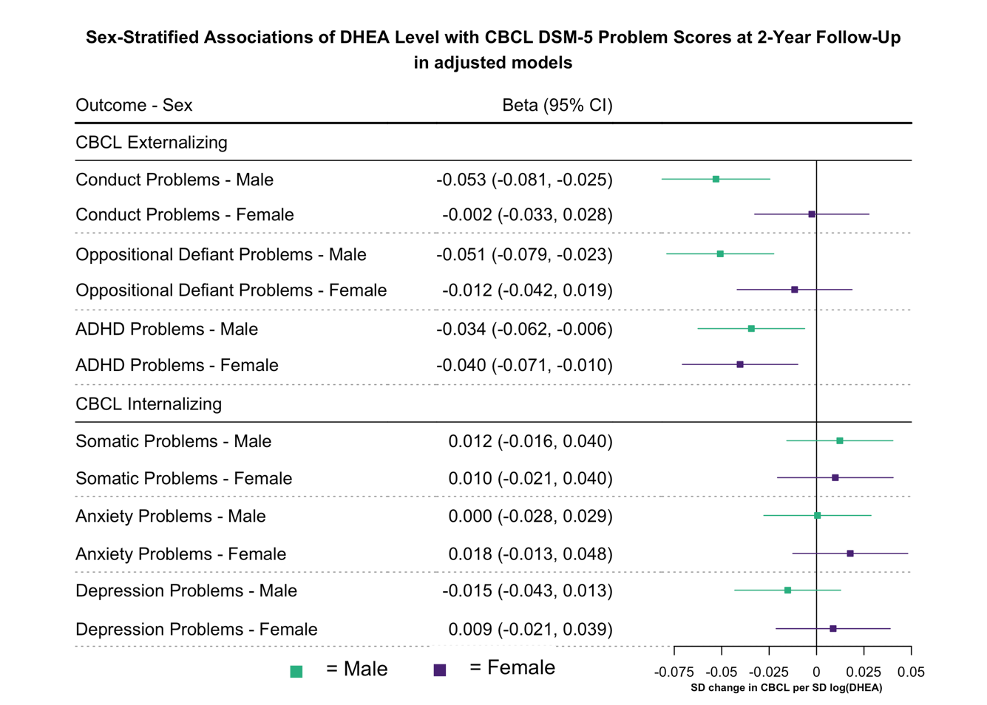Supplementary Figure S16. Associations of DHEA with DSM-5 Problem Scores at 2-Year Follow-Up.
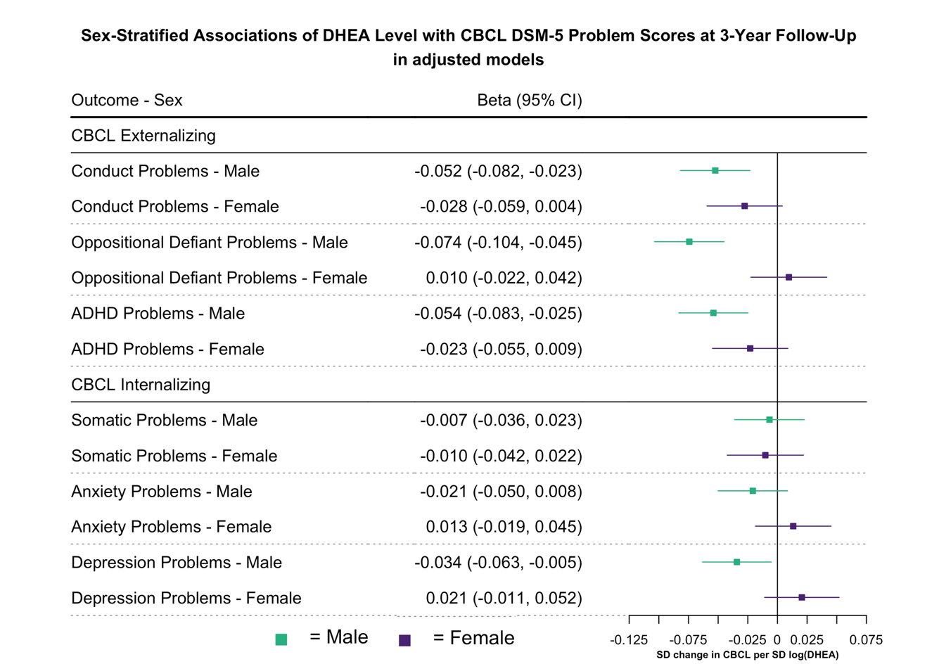
Supplementary Figure S17. Associations of DHEA with DSM-5 Problem Scores at 3-Year Follow-Up.

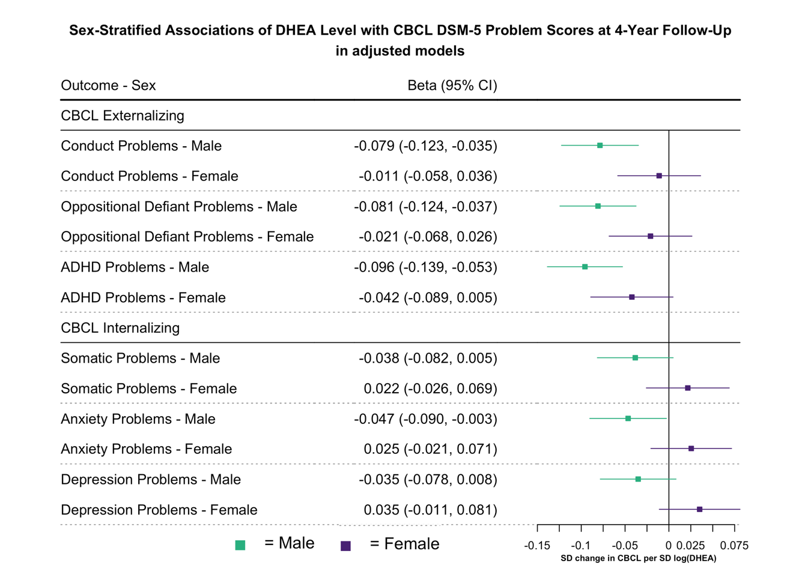Supplementary Figure S18. Associations of DHEA with DSM-5 Problem Scores at 4-Year Follow-Up.
Risk Ratio Analysis
To improve interpretability of the main analysis results, we computed risk ratios (RRs) for the association between DHEA levels and CBCL outcomes at 2-, 3-, and 4-year follow-up assessments. Therefore, we estimated adjusted risk ratios based on binomial regression models with a log link, directly quantifying the relative change in risk for meeting CBCL-defined thresholds per one-unit increase in log-transformed DHEA levels. These models were adjusted for age, race/ethnicity, BMI-SDS and physical activity, all assessed at baseline and were conducted separately for males and females. Due to convergence issues, random intercepts for family and site were not included in the final models. As a result, models do not account for potential clustering at the family or site level.
CBCL outcomes were categorized based on established T-score thresholds:
- T-score ≤ 59: Non-pathological (normal range)
- T-score 60–63: Borderline range
- T-score ≥ 64: Clinically significant (clinical range)
Separate models were computed for Externalizing and Internalizing problems at each follow-up time point (2, 3, and 4 years). For each domain, two binary outcome definitions were applied:
- Borderline + Clinical: T-score ≥ 60 vs. T-score ≤ 59
- Clinical: T-score ≥ 64 vs. T-score ≤ 59
This approach yielded four outcome models per follow-up year, allowing for consistent comparison of adjusted risk estimates across symptom domains and time points. Results are presented in Figure 2.

Sex-Interaction Effects
To investigate whether the relationship between hormonal levels and mental health outcomes varied by sex, we fitted linear mixed-effects models including a sex-by-hormone interaction term. We compared four nested models: (1) a baseline model with sex and covariates only, (2) a main-effects model adding hormone exposure (log-transformed mean or change in DHEA), and (3) a full model incorporating the sex × hormone interaction and (4) a model incorporating the sex × hormone interaction with CBCL externalizing/internalizing scores assessed at baseline as an additional covariate as prior symptomatology is known to predict later CBCL scores.
The sex-interaction effects of DHEA level on CBCL outcomes are illustrated in Figure 1. The table below further presents the effects of DHEA change across follow-ups, which did not show consistent or meaningful differences. We report beta estimates and 95% confidence intervals for our models. Adjusting for baseline CBCL scores did not substantially alter the estimates.

Supplementary Table S27. DHEA × Sex-Interaction Effects on CBCL Outcomes Across Follow-Up Years.

DHEA  Exposure | CBCL Outcome | Sex Effect |  | Sex Interaction |  | CBCL baseline ^{c}
 |  | b | 95%-CI | b | 95%-CI | b | 95%-CI
2-Year Follow-Up
Level ª | Externalizing | -0.15 | (-0.19, -0.11) | 0.05 | (0.02, 0.09) | 0.05 | (0.02, 0.08)
 | Internalizing | 0.09 | (0.05, 0.13) | 0.04 | (0.01, 0.08) | 0.04 | (0.01, 0.07)
Change ^{b} | Externalizing | -0.17 | (-0.22, -0.12) | -0.03 | (-0.08, 0.02) | -0.02 | (-0.06, 0.01)
 | Internalizing | 0.08 | (0.03, 0.13) | -0.03 | (-0.08, 0.02) | 0.00 | (-0.04, 0.04)
3-Year Follow-Up
Level ª | Externalizing | -0.15 | (-0.19, -0.11 ) | 0.06 | (0.02, 0.10) | 0.05 | (0.02, 0.08)
 | Internalizing | 0.17 | (0.13, 0.21) | 0.05 | (0.01, 0.09) | 0.04 | (0.01, 0.08)
Change ^{b} | Externalizing | -0.16 | (-0.22, -0.11) | -0.01 | (-0.06, 0.04) | 0.00 | (-0.04, 0.04)
 | Internalizing | 0.17 | (0.12, 0.23) | -0.02 | (-0.07, 0.03) | 0.01 | (-0.03, 0.05)
4-Year Follow-Up
Level ª | Externalizing | -0.09 | (-0.15, -0.03) | 0.07 | (0.01, 0.13) | 0.04 | (0.01, 0.09)
 | Internalizing | 0.27 | (0.21, 0.33) | 0.08 | (0.02, 0.14) | 0.05 | (0.00, 0.11)
Change ^{b} | Externalizing | -0.13 | (-0.20, -0.06) | -0.01 | (-0.07, 0.07) | 0.01 | (-0.05, 0.07)
 | Internalizing | 0.26 | (0.20, 0.33) | -0.03 | (-0.10, 0.03) | -0.01 | (-0.06, 0.05)
Abbreviations: DHEA = Dehydroepiandrosterone; CBCL = Child Behavior Checklist; b = Beta Estimate; 95%-CI = 95% Confidence Interval
a DHEA Level is defined as the natural logarithm of the arithmetic mean of Baseline and 1-Year Follow-Up DHEA values per participant.
b DHEA Change is defined as the natural logarithm of the ratio between 2-Year Follow-Up and Baseline DHEA values per participant.
c Sex-interaction model with CBCL baseline score as additional covariate.
Models were estimated using linear mixed-effects modeling (lmer package in R).

DHEA x Age Interaction Effects.

To examine whether the association between DHEA levels and behavioral outcomes varies with age, we conducted linear mixed-effects models including a DHEA × age interaction. Age at the time of outcome assessment, relevant covariates (race/ethnicity, BMI, physical activity), and random intercepts for site, family, and subject ID were included to account for clustering and repeated measurements.
Supplementary Table S28 presents the results. Across both sexes and CBCL domains, none of the DHEA × age interactions reached statistical significance, indicating that the relationship between DHEA and behavioral outcomes does not meaningfully change with age in this follow-up period.

Supplementary Table S28. DHEA x Age Interactions on CBCL Scores.
Outcome: CBCL Categories |  | Male |  |  | Female
Outcome: CBCL Categories |  | b | 95%-CI | p | b | 95%-CI | p
Externalizing |  | -0.01 | [-0.02, 0.01] | 0.357 | -0.01 | [-0.03, 0.00] | 0.071
Internalizing |  | -0.01 | [-0.02, 0.01] | 0.225 | 0.00 | [-0.01, 0.02] | 0.769
Abbreviations: CBCL = Child Behavior Checklist.
References
1. Lipsky AM, Greenland S. Causal directed acyclic graphs. Jama. 2022;327(11):1083-1084.
2. Sizonenko PC, Paunier L, Carmignac D. Hormonal changes during puberty: IV. Longitudinal study of adrenal androgen secretions. Hormone Research in Paediatrics. 1976;7(4-5):288-302.
3. Ilondo MM, Vanderschueren-Lodeweyckx M, Vlietinck R, Pizarro M, Malvaux P, Eggermont E, et al. Plasma Androgens in Children and Adolescents: Part I: Control Subjects. Hormones. 1982;16(2):61-77.
4. Öncü B, Öner Ö, Öner P, Erol N, Aysev A, Canat S. Symptoms defined by parents' and teachers' ratings in attention-deficit hyperactivity disorder: changes with age. The Canadian Journal of Psychiatry. 2004;49(7):487-491.
5. Goddings A-L, Viner RM, Mundy L, Romaniuk H, Molesworth C, Carlin JB, et al. Growth and adrenarche: findings from the CATS observational study. Archives of Disease in Childhood. 2021;106(10):967-974.
6. Erermis S, Cetin N, Tamar M, Bukusoglu N, Akdeniz F, Goksen D. Is obesity a risk factor for psychopathology among adolescents? Pediatrics international. 2004;46(3):296-301.
7. Bradley RH, Houts R, Nader PR, O'Brien M, Belsky J, Crosnoe R. The relationship between body mass index and behavior in children. The Journal of pediatrics. 2008;153(5):629-634. e623.
8. Camfferman R, Jansen PW, Rippe RC, Mesman J, Derks IP, Tiemeier H, et al. The association between overweight and internalizing and externalizing behavior in early childhood. Social Science & Medicine. 2016;168:35-42.
9. Mamun AA, O'callaghan MJ, Cramb SM, Najman JM, Williams GM, Bor W. Childhood behavioral problems predict young adults' BMI and obesity: Evidence from a birth cohort stud. Obesity. 2009;17(4):761-766.
10. Girgis R, Abrams S, Castracane VD, Gunn SK, Ellis KJ, Copeland KC. Ethnic differences in androgens, IGF-I and body fat in healthy prepubertal girls. Journal of Pediatric Endocrinology and Metabolism. 2000;13(5):497-504.
11. Nguyen L, Huang LN, Arganza GF, Liao Q. The influence of race and ethnicity on psychiatric diagnoses and clinical characteristics of children and adolescents in children's services. Cultural diversity & ethnic minority psychology. 2007;13(1):18.
12. Patel NC, Crismon ML, Shafer A, De Leon A, Lopez M, Lane DC. Ethnic variation in symptoms and response to risperidone in youths with schizophrenia-spectrum disorders. Social Psychiatry and psychiatric epidemiology. 2006;41(5):341-346.
13. Al-Turk W, Al-Dujaili EA. Effect of age, gender and exercise on salivary dehydroepiandrosterone circadian rhythm profile in human volunteers. Steroids. 2016;106:19-25.
14. Mäntyselkä A, Jääskeläinen J, Eloranta AM, Väistö J, Voutilainen R, Ong K, et al. Associations of lifestyle factors with serum dehydroepiandrosterone sulphate and insulin‐like growth factor‐1 concentration in prepubertal children. Clinical endocrinology. 2018;88(2):234-242.
15. Wu XY, Han LH, Zhang JH, Luo S, Hu JW, Sun K. The influence of physical activity, sedentary behavior on health-related quality of life among the general population of children and adolescents: A systematic review. PloS one. 2017;12(11):e0187668.
16. Sallis JF, Prochaska JJ, Taylor WC. A review of correlates of physical activity of children and adolescents. Medicine and science in sports and exercise. 2000;32(5):963-975.
17. Kantomaa MT, Tammelin TH, Näyhä S, Taanila AM. Adolescents' physical activity in relation to family income and parents' education. Preventive medicine. 2007;44(5):410-415.
18. Richmond RC, Davey Smith G, Ness AR, den Hoed M, McMahon G, Timpson NJ. Assessing causality in the association between child adiposity and physical activity levels: a Mendelian randomization analysis. PLoS medicine. 2014;11(3):e1001618.
19. Shirtcliff EA, Dahl RE, Pollak SD. Pubertal development: correspondence between hormonal and physical development. Child development. 2009;80(2):327-337.
20. Herting MM, Uban KA, Gonzalez MR, Baker FC, Kan EC, Thompson WK, et al. Correspondence between perceived pubertal development and hormone levels in 9-10 year-olds from the adolescent brain cognitive development study. Frontiers in Endocrinology. 2021;11:549928.
21. MacSweeney N. The role of brain structure in the association between pubertal timing and depression risk in early adolescence. Psychoneuroendocrinology. 2024;160:106702.
22. Laitinen‐Krispijn S, Van der Ende J, Hazebroek‐Kampschreur A, Verhulst F. Pubertal maturation and the development of behavioural and emotional problems in early adolescence. Acta Psychiatrica Scandinavica. 1999;99(1):16-25.
23. Tomova A, Robeva R, Kumanov P. Influence of the body weight on the onset and progression of puberty in boys. Journal of Pediatric Endocrinology and Metabolism. 2015;28(7-8):859-865.
24. Luo D, Dashti SG, Sawyer SM, Vijayakumar N. Pubertal hormones and mental health problems in children and adolescents: a systematic review of population-based studies. Eclinicalmedicine. 2024;76.
25. Parker LN. Adrenarche. Endocrinology and metabolism clinics of North America. 1991;20(1):71-83.
26. Hibel LC, Granger DA, Cicchetti D, Rogosch F. Salivary biomarker levels and diurnal variation: associations with medications prescribed to control children's problem behavior. Child development. 2007;78(3):927-937.
27. Rapp L, Pollatos O. Examining parental stress and its link to hair cortisol and DHEA levels in kindergartners. Psychology & Health. 2024:1-25.
28. Assari S. Youth social, emotional, and behavioral problems in the ABCD study: minorities’ diminished returns of family income. Journal of economics and public finance. 2020;6(4):1.
29. Lee A, Chua H-w, Chan M, Leung PW, Wong JW, Chuh AA. Health disparity still exists in an economically well-developed society in Asia. Plos one. 2015;10(6):e0130424.
30. Assari S, Malek-Ahmadi MR, Caldwell CH. Parental education or household income? Which socioeconomic Status indicator can better reduce body mass index disparities among Latino children? Journal of economics and public finance. 2021;7(1):19.
31. Bramsved R, Regber S, Novak D, Mehlig K, Lissner L, Mårild S. Parental education and family income affect birthweight, early longitudinal growth and body mass index development differently. Acta Paediatrica. 2018;107(11):1946-1952.
32. Petty CR, Rosenbaum JF, Hirshfeld-Becker DR, Henin A, Hubley S, LaCasse S, et al. The child behavior checklist broad-band scales predict subsequent psychopathology: A 5-year follow-up. Journal of anxiety disorders. 2008;22(3):532-539.
33. Oskis A, Loveday C, Hucklebridge F, Thorn L, Clow A. Diurnal patterns of salivary cortisol and DHEA in adolescent anorexia nervosa. Stress. 2012;15(6):601-607.
34. Uban KA, Horton MK, Jacobus J, Heyser C, Thompson WK, Tapert SF, et al. Biospecimens and the ABCD study: Rationale, methods of collection, measurement and early data. Developmental cognitive neuroscience. 2018;32:97-106.
35. Team RC. R: A language and environment for statistical computing. 4.4.3 ed. Vienna, Austria: R Foundation for Statistical Computing; 2025.
36. Burnham KP, Anderson DR. Multimodel inference: understanding AIC and BIC in model selection. Sociological methods & research. 2004;33(2):261-304.
37. Lewis F, Butler A, Gilbert L. A unified approach to model selection using the likelihood ratio test. Methods in ecology and evolution. 2011;2(2):155-162.
38. Petersen AC, Crockett L, Richards M, Boxer A. A self-report measure of pubertal status: Reliability, validity, and initial norms. Journal of youth and adolescence. 1988;17(2):117-133.
39. Huang B, Hillman J, Biro FM, Ding L, Dorn LD, Susman EJ. Correspondence between gonadal steroid hormone concentrations and secondary sexual characteristics assessed by clinicians, adolescents, and parents. Journal of Research on Adolescence. 2012;22(2):381-391.

