Supplementary Material

1. Study 1 - Is social anxiety in autism associated with unique social behaviors?

1.1 Relationship between self-reported social anxiety diagnoses and self-reported social avoidance behaviors

Individuals’ attestation of having social anxiety (SA) disorder diagnoses was significantly related to higher rates of self-reported social avoidance behavior (χ² = 27.81, 𝛽 = 0.57, S.E. = 0.11, 95% CI = [0.35, 0.79], p < 0.0001, Figure S1).

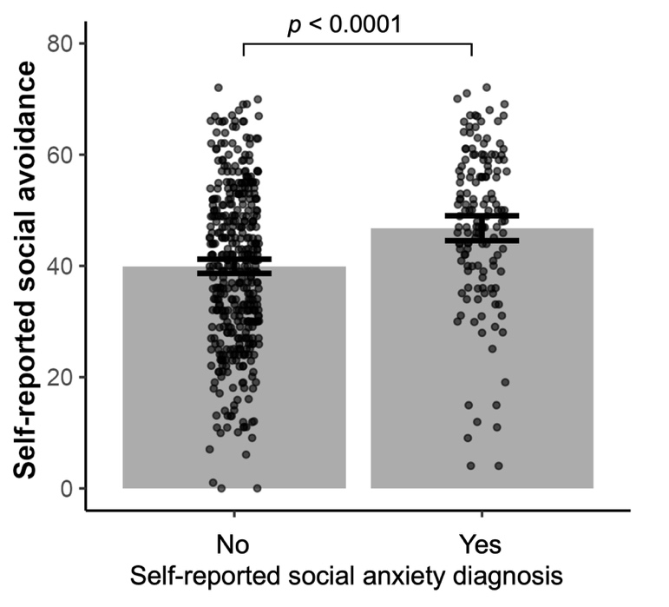
Figure S1. Relationship between self-reported social anxiety diagnoses and self-reported social avoidance behaviors in Study 1. Total sample size n = 575. Those reported social anxiety diagnoses n = 145 and those without social anxiety diagnoses n = 430. Error bars represent 95% confidence intervals.

Higher self-reported social avoidance behavior was also significantly correlated with self-rated autism symptom severity (r = 0.66, p < 0.0001). As in Study 1, higher self-reported social avoidance behavior was also significantly correlated with self-rated autism symptom severity in Study 2 (r = 0.79, p < 0.0001). This raises the possibility that the two constructs may overlap, that self-reported social avoidance could be elevated primarily due to autistic traits rather than true social anxiety, or that self-reported autistic traits are elevated due to high levels of social anxiety and avoidance rather than true autism-centered difficulties. Of note, higher clinician-rated autism symptoms on the Autism Diagnostic Observation Schedule (ADOS) in Study 2 was related to lower social avoidance (r = -0.24, p = 0.004), suggesting some independence of SA and autism symptoms

1.2 Demographic information comparing individuals with and without a self-reported history of social anxiety disorder diagnoses

Results showed that autistic individuals who reported SA, they were more likely to be females, and had lower education, lower cognitive function, higher self-rated autism symptom severity and higher social avoidance behaviors.

Table S1. Statistics of demographic information and main research variables for the online sample of autism (n = 575). Welch two-sample t-tests were performed to evaluate group differences of continuous variables based on self-reported depression diagnoses. Two-Proportion Z-Test was performed for proportion comparison. Significant differences are bolded.
 | Self-reported social anxiety Dx
 | YES (145, 25.22%) | NO (430, 74.78%) | test
Sex | 32 males  113 females | 134 males  296females | $χ^{2}$ = 4.37, p = 0.037
Age | 25.09 (3.33)  18.5 – 30.92 | 25.47 (3.30)  18.42 – 30.92 | t = -1.20, p = 0.230
Education | College and above  31  High school and below 114 | College and above  152  High school and below 278 | t = -3.11, p = 0.002
IQ | 26.54 (6.35)  3 – 36 | 27.87 (5.33)  3 – 36 | t = -2.27, p = 0.024
Cognitive delays | Yes 66  No 79 | Yes 152  No 278 | t = 2.14, p = 0.033
Self-rated autism symptom severity | 153.6 (20.68)  106 – 211 | 143.40 (22.78)  66 – 202 | t = 4.11, p < 0.0001
Social avoidance | 47.86 (13.92)  4 – 72 | 39.56 (14.33)  0 – 72 | t = 41.42, p < 0.0001
Affiliation behaviors | 0.09 (0.31)  -0.67 – 0.8 | 0.15 (0.30)  -0.80 – 0.80 | t = -1.78, p = 0.076
Power behaviors | -0.15 (0.21)  -0.67 – 0.47 | -0.11 (0.20)  -0.60 – 0.40 | t = -2.05, p = 0.042

Note: IQ was measured by standard cognitive test from TestMyBrain (https://www.testmybrain.org). Cognitive delays were self-reported conditions including intellectual disability, specific language impairment, or global developmental delays and related conditions. Self-reported autism symptom severity was measured by Broad Autism Phenotype Questionnaire (BAPQ, 68% (N = 391) of the sample completed it). Social avoidance was measured by self-report Liebowitz Social Anxiety Scale.
1.3 Robustness tests
To further confirm the robustness of our findings, we conducted two additional analyses. First, we reversed the roles of the independent and dependent variables by using task-derived power behavior as the dependent variable and SA (with other demographic information, IQ and self-reported cognitive delays as covariates) as predictors. This analysis yielded consistent results showing that lower task-derived power behavior was related to self-reported SA (F = 4.93, $β$ = -0.21, S.E. = 0.10, p = 0.027). When additionally adding task-derived affiliation behavior in the model as a covariate, the result was still significant (p = 0.042).

Next, our result also held in the subset (n = 391, 68% of the total sample) who completed Broad Autism Phenotype Questionnaire for self-rated autism symptom severity ($χ^{2}$ = 6.20, $β$ = -0.32, S.E. = 0.13, p = 0.013).

Finally, we ran 1,000 bootstrap iterations on the relationship between task-derived power behavior and self-reported SA, which produced consistent findings ($β$ = -0.23, S.E. = 0.11, 95% CI = [-0.46, -0.02]). These results show that SA in autism was reliably associated with acquiescent behaviors.

1.4 Social behaviors relation to social anxiety in ASD vs. neurotypical controls
In order to assess the relationship between SA and social behaviors for those with ASD and neurotypical (NT) controls, we conducted an exploratory analysis using a subset of participants from Study 1 who had no cognitive delays, and a matched NT online sample (n = 357) based on sex, age, and education. For demographic comparisons between the ASD and NT groups of Study 1 see Table S2. The results showed that compared with non-autistic individuals who reported SA diagnoses, those autistic individuals who declared SA had lower income, higher self-rated autism symptom severity and higher social avoidance behaviors. Consistent with the broad literature, the ASD sample had a greater proportion of SA than NT.

Table S2. Statistics of demographic information and main research variables for the comparison of ASD and neurotypical (NT) controls. Welch two-sample t-tests were performed to evaluate group differences of continuous variables between the ASD and NT samples. Two-Proportion Z-Tests were performed for proportion comparisons. Significant differences are bolded.
 | ASD (n = 357) | NT (n = 357) | test
Sex | M 84 F 273 | M 93 F 264 | $χ^{2}$ = 0.61, p = 0.435
Age | 25.33 (3.25)  18.5 – 30.92 | 25.01 (3.40)  18 – 34 | t = 1.28, p = 0.202
Education | College and above  129  High school and below 228 | College and above  187  High school and below 170 | t = -1.36, p = 0.173
Self-rated autism symptom severity | 145.52 (22.95)  96 – 211 | 113.00 (21.85)  50 – 189 | t = 19.10, p < 0.0001
Social avoidance | 42.11 (14.04)  1 – 72 | 31.47 (14.83)  0 – 69 | t = 9.84, p < 0.0001
Affiliation behaviors | 0.13 (0.30)  -0.8 – 0.8 | 0.33 (0.25)  -0.53 – 0.73 | t = -9.86, p < 0.0001
Power behaviors | -0.13 (0.20)  -0.60 – 0.47 | -0.02 (0.19)  -0.53 – 0.53 | t = -7.69, p < 0.0001
Self-reported social anxiety Dx | Yes 79 (22.13%)  Male 11 Female 68 | Yes 25 (7.08%)  Male 5 Female 20 | $χ^{2}$ = 32.82, p < 0.0001

Note: Self-reported autism symptom severity was measured by Broad Autism Phenotype Questionnaire (BAPQ, 68% (N = 391) of the sample completed it). Social avoidance was measured by self-report Liebowitz Social Anxiety Scale.

We also examined whether perceived social relations with game characters related to SA. We found that there was no main effect of SA on perceived affiliation (p = 0.650) or interaction between SA and group (ASD vs NT, p = 0.941), but there was a main effect of group where the NT group perceived greater affiliation with game characters than the ASD group (p = 0.004), see Fig. S2A. There was no main effect of SA (p = 0.482) and no main effect of group (p = 0.279) on perceived power, and there was no interaction of group and SA (p = 0.689), see Fig. S2B.

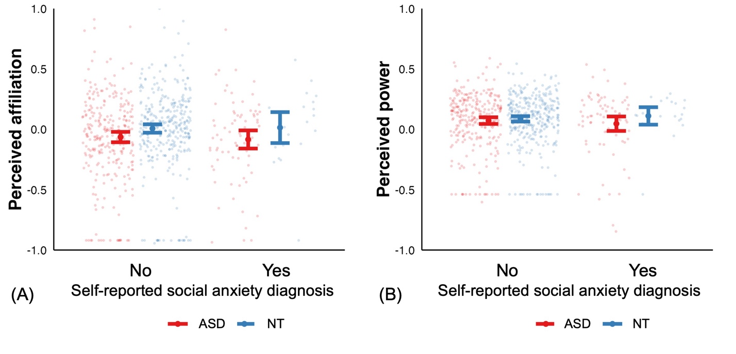Figure S2. Relationship between perceived social relations during the game and self-reported SA diagnoses in ASD and NT groups. Separate models predict perceived affiliation and perceived power including an interaction term for group (ASD vs. NT) and SA (yes vs. no), with sex, age, and education as covariates. Error bars represent 95% confidence intervals.

2. Study 2 – Are social anxiety and social behavior in autism associated with amygdala volume?

2.1 Relationship between self-reported social anxiety diagnoses and self-reported social avoidance behaviors

Individuals’ attestation of having SA diagnoses was significantly related to higher rates of self-reported social avoidance behavior (χ² = 5.90, 𝛽 = 0.89, S.E. = 0.40, 95% CI = [0.11, 1.67], p = 0.015, Figure S3). As in Study 1, higher self-reported social avoidance behavior was also significantly correlated with self-rated autism symptom severity in Study 2 (r = 0.79, p < 0.0001).
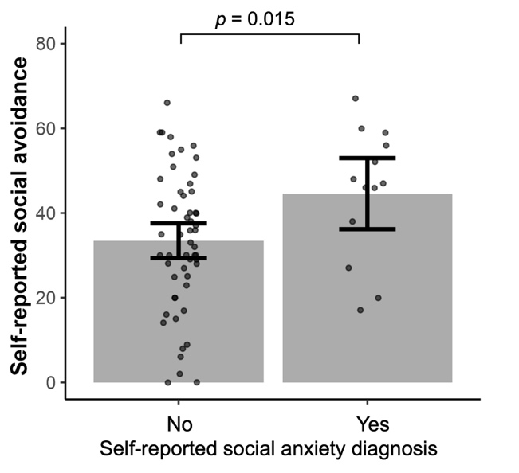
Figure S3. Relationship between self-reported social anxiety diagnoses and self-reported social avoidance behaviors in Study 2. Error bars represent 95% confidence intervals.

2.2 Demographic information comparing individuals with and without a self-reported history of social anxiety disorder diagnoses

Results showed that for autistic individuals who reported SA, they had lower clinician-rated autistic symptom severity and higher self-reported social avoidance behaviors.

Table S3. Statistics of demographic information and main research variables for onsite ASD neuroimaging sample (n = 72). Welch two-sample t-tests were performed to evaluate group differences of continuous variables based on self-reported depression diagnoses. Two-Proportion Z-Test was performed for proportion comparison. Significant differences are bolded.
 | Self-reported social anxiety Dx
 | YES (15, 21%) | NO (57, 78%) | test
Sex | 5 males  10 females | 29 males  28 females | $χ^{2}$ = 1.93, p = 0.164
Age | 25.68 (7.56)  18.16 – 45.80 | 27.15 (7.82)  18 – 50.36 | t = -0.67, p = 0.512
Education | College and above  8  High school and below 7 | College and above  36  High school and below 21 | t = -1.72, p = 0.097
IQ | 102.80 (14.50)  77 – 131 | 106.17 (17.05)  67 – 140 | t = -0.73, p = 0.473
Clinician-rated autism symptom severity | 12.87 (3.04)  6 – 19 | 14.84 (4.03)  7 – 26 | t = -2.08, p = 0.047
Self-rated autism symptom severity | 149.10 (27.52)  96 – 189 | 137.80 (24.21)  93 – 187 | t = 1.53, p = 0.141
Social avoidance | 44.20 (14.55)  17 – 67 | 33.33 (16.15)  0 – 66 | t = 11.77, p < 0.0001
Affiliation behaviors | 0.11 (0.38)  -0.43 – 0.80 | 0.17 (0.31)  -0.60 – 0.73 | t = -0.62, p = 0.540
Power behaviors | -0.07 (0.17)  -0.29 – 0.31 | -0.13 (0.19)  -0.52 – 0.31 | t = 1.31, p = 0.203
Right amygdala volume (mm³) | 1226 (203)  804 – 1664 | 1110 (282)  558 – 1765 | t = 1.81, p = 0.081
Left amygdala volume (mm³) | 1279 (151)  1079 – 1580 | 1155 (280)  416 – 1688 | t = 2.31, p = 0.026
Averaged amygdalae volume (mm³) | 1253 (132)  1041 – 1555 | 1133 (236)  531 – 1688 | t = 2.60, p = 0.013
Intracranial volume (mm³) | 921025 (116193)  765682 – 1206785 | 988001 (156985)  716799 – 1369934 | t = -1.83, p = 0.077

Note: IQ was measured by Wechsler Abbreviated Scale of Intelligence and Wechsler Intelligence Scale for Adults. Clinician-rated autism symptom severity was determined by licensed clinicians using Autism Diagnostic Observation Schedule, 2nd edition. Self-reported autism symptom severity was measured by Broad Autism Phenotype Questionnaire. Social avoidance was measured by self-report Liebowitz Social Anxiety Scale.

2.3 Robustness tests
To further confirm the robustness of our findings, we conducted two additional analyses. First, we reversed the independent and dependent variables by using amygdala volume as the dependent variable and SA (with other demographic information and IQ) as predictors. This analysis yielded consistent results showing that larger amygdala volume was related to self-reported SA (F = 5.26, $β$ = 0.67, S.E. = 0.29, p = 0.025). Second, we ran 1,000 bootstrap iterations on the relationship between amygdala volume and self-reported SA, which produced consistent findings ($β$ = 0.88, S.E. = 0.40, 95% CI = [0.15, 1.56]). These results show that SA in autism was reliably associated with larger amygdala volume.

2.4 Amygdala volume relation to social anxiety in ASD vs. NT
We conducted an exploratory analysis comparing ASD with NT onsite sample. These two samples did not differ by sex and age. For demographic comparisons between the ASD and NT groups of Study 2 see Table S4.
Table S4. Statistics of demographic information and main research variables for onsite samples. Welch two-sample t-tests were performed to evaluate group differences of continuous variables between the ASD and NT samples. Two-Proportion Z-Tests were performed for proportion comparisons. Significant differences are bolded.
 | ASD (n = 72) | NT (n = 72) | test
Sex | M 34 F 38 | M 27 F 45 | $χ^{2}$ = 1.39, p = 0.2378
Age | 26.85 (7.74)  18 – 50.36 | 25.89 (6.44)  18.87 – 50.02 | t = 0.83, p = 0.4107
Education | College and above  44  High school and below 28 | College and above  64  High school and below 8 | t = -4.79, p < 0.0001
IQ | 105.50 (16.54)  67 – 140 | 113.7 (13.91)  76 – 135 | t = -2.91, p = 0.0043
Intracranial volume | 974048 (151162) | 963996 (120313) | t = 0.44, p = 0.6596
Self-rated autism symptom severity | 140.30 (25.21) | 93.11 (21.14)  44 – 150 | t = 11.90, p < 0.0001
Social avoidance | 35.60 (16.35) | 21.16 (12.90)  1 – 51 | t = 18.48, p < 0.0001
Affiliation behaviors | 0.16 (0.33)  -0.60 – 0.80 | 0.36 (0.25)  -0.31 – 0.87 | t = -4.14, p < 0.0001
Power behaviors | -0.12 (0.18)  -0.52 – 0.31 | -0.09 (0.22)  -0.52 – 0.36 | t = -0.96, p = 0.341
Right amygdala volume (mm³) | 1134 (271)  558 – 1765 | 1129 (245)  509 – 1534 | t = 0.12, p = 0.903
Left amygdala volume (mm³) | 1181 (262)  416 – 1688 | 1131 (262)  396 – 1579 | t = 1.14, p = 0.257
Averaged amygdalae volume (mm³) | 1158 (223)  531 – 1688 | 1130 (205)  639 – 1521 | t = 0.77, p = 0.443
Intracranial volume (mm³) | 974048 (151163)  716799 – 1369934 | 962581 (120565)  695642 – 1304039 | t = 0.50, p = 0.617
Self-reported social anxiety Dx | Yes 15 (21 %)  Male 5 Female 10 | Yes 9 (12.5%)  Male 3 Female 6 | $χ^{2}$ = 1.8, p = 0.180

Note: IQ was measured by Wechsler Abbreviated Scale of Intelligence and Wechsler Intelligence Scale for Adults. Self-reported autism symptom severity was measured by Broad Autism Phenotype Questionnaire. Social avoidance is measured by self-report Liebowitz Social Anxiety Scale.

3. Naturalistic Social Navigation Task in Autistic Populations
In this study, participants engaged with a naturalistic game designed to map out their individual social space, tracing their interactive pathways with various characters. We have two versions of the game for Study 1 and Study 2. In Study 1, participants started a new school and needed to find their way around and settle in. Their task was to join a club and find a locker at their new school. In Study 2, participants found themselves in a new town, with the objective of securing employment and housing by interacting with local residents. The task structure, in terms of the number and type of interactions and roles of characters, was designed to parallel the original task exactly. During gameplay, participants encountered different social characters, with conversation occurring via text bubbles. The characters possessed distinct attributes suggestive of their social roles—such as an old acquaintance, an assistant, or a potential employer. Participants navigated the social scenarios by choosing from two dialogue options, using button presses to dictate their responses. The only active engagement required of participants in the scenario was choosing between the two presented actions for each situation. This was a forced-choice task. The options were validated during task development to ensure that each interaction reflected either power or affiliation, and that each choice represented a higher or lower level within that dimension. The task was pre-validated in an independent sample using an earlier version of the stimuli: in a sample of 100 participants, each interaction and its two response options were rated for whether they reflected power or affiliation and for the direction of movement along that dimension (e.g., gaining vs. losing power, increasing vs. decreasing affiliation). Only trials with strong consensus on the relevant social dimension and clear differentiation between the two options were retained, and the narrative was then iteratively refined on Amazon Mechanical Turk to ensure that choices reliably expressed the intended social dynamics.

Participants understood that they were acting as the protagonist in a fictional story. This design is similar to many simulation games that place individuals in scenarios where they respond according to their natural tendencies. The structure of the task resembles a choose-your-own-adventure game: the narrative is fixed across participants, but their individual choices personalize the storyline. There are no right or wrong responses and no feedback, and all participants ultimately reach the same goals. The task is designed to capture how participants make social decisions, rather than to assess learning or performance based on correct answers.

Some of these responses represent social affiliation behaviors with one option representing higher affiliation behavior (= +1) and the other option representing lower affiliation behavior (= -1). On the other hand, some of these responses represent social power behaviors – either being authoritative (= +1) or submissive (= -1). Each choice was validated to indicate directional movement along the affiliation or power axis—whether a decision brought the participant closer or further from the character, or increased or decreased their relative power. The +1/–1 scoring system approximates these directional shifts, capturing relative rather than absolute positions, and reflects whether participants endorsed or rejected pro-affiliation or pro-power options. Apart from an example power trial in Figure 1, some other power trials are: You wait for Chris to take the middle seat (+1) or you immediately move over to the middle seat (-1). Maya says to you: “there is a phone number on their website.” You go to the website on your phone (-1) or you say, “give them a call and schedule a meeting, please (+1).” Some example affiliation trials are: You say “So, what’s the deal with Maya? Catch me up! (+1) or you continue looking at your phone (-1). Chris goes in for a hug. You shake his hand instead (-1) or you hug him for a long moment (+1).

There are 5 characters in the game, such as boss or assistant, and for each character, there are 6 trials of affiliation choices and 6 trials of power choices. Three additional trials involved neutral interaction with a control character. For analysis, we calculated the mean of affiliation and power choices across all trials to represent affiliation behaviors and power behaviors, respectively. After completing the task, participants were asked to rate their feelings of affiliation and power with those characters on a 2-D space. They were instructed that affiliation represented the friendship or intimacy they felt with each character and that power represented the control and dominance they felt each character possessed over them. We then calculated the mean of the affiliation perceptions and power perceptions across the 5 characters to represent perceived affiliation and perceived power.

To address concerns regarding the construct validity of our naturalistic social navigation task, particularly its relevance and specificity to social affiliation and power dynamics in autistic populations, we conducted item-level analyses by categorizing trials according to core autism phenotype domains.
3.1 Trial Categorization Based on Autism Phenotypes
Affiliation Trials:
Within the 30 affiliation trials, we identified the following categories corresponding to autism-related social phenotypes:
- Physical Intimacy (2 trials): Items involving tactile engagement, such as “You go for a fist bump instead vs. You smile and hug him back” and “You hug her vs. You shake hands instead.”
- Social Approach/Avoidance (5 trials): Scenarios involving initiating or avoiding social contact, e.g., “You smile politely and wait to introduce yourself vs. You stand aside while they talk and check your schedule.”
- Theory of Mind / Perspective Taking (4 trials): Scenarios involving inference of others’ mental states, e.g., “I think that’s pretty common actually vs. Wow, they must really like you to have kept you that long.”
- Verbal Communication / Social Reciprocity (9 trials): Scenarios involving conversational reciprocity or social engagement, e.g., “Definitely, we have a lot to talk about vs. I’ll try but I have a lot going on right now.”
Other trials may integrate multiple features, but their overarching framing is affiliative and prosocial in nature. These trials simulate high-level, naturalistic social behaviors that align with real-life interpersonal interactions.
Power Trials:
Within the 30 power trials, no items involved physical touch or emotional expressivity. They reflect complex social behavior, but within a context of control, compliance, and autonomy.
- Following Demands / Obedience: Scenarios depicting compliance vs. resistance to authority or social pressure. For example:
  - “I'm good here—grab a chair and join us vs. You sit where he directed you.”
  - “You reluctantly stay late and walk home vs. You work hard but leave on time so you can get a ride home.”
  - “I can’t—maybe just leave it here and do it tomorrow vs. You hate when he bosses you around but drop off the supplies anyway.”
Although the power trials, like the affiliation trials, may include elements such as perspective taking, verbal negotiation, or routine preference, they are conceptually unified by their core framing around control, deference, and social-status negotiation. These features define the “power” construct in our task and therefore do not warrant subdivision into separate categories.
3.2 Group Differences on Item Categories
Using matched samples (n = 357 per group), we conducted statistical analyses for each phenotype category:
- Physical Intimacy: F = 60.26, β = 0.43, S.E. = 0.06, p < 0.001
- Social Approach/Avoidance: F = 32.14, β = 0.18, S.E. = 0.03, p < 0.001
- Theory of Mind / Perspective Taking: F = 52.81, β = 0.23, S.E. = 0.03, p < 0.001
- Verbal Communication / Reciprocity: F = 110.07, β = 0.31, S.E. = 0.03, p < 0.001
These results indicated that the ASD group showed significantly lower physical intimacy behaviors, greater social avoidance, reduced perspective taking, and poorer verbal communication than control group. We also found that autistic individuals with co-occurring social anxiety (ASD with SA) exhibited more pronounced difficulties than those without SA, particularly in:
- Social Avoidance Behaviors: χ² = 6.60, β = –0.56, S.E. = 0.22, p = 0.010
- Verbal Communication / Reciprocity: χ² = 7.98, β = –0.64, S.E. = 0.23, p = 0.005
These two aspects were supported by systematic reviews of features related to social anxiety in ASD (Montaser et al., 2023; Spain et al., 2017). Notably, differences between ASD with SA and ASD without SA emerged in average power trials but not in averaged affiliation trials as shown in our main analyses, further supporting the sensitivity of the task to distinct social anxiety profiles within the autism spectrum.
3.3 Summary
Our innovative naturalistic task was intentionally designed to simulate affiliation and power-based social scenarios that integrate multiple autism phenotype dimensions—including social motivation, reciprocity, compliance, and communication—within realistic decision-making contexts. By validating individual items against known autism-relevant constructs and documenting robust ASD vs. control group differences, we demonstrated the construct specificity and ecological validity of the task. Furthermore, the task proved sensitive enough to detect nuanced subgroup differences within the autistic population, such as the influence of social anxiety on power-related behaviors. These results support the task's utility for studying complex, higher-order social processes in autism and encourage future research applying it in intervention, stratification, and translational settings.
4. The effect of autism symptom severity on social behaviors and social anxiety
It is possible that autism symptom severity confounds the observed association between social anxiety and task-derived social behaviors or amygdala volume. We conducted additional analyses. First, we examined associations between BAPQ scores and task-derived affiliation and power behaviors; second, we re-ran the predictive models for social anxiety controlling for autism symptom severity.
In Study 1, self-rated autism symptom severity was negatively associated with task-derived power and affiliation behaviors (ps < .001): higher symptom severity corresponded to lower power and affiliation scores. When controlling for self-rated symptom severity, the association between task-derived power behaviors and social anxiety was attenuated by 20.6% (χ² = 3.78, p = .052). Higher self-rated autism symptom severity was also associated with a higher likelihood of social anxiety (χ² = 8.95, p = .003).
In Study 2, self-rated autism symptom severity showed a marginal association with affiliation behaviors (p = .056) and was unrelated to power behaviors (p = .456). Controlling for self-rated symptom severity did not change the association between amygdala volume and social anxiety (χ² = 6.09, p = .014). In addition, Study 2 also collected clinician-rated autism symptoms severity. We found that clinician-rated autism symptom severity was unrelated to both social behavior measures (ps > .23). Controlling for clinician-rated symptom severity attenuated the association between amygdala volume and social anxiety by 12% (χ² = 3.75, p = .053). The association between clinician-rated symptom severity showed the opposite trend from self-rated symptoms severity: higher clinician-rated symptom severity itself was marginally associated with lower likelihood of social anxiety (χ² = 3.25, p = .071).

Finally, although autism symptom severity (self-reported or clinician-rated) showed mixed associations with task-derived social behaviors across our two studies, exploratory analyses suggest that autism symptom severity might partially contribute to individual differences in social anxiety among autistic adults. Given our modest sample sizes and marginal results, we interpret these findings cautiously and encourage future studies with larger and more heterogeneous ASD samples to examine this relationship more systematically.

