Supplementary Information

Faerman A, Lissemore JI, Geoly A, et al; Is ibogaine treatment durable? 12-month follow-up of magnesium–ibogaine therapy (MISTIC) in Special Operations Veterans with traumatic brain injuries.

Definitions of Remission, Response, and Relapse
The following definitions were used to define remission, response, and relapse in Kaplan-Meier survival analyses. Remission was defined as a loss of diagnosis and Clinician-Administered PTSD Scale for DSM-5 (CAPS-5) total score <12 for posttraumatic stress disorder (PTSD), Montgomery–Åsberg Depression Rating Scale (MADRS) total score <8 for major depressive disorder (MDD), and Hamilton Anxiety Rating Scale (HAM-A) total score <8 for anxiety. Response was defined as a reduction of at least 10 points on the CAPS-5 for PTSD, 50% on the MADRS for MDD, and 50% on the HAM-A for anxiety. To assess the duration of remission, relapse was defined as the first recorded departure from remission criteria for a respective diagnosis. To assess the duration of response, relapse was defined as the first recorded departure from response criteria for a respective diagnosis.

Kaplan-Meier Survival Analysis of Duration of Remission
Kaplan-Meier survival estimates were derived using the survfit function from the survival package in R (4.3.2). Of note, Kaplan-Meier survival analyses typically report median survival times with corresponding 95% confidence intervals for upper and lower bounds. The median survival time is defined as the length of time in which half of the patients develop clinical events. Modest to low survival rates (less than 50%), minimal censoring, large sample sizes, and sufficient follow-up are required for survival to be estimated at less than 50%. Otherwise, the median survival time and corresponding 95% confidence intervals cannot be determined reliably. In such cases, the restricted mean survival time (RMST) and its standard error may be reported instead, as was done presently. Survival curves, cumulative risk, and censor tables were then visualized using the ggsurvplot function in R.

Survival curves for MDD, anxiety, and PTSD were compared statistically using a log-rank test with the survdiff function to evaluate any differences in relapse across each diagnostic dimension, with significance defined as p<0.05. Where significant differences (if any) were detected, follow-up pairwise log-rank comparisons using the pairwise_survdiff function were performed using FDR correction for multiple comparisons.

Kaplan-Meier Survival Analysis of Duration of Response
Kaplan-Meier survival analysis was also performed for participants who met MINI diagnostic criteria at baseline and also met response criteria immediately post-MISTIC for PTSD (n=22), depression (n=15), and anxiety (n=13), respectively. The duration of response was also explored in all participants who met response criteria immediately post-MISTIC for PTSD (n=28), depression (n=29), and anxiety (n=28), respectively. Cases that were lost to follow-up or never experienced a relapse were censored at their last recorded observation.

Cox Regression Analysis
Additional exploratory analyses of pretreatment predictors of relapse were performed using separate univariate Cox regression models using the R coxph function, examining hazard ratios (HR) for age, Combat Exposure Scale (CES), baseline symptom severity (CAPS-5, MADRS, HAM-A), and number of TBIs, respectively. If significant (p < 0.05) univariate predictors were found, a follow-up multivariate analysis was performed to explore joint contributions to relapse for each diagnosis.

Baseline Correlates of Long-Term Clinical Score Trajectories
Exploratory correlations were also performed to investigate whether baseline characteristics were related to long-term clinical score trajectories after ibogaine treatment. The long-term variability of clinical scores was quantified by first fitting a linear model of clinical change from immediately post-MISTIC to the 12-month follow-up (for World Health Organization Disability Assessment Schedule/WHODAS, CAPS-5, MADRS, and HAM-A separately), then calculating average model residuals for each participant (i.e., the difference between observed values and values predicted by the model). Positive residuals, therefore, reflect poorer, less stable outcomes over time, and zero or negative residuals reflect more favorable outcomes. Spearman’s correlations were performed between baseline characteristics (age, CES, and baseline symptom severity) and model residuals for each outcome measure. FDR correction was applied to correct for multiple comparisons.

RESULTS
Table S1. Additional interventions pursued during long-term follow-up. Of the 27 participants with long-term follow-up data, subgroups of interest were defined based on types of interventions pursued at any point during the 12-month follow-up period. Percentage improvement from baseline to last follow-up is reported for participants who did not pursue each intervention. When sample size permitted, percentage change from baseline to last recorded follow-up was compared between participants who did vs. did not pursue the intervention (p-values shown for two-tailed non-parametric Mann-Whitney tests). Of note, these subgroups are not sensitive to the modality, duration, and consistency of the interventions provided, and instead reflect whether participants pursued different types of activities. Given the small sample sizes in these subgroup analyses, results should be interpreted with caution. One participant reported no subsequent psychedelic use, structured mental health treatment, or psychotropic medication during follow-up, precluding meaningful subgroup analysis of a no-intervention subgroup. Of note, that participant showed large clinical improvements at 12 months (>85% improvement across all scales).
Intervention pursued | n pursued | n not pursued | % improvement (Mean ± SD, did not pursue) | Mann-Whitney test (p-value: pursued vs. not pursued)
Structured mental health treatment* | 12 | 15 | WHODAS: 79 ± 17  CAPS: 90 ± 10  MADRS: 81 ± 16  HAMA: 80 ± 14 | WHODAS: 0.64  CAPS: 0.51  MADRS: 0.77  HAMA: 0.73
Psychotropic medication | 3 | 24 | WHODAS: 81 ± 17  CAPS: 90 ± 11  MADRS: 85 ± 15  HAMA: 84 ± 13 | N/A
Psychedelics
5-MeO-DMT** | 19 | 8 | WHODAS: 81 ± 20  CAPS: 77 ± 24  MADRS: 74 ± 23  HAMA: 70 ± 27 | WHODAS: 0.51  CAPS: 0.17  MADRS: 0.23  HAMA: 0.12
Psilocybin*** | 15 | 12 | WHODAS: 83 ± 15  CAPS: 87 ± 20  MADRS: 82 ± 21  HAMA: 79 ± 25 | WHODAS: 0.23  CAPS: 0.45  MADRS: 0.34  HAMA: 0.61
Ibogaine*** | 5 | 22 | WHODAS: 75 ± 26  CAPS: 86 ± 19  MADRS: 84 ± 17  HAMA: 79 ± 24 | N/A
Ayahuasca | 1 | 26 | WHODAS: 75 ± 24  CAPS: 86 ± 18  MADRS: 82 ± 18  HAMA: 78 ± 23 | N/A
* Includes any type of therapy or counselling with a health professional. Does not include mindfulness, coaching, AA, and self-help.
** Ambio Life Sciences offers a 5-MeO-DMT treatment session after ibogaine treatment as part of their usual services (offered after the 1-month follow-up for study participants).
*** Includes reports of microdosing.

Table S2. Sensitivity analyses excluding participants who did not meet diagnostic criteria for PTSD, depression, or anxiety disorder at baseline. Linear mixed-effects model results show long-term improvements in PTSD, depression, and anxiety after MISTIC in participants who met diagnostic criteria. Only 12-month primary outcomes are shown due to small sample sizes at 3, 6, and 9 months in subgroups.
 |  | Baseline | 12 Months
CAPS | N | 23 | 19
CAPS | M (SD) | 35.7 (11.0) | 5.1 (7.7)
CAPS | F | - | 322.82
CAPS | $$p_{FDR}$$ | - | <.001
CAPS | d | - | 3.04
MADRS | N | 15 | 11
MADRS | M (SD) | 31.3 (6.5) | 8.5 (6.6)
MADRS | F | - | 183.01
MADRS | $$p_{FDR}$$ | - | <.001
MADRS | d | - | 3.58
HAMA | N | 14 | 12
HAMA | M (SD) | 23.8 (7.6) | 3.9 (4.1)
HAMA | F | - | 123.50
HAMA | $$p_{FDR}$$ | - | <.001
HAMA | d | - | 2.16
Results are presented as raw mean (M) and standard deviation (SD). Degrees of freedom: (1, 117) for CAPS-5, (1, 72) for MADRS, and (1,71) for HAM-A. Cohen’s d reflects the effect size for the contrast between 12 months post-treatment and baseline. Abbreviations: CAPS-5 = Clinician Administered PTSD Scale for DSM-5; MADRS = Montgomery–Åsberg Depression Rating Scale; HAM-A = Hamilton Anxiety Rating Scale; p_{FDR} = p-value with false discovery rate correction for multiple comparisons.

Table S3. Sensitivity analyses including only participants with a history of mild TBI. Linear mixed-effects model results demonstrate sustained improvements in functional disability (WHODAS-2.0), PTSD (CAPS-5), depression (MADRS), and anxiety (HAM-A) after ibogaine treatment.
 |  | Baseline | 3 Months | 6 Months | 9 Months | 12 Months
WHODAS | N | 28 | 7 | 15 | 14 | 24
WHODAS | M (SD) | 30.2 (14.8) | 5.2 (6.3) | 8.3 (8.7) | 7.8 (7.2) | 8.7 (12.5)
WHODAS | F | - | 47.61 | 63.67 | 60.82 | 95.25
WHODAS | $$p_{FDR}$$ | - | <.001 | <.001 | <.001 | <.001
WHODAS | d |  | 2.41 | 1.96 | 1.79 | 2.25
CAPS | N | 28 | 9 | 19 | 16 | 24
CAPS | M (SD) | 31.7 (13.0) | 3.2 (2.5) | 4.8 (5.8) | 4.6 (5.4) | 4.5 (7.0)
CAPS | F | - | 155.76 | 227.06 | 222.62 | 279.97
CAPS | $$p_{FDR}$$ | - | <.001 | <.001 | <.001 | <.001
CAPS | d | - | 3.28 | 2.22 | 2.86 | 2.66
MADRS | N | 28 | 9 | 19 | 16 | 24
MADRS | M (SD) | 25.2 (8.7) | 2.0 (2.7) | 4.5 (5.3) | 4.3 (4.1) | 5.0 (5.6)
MADRS | F | - | 188.11 | 247.38 | 240.86 | 274.87
MADRS | $$p_{FDR}$$ | - | <.001 | <.001 | <.001 | <.001
MADRS | d | - | 4.21 | 2.88 | 3.94 | 3.29
HAMA | N | 28 | 9 | 19 | 16 | 24
HAMA | M (SD) | 20.7 (8.6) | 3.8 (2.7) | 3.5 (3.1) | 4.7 (4.6) | 3.8 (3.7)
HAMA | F | - | 107.59 | 185.10 | 150.01 | 207.14
HAMA | $$p_{FDR}$$ | - | <.001 | <.001 | <.001 | <.001
HAMA | d | - | 2.58 | 2.30 | 2.05 | 2.16
Results are presented as raw mean (M) and standard deviation (SD). Degrees of freedom: (1, 130) for WHODAS; (1, 142) for CAPS-5, MADRS, and HAM-A. Cohen’s d reflects the effect size for the contrast between each post-treatment time point and baseline.
Abbreviations: CAPS-5 = Clinician Administered PTSD Scale for DSM-5; HAM-A = Hamilton Anxiety Rating Scale; MADRS = Montgomery–Åsberg Depression Rating Scale; WHODAS-2.0 = World Health Organization Disability Assessment Schedule, 2nd Edition; ; p_{FDR} = p-value with false discovery rate correction for multiple comparisons.

Table S4. Kaplan-Meier sustained remission (non-relapse) estimates (with 95% confidence intervals) for PTSD (n=19), depression (n=11), and anxiety (n=11) diagnoses over time following MISTIC for participants meeting MINI diagnostic criteria at baseline.
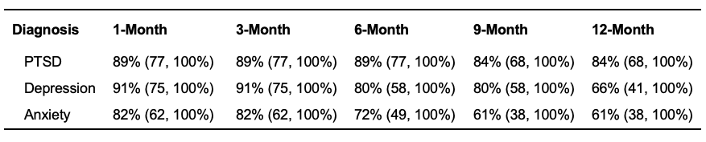

Table S5. Kaplan-Meier sustained response (non-relapse) estimates (and 95% confidence intervals) for PTSD (n=22), depression (n=15), and anxiety (n=13) diagnoses over time following MISTIC for participants meeting MINI diagnostic criteria at baseline.
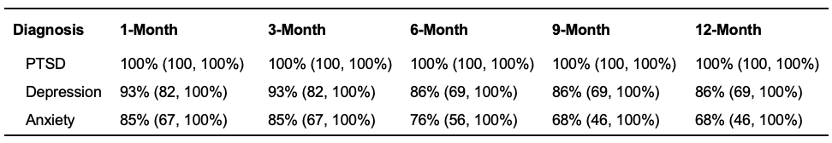

Table S6. Kaplan-Meier sustained response (non-relapse) estimates (and 95% confidence intervals) for PTSD (n=28), depression (n=29), and anxiety (n=28) diagnoses over time following MISTIC for all participants.
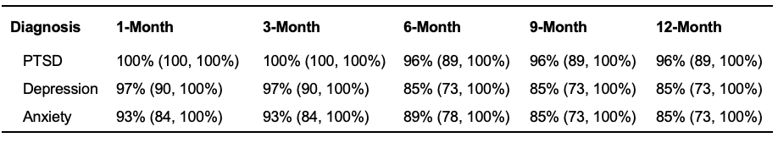

Kaplan-Meier Survival Analysis of Duration of Response
In participants who met MINI diagnostic criteria at baseline and response criteria immediately post-MISTIC, Kaplan-Meier survival analysis revealed mean durations of clinical response of 12.0 (SE=0.0), 10.8 (SE=0.8), and 9.5 (SE=1.3) months for PTSD, depression, and anxiety, respectively. A significant difference in survival curves was observed between diagnoses (𝛘² = 7.3, df = 2, p = 0.027), which was driven largely by the lack of observed relapse events in PTSD. Subsequent pairwise log-rank testing comparing each diagnosis pair revealed no significant differences in survival curves between anxiety and depression (𝛘² = 1.1, df = 1, p = 0.3, p_{FDR} = 0.3) or PTSD and depression (𝛘² = 3.1, df = 1, p = 0.08, p_{FDR} = 0.12). However, there was a significant difference between PTSD and anxiety (𝛘² = 7.6, df = 1, p = 0.006, p_{FDR} = 0.018).

In all participants who met response criteria immediately post-MISTIC, Kaplan-Meier survival analysis revealed mean durations of clinical response of 11.8 (SE=0.2), 11.0 (SE=0.5), and 10.9 (SE=0.6) months for PTSD, depression, and anxiety, respectively. No significant differences in survival curves were found between diagnoses (𝛘² = 2.2, df = 2, p = 0.34).

Baseline Predictors of Relapse
PTSD
Univariate Cox regression analysis did not reveal a significant effect of age (HR, 0.84; 95% CI, 0.67-1.07, p = 0.2), number of TBIs (HR, 0.95; 95% CI, 0.86-1.06, p = 0.4), or baseline CAPS-5 score on the duration of remission (HR, 1.19; 95% CI, 1.00-1.41, p = 0.052). However, there was a significant effect of CES on the duration of PTSD remission (HR, 0.81; 95% CI, 0.66-1.00, p = 0.044), such that for each one-unit increase in CES, the risk of a PTSD relapse was reduced by 19%.

Depression
Univariate Cox regression analysis did not reveal a significant effect of age (HR, 0.97; 95% CI, 0.80-1.18, p = 0.8), number of TBIs (HR, 0.99; 95% CI, 0.95-1.04, p = 0.8), baseline MADRS score (HR, 1.08; 95% CI, 0.90-1.30, p = 0.4), or CES on the duration of remission (HR, 0.71; 95% CI, 0.49-1.04, p = 0.079).

Anxiety
Univariate Cox regression analysis did not reveal a significant effect of age (HR, 0.81; 95% CI, 0.63-1.03, p = 0.087), number of TBIs (HR, 0.84; 95% CI, 0.60-1.17, p = 0.3), baseline HAM-A score (HR, 1.06; 95% CI, 0.95-1.18, p = 0.3), or CES on the duration of remission (HR, 0.86; 95% CI, 0.73-1.02, p = 0.085).

Baseline Correlates of Long-Term Clinical Score Trajectories
Significant correlations were observed between higher baseline symptom severity and larger positive residuals, i.e., poorer long-term outcomes (Figure S1; WHODAS: rho = 0.77, p < 0.001, p_{FDR} < 0.001; CAPS: rho = 0.64, p < 0.001, p_{FDR} < 0.001; MADRS: rho = 0.64, p < 0.001, p_{FDR} < 0.001; HAM-A: rho = 0.51, p = 0.0039, p_{FDR} = 0.012). Lower CES was also significantly correlated with larger positive residuals for disability and depressive symptom outcomes (WHODAS: rho = -0.41, p = 0.025, p_{FDR} = 0.050; MADRS: rho = -0.44, p = 0.016, p_{FDR} = 0.039), but not residuals for PTSD and anxiety outcomes (CAPS: rho = -0.22, p = 0.24; HAM-A: rho = -0.30, p = 0.11). Age was not significantly correlated with residuals (p > 0.05).

These findings suggest that individuals with higher severity of disability and psychiatric symptoms before treatment might show less favorable long-term outcomes than those with less severe symptoms at baseline. Individuals with higher symptom severity at baseline might therefore benefit from maintenance treatments after the initial treatment course.

Interestingly, higher combat exposure was associated with more favorable long-term outcomes after ibogaine treatment, both as a baseline predictor of relapse and as a baseline correlate of score trajectories. Of note, CES scores were not significantly correlated with baseline disability, PTSD, depression, or anxiety severity (all p > 0.15). Though speculative, one possibility is that veterans with greater combat exposure, who did not present with correspondingly more severe symptoms, may represent a more resilient subgroup. Alternatively, magnesium-ibogaine could be particularly relevant for veterans whose symptoms stem from higher combat exposure (e.g., greater load from brain injury). Future studies should investigate whether veterans with higher versus lower combat exposure differ in clinically or neurobiologically meaningful ways that may influence treatment outcomes.

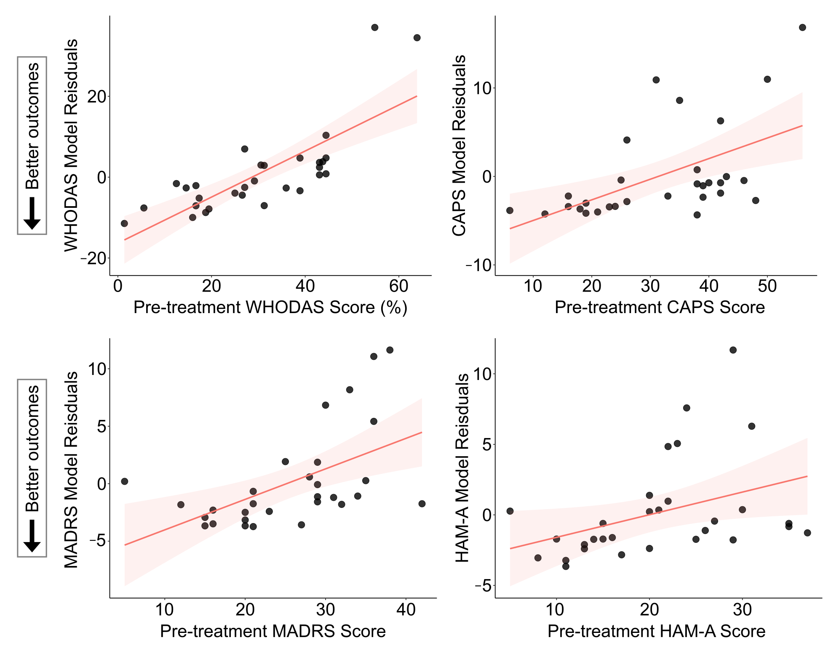

Figure S1. Associations between higher baseline symptom severity and poorer 12-month symptom trajectories. Scatterplots show baseline symptom severity and average model residuals for each participant. Larger positive residuals reflect poorer symptom trajectories as compared to the overall group trend from immediately post-MISTIC to the 12-month follow-up. The pink line represents a least squares linear fit with standard error confidence intervals for visualization purposes only.

