Supplementary Information
Comparative Efficacy of Non-pharmacological Interventions on Executive Function and Attentional Control in Children and Adolescents with ADHD: A Bayesian Network Meta-analysis Based on Task-based Cognitive Outcomes
Zifan You, Ruotong Han, Yanan Du, and Aihua Cao

Supplementary Methods
Section 1. Standardized data extraction fields and data dictionary
This supplementary file provides the standardized extraction fields used for arm-level data collection and effect-size computation, together with a concise data dictionary. Example rows are shown for illustration. When required information was missing or unclear, we attempted to contact study authors for clarification. No automation tools were used in the data extraction process.
A. Data extraction form (template)
Field | Brief description
ID | Study identifier (unique within the extraction database). Use a consistent ID for multi-publication trials.
Arm_ID_Exp | Experimental arm identifier within a study (links to trial arms).
Arm_ID_Ctrl | Comparator/control arm identifier within a study.
Study_design | Randomized trial design type.
Node_EXP | Intervention node assigned to the experimental arm for the NMA.
Node_CTRL | Comparator node assigned to the control arm.
Outcome_name | Outcome label as reported (task/measure name).
Metric | Outcome metric or unit.
Primary_Domain | Cognitive domain mapping for domain-specific networks.
Scale_direction (↑=better/↓=better) | Indicates whether higher or lower values reflect better performance (used for direction harmonization).
Exp_post_M | Experimental arm mean at the selected post-intervention time point (primary endpoint window).
Exp_post_SD | Standard deviation corresponding to Exp_post_M.
Exp_post_n | Sample size analyzed for Exp_post_M/SD.
Ctrl_post_M | Control arm mean at the selected post-intervention time point.
Ctrl_post_SD | Standard deviation corresponding to Ctrl_post_M.
Ctrl_post_n | Sample size analyzed for Ctrl_post_M/SD.
Effect_size | Computed standardized mean difference (Hedges' g) for Exp vs Ctrl after direction harmonization (optional to compute at extraction stage).
Var | Variance of the effect size (optional to compute at extraction stage).
Exp_pre_M | Experimental arm baseline (pre-intervention) mean (if reported).
Exp_pre_SD | Experimental arm baseline SD (if reported).
Exp_pre_n | Experimental arm baseline sample size (if reported).
Ctrl_pre_M | Control arm baseline mean (if reported).
Ctrl_pre_SD | Control arm baseline SD (if reported).
Ctrl_pre_n | Control arm baseline sample size (if reported).

B. Data dictionary (full)
Field | Description | Allowed values / format | Example
ID | Study identifier (unique within the extraction database). Use a consistent ID for multi-publication trials. | Integer or string (e.g., 10, Study01). | 10
Arm_ID_Exp | Experimental arm identifier within a study (links to trial arms). | Short code (e.g., A1, A2). | A1
Arm_ID_Ctrl | Comparator/control arm identifier within a study. | Short code (e.g., B1, B2). | B1
Study_design | Randomized trial design type. | Parallel or Crossover (extend if needed). | Parallel
Node_EXP | Intervention node assigned to the experimental arm for the NMA. | One of the pre-specified nodes (e.g., Cognitive Training; Behavioral Therapy and Parent Training; Neurostimulation; Neurofeedback; Physical Activity and Motor Training; Nutritional and Dietary Interventions; Mind–Body and Traditional Interventions; Multicomponent Interventions). | Cognitive Training
Node_CTRL | Comparator node assigned to the control arm. | Typically 'Control' (pooled) in primary analysis; may reflect specific comparator in sensitivity analyses. | Control
Outcome_name | Outcome label as reported (task/measure name). | Text. | ANT conflict
Metric | Outcome metric or unit. | Text (e.g., seconds, errors, standard score, T-score, z-score). | Milliseconds
Primary_Domain | Cognitive domain mapping for domain-specific networks. | One of: Inhibition, Working Memory, Cognitive Flexibility, Planning/High-order Executive Function, Sustained Attention, Selective Attention, Processing Speed (or your finalized labels). | Inhibitory control
Scale_direction (↑=better/↓=better) | Indicates whether higher or lower values reflect better performance (used for direction harmonization). | Use '↑=better' or '↓=better'. | ↓=better
Exp_post_M | Experimental arm mean at the selected post-intervention time point (primary endpoint window). | Numeric. | 10.8
Exp_post_SD | Standard deviation corresponding to Exp_post_M. | Numeric. | 2.0
Exp_post_n | Sample size analyzed for Exp_post_M/SD. | Integer. | 33
Ctrl_post_M | Control arm mean at the selected post-intervention time point. | Numeric. | 10.9
Ctrl_post_SD | Standard deviation corresponding to Ctrl_post_M. | Numeric. | 1.9
Ctrl_post_n | Sample size analyzed for Ctrl_post_M/SD. | Integer. | 34
Effect_size | Computed standardized mean difference (Hedges' g) for Exp vs Ctrl after direction harmonization (optional to compute at extraction stage). | Numeric or blank (computed downstream).
Var | Variance of the effect size (optional to compute at extraction stage). | Numeric or blank (computed downstream).
Exp_pre_M | Experimental arm baseline (pre-intervention) mean (if reported). | Numeric or blank. | 9.0
Exp_pre_SD | Experimental arm baseline SD (if reported). | Numeric or blank. | 2.2
Exp_pre_n | Experimental arm baseline sample size (if reported). | Integer or blank. | 38
Ctrl_pre_M | Control arm baseline mean (if reported). | Numeric or blank. | 9.7
Ctrl_pre_SD | Control arm baseline SD (if reported). | Numeric or blank. | 1.9
Ctrl_pre_n | Control arm baseline sample size (if reported). | Integer or blank. | 37

C. Example rows (illustrative) Rows correspond to the same illustrative records across C1-C3.
C1. Study, arm, node, and outcome descriptors
ID | Arm_ID_Exp | Arm_ID_Ctrl | Study_design | Node_EXP | Node_CTRL | Outcome_name | Metric | Primary_Domain | Scale_direction (↑=better/↓=better)
2 | A1 | B1 | Parallel | Cognitive Training | Control | CPT errors commision | Percentage | Inhibitory control | ↓=better
9 | A1 | B1 | Parallel | Mind-Body and Traditional Interventions | Behavioral therapy and parent training | TEA-Ch Opposite Worlds opposite world total time | Seconds | Inhibitory control | ↓=better
9 | A1 | B1 | Parallel | Mind-Body and Traditional Interventions | Behavioral therapy and parent training | ANT conflict | Milliseconds | Inhibitory control | ↓=better
10 | A1 | B1 | Parallel | Cognitive Training | Control | CW Controlled attention | Scaled score | Inhibitory control | ↑=better
10 | A1 | B1 | Parallel | Cognitive Training | Control | CPT-II Hyperactivity-Impulsivity | T-score | Inhibitory control | ↓=better

C2. Post-intervention values and effect-size fields
ID | Exp_post_M | Exp_post_SD | Exp_post_n | Ctrl_post_M | Ctrl_post_SD | Ctrl_post_n | Effect_size | Var
2 | -39.77 | 27.36 | 41 | -52.2 | 21.15 | 39
9 | -11.4 | 3.7 | 52 | -11.7 | 3.8 | 56
9 | -82.5 | 76.1 | 52 | -74.4 | 62.8 | 56
10 | 10.8 | 2 | 33 | 10.9 | 1.9 | 34
10 | -45 | 5 | 33 | -47 | 6 | 34

C3. Baseline values
ID | Exp_pre_M | Exp_pre_SD | Exp_pre_n | Ctrl_pre_M | Ctrl_pre_SD | Ctrl_pre_n
2 | -58.6 | 22.77 | 41 | -62.06 | 17.05 | 39
9 | -10.1 | 3.2 | 52 | -10.3 | 3.3 | 56
9 | -101.6 | 73.6 | 52 | -104.6 | 66.7 | 56
10 | 9 | 2.2 | 38 | 9.7 | 1.9 | 37
10 | -45 | 5 | 38 | -45 | 5 | 37

Supplementary Table Legends
Supplementary Tables S1-S18 are provided in the accompanying Supplementary Tables.xlsx file. The tables are arranged to mirror the workflow of the manuscript: search and coding materials, risk-of-bias assessment, primary network results, sensitivity and exploratory study-level covariate analyses, and confidence-in-evidence assessments.
A. Search, outcome classification, intervention coding, and risk-of-bias assessment
Table S1. Search strategies and study-selection exclusion categories.
Table S2. Classification rules for task-based executive-function and attentional-control task-family domains.
Table S3. Operational definitions and coding rules for intervention and comparator nodes.
Table S4. Risk-of-bias assessments for individual trials using the Cochrane RoB 2 tool.
B. Primary network meta-analysis and inconsistency checks
Table S5. Network geometry, between-study heterogeneity, and convergence diagnostics by cognitive domain in the primary analysis.
Table S6. Relative effects versus pooled Control and SUCRA rankings in the primary Bayesian network meta-analysis.
Table S7. Node-splitting inconsistency checks by cognitive domain in the primary analysis.
C. Sensitivity, robustness, and exploratory study-level covariate analyses
Table S8. Sensitivity analyses specified before the final quantitative synthesis: restrictions, estimands, rationale, and interpretation rules.
Table S9. Network size across primary and sensitivity analyses by cognitive domain.
Table S10. Relative effects versus pooled Control and SUCRA values across sensitivity analyses.
Table S11. Between-study heterogeneity (τ) by cognitive domain across sensitivity analyses.
Table S12. Node-splitting inconsistency checks across sensitivity analyses.
Table S13. Exploratory study-level mean-age moderator analyses.
Table S14. Direct-evidence subgroup analysis by study-level mean age (<9 vs. ≥9 years).
Table S15. Exploratory study-level male-proportion moderator analyses.
Table S16. Direct-evidence subgroup analysis by study-level male proportion (<75% vs. ≥75% male).
D. Confidence in the network estimates
Table S17. CINeMA assessment for network estimates versus pooled Control by cognitive domain.
Table S18. CINeMA assessment for all pairwise comparisons by cognitive domain.

Supplementary Figure Legends and Figures
Figure S1. Inhibitory control.
Bayesian NMA evidence structure and results for inhibitory control. (A) Evidence network. Node size and edge width are proportional to the number of trials and direct comparisons, respectively; node colour indicates SUCRA. (B) League table showing posterior mean relative effects (lower triangle); * denotes 95% CrI excluding 0. (C) SUCRA ranking probabilities and rankogram. (D) Node-splitting inconsistency checks summarised into pre-specified P-value categories. Positive Hedges’ g values indicate better task performance.
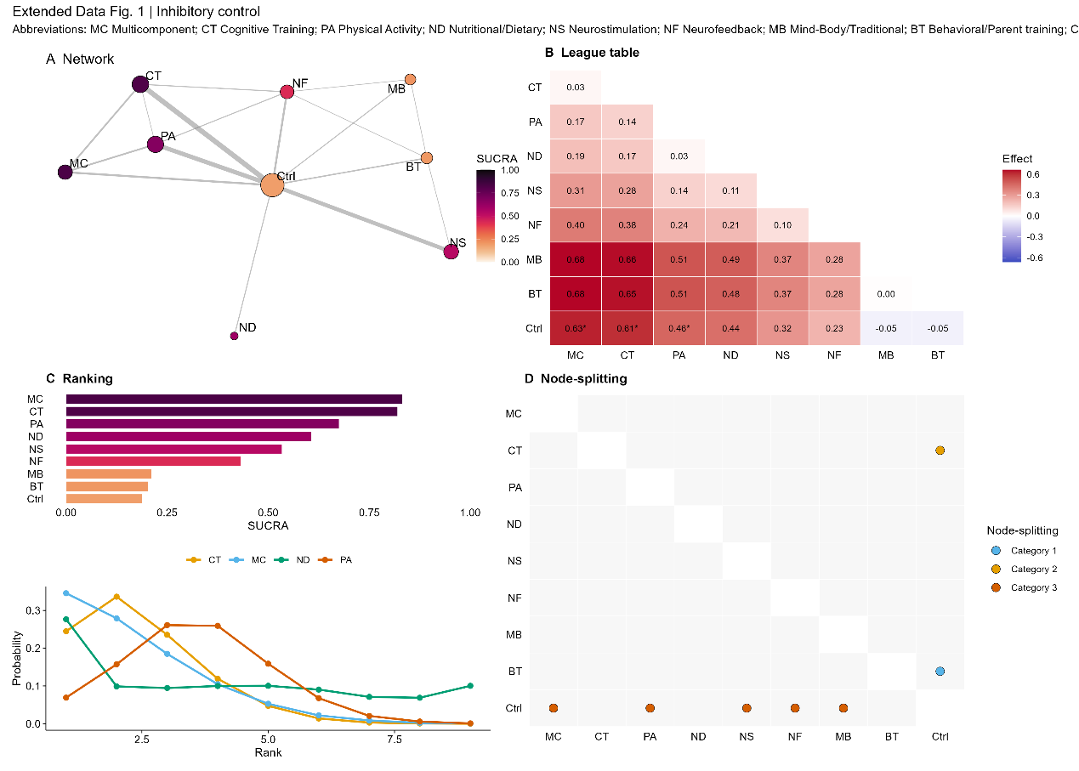

Figure S2. Working memory.
Same layout as Figure S1. (A) Evidence network with node size and edge width proportional to trial counts; node colour indicates SUCRA. (B) League table (lower triangle) showing posterior mean relative effects; * denotes 95% CrI excluding 0. (C) SUCRA ranking probabilities and rankogram. (D) Node-splitting inconsistency checks. Positive Hedges’ g values indicate better task performance.

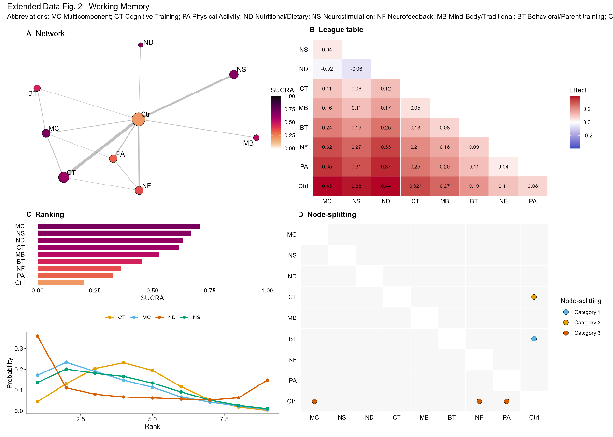
Figure S3. Cognitive flexibility.
Same layout as Figure S1. (A) Evidence network; node colour indicates SUCRA. (B) League table (lower triangle) with posterior mean relative effects; * denotes 95% CrI excluding 0. (C) SUCRA ranking and rankogram for the top-ranked interventions. (D) Node-splitting inconsistency checks. Positive Hedges’ g values indicate better task performance.
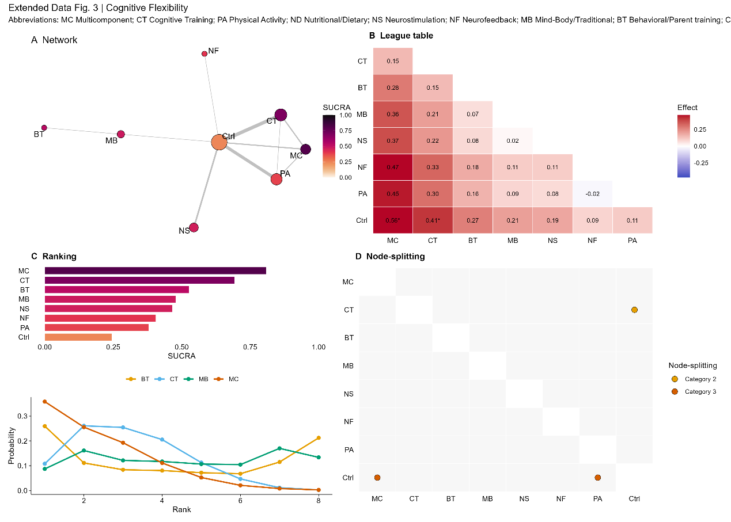
Figure S4. Planning / high-order executive function.
Same layout as Figure S1. (A) Evidence network; node colour indicates SUCRA. (B) League table (lower triangle) showing posterior mean relative effects; * denotes 95% CrI excluding 0. (C) SUCRA ranking and rankogram for the top-ranked interventions. (D) Node-splitting inconsistency checks. Positive Hedges’ g values indicate better task performance.
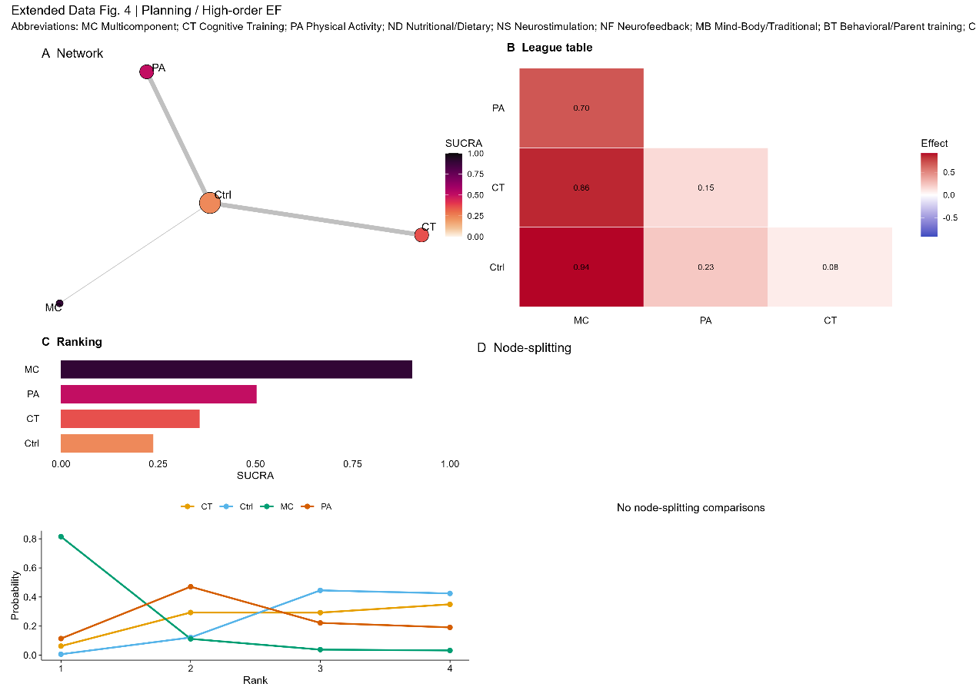
Figure S5. Sustained attention.
Same layout as Figure S1. (A) Evidence network; node colour indicates SUCRA. (B) League table (lower triangle) showing posterior mean relative effects; * denotes 95% CrI excluding 0. (C) SUCRA ranking and rankogram for the top-ranked interventions. (D) Node-splitting inconsistency checks. Positive Hedges’ g values indicate better task performance.
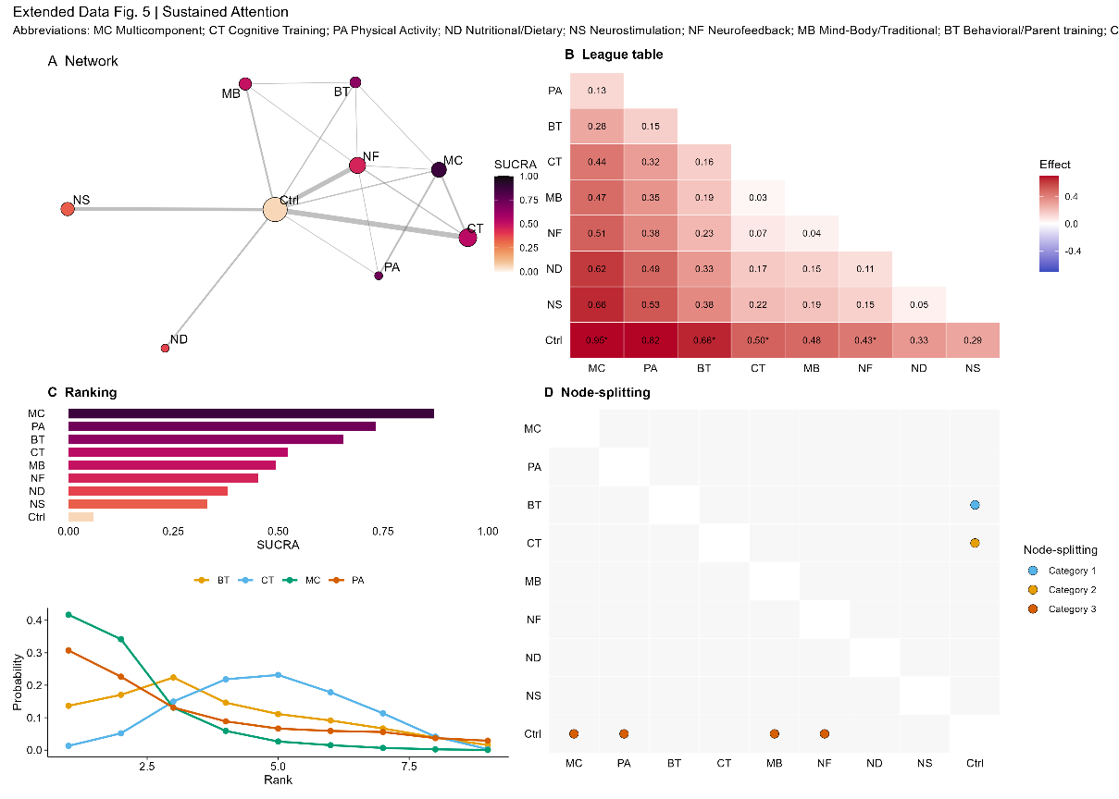
Figure S6. Selective attention.
Same layout as Figure S1. (A) Evidence network; node colour indicates SUCRA. (B) League table (lower triangle) showing posterior mean relative effects; * denotes 95% CrI excluding 0. (C) SUCRA ranking and rankogram for the top-ranked interventions. (D) Node-splitting inconsistency checks. Positive Hedges’ g values indicate better task performance.

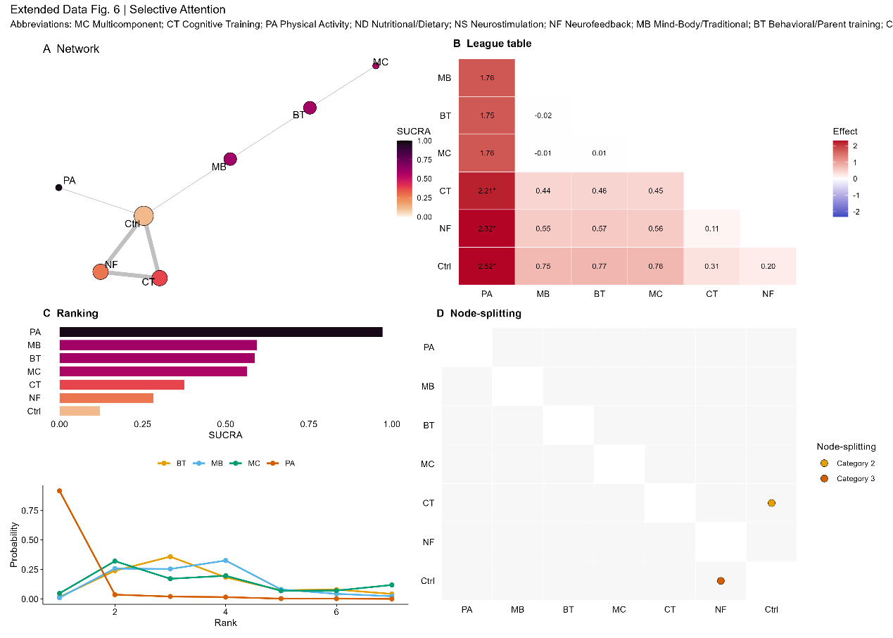
Figure S7. Processing speed / reaction time variability.
Same layout as Figure S1. (A) Evidence network; node colour indicates SUCRA. (B) League table (lower triangle) showing posterior mean relative effects; * denotes 95% CrI excluding 0. (C) SUCRA ranking and rankogram for the top-ranked interventions. (D) Node-splitting inconsistency checks. Positive Hedges’ g values indicate better task performance.

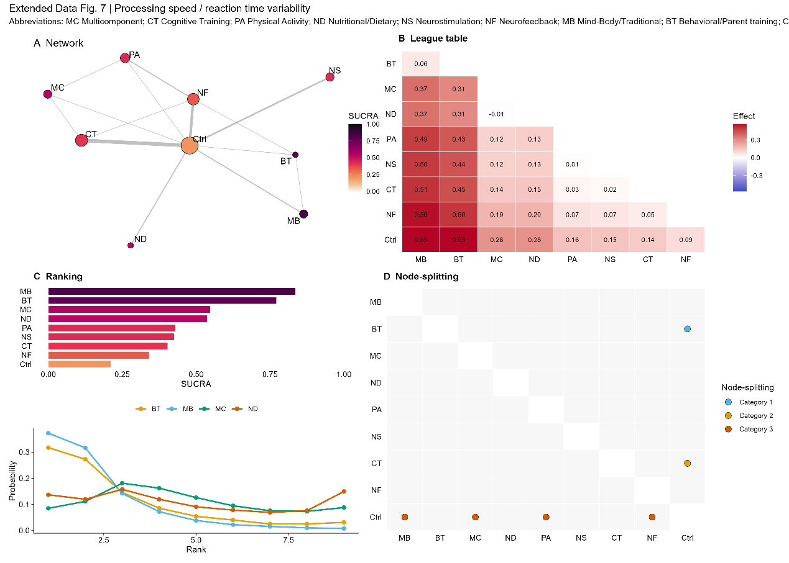

Figure S8. Study-level moderator coefficients for age and male proportion across main domains.
Exploratory post-based aggregate-level moderator coefficients are shown for the four better-powered domains. The age coefficient represents the change in Hedges’ g per 1-year increase in study-level mean age centered at 9 years. The male-proportion coefficient represents the change in Hedges’ g per 1-percentage-point increase in study-level male proportion centered at 75% male. Horizontal bars indicate 95% confidence intervals.
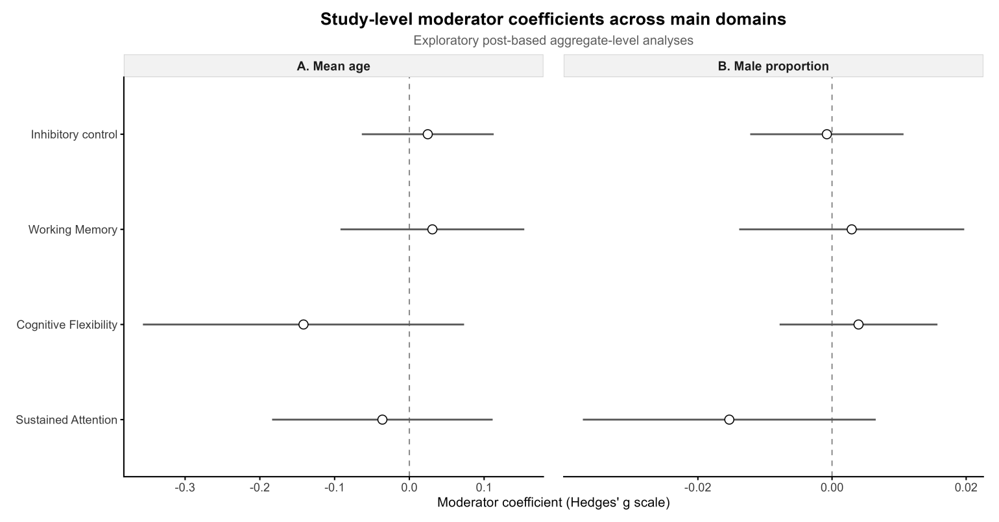

Figure S9. Direct-evidence subgroup analysis by study-level mean age across main domains.
Direct active-versus-Control post-based effect estimates are stratified by study-level mean age (<9 years vs. ≥9 years) for the four better-powered domains. Positive Hedges’ g values indicate better task performance in the active intervention arm. Estimates are exploratory and based on study-level rather than individual-level age.
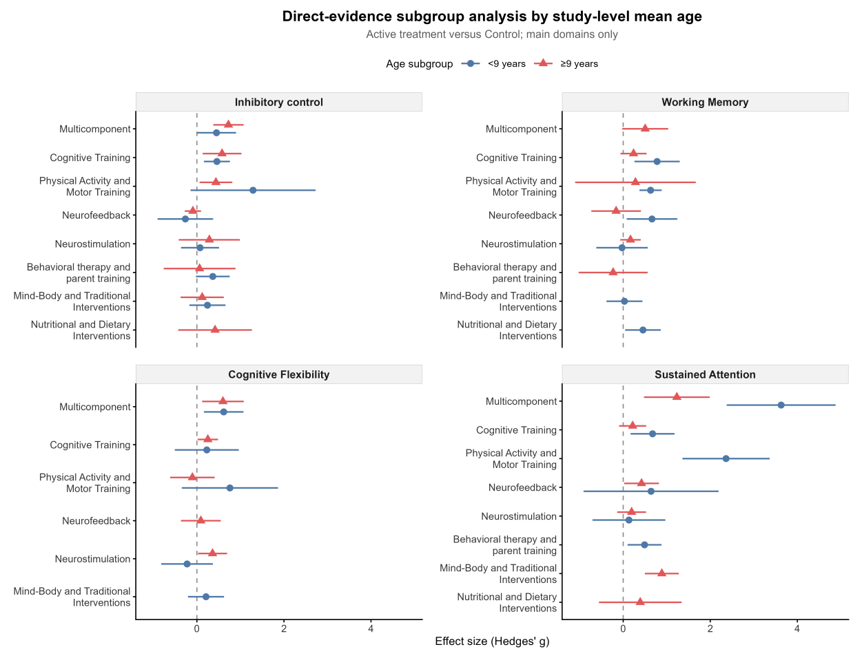

Figure S10. Direct-evidence subgroup analysis by study-level male proportion across main domains.
Direct active-versus-Control post-based effect estimates are stratified by study-level male proportion (<75% male vs. ≥75% male) for the four better-powered domains. Positive Hedges’ g values indicate better task performance in the active intervention arm. Estimates are exploratory and based on study-level sex composition rather than individual-level sex-specific effects.
