SUPPLEMENTARY MATERIAL

Social Interaction test. The test was performed in a circular open arena placed in a deemed lit room and registered by a videocamera. Pairs were matched based on sex, weight and treatment. LPS-treated rats were paired with Saline group partners of the same sex and weight. All rats were marked on their back and placed simultaneously in the arena, facing each other for 10 minutes. Subsequently, a blind observer scored the time (measured in seconds) and the frequency (in numbers) that each rat spent performing social behaviors, such as sniffing, following and climbing the partner. The cohort of rats which underwent the Social Interaction test is not the same subjected to the other behavioral tests reported in material and methods.
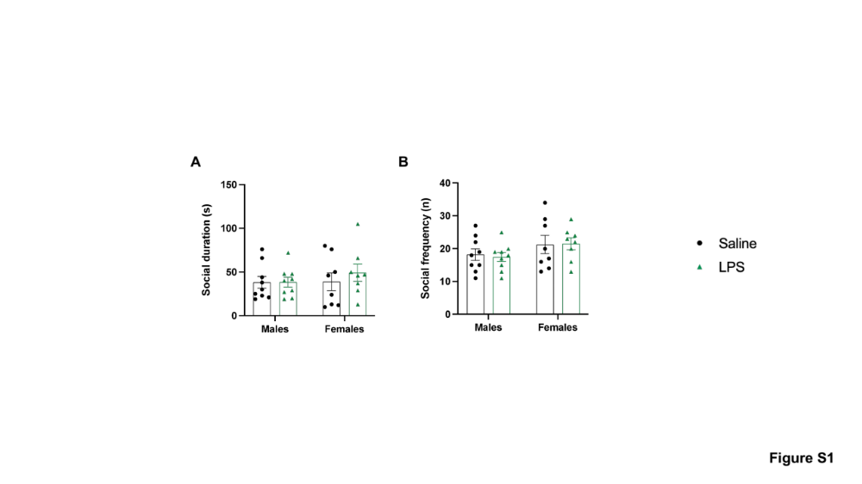

Figure S1. Effects of LPS on sociability in both sexes. Male and female Saline and LPS rats were subjected to Social Interaction Test. The LPS challenge did not affect sociability features among all groups meant as duration (A), expressed in seconds (s) and social frequency (B), expressed as number of occurrences (n).

Supplementary Table S1

Cytokines | Wistar ♂️ | Wistar+LPS ♂️ | Wistar ♀️ | Wistar+LPS ♀️
G-CSF | 19,33 ± 1,96 | 29,25 ± 6,856 | 16,24 ± 1,744 | 20,28 ± 0,8732
GM-CSF | 233,5 ± 65,29 | 703,8 ± 183,6 | 359,3 ± 104 | 1094 ± 277,7#
GRO-KC | 214,2 ± 29,09 | 344 ± 27,92* | 241,4 ± 36,9 | 391,2 ± 32,21#
IFN-γ | 637,9 ± 88,55 | 1003 ± 150,7 | 751,4 ± 88,72 | 747,4 ± 36,34
IL-1α | 545,1 ± 34,93 | 630,5 ± 40,81 | 527,9 ± 12,47 | 603,7 ± 23,08
IL-1β | 215,3 ± 53,42 | 619,3 ± 87,01 | 378,8 ± 130,1 | 1182 ± 312,2#
MCP-1 | 1534 ± 193,4 | 2788 ± 256,4 | 1743 ± 272,3 | 4204 ± 894,7#
IL-18 | 22113 ± 3602 | 31335 ± 3417 | 17319 ± 2777 | 31093 ± 6115
IL-2 | 1110 ± 100,5 | 1349 ± 125,2 | 1075 ± 57,32 | 1245 ± 41,24
IL-4 | 409,6 ± 33,57 | 501,4 ± 41,31 | 421,1 ± 19,79 | 417,9 ± 23,62
IL-5 | 463,7 ± 13,87 | 498,7 ± 19,42 | 455,1 ± 11,73 | 487,8 ± 6,183
IL-6 | 489,2 ± 156,6 | 1043 ± 190,7 | 683 ± 145,6 | 735,9 ± 36,44
IL-7 | 222,9 ± 48,98 | 476,4 ± 61,44 | 332,5 ± 90,7 | 943,9 ± 237,1#
IL-10 | 385,1 ± 17,76 | 450,9 ± 32,6 | 371,4 ± 8,269 | 402,6 ± 15,83
IL-12 (p70) | 628,6 ± 33,66 | 671,6 ± 43,78 | 632,7 ± 27,63 | 602,4 ± 44,7
IL-13 | 321,5 ± 65,99 | 496 ± 49,61 | 375,2 ± 48,77 | 513,1 ± 34,43
IL-17α | 137,9 ± 7,264 | 176,2 ± 18,88 | 129,3 ± 7,873 | 146,3 ± 3,392
M-CSF | 52,62 ± 10,31 | 93,01 ± 6,13* | 48,04 ± 4,048 | 61,56 ± 10,11
MIP-1α | 104,3 ± 17,55 | 285,9 ± 60,41 | 147,1 ± 40,34 | 483 ± 135,4#
MIP-3α | 39,06 ± 3,355 | 43,4 ± 2,127 | 40,56 ± 2,374 | 42,79 ± 2,575
RANTES | 1225 ± 176,5 | 1406 ± 153 | 1354 ± 126,5 | 1427 ± 136,5
TNF-α | 1083 ± 102,8 | 1217 ± 110,5 | 1076 ± 1076 | 1050 ± 1050
VEGF | 101,7 ± 28,67 | 152,4 ± 15,95 | 98,4 ± 12,18 | 164,5 ± 5,006

Table S1. LPS effects on systemic inflammation considering sex variable. 23-Cytokine Multiplex assay was performed in both male and female saline and LPS rats. Two-way ANOVA analysis was performed identifying significance for GM-CSF, MIP-1α, MCP-1, IL-1β, and IL-7 in female LPS-treated rats vs female saline-injected group (#P < 0.05), while M-CSF in male LPS-treated rats vs male saline-injected group (*P < 0.05), and Gro-KC in both sex LPS-treated groups vs respective controls.

Supplementary Table S2. Complete statistical outputs for two-way ANOVA analyses

Figure | Outcome | Effect | F value | df | Exact p value | Effect size (ηp²)
Figure 1
Fig. 1B | Marble burying | Treatment | 2.172 | 1,42 | 0.1480 | 0.049
Fig. 1B | Marble burying | Sex | 0.665 | 1,42 | 0.4195 | 0.016
Fig. 1B | Marble burying | Treatment × Sex | 8.087 | 1,42 | 0.0069 | 0.161
Fig. 1C | Self-grooming | Treatment | 11.280 | 1,42 | 0.0017 | 0.212
Fig. 1C | Self-grooming | Sex | 0.141 | 1,42 | 0.7088 | 0.003
Fig. 1C | Self-grooming | Treatment × Sex | 0.619 | 1,42 | 0.4357 | 0.015
Fig. 1D | Total distance travelled | Treatment | 256.400 | 1,38 | < 0.0001 | 0.871
Fig. 1D | Total distance travelled | Sex | 2.913 | 1,38 | 0.0960 | 0.071
Fig. 1D | Total distance travelled | Treatment × Sex | 3.232 | 1,38 | 0.0802 | 0.078
Fig. 1D | Freezing time | Treatment | 85.720 | 1,39 | < 0.0001 | 0.687
Fig. 1D | Freezing time | Sex | 3.023 | 1,39 | 0.0900 | 0.072
Fig. 1D | Freezing time | Treatment × Sex | 3.023 | 1,39 | 0.0900 | 0.072
Fig. 1D | Freezing frequency | Treatment | 387.700 | 1,39 | < 0.0001 | 0.909
Fig. 1D | Freezing frequency | Sex | 4.843 | 1,39 | 0.0337 | 0.110
Fig. 1D | Freezing frequency | Treatment × Sex | 4.843 | 1,39 | 0.0337 | 0.110
Fig. 1D | Time spent in center | Treatment | 22.470 | 1,37 | < 0.0001 | 0.378
Fig. 1D | Time spent in center | Sex | 0.801 | 1,37 | 0.3767 | 0.021
Fig. 1D | Time spent in center | Treatment × Sex | 0.238 | 1,37 | 0.6289 | 0.006
Figure 3
Fig. 3A | PFC GABA | Treatment | 5.889 | 1,16 | 0.0274 | 0.269
Fig. 3A | PFC GABA | Sex | 3.778 | 1,16 | 0.0697 | 0.191
Fig. 3A | PFC GABA | Treatment × Sex | 4.161 | 1,16 | 0.0582 | 0.206
Fig. 3B | PFC DA | Treatment | 0.037 | 1,16 | 0.8501 | 0.002
Fig. 3B | PFC DA | Sex | 0.005 | 1,16 | 0.9469 | 0.000
Fig. 3B | PFC DA | Treatment × Sex | 0.112 | 1,16 | 0.7425 | 0.007
Fig. 3C | PFC 5-HT | Treatment | 14.080 | 1,15 | 0.0019 | 0.484
Fig. 3C | PFC 5-HT | Sex | 3.292 | 1,15 | 0.0897 | 0.180
Fig. 3C | PFC 5-HT | Treatment × Sex | 4.796 | 1,15 | 0.0447 | 0.242
Fig. 3D | Striatum GABA | Treatment | 0.357 | 1,16 | 0.5586 | 0.022
Fig. 3D | Striatum GABA | Sex | 5.786 | 1,16 | 0.0286 | 0.266
Fig. 3D | Striatum GABA | Treatment × Sex | 5.964 | 1,16 | 0.0266 | 0.272
Fig. 3E | Striatum DA | Treatment | 1.946 | 1,16 | 0.1821 | 0.108
Fig. 3E | Striatum DA | Sex | 8.677 | 1,16 | 0.0095 | 0.352
Fig. 3E | Striatum DA | Treatment × Sex | 6.291 | 1,16 | 0.0233 | 0.282
Fig. 3F | Striatum 5-HT | Treatment | 0.000 | 1,16 | 0.9977 | 0.000
Fig. 3F | Striatum 5-HT | Sex | 3.032 | 1,16 | 0.1009 | 0.159
Fig. 3F | Striatum 5-HT | Treatment × Sex | 4.947 | 1,16 | 0.0409 | 0.236
Figure 4
Fig. 4A | PFC Nlrp3 | Treatment | 0.604 | 1,22 | 0.4454 | 0.027
Fig. 4A | PFC Nlrp3 | Sex | 0.087 | 1,22 | 0.7709 | 0.004
Fig. 4A | PFC Nlrp3 | Treatment × Sex | 0.062 | 1,22 | 0.8057 | 0.003
Fig. 4B | PFC Nfkb1 | Treatment | 1.511 | 1,22 | 0.2320 | 0.064
Fig. 4B | PFC Nfkb1 | Sex | 0.215 | 1,22 | 0.6470 | 0.010
Fig. 4B | PFC Nfkb1 | Treatment × Sex | 0.505 | 1,22 | 0.4846 | 0.022
Fig. 4C | PFC Tnf | Treatment | 3.089 | 1,20 | 0.0941 | 0.134
Fig. 4C | PFC Tnf | Sex | 19.630 | 1,20 | 0.0003 | 0.495
Fig. 4C | PFC Tnf | Treatment × Sex | 13.090 | 1,20 | 0.0017 | 0.396
Fig. 4D | PFC Il1b | Treatment | 19.740 | 1,20 | 0.0002 | 0.497
Fig. 4D | PFC Il1b | Sex | 0.003 | 1,20 | 0.9604 | 0.000
Fig. 4D | PFC Il1b | Treatment × Sex | 0.948 | 1,20 | 0.3418 | 0.045
Fig. 4E | Striatum Nlrp3 | Treatment | 0.035 | 1,21 | 0.8543 | 0.002
Fig. 4E | Striatum Nlrp3 | Sex | 3.736 | 1,21 | 0.0668 | 0.151
Fig. 4E | Striatum Nlrp3 | Treatment × Sex | 2.072 | 1,21 | 0.1647 | 0.090
Fig. 4F | Striatum Nfkb1 | Treatment | 0.361 | 1,24 | 0.5537 | 0.015
Fig. 4F | Striatum Nfkb1 | Sex | 7.241 | 1,24 | 0.0128 | 0.232
Fig. 4F | Striatum Nfkb1 | Treatment × Sex | 6.423 | 1,24 | 0.0182 | 0.211
Fig. 4G | Striatum Tnf | Treatment | 13.090 | 1,20 | 0.0017 | 0.396
Fig. 4G | Striatum Tnf | Sex | 0.016 | 1,20 | 0.9001 | 0.001
Fig. 4G | Striatum Tnf | Treatment × Sex | 0.978 | 1,20 | 0.3345 | 0.047
Fig. 4H | Striatum Il1b | Treatment | 14.220 | 1,21 | 0.0011 | 0.404
Fig. 4H | Striatum Il1b | Sex | 0.126 | 1,21 | 0.7263 | 0.006
Fig. 4H | Striatum Il1b | Treatment × Sex | 3.361 | 1,21 | 0.0810 | 0.138
Figure 5
Fig. 5A | PFC ROS | Treatment | 2.840 | 1,14 | 0.1141 | 0.169
Fig. 5A | PFC ROS | Sex | 12.490 | 1,14 | 0.0033 | 0.471
Fig. 5A | PFC ROS | Treatment × Sex | 3.798 | 1,14 | 0.0716 | 0.213
Fig. 5B | Striatum ROS | Treatment | 3.198 | 1,16 | 0.0927 | 0.167
Fig. 5B | Striatum ROS | Sex | 7.190 | 1,16 | 0.0164 | 0.310
Fig. 5B | Striatum ROS | Treatment × Sex | 5.432 | 1,16 | 0.0332 | 0.253
Fig. 5C | Thalamus ROS | Treatment | 0.147 | 1,13 | 0.7075 | 0.011
Fig. 5C | Thalamus ROS | Sex | 3.442 | 1,13 | 0.0864 | 0.209
Fig. 5C | Thalamus ROS | Treatment × Sex | 1.523 | 1,13 | 0.2390 | 0.105
Fig. 5D | PFC 4-HNE | Treatment | 1.613 | 1,15 | 0.2234 | 0.097
Fig. 5D | PFC 4-HNE | Sex | 7.537 | 1,15 | 0.0150 | 0.334
Fig. 5D | PFC 4-HNE | Treatment × Sex | 0.664 | 1,15 | 0.4281 | 0.042
Fig. 5E | Striatum 4-HNE | Treatment | 8.193 | 1,16 | 0.0113 | 0.339
Fig. 5E | Striatum 4-HNE | Sex | 8.834 | 1,16 | 0.0090 | 0.356
Fig. 5E | Striatum 4-HNE | Treatment × Sex | 1.976 | 1,16 | 0.1789 | 0.110
Fig. 5F | Thalamus 4-HNE | Treatment | 22.590 | 1,15 | 0.0003 | 0.601
Fig. 5F | Thalamus 4-HNE | Sex | 4.547 | 1,15 | 0.0499 | 0.233
Fig. 5F | Thalamus 4-HNE | Treatment × Sex | 2.864 | 1,15 | 0.1112 | 0.160

Supplementary Table S3. Statistical outputs for serum inflammatory and immune mediators (Figure 2)
Analyte | Statistical test | t | df | Exact p value | Effect size (η²)
GM-CSF | Unpaired t-test | 3.335 | 18 | 0.0037 | 0.3819
M-CSF | Unpaired t-test | 2.900 | 18 | 0.0095 | 0.3185
MIP-1α | Unpaired t-test | 3.222 | 18 | 0.0047 | 0.3658
MCP-1 | Unpaired t-test | 3.548 | 18 | 0.0023 | 0.4116
Gro-KC | Unpaired t-test | 4.473 | 18 | 0.0003 | 0.5265
IL-1α | Unpaired t-test | 2.811 | 18 | 0.0116 | 0.3051
IL-1β | Unpaired t-test | 3.446 | 18 | 0.0029 | 0.3975
IL-2 | Unpaired t-test | 2.140 | 18 | 0.0463 | 0.2028
IL-5 | Unpaired t-test | 2.591 | 18 | 0.0185 | 0.2716
IL-7 | Unpaired t-test | 3.285 | 18 | 0.0041 | 0.3748
IL-10 | Unpaired t-test | 2.294 | 18 | 0.0341 | 0.2262
IL-13 | Unpaired t-test | 2.518 | 18 | 0.0215 | 0.2605
IL-17α | Unpaired t-test | 2.392 | 18 | 0.0279 | 0.2412
IL-18 | Unpaired t-test | 2.862 | 18 | 0.0104 | 0.3127
VEGF | Unpaired t-test | 3.623 | 18 | 0.0019 | 0.4217
Table S3. Data from male and female rats were pooled and analyzed using two-tailed unpaired t-tests. Effect sizes are reported as eta squared (η²).

Figure S2

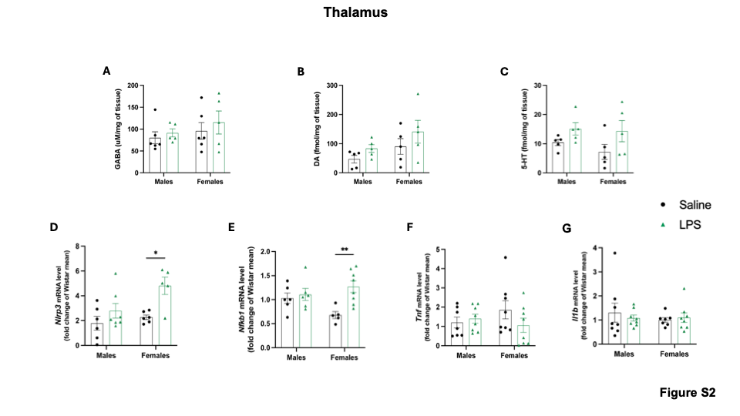

Figure S2. LPS effects on neurotransmitters and inflammatory markers levels in Thalamus. The levels of GABA (A), DA (B) and 5-HT were evaluated by HPLC analysis in thalamus from all experimental groups. The LPS challenge did not affect at all the neurotransmitters quantification. Moreover, we analyzed by real time PCR the transcriptional levels of Nlrp3 (D), Nfkb1 (E), Tnf (F) and Il1b (G). Although there were no differences among groups in transcriptional levels of tnf and Il1b, female rats challenged with LPS expressed higher mRNA levels of Nlrp3 and Nfkb1 compared to the female vehicle group. Data were expressed as mean ± SEM reaching the significance at P < 0.05 (*P < 0.05, **P < 0.01).

Figure S3

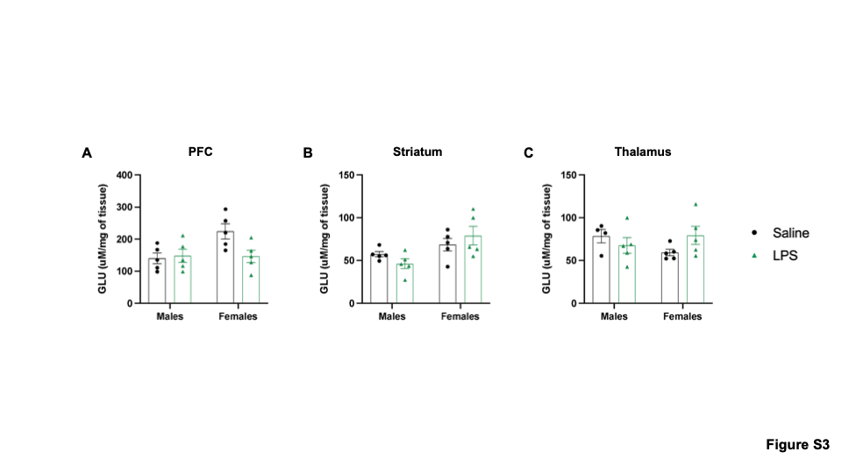
Figure S3. Glutamate quantification in cortico-striatal-thalamic circuit. Glutamate (GLU) quantification was performed by HPLC analysis in PFC (A), striatum (B) and thalamus (C) in rats from all experimental groups. However, the LPS did not affect GLU levels, measured at PND45, in all the circuit.

Figure S4

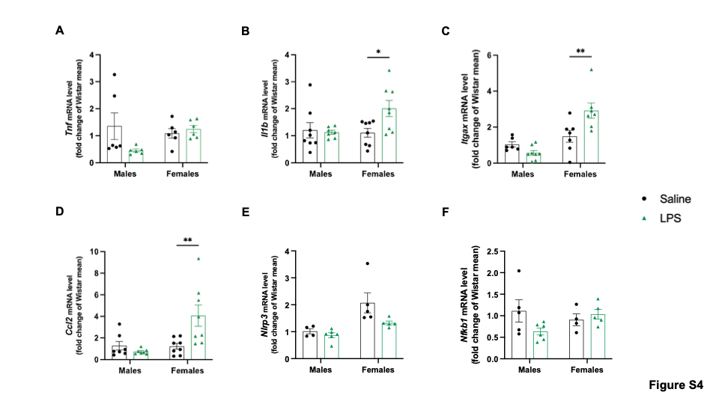

Figure S4. LPS effects on hippocampus of both sexes’ rats. Here we evaluated by Real-Time PCR the gene expression of several inflammatory and immune markers in hippocampus from all the experimental groups such as Tnf (A), Il1b (B), Itgax (C), Ccl2 (D), Nlrp3 (E), Nfkb1 (F). In this brain area, the LPS did not change the transcriptional levels of every tested pattern in male rats. However, our data evidenced a greater susceptibility of female rats subjected to the bacterial challenge compared to male ones. Indeed, the mRNA expression of Il1b (B), Itgax (C), and Ccl2 (D) was enhanced in the female LPS group. Data were expressed as mean ± SEM reaching the significance at P < 0.05 (*P < 0.05, **P < 0.01).

