Hejazi et al — Insomnia and Anxiety Exhibit Distinct Short-Term Associations
Following Ketamine in Treatment-Resistant Depression

Supplementary Materials
Statistical Analysis
Changes in Hamilton Anxiety Rating Scale (HAM-A) scores, the insomnia items of the Hamilton Depression Rating Scale (HAM-D), and Montgomery-Åsberg Depression Rating Scale (MADRS) scores from baseline to post-ketamine were analyzed using separate linear mixed-effects models (LMMs) with a random intercept for participant and time (baseline vs post-ketamine) as the sole fixed effect. The rationale for fitting three separate models was that the primary question was whether any of the three domains (anxiety, insomnia, depression) showed improvement pre–post ketamine. To account for multiplicity, the Holm procedure was applied to control the family-wise error rate across the three pre–post models (MADRS, HAM-A, and HAM-D insomnia items), with adjusted P-values < 0.05 considered statistically significant. To ensure robustness, paired-samples t-tests (or Wilcoxon signed-rank tests for non-normal differences assessed with the Lilliefors test) were performed with standardized effect sizes. These results, together with normality assessments, are presented in Supplementary Table S1 and Figure S1 and are consistent with the mixed-model findings.
To visualize individual and group-level changes across time, paired trajectory and boxplot overlays were generated for each clinical measure (HAM-A, HAM-D insomnia items, and MADRS). These plots depict within-subject pre–post changes alongside summary distributions, facilitating direct comparison of individual trajectories and overall treatment effects. Additionally, empirical cumulative distribution function (ECDF) plots were used to characterize the distribution and relative magnitude of individual score changes across domains. Moreover, a standardized heatmap of individual Δ-scores (baseline minus post-treatment; ΔMADRS, ΔHAM-A, ΔINS (insomnia)) was constructed to visualize the degree of covariation among symptom changes, providing a complementary view of potential inter-relationships between depression, anxiety, and insomnia.
Associations between insomnia, anxiety, and depression were assessed using correlation analyses. The normality of each pairwise distribution was first inspected (see Supplementary Figure S1), and Spearman’s ρ was used as the primary nonparametric measure. For exploratory robustness, Kendall’s tau-b correlations were also computed to account for the ordinal and discrete nature of insomnia scores, which often result in ties. Both methods were supplemented with 2000 bootstrap resamples to derive 95% confidence intervals (see Supplementary Table S2). In addition to correlational analyses, simple linear regression models were also applied to evaluate the strength and direction of associations between symptom changes, allowing a more direct quantification of how improvements in depression predict concurrent changes in anxiety and insomnia. To examine whether the association between insomnia and anxiety was independent of depressive severity, partial Spearman correlation analyses were conducted that controlled for MADRS scores at baseline, post-ketamine, and for pre–post change scores (Δ), thereby assessing cross-sectional and longitudinal inter-relationships while accounting for shared variance with depression. To address the potential overlap attributable to shared insomnia content in the MADRS and HAM-A, sensitivity analyses were conducted after removing sleep-related items from the MADRS (item 4: Reduced Sleep) and HAM-A (item 4: Insomnia). All cross-sectional and longitudinal analyses were repeated using these adjusted totals. For the post hoc analysis of PSG data, pre–post changes in sleep parameters were evaluated using the Wilcoxon matched-pairs signed-rank test, with Holm correction applied to control for multiple comparisons across the five PSG variables.
To evaluate whether pretreatment insomnia severity predicted insomnia improvement following ketamine, a series of predictive analyses was conducted using baseline HAM-D insomnia scores as the sole predictor. Insomnia improvers were defined as patients whose HAM-D insomnia score decreased from baseline to post-ketamine (i.e., ΔINS > 0). Improvers (N = 42) versus non-improvers (N = 29) in insomnia were compared using the Wilcoxon rank-sum and two-sample t-tests. Associations between baseline insomnia and change scores (baseline minus post-ketamine) were assessed with Spearman and Pearson correlations, and a simple linear regression model. Receiver operating characteristic (ROC) analysis was performed using perfcurve to quantify the discriminative capacity of baseline insomnia, yielding the area under the curve (AUC) and the optimal cut-off determined by the Youden index. Classification accuracy, sensitivity, and specificity were computed using this cut-off. To assess generalizable predictive performance, both linear discriminant analysis (LDA) and logistic regression classifiers were trained using 10-fold cross-validation repeated 100 times, each iteration generating a new fold partition. Classification accuracies were averaged within and across iterations, and the resulting accuracy distributions were compared across models. Both logistic regression and LDA were applied to evaluate whether predictive performance was robust across modeling frameworks with differing statistical assumptions. Predictive modeling was performed for insomnia because its response to ketamine was heterogeneous (42 improved, 29 not improved), whereas anxiety (HAM-A) and depressive symptoms (MADRS) improved in nearly all patients (63/71 and 57/71, respectively), leaving too few non-responders to support valid prediction analyses.
Supplementary Tables

Table S1. Robustness analyses with paired-samples t-tests or Wilcoxon signed-rank tests (based on normality assessment)
Measure | Test | P-value | Effect size | 95% CI (Low) | 95% CI (High)
MADRS | Paired t-test | <0.001 | 1.10 | 0.88 | 1.38
HAM-A | Wilcoxon signed-rank | <0.001 | 0.93 | 0.85 | 0.99
Insomnia | Wilcoxon signed-rank | <0.001 | 0.57 | 0.30 | 0.80
Tests were chosen based on the normality of paired differences (Lilliefors test, α = 0.05, see Figure S1). Cohen’s d with 95% confidence intervals (CIs) is reported for t-tests, and rank-biserial correlations with 95% CIs are reported for Wilcoxon tests. Significant correlations (P < 0.05) are highlighted in bold.
MADRS: Montgomery-Åsberg Depression Rating Scale; HAM-A: Hamilton Anxiety Rating Scale

Table S2. Diagnosis-adjusted linear mixed-effects model (LMM) sensitivity analyses: ANOVA results
Outcome | Effect | F | df1 | df2 | p
MADRS | Time | 49.51 | 1 | 71.00 | <0.001
MADRS | Diagnosis | 0.03 | 1 | 134.35 | .855
MADRS | Time × Diagnosis | 0.86 | 1 | 71.00 | .358
HAM-A | Time | 59.32 | 1 | 71.00 | <0.001
HAM-A | Diagnosis | 0.17 | 1 | 117.79 | .677
HAM-A | Time × Diagnosis | 0.04 | 1 | 71.00 | .851
HAM-D insomnia | Time | 14.09 | 1 | 71.00 | <0.001
HAM-D insomnia | Diagnosis | 1.84 | 1 | 135.77 | .177
HAM-D insomnia | Time × Diagnosis | 1.35 | 1 | 71.00 | .249
Linear mixed-effects models included Time, Diagnosis, and Time × Diagnosis as fixed effects, with participant as a random intercept. Major depressive disorder (MDD) patients served as the reference group. Diagnosis was coded as MDD versus bipolar depression (BP). Mood stabilizer/medication status was collinear with diagnosis and was therefore not modeled separately.
MADRS: Montgomery-Åsberg Depression Rating Scale; HAM-A: Hamilton Anxiety Rating Scale; HAM-D: Hamilton Depression Rating Scale.

Table S3. Diagnosis-adjusted linear mixed-effects model (LMM) sensitivity analyses: fixed-effect estimates
Outcome | Fixed effect | β (SE) | 95% CI | t(df) | p
MADRS | Intercept | 32.93 (1.25) | [30.46, 35.41] | 26.31 (138) | <0.001
MADRS | Time: Post | −10.87 (1.54) | [−13.92, −7.81] | −7.04 (138) | <0.001
MADRS | Diagnosis: BP | 0.39 (2.11) | [−3.79, 4.56] | 0.18 (138) | .855
MADRS | Time Post × BP | −2.41 (2.60) | [−7.56, 2.74] | −0.93 (138) | .356
HAM-A | Intercept | 21.52 (0.96) | [19.62, 23.43] | 22.33 (138) | <0.001
HAM-A | Time: Post | −7.76 (1.01) | [−9.75, −5.77] | −7.70 (138) | <0.001
HAM-A | Diagnosis: BP | 0.68 (1.62) | [−2.53, 3.89] | 0.42 (138) | .677
HAM-A | Time Post × BP | −0.32 (1.70) | [−3.68, 3.04] | −0.19 (138) | .851
HAM-D insomnia | Intercept | 2.39 (0.23) | [1.93, 2.85] | 10.35 (138) | <0.001
HAM-D insomnia | Time: Post | −1.09 (0.29) | [−1.66, −0.51] | −3.75 (138) | <0.001
HAM-D insomnia | Diagnosis: BP | 0.53 (0.39) | [−0.24, 1.30] | 1.36 (138) | .177
HAM-D insomnia | Time Post × BP | 0.57 (0.49) | [−0.40, 1.53] | 1.16 (138) | .247
Intercept represents the estimated baseline score in the major depressive disorder (MDD) group. Time: Post represents the estimated pre–post change in the MDD group. Diagnosis: bipolar depression (BP) represents the baseline difference between BP and MDD participants. Time Post × BP represents the difference in pre–post change between BP and MDD participants.
MADRS: Montgomery-Åsberg Depression Rating Scale; HAM-A: Hamilton Anxiety Rating Scale; HAM-D: Hamilton Depression Rating Scale.

Table S4. Ordinal-safe correlations (Spearman’s ρ and Kendall’s τ-b with bootstrap 95% CIs).
Var1 | Var2 | Spearman ρ | P (ρ) | 95% CI (ρ) | Kendall τ-b | P (τ) | 95% CI (τ)
INS_BL | HAM-A_BL | 0.364 | 0.00182 | [0.16, 0.54] | 0.266 | 0.00285 | [0.12, 0.40]
INS_K | HAM-A_K | 0.359 | 0.00213 | [0.13, 0.56] | 0.278 | 0.00200 | [0.10, 0.43]
ΔINS | ΔHAM-A | 0.145 | 0.228 | [–0.09, 0.35] | 0.104 | 0.238 | [–0.06, 0.28]
INS_BL | MADRS_BL | 0.202 | 0.0919 | [–0.04, 0.43] | 0.153 | 0.0869 | [–0.04, 0.33]
INS_K | MADRS_K | 0.219 | 0.0668 | [–0.04, 0.45] | 0.171 | 0.0561 | [–0.02, 0.35]
ΔINS | ΔMADRS | 0.134 | 0.266 | [–0.11, 0.36] | 0.095 | 0.282 | [–0.07, 0.26]
HAM-A_BL | MADRS_BL | 0.394 | <0.001 | [0.19, 0.57] | 0.284 | <0.001 | [0.13, 0.43]
HAM-A_K | MADRS_K | 0.577 | <0.001 | [0.35, 0.75] | 0.449 | <0.001 | [0.28, 0.59]
ΔHAM-A | ΔMADRS | 0.607 | <0.001 | [0.39, 0.78] | 0.472 | <0.001 | [0.30, 0.62]
ρ = Spearman correlation coefficient; τ-b = Kendall’s tau-b correlation coefficient. Confidence intervals were derived from 2000 bootstrap resamples. Significant correlations (P < 0.05) are highlighted in bold.
BL: baseline; K: ketamine; MADRS: Montgomery-Åsberg Depression Rating Scale; HAM-A: Hamilton Anxiety Rating Scale; INS: insomnia (score derived from the insomnia items of the Hamilton Depression Rating Scale (HAM-D))

Table S5. Sensitivity Analysis Excluding Sleep Items from the MADRS and HAM-A.
Var1 | Var2 | Original Correlation coefficient | Original P | Sleep-removed Correlation coefficient | Sleep-removed P
INS_BL | HAM-A_BL | 0.36 | 0.002 | 0.32 | 0.007
INS_K | HAM-A_K | 0.36 | 0.002 | 0.35 | 0.003
ΔINS | ΔHAM-A | 0.14 | 0.23 | 0.15 | 0.21
INS_BL | MADRS_BL | 0.20 | 0.09 | 0.22 | 0.06
INS_K | MADRS_K | 0.22 | 0.07 | 0.23 | 0.051
ΔINS | ΔMADRS | 0.13 | 0.27 | 0.11 | 0.36
HAM-A_BL | MADRS_BL | 0.39 | <0.001 | 0.40 | <0.001
HAM-A_K | MADRS_K | 0.57 | <0.001 | 0.53 | <0.001
ΔHAM-A | ΔMADRS | 0.61 | <0.001 | 0.56 | <0.001
Sensitivity analyses were conducted after removing sleep-related items from the MADRS (item 4) and HAM-A (item 4). The overall pattern, direction, and statistical significance of correlations remained unchanged. Significant correlations (P < 0.05) are highlighted in bold.
BL: baseline; K: ketamine; MADRS: Montgomery-Åsberg Depression Rating Scale; HAM-A: Hamilton Anxiety Rating Scale; INS: insomnia (score derived from the insomnia items of the Hamilton Depression Rating Scale (HAM-D))

Table S6. Comparison of insomnia polysomnography (PSG) related measures at baseline and post-ketamine (n = 71).
Variable | Baseline (Mean ± SEM) | Post-Ketamine (Mean ± SEM) | Raw P | Holm-adjusted P
Slow-Wave Sleep (SWS) (min) | 12.43 ±1.75 | 23.52 ±3.03 | 0.002 | 0.008
Sleep Efficiency (SE) (%) | 87.27 ±1.08 | 89.91 ± 0.86 | 0.01 | 0.030
Total Sleep Time (TST) (min) | 384.6 ± 6.11 | 412.4 ± 4.99 | 0.0001 | 0.0005
Sleep Latency (SL) (min) | 16.25 ± 1.7 | 12.13 ± 1.2 | 0.004 | 0.012
Wake After Sleep Onset (WASO) (min) | 29.13 ± 2.68 | 25.34 ± 2.49 | 0.4 | 0.400
Significant results (P < 0.05) are highlighted in bold.

Table S7. Spearman correlations between changes in MADRS scores and changes in objective PSG-related measures following ketamine administration (n = 71).
PSG Measure | Correlation Coefficient (r) | 95% Confidence Interval | Raw P | Holm-adjusted P
Total Sleep Time (TST) | –0.21 | [–0.44, 0.03] | 0.07 | 0.21
Sleep Efficiency (SE) | –0.17 | [–0.43, 0.03] | 0.07 | 0.21
Slow-Wave Sleep (SWS) | 0.26 | [0.02, 0.49] | 0.030 | 0.15
Sleep Latency (SL) | –0.21 | [–0.44, 0.03] | 0.075 | 0.225
Wake After Sleep Onset (WASO) | 0.04 | [–0.20, 0.27] | 0.75 | 0.75
Significant results (P < 0.05) are highlighted in bold.
PSG: polysomnography; MADRS: Montgomery-Åsberg Depression Rating Scale

Table S8. Changes in polysomnography (PSG) variables pre- and post-ketamine in those whose insomnia improved post-ketamine (n = 71).
PSG Variable | Baseline Mean ± SEM | Post-Ketamine Mean ± SEM | Raw P | Holm-adjusted P
Slow Wave Sleep (SWS) (min) | 26.86 ± 6.43 | 23.79 ± 4.09 | 0.32 | 0.32
Wake After Sleep Onset (WASO) (min) | 39.93 ± 6.89 | 31.78 ± 5.30 | 0.093 | 0.186
Sleep Efficiency (SE) (%) | 84.29 ± 2.32 | 89.97 ± 1.32 | 0.0013 | 0.005
Total Sleep Time (TST) (min) | 379.2 ± 12.76 | 412.0 ± 7.47 | 0.0004 | 0.002
Sleep Latency (SL) (min) | 31.0 ± 7.50 | 14.89 ± 2.59 | 0.0014 | 0.005

Significant results (P < 0.05) are highlighted in bold.

Table S9. Changes in polysomnographic (PSG) variables pre- and post-ketamine in those whose insomnia did not improve post-ketamine (n = 71)
PSG Variable | Baseline Mean ± SEM | Post-Ketamine Mean ± SEM | Raw P | Holm-adjusted P
Slow Wave Sleep (SWS) (min) | 18.21 ± 4.27 | 29.81 ± 6.52 | 0.079 | 0.395
Wake After Sleep Onset (WASO) (min) | 40.07 ± 7.27 | 53.52 ± 10.98 | 0.12 | 0.395
Sleep Efficiency (SE) (%) | 84.21 ± 3.02 | 84.53 ± 2.55 | 0.079 | 0.395
Total Sleep Time (TST) (min) | 378.5 ± 13.75 | 391.8 ± 11.85 | 0.12 | 0.395
Sleep Latency (SL) (min) | 34.3 ± 9.94 | 25.66 ± 6.09 | 0.22 | 0.395

Table S10. Spearman correlations between change scores in HAM-A and change scores in objective PSG-related measures following ketamine administration.(n = 71)
PSG Measure | Correlation Coefficient (r) | 95% Confidence Interval | P
Total Sleep Time (TST) | –0.094 | [–0.32, -0.14] | 0.43
Sleep Efficiency (SE) | –0.13 | [–0.36, 0.10] | 0.25
Slow-Wave Sleep (SWS) | 0.14 | [0.10, 0.36] | 0.25
Sleep Latency (SL) | –0.21 | [–0.44, 0.03] | 0.075
Wake After Sleep Onset (WASO) | -0.06 | [–0.29, 0.19] | 0.65
PSG: polysomnography; HAM-A: Hamilton Anxiety Rating Scale

Supplementary Figures

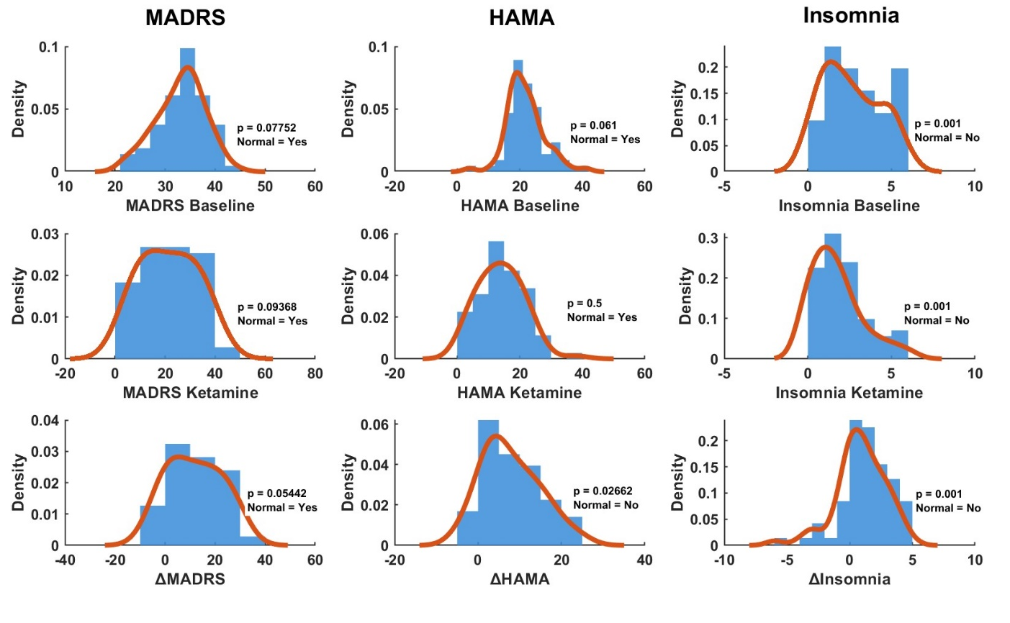
Figure S1. Distribution and normality diagnostics for study outcomes. Columns correspond to (left) Montgomery-Åsberg Depression Rating Scale (MADRS) ((top) baseline, (middle) post-ketamine, and (bottom) ΔMADRS= baseline–ketamine), (middle) Hamilton Anxiety Rating Scale (HAM-A) ((top) baseline, (middle) post-ketamine, and (bottom) ΔHAM-A= baseline–ketamine), and (right) Insomnia (derived from the insomnia items of the Hamilton Depression Rating Scale (HAM-D) ((top) baseline, (middle) post-ketamine, and (bottom) ΔINS= baseline–ketamine). Each panel shows a histogram (density scale; Freedman–Diaconis binning) with an overlaid kernel-density estimate. An inset reports the Lilliefors test p-value and whether normality was retained at α=0.05 (“Normal = Yes/No”). Sample size: N = 71 (pairwise complete cases per panel).

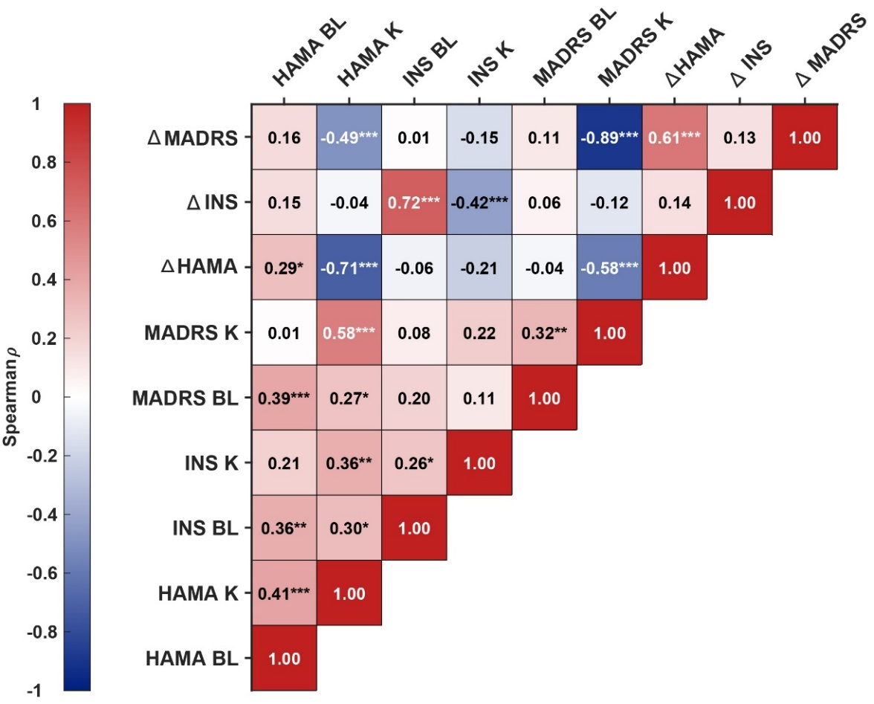
Figure S2. Spearman correlation matrix across symptom domains. Cells display ρ values (Spearman rank correlations) between Hamilton Anxiety Rating Scale (HAM-A) (anxiety), Hamilton Depression Rating Scale (HAM-D) insomnia items (INS), and Montgomery-Åsberg Depression Rating Scale (MADRS) (depression) measured at baseline (BL), post-ketamine (K), and their changes (Δ = BL − K). Only the lower triangle is shown to avoid redundancy; the color scale indicates the magnitude and direction of ρ. Asterisks denote significance (P < 0.05 = *, P < 0.01 = **, P < 0.001 = ***). Correlations were computed with pairwise deletion of missing data.

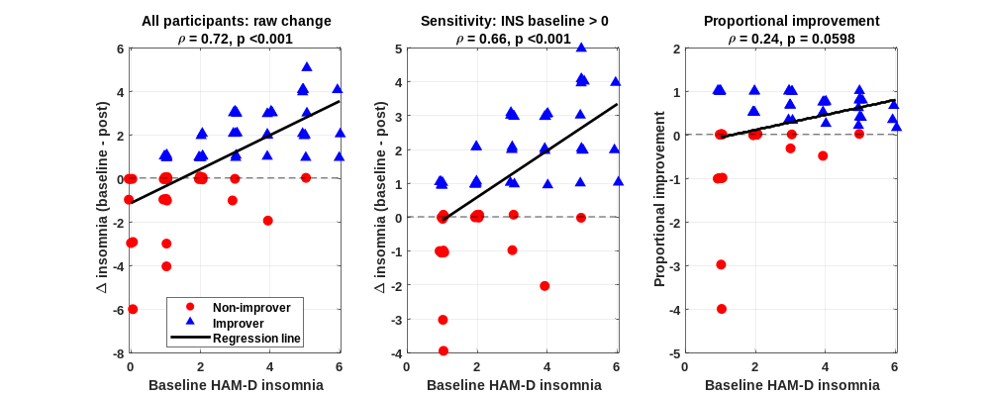

Figure S3. Sensitivity analyses for the association between baseline Hamilton Depression Rating Scale (HAM-D) insomnia severity and insomnia symptom improvement. Scatterplots show the association between baseline HAM-D insomnia score and insomnia change scores following ketamine treatment. Positive Δ insomnia values indicate improvement, calculated as baseline minus post-ketamine HAM-D insomnia score. Red circles indicate non-improvers, blue triangles indicate improvers, and black lines represent fitted linear regression lines. Left: association between baseline insomnia and raw insomnia change in the full sample. Middle: sensitivity analysis restricted to participants with baseline HAM-D insomnia symptoms greater than zero. Right: proportional improvement among participants with baseline HAM-D insomnia symptoms greater than zero, calculated as Δ insomnia divided by baseline HAM-D insomnia score.

