Supplementary Material: Eating disorder symptoms are associated with altered reinforcement learning in the general population
M. L. Westwater, F. Shang & M. Browning

- Supplementary Methods
1.1 Linear mixed-effects model notation
We examined the effects of EDEQ score, reward condition (food versus money), valence (loss versus win), and their interaction on task accuracy and computational parameters using linear mixed-effects modelling in R (R package nlme). Each model included random intercepts for reward condition and valence that were nested within the random effect of the participant. Age, sex, and working memory capacity were included as covariates of no interest. The models have been described in Wilkinson-Rogers notation below:
Main effect model:
Accuracy ~ Condition + Valence + EDEQ_Tot + Sex + Age + sum_score + (1|ID/Condition/Valence)
Two-way interaction model:
Accuracy ~ Condition*Valence + Condition *EDEQ_Tot + Valence*EDEQ_Tot + Sex + Age + sum_score + (1|ID/Condition/Valence)
Three-way interaction model:
Accuracy ~ Condition*Valence*EDEQ_Tot + Sex + Age + sum_score + (1|ID/Condition/Valence)
  - Reaction time analysis
Using the modelling approach described above, we examined the effects of task condition, valence, and EDEQ score on reaction time. This exploratory analysis was conducted in the same sample as the primary accuracy analysis (n = 368). Prior to analysis, trial-wise reaction times were averaged across both blocks for each condition, and resulting averages were inspected for outlier values. Because reaction times demonstrate a non-Gaussian distribution that renders standard deviation-based methods of outlier detection less effective, outliers were defined as values >1.5 times the interquartile range below the 25th percentile or above the 75th percentile. This resulted in the exclusion of 32 observations (2.72% of observations). A rank-based inverse normal transformation was applied to RTs (R package RNOmni; McCaw, 2019) to minimize positive skew before analysis.
  - Win-stay lose-shift analysis
We conducted an additional exploratory analysis of win-stay, lose-shift responding to determine if EDEQ scores may be associated with individual differences in this learning strategy. In the primary analytic sample (n = 368), we calculated win-stay responses as the conditional probability of repeating the same cue on consecutive trials, and lose-shift responding reflected the probability of shifting one’s response pattern to select the alternative cue on consecutive trials. These probabilities were calculated separately for each trial valence (win, loss) and condition (food, money), and they were averaged across both task blocks for each condition. As win-stay probabilities demonstrated a negative skew, a cubic transform was applied prior to analysis. Analyses were performed with the LMMs that were used in all other analyses (see Supplementary Section 1.1).
  - Model comparison
We performed model comparisons to determine if our reinforcement learning model demonstrated improved fit relative to three variants. As in our primary model, all models estimated learning rate parameters to update the value of task stimuli, as well as inverse choice temperature parameters that control choice behaviour. For model comparison, we fit models which either utilised different parameter values for each of the two conditions (i.e., win and loss), or a single parameter value across both conditions. Model fit was evaluated by comparing AIC values across models with condition-specific versus independent parameters (see Supplementary Table 4). Smaller AIC values indicate improved model fit; however, as established in information theory, a difference of ≥ 10 indicates strong evidence for an optimal model, and a difference <2 suggests that models are largely indistinguishable. The difference in AIC across our models was ~2, suggesting each had similar fit to the data (39). Given the absence of clear differences in model fit, we retained the original model for our primary analysis, which mirrors our behavioural analyses, aligns with prior literature (30, 35), and facilitates our aim of testing effects of valence on both model parameters.
- Supplementary Results
  - Reaction time
As in our primary analysis of task accuracy, we observed significant main effects of reward condition (B(SE) = -0.20(0.04), p < .001) and valence (B(SE) = 0.54(0.02), p < .001) on reaction time. Participants responded more quickly in response to monetary versus food reward, and they were slower on loss relative to win trials. EDEQ scores were not related to individual differences in reaction time (p = 0.41). Aligning with accuracy results, a significant EDEQ-by-valence interaction effect indicated that participants with elevated EDEQ scores had nominally slower reaction times on loss versus win trials (B(SE) = 0.04(0.02), p = .033). A condition-by-valence interaction effect was also nominally significant, showing that participants were slower on monetary loss versus win trials than on food loss versus win trials (B(SE) = 0.11(0.05), p = .023). The inclusion of two-way interaction effects resulted in improved model fit (χ²(3) = 10.61, p = 0.014), but the inclusion of a three-way interaction term did not (p = 0.14).
  - Win-stay lose-shift
The main effects of condition (B(SE) = 0.035(0.011), p = 1.8x10⁻³) and valence (B(SE) = -0.20(0.01), p < .001) were related to win-stay responses, with participants being more likely to make the same choice for reinforced money trials than food trials and less likely to repeat their choice on loss relative to win trials. EDEQ score was not related to individual differences in win-stay responding (p = .11). The inclusion of two-way (p = .16) and three-way (p = .44) interaction effects did not significantly improve model fit indices.
Valence was significantly associated with lose-shift behaviour, where participants were more likely to shift following punishment in the loss relative to the win condition (B(SE) = 0.196(0.007), p < .001). There was a nominally significant effect of EDEQ score condition (B(SE) = 0.011(0.005), p = .042), suggesting that participants with increased EDEQ scores had greater lose-shift responding. The main effect of condition (p = 0.123) was not significant. However, a significant condition-by-valence interaction effect indicated that participants were more likely to shift their response following a monetary loss versus no-win than a food loss versus no-win (B(SE) = 0.040(0.013), p = .002). Two nominally significant interaction effects were also observed. A nominally significant EDEQ-by-condition interaction effect showed that individuals with greater EDEQ scores were less likely to shift their choice behaviour following a loss or no-win in the money condition than in the food condition (B(SE) = -0.012(0.006), p = 0.046). Finally, an EDEQ-by-valence interaction effect indicated that greater EDEQ scores were associated with nominally increased lose-shift responding in the loss relative to the win condition (B(SE) = 0.011(0.005), p = 0.045). The inclusion of two-way interaction effects resulted in improved model fit (χ²(3) = 17.52, p = 6.0x10⁻⁴), but the inclusion of a three-way interaction term did not (p = 0.59).

Supplementary Figure 1. Distribution of EDEQ scores in final analytic sample.
Supplementary Figure 2. Parameter distributions across reward conditions and valence. A) Density plot of learning rates for win and loss trials during monetary reward condition. B) Density plot of inverse choice temperature values for win and loss trials during monetary reward condition. C) Density plot of learning rates for win and loss trials during food reward condition. D) Density plot of inverse choice temperature values for win and loss trials during food reward condition.

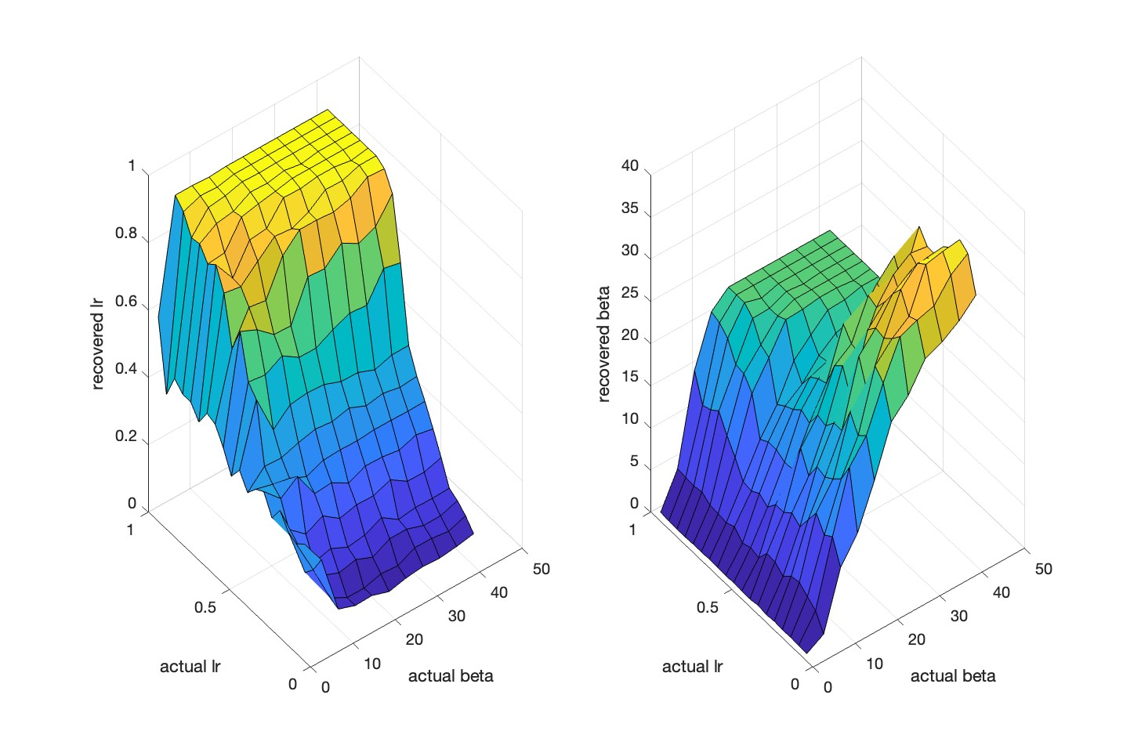
Supplementary Figure 3. Reinforcement learning model parameter recovery. Using simulated data across the range of observed learning rate (α) and inverse choice temperature (β) values, our model fitting procedure reproduced relevant features of participant data. Left: Learning rates could be recovered across the full range except when β values were very low (indicating more stochastic responding). Right: Inverse choice temperature values < 20 were recovered at any learning rate. High β values were recoverable when learning rate values were low, which would be expected: individuals would show a more deterministic response pattern when learning rates are low.

