SUPPLEMENTAL INFORMATION
Real-world alcohol cue exposure and drinking risk in alcohol use disorder
Authors: Ali Ghadami^{1,8}, MSc, Abhijit Sreepada^{1,8}, MSc, Iris Reinhard², PhD, Marvin Ganz¹, MSc, Justin Boehmer^{3,9,10}, PhD, Kanya Meyer-Degering^{3,9}, MSc, Henrik Walter^{9,10}, MD PhD, Jamila Andoh¹, PhD, Bernd Lenz^{5,8}, MD, Patrick Bach^{5,8}, MD PhD, Falk Kiefer^{5,8}, MD PhD, Emanuel Schwarz^{1,4,8}, PhD, Markus Reichert^{1,6}, PhD, Ulrich W. Ebner-Priemer^{1,7}, PhD, Andreas Meyer-Lindenberg^{1,8}, MD PhD, Christine Heim^{3,10,11}, PhD, Heike Tost^{1,8}, MD PhD
¹ Department of Psychiatry and Psychotherapy, Central Institute of Mental Health, University of Heidelberg, Medical Faculty Mannheim, Mannheim, Baden-Württemberg, Germany.
² Core Facility Biostatistics, Central Institute of Mental Health, University of Heidelberg, Medical Faculty Mannheim, Mannheim, Baden-Württemberg, Germany.
³ Charité-Universitätsmedizin Berlin, Corporate Member of Freie Universität Berlin and Humboldt-Universität zu Berlin, Institute of Medical Psychology, Berlin, Germany.
⁴ Hector Institute for Artificial Intelligence in Psychiatry, Central Institute of Mental Health, Medical Faculty Mannheim, Heidelberg University, Mannheim, Germany.
⁵ Department of Addictive Behavior and Addiction Medicine, Central Institute of Mental Health, Medical Faculty Mannheim, Heidelberg University, Mannheim, Germany.
⁶ Department of Sport and Exercise Science, Faculty of Natural and Life Sciences, University of Salzburg, Salzburg, Austria.
⁷ Mental mHealth Lab, Department of Applied Psychology, Institute of Sports and Sports Science, Karlsruhe Institute of Technology, Karlsruhe, Germany
⁸ German Center for Mental Health (DZPG), Partner Site Mannheim-Heidelberg-Ulm, Germany
⁹ Charité-Universitätsmedizin Berlin, Corporate Member of Freie Universität Berlin and Humboldt-Universität zu Berlin, Department of Psychiatry and Psychotherapy (CCM), Berlin, Germany.
¹⁰ German Center for Mental Health (DZPG), Partner Site Berlin-Potsdam, Germany
¹¹ Charité-Universitätsmedizin Berlin, Corporate Member of Freie Universität Berlin and Humboldt-Universität zu Berlin, NeuroCure Cluster of Excellence, Berlin, Germany.

Table of Contents
1. Supplementary Information 3
Multilevel analysis 3
Bootstrap cluster-stability analysis 4
2. Supplementary Tables 5
Table S1. Pooled sample GLMM output 5
Table S2a. Random effects variance estimates from full model 7
Table S2b. Model fit statistics for pooled-sample random-effects specifications 8
Table S2c. Random effects variance estimates from primary (reduced) model 9
Table S3. Exploratory clustering descriptives and post hoc comparisons 9
Table S4. Sensitivity analyses: Cue effect estimates 10
3. Supplementary Figures 12
Figure S1. Cluster analysis diagnostics 12
Figure S2. Alcohol-related cue images 14
Figure S3. Individual slopes (log-odds) for the three predictor pairs, by cluster. 16
4. Supplementary References 17

1. Supplementary Information

Multilevel analysis
Continuous WP deviations were SD-standardized, and binary predictors (alcohol cue exposure, being in company, and drinking companion exposure) were coded as 0/1 at each prompt and then decomposed into person means (PM; proportions) and within-person deviations (WP; deviations from the person mean) for modeling. For pooled analysis, SD-standardization of continuous within-person deviations was performed in the combined dataset to ensure a common scale across cohorts. All models were adjusted for age, sex, and time of day. Observations with missing values for any model term were excluded (complete case at the observation level). Event-appraisal intensity ratings were log-transformed prior to the WP/PM decomposition. Analyses were conducted in R version 4.5.2 ¹ using lme4::glmer, with estimation via maximum likelihood (Laplace approximation) using the bobyqa optimizer and increased iteration limits.
Model specification. For participant i at prompt j, the primary model can be written as
(1)
$$\text{logit}\left(P({\text{drinking}}_{ij}=1)\right)=β_{00}+\sum_{k∈K_{\text{WP}}}{β_{k0}}X_{k,ij}^{\text{WP}}+\sum_{k∈K_{\text{PM}}}{β_{0k}}X_{k,i}^{\text{PM}}+β_{020} {\text{age}}_{i}+β_{030} {\text{female}}_{i}+β_{040} {\text{time}}_{ij}+u_{0i}$$
Where the within-person predictor set $K_{\text{WP}}$comprised: valence (WP, SD), positive event appraisal (WP, SD), negative event appraisal (WP, SD), being in company (WP), alcohol cue exposure (WP), drinking companion exposure (WP), anxious (WP, SD), loneliness (WP, SD), irritated (WP, SD), guilt (WP, SD), energetic arousal (WP, SD), calmness (WP, SD) and the between-person predictor set $K_{\text{PM}}$comprised: valence (PM), positive event appraisal (PM, SD), negative event appraisal (PM, SD), being in company (PM), alcohol cue exposure (PM), drinking companion exposure (PM), anxious (PM, SD), loneliness (PM, SD), irritated (PM, SD), guilt (PM, SD), energetic arousal (PM, SD), calmness (PM, SD).
$P({\text{drinking}}_{ij}=1)$ is the probability that participant i reported currently drinking at assessment j. Within-subject effects were modelled at Level 1 (EMA prompts within individuals) and between-subject effects at Level 2 (differences between individuals). For each EMA predictor, the WP component equals the observed value minus participant i’s mean for that predictor, and the PM component equals participant i’s mean for that predictor. Fixed effects include the intercept $β_{00}$, WP and PM main effects, and covariate effects (age, female, time of day). Random effects in the cohort-specific primary models included a participant-specific intercept only.
Effect size reporting. Odds ratios (OR) were computed as $\text{OR}=exp⁡(\hat{β})$, with Wald 95% confidence intervals $exp⁡(\hat{β}±1.96⋅SE(\hat{β}))$. For originally binary WP and PM predictors, ORs/CIs were rescaled to represent a 0.1-unit increase and were calculated as $\text{OR}=\exp\left(0.1\hat{β}\right)$. For binary WP predictors, a change from absence to presence corresponds to a 1-unit difference after person-mean centering, with $\text{OR}=exp⁡(\hat{β})$. ORs/CIs for all other predictors were reported per 1-unit increase (continuous WP terms are SD-standardized). Wald z-tests were used for fixed effects. Model convergence and diagnostics were evaluated using gradient tolerance and the number of function evaluations (maxfun = 2e6); convergence was confirmed for all reported models.
Discovery/replication/pooled sample workflow. The model was fitted in the discovery sample, re-estimated with the same specification plus site (Mannheim, Berlin, reference = Mannheim) as a covariate in the replication sample, and then re-estimated in the pooled dataset where both site (same coding) and cohort (discovery, replication; reference = discovery) were included as covariates. To identify predictors with substantial between-participant heterogeneity for the replicated items (alcohol cue exposure (WP), being in company (WP), drinking companion exposure (WP), and energetic arousal (WP)), we first fitted a random-slopes screening model including random slopes for these four within-person predictors (Full model). This model showed a singular fit, due to the negligible heterogeneity for energetic arousal (WP). Accordingly, the primary pooled model retained a random intercept and random slopes only for three predictors of alcohol cue exposure (WP), being in company (WP), drinking companion exposure (WP) (Reduced model; Table S2c), dropping slopes with negligible variance for parsimony and model stability. Model fit statistics for the Full vs Reduced specifications are reported in Table S2b.

Bootstrap cluster-stability analysis
To characterize the internal stability of the exploratory two-cluster partition, we generated 500 bootstrap samples by resampling with replacement from the 129 participant-level, z-standardized slope vectors and reran k-means clustering in each sample (k = 2; 100 random starts). Cluster stability was quantified using cluster-specific Jaccard similarity and the partition-level adjusted Rand index (ARI). For each reference cluster, Jaccard similarity was calculated with the best-matching bootstrap cluster among the uniquely sampled participants. For the ARI, all participants in the original sample were assigned to their nearest centroid from each bootstrap solution, and the resulting partition was compared with the reference partition. The cue-reactive and social context-reactive reference clusters comprised 67 and 62 participants, respectively. Mean Jaccard coefficients were 0.949 and 0.944, respectively, and the mean ARI was 0.894 (SD = 0.090). These findings indicate high internal stability of the partition under resampling of the participant-level slope features. However, these results do not constitute independent validation of distinct subtypes.

2. Supplementary Tables

Table S1. Pooled sample GLMM output
Predictor | Estimate | SE | z | p | OR | 95% CI
Within-person (WP)
Alcohol cue exposure (WP) | 3.522 | 0.228 | 15.458 | <.001 | 1.422 | 1.360 - 1.487
Being in company (WP) | 1.365 | 0.171 | 7.973 | <.001 | 1.146 | 1.108 - 1.185
Drinking companion exposure (WP) | 0.765 | 0.143 | 5.358 | <.001 | 1.080 | 1.050 - 1.110
Energetic arousal (WP, SD) | 0.370 | 0.042 | 8.759 | <.001 | 1.447 | 1.333 - 1.572
Valence (WP, SD) | 0.095 | 0.056 | 1.682 | .093 | 1.099 | 0.984 - 1.228
Loneliness (WP, SD) | 0.082 | 0.041 | 1.994 | .046 | 1.085 | 1.001 - 1.176
Calmness (WP, SD) | 0.050 | 0.050 | 1.005 | .315 | 1.052 | 0.953 - 1.160
Negative event appraisal (WP, SD) | 0.057 | 0.037 | 1.552 | .121 | 1.059 | 0.985 - 1.138
Anxious (WP, SD) | 0.030 | 0.043 | 0.687 | .492 | 1.030 | 0.946 - 1.122
Guilt (WP, SD) | 0.025 | 0.042 | 0.604 | .546 | 1.025 | 0.945 - 1.112
Positive event appraisal (WP, SD) | 0.027 | 0.036 | 0.752 | .452 | 1.027 | 0.958 - 1.101
Irritated (WP, SD) | -0.097 | 0.043 | -2.246 | .025 | 0.907 | 0.834 - 0.988
Between-person (PM)
Alcohol cue exposure (PM) | 3.134 | 0.552 | 5.672 | <.001 | 1.368 | 1.228 - 1.524
Being in company (PM) | 1.126 | 0.556 | 2.026 | .043 | 1.119 | 1.004 - 1.248
Drinking companion exposure (PM) | -1.169 | 0.474 | -2.469 | .014 | 0.890 | 0.811 - 0.976
Energetic arousal (PM, SD) | -0.107 | 0.137 | -0.783 | .434 | 0.898 | 0.686 - 1.175
Valence (PM, SD) | 0.117 | 0.267 | 0.439 | .661 | 1.124 | 0.667 - 1.896
Loneliness (PM, SD) | 0.002 | 0.188 | 0.010 | .992 | 1.002 | 0.693 - 1.449
Calmness (PM, SD) | -0.081 | 0.249 | -0.325 | .745 | 0.922 | 0.567 - 1.501
Negative event appraisal (PM, SD) | 0.165 | 0.157 | 1.050 | .294 | 1.179 | 0.867 - 1.605
Anxious (PM, SD) | -0.058 | 0.149 | -0.386 | .699 | 0.944 | 0.705 - 1.264
Guilt (PM, SD) | -0.040 | 0.161 | -0.250 | .802 | 0.961 | 0.701 - 1.317
Positive event appraisal (PM, SD) | -0.171 | 0.154 | -1.106 | .269 | 0.843 | 0.623 - 1.141
Irritated (PM, SD) | 0.130 | 0.192 | 0.679 | .497 | 1.139 | 0.782 - 1.660
Covariates
Age (Z-transformed) | 0.302 | 0.105 | 2.880 | .004 | 1.352 | 1.101 - 1.660
Female | -0.268 | 0.208 | -1.288 | .198 | 0.765 | 0.509 - 1.150
Time of day (Z-transformed) | 1.391 | 0.050 | 27.621 | <.001 | 4.018 | 3.641 - 4.435
Site | -0.446 | 0.338 | -1.319 | .187 | 0.640 | 0.330 - 1.242
Cohort | 0.363 | 0.219 | 1.659 | .097 | 1.437 | 0.936 - 2.207
Intercept | -6.396 | 0.446 | -14.328 | <.001 | 0.002 | 0.001 - 0.004
Note: WP = within-person (person-mean-centered); PM = person-mean (between-person); SD = SD-standardized; OR = odds ratio; CI = confidence interval. Estimates and SEs are reported on the original 1-unit scale. ORs/CIs for originally binary WP/PM predictors are reported per 0.1-unit increase and were calculated as $\text{OR}=\exp\left(0.1\hat{β}\right)$; all other ORs/CIs are reported per 1-unit increase. Random slopes included for being in company (WP), alcohol cue exposure (WP), and drinking companion exposure (WP). n = 129 participants; 19579 observations.

Table S2a. Random effects variance estimates from full model
Random-slope variance estimates from the pooled-sample maximal random-slopes screening model, including random slopes for four within-person predictors (being in company, alcohol cue exposure, drinking companion exposure, and energetic arousal). This table documents the empirical basis for simplifying the random-effects structure in the primary pooled model.
Predictor | Variance | SD | Retained in Reduced?
Intercept | 1.855 | 1.362 | Yes
Being in company (WP) | 1.309 | 1.144 | Yes
Alcohol cue exposure (WP) | 2.853 | 1.689 | Yes
Drinking companion exposure (WP) | 0.851 | 0.923 | Yes
Energetic arousal (WP, SD) | 0.053 | 0.231 | No
Note: WP = within-person (person-mean-centered); SD = SD-standardized

Table S2b. Model fit statistics for pooled-sample random-effects specifications
Model fit indices for the pooled-sample maximal random-slopes screening model and primary reduced random effects model.
Model | Random effects | AIC | BIC | logLik | N observations | N participants
Full model | Random intercept + random slopes for being in company (WP), alcohol cue exposure (WP), drinking companion exposure (WP), energetic arousal (WP, SD) | 6234.9 | 6589.6 | -3072.4 | 19579 | 129
Reduced model | Random intercept + random slopes for being in company (WP), alcohol cue exposure (WP), drinking companion exposure (WP) | 6241.5 | 6556.8 | -3080.7 | 19579 | 129
Note: AIC/BIC/logLik values are reported as printed in the model summaries; both models were fit using maximum likelihood (Laplace approximation).

Table S2c. Random effects variance estimates from primary (reduced) model
Effect | Variance | SD | Correlations (with intercept; between slopes)
(Intercept) | 1.748 | 1.322 | -
Being in company (WP) | 1.353 | 1.163 | corr with intercept = -0.35
Alcohol cue exposure (WP) | 2.836 | 1.684 | corr with intercept = -0.46; corr with company = -0.26
Drinking companion exposure (WP) | 0.776 | 0.881 | corr with intercept = -0.32; corr with company = 0.45; corr with cues = -0.54

Table S3. Exploratory clustering descriptives and post hoc comparisons
 | C1 (n = 67) mean ± SD / Count | C2 (n = 62) mean ± SD / Count | Welch t / chi-square | t_df | p (t) /  p (χ²)
Individual Slopes
Being in company (WP) | 0.77 ± 0.66 | 1.86 ± 0.50 | -10.62 | 122.88 | <.001
Alcohol cue exposure (WP) | 4.01 ± 0.99 | 2.70 ± 1.09 | 7.14 | 123.58 | <.001
Drinking companion exposure (WP) | 0.31 ± 0.46 | 1.19 ± 0.38 | -11.92 | 125.60 | <.001
Sociodemographic
Age | 37.09 ± 12.49 | 26.89 ± 8.02 | 5.56 | 113.54 | <.001
Sex | Female: 27 / Male: 40 | Female: 28 / Male: 34 | 0.14 | 1 | .704
Income | 4.62 ± 2.42 | 3.20 ± 2.37 | 3.33 | 123.27 | .001
Education | 7.06 ± 1.47 | 6.92 ± 2.15 | 0.43 | 102.78 | .665
Psychological/Clinical assessments
AUD criteria | 4.28 ± 2.27 | 3.11 ± 1.86 | 3.22 | 125.17 | .002
AUD criteria lifetime | 5.01 ± 2.63 | 3.79 ± 2.45 | 2.74 | 126.99 | .007
AUDIT | 14.91 ± 6.24 | 12.68 ± 5.60 | 2.14 | 126.89 | .034
Consumption intensity (sum of AUDIT items 1-3) | 6.55 ± 2.23 | 5.89 ± 1.63 | 1.94 | 120.68 | .054
SRRS | 361.47 ± 192.05 | 270.41 ± 165.45 | 2.87 | 124.40 | .005
CTS | 7.81 ± 3.05 | 7.21 ± 2.43 | 1.23 | 124.36 | .220
PSS | 27.03 ± 7.12 | 26.82 ± 6.37 | 0.18 | 124.88 | .861
OSSS-3 | 10.26 ± 2.14 | 10.44 ± 2.00 | -0.50 | 124.98 | .615
BIS15 | 33.35 ± 8.07 | 33.12 ± 7.04 | 0.17 | 118.67 | .868
neo_Neuroticism | 10.61 ± 5.24 | 9.70 ± 5.27 | 0.97 | 124.13 | .336
neo_Extraversion | 14.11 ± 3.65 | 14.80 ± 3.76 | -1.06 | 123.51 | .292
neo_Openness (to experience) | 14.11 ± 5.20 | 14.07 ± 5.18 | 0.04 | 124.32 | .965
neo_Agreeableness | 15.83 ± 4.55 | 16.93 ± 3.80 | -1.49 | 123.78 | .140
neo_Conscientiousness | 15.98 ± 4.82 | 17.44 ± 3.93 | -1.87 | 123.14 | .063
CTQ_emotional_abuse | 10.09 ± 5.03 | 9.00 ± 4.67 | 1.28 | 127.00 | .204
CTQ_physical_abuse | 6.52 ± 2.51 | 5.74 ± 1.78 | 2.05 | 119.30 | .043
CTQ_sexual_abuse | 5.91 ± 2.21 | 5.45 ± 1.17 | 1.49 | 101.95 | .139
CTQ_emotional_neglect | 12.07 ± 5.44 | 9.27 ± 4.20 | 3.28 | 123.14 | .001
CTQ_phys_neglect | 9.43 ± 3.58 | 8.50 ± 2.64 | 1.69 | 121.17 | .093
Note: C1 = alcohol cue-reactive cluster, C2 = social context-reactive cluster, WP = within-person slopes (log-odds scale). Clusters were derived via k-means clustering (k = 2) of z-standardized participant-specific slopes. Between-cluster comparisons used Welch's t-tests for continuous variables and a chi-square test for sex; df values are from Welch's t-tests.

Table S4. Sensitivity analyses: Cue effect estimates
Alcohol cue coefficient and odds ratio from Supplementary models in discovery and replication samples. All models are logistic GLMMs with the same fixed-effect specification as the primary model; only the cue term (same-time vs lagged) and/or the observation subset differs.
Cohort | Model description | n (participant / obs) | Estimate | SE | z | p | OR | 95% CI
Discovery | same-time cue; subset: drinking at t-1 = 0 | 73 / 10850 | 3.004 | 0.134 | 22.441 | <.001 | 1.350 | 1.315 - 1.386
Discovery | lagged cue (t-1) (full sample) | 73 / 11932 | 0.515 | 0.091 | 5.675 | <.001 | 1.053 | 1.034 - 1.072
Replication | same-time cue; subset: drinking at t-1 = 0 | 56 / 6831 | 3.673 | 0.185 | 19.828 | <.001 | 1.444 | 1.392 - 1.497
Replication | lagged cue (t-1) (full sample) | 56 / 7518 | 0.990 | 0.114 | 8.662 | <.001 | 1.104 | 1.080 - 1.129
Note: WP = within-person (person-mean-centered); OR = odds ratio; CI = confidence interval (Wald). Estimate/SE/z are on the original log-odds scale. “Lagged” = cue at previous prompt (t−1) within the same participant. ORs and 95% CIs represent a 0.1-unit increase and were calculated as $\text{OR}=\exp\left(0.1\hat{β}\right)$.

3. Supplementary Figures

Figure S1. Cluster analysis diagnostics
Diagnostics for selecting the number of clusters (k-means) for exploratory clustering based on participant-specific within-person slopes
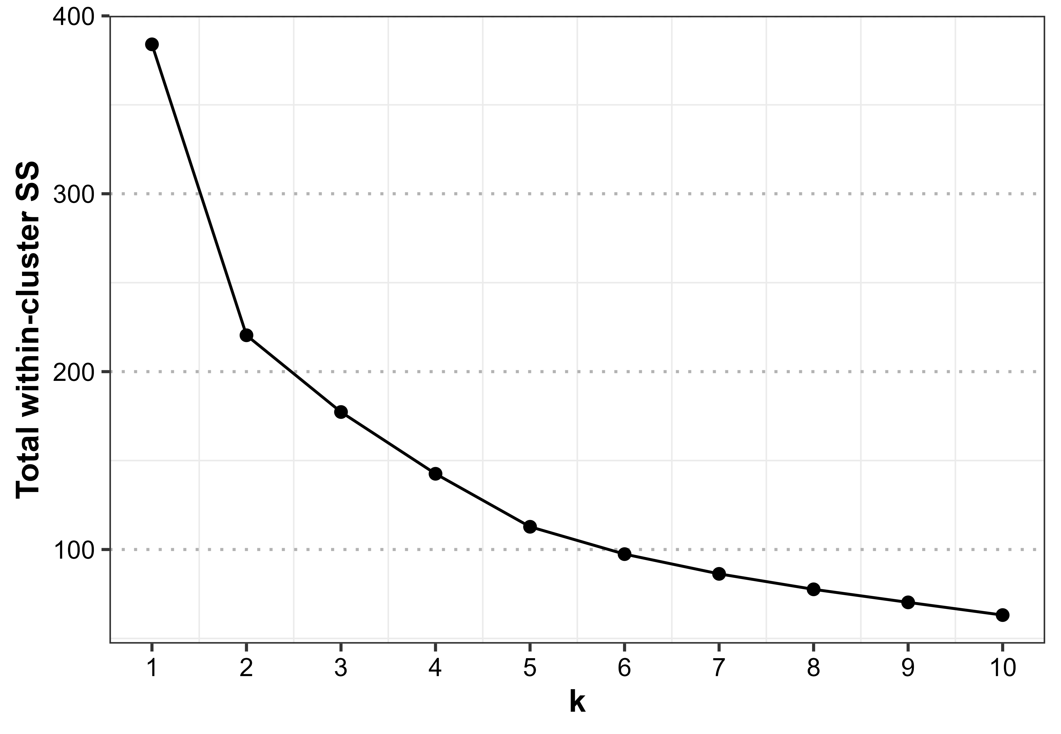
Figure S1A. Elbow plot.
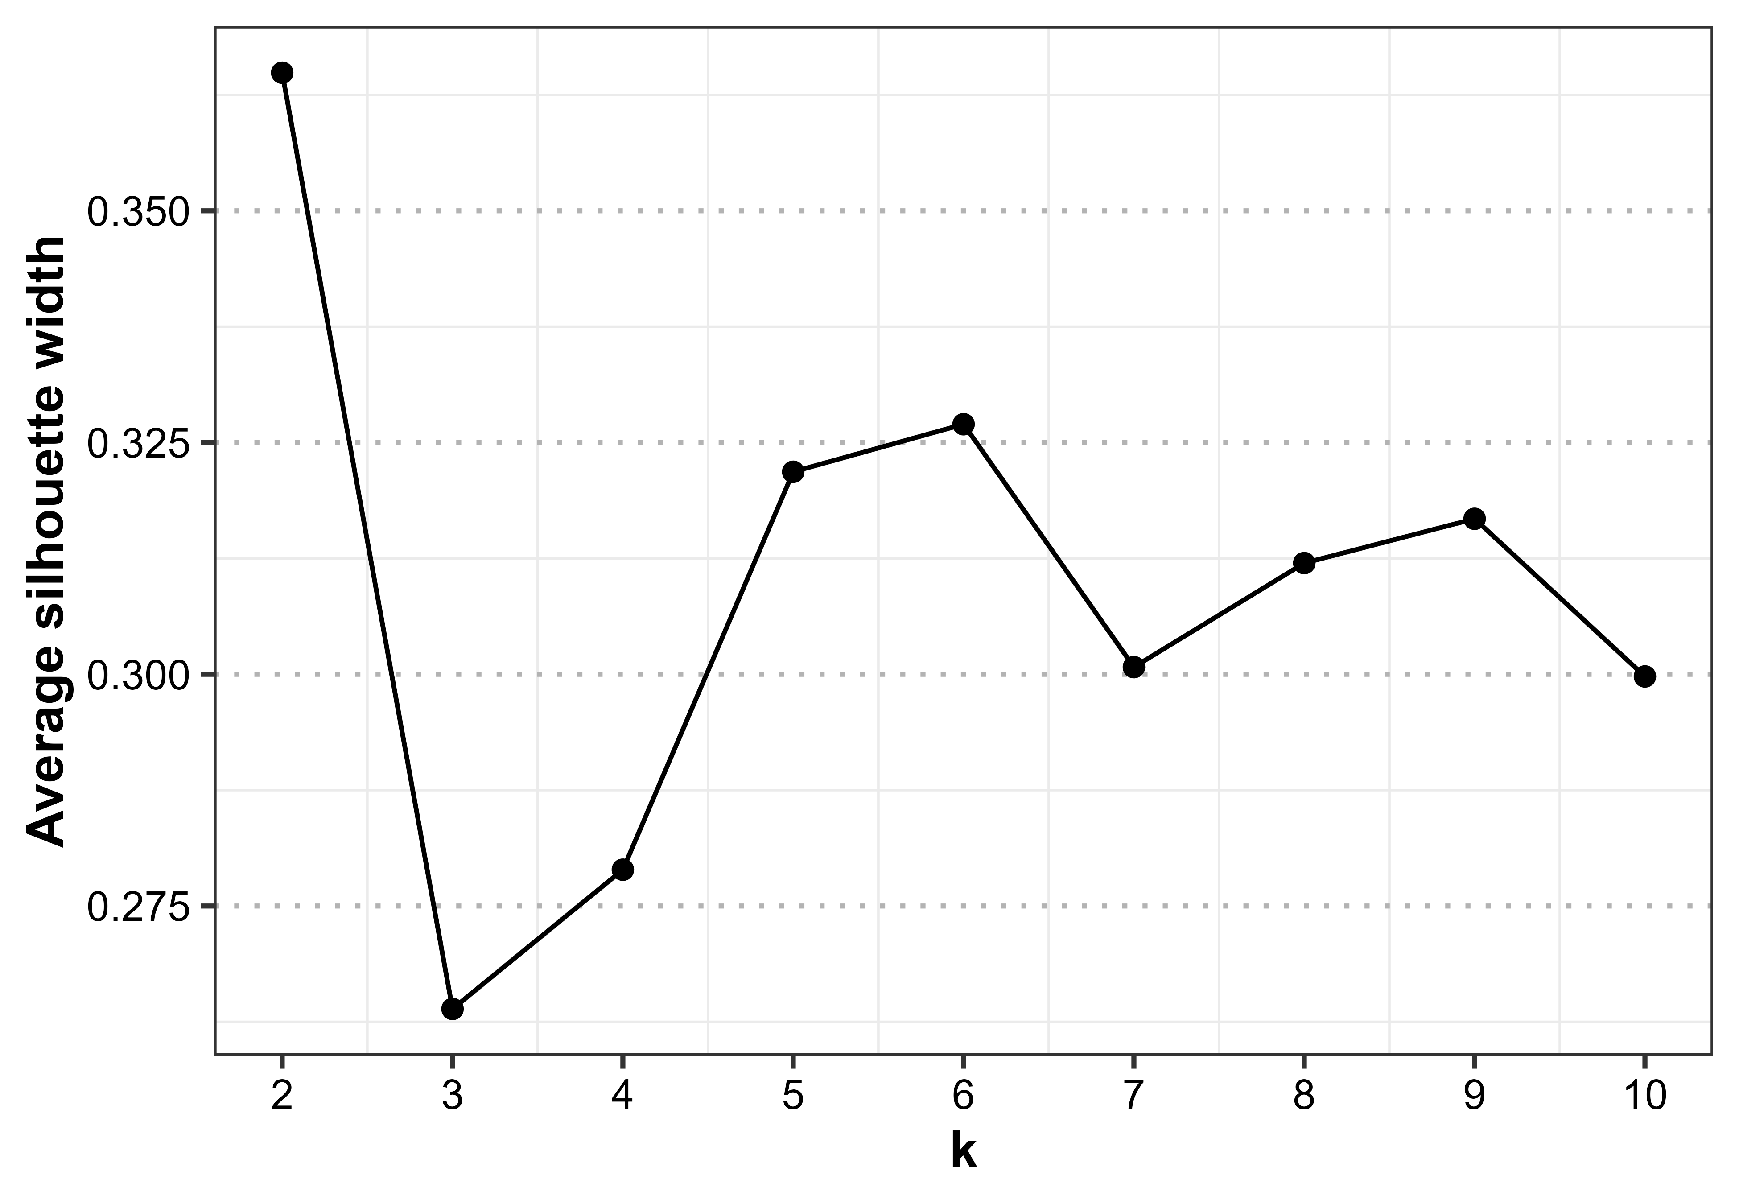
Figure S1B. Silhouette plot.

Figure S2. Alcohol-related cue images

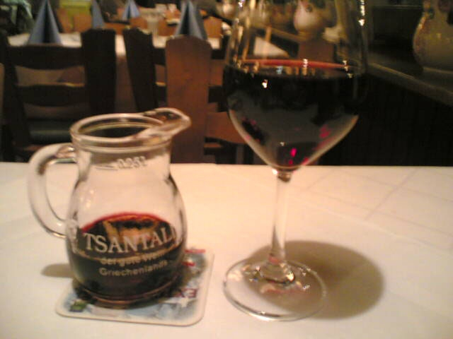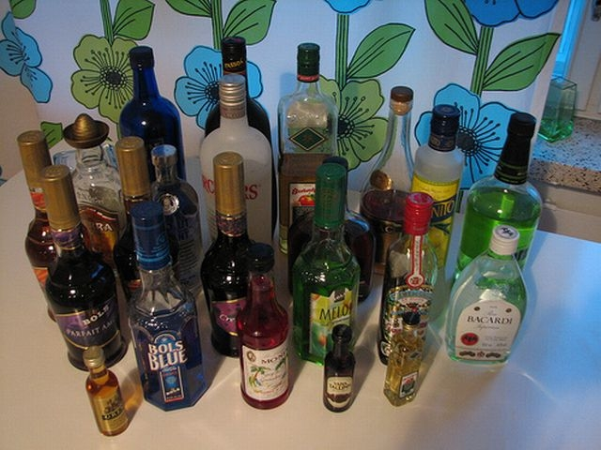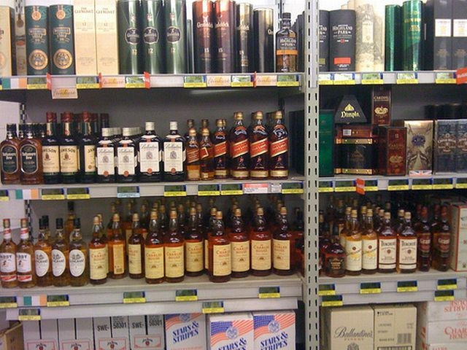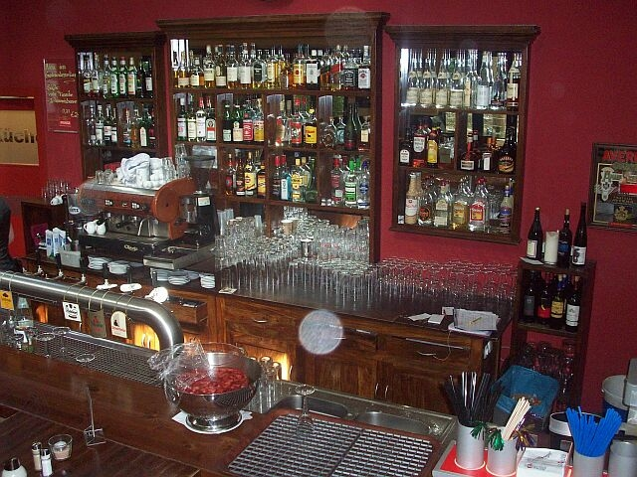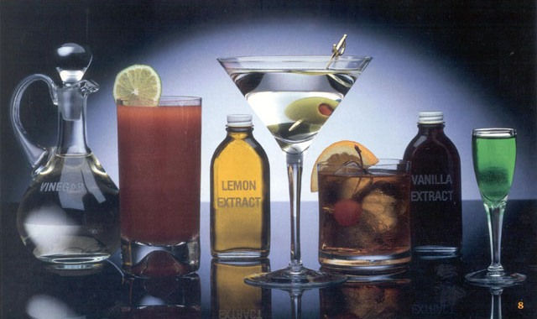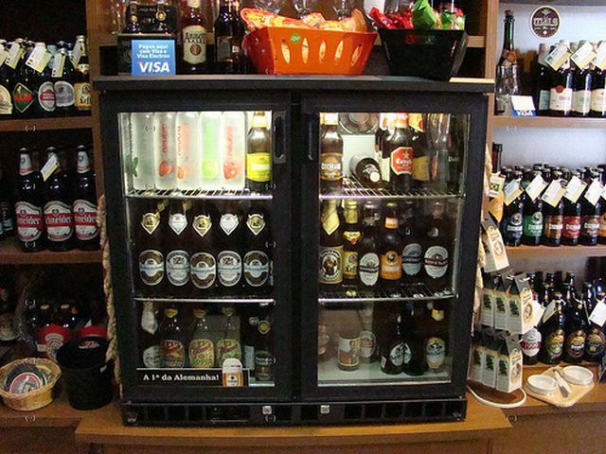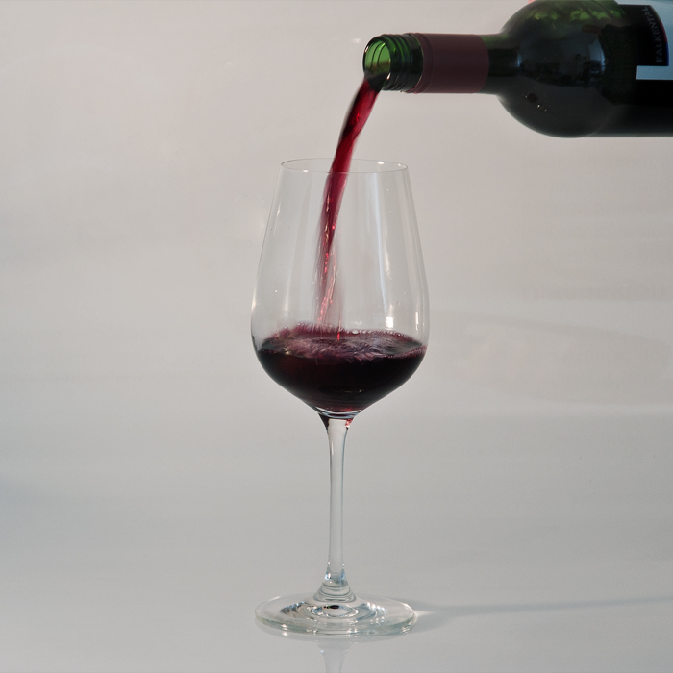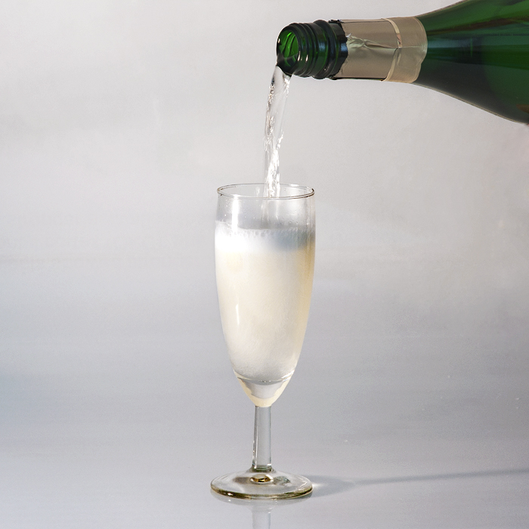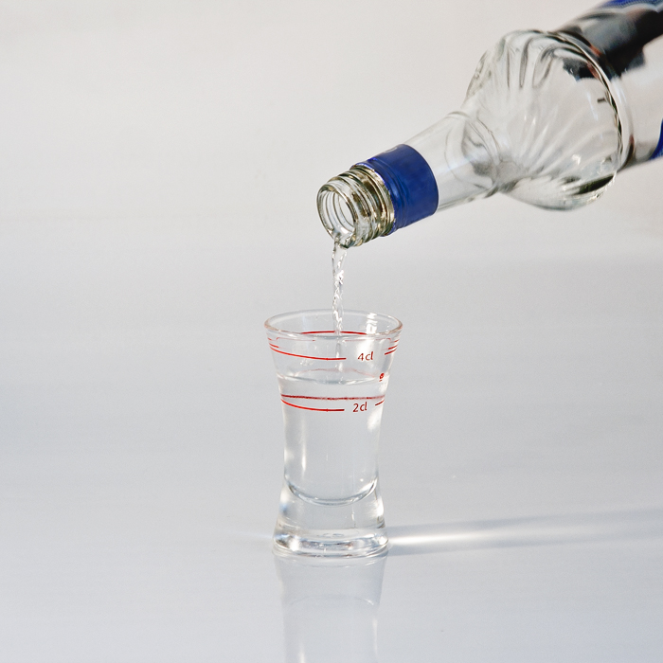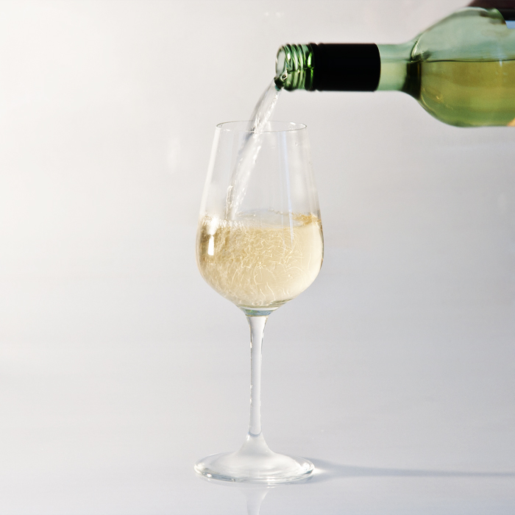
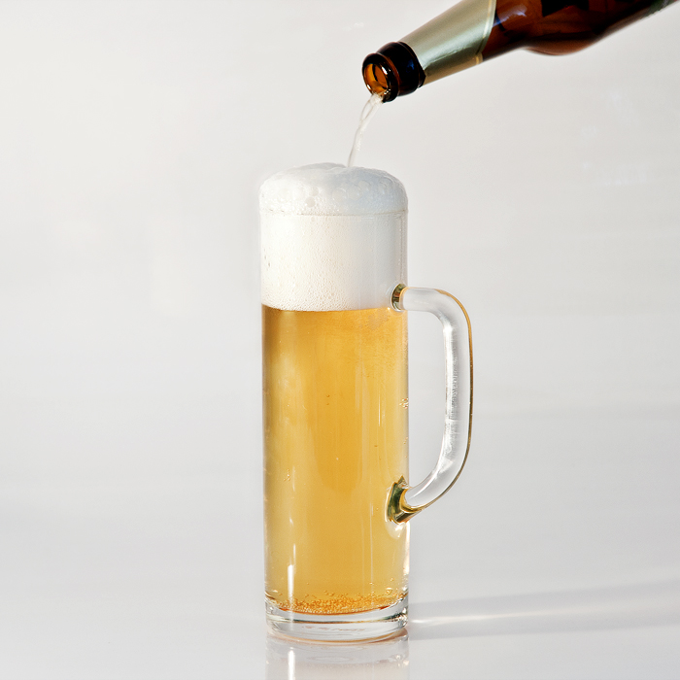

Figure S3. Individual slopes (log-odds) for the three predictor pairs, by cluster.
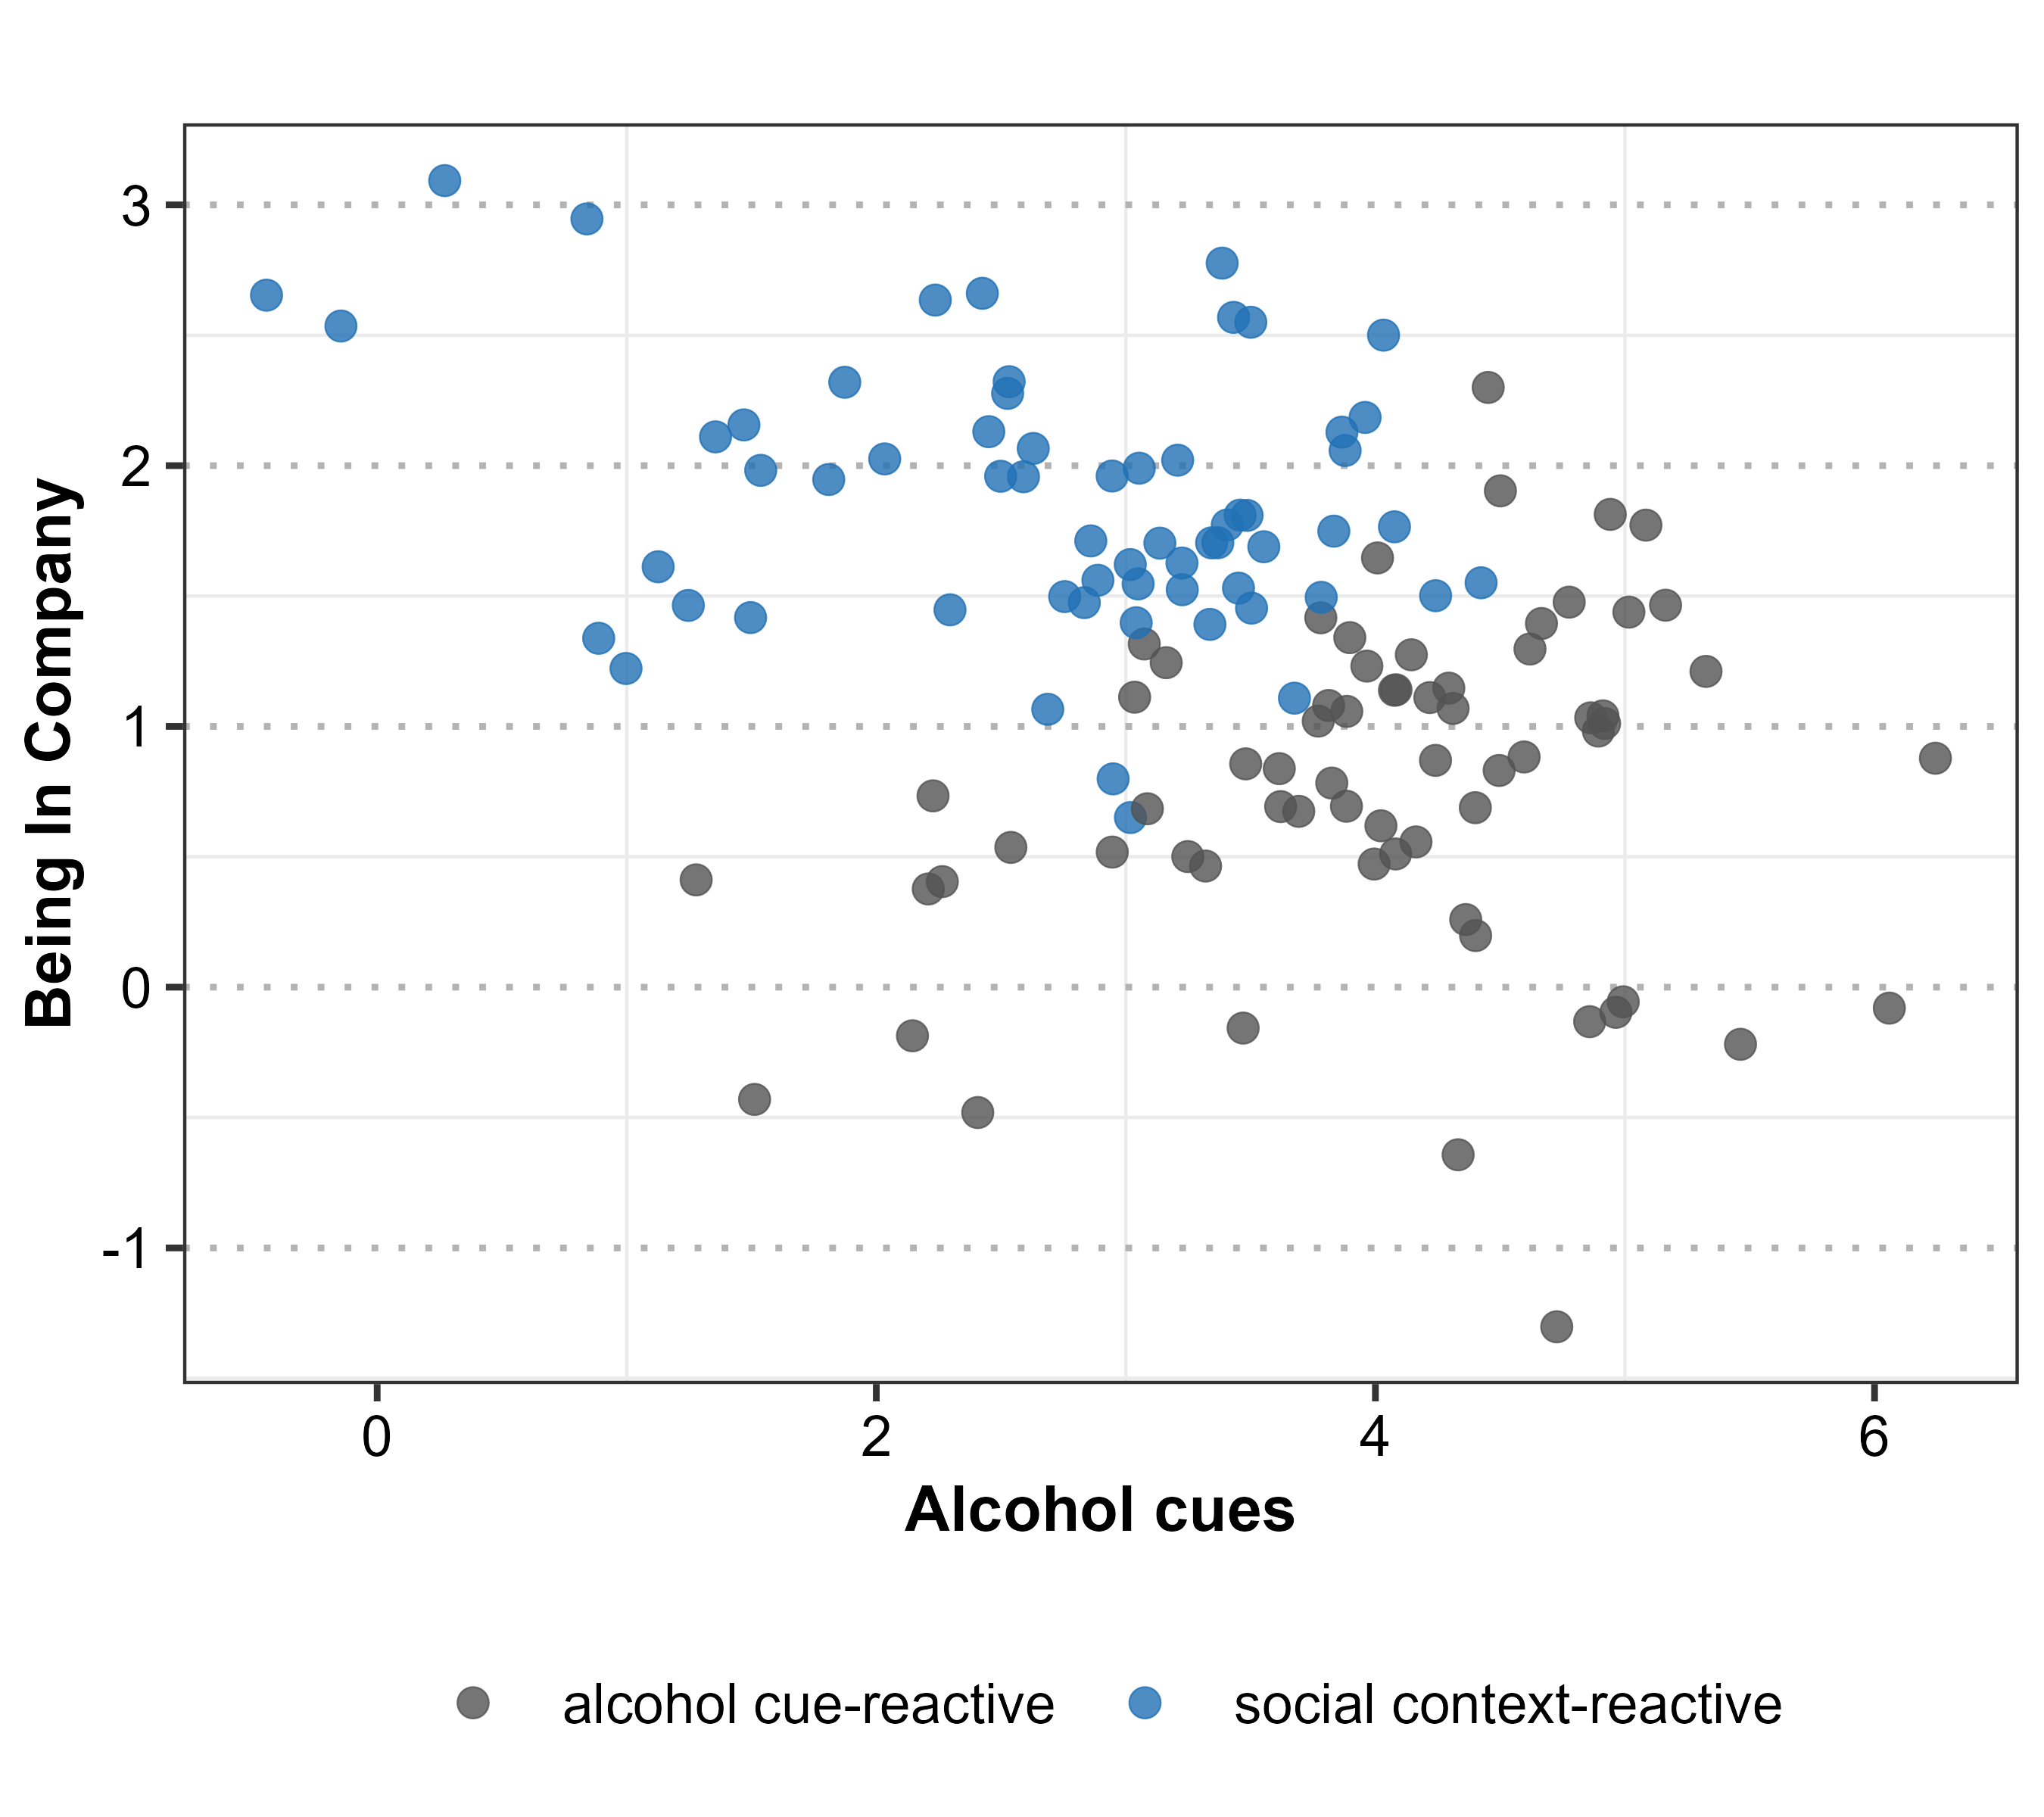
Figure S3A: Alcohol cues vs Being in company.
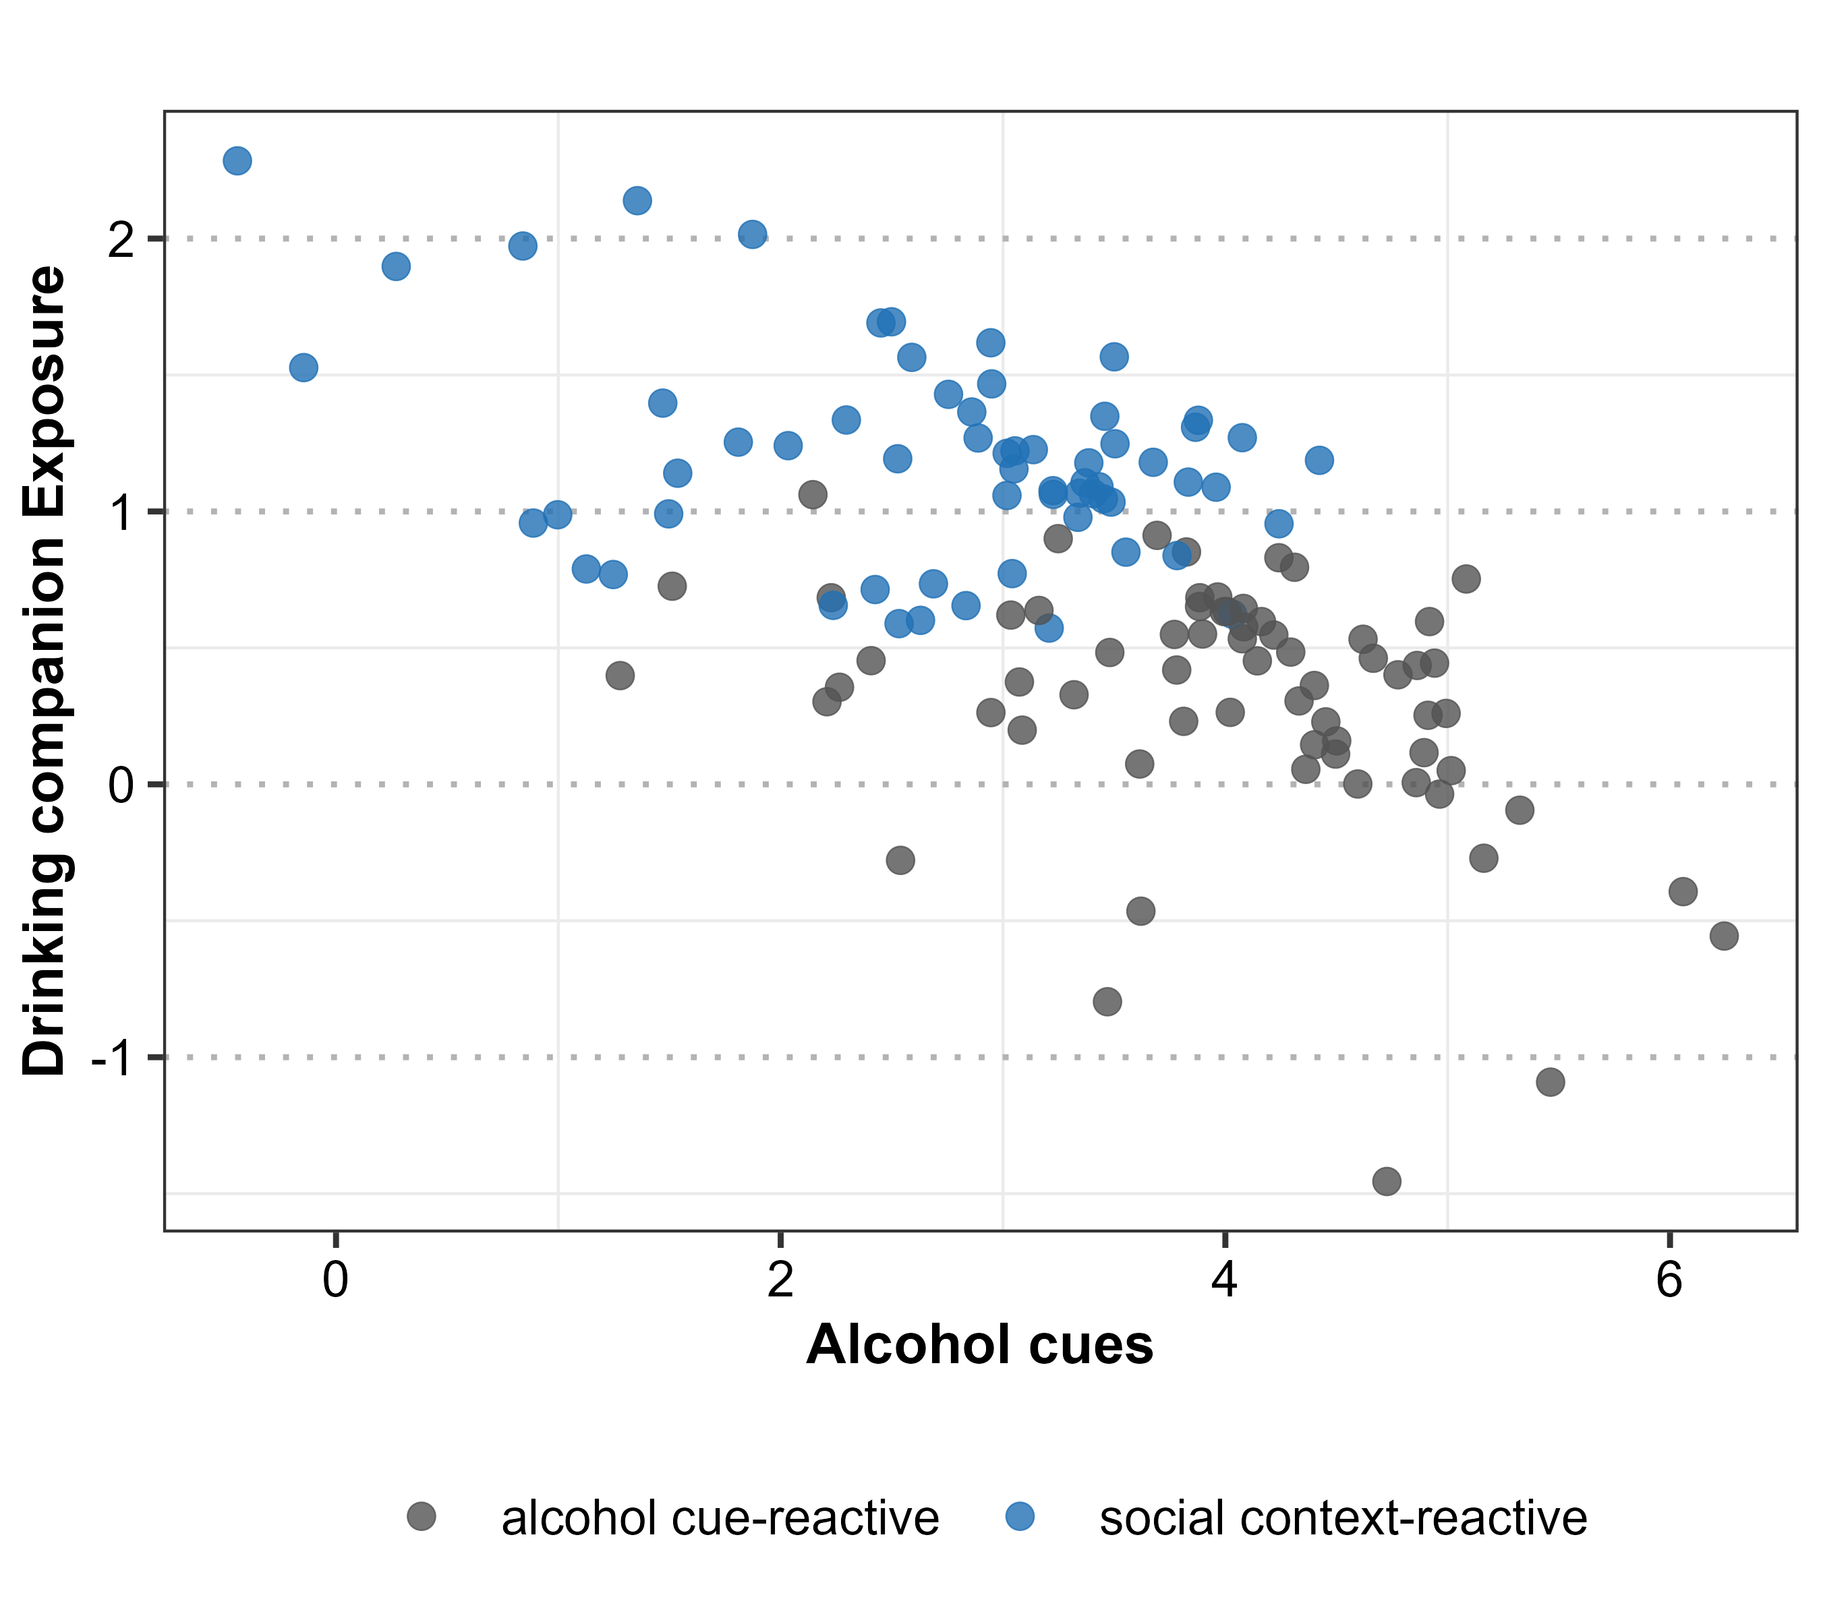
Figure S3B: Alcohol cues vs Drinking companion exposure.
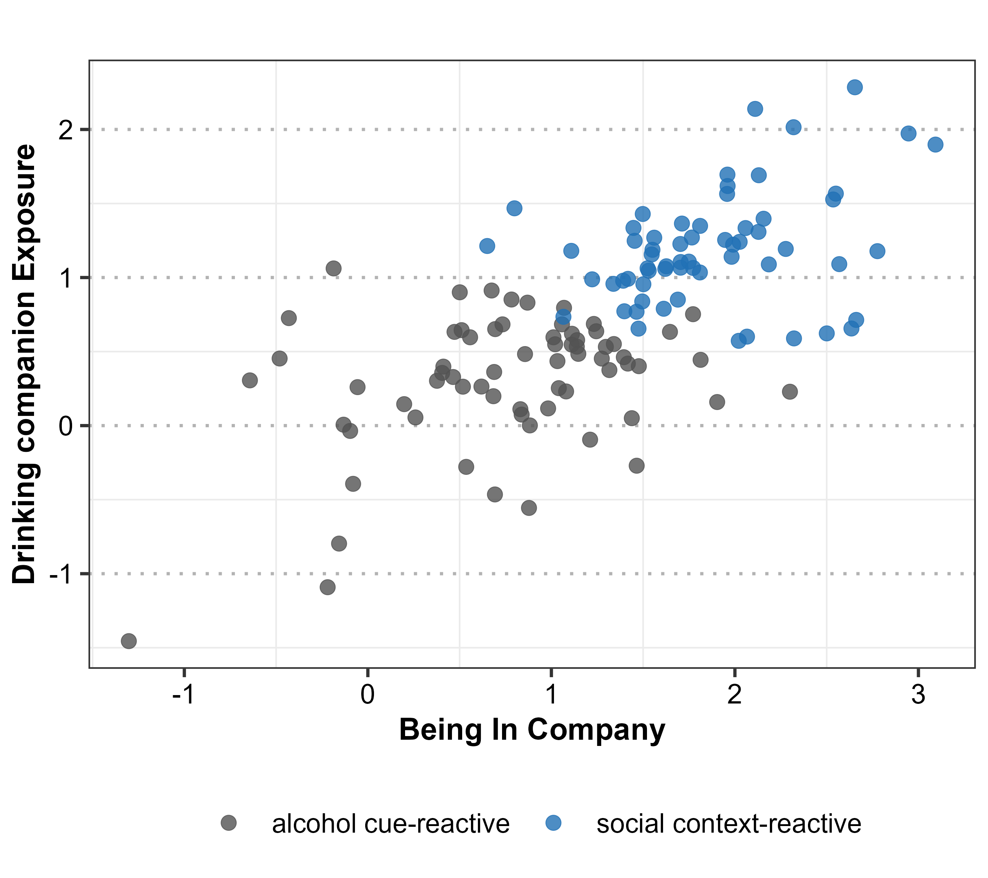
Figure S3C: Being in company vs Drinking companion exposure.

4. Supplementary References
1 R Core Team. R: A Language and Environment for Statistical Computing (R Foundation for Statistical Computing, Vienna, Austria, 2025).

