Supplementary Information for
Original article
A GLP-1 analog lowers ER stress and enhances protein folding to ameliorate homocysteine-induced endothelial dysfunction

Chak Kwong Cheng^{1,2}, Jiang-Yun Luo^{1,2}, Chi Wai Lau^{1,2}, William Chi-shing Cho³, Chi Fai Ng⁴, Ronald Ching Wan Ma⁵, Xiao Yu Tian^{1,2,}*, Yu Huang^{1,2,}*

¹School of Biomedical Sciences and Li Ka Shing Institute of Health Science, The Chinese University of Hong Kong, Hong Kong SAR, China
²Heart and Vascular Institute and Shenzhen Research Institute, The Chinese University of Hong Kong, Hong Kong SAR, China
³Department of Clinical Oncology, Queen Elizabeth Hospital, Kowloon, Hong Kong SAR, China
⁴Department of Surgery, The Chinese University of Hong Kong, Hong Kong SAR, China
⁵Department of Medicine and Therapeutics, Hong Kong Institute of Diabetes and Obesity, The Chinese University of Hong Kong, The Prince of Wales Hospital, Hong Kong SAR, China

Running title: GLP-1 receptor activation against vascular ER stress

*To whom correspondence should be addressed.
Email addresses: yu-huang@cuhk.edu.hk (Yu Huang)
xytian@cuhk.edu.hk (Xiao Yu Tian)

Supplementary results
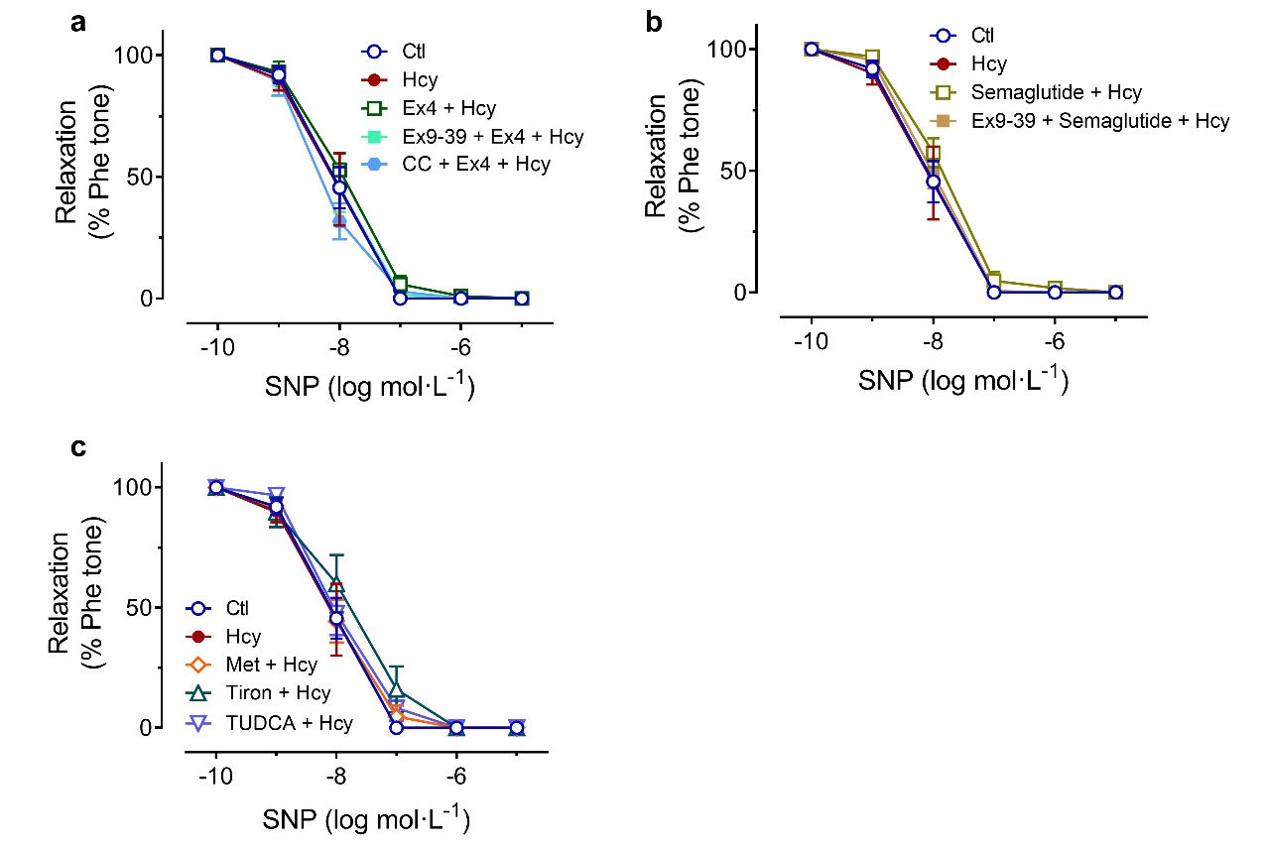
Figure S1. Endothelium-independent relaxations of mouse aortae after ex vivo treatment. (a-c) Upon different pharmacological treatments, the SNP-induced relaxations were unaltered. The same curves for Ctl and Hcy groups in (a), (b) and (c). CC: compound C; Ex4: exendin-4; Ex9-39: exendin9-39; Hcy: homocysteine; Met: metformin; TUDCA: tauroursodeoxycholic acid. The data are mean ± SEM (n=6 to 7 per group).

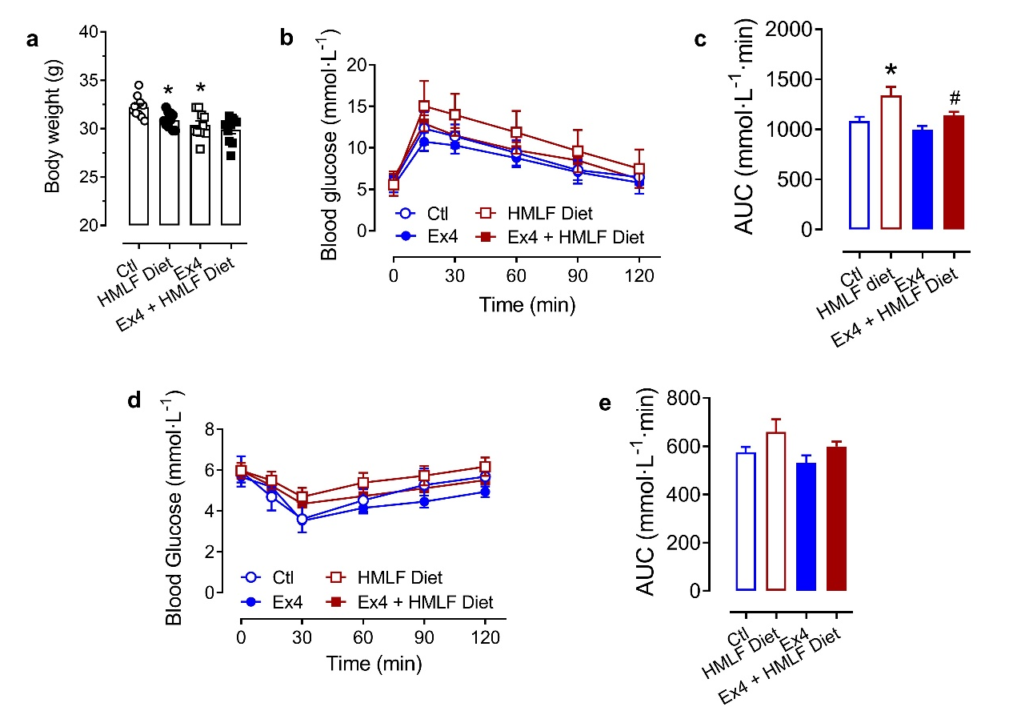
Figure S2. Body parameters of diet-induced HHcy mice. (a) HMLF diet and exendin-4 treatment slightly lowered the body weights of diet-induced HHcy mice. (b), (c) HMLF diet caused slight glucose intolerance, while exendin-4 treatment improved glucose tolerance, in diet-induced HHcy mice as shown by GTT. (d), (e) HMLF diet did not induce significant insulin resistance in diet-induced HHcy mice as shown by ITT. HMLF: high methionine low folate. *P<0.05 vs Ctl group; #P<0.05 vs HMLF Diet group. The data are mean ± SEM (n=10 per group).

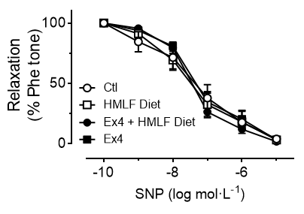
Figure S3. Endothelium-independent relaxations of mouse aortae after chronic HMLF diet and Ex4 treatment. The SNP-induced relaxations were unaltered among different groups. Ex4: exendin-4; HMLF: high methionine low folate. The data are mean ± SEM (n=6 per group).

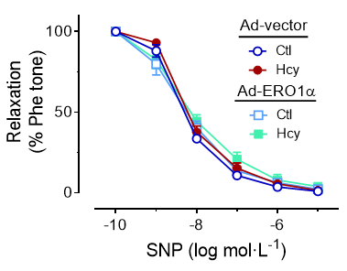
Figure S4. Endothelium-independent relaxations of mouse aortae after ex vivo adenoviral transduction. The SNP-induced relaxations were unaltered among different groups. Hcy: homocysteine. The data are mean ± SEM (n=6 per group).

