Supplementary Information
LTr1, derived from cruciferous vegetables, inhibits glioma proliferation via TrkA/ PI3K/AKT pathway

Table of contents
Supplementary Figures
Supplementary Fig. 1. The levels of LDH release in the culture of glioma cells.
Supplementary Fig. 2. Cell viability of primary astrocytes and SVG P12 treated with various compounds.
Supplementary Fig. 3. The chromatographic graph of internal standard ketoconazole.
Supplementary Fig. 4. Cell viability of glioma cells treated with TMZ and PTX.
Supplementary Fig. 5. Statistical analysis of protein levels and EdU positive cells related to Fig. 2.
Supplementary Fig. 6. LTr1 induced DNA damage in SHG-44 and U87 glioma cells.
Supplementary Fig. 7. Statistical analysis related to Fig. 3.
Supplementary Fig. 8. LTr1 decreased the mitochondrial membrane potential (MMP) of glioma cells.
Supplementary Fig. 9. The structures of representative TrkA inhibitors with indole or indole bioisostere pharmacophores (in light blue).
Supplementary Fig. 10. Inhibiting TrkA induced apoptosis and inhibited proliferation in glioma cells.
Supplementary Fig. 11. NGF, the positive ligand of TrkA directly bound to TrkA determined by microscale tthermophoresis (MST) assay.
Supplementary Fig. 12. LTr1 directly bound to TrkA determined by biolayer interferometry (BLI) assay.
Supplementary Fig. 13. Statistical analysis of protein levels related to Fig. 6.
Supplementary Fig. 14. LTr1 played an anti-glioma role via TrkA.
Supplementary Fig. 15. LTr1 had no toxicity in vivo.
Supplementary Fig. 16. The statistical analysis of Ki67 positive cells.
Supplementary Fig. 17. The H&E staining of the lung in the orthotopic xenograft glioma model.

Supplementary Tables
Supplementary Table 1. Cytotoxicity of the seven lead compounds.
Supplementary Table 2. The concentration of LTr1 in plasma and various tissues in vivo.

Supplementary Fig. 1. The levels of LDH release in the culture of glioma cells. Glioma cells SHG-44, U87, and U251 were treated with the seven compounds (No. 32, 90, 91, 106, 113, 126 and 133) at indicated concentrations for 48 h, respectively, using LDH assay kit. Data are analyzed using One-way ANOVA. *P < 0.05, **P < 0.01 and ***P < 0.001 vs. control. Values are presented as means ± SEM from three independent experiments.
Supplementary Fig. 2. Cell viability of primary astrocytes and SVG P12 treated with various compounds. Primary astrocytes a and SVG P12 b were cultured and treated with the indicated concentrations of compounds 32, 90, 91, 106, 113, 124, 126 and 133, and their cell viabilities were analyzed by CCK-8 assay. Data are analyzed using One-way ANOVA. *P < 0.05, **P < 0.01 and ***P < 0.001 vs. control. Values are presented as means ± SEM from three independent experiments.

Supplementary Fig. 3. The chromatographic graph of internal standard ketoconazole.

Supplementary Fig. 4. Cell viability of glioma cells treated with TMZ and PTX. SHG-44 and U87 cells were cultured and treated with the indicated concentrations of chemotherapy drugs TMZ a and PTX b for 72 h, respectively, and their cell viabilities were analyzed by CCK-8 assay. Values are presented as means ± SEM from three independent experiments.

Supplementary Fig. 5. Statistical analysis of protein levels and EdU positive cells related to Fig. 2. a-d The statistical analysis of cyclinA2, CDK4, CDK2 and p21, respectively. e The statistical analysis of EdU positivie cells. Data are analyzed using One-way ANOVA. *P < 0.05, **P < 0.01 and ***P < 0.001 vs. control. Values are presented as means ± SEM from three independent experiments.

Supplementary Fig. 6. LTr1 induced DNA damage in SHG-44 and U87 glioma cells. a SHG-44 and U87 cells were treated with LTr1 (0.5, 1, and 2 μM) for 48 h, followed by incubation with antibody γ-H2AX, and visualization under a fluorescence microscope (scale bar, 100 μm). b DNA damage indicated by the γ-H2AX positive cells. Data are analyzed using One-way ANOVA. *P < 0.05, **P < 0.01 and ***P < 0.001 vs. control. Values are presented as means ± SEM from three independent experiments.

Supplementary Fig. 7. Statistical analysis related to Fig. 3. a The statistical analysis of apoptosic cells analyzed by Hoechst 233342 staining. b The statistical analysis of apoptosic cells analyzed by Annexin V-FITC/PI staning. c-h The statistical analysis of cleaved cas3, Bcl-2, Bax, cleaved cas9 and cyto C, respectively. Data are analyzed using One-way ANOVA. *P < 0.05 ,**P < 0.01 and ***P < 0.001vs. control. Values are presented as means ± SEM from three or four independent experiments.

Supplementary Fig. 8. LTr1 decreased the mitochondrial membrane potential (MMP) of glioma cells. SHG-44 and U87 cells were treated with LTr1 and PTX at the indicated concentration for 48 h, were loaded with JC-1 probe for 30 min followed by observing under a fluorescence microscope (scale bar, 100 μm).
Supplementary Fig. 9. The structures of representative TrkA inhibitors with indole or indole bioisostere pharmacophores (in light blue).

Supplementary Fig. 10. Inhibiting TrkA induced apoptosis and inhibited proliferation in glioma cells. SHG-44 and U87 cells were treated with TrkA inhibitor LOXO-101 and LTr1 for 48 h. a Levels of LDH release were tested by LDH assay kit. b Statistical analysis of apoptotic cells. c Statistical analysis of EdU positive cells. Data are analyzed using One-way ANOVA. *P <0.05, **P < 0.01 and ***P < 0.001 vs. NC group. Values are presented as means ± SEM from three independent experiments.

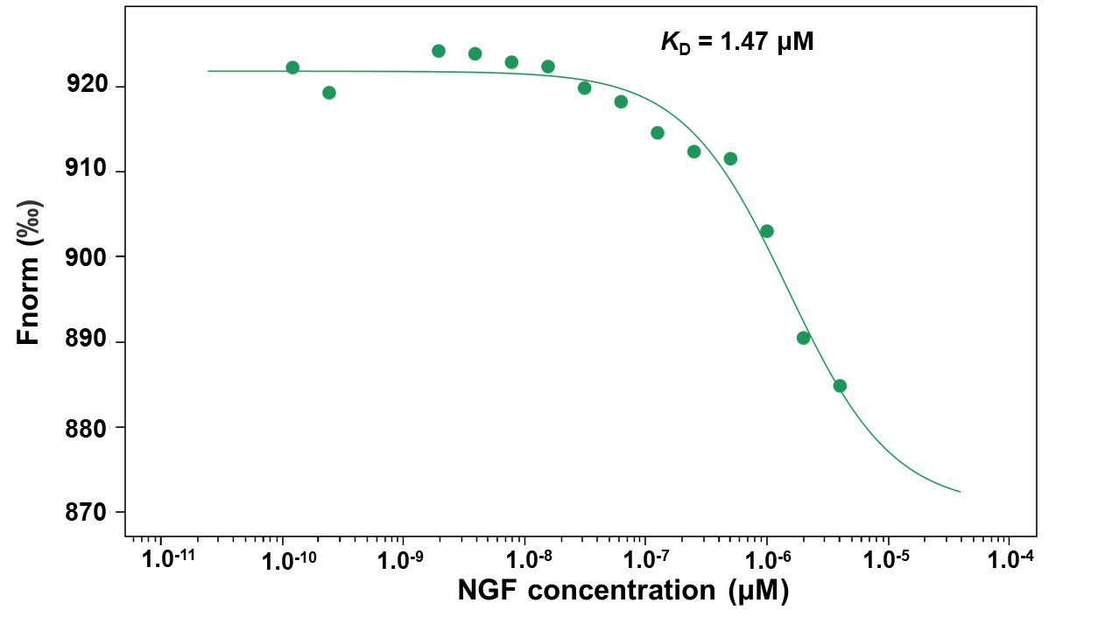
Supplementary Fig. 11. NGF, the positive ligand of TrkA directly bound to TrkA determined by microscale tthermophoresis (MST) assay.

Supplementary Fig. 12. LTr1 directly bound to TrkA determined by biolayer interferometry (BLI) assay.

Supplementary Fig. 13. Statistical analysis of protein levels related to Fig. 6. a-c The statistical analysis of TrkA, p-AKT and p-PI3K, respectively. Data are analyzed using One-way ANOVA. *P < 0.05 and **P < 0.01 vs. control. Values are presented as means ± SEM from three independent experiments.

Supplementary Fig. 14. LTr1 played an anti-glioma role via TrkA. SHG-44 and U87 cells were transfected with TrkA-siRNA for 48 h and then treated with LTr1 for 48 h. a Cell viability was analyzed by CCK-8 assay. b and d Cells were stained by Annexin V-FITC and PI and analyzed by flow cytometry. c and e The proliferation of glioma cells was performed by EdU assay kit and observed under a fluorescence microscope (scale bar, 100 μm). Data are analyzed using One-way ANOVA. *P < 0.05, **P < 0.01 and ***P < 0.001 vs. NC group. Values are presented as means ± SEM from three or four independent experiments.

Supplementary Fig. 15. LTr1 had no toxicity in vivo. a Body weight variation of mice during the experimental period. b Representative H&E stained images of peripheral tissues in different groups (scale bars, 40 µm). n =6 mice per group.

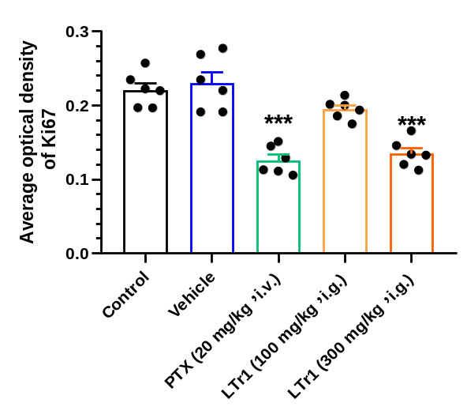
Supplementary Fig. 16. The statistical analysis of Ki67 positive cells. Data are analyzed using One-way ANOVA. ***P < 0.001 vs. control. Values are presented as means ± SEM.n=6 mice per group.

Supplementary Fig. 17. The H&E staining of the lung in the orthotopic xenograft glioma model. Representative H&E stained images of peripheral tissues in different groups (scale bars, 40 µm). n =6 mice per group.

Supplementary Table 1. Cytotoxicity of the seven lead compounds (IC₅₀ in μM).
Compound number | IC₅₀ (μM)
Compound number | SHG-44 | U87 | U251
32 | 0.26 | 0.27 | 0.98
90 | 0.96 | 0.74 | 0.58
91 | 0.74 | 0.94 | 2.12
106 | 0.17 | 0.001 | 0.04
113 | 0.52 | 0.45 | 0.65
124 | 0.26 | 0.29 | 0.76
126 | 0.11 | 0.01 | 0.05
133 (LTr1) | 1.97 | 1.84 | 2.03

Supplementary Table 2. The concentration of LTr1 in plasma and various tissues in vivo.
 | LTr1 (300 mg/kg, i.g.)
 | 3 h |  | 6 h |  | 24 h
 | μg/mL | μM | μg/mL | μM | μg/mL | μM
Plasma | 6.77±0.75 | 18.04±1.99 | 6.16±1.31 | 16.42±3.49 | 0.59±0.17 | 1.57±0.45
Intestine | 16.72±3.92 | 44.57±10.44 | 16.89±3.37 | 45.01±8.99 | 12.19±2.58 | 32.51±6.88
Liver | 16.02±2.41 | 42.70±6.43 | 9.20±2.25 | 24.53±5.99 | 2.36±0.96 | 6.30±2.58
Kidney | 10.75±2.41 | 28.67±6.43 | 6.71±1.72 | 17.90±4.58 | 1.94±0.74 | 5.19±1.97
Lung | 9.89±2.13 | 26.35±5.67 | 10.63±2.62 | 28.33±6.98 | 3.37±1.38 | 8.98±3.70
Spleen | 6.22±1.32 | 16.58±3.51 | 4.07±1.48 | 10.84±3.93 | 0.69±0.21 | 1.85±0.57
Muscle | 4.454±1.24 | 11.87±3.29 | 4.10±1.07 | 10.93±2.85 | 0.39±0.32 | 1.04±0.86
Brain | 3.79±8.99 | 10.08±2.39 | 3.08±0.78 | 8.23±2.09 | 0.77±0.35 | 2.05±0.93
Heart | 2.23±0.55 | 5.96±1.45 | 2.07±0.77 | 5.54±2.05 | 0.14±0.06 | 0.29±0.15

