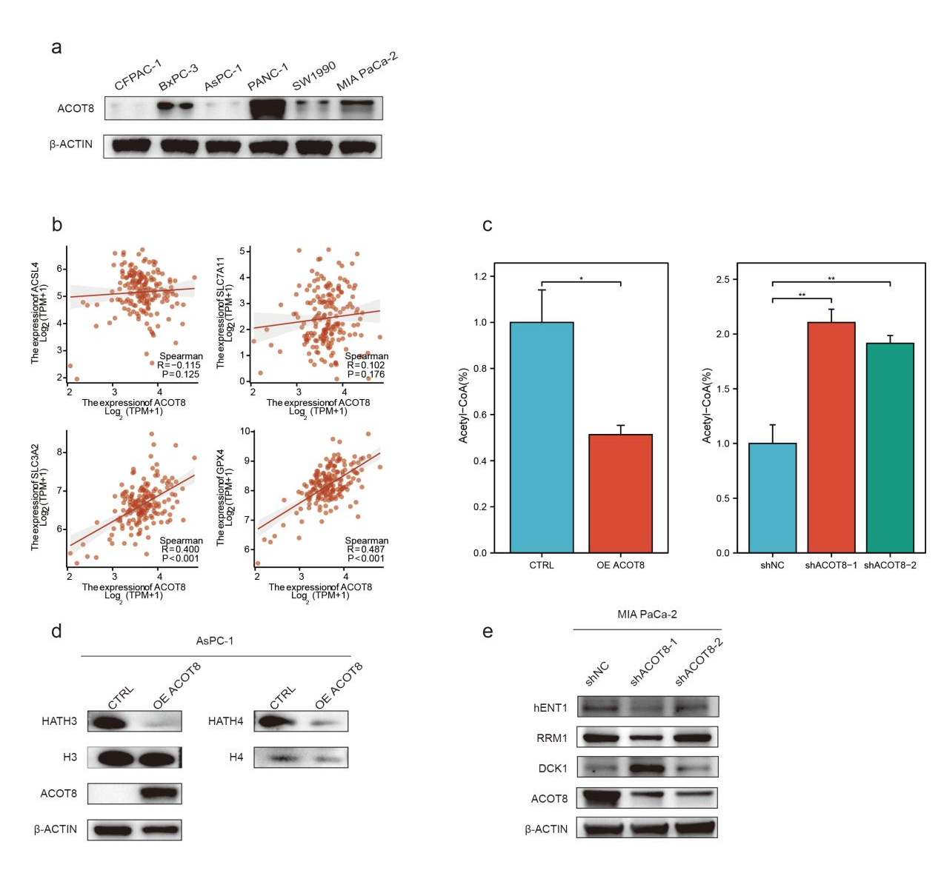
Supplementary Figure 1. (a) ACOT8 expression levels in various PDAC cell lines. (b) Correlation of the expression of some core ferroptosis-related genes with ACOT8 in The Cancer Genome Atlas (TCGA) database. (c) Altered intracellular acetyl-CoA content due to changes in ACOT8 expression levels. (d) Altered histone acetylation levels due to changes in ACOT8 expression levels. (e) Effects of altered ACOT8 expression levels on the classical gemcitabine resistance pathway.

