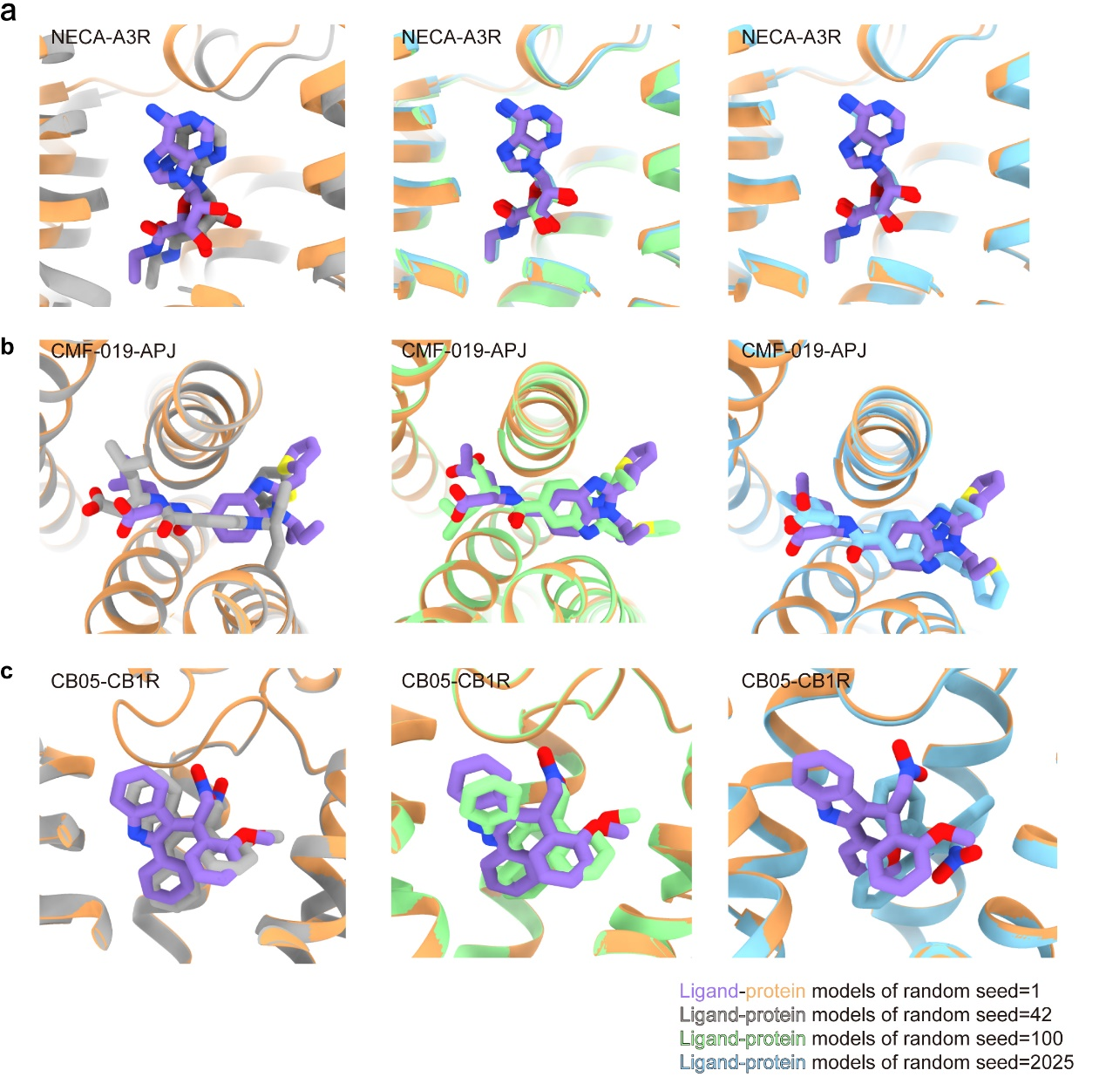
Figure S1. Comparison of AlphaFold3-predicted models of random seed=1 with models of random seed=42, 100, 2025 in three representative cases.
(a) Structural superimposition of AlphaFold3-predicted NECA-A3R complexes of random seed=1 with other different random seeds, (b) Structural superimposition of AlphaFold3-predicted CMF-019-APJ complexes of random seed=1 with other different random seeds, (c) structural superimposition of AlphaFold3-predicted CB05-CB1R complexes of random seed=1 with other different random seeds.

