Supplementary Figure 1: OS (1A) and PFS (1B) of MM patients, stratified by International Staging System (ISS)

Figure 1A:
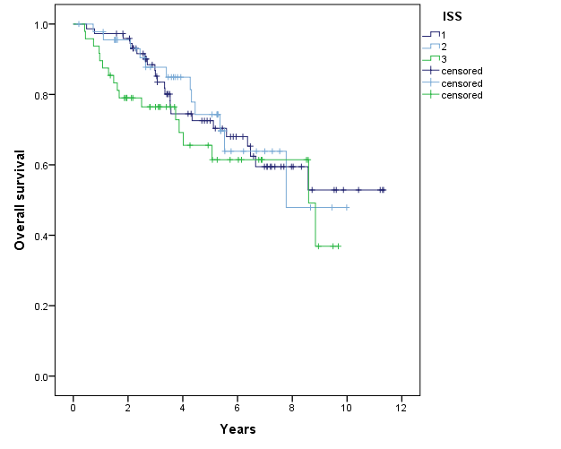

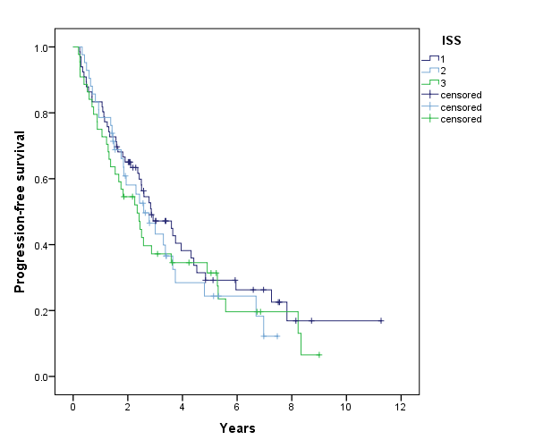
Figure 1B:

