SUPPLEMENTARY INFORMATION
Supplementary information 1. Personal history of cancer. ENT: Ear, Nose and Throat, DLBCL: Diffuse Large B-cell Lymphoma, CLL: Chronic Lymphocytic Leukemia, MGUS: Monoclonal Gammopathy of Undetermined Significance, MALT: Mucosa-Associated/Lymphoma Tissue.

Cancer | n=31 malignancies
Prostate | 8
Colorectal | 4
Melanoma | 3
Non melanoma skin cancer | 2
Thyroid | 2
Breast | 2
MGUS | 2
Testicular | 1
Kaposi | 1
Pancreas | 1
Cervix | 1
ENT | 1
MALT | 1
DLBCL | 1
CLL | 1

Supplementary information 2. Familial history of cancer. MPN: Myeloproliferative Neoplasm, AML: Acute Myeloid Leukemia, MM: Multiple Myeloma.

Solid cancer | n=69 malignancies
Bronchopulmonary | 12
Colorectal | 11
Breast | 10
Kidney | 6
ENT | 6
Uterus | 4
Prostate | 3
Unknown | 4 |  |  | Hematological malignancy | n=16 malignancies
Brain | 3 |  |  | Leukemia | 5
Pancreas | 2 |  |  | Lymphoma | 3
Liver | 2 |  |  | CLL | 2
Gastric | 2 |  |  | MPN | 2
Bone | 1 |  |  | AML | 1
Cutaneous | 1 |  |  | HCL | 1
Biliairy duct | 1 |  |  | MM | 1
Rhabdomyosarcoma | 1 |  |  | MGUS | 1

Supplementary information 3. Flow chart. *arterial ischemia (1), hemorrhagic shock (1), road accident (1), post-operative death (1), tamponade (1), CR: Complete Remission, PR: Partial Remission, PD: Progressive Disease.

n = 279 patients
Death = 50 patients
Still alive at last follow-up
229 patients

Cause of death | n = 50
Unknown | 17
Second cancer | 11
Progression of HCL | 9
Infection | 8
Other* | 5

Supplementary information 4. Response to first line treatment. ORR: Overall Response Rate. CR: Complete Response, other treatments including all treatments and IFNα except cladribine or pentostatin in monotherapy. *p < 0.001 (χ² test) compared to cladribine and pentostatin.

Supplementary information 5. Median DOR according to the line of treatment. DOR: Duration Of Response.

Line | Median DOR [min-max] (months)
1 | 91 [3-335]
2 | 55 [0-281]
3 | 45 [0-235]
4 | 23 [7-343]

Supplementary information 6. OS, uni- and multivariate analyses. Cox regression analysis. HR: Hazard Ratio. CI-: Confidence Interval. CR1=achieving CR after first line treatment. *percentage of hairy cells at diagnosis taken as a continuous variable. **cladribine taken as reference.

Overall Survival
Univariate analysis |  |  |  |  | Multivariate analysis
Variables | p | HR | 95% CI |  | Variables | p | HR | 95% CI
Age at diagnosis | < 0,001 | 1,098 | 1,065;1,133 |  | Age at diagnosis | < 0,001 | 1,082 | 1,044;1,121
Hairy cells at diagnosis* | 0,635 | 0,997 | 0,983;1,011 |  | Hairy cells at diagnosis* | 0,733 | 1,003 | 0,988;1,018
Infection at diagnosis | 0,099 | 1,685 | 0,906;3,133 |  | Infection at diagnosis | 0,270 | 1,524 | 0,720;3,225
Second cancer | 0,192 | 1,520 | 0,810;2,850 |  | Second cancer | 0,782 | 1,111 | 0,525;2,352
First line treatment** | 0,042 | 0,465 | 0,222;0,974 |  | First line treatment** | 0,261 | 0,600 | 0,246;1,462
CR1 | 0,452 | 0,781 | 0,409;1,489 |  | CR1 | 0,230 | 0,602 | 0,263;1,378
Supplementary information 7. RFS after first line treatment: (A) all patients, (B) according to first line treatment: cladribine, pentostatin, ‘other’ treatments including IFN, (C) according to first line treatment: cladribine, pentostatin, IFN. Kaplan Meier method.

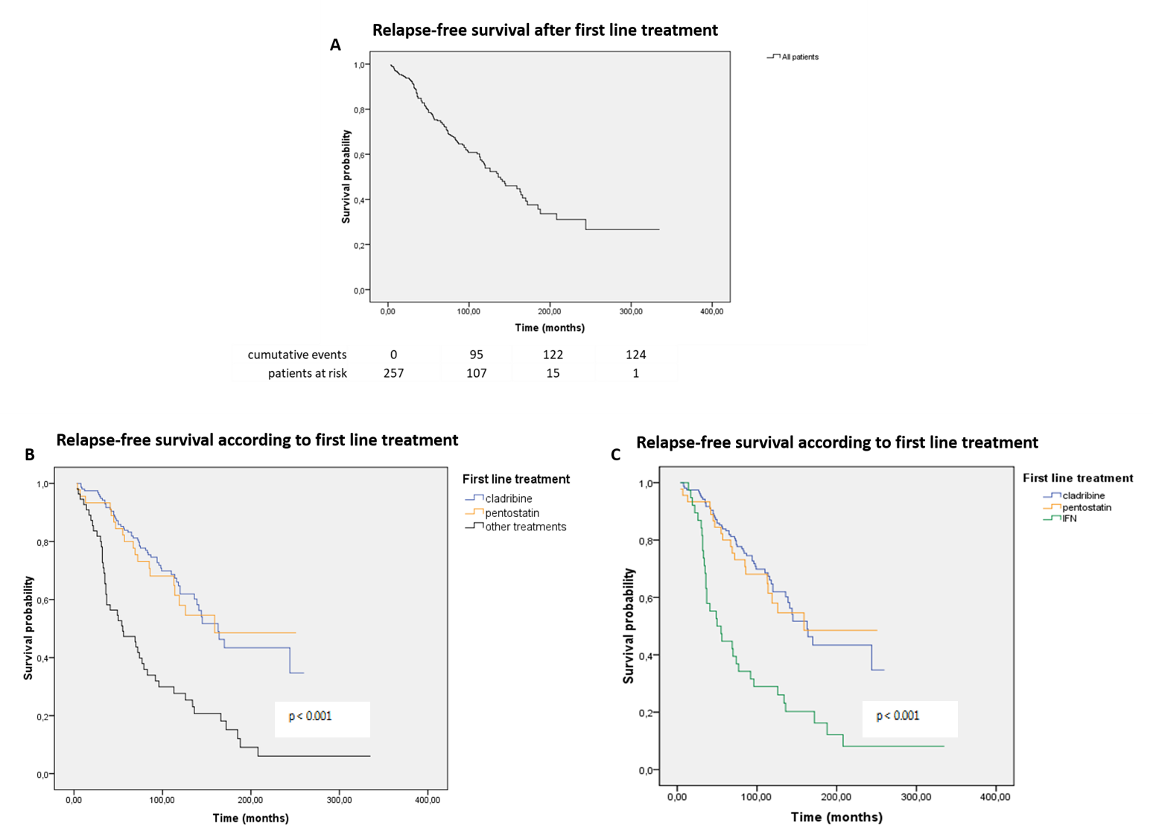

Supplementary information 8. RFS after first line treatment, uni- and multivariate analyses. Cox regression analysis. HR=hazard ratio. CI=confidence interval. CR1=achieving CR after first line treatment. *percentage of hairy cells at diagnosis taken as a continuous variable. **’other’ treatments taken as reference.

Relapse-Free Survival
Univariate analysis |  |  |  |  | Multivariate analysis
Variables | p | HR | 95% CI |  | Variables | p | HR | 95% CI
Age at diagnosis | 0,239 | 0,991 | 0,975;1,006 |  | Age at diagnosis | 0,331 | 0,991 | 0,974;1,009
Hairy cells at diagnosis | 0,002 | 1,011 | 1,004;1,018 |  | Hairy cells at diagnosis | 0,006 | 1,010 | 1,003;1,018
Infection at diagnosis | 0,397 | 1,203 | 0,784;1,844 |  | Infection at diagnosis | 0,219 | 1,359 | 0,833;2,218
Second cancer | 0,842 | 0,957 | 0,620;1,477 |  | Second cancer | 0,339 | 1,270 | 0,778;2,074
First line treatment** | < 0,001 | 3,032 | 1,777;5,174 |  | First line treatment** | 0,004 | 2,533 | 1,349;4,754
CR1 | < 0,001 | 0,293 | 0,199;0,430 |  | CR1 | < 0,001 | 0,355 | 0,228;0,555

Supplementary information 9. RFS according to second line treatment (RFS2). Kaplan Meier method.

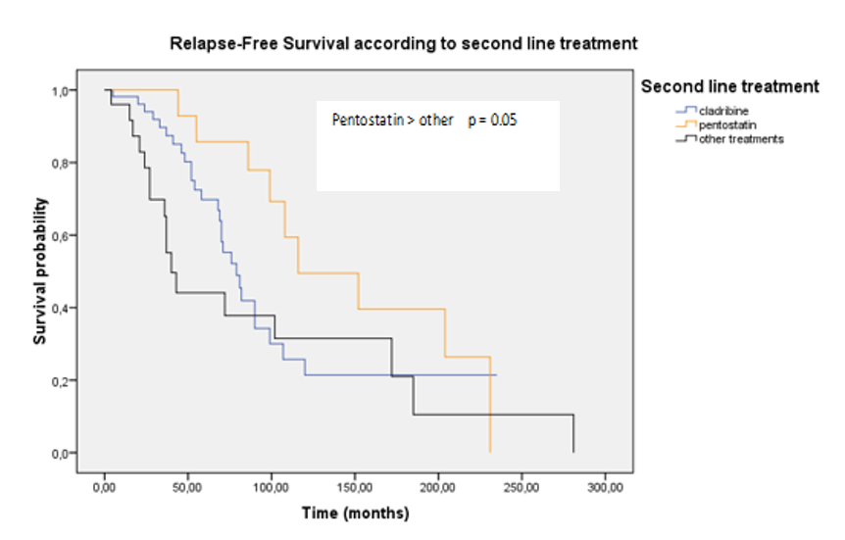

Supplementary information 10. Patients who received PNA both in first and second lines.

PNA in first and second lines | n=44
No switch | 31
Cladribine cladribine | 30
Pentostatin pentostatin | 1
Switch | 13
Cladribine pentostatin | 8
Pentostatin cladribine | 5

Supplementary information 11. RFS2 for patients treated with PNA both in first and second lines. ‘switch’ patients (black) versus ‘no switch’ patients (red). Kaplan Meier method.

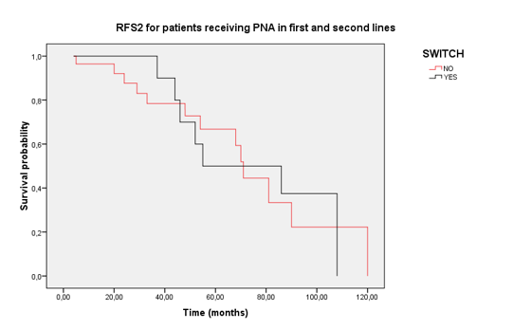

Supplementary information 12. Cumulative incidence of second cancers, uni- and multivariate analyses: (A) all cancers, (B) solid cancers, (C) hematological malignancies. sdHR=subdistribution hazard ratio. CI=confidence interval. IFN=interferon alpha.

A | All cancers
 | Univariate analysis |  |  |  |  |  | Multivariate analysis
 | Variables | p | sdHR | 95% CI |  |  | Variables | p | sdHR | 95% CI
 | Age at diagnosis | 0,006 | 1,030 | 1,010;1,050 |  |  | Age at diagnosis | 0,063 | 1,020 | 0,999;1,042
 | Familial history of cancer | 0,190 | 1,460 | 0,827;2,580 |  |  | Familial history of cancer | 0,150 | 1,521 | 0,859;2,691
 | Personal history of cancer | 0,100 | 1,820 | 0,886;3,730 |  |  | Personal history of cancer | 0,530 | 1,291 | 0,585;2,845
 | Cladribine | 0,078 | 0,632 | 0,379;1,050 |  |  | Cladribine | 0,120 | 0,627 | 0,347;1,133
 | Pentostatin | 0,750 | 0,916 | 0,539;1,560 |  |  | Pentostatin | 0,380 | 0,764 | 0,418;1,396
 | IFN | 0,013 | 0,468 | 0,257;0,852 |  |  | IFN | 0,038 | 0,529 | 0,290;0,966
B | Solid cancers
 | Univariate analysis |  |  |  |  |  | Multivariate analysis
 | Variables | p | sdHR | 95% CI |  |  | Variables | p | sdHR | 95% CI
 | Age at diagnosis | 0,068 | 1,020 | 0,999;1,030 |  |  | Age at diagnosis | 0,098 | 1,018 | 0,997;1,040
 | Familial history of cancer | 0,033 | 1,950 | 1,050;3,610 |  |  | Familial history of cancer | 0,017 | 2,117 | 1,146;3,910
 | Personal history of cancer | 0,530 | 0,688 | 0,213;2,220 |  |  | Personal history of cancer | 0,300 | 0,500 | 0,134;1,870
 | Cladribine | 0,850 | 0,943 | 0,518;1,710 |  |  | Cladribine | 0,420 | 0,747 | 0,367;1,520
 | Pentostatin | 0,100 | 0,594 | 0,320;1,110 |  |  | Pentostatin | 0,093 | 0,541 | 0,265;1,110
 | IFN | 0,090 | 0,563 | 0,290;1,090 |  |  | IFN | 0,170 | 0,618 | 0,310;1,230
C | Hematological malignancies
 | Univariate analysis |  |  |  |  |  | Multivariate analysis
 | Variables | p | sdHR | 95% CI |  |  | Variables | p | sdHR | 95% CI
 | Age at diagnosis | 0,012 | 1,060 | 1,010;1,100 |  |  | Age at diagnosis | 0,120 | 1,035 | 0,991;1,080
 | Familial history of cancer | 0,460 | 0,631 | 0,186;2,140 |  |  | Familial history of cancer | 0,500 | 0,651 | 0,189;2,250
 | Personal history of cancer | < 0,001 | 5,210 | 2,060;13,200 |  |  | Personal history of cancer | 0,028 | 3,473 | 1,144;10,550
 | Cladribine | 0,170 | 0,526 | 0,211;1,310 |  |  | Cladribine | 0,930 | 0,947 | 0,303;2,960
 | Pentostatin | 0,250 | 1,720 | 0,678;4,340 |  |  | Pentostatin | 0,420 | 1,558 | 0,528;4,600
 | IFN | 0,033 | 0,234 | 0,061;0,893 |  |  | IFN | 0,095 | 0,315 | 0,081;1,220

Study | Type | n | Follow-up | Treatments | ORR | CR | RFS/PFS | Relapses | OS
Bastie et al | retrospective | 30 | 5 years | cladribine | 96% | 86% | 66% at 5 years | 17% | 83% at 5 years
Ongoren et al | retrospective | 71 | 57 months | cladribine 31 IFN 19 splenectomy 16 rituximab 1 | 97% 84% 81% | ND | 62% (entire cohort) | 16% 53% 69% | 83% (entire cohort)
Jehn et al | retrospective | 44 | 8.5 years | cladribine | 99% | 98% | 36% at 12 years | 39% | 79% at 12 years
Mandanat et al | retrospective | 61 | 72 months | cladribine | 97% | 78% | 51% at 10 years | 31% | 93% at 10 years
Gaman et al | retrospective | 39 | 52 months | IFN 29  (with maintenance 14) | 78% (for IFN) | 14% (for IFN) | median 28 months in case of maintenance IFN |  | median 8 years
Lopez Rubio et al | retrospective | 107 | ND | cladribine 80 pentostatin 27 | 100% 100% | 88% 92% | 144 months 95 months | 25% 51% | ND
Hacioglu et al | retrospective | 94 | 28 months | cladribine (majority) | 97% (for cladribine) | 81% (for cladribine) | median 36 months | 17% (for cladribine) | 96% at 5 years (for cladribine)
Else et al | retrospective | 233 | 16 years | pentostatin 188 cladribine 45 | 96% 100% | 82% 76% | median 16 years | 47% 48% at 15 years | 78% at 15 years
Supplementary information 13 (Part 1). Outcomes in other HCL cohorts. ND=no data; TFI=treatment-free interval; TTF=time to treatment failure.
Supplementary information 13 (Part 2). Outcomes in other HCL cohorts. ND=no data; TFI=treatment-free interval; TTF=time to treatment failure.

Study | Type | n | Follow-up | Treatments | ORR | CR | RFS/PFS | Relapses | OS
Zinzani et al | retrospective | 121 | 105 months | cladribine 75 pentostatin 10 IFN 33 splenectomy 3 | 95% | 77% | ND | 44% | 88%
Rosenberg et al | retrospective | 88 | 251 months | cladribine | 100% | 88% | median 56 months | 58% | median 251 months
Johnston et al | prospective | 28 | 118 months | pentostatin | 100% | 89% | median 119 months | 32% | 82%
Getta et al | retrospective | age < 40: 63 age > 40: 268 | 69 months | cladribine | 98% 94% | 87% 83% | ND | ND | 100% 82%  at 10 years
Maloisel et al | retrospective | 238 | 64 months | pentostatin | 96% | 79% | 69% at 10 years | 15% | 89% at 10 years
Goodman et al | retrospective | 209 | >7 years | cladribine | 100% | 95% | median 42 months | 37% | 97%
Flinn et al | prospective | 241 | 9.3 years | pentostatin 154 pentostatin after IFN failure 87 | ND | 72% | 67% at 10 years | 18% | 81% at 10 years
Saven et al | retrospective | 358 | 58 months | cladribine (majority) | 98% | 91% | 19% at 48 months | 26% | 96% at 48 months

