TABLE OF CONTENTS
Supplemental Table 1………………………………………………………………………….2
Supplemental Table 2………………………………………………………………………….3
Supplemental Table 3………………………………………………………………………….7
Supplemental Figure 1…………………………………………………………………………9
Supplemental Figure 2…………..………….………………………………………………..12
Supplemental Figure 3…………..………….………………………………………………..15
Supplemental Figure 4…………..………….………………………………………………..18
Supplemental Figure 5…………..………….………………………………………………..19
Supplemental Figure 6…………..………….………………………………………………..20
Supplemental Figure 7……………………………………………………………………….21

Supplemental Table 1. Description of the antibodies used in this study.
Panel | Antigen | Label | Clone | Cat # | Company
Granulocytes and APC | CD36 | FITC | CLB-IVC7 | IM1613 | Sanquin
Granulocytes and APC | SLAN | PE | DD-1 | 130-093-029 | Miltenyi Biotec
Granulocytes and APC | CD33 | PerCP-Cy5.5 | P67.6 | 333146 | BDB
Granulocytes and APC | CD16 | PE-Cy7 | 3G8 | 560716 | BDB
Granulocytes and APC | CD123 | APC | AC145 | 130-090-901 | Miltenyi Biotec
Granulocytes and APC | CD14 | APCH7 | MϕP9 | 641394 | BDB
Granulocytes and APC | HLA-DR | PacB | L243 | 307633 | Biolegend
Granulocytes and APC | CD45 | OC515 | GA90 | CYT-450C | Cytognos
T cells | CD45RA | FITC |  | 335039 | BDB
T cells | CD25 | PE | 2A3 | 341011 | BDB
T cells | CD8 | PerCP-Cy5.5 | SK1 | 341050 | BDB
T cells | CD279 | PE-Cy7 | PD1.3 | A78885 | Beckman Coulter
T cells | CXCR5 | APC |  | FAB190A | R&D
T cells | CD197 | APC-Cy7 |  | 353212 | Biolegend
T cells | CD4 | PacB | 13B8.2 | B49197 | Beckman Coulter
T cells | CD127 | BV510 | HIL-7R-M21 | 563086 | BDB
B cells | IgE+IgA | FITC |  | H15701 / 130-093-071 | Life Technologies / Miltenyi Biotec
B cells | IgG+IgA | PE | G18-145 | 555787 / 130-093-128 | BD / Miltenyi Biotec
B cells | IgD | PerCP-Cy5.5 | IA6-2 | 348208 | Biolegend
B cells | CD19 | PE-Cy7 | J3-119 | IM3628 | Beckman Coulter
B cells | CD21 | APC | B-ly4 | 559867 | BD
B cells | CD38 | APCH7 | HB7 | 656646 | BD
B cells | CD27 | BV421 | M-T271 | 562513 | BD
B cells | IgM | BV510 | MHM-88 | 314521 | Biolegend
BDB, Beckton Dickinson Biosciences

Supplemental Table 2. Immunophenotypic profile of the 59 immune cell-types identified by automated clustering using FlowCT.
Immune subset | Immune cell type | Immunophenotype
Granulocytes | Basophils | SSC^{lo} FSC^{hi} CD45^{lo} CD33⁺ CD16⁻ HLA-DR⁻ CD123⁺
Granulocytes | Eosinophils | SSC^{hi} FSC^{hi} CD45^{hi} CD33⁺ CD16⁻ HLA-DR⁻ CD123⁻
Granulocytes | Neutrophils | SSC^{hi} FSC^{hi} CD45⁺ CD33^{het} CD16^{hi} HLA-DR⁻ CD123⁻
APC | Classical monocytes | SSC^{lo} FSC^{lo} CD45^{hi} CD33⁺ CD16⁻ CD14⁺ CD36⁺ HLA-DR⁺ CD123⁻ SLAN⁻
APC | Intermediate monocytes | SSC^{lo} FSC^{lo} CD45^{hi} CD33⁺ CD16⁺ CD14⁺ CD36⁺ HLA-DR^{hi} CD123⁻ SLAN⁻
APC | SLAN⁻ Non-Classical monocytes | SSC^{lo} FSC^{lo} CD45^{hi} CD33⁺ CD16⁺ CD14⁻ CD36⁺ HLA-DR^{hi} CD123⁻ SLAN⁻
APC | SLAN⁺ Non-Classical monocytes | SSC^{lo} FSC^{lo} CD45^{high} CD33⁺ CD16⁺ CD14⁻ CD36⁺ HLA-DR^{hi} CD123⁻ SLAN⁺
APC | Myeloid dendritic cells (mDC) | SSC^{lo} FSC^{lo} CD45^{hi} CD33⁺ CD16⁻ CD14⁻ CD36^{lo} HLA-DR^{hi} CD123⁻ SLAN⁻
APC | Plasmacytoid dendritic cells (pDC) | SSC^{lo} FSC^{lo} CD45^{hi} CD33^{lo} CD16⁻ CD14⁻ CD36^{lo} HLA-DR⁺ CD123⁺ SLAN⁻
T cells
T cells | CD4⁺ Naive | CD4⁺ CD8⁻ CD197⁺ CD45RA⁺ CD127⁺ CD25^{het} PD1⁻ CXCR5⁻
T cells | CD4⁺ CM ^{neg} | CD4⁺ CD8⁻ CD197⁺ CD45RA⁻ CD127⁻ CD25⁻ PD1⁻ CXCR5⁻
T cells | CD4⁺ CM CD127⁺ | CD4⁺ CD8⁻ CD197⁺ CD45RA⁻ CD127⁺ CD25⁻ PD¹⁺ CXCR5⁻
T cells | CD4⁺ CM CD127⁺ CD25⁺ | CD4⁺ CD8⁻ CD197⁺ CD45RA⁻ CD127⁺ CD25⁺ PD1⁺ CXCR5⁻
T cells | CD4⁺ CM CD127^{lo} PD1⁺ | CD4⁺ CD8⁻ CD197⁺ CD45RA⁻ CD127^{lo} CD25⁻ PD1⁺ CXCR5⁻
T cells | CD4⁺ CM CD127⁺ PD1⁺ | CD4⁺ CD8⁻ CD197⁺ CD45RA⁻ CD127⁺ CD25⁻ PD1⁺ CXCR5⁻
T cells | CD4⁺ EM CD127^{lo} | CD4⁺ CD8⁻ CD197⁻ CD45RA⁺ CD127^{lo} CD25⁻ PD1⁻ CXCR5⁻
T cells | CD4⁺ EM CD127⁺ | CD4⁺ CD8⁻ CD197⁻ CD45RA⁻ CD127⁺ CD25⁻ PD1⁻ CXCR5⁻
T cells | CD4⁺ EM CD127⁺ CD25⁺ | CD4⁺ CD8⁻ CD197⁻ CD45RA⁻ CD127⁺ CD25⁺ PD1⁻ CXCR5⁻
T cells | CD4⁺ EM CD127^{lo} PD1⁺ | CD4⁺ CD8⁻ CD197⁻ CD45RA⁻ CD127^{lo} CD25⁻ PD1⁺ CXCR5⁻
T cells | CD4⁺ EM CD127⁺ PD1⁺ | CD4⁺ CD8⁻ CD197⁻ CD45RA⁻ CD127⁺ CD25⁻ PD1⁺ CXCR5⁻
T cells | CD4⁺ EM CD127⁺ CD25⁺ PD1⁺ | CD4⁺ CD8⁻ CD197⁻ CD45RA⁻ CD127⁺ CD25⁺ PD1⁺ CXCR5⁻
T cells | CD4⁺ TEMRA CD127^{lo} | CD4⁺ CD8⁻ CD197⁻ CD45RA⁺ CD127^{lo} CD25- PD1⁻ CXCR5⁻
T cells | CD4⁺ TEMRA CD127⁺ | CD4⁺ CD8⁻ CD197⁻ CD45RA⁺ CD127⁺ CD25⁻ PD1⁻ CXCR5⁻
T cells | Naïve Treg | CD4⁺ CD8⁻ CD197⁺ CD45RA⁺ CD127^{lo} CD25⁺ PD1⁻ CXCR5⁻
T cells | CM Treg | CD4⁺ CD8⁻ CD197⁺ CD45RA⁻ CD127^{lo} CD25⁺ PD1⁻ CXCR5⁻
T cells | EM Treg | CD4⁺ CD8⁻ CD197⁻ CD45RA⁻ CD127^{lo} CD25⁺ PD1⁻ CXCR5⁻
T cells | Tfh | CD4⁺ CD8⁻ CD197⁺ CD45RA⁻ CD127⁺ CD25⁻ PD1⁺ CXCR5⁺
T cells | Tfh-like CM | CD4⁺ CD8⁻ CD197⁺ CD45RA⁻ CD127⁺ CD25⁻ PD1⁻ CXCR5⁺
T cells | CD8⁺ naïve | CD4⁻ CD8⁺ CD197⁺ CD45RA⁺ CD127⁺ CD25⁻ PD1⁻ CXCR5⁻
T cells | CD8⁺ CM CD127^{lo} | CD4⁻ CD8⁺ CD197⁺ CD45RA⁻ CD127^{lo} CD25⁻ PD1⁻ CXCR5⁻
T cells | CD8⁺ CM CD127⁺ | CD4⁻ CD8⁺ CD197⁺ CD45RA⁻ CD127⁺ CD25⁻ PD1⁻ CXCR5⁻
T cells | CD8⁺ CM CD127⁺ CD25⁺ | CD4⁻ CD8⁺ CD197⁺ CD45RA⁻ CD127⁺ CD25⁺ PD1⁻ CXCR5⁻
T cells | CD8⁺ EM CD127^{lo} | CD4⁻ CD8⁺ CD197⁻ CD45RA⁻ CD127^{lo} CD25⁻ PD1⁻ CXCR5⁻
T cells | CD8⁺ EM CD127⁺ | CD4⁻ CD8⁺ CD197⁻ CD45RA⁻ CD127⁺ CD25⁻ PD1⁻ CXCR5⁻
T cells | CD8⁺ EM PD1⁺ | CD4⁻ CD8⁺ CD197⁻ CD45RA⁻ CD127⁻ CD25⁻ PD1⁺ CXCR5⁻
T cells | CD8⁺ EM CD127⁺ PD1⁺ | CD4⁻ CD8⁺ CD197⁻ CD45RA⁻ CD127⁺ CD25⁻ PD1⁺ CXCR5⁻
T cells | CD8⁺ EM CXCR5⁺ CD127⁺ PD1⁺ | CD4⁻ CD8⁺ CD197⁻ CD45RA⁻ CD127⁺ CD25⁻ PD1⁺ CXCR5⁺
T cells | CD8⁺ TEMRA CD127^{lo} | CD4⁻ CD8⁺ CD197⁻ CD45RA⁺ CD127^{lo} CD25⁻ PD1⁻ CXCR5⁻
T cells | CD8⁺ TEMRA CD127⁺ | CD4⁻ CD8⁺ CD197⁻ CD45RA⁺ CD127⁺ CD25⁻ PD1⁻ CXCR5⁻
T cells | CD8⁺ TEMRA CD127⁺ PD1⁺ | CD4⁻ CD8⁺ CD197⁻ CD45RA⁺ CD127⁺ CD25⁻ PD1⁺ CXCR5⁻
T cells | CD8⁺ TEMRA PD1⁺ | CD4⁻ CD8⁺ CD197⁻ CD45RA⁺ CD127⁻ CD2⁵⁻ PD1⁺ CXCR5⁻
B cells | Naive CD21⁻ | CD27⁻ CD38⁻ CD21⁻ IgD⁺ IgM⁺ IgA⁻ IgG⁻ IgE⁻
B cells | Naive CD21⁺ | CD27⁻ CD38⁻ CD21⁺ IgD⁺ IgM⁺ IgA⁻ IgG⁻ IgE⁻
B cells | Transitional | CD27⁻ CD38⁺ CD21⁺ IgD⁻ IgM^{lo} IgA⁻ IgG⁻ IgE⁻
B cells | IgM⁺D⁺ CD27⁺ CD21⁻ memory | CD27⁺ CD38⁻ CD21⁻ IgD⁺ IgM⁺ IgA⁻ IgG⁻ IgE⁻
B cells | IgM⁺D⁺ CD27⁺ CD21⁺ memory | CD27⁺ CD38⁻ CD21⁻ IgD⁺ IgM⁺ IgA⁻ IgG⁻ IgE⁻
B cells | IgM⁺D⁻ CD27⁻ CD21⁻ memory | CD27⁻ CD38⁻ CD21⁻ IgD⁻ IgM⁺ IgA⁻ IgG⁻ IgE⁻
B cells | IgM⁺D⁻ CD27⁻ CD21⁺ memory | CD27⁻ CD38⁻ CD21⁺ IgD⁻ IgM⁺ IgA⁻ IgG⁻ IgE⁻
B cells | IgM⁺D⁻ CD27⁺ CD21⁻ memory | CD27⁺ CD38⁻ CD21⁻ IgD⁻ IgM⁺ IgA⁻ IgG⁻ IgE⁻
B cells | IgM⁺D⁻ CD27⁺ CD21⁺ memory | CD27⁺ CD38⁻ CD21⁺ IgD⁻ IgM⁺ IgA⁻ IgG⁻ IgE⁻
B cells | IgG⁺ CD27⁻ CD21⁻ memory | CD27⁻ CD38⁻ CD21⁻ IgD⁻ IgM⁻ IgA⁻ IgG⁺ IgE⁻
B cells | IgG⁺ CD27⁻ CD21⁺ memory | CD27⁻ CD38⁻ CD21⁺ IgD⁻ IgM⁻ IgA⁻ IgG⁺ IgE⁻
B cells | IgG⁺ CD27⁺ CD21^{lo} memory | CD27⁺ CD38⁻ CD21^{lo} IgD⁻ IgM⁻ IgA⁻ IgG⁺ IgE⁻
B cells | IgG⁺ CD27⁺ CD21⁺ memory | CD27⁺ CD38⁻ CD21⁺ IgD⁻ IgM⁻ IgA⁻ IgG⁺ IgE⁻
B cells | IgA⁺ CD27⁻ CD21⁻ memory | CD27⁻ CD38⁻ CD21⁻ IgD- IgM⁻ IgA⁺ IgG⁻ IgE⁻
B cells | IgA⁺ CD27⁻ CD21⁺ memory | CD27⁻ CD38⁻ CD21⁺ IgD⁻ IgM⁻ IgA⁺ IgG⁻ IgE⁻
B cells | IgA⁺ CD27⁺ CD21⁺ memory | CD27⁺ CD38⁻ CD21⁺ IgD⁻ IgM⁻ IgA⁺ IgG⁻ IgE⁻
B cells | IgG⁺IgM⁺ circulating PC | CD27^{hi} CD38^{hi} CD21⁻ IgD⁻ IgM⁺ IgA⁻ IgG⁺ IgE⁻
B cells | IgA circulating PC | CD27^{hi} CD38^{hi} CD21⁻ IgD⁻ IgM⁻ IgA⁺ IgG⁻ IgE⁻

APC, antigen-presenting cells; CM, central memory; EM, effector memory; TEMRA, effector memory T-cell re-expressing CD45RA; Tfh, follicular helper T cell, Treg, regulatory T cell; Ig, immunoglobulin; PC, plasma cells.

Supplemental Table 3. Optimal cutoffs in percentages (%) and absolute counts (cells/uL) for each immune cell-type.
Immune subset | Cutoff (%) | Cutoff  (Cells/uL) | AUC | P value
Basophils | 1.12 | 66 | 0.571 | 0.193
Eosinophils | 3.09 | 180 | 0.5 | 0.442
Neutrophils | 60 | 3550 | 0.58 | 0.077
Classical monocytes | 10 | 631 | 0.59 | 0.019
Intermediate monocytes | 0.67 | 39 | 0.57 | 0.051
SLAN- non-classical monocytes | 0.37 | 22 | 0.58 | 0.019
SLAN+ non-classical monocytes | 0.01 | 1 | 0.6 | 0.100
Myeloid dendritic cells | 0.37 | 22 | 0.611 | 0.050
Plasmacytoid dendritic cells | 0.14 | 8 | 0.7 | 0.003
CD4+ CM CD127low PD1+ | 0.03 | 2 | 0.61 | 0.006
CD4+ CM CD127+ | 1.61 | 94 | 0.73 | 0.001
CD4+ CM CD127+ CD25+ | 0.34 | 20 | 0.67 | 0.001
CD4+ CM CD127+ PD1+ | 0.15 | 9 | 0.63 | 0.011
CD4+ CM neg | 0.16 | 9 | 0.65 | 0.005
CD4+ EM CD127low | 0.21 | 12 | 0.64 | 0.001
CD4+ EM CD127low PD1+ | 0.49 | 28 | 0.58 | 0.021
CD4+ EM CD127+ | 1.07 | 62 | 0.53 | 0.511
CD4+ EM CD127+ CD25+ | 0.65 | 38 | 0.66 | 0.004
CD4+ EM CD127+ CD25+ PD1+ | 0.29 | 17 | 0.67 | 0.007
CD4+ EM CD127+ PD1+ | 0.47 | 28 | 0.59 | 0.145
CD4+ Naive | 1.35 | 79 | 0.75 | 0.000
CD4+ TEMRA CD127low | 0.11 | 6 | 0.51 | 0.224
CD4+ TEMRA CD127+ | 0.01 | 1 | 0.51 | 0.215
Tfh | 0.17 | 10 | 0.59 | 0.042
Tfh-like CM | 0.50 | 29 | 0.73 | 0.000
Treg CM | 0.17 | 10 | 0.65 | 0.004
Treg EM | 0.74 | 43 | 0.48 | 0.515
Treg Naïve | 0.05 | 3 | 0.73 | 0.000
CD8+ CM CD127low | 0.34 | 20 | 0.52 | 0.326
CD8+ CM CD127+ | 0.49 | 28 | 0.66 | 0.008
CD8+ CM CD127+ CD25+ | 0.07 | 4 | 0.56 | 0.018
CD8+ EM CD127low | 0.84 | 49 | 0.67 | 0.003
CD8+ EM CD127+ | 1.05 | 61 | 0.54 | 0.303
CD8+ EM CD127+ PD1+ | 0.16 | 9 | 0.66 | 0.001
CD8+ EM CXCR5+ CD127+ PD1+ | 0.06 | 3 | 0.52 | 0.444
CD8+ EM PD1+ | 0.42 | 25 | 0.53 | 0.154
CD8+ Naive | 1.15 | 67 | 0.71 | 0.001
CD8+ TEMRA CD127low | 0.99 | 58 | 0.56 | 0.227
CD8+ TEMRA CD127+ | 0.36 | 21 | 0.44 | 0.589
CD8+ TEMRA CD127+ PD1+ | 0.03 | 2 | 0.69 | 0.002
CD8+ TEMRA PD1+ | 0.08 | 5 | 0.52 | 0.124
Naïve CD21- | 0.01 | 1 | 0.71 | <0.001
Naïve CD21+ | 0.47 | 27 | 0.75 | <0.001
Transitional | 0.02 | 1 | 0.65 | 0.001
IgM+ IgD+ memory CD27+ CD21- | 0.01 | 0.3 | 0.79 | <0.001
IgM+ IgD+ memory CD27+ CD21+ | 0.02 | 1 | 0.8 | <0.001
IgM+ memory CD27- CD21- | 0.002 | 0.1 | 0.74 | <0.001
IgM+ memory CD27- CD21+ | 0.002 | 0.1 | 0.76 | <0.001
IgM+ memory CD27+ CD21- | 0.001 | 0.03 | 0.8 | <0.001
IgM+ memory CD27+ CD21+ | 0.01 | 1 | 0.81 | <0.001
IgG+ memory CD27- CD21- | 0.003 | 0.2 | 0.68 | <0.001
IgG+ memory CD27- CD21+ | 0.01 | 0.3 | 0.77 | <0.001
IgG+ memory CD27+ CD21low | 0.01 | 0.5 | 0.8 | <0.001
IgG+ memory CD27+ CD21+ | 0.02 | 1 | 0.78 | <0.001
IgA+ memory CD27- CD21- | 0.001 | 0.1 | 0.73 | <0.001
IgA+ memory CD27- CD21+ | 0.003 | 0.2 | 0.77 | <0.001
IgA+ memory CD27+ CD21+ | 0.02 | 1 | 0.81 | <0.001
IgG+ IgM+ circulanting PCs | 0.0004 | 0.02 | 0.65 | <0.001
IgA+ circulating PCs | 0.001 | 0.1 | 0.69 | 0.001

APC, antigen-presenting cells; AUC, area under the receiver operating characteristics curve; CM, central memory; EM, effector memory; TEMRA, effector memory T cell re-expressing CD45RA; Tfh, follicular helper T cell, Treg, regulatory T cell; Ig, immunoglobulin; PC, plasma cells.

Supplemental Figure 1. Gating strategy of immune cell subsets identified by FlowCT. (A) Uniform manifold approximation and projection (UMAP) and dot plots showing the distribution of several myeloid subsets: eosinophils, neutrophils, basophils, antigen presenting cells (APC) and lymphocytes, considering their respective size (FSC) and complexity (SSC) as well as expression of CD45, HLA-DR, CD123, CD33 and CD16 biomarkers. (B) UMAP and dot plots displaying the distribution of APC subsets according to the expression levels of CD14, CD16, CD45, CD36, CD123, HLA-DR and SLAN: classical, intermediate, SLAN- and SLAN+ non-classical monocytes, myeloid and plasmacytoid dendritic cells (mDC and pDC, respectively). (C) UMAP and dot plots showing several subpopulations within CD19⁺ compartment, considering the expression of CD27, CD38, CD21 and immunoglobulins D, M, A and G (IgD, IgM, IgA and IgG, respectively). (D) UMAP and dot plots displaying T-cell subsets according to the expression of CD4, CD8, CD127, CD25, CD197, CD45RA, CD279 and CXCR5 within both CD4 and CD8 compartments. CM, central memory; EM, effector memory; TEMRA, effector memory re-expressing CD45RA; Tfh, helper folicular T cells; Treg; regulatory T cells.
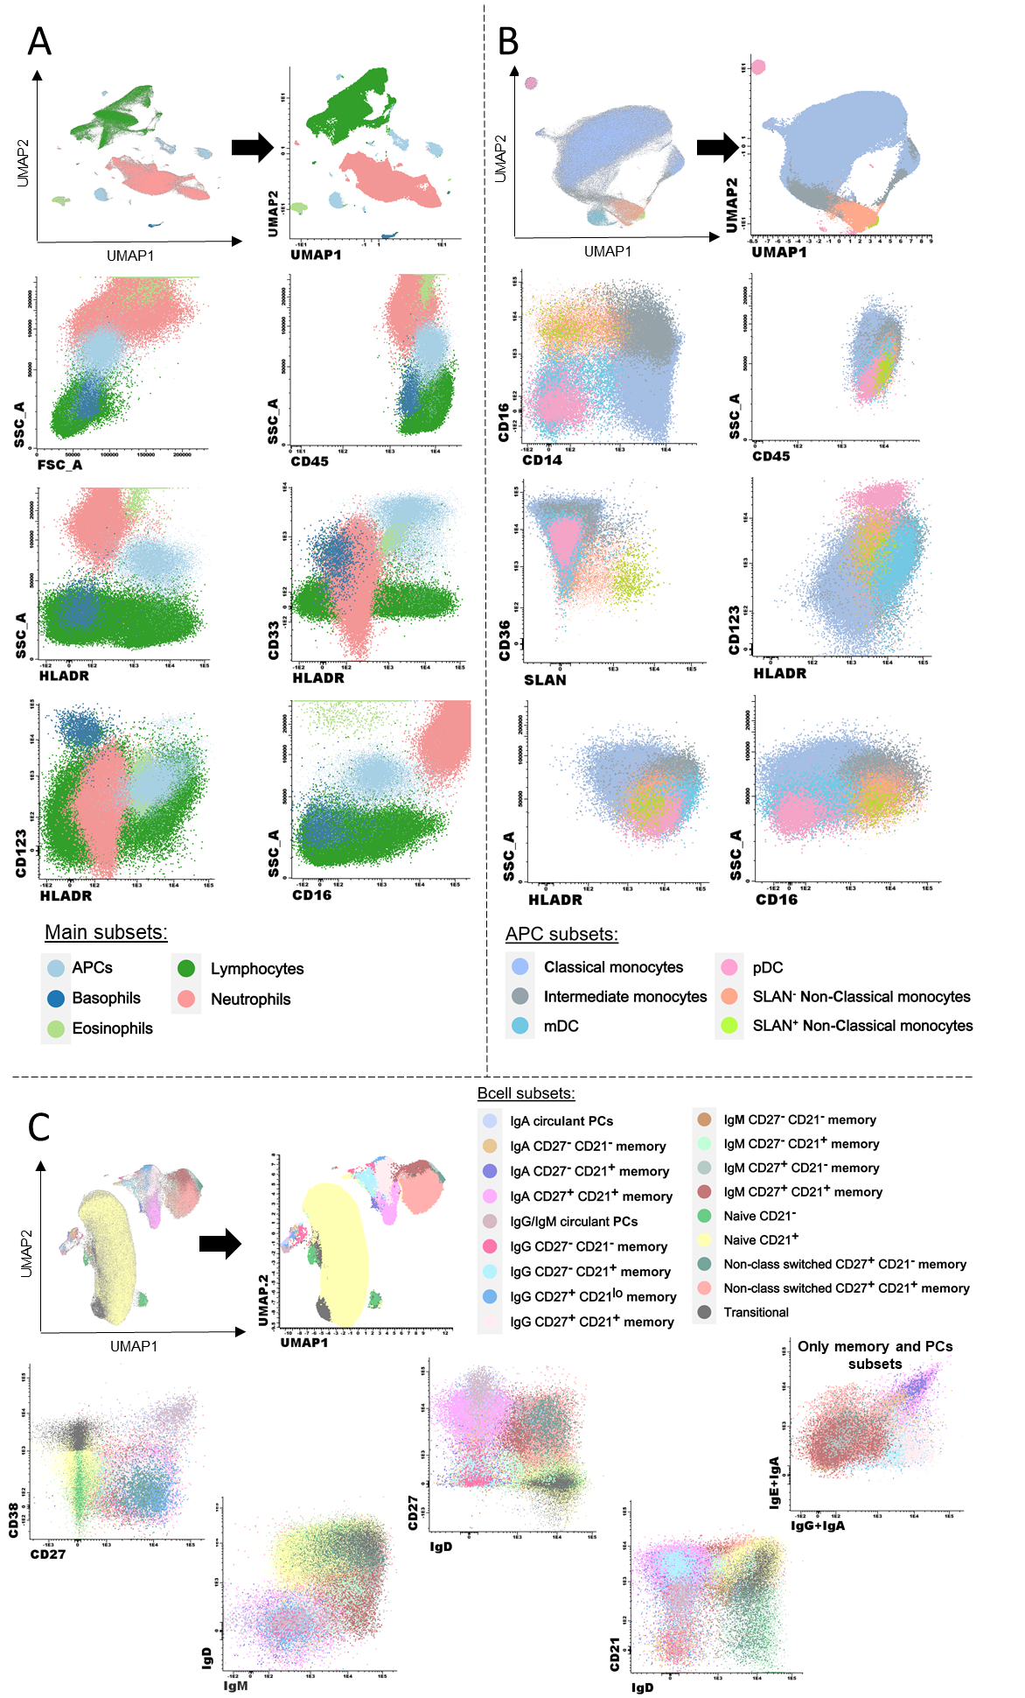

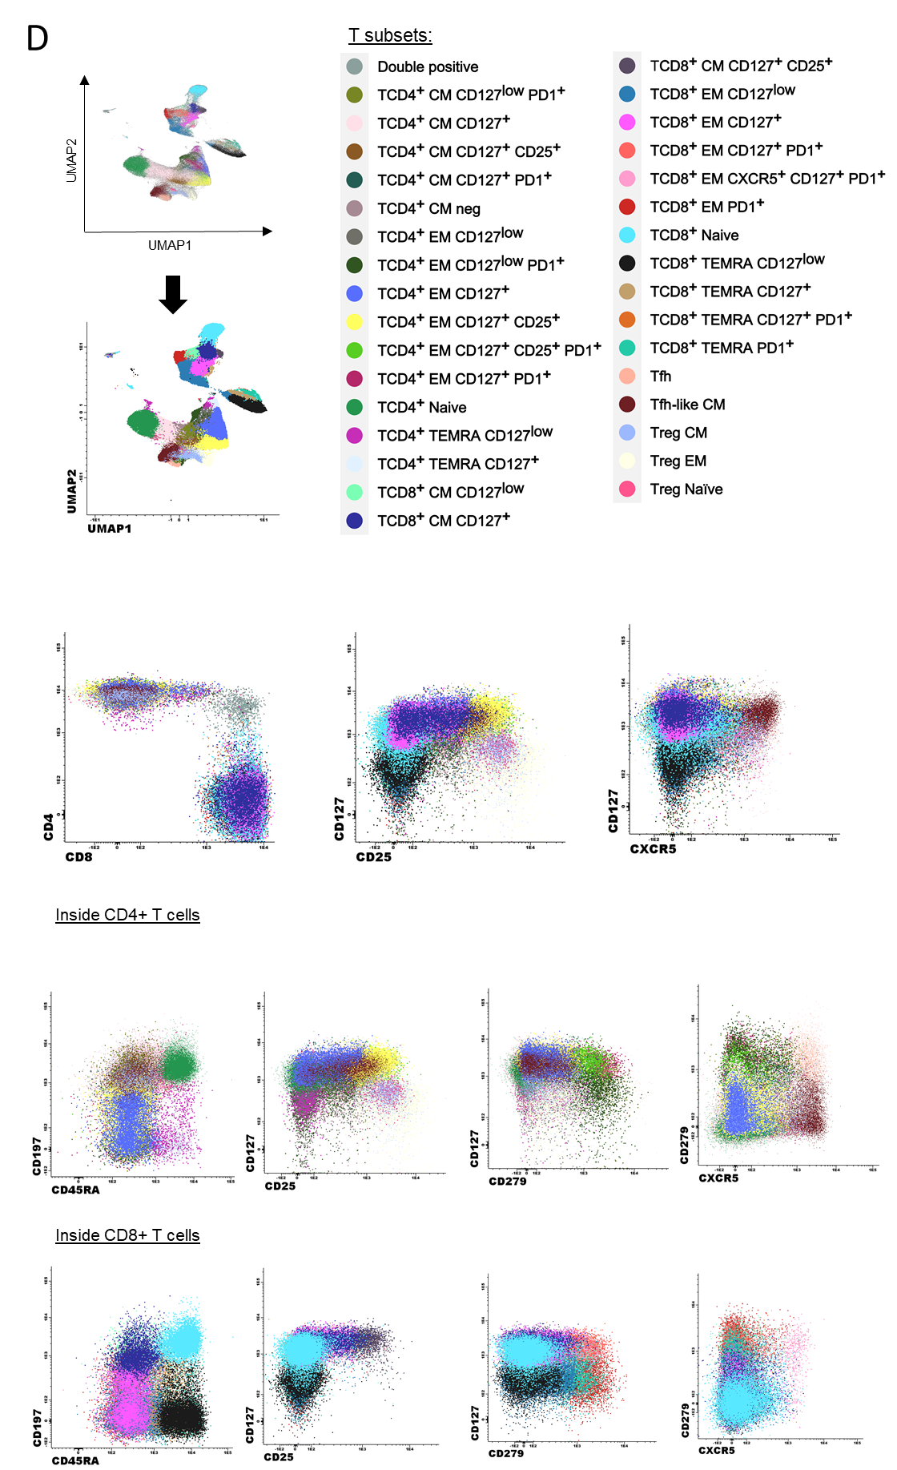

Supplemental Figure 2. Relative distribution of the 59 immune cell-types identified in health care practitioners (HCP) and patients with a B-cell neoplasm, Hodgkin lymphoma (HL) and monoclonal gammopathy (MG). Percentages of (A) granulocytes, (B) antigen-presenting cells, (C) CD4+ and (D) CD8+ T cells, as well as (E) B cells. Statistical significance among all comparisons is detailed in Figure 2.
A) Granulocytes
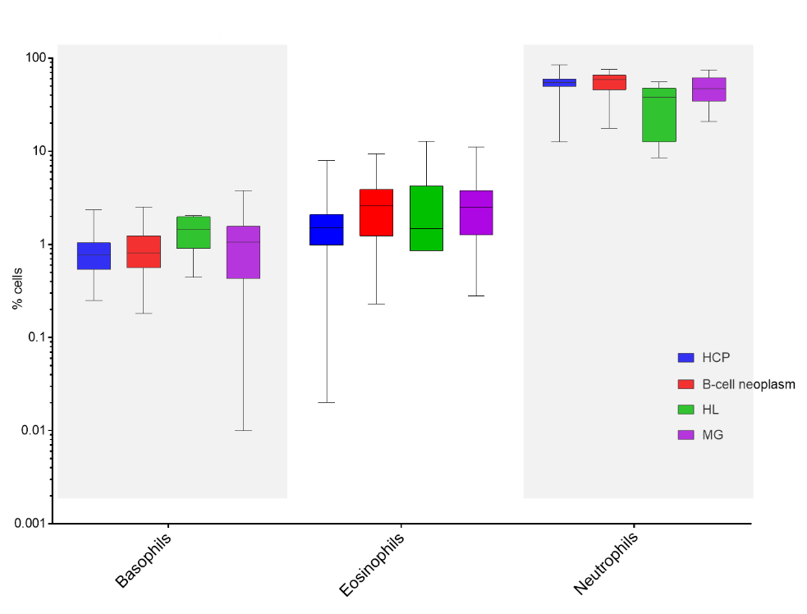
B) Antigen-presenting cells
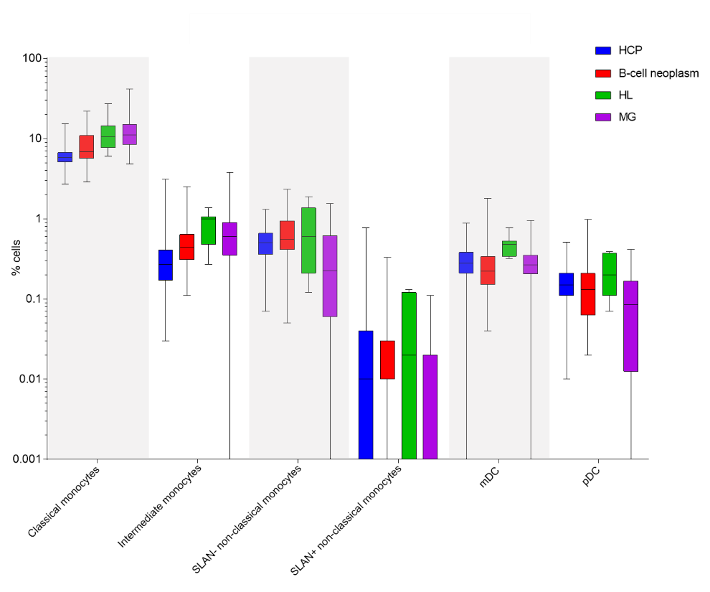
C) CD4 T cells
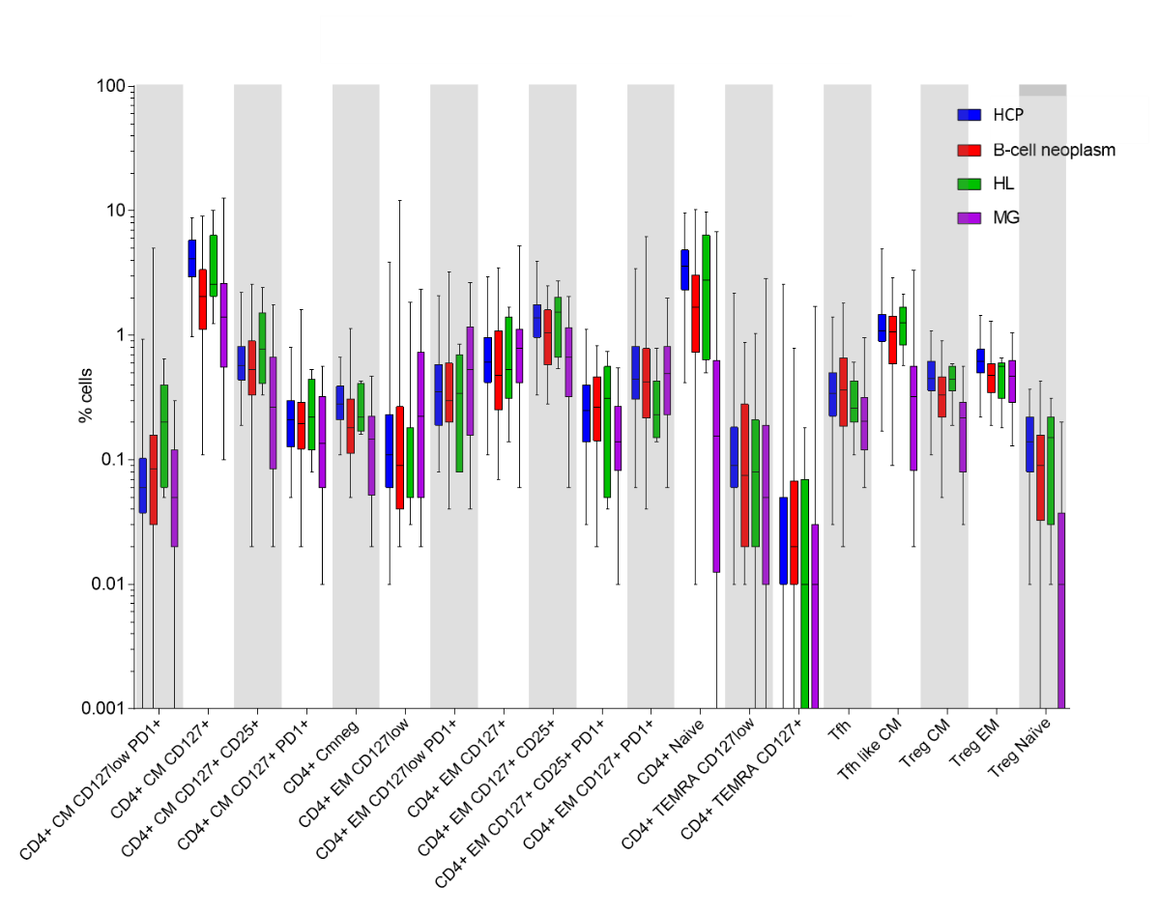

D) CD8 T cells
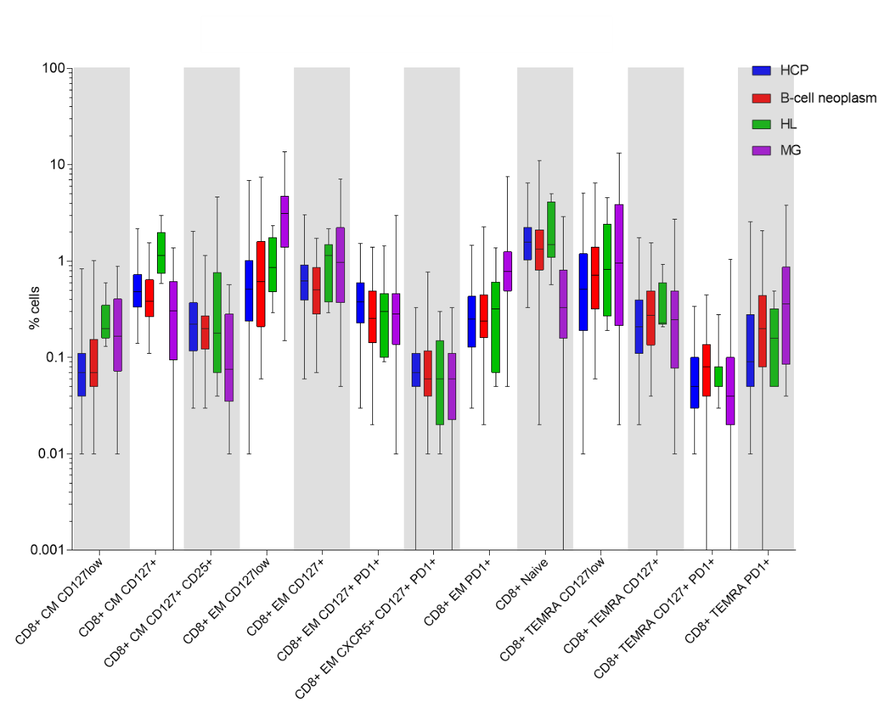

E) B cells
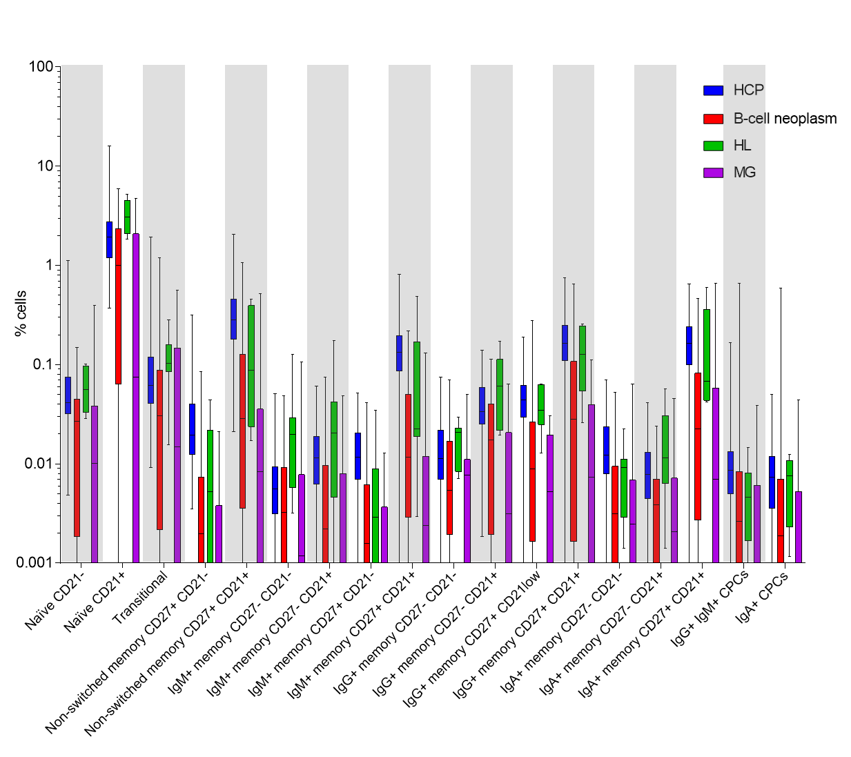

Supplemental Figure 3. Relative distribution of the 59 immune cell-types identified in health care practitioners (HCP), hematological patients that had never received treatment (No tx), those that were on (Active tx,) and patients that were off-treatment (Post-tx,) before vaccination. Percentages of (A) granulocytes, (B) antigen-presenting cells, (C) CD4+ and (D) CD8+ T cells, as well as (E) B cells. Statistical significance among all comparisons is detailed in Figure 3.
A) Granulocytes
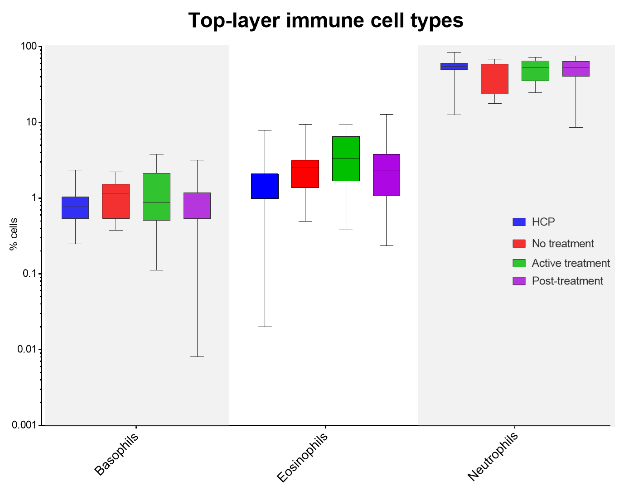
B) Antigen-presenting cells
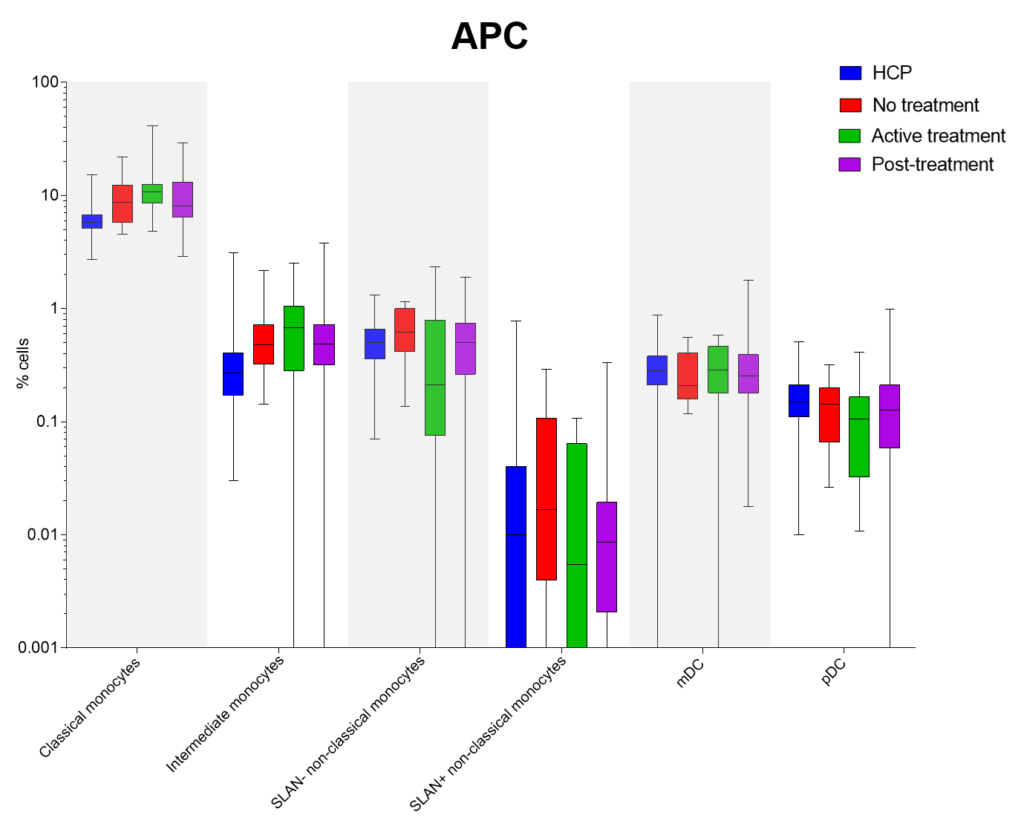
C) CD4 T cells
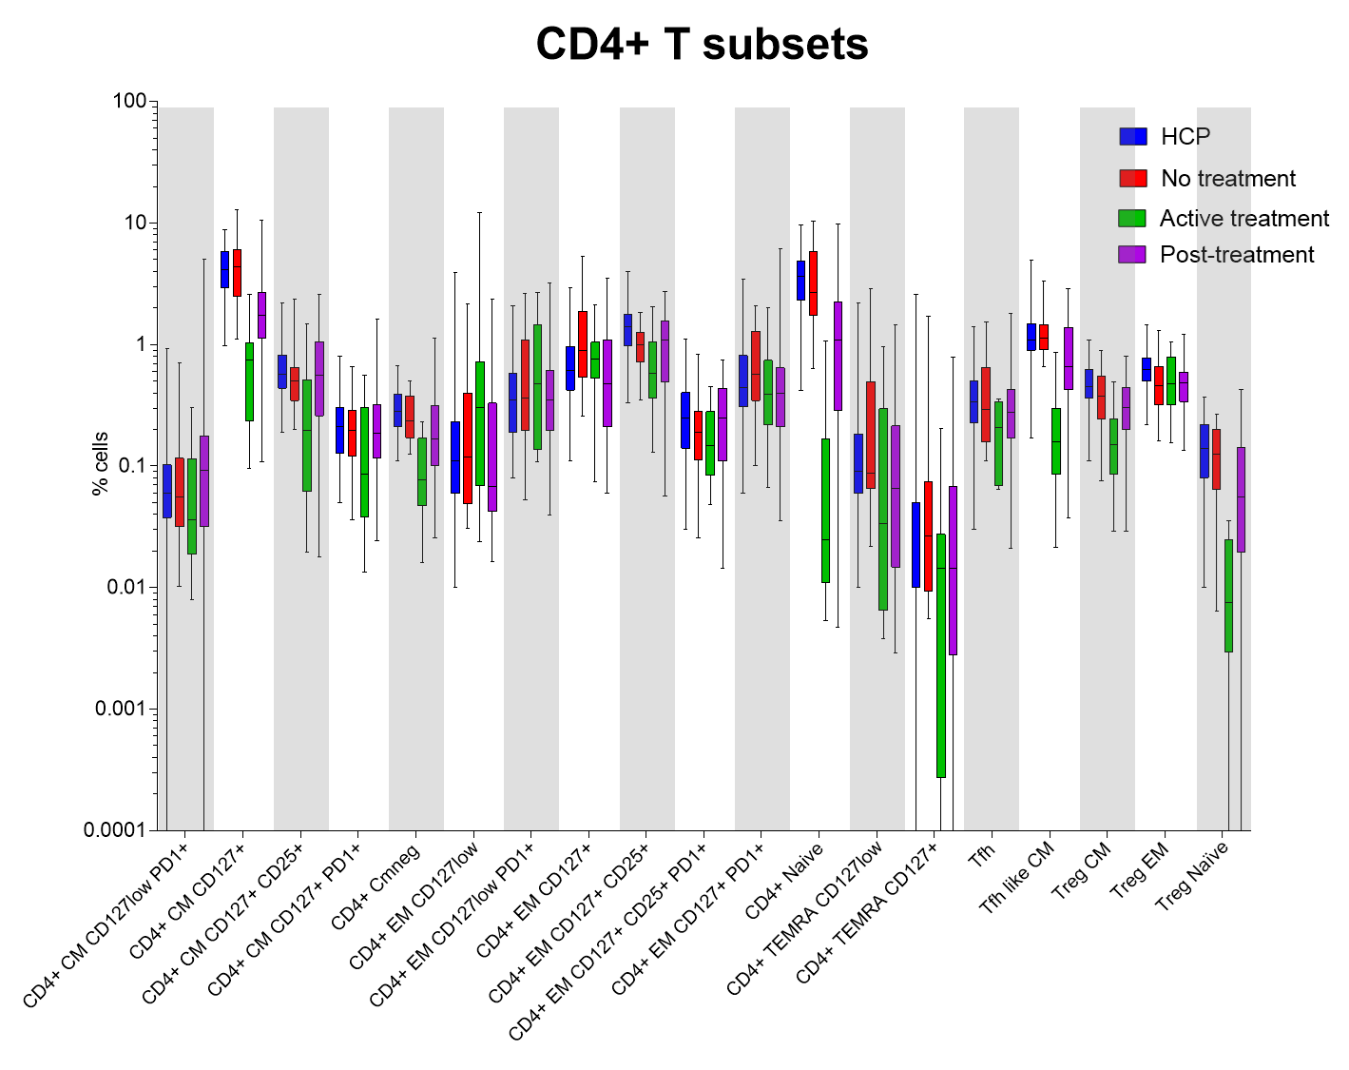
D) CD8 T cells
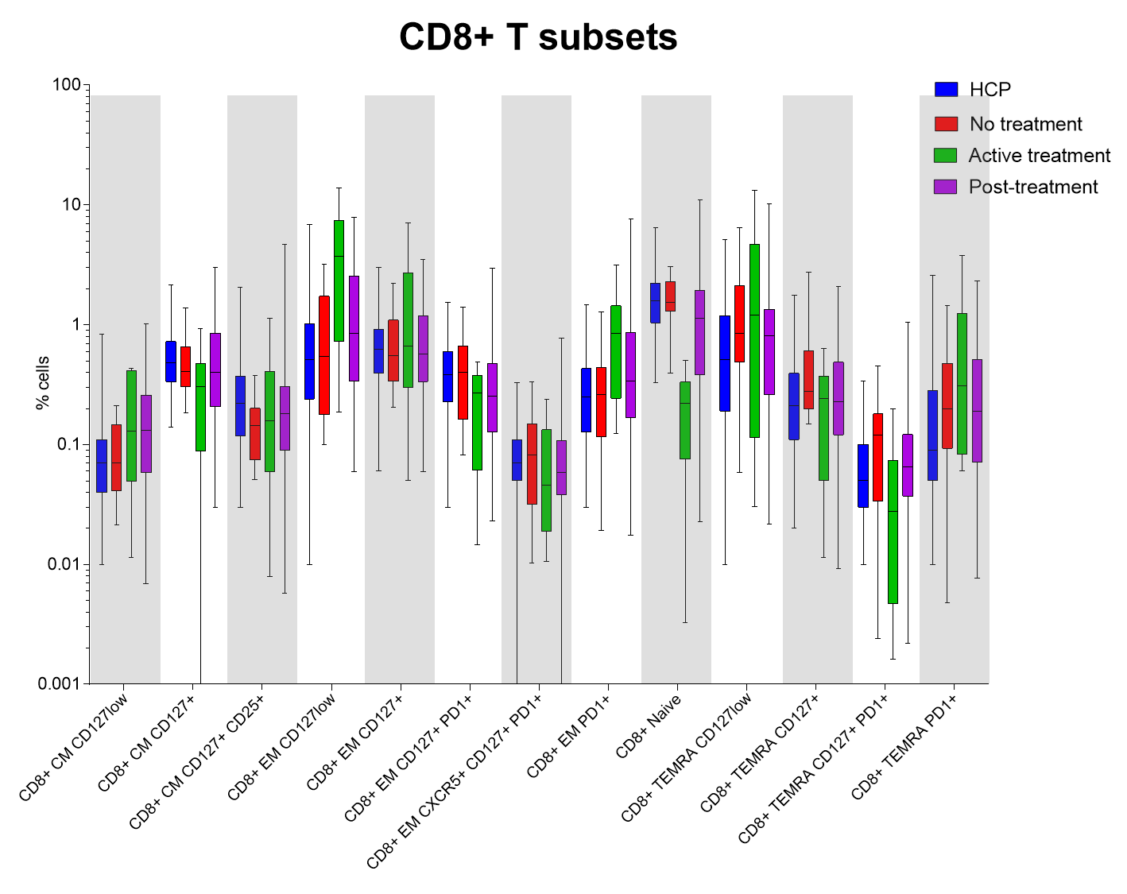
E) B cells
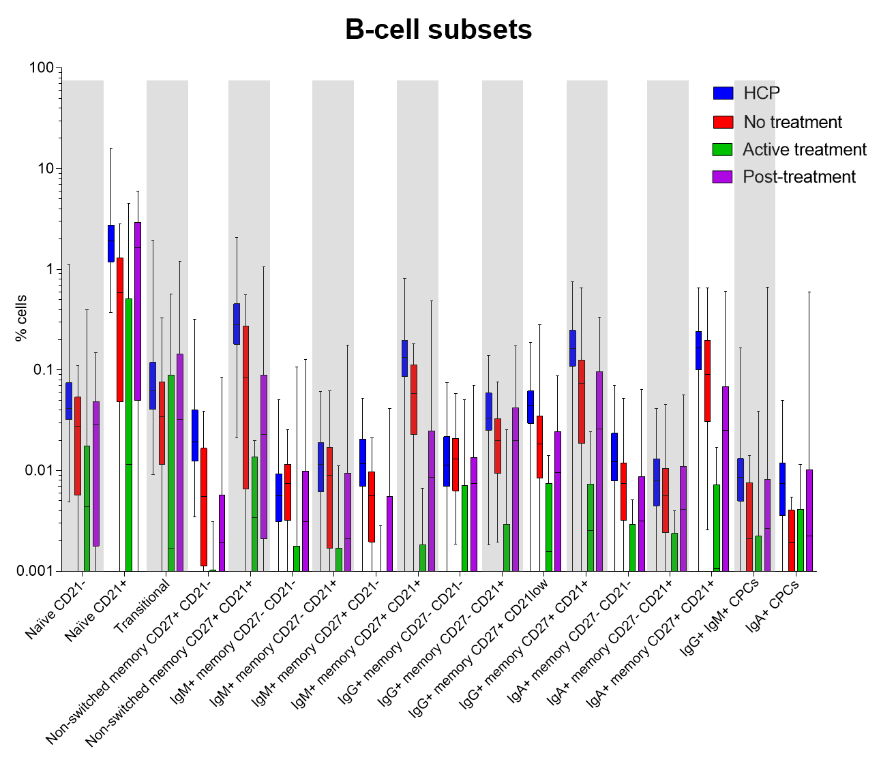

Supplemental Figure 4. Index of IgM, IgG and IgA antibodies against the S-glycoprotein in health care practitioners (HCP) (N = 102) and hematological patients (N = 83) after second-dose vaccination. (***, P < .001).

Supplemental Figure 5. IgG levels against the receptor binding domain (RBD) in health care practitioners (HCP) and patients with hematological malignancies, after BNT162b2 or the mRNA-1273 vaccine. Antibody levels were measured at day 7 after the second-dose vaccination in 102 HCP and 83 patients. Horizontal lines represent the median value. (*, P < .05).

Supplemental Figure 6. IgG levels against the receptor binding domain (RBD) in hematological patients and health care practitioners (HCP). The concentration of anti-RBD-IgG antibody was measured after the second-dose vaccination in 102 HCP and 83 patients. Horizontal lines represent the median value. (***, P < .001).

Supplemental Figure 7. Relative distribution of each of the 59 immune cell-types in patients with hematological malignancies, according to their clustering into the two immunotypes identified in Figure 5 of the main text. Cluster 1 refers to the largest branch, and Cluster 2 corresponds to the smallest one, with lower seroconversion rates).
A) Granulocytes
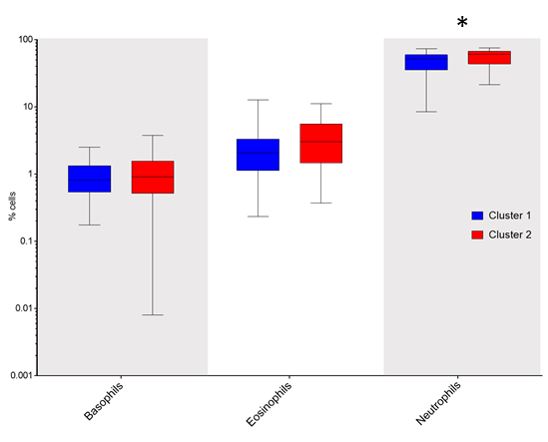
B) Antigen-presenting cells
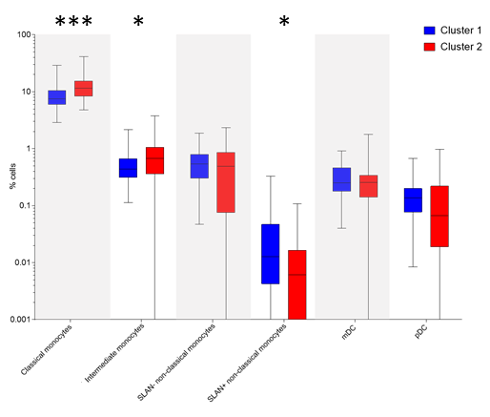
C) CD4 T cells
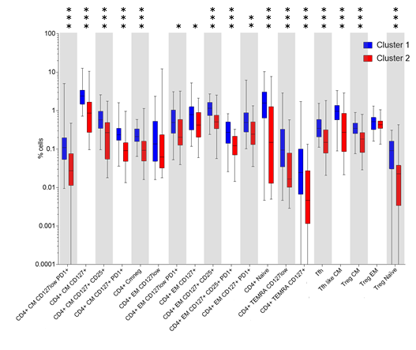

D) CD8 T cells
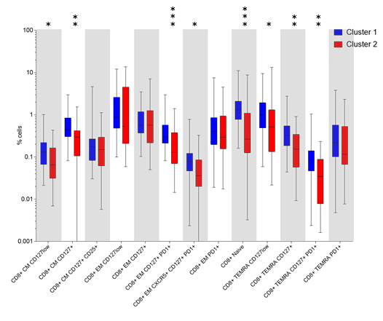

E) B cells

