SUPPLEMENTAL APPENDIX

Implications and prognostic impact of mass spectrometry in
patients with newly-diagnosed multiple myeloma

Mai E. K. et al.
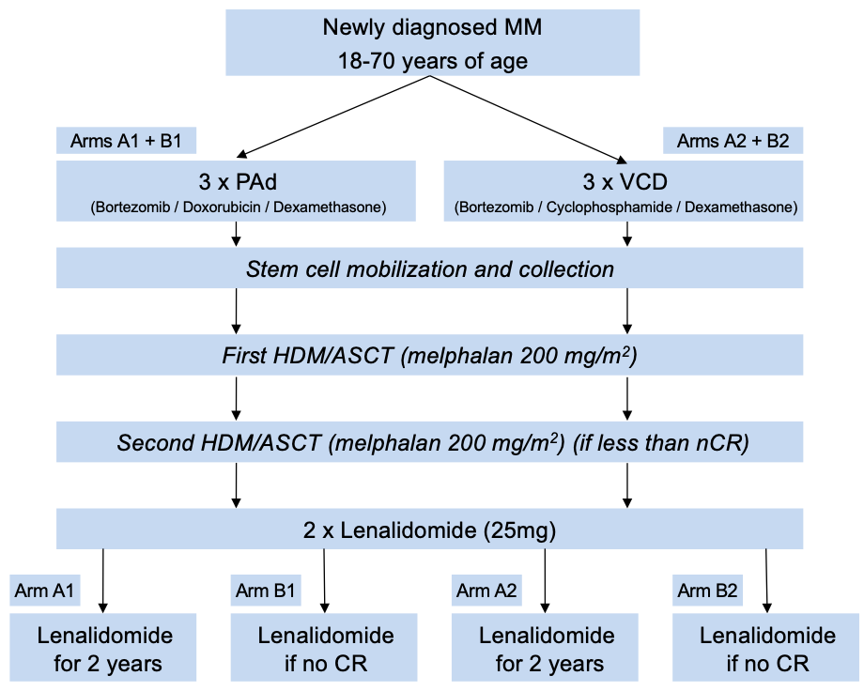
Supplemental Figure 1: Study design and treatment within the GMMG-MM5 trial.
Randomization was performed prior to the start of induction therapy. Maintenance therapy consisted of either Lenalidomide for 2 years or Lenalidomide in case no complete remission (CR) was achieved. Abbreviations: MM = Multiple Myeloma; GMMG = German-speaking Myeloma Multicenter Group; PAd = Bortezomib / Adriamycin / Dexamethasone; VCD = Bortezomib / Cyclophosphamide / Dexamethasone; CAD = Cyclophosphamide / Adriamycin / Dexamethasone; G-CSF = Granulocyte-Colony Stimulating Factor; HDM = high-dose melphalan; ASCT = autologous stem cell transplantation; CR = complete response; nCR = near complete remission.

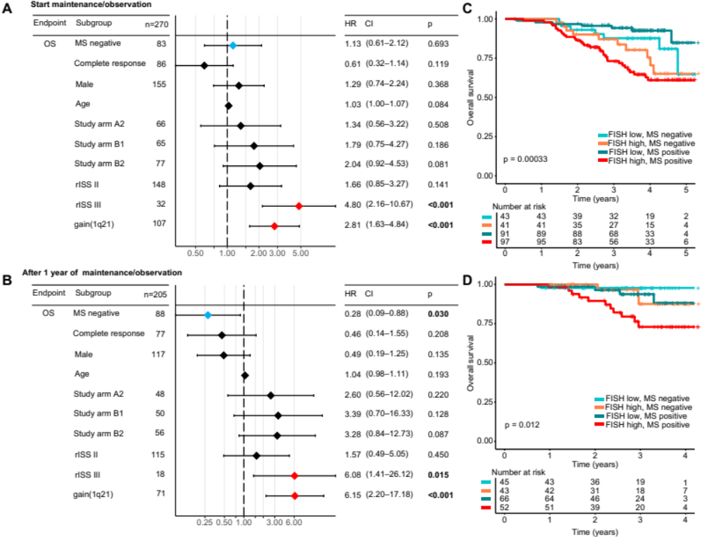
Supplemental Figure 2: Independent prognostic impact of mass spectrometry and its combination with established high-risk markers.
Results of a multivariable model for OS from the start of maintenance therapy/observation (A), and after one year (±3 months) of maintenance/observation (B). PFS from start of maintenance therapy (C) and after one year of maintenance / observation (D) stratified by the combination of mass spectrometry (MS) and baseline high-risk cytogenetics. High risk was defined by the presence of t(4;14), t(14;16), del(17p) and/or gain(1q21).

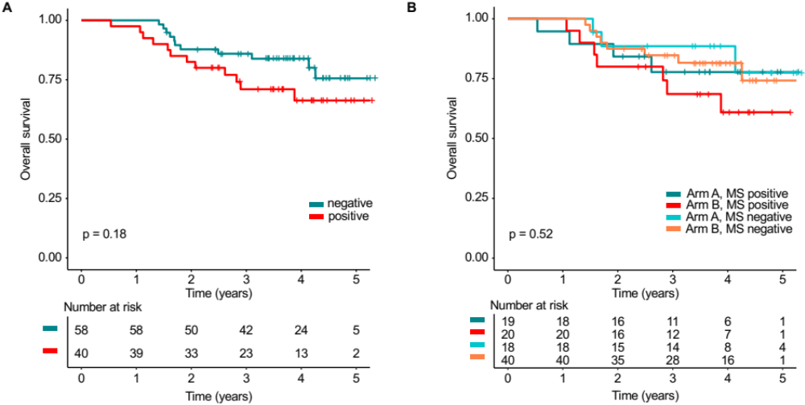
Supplemental Figure 3: Prognostic Impact of mass spectrometry in patients with complete response.
(A) OS landmark analysis of patients in CR from the start of maintenance therapy/observation stratified by mass spectrometry (MS). In (B) patients were stratified by the combination of mass spectrometry and the GMMG-MM5 treatment arm (arm A = lenalidomide maintenance for two years, arm B = observation).

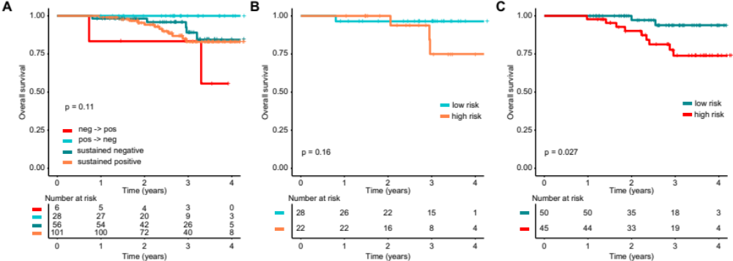
Supplemental Figure 4: The impact of sequential mass spectrometry on OS and the combination with the cytogenetic risk status.
(A) OS landmark analysis from 1 year (±3 months) of maintenance/observation. The patients were grouped according to the combination of the two MS test results at the start of maintenance treatment/observation and after 1 year (±3 months) of maintenance treatment/observation. We discriminated between sustained negativity (both test negative), sustained positivity (both test positive) as well as conversion from positivity to negativity (pos .> neg) or vice versa (neg -> pos). In (B) and (C) sustained negative and positive patients were further stratified by the baseline FISH risk status, respectively. High risk was defined by the presence of t(4;14), t(14;16), del(17p) and/or gain(1q21).

 | After induction |  | Prior to maintenance/observation |  | After one year of maintenance/observation
Isotype | MS positive | MS negative | MS positive | MS negative | MS positive | MS negative
IgA | 92 (94%) | 6 (6%)* | 41 (65%) | 22 (35%) | 23 (55%) | 19 (45%)
IgG | 258 (98%) | 5 (2%)** | 143 (76%) | 45 (24%)** | 85 (59%) | 60 (41%)
IgD | 3 (75%) | 1 (25%) | 2 (100%) | 0 (0%) | 2 (67%) | 1 (33%)
Bence Jones | 65 (82%) | 14 (18%) | 24 (46%) | 28 (54%) | 17 (46%) | 20 (54%)
Total | 418 (94%) | 26 (6%) | 210 (69%) | 95 (31%) | 127 (56%) | 100 (44%)

Supplemental Table 1: Mass spectrometry results according to immunoglobulin isotype.
Fisher's exact test for comparison with Bences Jones: * P<0.05; ** P<0.001. Abbreviations: MS = Mass Spectrometry; Ig = Immunoglobulin.

 | After induction |  |  | Prior to maintenance/observation |  |  | After one year of maintenance/observation
Immunofixation | MS positive | MS negative | Total | MS positive | MS negative | Total | MS positive | MS negative | Total
Positive | 265 | 6 | 271 | 98 | 14 | 112 | 54 | 8 | 62
Negative | 69 | 20 | 89 | 78 | 78 | 156 | 49 | 84 | 133
Not done | 84 | 0 | 84 | 34 | 3 | 37 | 24 | 8 | 32
Total | 418 | 26 | 444 | 210 | 95 | 305 | 127 | 100 | 227

Supplemental Table 2: Mass spectrometry versus serum immunofixation results at three different time points.
Discrepant results are printed in bold. Abbreviations: MS = Mass Spectrometry.

Patient | MRD | MS | Time point | Response
1 | negative | negative | After consolidation | CR
2 | negative | negative | After 1st ASCT | VGPR
3 | negative | negative | After 2nd ASCT | CR
4 | negative | negative | After 1st ASCT | CR
5 | negative | negative | After 1st ASCT | CR
6 | negative | negative | After 1st ASCT | VGPR
7 | negative | negative | After three months of maintenance | CR
8 | negative | negative | After 11 months of maintenance | CR
9 | negative | positive | After three months of observation | CR
10 | negative | positive | After 10 months of observation | CR
11 | negative | positive | After consolidation | CR
12 | negative | positive | After 2nd ASCT | VGPR
13 | negative | positive | After 1st ASCT | CR
14 | negative | positive | After three months of observation | CR
15 | negative | positive | After three months of observation | CR
16 | positive | negative | After 1st ASCT | CR
17 | positive | negative | After 1st ASCT | CR
18 | positive | negative | After 1st ASCT | CR
19 | positive | negative | After consolidation | CR
20 | positive | negative | After consolidation | CR
21 | positive | negative | After consolidation | CR
22 | positive | negative | After 1st ASCT | VGPR
23 | positive | negative | 11 months after start of maintenance | CR
24 | positive | negative | After six months of maintenance | CR
25 | positive | negative | After six months of maintenance | CR
26 | positive | negative | After consolidation | CR
27 | positive | negative | After six months of maintenance | CR
28 | positive | positive | After 1st ASCT | CR
29 | positive | positive | After consolidation | CR
30 | positive | positive | After four months of maintenance | CR
31 | negative | negative | After three months of maintenance | CR
32 | positive | positive | After consolidation | CR
33 | positive | positive | After consolidation | CR
34 | positive | positive | After 1st ASCT | VGPR
35 | positive | positive | After 1st ASCT | CR
36 | positive | positive | After consolidation | CR
37 | positive | positive | After consolidation | CR
38 | positive | positive | After 1st ASCT | CR
39 | positive | positive | After 1st ASCT | VGPR
40 | positive | positive | After consolidation | CR
41 | positive | positive | After 1st ASCT | CR
42 | positive | positive | After three months of maintenance | VGPR
43 | positive | positive | After 1st ASCT | CR
44 | positive | positive | After one month of maintenance | CR
45 | positive | positive | After three months of maintenance | CR

Supplemental Table 3: Minimal residual disease, mass spectrometry, response status and time point of patients included in the analysis.
Abbreviations: MRD = Minimal Residual Disease; MS = Mass Spectrometry; CR = complete response; VGPR = very good partial response; ASCT = autologous stem cell transplantation.

