Supplementary Table 1. Baseline characteristics of patients
Characteristic | All patients  n=219 | Single  CD19  n=147 | Tandem CD19/CD22  n=51 | Sequential CD19/CD22  n=21 | P value
Characteristic | N (%) | n/N (%) | n/N (%) | n/N (%) | P value
Gender |  |  |  |  | 0.184
Male | 106(48.4%) | 68(46.3%) | 30(58.8%) | 8(38.1%)
Female | 113(51.6%) | 79(53.7%) | 21(41.2%) | 13(61.9%)
Age (y) |  |  |  |  | 0.456
≤14 | 20(9.1%) | 11(7.5%) | 7(13.7%) | 2(9.5%)
15-34 | 107(48.9%) | 69(46.9%) | 26(51.0%) | 12(57.1%)
≥35 | 92(42.0%) | 67(45.6%) | 18(35.3%) | 7(33.3%)
Disease status |  |  |  |  | 0.525
Refractory | 50(22.8%) | 32(21.8%) | 15(29.4%) | 3(14.3%)
First relapse | 120(54.8%) | 80(54.4%) | 28(54.9%) | 12(57.1%)
Second or more relapse | 49(22.4%) | 35(23.8%) | 8(15.7%) | 6(28.6%)
Course of prior therapy |  |  |  |  | 0.211
≤3 | 101(46.1%) | 72(49.0%) | 23(45.1%) | 6(28.6%)
≥4 | 118(53.9%) | 75(51.0%) | 28(54.9%) | 15(71.4%)
Prior allo-HSCT |  |  |  |  | 0.570
Yes | 46(21.0%) | 31(21.1%) | 9(17.6%) | 6(28.6%)
No | 173(79.0%) | 116(78.9%) | 42(82.4%) | 15(71.4%)
EMD |  |  |  |  | 0.285
CNSL | 5(2.3%) | 5(3.4%) | 0(0.0%) | 0(0.0%)
Other EMD | 15(6.8%) | 9(6.1%) | 6(11.8%) | 0(0.0%)
Negative | 199(90.9%) | 133(90.5%) | 45(88.2%) | 21(100.0%)
BM blasts by morphology |  |  |  |  | 0.562
<5% | 90(41.1%) | 64(43.5%) | 19(37.3%) | 7(33.3%)
5-20% | 40(18.3%) | 28(19.0%) | 7(13.7%) | 5(23.8%)
≥20% | 89(40.6%) | 55(37.4%) | 25(49.0%) | 9(42.9%)
Complex karyotype |  |  |  |  | 0.223
Yes | 22(10.0%) | 12(8.2%) | 6(11.8%) | 4(19.0%)
No | 197(90.0%) | 135(91.8%) | 45(88.2%) | 17(81.0%)
Fusion gene
BCR-ABL1 | 64(29.2%) | 48(32.7%) | 16(31.4%) | 0(0.0%) | 0.008
Ph-like | 10(4.6%) | 4(2.7%) | 5(9.8%) | 1(4.8%) | 0.091
KMT2A rearrangement | 12(5.5%) | 9(6.1%) | 1(2.0%) | 2(9.5%) | 0.347
Other fusion genes | 12(5.5%) | 6(4.1%) | 4(7.8%) | 2(9.5%) | 0.308
Negative | 121(55.3%) | 80(54.4%) | 25(49.0%) | 16(76.2%) | 0.102
Gene mutation
T315I | 30(13.7%) | 25(17.0%) | 5(9.8%) | 0(0.0%) | 0.061
TP53 | 17(7.8%) | 8(5.4%) | 7(13.7%) | 2(9.5%) | 0.125
IKZF1 | 3(1.4%) | 2(1.4%) | 0(0.0%) | 1(4.8%) | 0.383

Supplementary Table 2. Subgroup analysis of MRD-negative CR rate
Characteristic | Single  CD19  n=147 | Tandem CD19/CD22  n=51 | Sequential CD19/CD22  n=21 | P value
Characteristic | n/N (%) | n/N (%) | n/N (%) | P value
Gender
Male | 44/68(64.7%) | 26/30(86.7%) | 5/8(62.5%) | 0.054
Female | 52/79(65.8%) | 18/21(85.7%) | 11/13(84.6%) | 0.137
Age (y)
≤14 | 9/11(81.8%) | 6/7(85.7%) | 2/2(100.0%) | 1.000
15-34 | 49/69(71.0%) | 20/26(76.9%) | 9/12(75.0%) | 0.897
≥35 | 38/67(56.7%)# | 18/18(100.0%)# | 5/7(71.4%) | <0.001
Disease status
Refractory | 20/32(62.5%) | 13/15(86.7%) | 3/3(100.0%) | 0.164
First relapse | 55/80(68.8%)# | 26/28(92.9%)# | 9/12(75.0%) | 0.029
Second or more relapse | 21/35(60.0%) | 5/8(62.5%) | 4/6(66.7%) | 1.000
Course of prior therapy
≤3 | 46/72(63.9%) | 20/23(87.0%) | 5/6(83.3%) | 0.075
≥4 | 50/75(66.7%) | 24/28(85.7%) | 11/15(73.3%) | 0.168
Prior allo-HSCT
Yes | 20/31(64.5%) | 8/9(88.9%) | 5/6(83.3%) | 0.379
No | 76/116(65.5%)# | 36/42(85.7%)# | 11/15(73.3%) | 0.041
EMD
CNSL | 2/5(40.0%) | 0/0 | 0/0 | —
Other EMD | 2/9(22.2%)# | 5/6(83.3%)# | 0/0 | 0.041
Negative | 92/133(69.2%) | 39/45(86.7%) | 16/21(76.2%) | 0.067
BM blasts by morphology
<5% | 41/64(64.1%) | 17/19(89.5%) | 4/7(57.1%) | 0.062
5-20% | 19/28(67.9%) | 5/7(71.4%) | 5/5(100.0%) | 0.463
≥20% | 36/55(65.5%) | 22/25(88.0%) | 7/9(77.8%) | 0.092
Complex karyotype
Yes | 8/12(66.7%) | 5/6(83.3%) | 2/4(50.0%) | 0.598
No | 88/135(65.2%)# | 39/45(86.7%)# | 14/17(82.4%) | 0.012
Fusion gene
BCR-ABL1 | 29/48(60.4%)# | 16/16(100.0%)# | 0/0 | 0.002
Ph-like | 4/4(100.0%) | 3/5(60.0%) | 1/1(100.0%) | 0.556
KMT2A rearrangement | 6/9(66.7%) | 1/1(100.0%) | 2/2(100.0%) | 1.000
Other fusion genes | 4/6(66.7%) | 4/4(100.0%) | 1/2(50.0%) | 0.345
Negative | 53/80(66.3%) | 20/25(80.0%) | 12/16(75.0%) | 0.401
Gene mutation
T315I | 14/25(56.0%) | 5/5(100.0%) | 0/0 | 0.129
TP53 | 5/8(62.5%) | 7/7(100.0%) | 1/2(50.0%) | 0.165
IKZF1 | 1/2(50.0%) | 0/0 | 0/1(0.0%) | 1.000
# Statistically significant difference between the two groups.

Supplementary Table 3. Univariate analysis for CR rate
Characteristic | CR rate | P value | Exp(B)(95%CI)
Gender
Male* | 90/106(84.9%)
Female | 102/113(90.3%) | 0.231 | 0.607(0.268-1.375)
Age (y) |  | 0.605
≤14* | 19/20(95.0%)
15-34 | 93/107(86.9%) | 0.324 | 2.860(0.355-23.076)
≥35 | 80/92(87.0%) | 0.328 | 2.850(0.349-23.283)
Disease status |  | 0.031
Refractory* | 48/50(96.0%)
First relapse | 106/120(88.3%) | 0.137 | 3.170(0.693-14.498)
Second or more relapse | 38/49(77.6%) | 0.015 | 6.947(1.452-33.247)
Course of prior therapy
≤3* | 91/101(90.1%)
≥4 | 101/118(85.6%) | 0.315 | 1.532(0.667-3.516)
Prior allo-HSCT
Yes | 38/46(82.6%) | 0.244 | 1.706(0.694-4.193)
No* | 154/173(89.0%)
EMD |  | <0.001
CNSL | 2/5(40.0%) | 0.003 | 16.059(2.508-102.844)
Other EMD | 8/15(53.3%) | <0.001 | 9.368(3.027-28.988)
Negative* | 182/199(91.5%)
BM blasts by morphology |  | 0.439
<5%* | 82/90(91.1%)
5-20% | 34/40(85.0%) | 0.305 | 1.809(0.583-5.508)
≥20% | 76/89(85.4%) | 0.239 | 1.753(0.689-4.463)
Complex karyotype
Yes | 19/22(86.4%) | 0.844 | 1.138(0.313-4.136)
No* | 173/197(87.8%)
Fusion gene |  | 0.983
BCR-ABL1 | 56/64(87.5%) | 0.889 | 0.938(0.378-2.326)
Ph-like | 10/10(100.0%) | 0.999 | —
KMT2A rearranged | 11/12(91.7%) | 0.632 | 0.597（0.072-4.939）
Other fusion genes | 10/12(83.3%) | 0.740 | 1.313（0.263-6.545）
Negative* | 105/121(86.8%)
Gene mutation
T315I | 26/30(86.7%) | 0.857 | 1.110(0.355-3.470)
TP53 | 14/17(82.4%) | 0.491 | 1.589(0.426-5.836)
IKZF1 | 2/3(66.7%) | 0.297 | 3.654(0.320-41.720)
Target |  | 0.036
Single CD19* | 122/147(83.0%)
Tandem CD19/CD22 | 50/51(98.0%) | 0.024 | 0.098(0.013-0.740)
Sequential CD19/CD22 | 20/21(95.2%) | 0.178 | 0.244(0.031-1.903)
* Control group
Supplementary Table 4. Univariate analysis for MRD-negative CR rate
Characteristic | CR rate | P value | Exp(B)(95%CI)
Gender
Male* | 75/106(70.8%)
Female | 81/113(71.7%) | 0.883 | 1.045(0.582-1.877)
Age (y) |  | 0.228
≤14* | 17/20(85.0%)
15-34 | 78/107(72.9%) | 0.261 | 2.107(0.575-7.725)
≥35 | 61/92(66.3%) | 0.111 | 2.880(0.784-10.580)
Disease status |  | 0.203
Refractory* | 36/50(70.0%)
First relapse | 90/120(75.0%) | 0.684 | 0.857(0.408-1.802)
Second or more relapse | 30/49(63.3%) | 0.257 | 1.629(0.701-3.785)
Course of prior therapy
≤3* | 71/101(70.3%)
≥4 | 85/118(72.0%) | 0.777 | 0.919(0.511-1.651)
Prior allo-HSCT
Yes | 33/46(71.7%) | 0.932 | 0.969(0.471-1.993)
No* | 123/173(71.1%)
EMD |  | 0.034
CNSL | 2/5(40.0%) | 0.119 | 4.240(0.689-26.091)
Other EMD | 7/15(46.7%) | 0.031 | 3.231(1.116-9.349)
Negative* | 147/199(73.9%)
BM blasts by morphology |  | 0.813
<5%* | 62/90(68.9%)
5-20% | 29/40(72.5%) | 0.679 | 0.840(0.368-1.917)
≥20% | 65/89(73.0%) | 0.542 | 0.818(0.428-1.561)
Complex karyotype
Yes | 15/22(68.2%) | 0.739 | 1.175(0.455-3.035)
No* | 141/197(71.6%)
Fusion gene |  | 0.961
BCR-ABL1 | 45/64(70.3%) | 0.993 | 0.997(0.514-1.934)
Ph-like | 8/10(80.0%) | 0.518 | 0.590(0.119-2.917)
KMT2A rearranged | 9/12(75.0%) | 0.731 | 0.787(0.201-3.077)
Other fusion genes | 9/12(75.0%) | 0.731 | 0.787(0.201-3.077)
Negative* | 85/121(70.2%)
Gene mutation
T315I | 19/30(63.3%) | 0.306 | 1.525(0.680-3.423)
TP53 | 13/17(76.5%) | 0.620 | 0.746(0.234-2.381)
IKZF1 | 1/3(33.3%) | 0.188 | 5.082(0.452-57.075)
Target |  | 0.020
Single CD19* | 96/147(65.3%)
Tandem CD19/CD22 | 44/51(86.3%) | 0.006 | 0.299(0.126-0.713)
Sequential CD19/CD22 | 16/21(76.2%) | 0.327 | 0.588(0.204-1.698)
* Control group

Supplementary Table 5. Organ toxicity associated to CAR T-cell therapy
Characteristic | Grade | Single  CD19 | Tandem CD19/CD22 | Sequential CD19/CD22 | P value
Hematological Toxicity
Myelosuppression
Neutrophil granulocyte | 1-2 | 20/147(13.6%) | 7/51(13.7%) | 0/21(0.0%) | 0.183
 | 3-4 | 117/147(79.6%) | 38/51(74.5%) | 20/21(95.2%) | 0.130
Hemoglobin | 1-2 | 50/147(34.0%) | 13/51(25.5%) | 4/21(19.0%) | 0.252
 | 3-4 | 92/147(62.6%) | 35/51(68.6%) | 15/21(71.4%) | 0.592
Platelet | 1-2 | 41/147(27.9%) | 13/51(25.5%) | 2/21(9.5%) | 0.196
 | 3-4 | 66/147(44.9%) | 30/51(58.8%) | 15/21(71.4%) | 0.031
Coagulation abnormality | 1-2 | 61/147(41.5%) | 25/51(49.0%) | 10/21(47.6%) | 0.605
 | 3-4 | 1/147(0.7%) | 0/51(0.0%) | 0/21(0.0%) | 1.000
Bleeding | 1-2 | 6/147(4.1%) | 3/51(5.9%) | 0/21(0.0%) | 0.654
 | 3-4 | 1/147(0.7%) | 0/51(0.0%) | 0/21(0.0%) | 1.000
Non-hematological Toxicity
Infection | 1-2 | 19/147(12.9%) | 4/51(7.8%) | 3/21(14.3%) | 0.576
 | 3-4 | 23/147(15.6%) | 13/51(25.5%) | 5/21(23.8%) | 0.246
Gastrointestinal reaction | 1-2 | 13/147(8.8%) | 2/51(3.9%) | 2/21(9.5%) | 0.608
 | 3-4 | 2/147(1.4%) | 1/51(2.0%) | 0/21(0.0%) | 1.000
Cardiotoxicity | 3-4 | 7/147(4.8%) | 2/51(3.9%) | 1/21(4.8%) | 1.000
Hepatotoxicity | 1-2 | 40/147(27.2%) | 15/51(29.4%) | 6/21(28.6%) | 0.953
 | 3-4 | 19/147(12.9%) | 4/51(7.8%) | 1/21(4.8%) | 0.513
Renal toxicity | 1-2 | 14/147(9.5%) | 7/51(13.7%) | 2/21(9.5%) | 0.693
 | 3-4 | 1/147(0.7%) | 0/51(0.0%) | 0/21(0.0%) | 1.000

Supplementary Table 6. Univariate analysis for LFS
Characteristic | 2-year LFS | P value | Exp(B)(95%CI)
Gender
Male* | 51.5%
Female | 56.2% | 0.344 | 0.810(0.523-1.254)
Age (y) |  | 0.477
≤14* | 46.3%
15-34 | 60.5% | 0.289 | 0.694(0.353-1.364)
≥35 | 48.1% | 0.677 | 0.865(0.438-1.708)
Disease status |  | 0.003
Refractory* | 61.4%
First relapse | 57.9% | 0.397 | 1.282(0.722-2.277)
Second or more relapse | 32.1% | 0.002 | 2.765(1.443-5.299)
Course of prior therapy
≤3* | 57.9%
≥4 | 50.3% | 0.133 | 1.403(0.902-2.182)
Prior allo-HSCT
Yes | 59.1% | 0.789 | 0.926(0.529-1.623)
No* | 52.7%
EMD
Yes | 57.9% | 0.403 | 0.611(0.193-1.937)
No* | 53.5%
BM blasts by morphology |  | 0.269
<5%* | 59.5%
5-20% | 49.5% | 0.443 | 1.276(0.684-2.383)
≥20% | 50.0% | 0.106 | 1.494(0.919-2.430)
Complex karyotype
Yes | 33.7% | 0.146 | 1.603(0.848-3.032)
No* | 56.1%
Fusion gene |  | 0.935
BCR-ABL1 | 54.6% | 0.916 | 0.973(0.589-1.609)
Ph-like | 45.0% | 0.721 | 1.183(0.470-2.982)
KMT2A rearranged | 46.8% | 0.511 | 1.364(0.540-3.441)
Other fusion genes | 80.0% | 0.662 | 0.771(0.239-2.481)
Negative* | 53.1%
Gene mutation
T315I | 47.2% | 0.323 | 1.349(0.745-2.442)
TP53 | 57.1% | 0.678 | 0.838(0.365-1.926)
Target |  | 0.245
Single CD19* | 50.7%
Tandem CD19/CD22 | 63.9% | 0.121 | 0.655(0.384-1.118)
Sequential CD19/CD22 | 43.5% | 0.733 | 1.131(0.558-2.293)
Response
MRD-negative CR | 58.4% | 0.005 | 0.499(0.306-0.815)
MRD-positive CR* | 35.1%
Bridging to HSCT
Yes | 67.5% | <0.001 | 0.356(0.226-0.560)
No* | 37.8%
CRS |  | 0.406
Grade 0* | 58.4%
Grade 1-2 | 55.6% | 0.618 | 1.151(0.663-1.999)
Grade 3-4 | 44.3% | 0.197 | 1.514(0.806-2.843)
* Control group

Supplementary Figure 1. Peak of cytokine levels.
The peak concentration of serum Fer, CRP, IL-2, IL-4, IL-6, IL-10, TNF-α and IFN-γ in the single CD19, tandem CD19/CD22 and sequential CD19/CD22 group.
Supplementary Figure 2. Survival of patients with high-risk factors according to different CAR T-cell therapies.
(A) Overall survival (B) leukemia-free survival and (C) cumulative incidence of relapse of patients who underwent allo-HSCT after CAR T-cell therapy in the single CD19 group, tandem CD19/CD22 group and sequential CD19/CD22 group.
(D) Overall survival (E) leukemia-free survival and (F) cumulative incidence of relapse of patients without allo-HSCT after CAR T-cell therapy among the three groups.
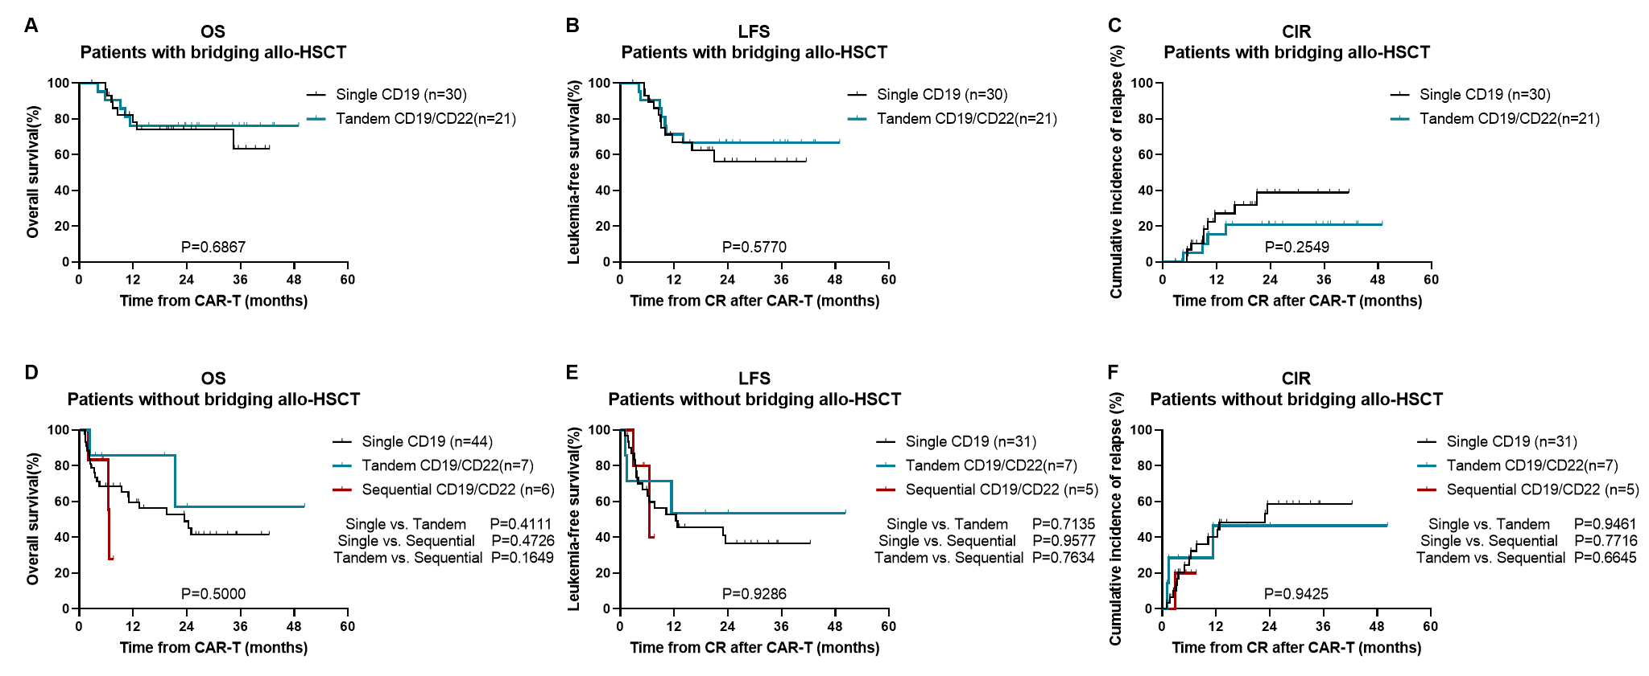

Supplementary Figure 3. Survival of patients without high-risk factors according to different CAR T-cell therapies.
(A) Overall survival (B) leukemia-free survival and (C) cumulative incidence of relapse of patients who underwent allo-HSCT after CAR T-cell therapy in the single CD19 group, tandem CD19/CD22 group and sequential CD19/CD22 group.
(D) Overall survival (E) leukemia-free survival and (F) cumulative incidence of relapse of patients without allo-HSCT after CAR T-cell therapy among the three groups.
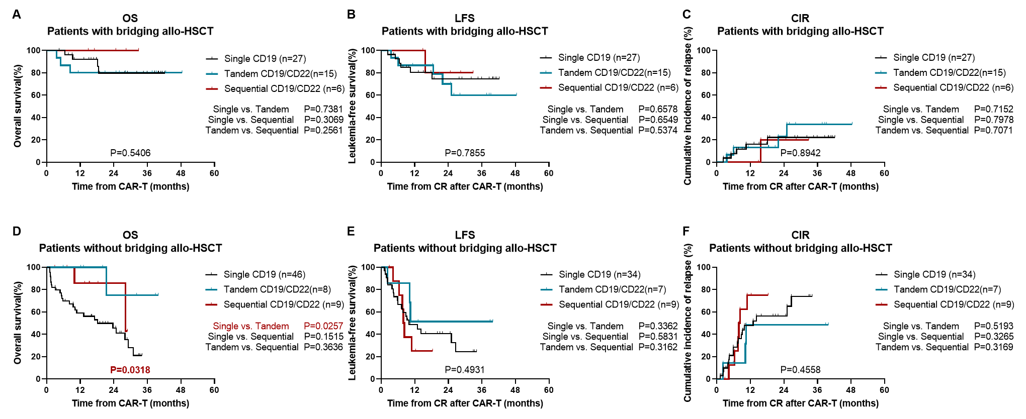

Supplementary Figure 4. Survival of the entire study population.
- Leukemia-free survival of patients according to disease status.
- Leukemia-free survival of patients according tumor burden.
- Leukemia-free survival of patients according to response.
- Leukemia-free survival of patients according to bridging to allo-HSCT.
