Title: Real-world data of long-term survival in patients with T-cell lymphoma who underwent stem cell transplantation

Running title: Outcomes of stem cell transplantation in T-cell lymphomas

Authors: Dong Won Baek, Joon Ho Moon, Jae Hoon Lee, Ka-Won Kang, Ho Sup Lee, Hyeon-Seok Eom, Enuyoung Lee, Ji Hyun Lee, Jeong-Ok Lee, Seong Kyu Park, Seok Jin Kim, Keon Hee Yoo, Sung-Soo Yoon, Youngil Koh, Hyoung Jin Kang, Jong-Ho Won, Chuhl Joo Lyu, Seung Min Hahn, Jung-Hee Lee, Joon Seong Park, Jae-Cheol Jo, Yeung-Chul Mun, Deok-Hwan Yang, Ga-Young Song, Sung-Nam Lim, Sang Kyun Sohn, and The Korean Society of Blood and Marrow Transplantation

Supplementary Figure 1. Survival outcomes. Progression-free survival (A) and overall survival (B) of all patients.
(A) PFS

(B) OS
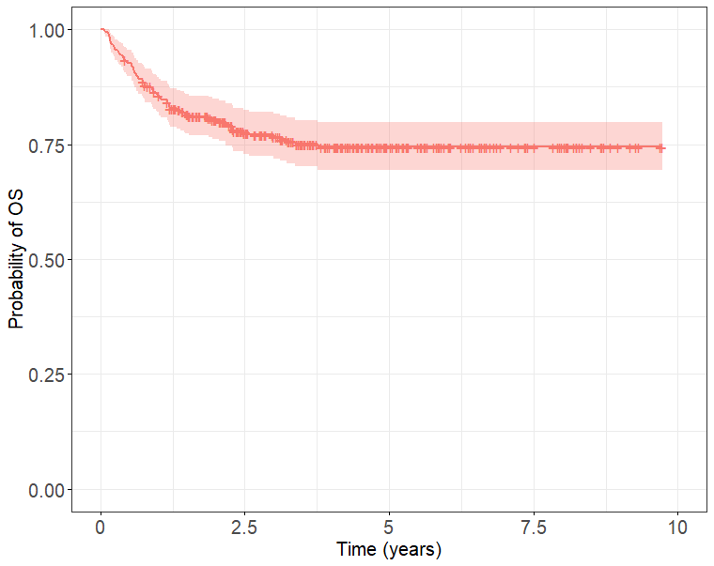

Supplementary Figure 2. Survival outcomes according to the first-line treatment response in patients who underwent up-front stem cell transplantation. Progression-free survival (A) and overall survival (B).
(A) PFS
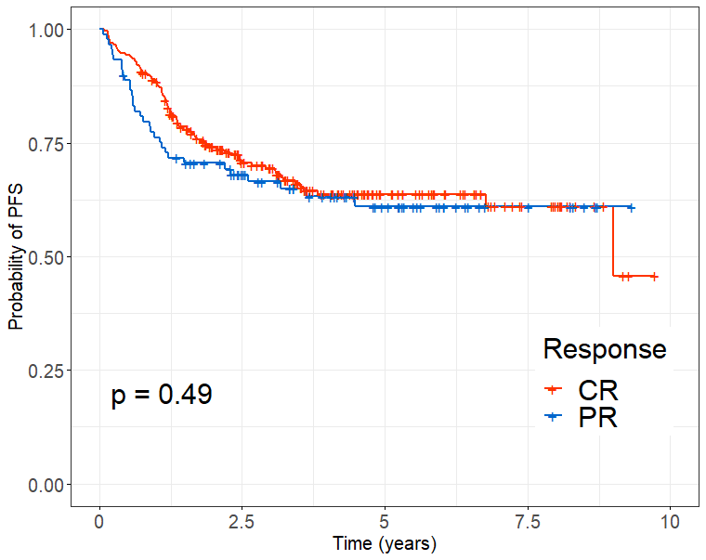
(B) OS
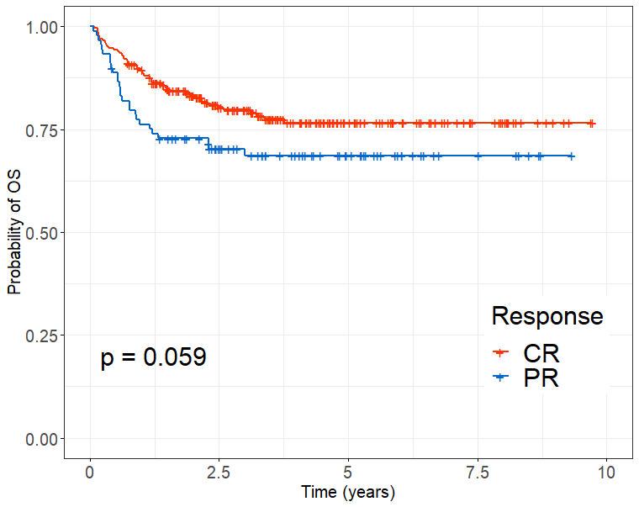
Supplementary Figure 3. Cumulative relapse incidence of the patients with CR (A), and PR (B), and non-relapse mortality of the patients with CR (C), and PR (D)
(A) Cumulative relapse incidence of CR patients (p-value = 0.23)
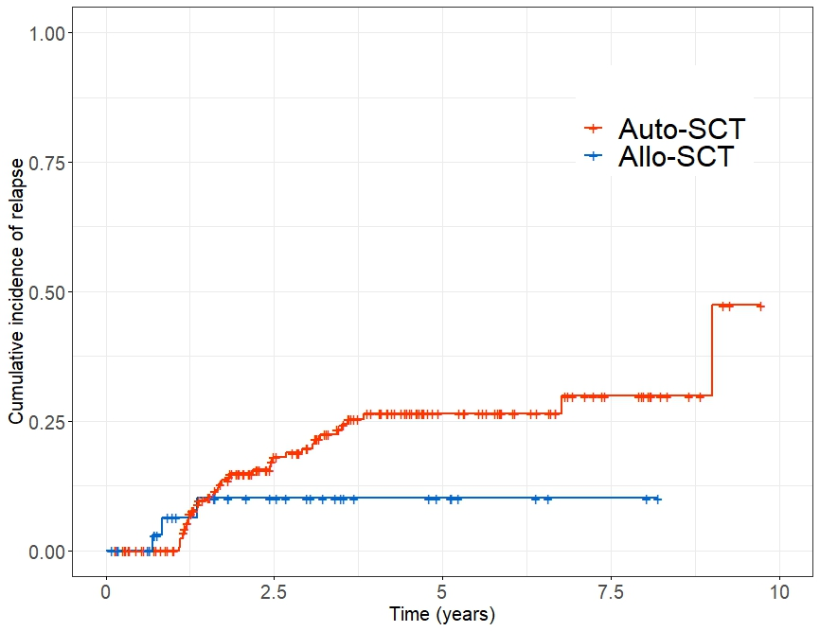
(B) Cumulative relapse incidence of PR patients (p-value = 0.86)
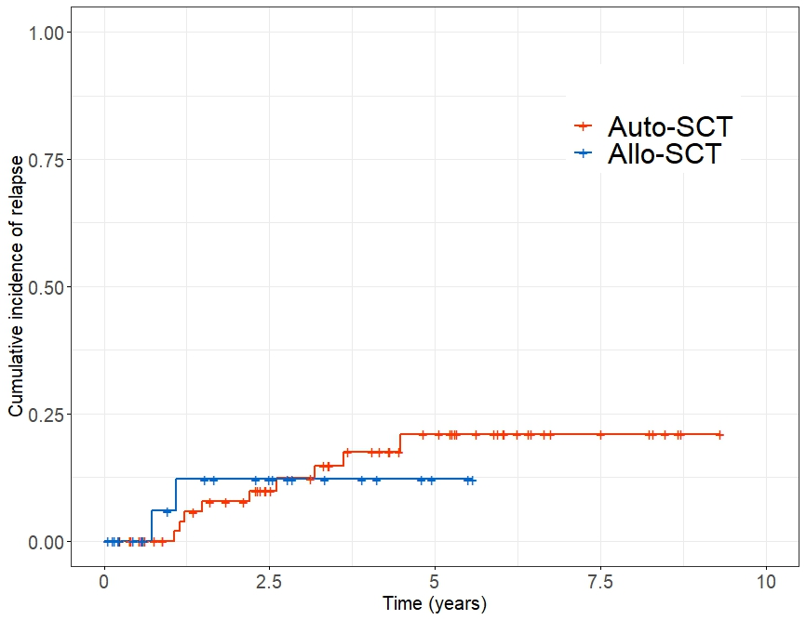

(C) Non-relapse mortality of CR patients (p-value = 0.054)
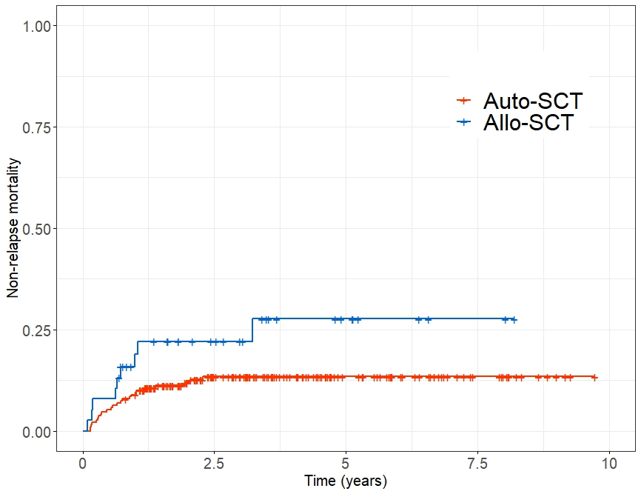
(D) Non-relapse mortality of PR patients (p-value = 0.049)
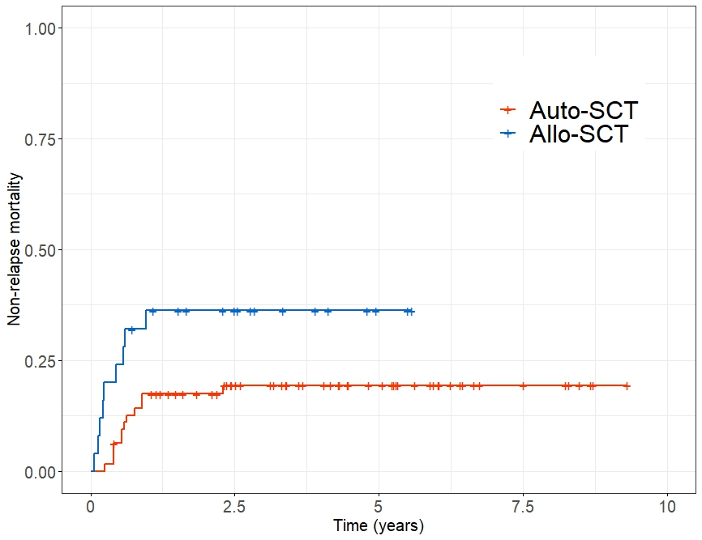

Supplementary Figure 4. Kaplan-Meier curve. Patients aged < 50 years exhibited better progression-free survival (PFS) (A) and overall survival (OS) (B) than older patients. There were no survival differences between auto- and allo-SCT in terms of PFS (C), and OS (D) in patients aged < 50 years. In older patients aged ≥ 50 years, patients who underwent auto-SCT showed better tendency of PFS (E), and improved OS (F) than those with allo-SCT.
(A) PFS
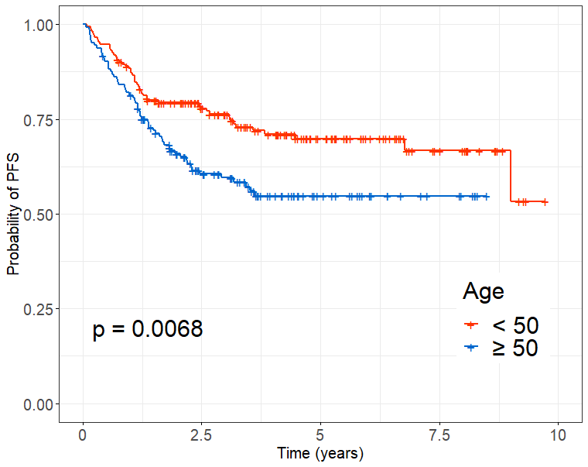
(B) OS
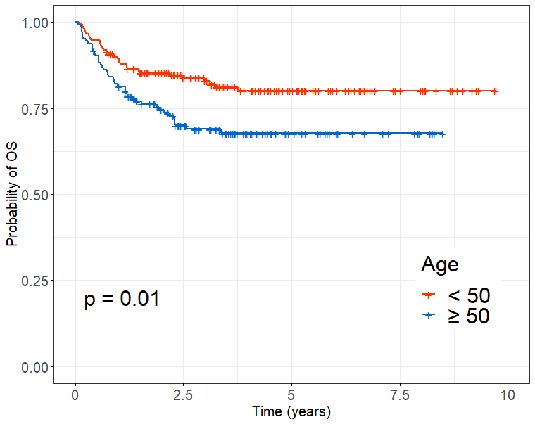

(C) PFS in patients aged < 50 years
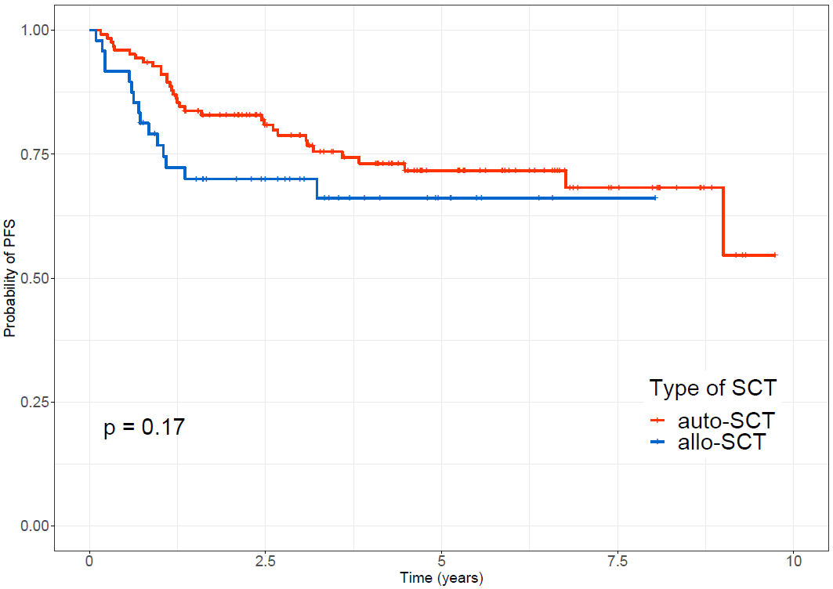

(D) OS in patients aged <5 0 years
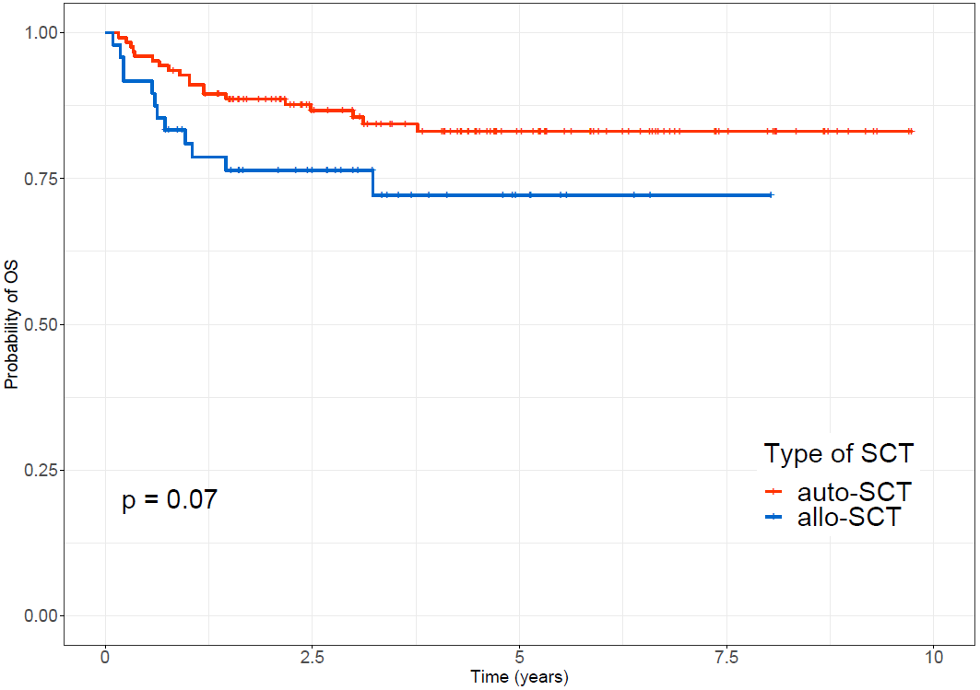

(E) PFS in patients aged ≥ 50 years
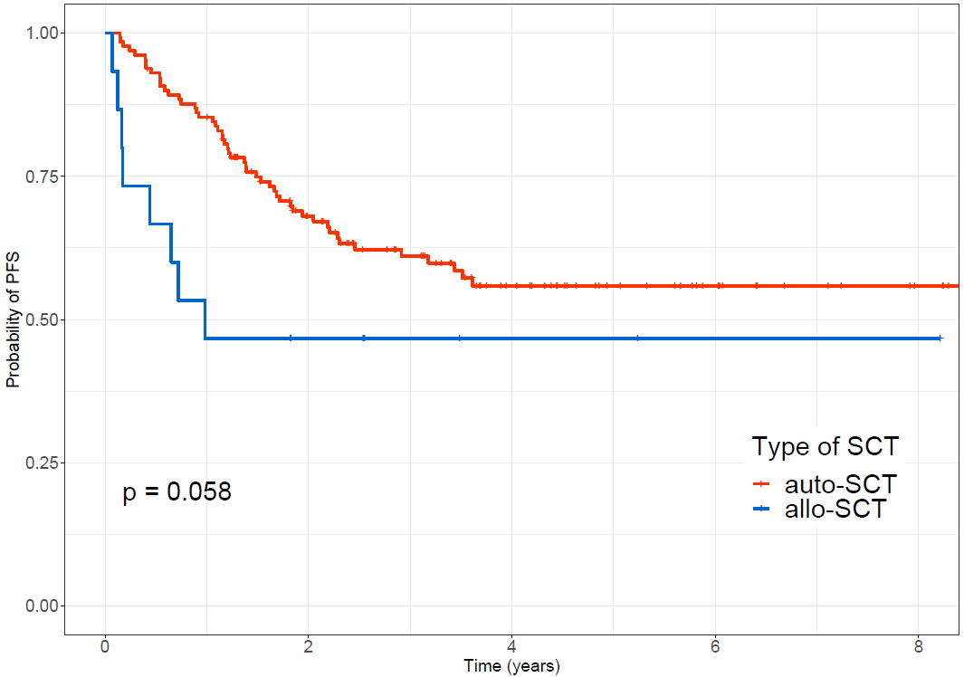

(F) OS in patients aged ≥ 50 years
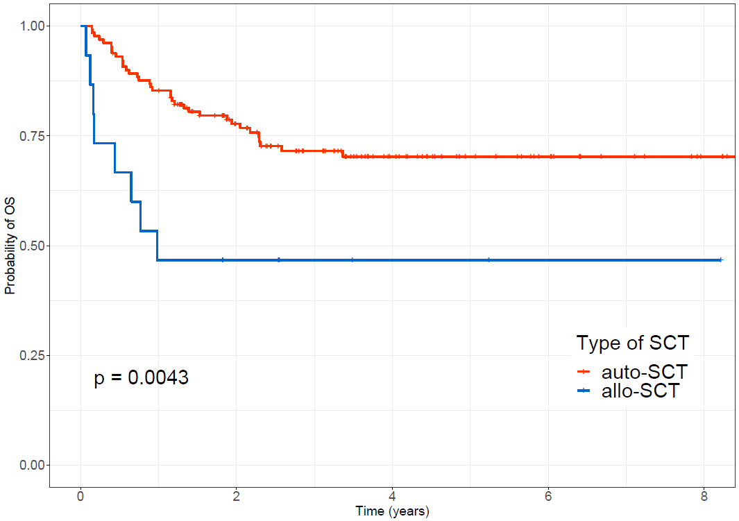

Supplementary Figure 5. Propensity score matched analysis in patients with up-front SCT. (A) Results of propensity score matching, (B) PFS in patients with CR/PR who received up-front SCT, (C) OS in patients with CR/PR who received up-front SCT.
(A) Propensity score matching results
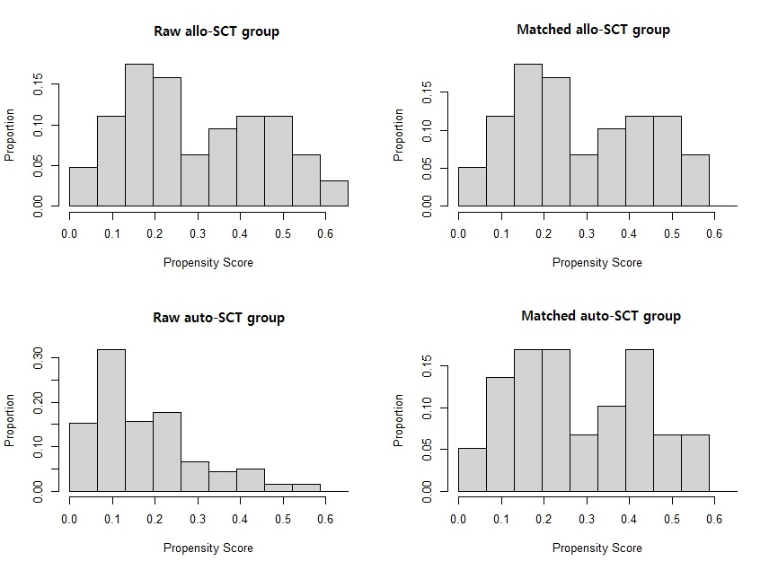
(B) PFS
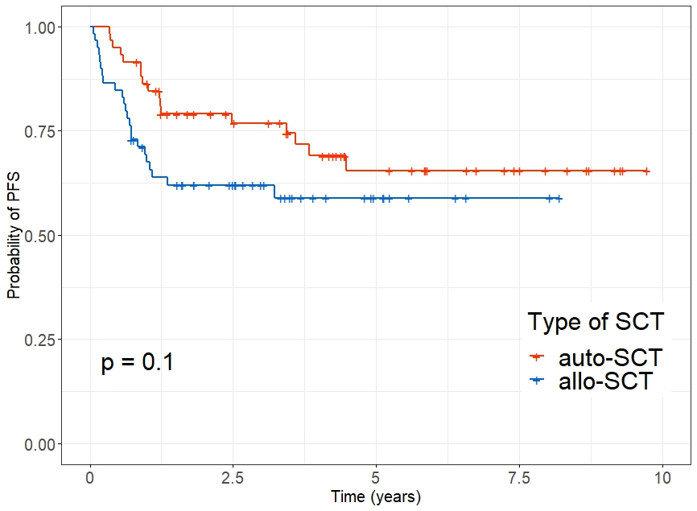
(C) OS
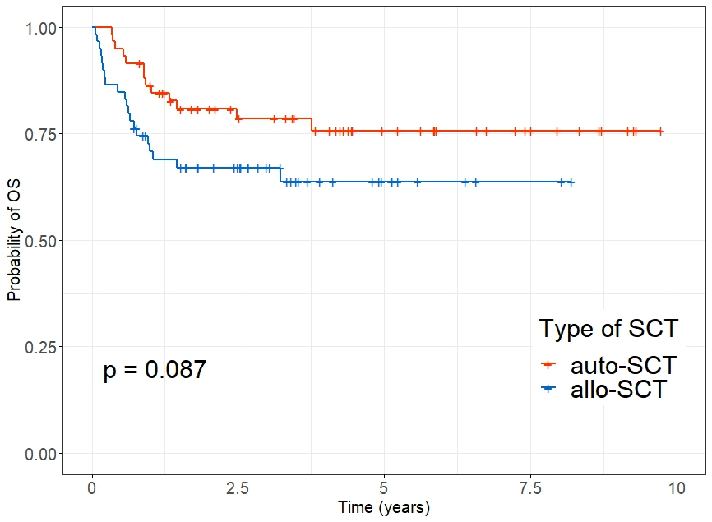

Supplementary Figure 6. Cumulative relapse incidence of the patients with CR/PR (A), and relapsed/refractory status (B), and non-relapse mortality of the patients with CR/PR (C), and relapsed/refractory status (D)
(A) Cumulative relapse incidence of CR/PR patients (p-value = 0.005)
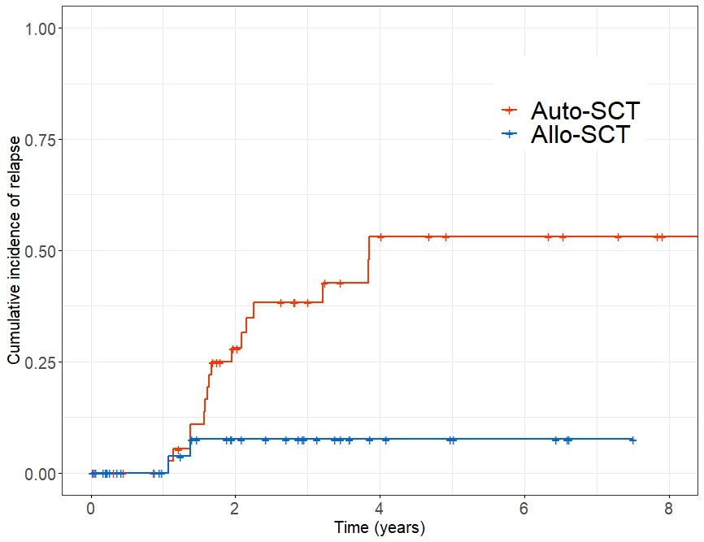
(B) Cumulative relapse incidence of relapsed/refractory status patients (p-value = 0.13)
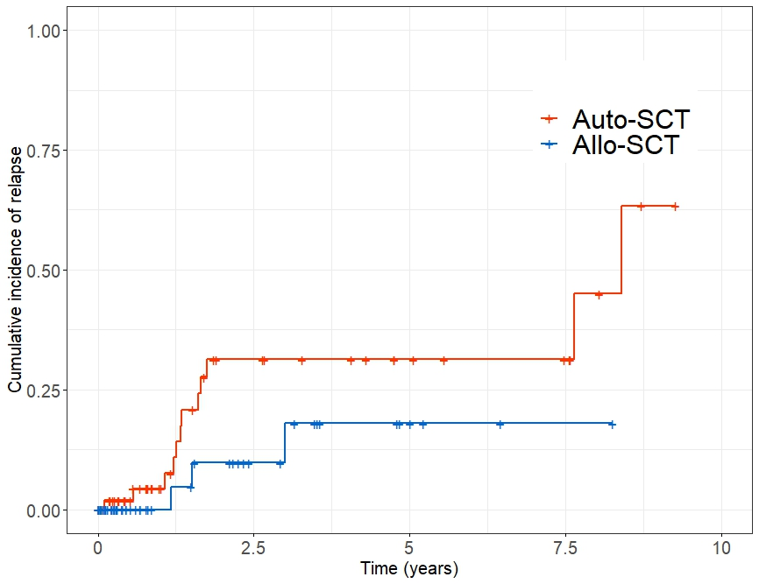

(C) Non-relapse mortality of CR/PR patients (p-value < 0.001)
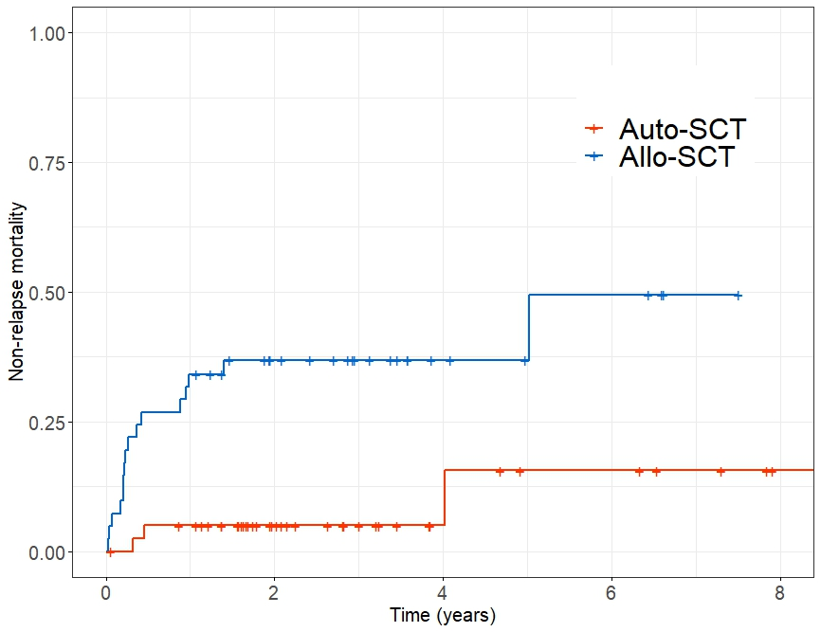
(D) Non-relapse mortality of relapsed/refractory status patients (p-value = 0.023)
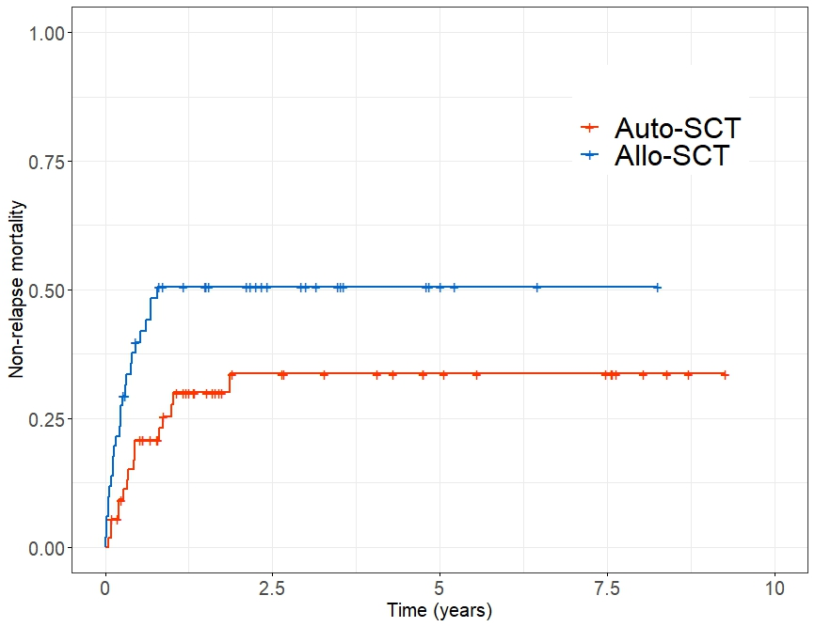

Supplementary Figure 7. Propensity score matched analysis in patients with salvage setting. (A) Results of propensity score matching in patients with CR/PR, (B) PFS in patients with CR/PR, (C) OS in patients with CR/PR, (D) Results of propensity score matching in patients with relapsed/refractory disease, (E) PFS in patients with relapsed/refractory disease, (F) OS in patients with relapsed/refractory disease.
(A) Propensity score matching results
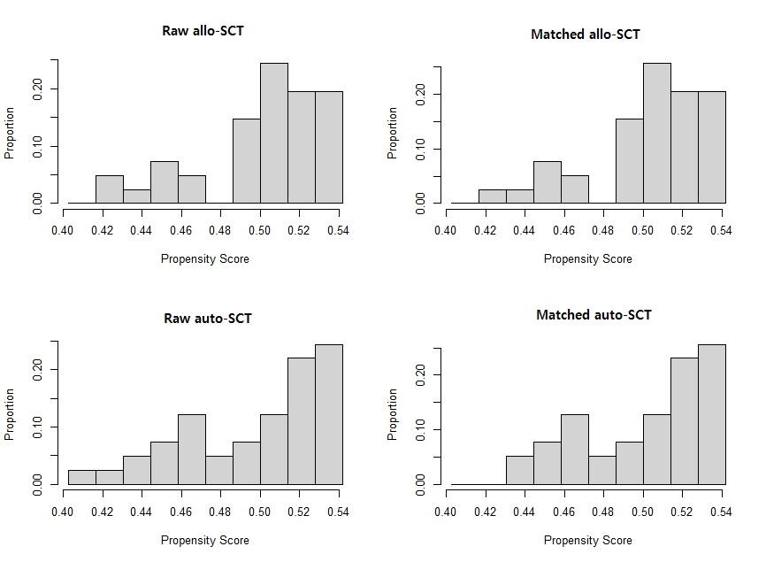
(B) PFS in patients with CR/PR
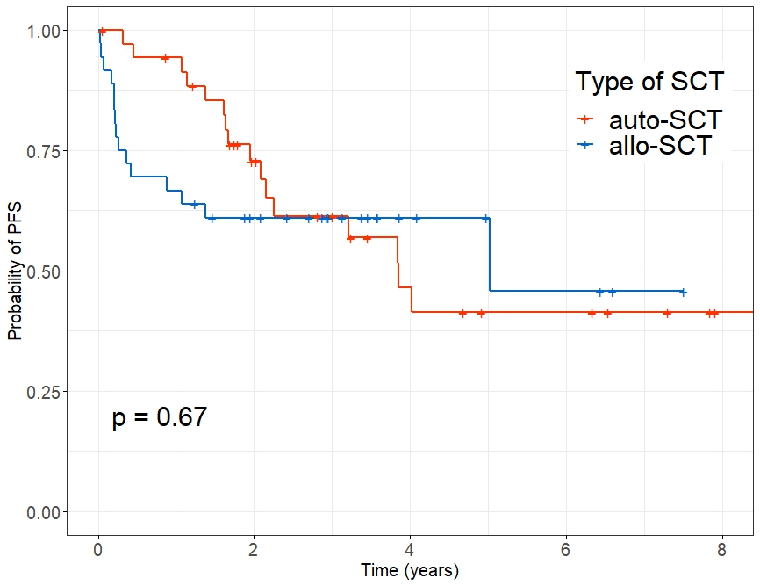
(C) OS in patients with CR/PR
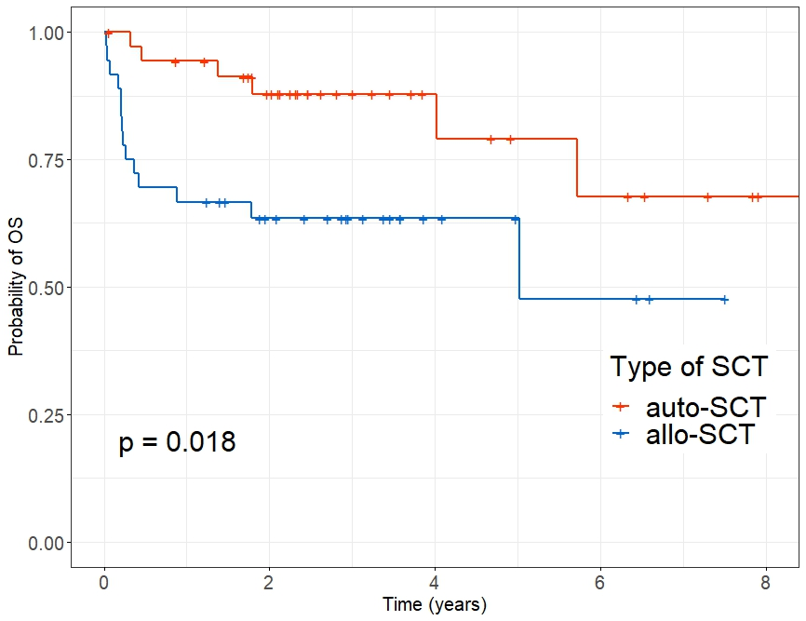
(D) Results of propensity score matching in patients with relapsed/refractory disease
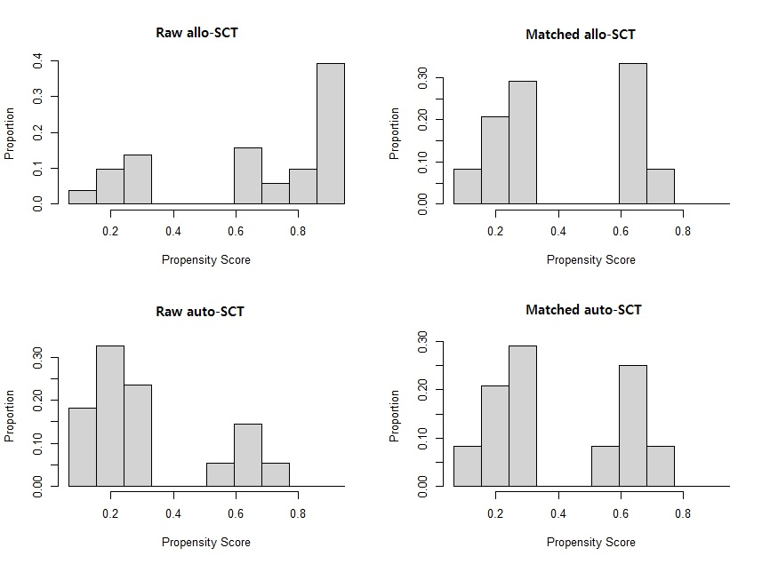

(E) PFS in patients with relapsed/refractory disease
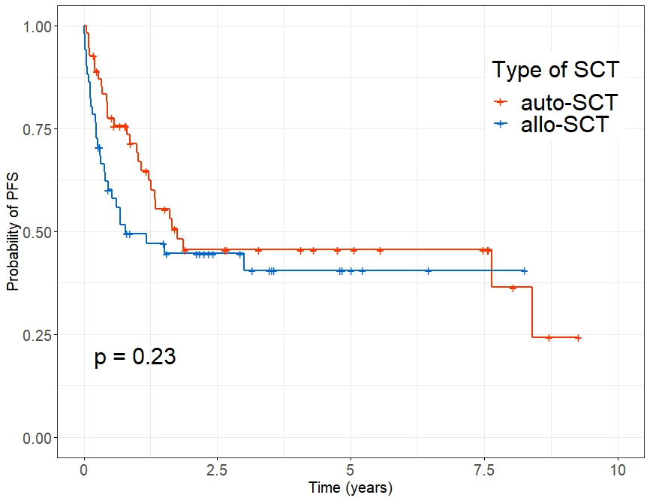
(F) OS in patients with relapsed/refractory disease
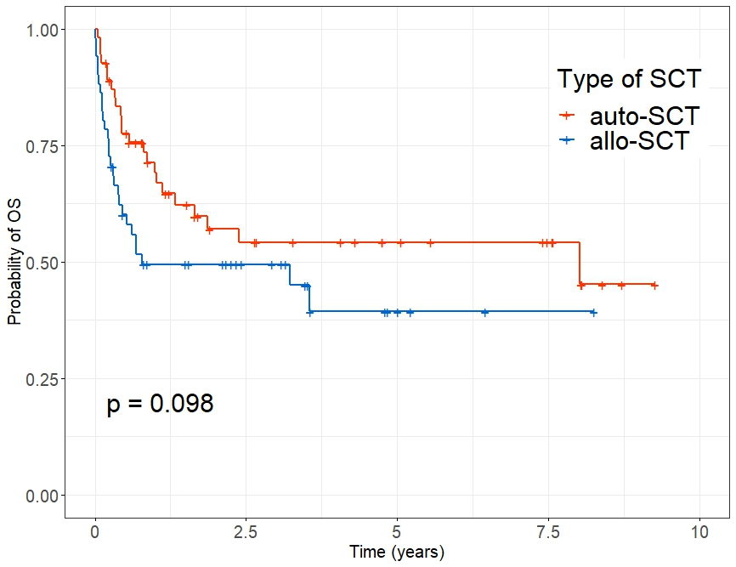

Supplementary Tables
Supplementary Table 1. Outcomes according to the disease status and transplantation type of patients who underwent up-front stem cell transplantation
Response | SCT type | Relapse, n (%) | Death, n (%) | Death 100-days after SCT, n (%) | Death 1-yr after SCT, n (%) | 3-yr PFS, % (95% CI) | 3-yr OS, % (95% CI) | 5-yr PFS, % (95% CI) | 5-yr OS, % (95% CI)
CR  (n = 228) | Auto-SCT (n = 190) | 39/190 (20.5%) | 37/190 (19.5%) | 5/190 (2.6%) | 16/190 (8.4%) | 69.5% (0.63-0.77) | 80.7% (0.75-0.87) | 63.7% (0.57-0.72) | 77.9% (0.72-0.85)
CR  (n = 228) | Allo-SCT (n=38) | 3/38 (7.9%) | 10/38 (26.3%) | 3/38 (7.8%) | 7/38 (18.4%) | 70.0% (0.57-0.87) | 75.2% (0.62-0.91) | 65.0% (0.50-0.84) | 69.8% (0.55-0.89)
PR  (n = 89) | Auto-SCT (n = 64) | 9/64 (14.1%) | 17/64 (26.6%) | 1/64 (1.6%) | 11/64 (17.2%) | 70.8% (0.60-0.83) | 72.3% (0.62-0.85) | 63.8% (0.52-0.78) | -
PR  (n = 89) | Allo-SCT (n = 25) | 2/25 (8.0%) | 10/25 (40.0%) | 5/25 (20%) | 10/25 (40.0%) | 56.0% (0.40-0.79) | 60.0% (0.44-0.83) | - | -
Allo-, allogeneic; Auto, autologous; CR, complete remission; OS, overall survival; PFS, progression-free survival; PR, partial remission; SCT: stem cell transplantation; yr, year

Supplementary Table 2. Causes of death in patients who received up-front stem cell transplantation (n=74).
Auto-SCT (n=54) | No. (%)
Infection | 20 (37.0)
Disease progression | 18 (33.3)
Cardiac cause | 2 (3.7)
Secondary malignancy | 1 (1.9)
Hepatitis | 1 (1.9)
Hemorrhage | 1 (1.9)
Others | 11 (20.4)
Allo-SCT (n=20) | No. (%)
Infection | 11 (55.0)
Disease progression | 2 (10.0)
GVHD | 4 (20.0)
Others | 3 (15.0)
Allo-SCT, allogeneic stem cell transplantation; auto-SCT, autologous stem cell transplantation; GVHD, graft versus host disease

Supplementary Table 3. Factors affecting long-term survival in patients who underwent up-front stem cell transplantation
1) Progression-free survival
 | Univariate |  |  |  | Multivariate
 | HR | 95% CI | p-value |  | HR | 95% CI | p-value
Age at SCT, ≥ 50 vs. < 50 | 1.89 | 1.267-2.825 | 0.002 |  | 1.88 | 1.260-2.802 | 0.002
Sex, female vs. male | 0.84 | 0.551-1.287 | 0.427
Disease status at SCT, PR vs. CR | 1.13 | 0.743-1.710 | 0.573
SCT type, allo-SCT vs. auto-SCT | 1.68 | 1.038-2.732 | 0.035 |  | 1.70 | 1.053-2.758 | 0.030

2) Overall survival
 | Univariate |  |  |  | Multivariate
 | HR | 95% CI | p-value |  | HR | 95% CI | p-value
Age at SCT, ≥ 50 vs. < 50 | 2.24 | 1.368-3.651 | 0.001 |  | 2.23 | 1.366-3.644 | 0.001
Sex, female vs. male | 0.90 | 0.540-1.491 | 0.677
Disease status at SCT, PR vs. CR | 1.50 | 0.933-2.424 | 0.094 |  | 1.52 | 0.943-2.441 | 0.086
SCT type, allo-SCT vs. auto-SCT | 2.23 | 1.293-3.861 | 0.004 |  | 2.24 | 1.298-3.869 | 0.004
Allo-, allogeneic; Auto, autologous; CI, confidence interval; CR, complete remission; HR, hazard ratio; PR, partial remission; SCT: stem cell transplantation

Supplementary Table 4. Outcomes according to the disease status and transplantation type of patients who underwent stem cell transplantation as a part of salvage therapy
Disease status at the time of SCT | Type of SCT | Progression, n (%) | Death, n (%) | Death within 100-days after SCT, n (%) | Death within 1-yr after SCT, n (%) | 3-yr PFS, % (95% CI) | 3-yr OS, % (95% CI)
CR (n = 64) | Auto-SCT (n = 32) | 13 (40.6%) | 4 (12.5%) | 0 | 1 (7.7%) | 60.3% (0.44-0.82) | 79.5% (0.57-1.00)
CR (n = 64) | Allo-SCT (n = 33) | 2 (6.1%) | 14 (42.4%) | 7 (21.2%) | 11 (33.3%) | 57.6% (0.43-0.77) | 60.3% (0.46-0.80)
PR (n = 17) | Auto-SCT (n = 9) | 3 (33.3%) | 3 (33.3%) | 0 | 1 (11.1%) | 53.3% (0.28-1.00) | 66.7% (0.42-1.00)
PR (n = 17) | Allo-SCT (n = 8) | 0 | 3 (37.5%) | 2 (25.0%) | 3 (37.5%) | 62.5% (0.37-1.00) | 62.5% (0.37-1.00)
Refractory (n = 65) | Auto-SCT (n = 47) | 10 (21.3%) | 19 (40.4%) | 4 (8.5%) | 11 (23.4%) | 32.9% (0.14-0.78) | 47.6% (0.29-0.79)
Refractory (n = 65) | Allo-SCT (n = 18) | 1 (5.6%) | 10 (55.6%) | 7 (38.9%) | 9 (50.0%) | 35.6% (0.17-0.76) | 35.6% (0.17-0.76)
Relapsed (n = 41) | Auto-SCT (n = 8) | 2 (25.0%) | 6 (75.0%) | 2 (25.0%) | 5 (62.5%) | 25.0% (0.75-083) | 37.5% (0.15-0.92)
Relapsed (n = 41) | Allo-SCT (n = 33) | 2 (6.1%) | 17 (51.5%) | 8 (24.2%) | 16 (48.5%) | 43.3% (0.29-0.65) | 50.5% (0.36-0.71)
Allo-, allogeneic; Auto, autologous; CR, complete remission; OS, overall survival; PFS, progression-free survival; PR, partial remission; SCT: stem cell transplantation; yr, year

Supplementary Table 5. Causes of death in patients who received stem cell transplantation in a salvage setting (n=76)
CR/PR  (n=24) | Auto-SCT (n=7) | No. (%)
CR/PR  (n=24) | Disease progression | 4 (57.1)
CR/PR  (n=24) | Infection | 1 (14.3)
CR/PR  (n=24) | Others | 2 (28.6)
CR/PR  (n=24) | Allo-SCT (n=17) | No. (%)
CR/PR  (n=24) | Infection | 10 (58.8)
CR/PR  (n=24) | GVHD | 2 (11.8)
CR/PR  (n=24) | Disease progression | 1 (5.9)
CR/PR  (n=24) | Hepatitis | 1 (5.9)
CR/PR  (n=24) | Cardiac cause | 1 (5.9)
CR/PR  (n=24) | Others | 2 (11.8)
Relapsed/Refractory  (n=52) | Auto-SCT (25) | No. (%)
Relapsed/Refractory  (n=52) | Infection | 11 (44.0)
Relapsed/Refractory  (n=52) | Disease progression | 9 (36.0)
Relapsed/Refractory  (n=52) | Cardiac cause | 1 (4.0)
Relapsed/Refractory  (n=52) | Others | 4 (16.0)
Relapsed/Refractory  (n=52) | Allo-SCT (27) | No. (%)
Relapsed/Refractory  (n=52) | Infection | 17 (63.0)
Relapsed/Refractory  (n=52) | GVHD | 5 (18.5)
Relapsed/Refractory  (n=52) | Disease progression | 2 (7.4)
Relapsed/Refractory  (n=52) | Cardiac cause | 2 (7.4)
Relapsed/Refractory  (n=52) | Hemorrhage | 1 (3.7)
Allo-SCT, allogeneic stem cell transplantation; auto-SCT, autologous stem cell transplantation; CR, complete remission; GVHD, graft versus host disease, PR, partial remission

Supplementary Table 6. Factors affecting long-term survival in patients with CR and PR who underwent stem cell transplantation as a salvage therapy
1) Progression-free survival
 | Univariate |  |  |  | Multivariate
 | HR | 95% CI | p-value |  | HR | 95% CI | p-value
Age at SCT, ≥ 50 vs. < 50 | 1.75 | 0.887-3.449 | 0.107
Female vs. Male | 0.61 | 0.264-1.424 | 0.255
Previous SCT, No vs. Yes | 1.92 | 0.907-4.079 | 0.187
Allogeneic-SCT vs. Autologous-SCT | 0.80 | 0.382-1.685 | 0.561
CR vs. PR | 0.86 | 0.371-1.994 | 0.725

2) Overall survival
 | Univariate |  |  |  | Multivariate
 | HR | 95% CI | p-value |  | HR | 95% CI | p-value
Age at SCT, ≥ 50 vs. < 50 | 1.10 | 0.450-2.685 | 0.835
Female vs. Male | 0.43 | 0.124-1.471 | 0.178
Previous SCT, No vs. Yes | 1,09 | 0.433-2.760 | 0.851
Allogeneic-SCT vs. Autologous-SCT | 2.81 | 1.023-7.694 | 0.045 |  | 3.03 | 1.256-7.327 | 0.014
CR vs. PR | 1.66 | 0.599-4.584 | 0.330
CI, confidence interval; CR, complete remission; HR, hazard ratio; PR, partial remission; SCT: stem cell transplantation

Supplementary Table 7. Factors affecting long-term survival in patients with relapsed/refractory status who underwent stem cell transplantation as a salvage therapy
1) Progression-free survival
 | Univariate |  |  |  | Multivariate
 | HR | 95% CI | p-value |  | HR | 95% CI | p-value
Age at SCT, ≥ 50 vs. < 50 | 0.96 | 0.553-1.662 | 0.881
Female vs. Male | 1.03 | 0.568-1.855 | 0.932
Previous SCT, No vs. Yes | 0.27 | 0.125-0.589 | <0.001 |  | 0.27 | 0.126-0.581 | <0.001
Allogeneic-SCT vs. Autologous-SCT | 0.87 | 0.451-1.668 | 0.670
Relapse vs. Refractory | 0.45 | 0.226-0.901 | 0.024 |  | 0.44 | 0.229-0.855 | 0.015

2) Overall survival
 | Univariate |  |  |  | Multivariate
 | HR | 95% CI | p-value |  | HR | 95% CI | p-value
Age at SCT, ≥ 50 vs. < 50 | 1.05 | 0.585-1.897 | 0.863
Female vs. Male | 1.03 | 0.550-1.022 | 0.932
Previous SCT, No vs. Yes | 0.27 | 0.123-0.612 | 0.002 |  | 0.28 | 0.126-0.610 | 0.001
Allogeneic-SCT vs. Autologous-SCT | 0.97 | 0.378-1.742 | 0.525
Relapse vs. Refractory | 0.49 | 0.238-1.014 | 0.055 |  | 0.50 | 0.251-0.986 | 0.045
CI, confidence interval; CR, complete remission; HR, hazard ratio; PR, partial remission; SCT: stem cell transplantation

Supplementary Table 8. Transplantation features of patients who underwent allo-SCT as a part of salvage therapy according to the conditioning intensity (n = 92).
Characteristics | RIC | MAC | p-value
Characteristics | No. (%) | No. (%) | p-value
No. of patients | 63 (68.5) | 29 (31.5)
Age at the time of SCT, years |  |  | 0.326
Median (range) | 44.0 (15.1-70.9) | 40.6 (15.3-63.4)
≤ 20 | 5 (7.9) | 8 (27.6)
21 - 30 | 9 (14.3) | 2 (6.9)
31 - 40 | 6 (9.5) | 5 (17.2)
41 - 50 | 13 (20.6) | 5 (17.2)
51 - 60 | 23 (36.5) | 7 (24.1)
> 60 | 7 (11.1) | 2 (6.9)
Sex |  |  | 0.108
Male | 43 (68.3) | 25 (86.2)
Female | 20 (31.7) | 4 (13.8)
Histopathology |  |  | 0.185
PTCL-NOS | 25 (39.7) | 14 (48.3)
Extranodal NK/T-cell lymphoma | 9 (14.3) | 6 (20.7)
AITL | 15 (23.8) | 5 (17.2)
ALCL | 11 (17.5) | 4 (13.8)
EATL | 2 (3.2) | 0
Others | 1 (1.6) | 0
Disease status at the time of SCT |  |  | 0.665
CR2 | 19 (30.2) | 11 (37.9)
> CR2 | 3 (4.8) | 0
≥ PR2 | 6 (9.5) | 2 (6.9)
Refractory | 13 (20.6) | 5 (17.2)
Relapsed | 22 (34.9) | 11 (37.9)
No. of SCT |  |  | 0.148
1 | 54 (85.7) | 21 (72.4)
2 | 7 (11.1) | 8 (27.6)
≥ 3 | 2 (3.2) | 0
Graft source |  |  | 1.000
Peripheral blood stem cell | 61 (96.8) | 28 (96.6)
Bone marrow | 1 (1.6) | 0
Cord blood | 1 (1.6) | 1 (3.4)
HLA matching |  |  | 0.291
Sibling identical | 23 (36.5) | 11 (37.9)
Matched unrelated donor | 22 (34.9) | 15 (51.7)
Mismatched unrelated donor | 0 | 1 (3.4)
Haploidentical | 17 (27.0) | 1 (3.4)
Cord blood | 1 (1.6) | 1 (3.4)
Total body irradiation |  |  | 0.990
Performed | 24 (38.7%) | 12 (41.4%)
T depletion |  |  | 0.899
ATG | 58 (92.0) | 28 (96.6)
Infused CD34+ cells |  |  | 0.824
Median (range) | 5.95 (1.08-17.7) | 5.34 (1.4-17.9)
AITL, angioimmunoblastic T-cell lymphoma; ALCL, anaplastic large-cell lymphoma; ALK, anaplastic lymphoma kinase; CR, complete remission; EATL, enteropathy-associated T-cell lymphoma; MAC, myeloablative conditioning; PR, partial remission; PTCL-NOS, peripheral T-cell lymphoma not otherwise specified; RIC, reduced intensity conditioning; SCT, stem cell transplantation

