SUPPLEMENTAL APPENDIX

Table of Contents 1

Patient characteristics – entire cohort: Table S1 2

Patient characteristics by large cells %: Table S2 3

Evaluation of Ki-67% and LC cut-offs as prognostic for PFS in MZL: Figure S1 4

PFS and OS from the start of systemic therapy based on large cells: Figure S2 5

PFS and OS from start of RT/Surgery for Stage 1 MALT based on presence of LC: Figure S3 6

PFS and OS for R-CHOP vs BR/R-CVP in MZL patients with large cells: Figure S4 6

PFS and OS from diagnosis based on the presence of large cells >10%: Figure S5 7

PFS and OS from the start of systemic therapy based on Ki67%: Figure S6 8

PFS and OS from start of RT/Surgery for Stage 1 MALT based on Ki67%: Figure S7 9

PFS and OS for R-CHOP vs BR/R-CVP in patients with MZL with Ki67 >20%: Figure S8 9

Association between LC or high Ki67 and risk of HT in MZL subtypes: Figure S9 10

Table 1: Patient Characteristics
Variable | N=785 (%)
Median age at diagnosis in years, (IQR) | 63 (55-72)
Sex
Male | 369 (47)
Female | 416 (53)
MZL Subtype
NMZL | 158 (20)
SMZL | 154 (20)
EMZL | 473 (60)
Stage
1/2 | 363 (46)
3/4 | 422 (54)
ECOG
0-1 | 647 (92)
2-4 | 55 (8)
Bone Marrow Involvement
No | 286 (53)
Yes | 250 (47)
B Symptoms
No | 639 (84)
Yes | 119 (16)
LDH
Normal | 520 (77)
Elevated | 152 (23)
Ki67
≤20% | 342 (78)
>20% | 98 (22)
Large Cells Reported
No | 694 (88)
Yes | 91 (12)
Large Cells >10%
No | 710 (94)
Yes | 44 (6)
First Line Therapy
Rituximab | 308 (39)
R-CHOP | 34 (4)
BR | 169 (22)
R-CVP | 16 (2)
Others* | 258 (33)
Median time from diagnosis to treatment, days (IQR) | 53 (27-113)
Abbreviations: BR, bendamustine, rituximab; ECOG, Eastern Cooperative Oncology Group; EMZL, extranodal marginal zone lymphoma; IQR, interquartile range; LDH, lactate dehydrogenase; MZL, marginal zone lymphoma; NMZL, nodal marginal zone lymphoma; R-CHOP, rituximab, cyclophosphamide, doxorubicin, vincristine, prednisone; R-CVP, rituximab, cyclophosphamide, vincristine, prednisone; SMZL, splenic marginal zone lymphoma
*Others include radiation therapy, surgical excision, antibiotic therapy, etc.
Table S2: Patient Characteristics by Large Cells % (>10% vs ≤10%)
Variable | Large Cells <10%  n=710 (%) | Large Cells ≥10%  n=44 (%) | p-value
Age, median (IQR) | 63 (55, 71) | 65 (57.5, 71.5) | 0.50
Sex |  |  | 0.88
Male | 336 (47.3%) | 20 (45.5%)
Female | 374 (52.7%) | 24 (54.5%)
MZL Subtype |  |  | 0.45
NMZL | 140 (19.7%) | 12 (27.3%)
SMZL | 142 (20.0%) | 7 (15.9%)
EMZL | 428 (60.3%) | 25 (56.8%)
Stage |  |  | 0.64
1/2 | 324 (45.6%) | 22 (50.0%)
3/4 | 386 (54.4%) | 22 (50.0%)
ECOG |  |  | 0.50
0-1 | 590 (92.2%) | 32 (97.0%)
2-4 | 50 (7.8%) | 1 (3.0%)
Bone Marrow Involvement |  |  | 0.99
No | 259 (52.7%) | 15 (53.6%)
Yes | 232 (47.3%) | 13 (46.4%)
B Symptoms |  |  | 0.38
No | 576 (84.1%) | 39 (90.7%)
Yes | 109 (15.9%) | 4 (9.3%)
LDH |  |  | 0.84
Normal | 472 (77.4%) | 29 (80.6%)
Elevated | 138 (22.6%) | 7 (19.4%)
Ki67% |  |  | 0.11
<20% | 322 (80.3%) | 10 (62.5%)
≥20% | 79 (19.7%) | 6 (37.5%)
First Line Therapy |  |  | <0.001
Rituximab | 289 (60.0%) | 5 (20.0%)
R-CHOP | 25 (5.2%) | 7 (28.0%)
BR | 154 (32.0%) | 11 (44.0%)
R-CVP | 14 (2.9%) | 2 (8.0%)
Median time from diagnosis to treatment, days (IQR) | 50 (28, 120) | 39.5 (23.5, 83) | 0.12
Abbreviations: BR, bendamustine, rituximab; ECOG, Eastern Cooperative Oncology Group; EMZL, extranodal marginal zone lymphoma; IQR, interquartile range; LDH, lactate dehydrogenase; MZL, marginal zone lymphoma; NMZL, nodal marginal zone lymphoma; R-CHOP, rituximab, cyclophosphamide, doxorubicin, vincristine, prednisone; R-CVP, rituximab, cyclophosphamide, vincristine, prednisone; SMZL, splenic marginal zone lymphoma

Figure S1. Evaluation of various Ki-67 and large cell (LC) cutoffs as prognostic for PFS in MZL.
For each cutoff, the study cohort was dichotomized, and a Cox model evaluated, including the calculation of Harrell’s C statistic (AUC). The cutoff of 20% was selected for further analysis based on the combination of prognostic strength (HR) and concordance statistic (AUC).
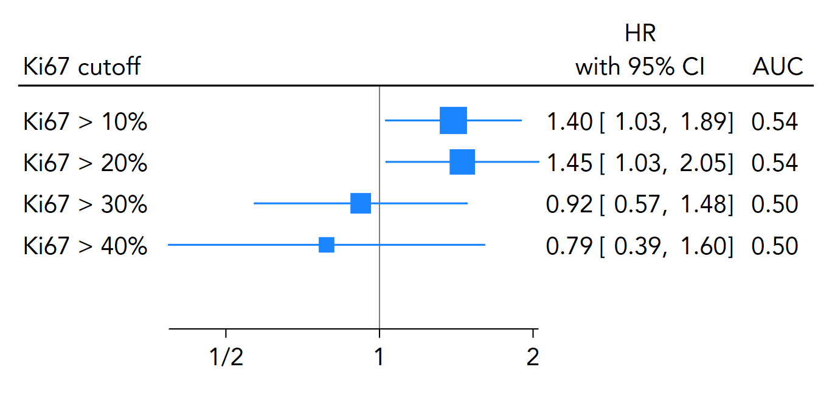
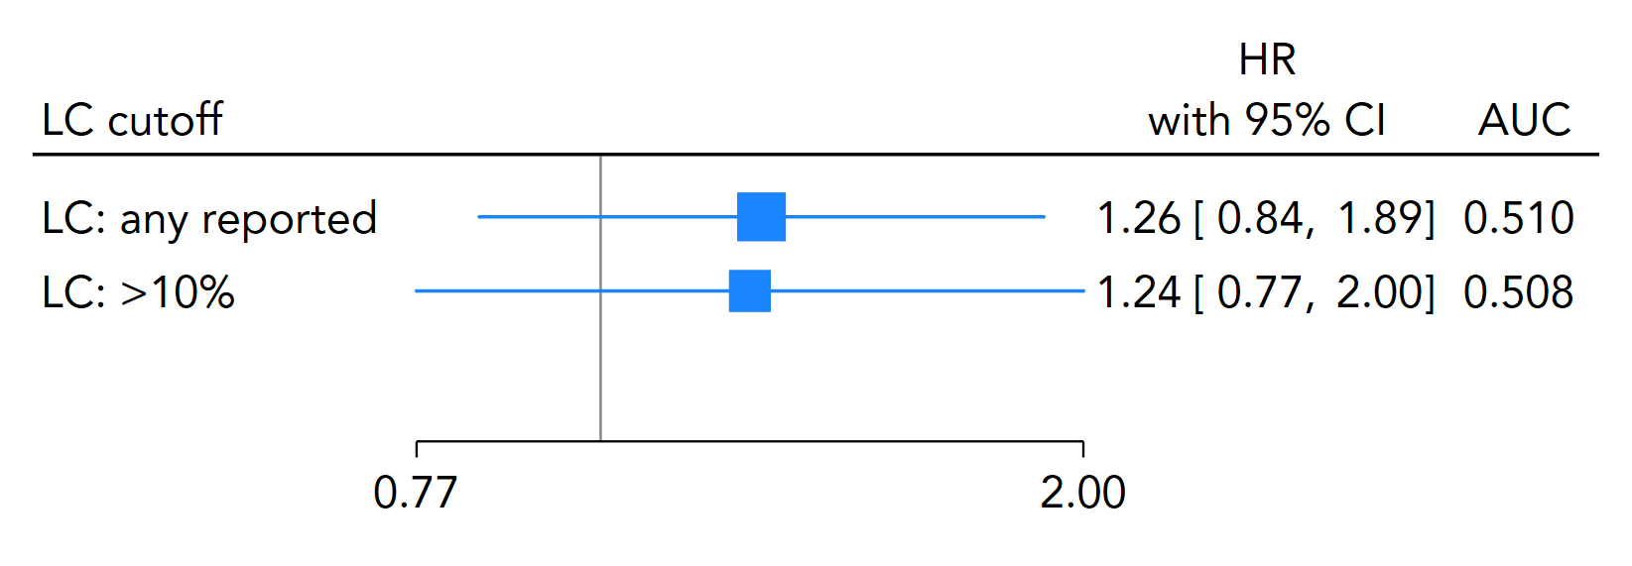

Figure S2. PFS and OS from the start of systemic therapy based on the presence of large cells. P-values are from log-rank tests.
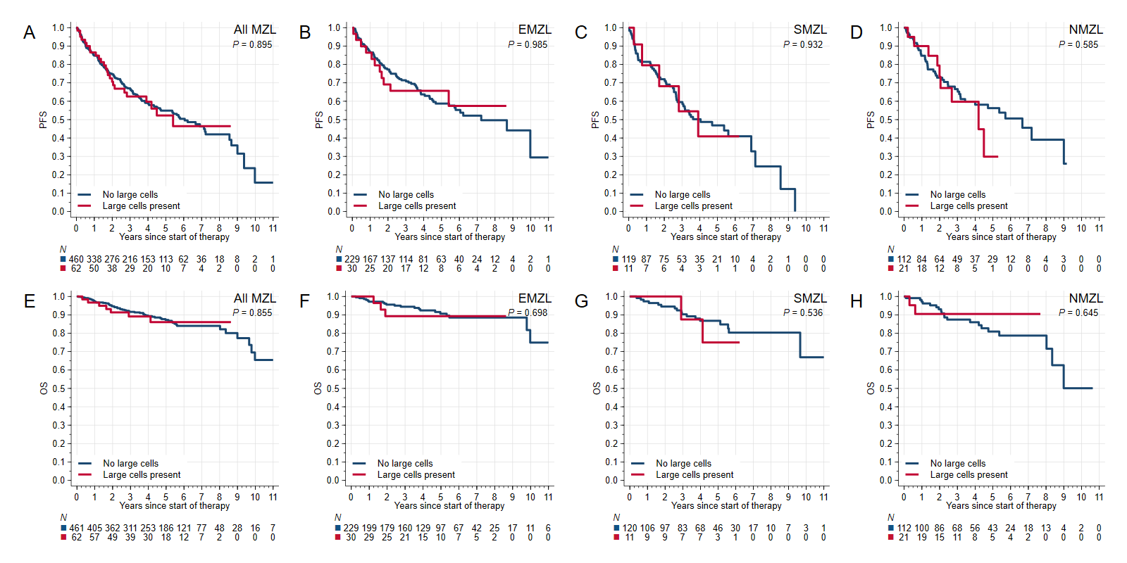
Figure S3. PFS and OS from start of Radiation/Surgery for Stage 1 MALT patients based on presence of large cells
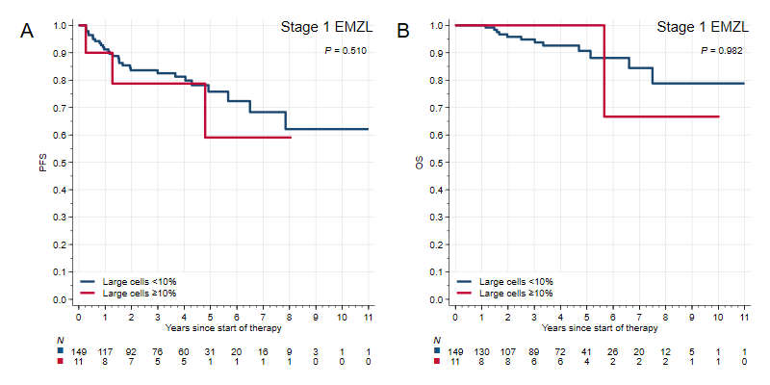

Figure S4. PFS and OS for R-CHOP vs. BR/R-CVP in patients with MZL with large cells
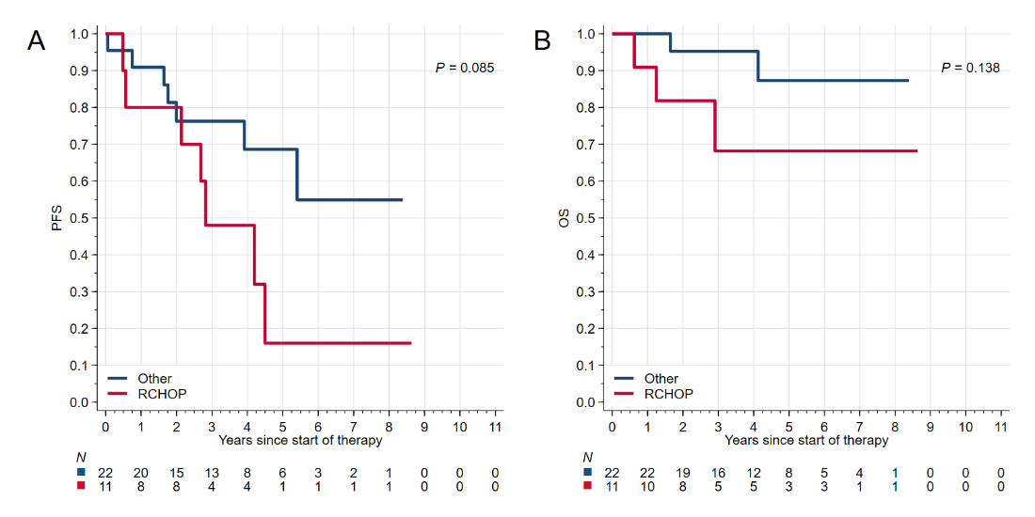

Figure S5. PFS and OS from diagnosis based on the presence of large cells >10%.
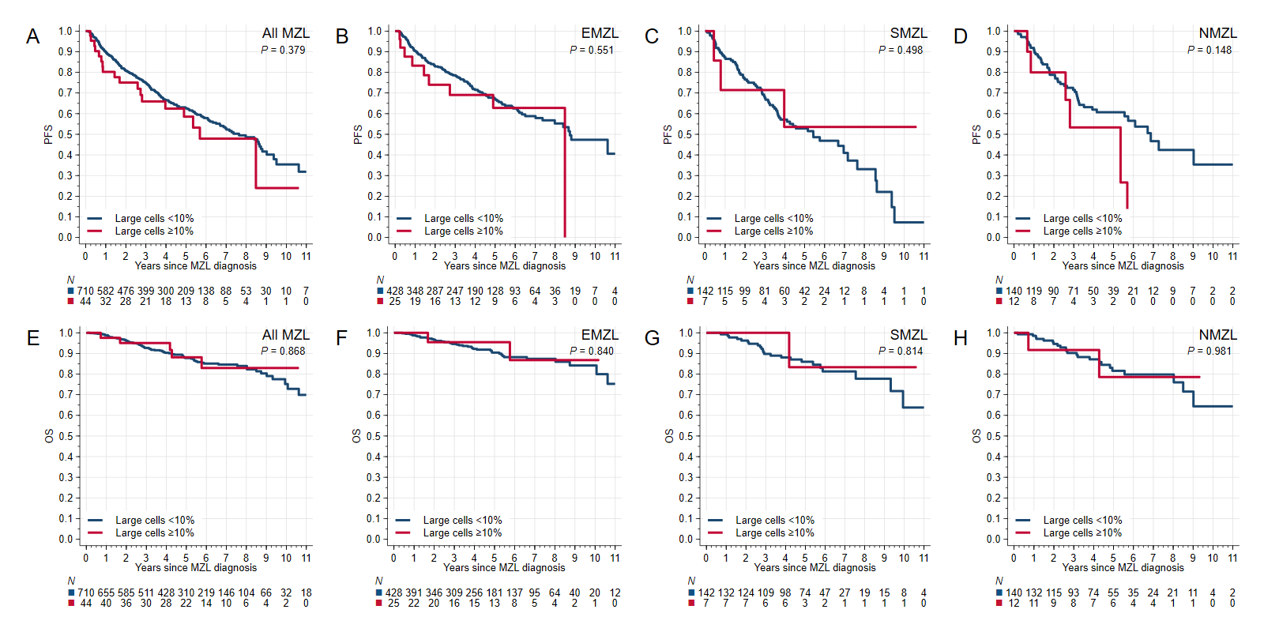

Figure S6. PFS and OS from the start of systemic therapy based on Ki67 Percentage
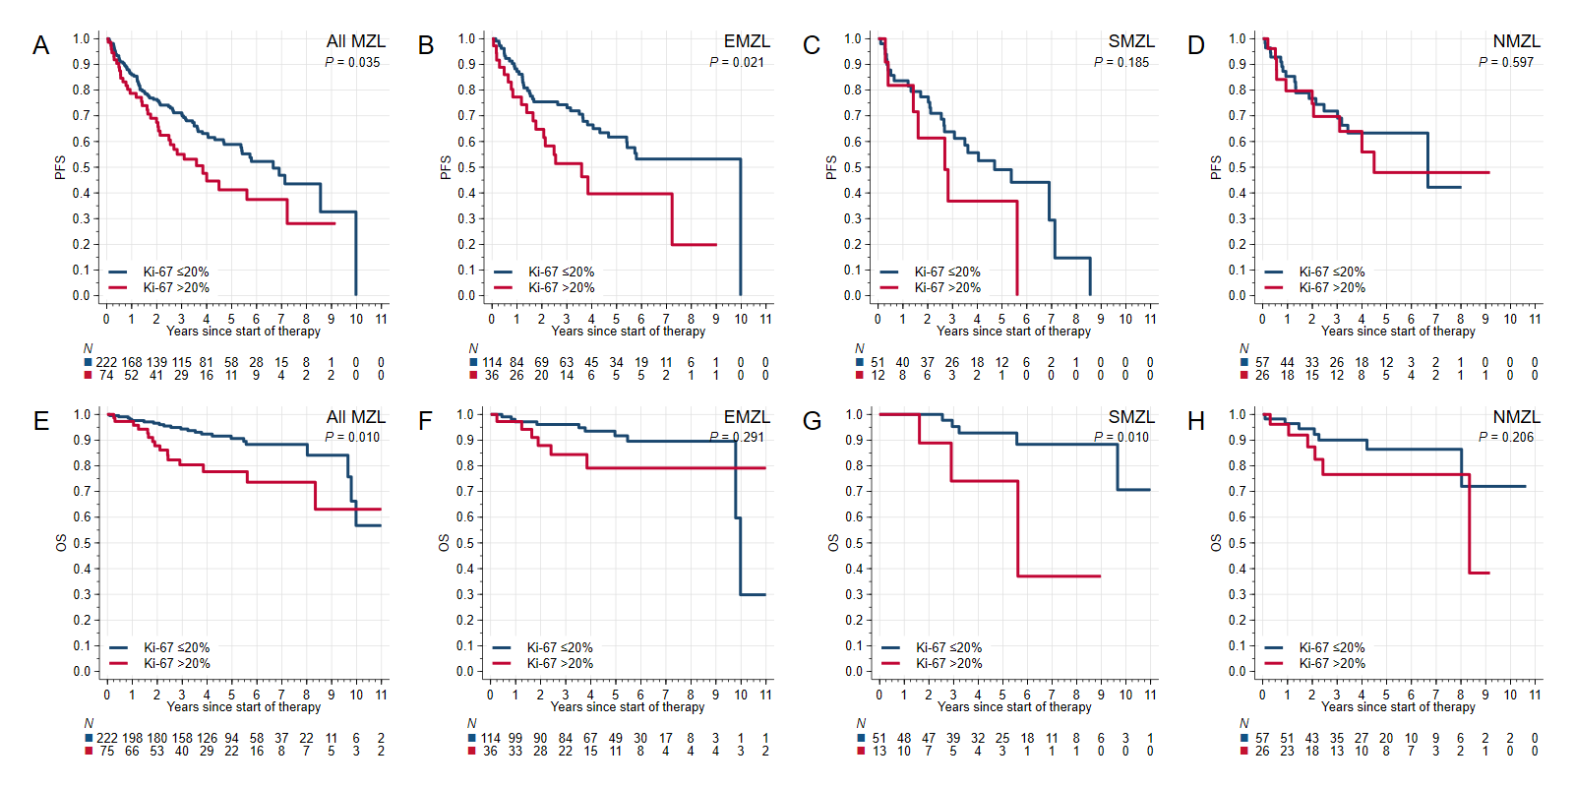

Figure S7. PFS and OS from the start of Radiation/Surgery for stage 1 MALT patients based on Ki67%
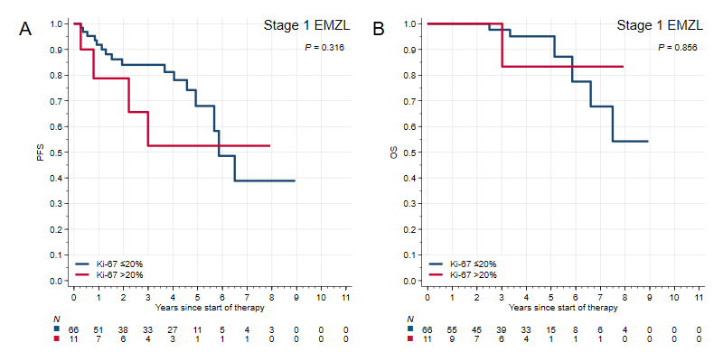

Figure S8. PFS and OS for R-CHOP vs BR/R-CVP in patients with MZL with Ki67 >20%
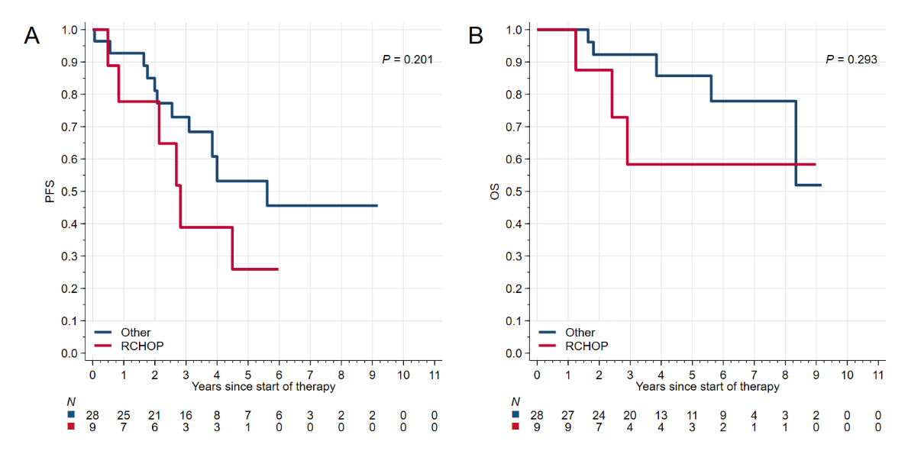

Figure S9. Association between presence of large cells or high Ki-67 expression and the risk of histologic transformation in histologic subtypes of marginal zone lymphoma.
The subhazard ratios (SHR) and 95 confidence intervals (CI) are derived from univariate Fine-Gray models fitted in subgroups of each MZL subtype. Note that because of lack of transformation events in the SMZL subgroup with reported large cells, estimation of SHR was not possible.
