Supplementary information for
Integration of Clinical Outcomes and Molecular Features in Extramedullary Disease in Multiple Myeloma.

Rie Nakamoto-Matsubara, Valentina Nardi, Nora Horick, Tsuyoshi Fukushima, Ryan S. Han, Rajib Shome, Kiyosumi Ochi, Cristina Panaroni, Keertik Fulzele, Farah Rexha, Andrew R. Branagan, Diana Cirstea, Andrew J. Yee, David T. Scadden, and Noopur S. Raje

Supplementary Figures 1-2.
A
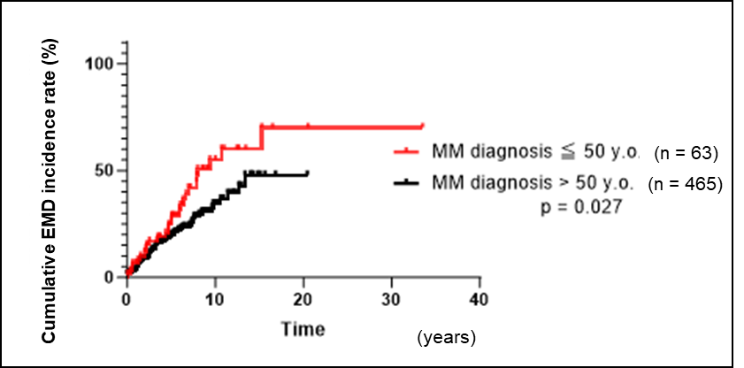
B

Supplementary Figure 1.
A. Overall EMD incidence rate decreases with increasing age of MM diagnosis.
B. Cumulative incidence rate of EMD is higher in patients <50 at the time of MM diagnosis (p = 0.027).

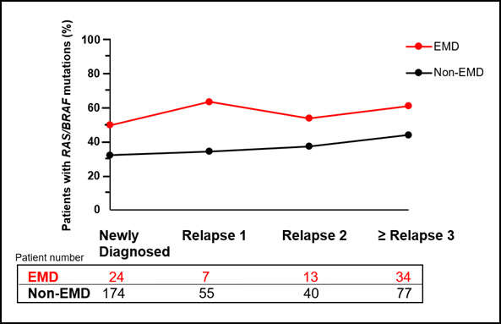
Supplementary Figure 2.
The incidence of BM-RAS/BRAF mutations increases over time in patients with EMD versus non-EMD.

Supplementary Tables 1-3.

Supplementary Table 1.
Targeted gene lists of this study.
The 111 gene targets covered by this test are as follows (exons) between 2019 and 2021: ABL1 (4-10), ALK (22-25), ANKRD26 (1), ARID1A (1-20), ASXL1 (1-12), ATM (1-63), ATRX (8-11,17-32), BCL2 (2), BCOR (2-15), BCORL1 (1-12), BCR (1-5), BIRC3 (2-9), BRAF (3,10-15), BTK (15), CALR (1-9), CARD11 (5-9), CBL (2-5,7-9,16), CBLB (3,9-10), CBLC (9-10), CCND2 (5), CCR4 (2), CD79A (4-5), CD79B (5-6), CDKN2A (1-3), CEBPA (1), CREBBP (1-31), CSF3R (10,14-18), CUX1(1-24), CXCR4 (1-2), DCK(2-3), DDX41 (1-17), DHX15 (3), DNM2 (17,19), DNMT3A (1-23), EP300 (1-31), ETNK1 (3), ETV6 (1-8), EZH2 (2-20), FBXW7(1-11), FLT3 (8-17,19-21), FOXO1 (1), GATA1 (2), GATA2 (2-6), GNAS (8-11), HRAS (2-4), IDH1 (3-4), IDH2 (4,6), IKZF1 (2-6, del 1-3), IKZF3 (5,8), JAK1 (14-16), JAK2 (12-16,19-25), JAK3 (3,11,13,15,18,19), KDM5A (8,11,13-14,18,21,23,25), KDM6A (1-29), KIT (1-2,5,8-15,17,18), KLF2 (1-3), KMT2A (1-36), KMT2C (14,25,27,36,38,43-44,55), KMT2D (8,11,15,31,34,39,44,53), KMT2E (14-15,21), KRAS (2-4), LUC7L2 (1-10), MAP2K1 (1-11), MEF2B (1-2), MPL (10,12), MYC (1-3), MYD88 (3-5), NF1 (1-57), NFKBIE (1), NOTCH1 (UTR,26-28,34), NOTCH2 (34), NPM1 (11), NRAS (2-5), NT5C2 (9,11,13,15,17-19), PDGFRA (12,14,15,18), PHF6 (2-10), PLCG2 (19,24), PML (1-9), PPM1D (6), PRPF40B (1-26), PTEN (1-9), PTPN11 (3-4,7-8,11-13), RAD21 (2-14), RARA (5-7,9), RB1 (1-27), RBBP6 (16,18), RHOA (2), RPS15 (4), RUNX1 (2-9), SETBP1 (4), SETD2 (1-21), SF3B1 (13-21), SH2B3 (2-8), SLC29A1 (4,13), SMC1A (1-25), SMC3 (10,13,19,23,25,28), SRC (10), SRSF2 (1-2), STAG2 (2-33), STAT3 (2-24), STAT5B (15-17), STAT6 (5,12), TET2 (3-11), TNFAIP3 (1-9), TNFRSF14 (1-6), TP53 (1-11), U2AF1 (2,6-7), U2AF2 (1-12), WT1 (1-9), XPO1 (15-16,18), ZRSR2 (1-11).

The 91 gene targets covered by this test are as follows (exons) between 2014 and 2019:
ABL1 (4-7), AKT1 (3,6), ALK (21-23,25), APC (16), ARID1A (1-20), ATM (1-63), ATRX (1-35), AURKA (2,5-8), BRAF (11,15), BRCA1 (2-23), BRCA2 (2-27), CCNE1 (3-8,10,12), CDH1 (1-16), CDK4 (2-7), CDKN2A (1-3), CIC (1-20), CSF1R (7,22), CTNNB1 (3), DAXX (1-8), DDR2 (12-18), DDX3X (1-17), EGFR (3,7,15,18-21), ERBB2 (8,10,19-21,24), ERBB3 (2-3,7-8), ERBB4 (3-4,6-9,15,23), ESR1 (8), EZH2 (16), FBXW7 (1-11), FGFR1 (4,7-8,13,15,17), FGFR2 (7,9,12,14), FGFR3 (7-9,14-16,18), FLT3 (11,14,16,20), FOXL2 (1), GNA11 (5), GNAQ (4-5), GNAS (6-9), H3F3A (2), HNF1A (3-4), HRAS (2-3), IDH1 (3-4), IDH2 (4), JAK2 (11,13-14,16,19), JAK3 (4,13,16), KDR (6-7,11,19,21,26-27,30), KEAP1 (2-6), KIT (2,8-11,13-15,17-18), KRAS (2-5), MAP2K1 (2,3,6-7), MAP3K1 (1-20), MDM2 (2-4,6,8,10), MEN1 (2-10), MET (2,11,14,16,19,21), MLH1 (12), MPL (10), MSH6 (1-10), MSI, MYC (1-3), MYCN (3), NF1 (1-58), NF2 (1-15), NOTCH1 (25-27,34), NPM1 (11), NRAS (2-5), PIK3CA (2,5,7-8,10,14,19,21), PIK3R1 (1-10), POLE (9-14), PTCH1 (1-23), PTEN (1-9), PTPN11 (3,13), RB1 (1-27), RET (10-11,13-16), RHOA (2-3), RNF43 (2-10), ROS1 (38), SDHB (1-8), SMAD2 (7), SMAD4 (2-12), SMARCA4 (3-36), SMARCB1 (2,4,5,9), SMO (3,5-6,9,11), SRC (14), STAG2 (3-34), STK11 (1-9), SUFU (1-12), TERT (1), TP53 (1-11), TP63 (1-14),
TSC1 (3-23), TSC2 (2-42), TSHR (10), VHL (1-3).

Supplementary Table 2.
Fluorescence in situ hybridization (FISH) probes used in this study.
1p36.3 (TP73), 1q22 or 1p36.3 (TP73), 1q21 (CKS1B)
3CEN (D3Z1), 7CEN (D7Z1)
4p16.3 (FGFR), 14q32(IGH)
6p21(CCND3), 14q32 (IGH)
8q24 (5’MYC, 3’MYC)
9CEN (D9Z1), 15CEN (D15Z4),
11q13 (CCND1-XT), 14q32 (IGH-XT)
13q14 (RB1), 13q34 (LAMP1)
14q32 (3’IGH, 5’IGH),
14q32 (IGH), 16q23 (MAF),
14q32(IGH), 20q12(MAFB),
17p13.1 (TP53), 17CEN (D17Z1)

Supplementary Table 3.
Treatment data of our cohort.
We have analyzed all treatments received. For EMD patients, we included only treatments received prior to the development of EMD. Among 528 patients, 498 received chemotherapy including novel drugs (immunomodulatory drugs, proteasome inhibitors, steroids, and monoclonal antibodies) as part of various combination therapies. A total of 30 patients did not receive treatment; seven EMD patients had EMD at the time of diagnosis of MM and 23 non-EMD patients did not receive therapy during their follow-up at our hospital and were referred to local hospitals for treatment (Supplementary Table 3A).
B-cell maturation antigen-targeted Chimeric antigen receptor T-cell therapy (CAR-T) and autologous peripheral blood stem cell transplant (aPBSCT) were performed on 31 and 183 patients, respectively (Supplementary Tables 3B, 3C). The incidence of EMD was higher in patients who underwent aPBSCT (p < 0.01). Since not all patients met the eligibility criteria for aPBSCT, we divided those patients into two groups based on age of MM diagnosis, as age is one of the factors influencing eligibility for aPBSCT and our data in Supplementary Figure 1A has shown negative correlation between the incidence of EMD and age of MM diagnosis. Regarding EMD and aPBSCT, we did not find a statistically significant difference in those 63 patients who were diagnosed with MM at age ≤ 50 (Supplementary Table 3D), but did find a significant difference only in 465 patients diagnosed at age > 50, whose cohort shows a difference in median age of MM diagnosis (Supplementary Table 3E). The findings in Supplementary Tables 3C and 3E cannot rule out the influence of age of MM diagnosis as a factor independent of aPBSCT. Considering that there are several eligibility criteria for aPBSCT and CAR-T treatments, and not all patients meet these criteria, along with the variability in follow-up periods, we think this discussion can only be appropriately addressed through a prospective study.

A. Chemotherapy (n = 528)
 | Chemo+ | Chemo-
EMD | 107 | 7 | 114
Non-EMD | 392 | 23 | 414
 | 498 | 30 | 528
EMD incidence rate 27.30% 23.33% p = 0.820

- CAR-T therapy (n = 528)
 | CART+ | CART-
EMD | 8 | 106 | 114
Non-EMD | 23 | 391 | 414
 | 31 | 497 | 528
EMD incidence rate 25.80% 21.33% p = 0.508

- aPBSCT (n = 528)
 | aPBSCT+ | aPBSCT-
EMD | 54 | 60 | 114
Non-EMD | 129 | 285 | 414
 | 183 | 345 | 528
EMD incidence rate 29.51% 17.39% p < 0.01
Median age of MM diagnosis 58 69 p < 0.0001

- aPBSCT (Age of MM diagnosis ≤ 50) (n = 63)
 | aPBSCT+ | aPBSCT-
EMD | 19 | 8 | 27
Non-EMD | 25 | 11 | 36
 | 44 | 19 | 63
EMD incidence rate 43.18% 42.11% p > 0.9999
Median age of MM diagnosis 48 46 p = 0.7220

- aPBSCT (Age of MM diagnosis > 50) (n = 465)
 | aPBSCT+ | aPBSCT-
EMD | 35 | 52 | 87
Non-EMD | 104 | 274 | 278
 | 139 | 326 | 465
EMD incidence rate 25.18% 16.00% p = 0.0267
Median age of MM diagnosis 60 69 p < 0.0001

