Supplementary Table 1: Carfilzomib prescribing patterns in myeloma trials

Trial | Active arm treatment | Carfilzomib prescribing pattern
PX-171-003 [1] | Single agent carfilzomib | 27 mg/m² twice weekly
ASPIRE [2] | Carfilzomib with lenalidomide and dexamethasone | 27 mg/m² twice weekly
ENDEAVOR [3] | Carfilzomib with dexamethasone | 56 mg/m² twice weekly
CHAMPION-1 [4] | Carfilzomib with dexamethasone | 45, 56, 70, or 88 mg/m² once weekly (dose escalation study)
ARROW [5] | Carfilzomib with dexamethasone | 70 mg/m² once weekly vs 27 mg/m² twice weekly
ARROW2 [6] | Carfilzomib with lenalidomide and dexamethasone | 56 mg/m² once weekly vs 27 mg/m² twice weekly
CANDOR [7] | Carfilzomib with daratumumab and dexamethasone | 56 mg/m² twice weekly
IKEMA [8] | Carfilzomib with isatuximab and dexamethasone | 56 mg/m² twice weekly

All carfilzomib dosing started at test dose of 20 mg/m² before dose escalation, either on day 8 of cycle 1 or day 1 of cycle 2.

Once-weekly dosing was administered on days 1, 8, and 15 of a 28-day cycle. Twice-weekly dosing was administered on days 1, 2, 8, 9, 15, and 16 of a 28-day cycle.

Abbreviations: mg/m2, milligrams per meter squared.

[1] Siegel DS, Martin T, Wang M, Vij R, Jakubowiak AJ, Lonial S, et al. A phase 2 study of single-agent carfilzomib (PX-171-003-A1) in patients with relapsed and refractory multiple myeloma. Blood. 2012 Oct 4;120(14):2817-25.
[2] Stewart AK, Rajkumar SV, Dimopoulos MA, Masszi T, Špička I, Oriol A, et al. Carfilzomib, lenalidomide, and dexamethasone for relapsed multiple myeloma. N Engl J Med. 2015 Jan 8;372(2):142-52.
[3] Dimopoulos MA, Moreau P, Palumbo A, Joshua D, Pour L, Hájek R, et al. Carfilzomib and dexamethasone versus bortezomib and dexamethasone for patients with relapsed or refractory multiple myeloma (ENDEAVOR): a randomised, phase 3, open-label, multicentre study. Lancet Oncol. 2016 Jan;17(1):27-38.
[4] Berenson JR, Cartmell A, Bessudo A, Lyons RM, Harb W, Tzachanis D, et al. CHAMPION-1: a phase 1/2 study of once-weekly carfilzomib and dexamethasone for relapsed or refractory multiple myeloma. Blood. 2016 Jun 30;127(26):3360-8.
[5] Moreau P, Mateos MV, Berenson JR, Weisel K, Lazzaro A, Song K, et al. Once weekly versus twice weekly carfilzomib dosing in patients with relapsed and refractory multiple myeloma (A.R.R.O.W.): interim analysis results of a randomised, phase 3 study. Lancet Oncol. 2018 Jul;19(7):953-964.
[6] Dimopoulos MA, Coriu D, Delimpasi S, Spicka I, Upchurch TE, Fang B, et al. A.R.R.O.W.2: Once- vs twice-weekly carfilzomib, lenalidomide, and dexamethasone in relapsed/refractory multiple myeloma. Blood Adv. 2024:doi: 10.1182/bloodadvances.2024013101. Online ahead of print.
[7] Dimopoulos M, Quach H, Mateos MV, Landgren O, Leleu X, Siegel D, et al. Carfilzomib, dexamethasone, and daratumumab versus carfilzomib and dexamethasone for patients with relapsed or refractory multiple myeloma (CANDOR): results from a randomised, multicentre, open-label, phase 3 study. Lancet. 2020 Jul 18;396(10245):186-197.
[8] Moreau P, Dimopoulos MA, Mikhael J, Yong K, Capra M, Facon T, et al. Isatuximab, carfilzomib, and dexamethasone in relapsed multiple myeloma (IKEMA): a multicentre, open-label, randomised phase 3 trial. Lancet. 2021 Jun 19;397(10292):2361-2371.
Supplementary Figure 1: Trends in Carfilzomib Usage Over Time in RRMM

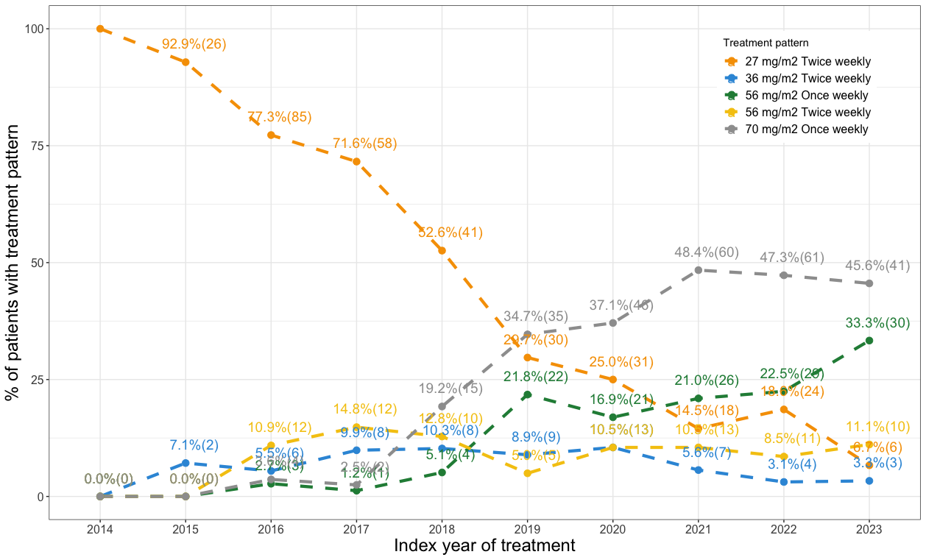

Abbreviations: mg/m2, milligrams per meter squared.

Supplemental Figure 2: Carfilzomib Prescribing Patterns based on Line of Therapy

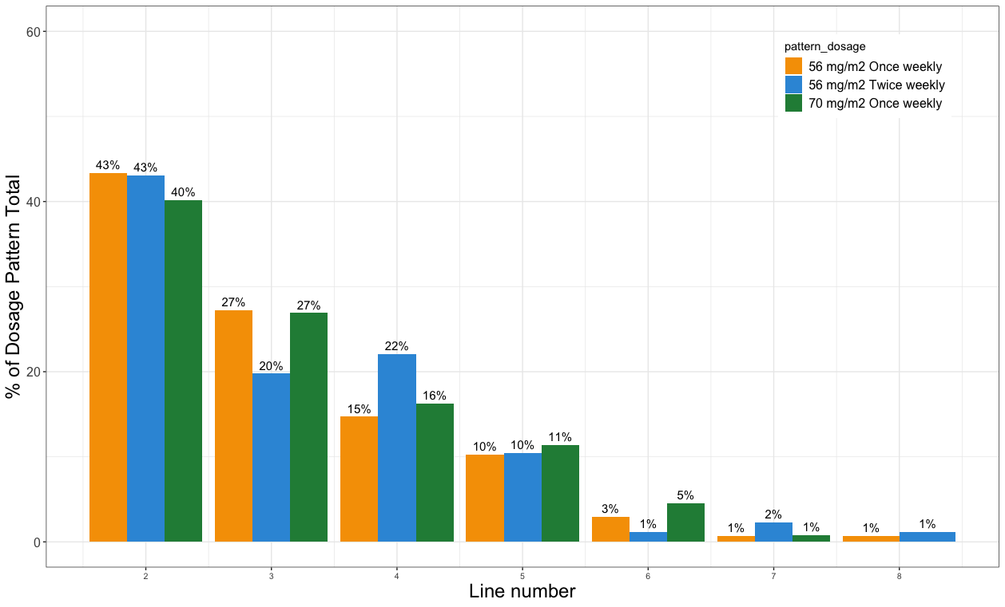
Abbreviations: mg/m2, milligrams per meter squared.

