Figure S1. Alluvial plot of nodal and extra-nodal disease involvement before and after apheresis in patients receiving systemic bridging therapy.
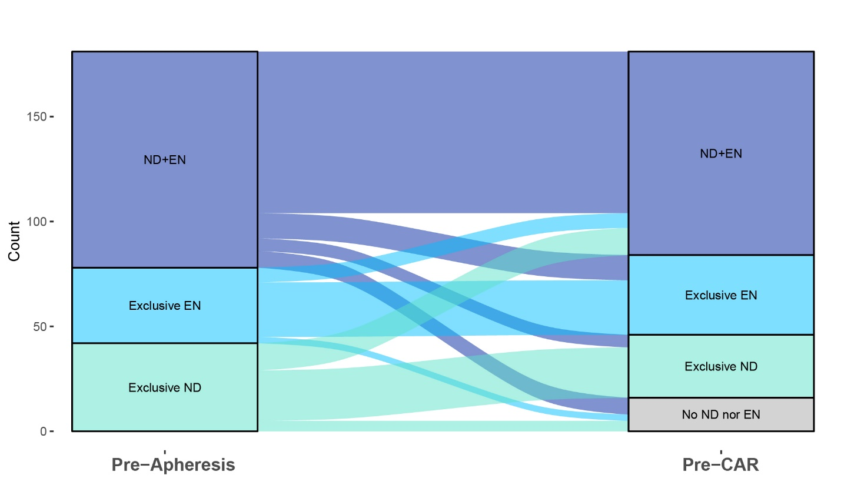
Nodal disease (ND); Extranodal disease (EN), concomitant nodal and extranodal disease (ND+EN).

Figure S2. Genomic landscape of LBCL by extranodal disease involvement before apheresis.
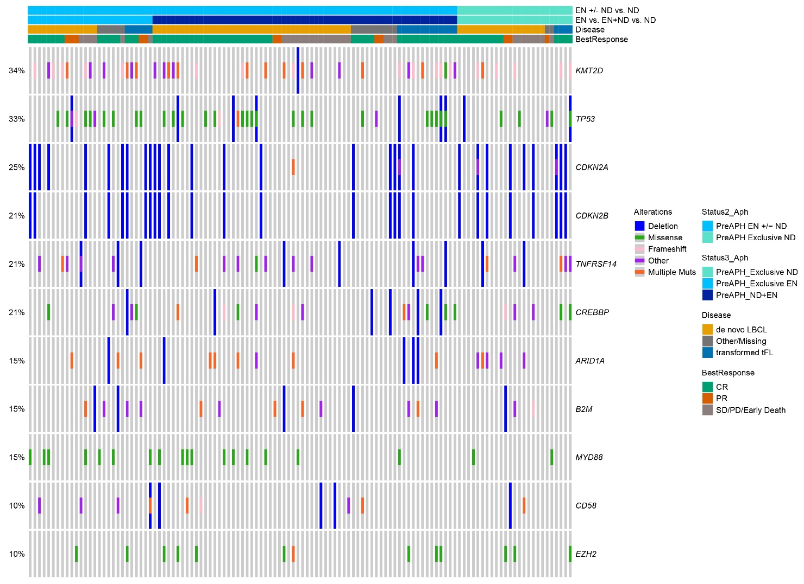

LBCL: Large B-cell Lymphoma, tFL: transformed follicular lymphoma. CR: complete response. PR: partial response. SD: stable disease. PD: progressive disease.
Table S1. Commonly altered genes by EN status before apheresis.
Gene altered | Overall patients evaluable (n=118) | Any EN disease (n=93) | Exclusive ND disease (n=25) | p-value² | q-value³
KMT2D | 43 (36%) | 37 (40%) | 6 (24%) | 0.15 | 0.6
TP53 | 41 (35%) | 35 (38%) | 6 (24%) | 0.2 | 0.6
CDKN2A | 31 (26%) | 22 (24%) | 9 (36%) | 0.2 | 0.6
CDKN2B | 27 (23%) | 19 (20%) | 8 (32%) | 0.2 | 0.6
TNFRSF14 | 27 (23%) | 20 (22%) | 7 (28%) | 0.5 | 0.9
CREBBP | 26 (22%) | 21 (23%) | 5 (20%) | 0.8 | 0.9
ARID1A | 19 (16%) | 14 (15%) | 5 (20%) | 0.5 | 0.9
B2M | 19 (16%) | 16 (17%) | 3 (12%) | 0.8 | 0.9
MYD88 | 19 (16%) | 17 (18%) | 2 (8.0%) | 0.4 | 0.8
CD58 | 13 (11%) | 11 (12%) | 2 (8.0%) | 0.7 | 0.9
EZH2 | 13 (11%) | 10 (11%) | 3 (12%) | >0.9 | >0.9

1. Pearson's chi-squared test; Fisher's exact test; 2. False discovery rate correction for multiple testing.

Table S2. Outcomes at two years after infusion by number of extranodal lesions determined at last assessment before CAR-T infusion.
Outcome | 1 EN site | 2 EN sites | 3 or more EN sites | p-value
PFS-2 years | 53% (41%, 70%) | 49% )31%,75%) | 26% (17%, 41%) | 0.003¹
OS-2 years | 55% (42%, 71%) | 56% (40%, 79%) | 34% (24%, 47%) | 0.016¹
Relapse-2 years | 53% (39%, 65%) | 67% (41%, 83%) | 75% (63%, 83%) | 0.024²

1. Log-rank test; 2. Gray’s test

Table S3. Association between the number of extranodal disease sites before CAR-T therapy and treatment outcome in multivariable regression models¹.
Number of Extranodal sites | Not achieving a CR | PFS | OS | Relapse
1 site | Reference | Reference | Reference | Reference
2 site | OR 0.70 (0.27-1.76, p=0.5) | HR 1.38 (0.80-2.38 , p=0.2) | HR 1.10 (0.56-2.18, p=0.8) | HR 1.36 (0.77-2.42, p=0.3)
3 or more sites | OR 2.39 (1.18-4.96, p=0.017) | HR 1.66 (1.07-2.57, p=0.023). | HR 1.77 (1.08-2.89, p=0.024) | HR 1.76 (1.12-2.76, p=0.015_

1. Multivariable regression models (logistic regression for CR and Cox regression for the remaining outcomes) were adjusted for age, transformed lymphoma, pre-lymphodepletion LDH, bridging, and CAR-T product.

Table S4. Bridging therapies by extranodal status.
Type of bridging | Exclusive ND | Exclusive EN | ND+EN | No evidence of disease (CR)
Polatuzumab-based | 17 (27%) | 18 (27%) | 35 (26%) | 7 (35%)
Intensive chemotherapy | 7 (11%) | 10 (15%) | 33 (25%) | 7 (35%)
Radiotherapy | 17 (27%) | 14 (21%) | 15 (11%) | 2 (10%)
Steroids monotherapy | 1 (1.6%) | 1 (1.5%) | 8 (6.0%) | 0 (0%)
Other categories | 5 (7.8%) | 12(18.2%) | 24 (18%) | 2 (10%)

