Supplemental table 1. Biological Markers
Characteristic | N | Overall¹ | Single lesion¹ | Multifocal¹
 |  | N = 44 | N = 31 | N = 13
Cell of origin  Non-GCB  GCB  Unknown | 36 | 26 (72%)  10 (28%)  8 | 16 (70%)  7 (30%)  8 | 10 (77%)  3 (23%)  0
BCL2 expression  Unknown | 39 | 33 (85%)  5 | 23 (82%)  3 | 10 (91%)  2
BCL6 expression  Unknown | 36 | 30 (83%)  8 | 21 (84%)  6 | 9 (82%)  2
MUM1 expression  Unknown | 34 | 29 (85%)  10 | 17 (81%)  10 | 12 (92%)  0
CD10 expression  Unknown | 39 | 3 (8%)  5 | 1 (4%)  3 | 2 (18%)  2
Ki67%  Unknown | 28 | 85 (70, 95)  16 | 85 (70, 90)  14 | 90 (75, 95)  2

Abbreviations: GCB, germinal center B-cell type
¹ Values reported as n (%) or median (range)

Supplemental Table 2. Response rates by treatment groups
Characteristic | Overall¹ | Radiation therapy¹ | Chemotherapy¹ | Chemotherapy + radiation¹ | P-value² | Other
 | N = 44 | N = 11 | N = 15 | N = 15 |  | N = 3
Response rates |  |  |  |  | 0.3
CR | 37 (84%) | 9 (82%) | 12 (80%) | 15 (100%) |  | 1 (33%)
PR | 1 (2%) | 0 (0%) | 1 (7%) | 0 (0%) |  | 0 (0%)
SD | 1 (2%) | 0 (0%) | 0 (0%) | 0 (0%) |  | 1 (33%)
PD | 5 (11%) | 2 (18%) | 2 (13%) | 0 (0%) |  | 1 (33%)

Abbreviations: CR, complete remission; PR, partial remission; PD, progressive disease
¹ Values reported as n (%)
² Statistical analysis performed using Fisher exact test.
The p-value indicates that there is no statistically significant difference in response rates among the radiation therapy, chemotherapy, and combined chemotherapy plus radiation groups.

Supplemental Table 3. Response rates by number of lesions
Characteristic | Overall¹ | Single Lesion¹ | Multifocal¹ | P-value
 | N = 44 | N = 31 | N = 13
Response rates |  |  |  | 0.4
CR | 37 (84%) | 27 (87%) | 10 (77%)
PR | 1 (2%) | 1 (3%) | 0 (0%)
SD | 1 (2%) | 0 (0%) | 1 (8%)
PD | 5 (11%) | 3 (10%) | 2 (15%)

Abbreviations: CR, complete remission; PR, partial remission ; SD, stable disease ; PD, progressive disease
¹ Values reported as n (%)
² Statistical analysis performed using Fisher exact test
The p-value indicates that there is no statistically significant difference in response rates between the single lesion and the multifocal groups.

Supplemental Table 4. Progression-free survival estimates
Characteristic | N | Events | Median PFS¹ | p-value²
Overall | 43 | 20 | 4.9 (2.6, —)
Treatment group  Radiation therapy  Chemotherapy  Chemo + radiation | 40 | 19 | 1.6 (0.98, —)  4.6 (1.0, —)  8.5 (4.9, —) | 0.13
Number of lesions  Single lesion  Multifocal | 43 | 20 | 4.9 (1.7, —)  4.6 (2.0, —) | 0.8

¹ Values reported as years (95% CI)
² Statistical analysis performed using log-rank test

Supplemental Table 5. Overall survival estimates
Characteristic | N | Events | Median OS¹ | p-value²
Overall | 44 | 18 | 9.9 (4.6, —)
Treatment group  Radiation therapy  Chemotherapy  Chemo + radiation | 41 | 16 | 9.9 (2.6, —)  9.9 (3.0, —)  14 (14, —) | 0.051
Number of lesions  Single lesion  Multifocal | 44 | 18 | 14 (9.9, —)  4.6 (2.6, —) | 0.11

¹ Values reported as years (95% CI)
² Statistical analysis performed using log-rank test

Supplemental Figure 1. Time to Event Analyses
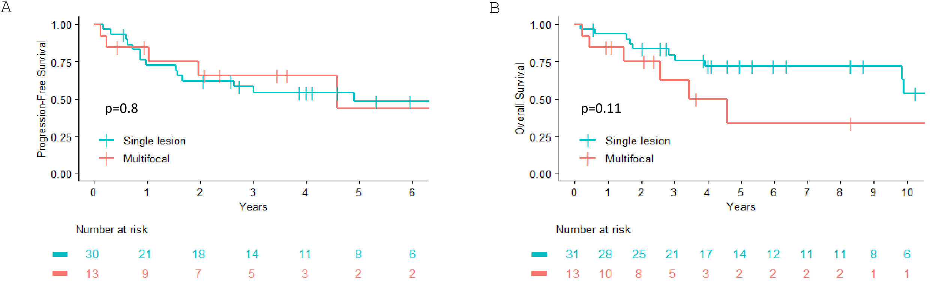

Time-to-event outcomes. A: Progression-free survival based on single versus multifocal disease. B: Overall Survival based on single versus multifocal disease.

Supplemental Figure 2. Cumulative incidence of central nervous system relapse
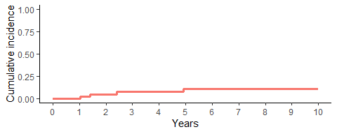
Central nervous System Relapse Estimate: 0.07 (95%CI, 0.02-0.22) at 3 years and 0.11 (95%CI, 0.04-0.29) at 5 years.

