SUPPLEMENTARY MATERIAL

Supplementary Figures

- Supplementary Fig. 1: Patient Flow Diagram
- Supplementary Fig. 2: Progression-Free Survival (PFS) and Overall Survival (OS) in patient subgroups by bridging therapy and disease status prior to lymphodepleting chemotherapy

Supplementary Tables

- Supplementary Table 1: Type of prior BCMA-directed therapies and efficacy outcomes of ciltacabtagene autoleucel in BCMA-exposed patients
- Supplementary Table 2: Bridging therapy in patients receiving ciltacabtagene autoleucel

- Supplementary Table 3: Multivariable analysis for factors impacting development of cytokine release syndrome (CRS) grade ≥ 2 following ciltacabtagene autoleucel

- Supplementary Table 4: Multivariable analysis for factors impacting development of any grade immune effector cell-associated neurotoxicity syndrome (ICANS) following ciltacabtagene autoleucel

- Supplementary Table 5: Safety outcomes including non-ICANS neurologic toxicity (NINT), second primary malignancies (SPM), and cause of death in patients receiving ciltacabtagene autoleucel

- Supplementary Table 6: Overall response rate (ORR) and complete response (CR) rates in patient subgroups receiving ciltacabtagene autoleucel

- Supplementary Table 7: Multivariable analysis for factors impacting complete response (CR) rates following ciltacabtagene autoleucel

Supplementary Fig. 1: Patient Flow Diagram

Study Population: Number of patients treated with commercial ciltacabtagene autoleucel in the United States registered in the CIBMTR database
Infused with ciltacabtagene autoleucel in specification and have at least one follow-up at day 100 or earlier if patient expired prior to day 100
Total Cohort, N=595
Safety, N=595
Responses, N=573 (excluding patients in ≥ CR prior to infusion)
PFS, N=595
OS, N=595

Median follow-up: 12.0 months (range, 1.1-25.4)

Abbreviations: CIBMTR: Center for International Blood and Marrow Transplant Research. CR: complete response. PFS: progression-free survival. OS: overall survival.

Supplementary Fig. 2: PFS and OS in patient subgroups by bridging therapy (A&B) and disease status prior to lymphodepletion (C&D)
A

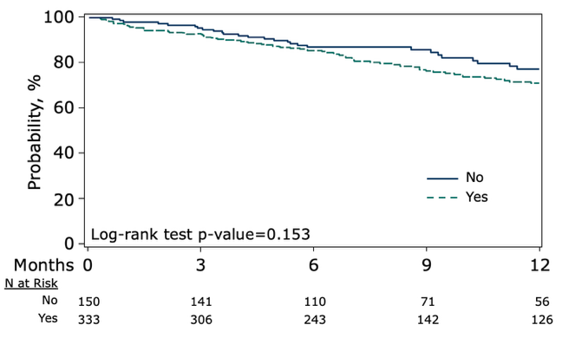
12-month PFS (95% CI): 77% (69-85)
vs 71% (65-77)
D
B
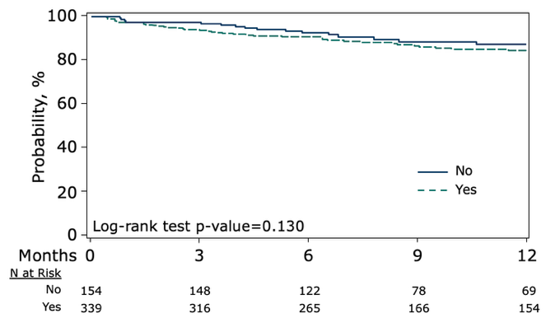
12-month OS (95% CI): 87% (81-93)
vs 85% (80-89)

C
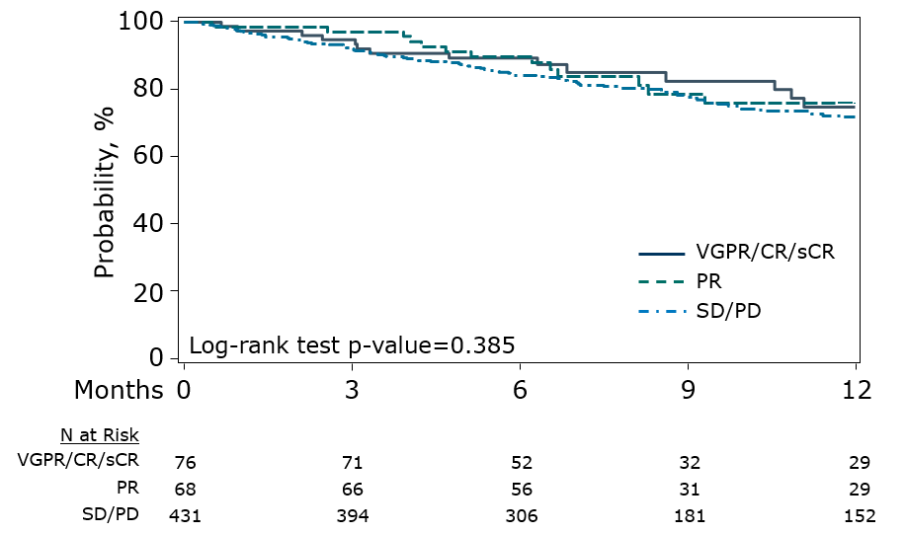
12-month PFS (95% CI): 75% (62-86)
vs 76% (63-87) vs 72% (66-77)

D
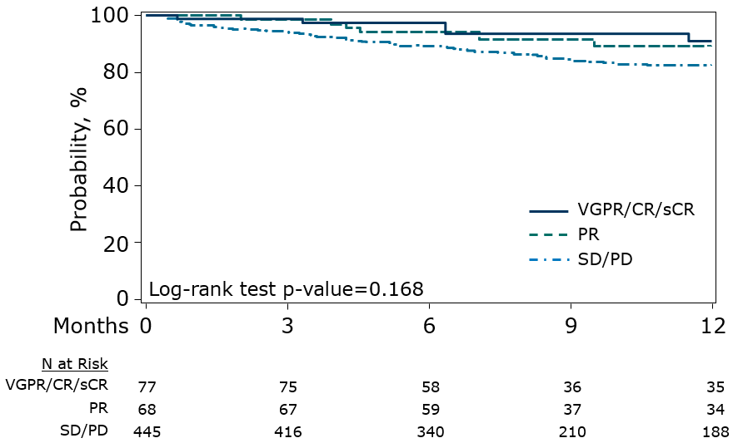
12-month (95% CI): 91% (82-97)
vs 89% (79-96) vs 83% (78-86)

Abbreviations: PFS: progression-free survival, OS: overall survival, CR: complete response, PR: partial response, PD: progressive disease, VGPR: very good partial response, sCR: stringent complete response, SD: stable disease.

Supplementary Table 1: Type of prior BCMA therapies and efficacy outcomes of ciltacabtagene autoleucel in BCMA-exposed patients
 | N or N(%) or median (range)
Type of prior BCMA Therapy
Prior antibody drug conjugate (ADC) (belantamab mafodotin) | 37 (6)
Prior BCMA bispecific antibody (teclistamab) | 7 (1)
Prior BCMA CAR T-cell therapy* | 3 (0.5)
More than one type of prior BCMA therapy | 1 (0.2)
Efficacy outcomes in patients with prior BCMA therapy exposure
Overall response Rate | 70
Complete Response Rate | 17
12-month PFS estimate, 95% CI | 51 (35 - 67)
12-month OS estimate, 95% CI | 81 (68 - 91)
Abbreviations and definitions: BCMA: B-cell maturation antigen. CAR T-cell therapy: Chimeric antigen receptor T-cell therapy.*Prior CAR-T (n=5) includes bb21217 (n=1), a CD28-based anti-BCMA CAR-T (n=1), an unknown anti-BCMA CAR-T (n=1), a clustered regularly interspaced short palindromic repeats-edited allogeneic anti-BCMA CAR-T (n=1), and anti-G-protein-coupled receptor, class C, group 5, member D (GPRC5D, n=1). PFS: progression-free survival, OS: overall survival.

Supplementary Table 2: Bridging therapy in patients receiving ciltacabtagene autoleucel

 | N (%)
Bridging Therapy Type
Yes | 339 (57)
Radiation therapy given as bridging therapy | 33 (10)
Systemic therapy given as bridging therapy | 330 (55)
Corticosteroids | 168 (50)
Carfilzomib | 125 (37)
Cyclophosphamide | 118 (35)
Pomalidomide | 97 (29)
Daratumumab | 70 (21)
Etoposide | 56 (17)
Bortezomib | 55 (16)
Cisplatin | 52 (15)
Doxorubicin | 35 (10)
Selinexor | 42 (12)
Venetoclax | 24 (7)
VCd(bortezomib-cyclophosphamide-dexamethasone) | 23 (7)
Bendamustine | 15 (4)
Isatuximab | 14 (4)
Elotuzumab | 13 (4)
Ixazomib | 8 (2)
Thalidomide | 7 (2)
Lenalidomide | 6 (2)
KRd (carfilzomib-lenalidomide-dexamethasone) | 6 (2)
Doxorubicin | 5 (1)
Teclistamab | 5 (1)
DVd (daratumumab-bortezomib-dexamethasone) | 4 (1)
Cytarabine | 4 (1)
Belantamab mafodotin | 4 (1)
Carmustine | 1 (0.3)
Clarithromycin | 1 (0.3)
Talquetamab | 1 (0.3)
Other systemic drug(s) | 79 (23)

Supplementary Table 3: Multivariable analysis for cytokine release syndrome (CRS) grade ≥ 2 following ciltacabtagene autoleucel

Parameter | Category | N | OR | 95% CI (lower) | 95% CI (upper) | P-value
Plasma cells in bone marrow ≥ 50% prior to infusion | No | 318 | 1.00 | - | - | -
Plasma cells in bone marrow ≥ 50% prior to infusion | Yes | 54 | 3.80 | 2.05 | 7.03 | <0.0001
Plasma cells in bone marrow ≥ 50% prior to infusion | Unknown | 220 | 1.21 | 0.77 | 1.89 | 0.41

Abbreviations: CI: confidence interval, CRS: cytokine release syndrome, OR: odds ratio.

Supplementary Table 4: Multivariable analysis for any grade immune effector cell-associated neurotoxicity syndrome (ICANS) following ciltacabtagene autoleucel

Parameter | Category | N | OR | 95% CI (lower) | 95% CI (upper) | P-value
Age at infusion | < 60 | 203 | 1.00 | - | - | -
 | 60 to 69 | 256 | 1.14 | 0.70 | 1.84 | 0.60
 | ≥70 | 134 | 1.98 | 1.17 | 3.37 | 0.01
Plasma cells in bone marrow ≥ 50% prior to infusion | No | 319 | 1.00 | - | - | -
 | Yes | 54 | 2.60 | 1.35 | 5.02 | 0.005
 | Unknown | 220 | 1.34 | 0.86 | 2.07 | 0.20
ANC < 750 /uL prior to infusion | No | 555 | 1.00 | - | - | -
 | Yes | 21 | 2.05 | 0.77 | 5.50 | 0.15
 | Unknown | 17 | 3.08 | 1.06 | 8.92 | 0.04
Hemoglobin < 8 g/dL prior to infusion | No | 539 | 1.00 | - | - | -
 | Yes | 54 | 2.54 | 1.37 | 4.73 | 0.003
HCT-CI | 0-1 | 288 | 1.00 | - | - | -
 | ≥2 | 300 | 1.81 | 1.20 | 2.74 | 0.005
 | Unknown | 5 | 2.14 | 0.23 | 19.91 | 0.51

Abbreviations: ANC: absolute neutrophil count, CI: confidence interval, HCT-CI: hematopoietic cell transplantation-specific comorbidity index, ICANS: immune effector cell associated neurotoxicity syndrome, OR: odds ratio.

Supplementary Table 5: Safety outcomes including non-ICANS neurologic toxicity (NINT), second primary malignancies (SPM), and cause of death in patients receiving ciltacabtagene autoleucel

 | N (%) or median (range)
Type of non-ICANS neurotoxicity (NINT)
Cranial nerve palsies | 15 (3)
Seventh cranial nerve palsy | 12/15 (80)
Other motor neuron disorder | 3/15 (20)
Parkinsonism | 16 (2.7)
Median time to onset of seventh nerve palsy | 20 (17-31)
Median time to onset of Parkinsonism | 10 (8-21)
Second primary malignancies (SPM)
Squamous cell skin cancer | 7 (1.2)
Myelodysplastic syndrome | 5 (0.8)
Genitourinary malignancy | 4 (0.7)
Non-Hodgkin’s lymphoma | 2 (0.3)
Basal cell skin cancer | 2 (0.3)
Gastrointestinal malignancy | 2 (0.3)
Lung cancer | 1 (0.2)
Breast cancer | 1 (0.2)
Melanoma | 1 (0.2)
Other malignancy | 2 (0.3)
Cause of death
Myeloma-related | 53 (9)
Infection | 11 (2)
Pulmonary | 4 (0.7)
CRS | 4 (0.7)
ICANS | 2 (0.3)
Multiorgan failure | 2 (0.3)
Second Primary Malignancy, MDS | 2 (0.3)
Cardiac | 1 (0.2)
CNS event/pathology | 1 (0.2)
Intracranial hemorrhage | 1 (0.2)
Gastrointestinal | 1 (0.2)
Unknown | 11 (2)

Abbreviations: CRS: cytokine release syndrome, CNS: central nervous system, ICANS: immune effector cell-associated neurotoxicity syndrome, MDS: myelodysplastic syndrome, NINT: non-immune effector cell-associated neurotoxicity syndrome, SPM: second primary malignancies. Two patients had overlapping attribution to CRS and organ failure.

Supplementary Table 6: Overall response rate (ORR) and complete response (CR) rates in patient subgroups receiving ciltacabtagene autoleucel

 | ORR | CR rate
Age  <70 years  ≥70 years | 88%  85% | 35%  34%
Cytogenetic Risk  High risk  Standard risk | 88%  89% | 31%  38%
Extramedullary Disease  Yes  No | 77%  92% | 40%  38%
ISS stage  Stage I  Stage II  Stage III | 94%  89%  85% | 52%  37%  26%
ECOG PS  0-1  2 or more | 89%  74% | 36%  32%
Lymphodepletion Therapy  Fludarabine and cyclophosphamide  Bendamustine  Others | 91%  80%  86% | 41%  22%  27%
Prior BCMA-directed therapy  No Prior BCMA-directed therapy  Prior BCMA-directed therapy | 91%  70% | 41%  17%

Abbreviation and definitions: BCMA: B-cell maturation antigen, CR: complete response, ECOG PS: Eastern Cooperative Oncology Group performance status. *High-risk cytogenetics: Includes del(17p), t(4;14) and t(14;16). ISS: International Staging System, ORR: overall response rate.

Supplementary Table 7: Multivariable analysis for factors impacting complete response (CR) rates following ciltacabtagene autoleucel

Parameter | Category | N | Odds Ratio | 95% CI (lower) | 95% CI (upper) | P-value
Lymphodepleting chemotherapy | Cyclophosphamide + Fludarabine | 438 | 1.00 | . | . | 0.0098
Lymphodepleting chemotherapy | Bendamustine | 106 | 0.50 | 0.32 | 0.78 | 0.0025
Lymphodepleting chemotherapy | Other | 22 | 0.83 | 0.42 | 1.62 | 0.5815
Race | White | 434 | 1.00 | . | . | 0.0265
 | Black or African American | 84 | 0.58 | 0.37 | 0.92 | 0.0192
 | Other | 24 | 0.76 | 0.36 | 1.63 | 0.4813
 | Not reported | 24 | 1.70 | 0.90 | 3.24 | 0.1039

Abbreviations: CI: confidence interval.

