Supplementary Figures
Supplementary Figure 1A. Post-transplant Progression-free survival (PFS_{HCT}) of patients in complete remission (CR) versus partial remission/stable disease (PR/SD) before transplant
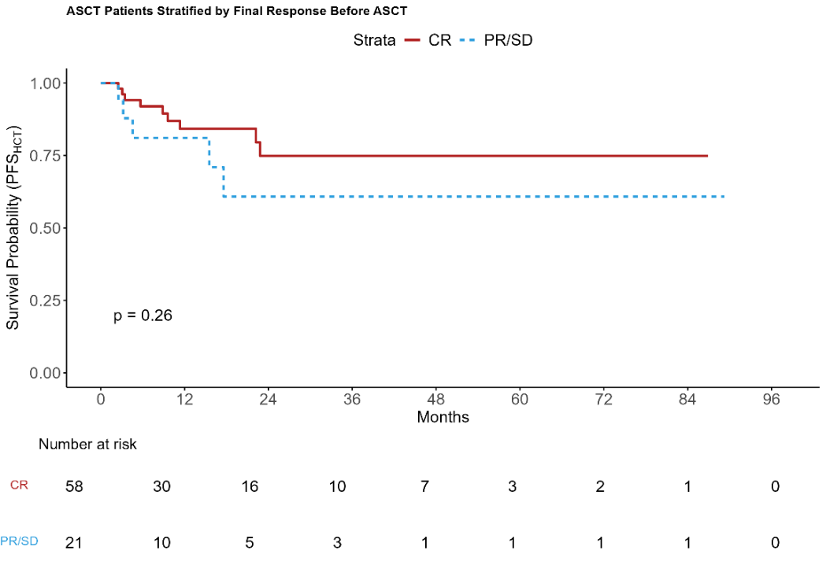

Supplementary Figure 1B. Post-transplant Progression-free survival (PFS_{HCT}) of patients receiving post-transplant maintenance versus no maintenance
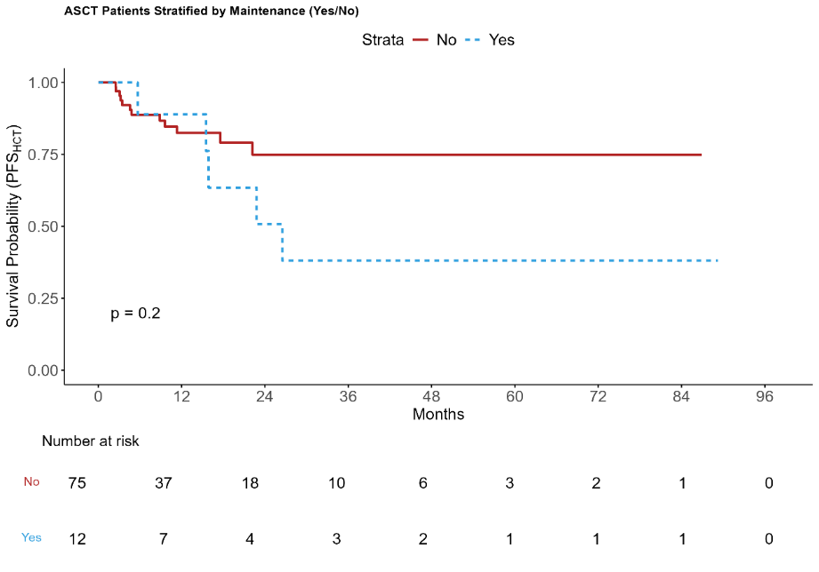
Supplementary Figure 2. Post-transplant Progression-free survival (PFS_{HCT}) of patients receiving transplant in second line versus later lines
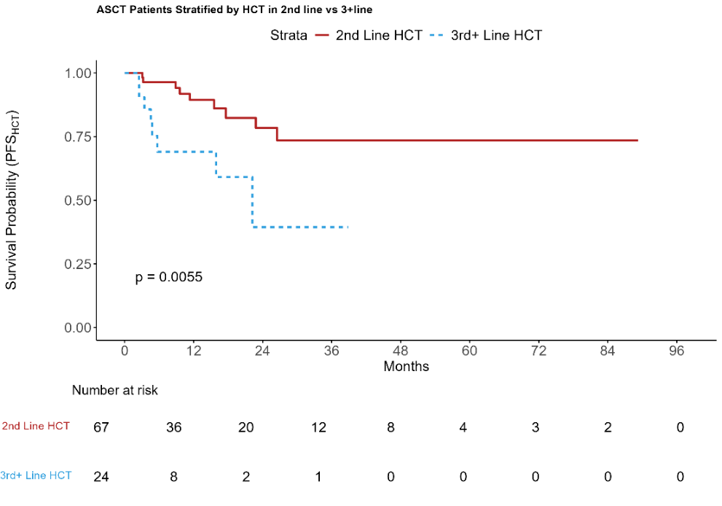
Supplementary Figure 3. Event-free survival (EFS) of patients receiving PD-1 blockade based initial salvage vs. non-PD-1 first salvage
