Supplemental Information

Expression profile of CASSIOPEIA patients refines prognostic value of MRD negativity in multiple myeloma
Magrangeas et al.

Supplemental Table 1: Characteristics of patients at baseline
Supplemental Table 2: Multivariable Cox regression analyses evaluating prognostic impact of AXL co-regulated dormancy signature on PFS (in overall cohort)
Supplemental Table 3: Multivariable Cox regression analyses evaluating the prognostic impact of CD38 expression on PFS (patients treated with daratumumab)
Supplemental Table 4: Post-consolidation MRD negativity according to transcriptomic risk groups for patients in D-VTd or VTd arms
Supplemental Table 5: Univariable and multivariable Cox regression analyses evaluating the prognostic impact of MRD on PFS across transcriptomic risk groups
Supplemental Table 6: Univariable Cox regression analyses evaluating the prognostic impact of MRD on OS across transcriptomic risk groups

Supplemental Figure 1: Trial profile of the RNA-seq cohort
Supplemental Figure 2: Progression-free and Overall Survivals according to treatment arm in the RNAseq cohort
Supplemental Figure 3: RNA-seq consensus clustering matrix
Supplemental Figure 4: Proliferative activity in the CASSIOPEIA cohort
Supplemental Figure 5: Gene ontology pathway enrichment investigated for MF, MS, HP, CD and LB RNA subtypes one vs. others
Supplemental Figure 6: Unsupervised hierarchical clustering of the 40-gene dormancy signature of the CASSIOPEIA RNAseq cohort
Supplemental Figure 7: RNA subtypes characteristics
Supplemental Figure 8: CD38 expression comparison between the fourth treatment groups
Supplemental Figure 9: CD38 expression according to FISH/genomic abnormalities.
Supplemental Figure 10: PFS according by CD38 expression in patients who received daratumumab-containing quadruplet regimen
Supplemental Figure 11: Kaplan-Meier PFS curves for low- intermediate- and high-risk patients with daratumumab administration at any time during treatment, according to post-consolidation MRD
Supplemental Figure 12: Gene expression levels of immunotherapy targets in RNA subtypes of CASSIOPEIA patients

*bortezomib, thalidomide, dexamethasone
⁺Daratumumab
Randomisation #2, N = 490
D-VTd – Daratumumab: N = 117; D-VTd - Observation: N = 129
VTd – Daratumumab: N = 122; VTd - Observation: N = 122;
Patients with progression data: N = 490
No randomisation #2: N = 99
Randomisation #1, N = 589
VTd*: N=301
D⁺-VTd: N=288
No randomisation #1: N = 39
Data available for analysis
N = 628

Supplemental Figure 1. Trial profile of the RNA-seq cohort. Flowchart representing patient distribution at the different timepoints of the study, for patients with available RNA-seq data.

A  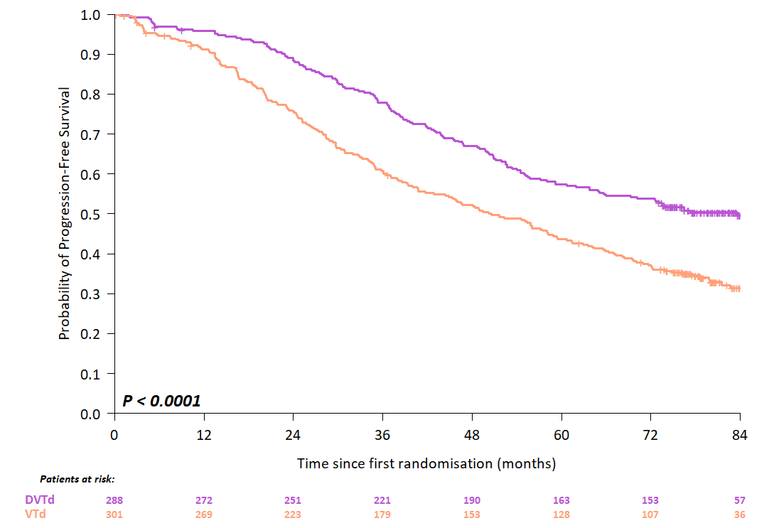 | B  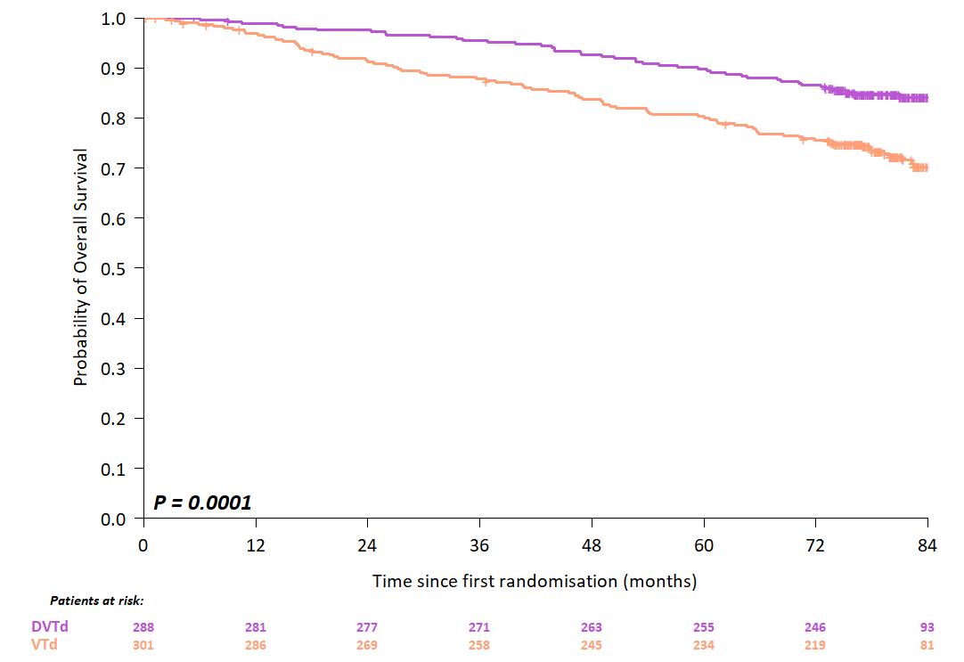
C  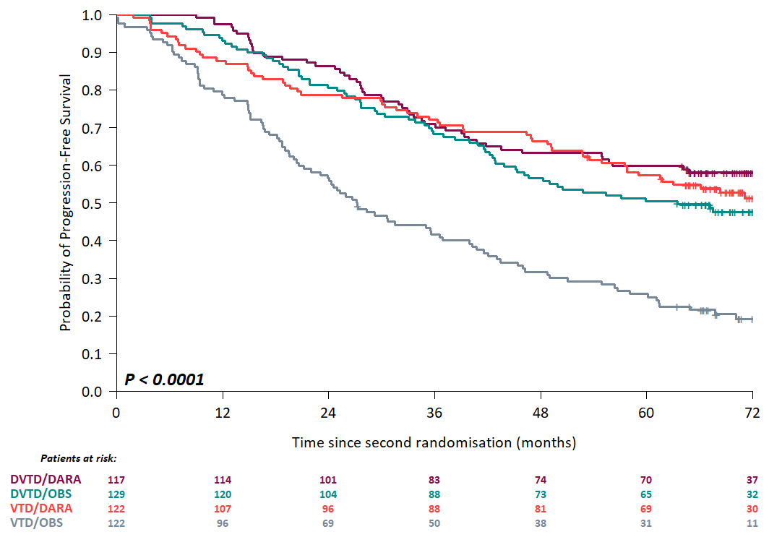 | D  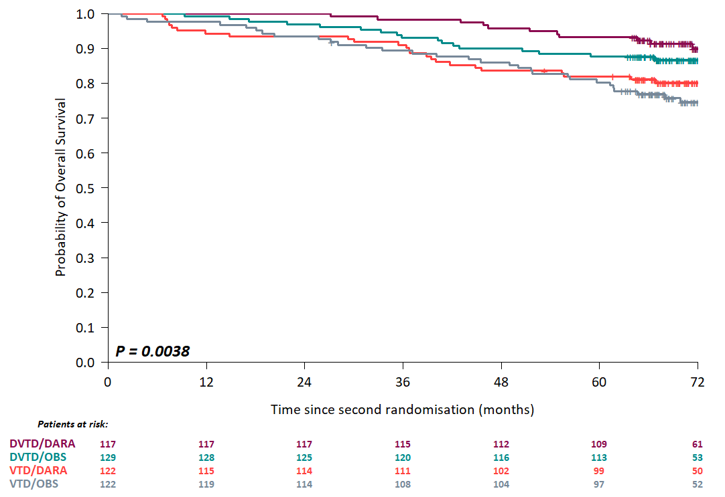
Supplemental Figure 2. Progression-free and Overall Survivals according to treatment arm in the RNAseq cohort. (A) Progression-Free Survival from first randomisation according to treatment. (B) Overall Survival from first randomisation according to treatment. (C) Progression-Free Survival from second randomisation according to treatment arm; pairwise comparisons identified two significantly different subgroups D-VTd + Dara., D-VTd + Obs., VTd + Dara. and VTd + Obs. (P < 0.0001). (D) Overall Survival from second randomisation according to treatment arm.

A  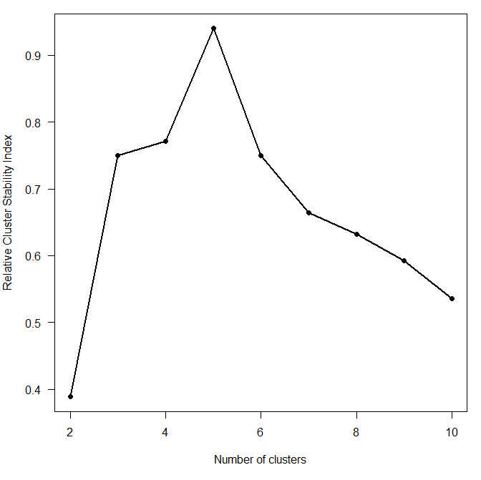 | B  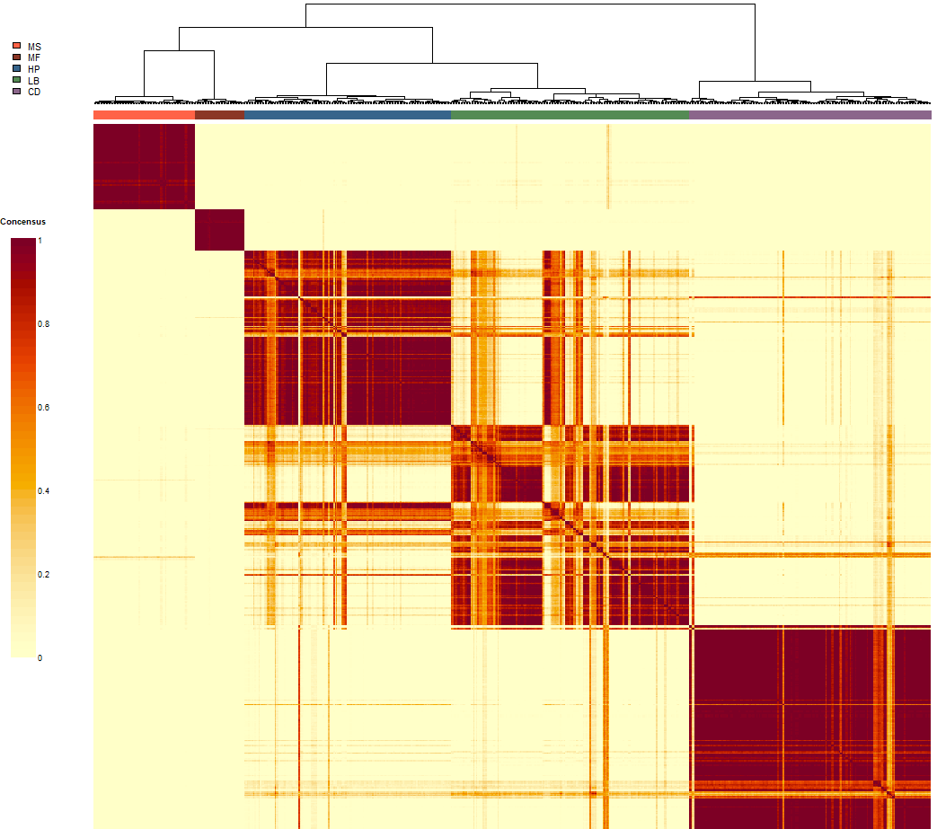  1  2  3  4  5

Supplemental Figure 3. RNA-seq consensus clustering matrix. (A) Optimal number of clusters determination from gene expression consensus clustering based on relative cluster stability index. (B) RNA-seq consensus clustering matrix. Consensus matrix showing the consistency of class assignment for K = 5 clustering of RNA-seq data derived from 628 samples and 932 feature-selected genes.

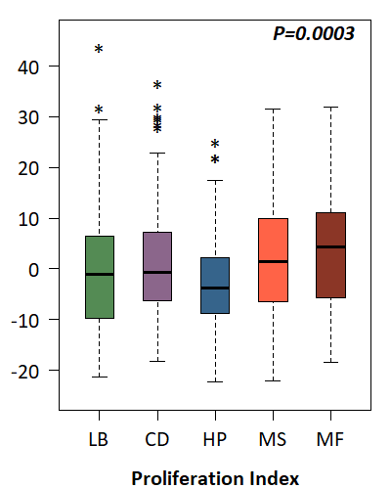
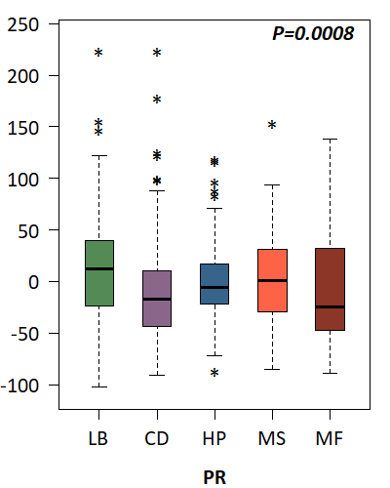
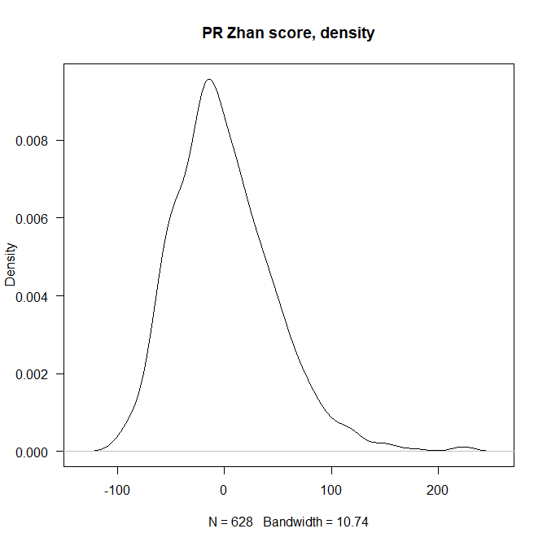
B
Signature score
A
Signature score
Distribution of PR scores
PR score
Density
C
PR

Proliferation index

Supplemental Figure 4. Proliferative activity in the CASSIOPEIA cohort (A) PR scores exhibit a continuous, unimodal distribution in CASSIOPEIA cohort. Distribution of PR scores (B) or Proliferation index scores (C) across RNA-defined subtypes.

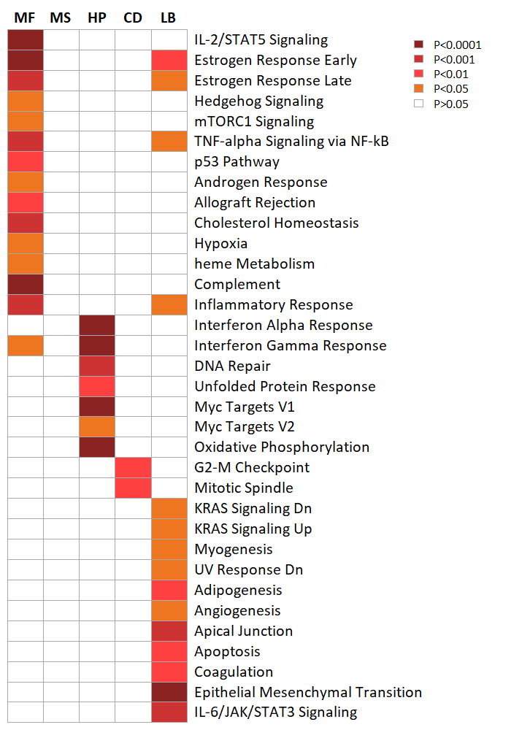

Supplemental Figure 5. Gene ontology pathway enrichment investigated for MF, MS, HP, CD and LB RNA subtypes one vs. others. Hallmark gene sets from MSigDB Human collections was used to test pathway enrichment

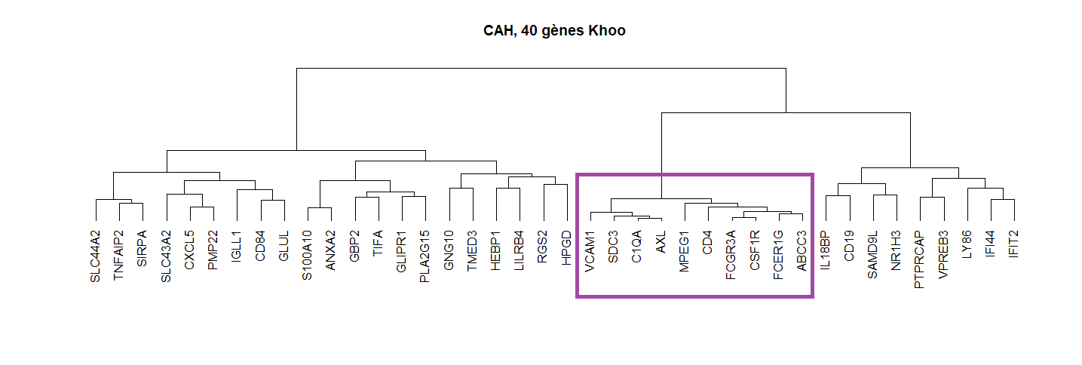
Supplemental Figure 6. Unsupervised hierarchical clustering of the 40-gene dormancy signature¹⁵ of the CASSIOPEIA RNAseq cohort. The gene dendrogram identified AXL-coregulated signature, the branch containing AXL-coregulated signature is boxed.

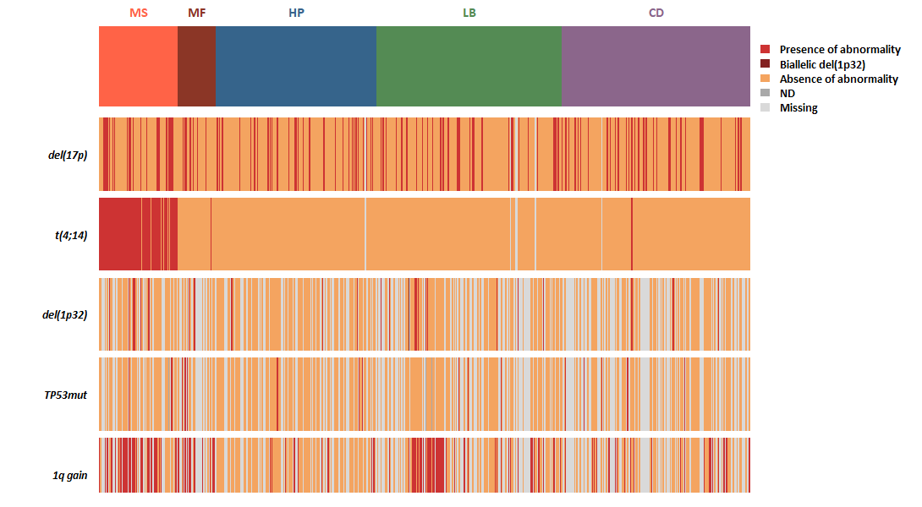

Supplemental Figure 7. RNA subtypes characteristics. RNA subtypes and genomic high-risk markers: del(17p) with a cutoff of > 20%, t(4;14), del(1p32), TP53 mutation and 1q gain.

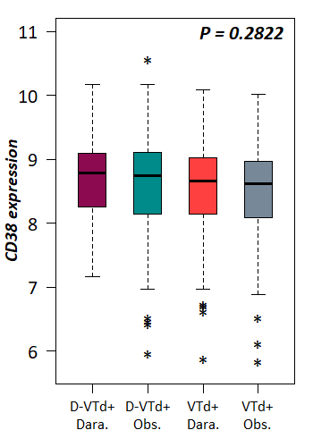

Supplemental Figure 8. CD38 expression comparison between the four treatment arms. Boxplots displaying CD38 expression distribution according to treatment arms.

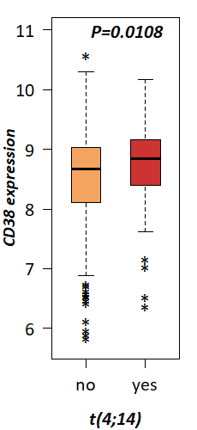
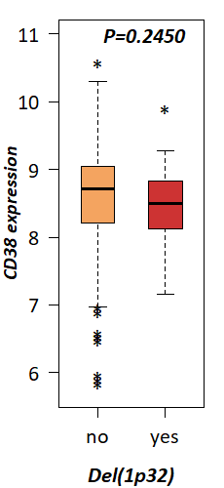
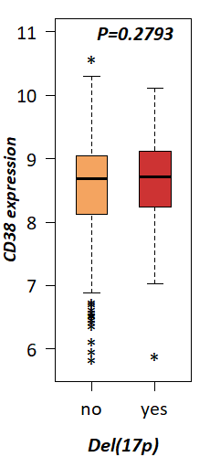
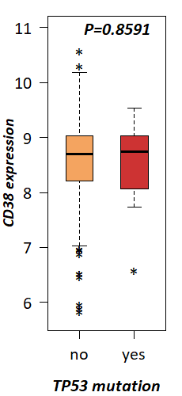
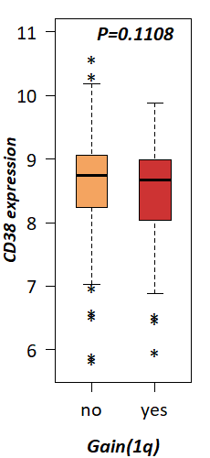

Supplemental Figure 9. CD38 expression according to FISH/genomic abnormalities.

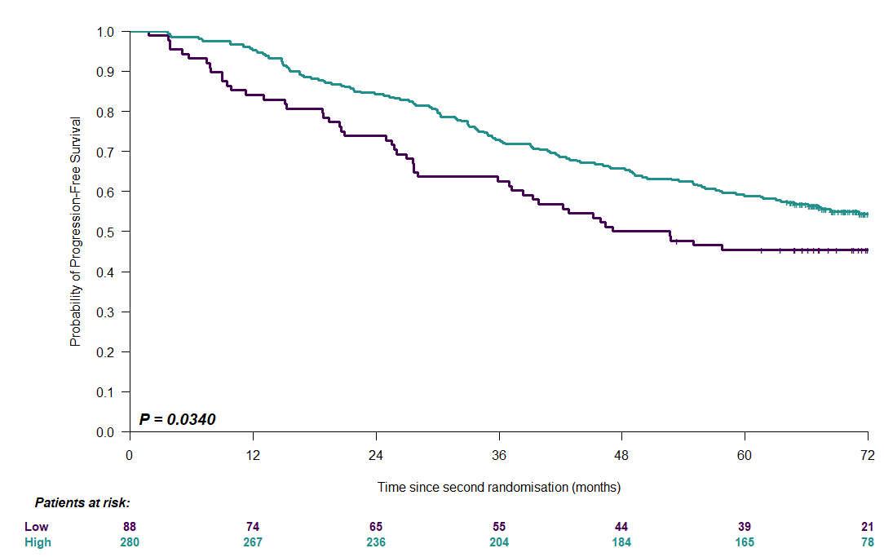

Supplemental Figure 10. PFS according by CD38 expression in patients who received daratumumab-containing quadruplet regimen. Kaplan-Meier curve and logrank test result for PFS according to CD38 expression, high vs. low. High expression of CD38 was defined as quartiles 2 to 4 and low as quartile 1.

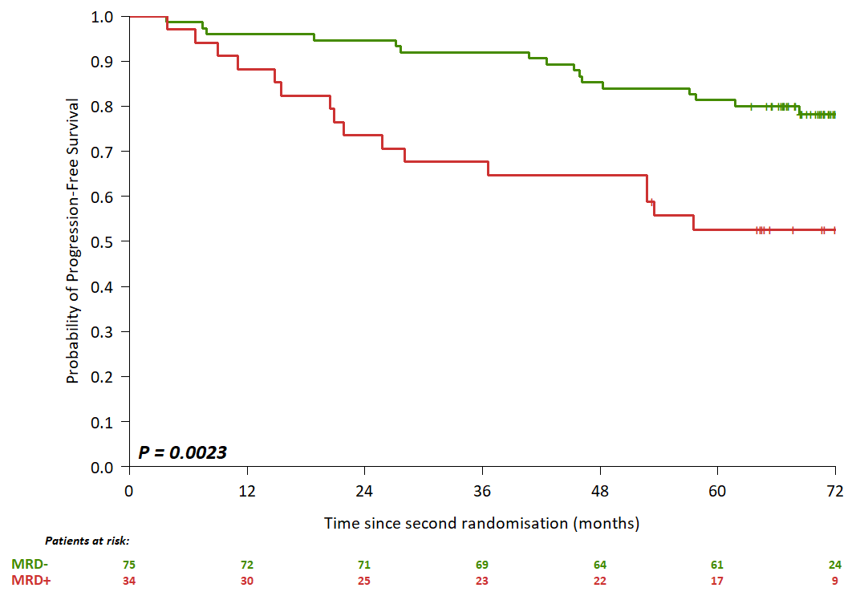
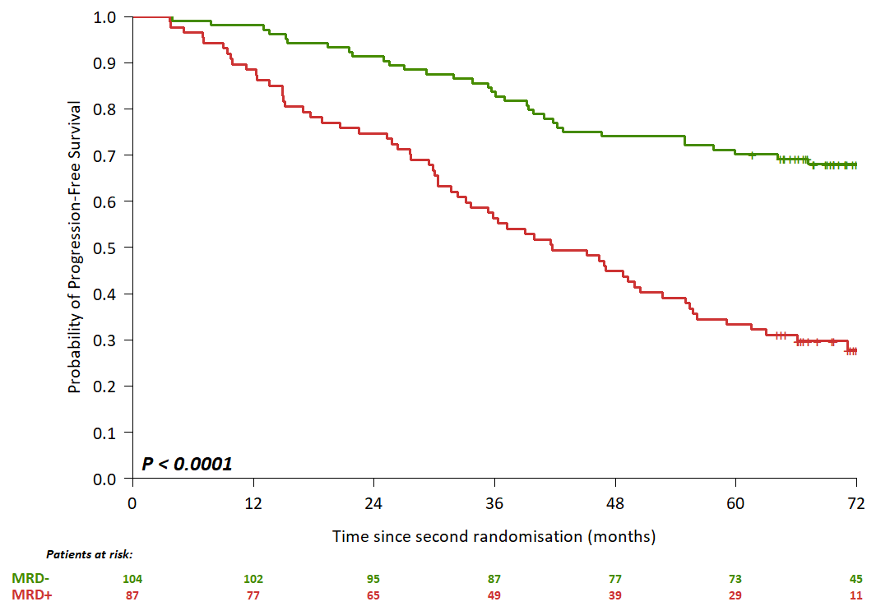
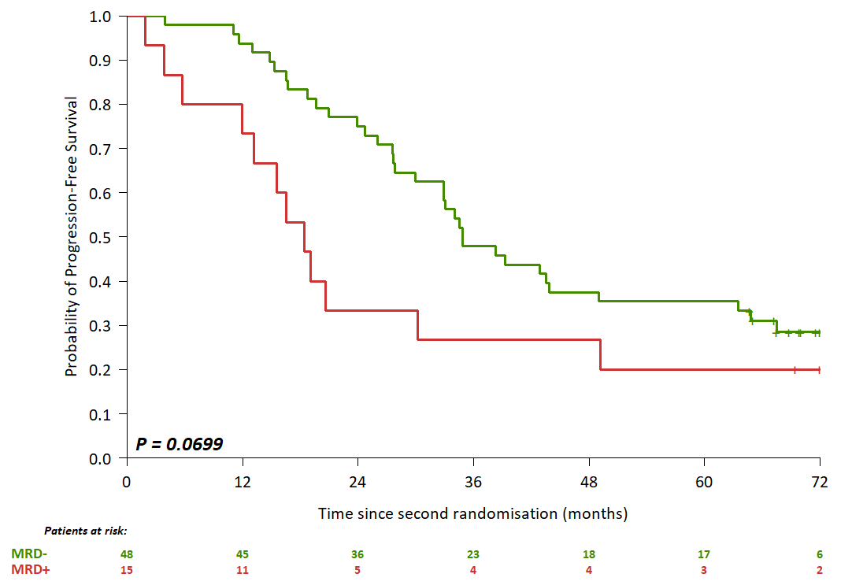
Low-risk patients
Intermediate-risk patients
High-risk patients

Supplemental Figure 11. Kaplan-Meier PFS curves for low- intermediate and high-risk patients with daratumumab administration at any time during treatment, according to post-consolidation MRD.

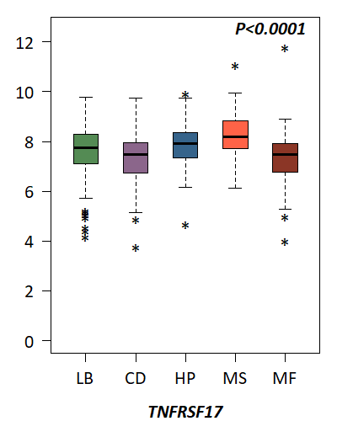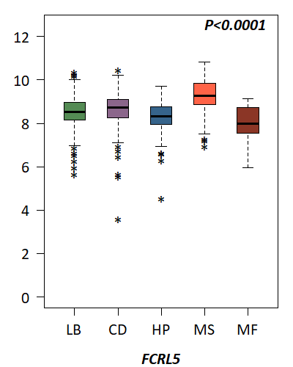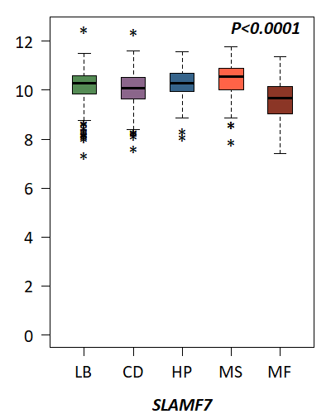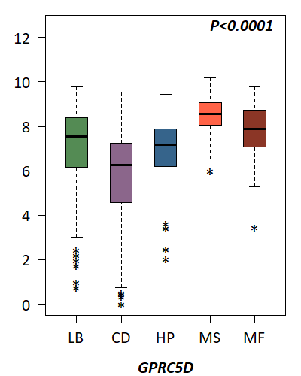

Supplemental Figure 12. Gene expression levels of immunotherapy targets in RNA subtypes of CASSIOPEIA patients. Boxplots representing expression levels of the 4 current T-cell immunotherapy targets TNFRSF17, FCRL5, SLAMF7 and GPRC5D in the five RNA subtypes.

