Supp. Fig. 1: Database search strategy

Database(s): Ovid MEDLINE(R) and Epub Ahead of Print and In-Process, In-Data-Review & Other Non-Indexed Citations and Daily 1946 to December 19, 2025
Search Strategy:
# | Searches | Results
1 | exp Lymphoma/ | 196297
2 | (lymphoma* or germinoblastoma* or reticulolymphosarcoma* or (germinoblastic adj3 sarcoma*)).mp. | 305434
3 | 1 or 2 | 327879
4 | exp Lenalidomide/ | 4014
5 | (lenalidomide* or revlimid* or revimid* or ladevina* or lenabdor* or polalid* or tolreso* or zelvina*).tw,kf. | 6619
6 | 4 or 5 | 7114
7 | 3 and 6 | 1185
8 | (Animals/ or Models, animal/ or Disease models, animal/) not Humans/ | 5373581
9 | ((animal or animals or canine* or cat or cats or dog or dogs or feline or hamster* or lamb or lambs or mice or monkey or monkeys or mouse or murine or pig or pigs or piglet* or swine or porcine or primate* or rabbit* or rats or rat or rodent* or sheep* or veterina*) not (human* or patient*)).ti,kf,jw. | 2789139
10 | 8 or 9 | 5941274
11 | 7 not 10 | 1181
Database(s): Embase Classic+Embase 1947 to 2025 December 18
Search Strategy:
# | Searches | Results
1 | exp lymphoma/ | 454864
2 | (lymphoma* or germinoblastoma* or reticulolymphosarcoma* or (germinoblastic adj3 sarcoma*)).mp. | 476787
3 | 1 or 2 | 536731
4 | lenalidomide/ | 34009
5 | (lenalidomide* or revlimid* or revimid* or ladevina* or lenabdor* or polalid* or tolreso* or zelvina*).tw,kf. | 22215
6 | 4 or 5 | 35222
7 | 3 and 6 | 7941
8 | (exp animal/ or exp juvenile animal/ or adult animal/ or animal cell/ or animal tissue/ or nonhuman/ or animal experiment/ or animal model/) not human/ | 9034159
9 | (animal or animals or canine* or cat or cats or dog or dogs or feline or hamster* or lamb or lambs or marmot* or mice or monkey or monkeys or mouse or murine or pig or pigs or piglet* or porcine or primate* or rabbit* or rats or rat or rodent* or sheep* or veterina*).ti,kw,dq,jx. not (human* or patient*).mp. | 2790543
10 | 8 or 9 | 9165185
11 | 7 not 10 | 7879

Supp. Fig. 2: risk of bias 2 tool for randomized controlled trials

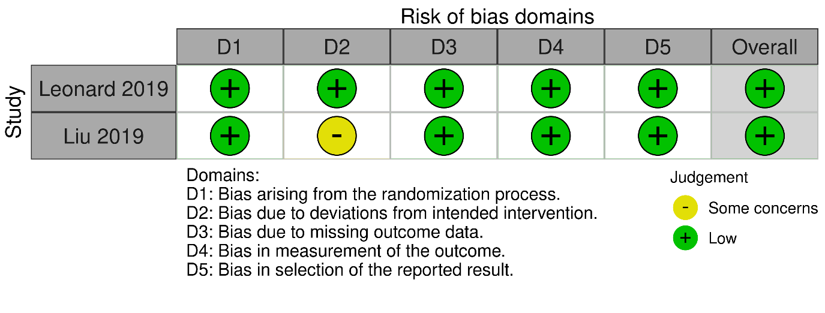
Supp. Figure 3: Overall (OR) and complete (CR) response rates according to therapy (lenalidomide +andti-CD20 + agent “X”), Subgroup analysis of studies which included bendamustine-exposed patients

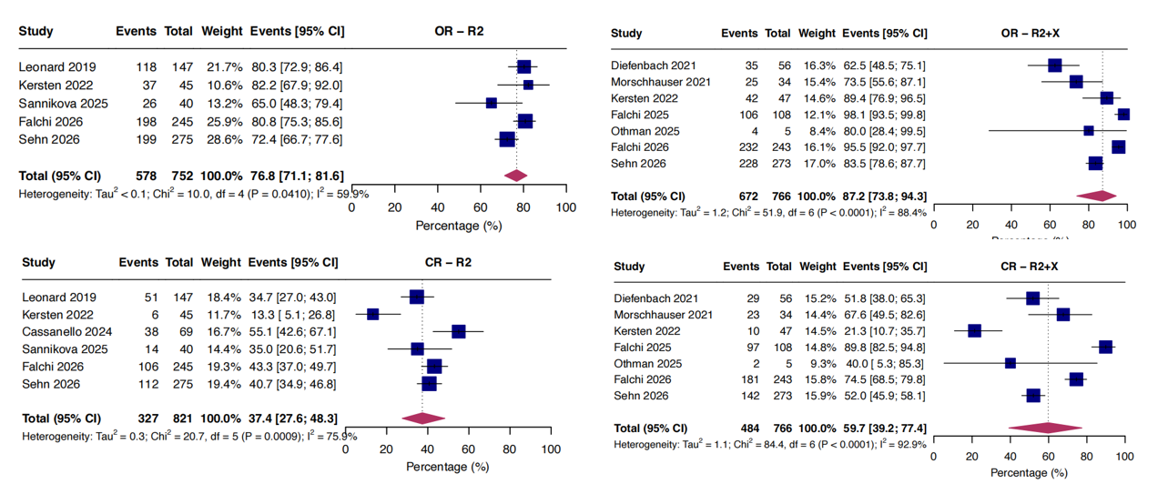
(A) OR – all studies (len-antiCD20, len-antiCD20 + “X”) (B) CR – all studies (len-antiCD20, len-antiCD20 + “X”)

Supp. Figure 4: Rates of grade 3 (G3) + adverse event rates for len-antiCD20 and len-antiCD20+X therapy
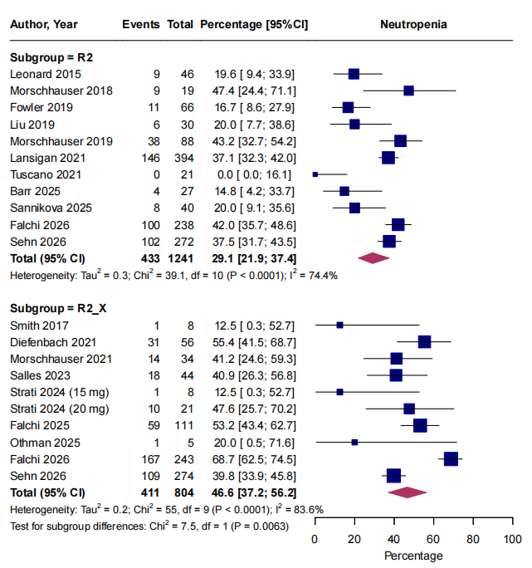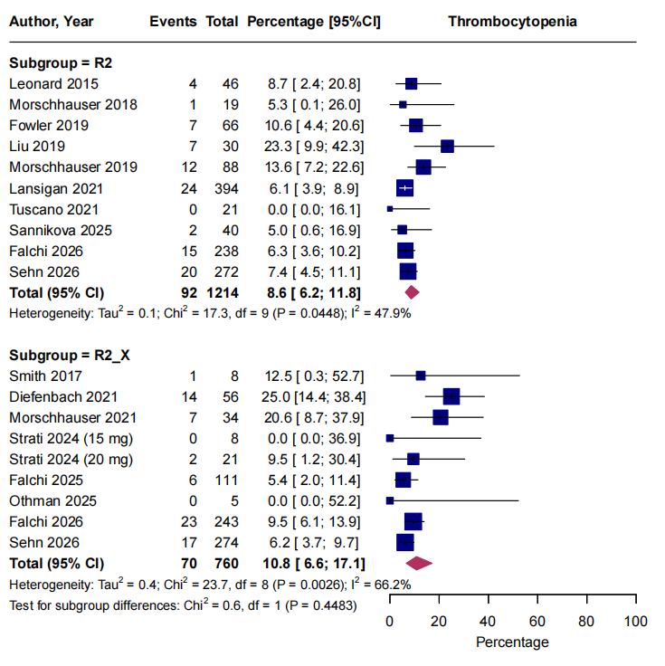
- Grade 3+ neutropenia: len-antiCD20 and len-antiCD20 + “X” (B) Grade 3+ thrombocytopenia: len-antiCD20 and len-antiCD20 + “X”
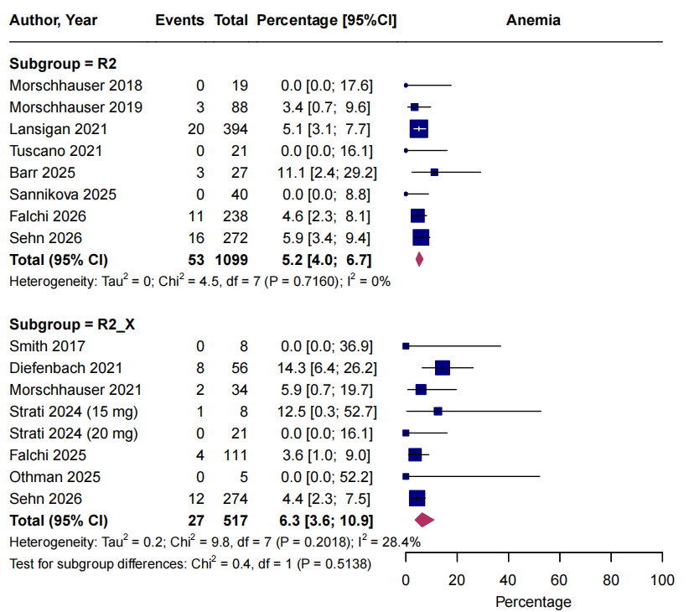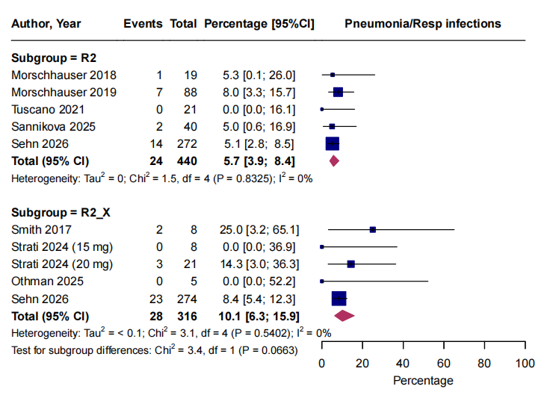
(C) Grade 3+ anemia: len-antiCD20 and len-antiCD20 + “X” (D) Grade 3+ respiratory infections: len-antiCD20 and len-antiCD20 + “X”
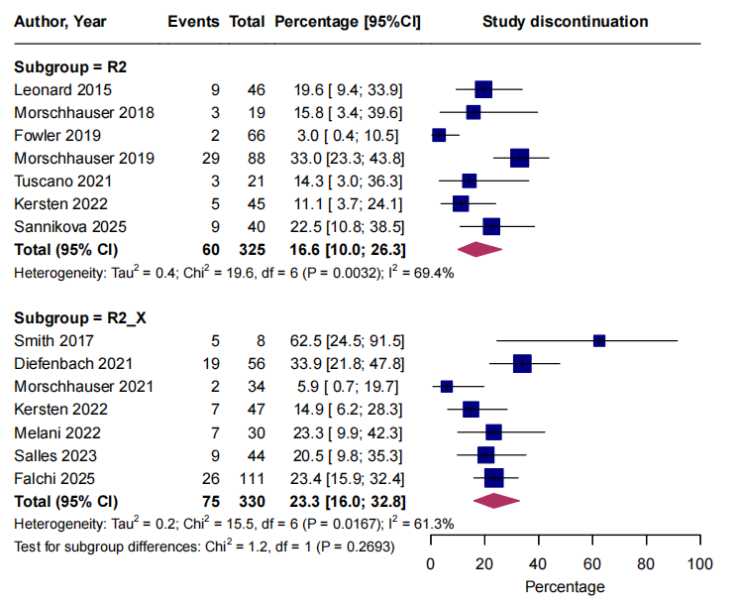
(E) Proportion of patients who discontinued therapy due to AEs: len-antiCD20 and len-antiCD20 + “X”

