Supplemental material:

Figure S1:
Comparison of OS of de novo BC versus patients in CP≥2 or accelerated phase (CPAP) at diagnosis

Figure S2:
OS of patients with (relapse, MRD+ or prophylactic n=49) or without TKI (n=96)

Figure S3:
DLI after relapse (n=34) and no DLI after relapse (n=25).

Figure S4:
OS in patients transplanted in Saint Petersburg (RGMI; n=68) and UKE Hamburg (n=79)

Figure S1

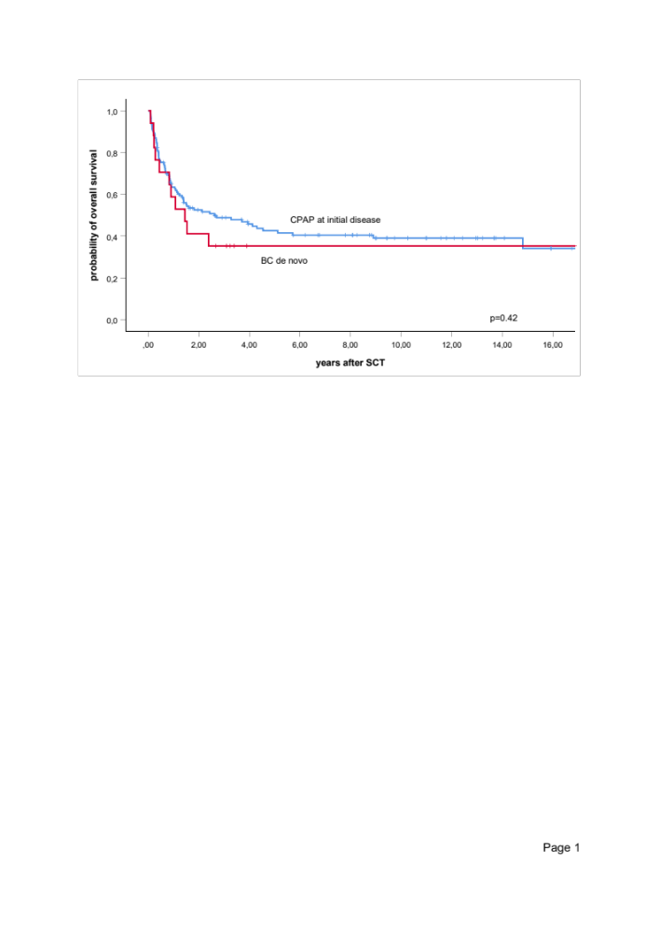
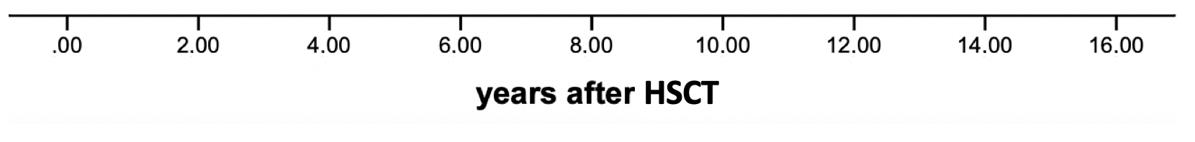
p=0.42
probability (OS)
CPAP at diagnosis (at risk) | 130 | 58 | 43 | 37 | 33 | 22 | 17 | 9 | 5
BC de novo (at risk) | 17 | 7 | 1 | 1 | 1 | 1 | 1 | 1 | 1

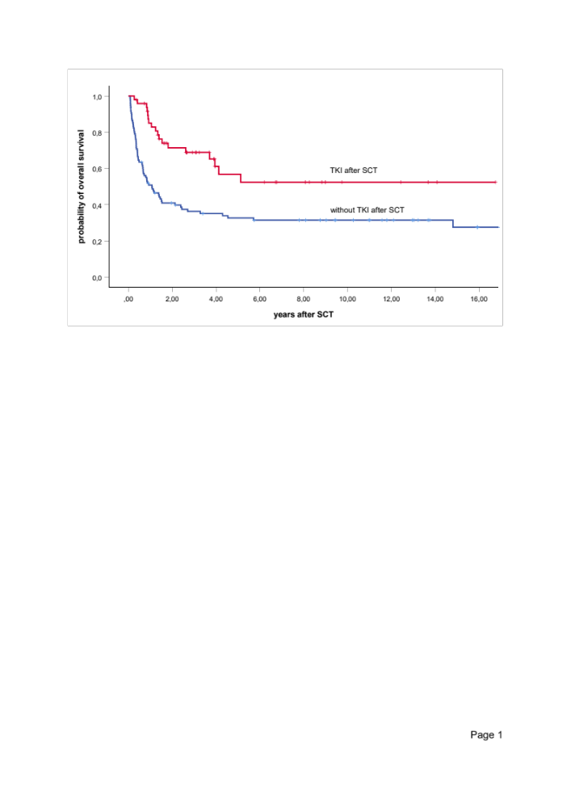
Figure S2
TKI after HSCT (at risk) | 49 | 28 | 14 | 12 | 9 | 4 | 4 | 2 | 1
No TKI after SCT (at risk) | 96 | 36 | 29 | 25 | 24 | 19 | 14 | 8 | 5

P<0.001
probability (OS)

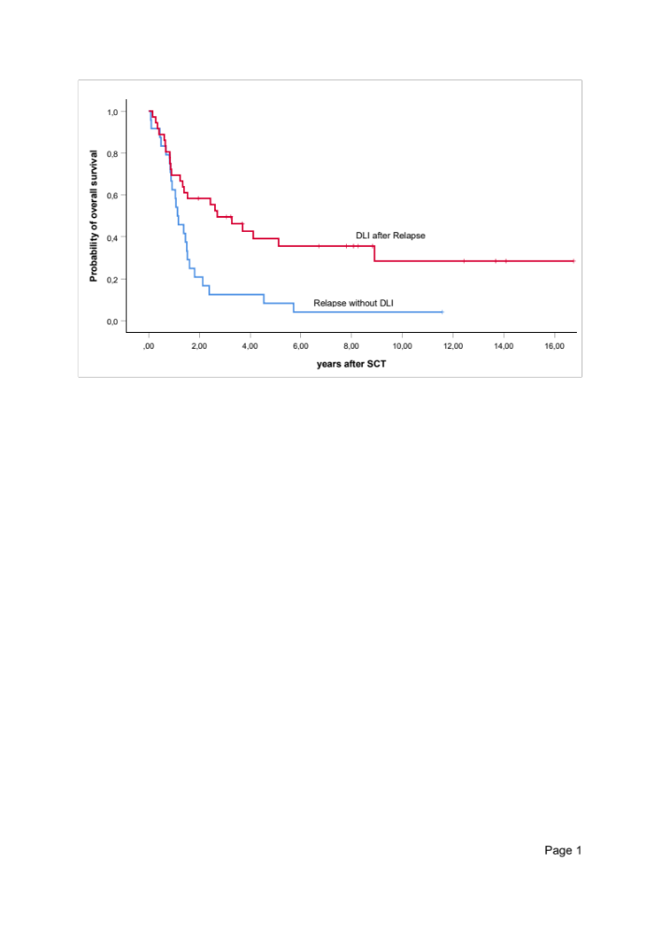
Figure S3

probability (OS)
p<0.001
DLI after relapse (at risk) | 34 | 20 | 12 | 10 | 8 | 4 | 4 | 2 | 1
no DLI after relapse (at risk) | 25 | 5 | 3 | 1 | 1 | 1 | 0 | 0 | 0

days |  |  | 0 |  | 100 |  | 200 |  | 300 |  | 400 |  | 500 |  | 600 |  | 700
cGVHD (at risk) | 147

Figure S4

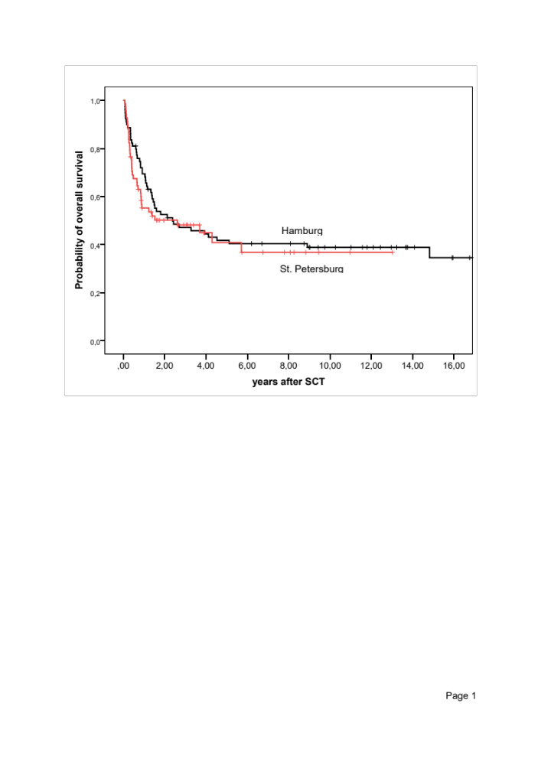
p=n.s.

probability (OS)
UKE Hamburg | 79 | 40 | 33 | 30 | 28 | 21 | 17 | 10 | 6
RGMI St. Petersburg | 68 | 25 | 11 | 8 | 6 | 2 | 0 | 0 | 0

